Characterizing parasite generalism illuminates patterns of host-parasite associations

Park, A.W.

Farrell, M.J.

Schmidt, J.P.

Huang, S.

Dallas, T.A.

Pappalardo, P.

Drake, J.M.

Stephens, P.R

Poulin, R.

Nunn, C.L.

Davies, T.J.

## Abstract

The distribution of parasites among mammalian hosts is complex and represents a differential ability or opportunity to explore the host tree of life. Using data on over 1500 parasite species known to each infect between 1-80 mammal host species, we characterize the generalism of parasites using standard effect sizes for three metrics relating to host phylogenetic distance (PD): average host relatedness, maximum PD and degree of aggregation of hosts (the tendency for the hosts of a parasite to cluster within the phylogenetic tree). We explore variation in these metrics in terms of parasite taxonomy and transmission mode. Of the multi-host parasites, the majority are generalist in the sense that the average relatedness of their mammalian host species is roughly equivalent to that expected from a random sample of mammals, with a minority associated with host sets that are more related than expected by chance. The degree of host relatedness is affected by both parasite taxonomy and transmission mode; bacteria and arthropod parasites are typically the most generalist, helminths are intermediate and viruses and protozoa are the most specialist on average. However, characterizing variation within and between groups is important; for example, viruses are more specialist than helminths on average, but the virus group has a larger range on the specialism-generalism continuum, such that the virus group contains some of the most generalist parasites. While not as strong as parasite taxonomy, transmission mode also influences the degree of parasite generalism, with closer relatedness of hosts exhibited for parasites that rely on close contact or vectors compared to those with environmental or complex life cycle transmission, which includes trophic transmission. Both the span of a parasite across the host tree and the tendency to infect clusters of related hosts vary among parasites. For example, all bacteria have large spans, equivalent to random host sets. However, they exhibit the least propensity to infect host clusters within this span. Instead, they appear to typically infect relatively unrelated host species. Collectively, this macroecological perspective helps to generate a broad picture of the tendency for certain types of parasite and transmission mode to associate with the acquisition of hosts, captured by metrics defining three complementary dimensions of parasite generalism.

## Keywords

Parasite, multi-host, generalism, transmission mode, phylogenetic, macroecology

## Introduction

A generalist parasite has a minimal definition: *able to infect at least two host species*. However, for an equivalent number of host species, parasites may vary in their ability to infect distantly related hosts, differentiating their potential to explore the space of host species along with their ability to infect target species, including humans. The underlying reasons for observing relatedness of hosts of a given parasite include biogeography and co-evolutionary history [1], translating to opportunities for infection, quality resources provided by a host, and limited costs in terms of immune defense and disease-induced mortality. Mechanisms that may allow parasites to overcome host species barriers include rapid evolution and antigenic plasticity [2], novel spatial translocation of host or parasite [3], and evolution of host tolerance [4]. Consequently, it is challenging to predict the potential for parasites to acquire hosts that are distantly or closely related to their existing hosts, in spite of the utility for understanding the distribution of parasites and predicting future zoonoses.

Previous research has defined parasite generalism in alternative ways, including satisfying the criteria of infecting humans and animals [2] as well as using host taxonomies to characterize the degree of parasite generalism [5,6]; for example, classifying parasites by their ability to infect hosts only within a species, or genus, or family, etc. Here, we build on methods to generate continuous measures of generalism [7] using a detailed mammalian host phylogeny to define parasite generalism by the patterns of relatedness of the host sets of parasites. Known associations between hosts and parasites come from the global mammal parasite database [8,9], from which this study focuses on 430 mammal species representing primates (), carnivores () and ungulates (). The approach allows both comparison among parasites and calibration against a null model [10]. From each host set, we calculate the standard effect size of mean pairwise PD between host species, a measure that has previously been used successfully to explain parasite community similarity in primates [11]. In addition, we calculate standard effect sizes for both the maximum PD of host sets and a similar metric that captures the tendency for hosts to be clustered in the phylogenetic tree [12].

We determine that average relatedness of hosts varies with parasite type, defined both taxonomically and by transmission mode, as has been suggested in earlier studies based on categorical definitions of parasite generalism [2,6]. The speciose study, which includes over 1500 parasite species, enables generalism to be characterized further. All taxonomic and transmission mode groupings contain parasites that have large spans in the host tree, measured by standard effect size of maximum PD among hosts. Bacteria and environmentally-transmitted parasites show the lowest propensity to infect phylogenetically clustered host groups. Single host parasites () are almost as common as multi-host parasites () and show similar distributions among parasite taxonomic and transmission mode groupings, with the notable exception of viruses, which are more likely to infect multiple host species. We observe that the number of parasites known to infect a host is partly explained by the evolutionary distinctiveness of the host species.

Macroecological approaches to analyzing large datasets, such as the one presented here, provide a backdrop against which to consider individual case studies, faciltate an appreciation and understanding of robust patterns of host-parasite associations and extend the concept of parasite generalism to include phenomena such as parasites associating with multiple `pockets' of related hosts. Further, the study lays out parasite group-level differences in generalism, including within-group variation, which helps navigate to sources of variation that may ultimately be explained by environmental, physiological and behavioral heterogeneity [13–16].

## Materials and Methods

Parasite records of occurrence with terrestrial mammals were obtained from the global mammal parasite database (GMPD) [8]. These records include latin binomials and taxonomic classification for host and parasite species, and transmission mode for the majority of parasite species (~80%). Transmission modes were assigned in GMPD based on an extensive literature review [8], from which we retain the four heierarchically-dominant transmission modes: close contact, complex life cycle, environmental and vector-borne (other transmission modes are recorded in GMPD, such as soil-transmission, but these belong to one of the four main transmission modes). GMPD data was manipulated in the R programming environment [17] to establish the number and identity of parasite species per host species and the number and identity of host species per parasite species.

Additionally, the mammal phylogenetic supertree [18] was used to obtain the PD between all pairs of hosts. For the host set of each parasite species, the mean pairwise PD between hosts was calculated, along with the standard effect size of mean pairwise distance [19]. The latter was obtained using the R package *Picante* [20], and a null model in which the community data matrix (host-parasite occurrences) was randomized with the independent swap algorithm [10] maintaining species occurrence frequency and sample species richness. This measure captures the average relatedness of the host species of a given parasite species on a standardized scale for comparison. Two further standard effect size metrics were calculated on each parasite species' host set in the same way: maximum PD of any two hosts in a parasite's set, and the ratio of the mean minimum PD to the maximum PD. The former metric provides a standardized measure of each parasite's span across the host phylogenetic tree, while the latter provides a measure of the tendency for the host species to exhibit an aggreagated or clumped distribution within the span [12]. This is achieved by calculating the PD of each host species to its nearest host, averaging this across all hosts and scaling by the span. The standard effect size calculations return a z-score and a p-value, where z-scores below -1.96 and above +1.96 are signifacntly different from the null expectation, assuming the null model generates a normally-distributed set of scores [21].

Host evolutionary distinctiveness, measured as millions of years of evolutionary change, was established from the mammal supertree data [18] using the *evol.distinct* function in the R package *Picante* [20], utilizing the *equal splits* routine in which shared branches are apportioned equally among descendant lineages [22].

## Results

Across all parasites there is a trend of infecting hosts that are more related than expected by chance, indicated by negative z-scores for mean pairwise PD between hosts (Fig. 1, global median z-score=-1.18). However, while 94% of parasites exhibit negative z-scores, only 26% of parasites have significantly negative z-scores. There are no parasites that have significantly positive z-scores. The proportion of these significantly negative z-scores varies across parasite type, with smallest to largest proportions corresponding to bacteria, arthropods, helminths, protozoa and viruses (test for equality of proportions, p<0.001, Fig. S1, supplementary material). The proportion of significantly negative z-scores also varies across parasite transmission modes, with smallest to largest proportions corresponding to environmental, vector-borne, complex life cycle and close contact transmission (test for equality of proportions, p<0.001, Fig. S2, supplementary material). Across the full range of z-scores each of the two covariates (parasite type and transmission mode) are predictive (GLM: parasite type , transmission mode ). However, there is no significant interaction effect; transmission mode trends are consistent across parasite types (). The two covariates explain significant variation in z scores, with a pseudo value [23] of 0.78.

On average, bacteria are the group containing parasites with the most distantly related hosts, followed by arthropods, helminths, viruses and finally protozoa. There is a tendency for parasites that rely on close contact between hosts to infect closely related host species. Conversely, vector-borne parasites and environmentally transmitted parasites are typically the most generalist among a given parasite group. In terms of absolute numbers, of those parasite species in the percentile for z scores (i.e. the most generalist), the descending order of parasite groups is helminth (), arthropod (), bacteria (), virus (), protozoa (). For transmission mode, the percentile for z scores is dominated by environmental transmission (), then complex life cycle (), vector-borne () and close contact ().

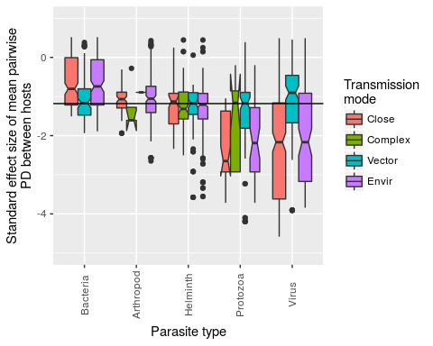

Figure 1. Boxplot of z-scores in each parasite group stratified by transmission mode. Positive z-scores indicate that a parasite species tends to infect host species that are more distantly related than expected by chance (under the null model). Alternatively, negative z-scores indicate the opposite. In terms of deviation from the null model, 26% of z-scores are significantly negative (none of the positive z-scores are statistically significant). Solid horizontal line indicates the global median z-score.

In comparing the most abundant parasite group (helminths) with the group containing the greatest number of specialists (viruses) it is noteable that viruses exhibit much wider variation in degree of generalism (Fig. 2), containing many extreme specialists (large, negative z-scores) but also many relative generalists (positive z-scores). By contrast, helminths are more consistent in their degree of generalism, and contain relatively few species that are extreme at either side of the generalism-specialistm continuum.

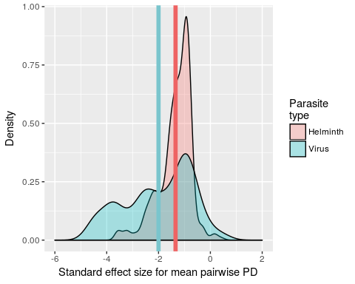

Figure 2: Probability density function of z-scores for helminths (red) and viruses (blue). Helminths are more generalist on average (mean values denoted by color-coded vertical lines), but the virus group contains more extreme parasites in terms of both specialism and generalism.

The standard effect size of maximum PD in a parasite's host set provides a comparative measure of the span that a parasite exhibits across the host phylogenetic tree (Fig. 3). In addition, the standard effect size of the ratio of mean minimum to maximum varies across parasite groups, with lowest values typically in viruses and protozoa (Fig. 2, inset). Low ratios indicate that a given parasite's host set includes a few outlier host species, distantly related to the other host species in the set.

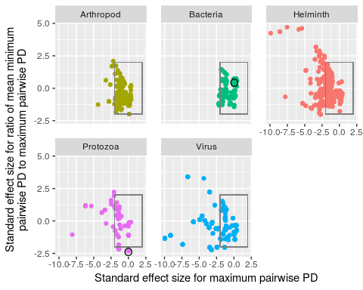

Figure 3: Scatter plot showing x: standard effect size of maximum pairwise PD of a parasite's host set and y: standard effect size of the ratio of mean minimum pairwise PD to maximum pariwise PD, colored by parasite type. The x-axis provides a comparative measure of a parasite's span across the host phylogenetic tree, and the y-axis provides a comparative measure of the aggregation of a parasite's hosts in the phylogenetic tree. Circled bacterial and protozoan parasites are *Escherichia coli* and *Trypanosoma cruzi*, respectively. These parasites have a similar span (x~0), but very different host aggregation patterns (*E. coli* regularly spaced host species, *T. cruzi* clumpily distributed host species). Boxes encompassing -2

Figure 4: Examples of clumpy vs. non-clumpy distributions of parasites in host phylogenetic tree. The parasites are *Escherichia coli* and *Tryapnosoma cruzi*, colored according to their groupings in Fig. 3.

The main analysis is centered on parasite species that infect at least two host species. However, there may be important information on parasite specialism revealed by studying those parasite species that are only known to infect one host species among the host orders studied. We consider these parasite species and examine the parasite type and transmission mode, along with the terminal branch length of the host, a simple measure of evolutionary distinctiveness.

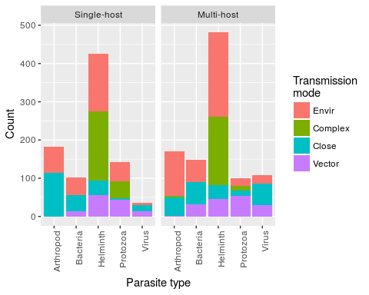

Host evolutionary distinctiveness contributes to low parasite species richness (PSR). A negative binomial generalized linear model was fitted to log transformed count data corresponding to parasite species richness. Two predictor variables were included: host evolutionary distinctiveness and number of host records in GMPD. Evolutionary distinctiveness, measured as millions of years of evolutionary change, was established from the mammal supertree data [18] using the *evol.distinct* function in R package *Picante* [20], utilizing the *equal splits* routine in which shared branches are apportioned equally among descendant lineages [22]. The number of host records in the GMPD was used to control for sampling bias. Both the number of host records and evolutionary distinctiveness were significant predictors of parasite species richness ( and , respectively). A unit increase in evolutionary distinctiveness decreased log(PSR) by 0.01, which corresponds to approximately 1 parasite fewer per million years of evolutionary distinctiveness.

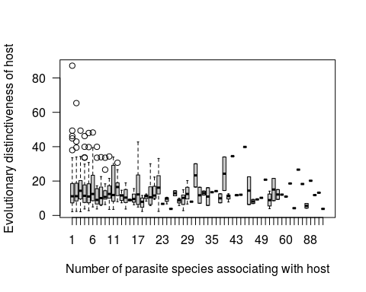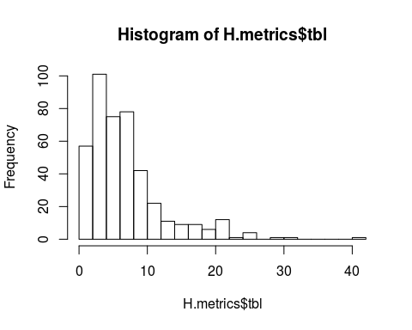

##   
## One-sample Kolmogorov-Smirnov test  
##   
## data: H.metrics$n.para  
## D = 0.51051, p-value < 2.2e-16  
## alternative hypothesis: two-sided

## Loading required package: grid

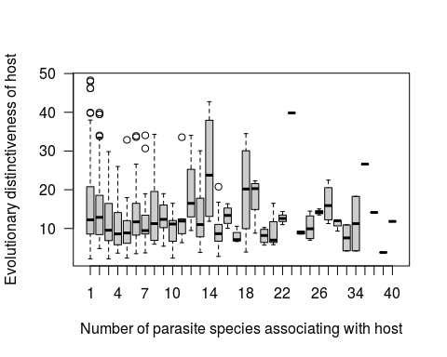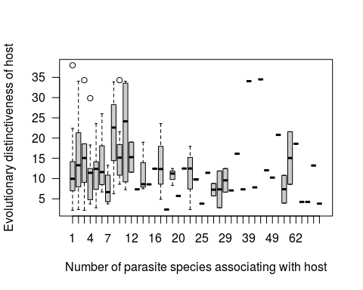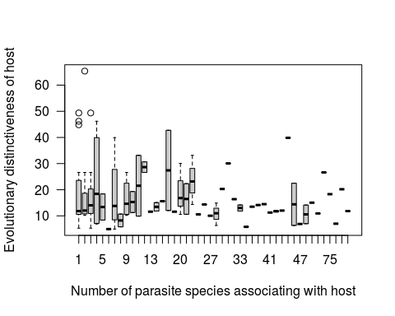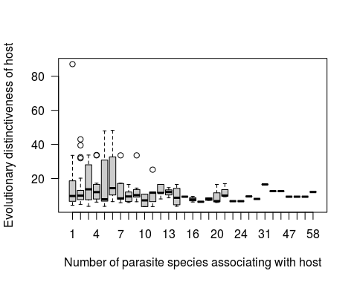

## Discussion

We have shown that, in general, parasites are relatively specialist. However, among the almost one thousand parasite species considered here, some infect host species that are comparatively distantly related. Of the five parasite groups, bacteria are the most generalist on average and helminths represent the group with the largest number of parasite species in the overall highest 10% of z scores (though they are also the most represented group). Conversely, protozoa are the most specialist on average, and have the fewest number of species in the overall highest 10% of z scores. After protozoa, viruses are the next most specialist group.

Previous research based on taxonomic definitions of generalism have tended to suggest that viruses and protozoa are relatively generalist and helminths relatively specialist [6]. The differences between those results and the ones we present here lie in the definition of generalism. For example, while viruses typically infect closely related hosts (shown by large negative z scores), they are also the group that occasionally acquires considerably distantly related hosts (low ratio in mean to maximum host phylogenetic pairwise distances). While other parasite groups may typically contain species whose hosts are more distantly related, they do not show this same propensity to make leaps across large host species barriers. A taxonomic definition of generalism such as the ability to infect hosts of different orders [6], will do well in detecting this potential, whereas looking at the standard effect size of mean host phylogenetic pairwise distances complements this as a continuous, standardized measure that facilitates comparison across parasite species and with null models.

While the underlying data represent known host-parasite occurrences, they are not necessarily indicative of parasite fitness. Parasites may jump between host species, establishing in each, e.g. Rabies virus [24], or maintain themselves in some host species and spillover to others, e.g. West Nile virus [25]. Consequently, it is difficult to infer future potential for novel host acquisition from existing data. Plausibly, parasites with rapid evolution may be both good adaptors to, and explorers of, the space of host species, as is indicated by the virus group.

Transmission mode naturally impacts the opportunity to encounter novel host species. Within each parasite group, contact based transmission typically results in a higher degree of specialism, whereas vector-borne and environmental transmission are associated with relative generalism, consistent with previous research [6]. Host species geographical ranges have previously been shown to be one of the strongest predictors of viral parasite sharing among primates [26], and is only implicitly included here due to the non-independence of range overlap and phylogenetic relatedness [1]. Explicit inclusion of geography is a promising line of macroecological inquiry.

## Supplementary material

Looking at all multi-host parasites for single factors...

nri9<-nri6[nri6$ntaxa>1,]  
  
nri9$close<-as.factor(nri9$close)  
nri9$nonclose<-as.factor(nri9$nonclose)  
nri9$intermediate<-as.factor(nri9$intermediate)  
nri9$vector<-as.factor(nri9$vector)  
nri9$para.type<-droplevels(nri9$para.type)  
  
a1<-aov(mpd.obs.z~para.type+(close+nonclose+vector+intermediate),data=nri9)  
#a1<-aov(mpd.obs.z~(close+nonclose+vector+intermediate),data=nri9)  
#a1<-aov(mpd.obs.z~para.type,data=nri9)  
TukeyHSD(x=a1, conf.level=0.95)

## Tukey multiple comparisons of means  
## 95% family-wise confidence level  
##   
## Fit: aov(formula = mpd.obs.z ~ para.type + (close + nonclose + vector + intermediate), data = nri9)  
##   
## $para.type  
## diff lwr upr p adj  
## Bacteria-Arthropod 0.2327664 0.01068357 0.45484919 0.0345571  
## Helminth-Arthropod -0.3067992 -0.50845206 -0.10514641 0.0003317  
## Protozoa-Arthropod -0.6886983 -0.95451476 -0.42288175 0.0000000  
## Virus-Arthropod -0.9640829 -1.16617120 -0.76199456 0.0000000  
## Helminth-Bacteria -0.5395656 -0.73228548 -0.34684574 0.0000000  
## Protozoa-Bacteria -0.9214646 -1.18056982 -0.66235943 0.0000000  
## Virus-Bacteria -1.1968493 -1.39002477 -1.00367375 0.0000000  
## Protozoa-Helminth -0.3818990 -0.62372249 -0.14007555 0.0001670  
## Virus-Helminth -0.6572836 -0.82657589 -0.48799141 0.0000000  
## Virus-Protozoa -0.2753846 -0.51757137 -0.03319789 0.0165620  
##   
## $close  
## diff lwr upr p adj  
## 1-0 -0.2508306 -0.3434853 -0.1581759 1e-07  
##   
## $nonclose  
## diff lwr upr p adj  
## 1-0 0.04310279 -0.05023757 0.1364431 0.36517  
##   
## $vector  
## diff lwr upr p adj  
## 1-0 0.2256658 0.1181006 0.3332311 4.09e-05  
##   
## $intermediate  
## diff lwr upr p adj  
## 1-0 0.1011447 -0.06901469 0.2713041 0.2438017

Look at proportion of significant, neg. z scores by parasite type

sig.z<-NULL #note all significant z scores are negative (checked independently)  
for (i in unique(nri9$para.type)){  
 tmp<-subset(nri9,para.type==i)  
 sig.z<-rbind(sig.z,c(i,dim(tmp)[1],length(which(tmp$mpd.obs.p<0.05))))  
}  
sig.z<-as.data.frame(sig.z)  
names(sig.z)<-c("para.type","n","x")  
sig.z$n<-as.integer(as.character(sig.z$n))  
sig.z$x<-as.integer(as.character(sig.z$x))  
sig.z$y<-sig.z$n-sig.z$x  
prop.test(sig.z$x,sig.z$n)

##   
## 5-sample test for equality of proportions without continuity  
## correction  
##   
## data: sig.z$x out of sig.z$n  
## X-squared = 206.19, df = 4, p-value < 2.2e-16  
## alternative hypothesis: two.sided  
## sample estimates:  
## prop 1 prop 2 prop 3 prop 4 prop 5   
## 0.06666667 0.20243902 0.11312217 0.50123457 0.31818182

sig<-NULL  
for (i in 1:dim(sig.z)[1]){  
 for(j in 1:sig.z[i,"x"]){  
 sig<-rbind(sig,c(as.character(sig.z$para.type[i]),1))  
 }  
 for(j in 1:sig.z[i,"y"]){  
 sig<-rbind(sig,c(as.character(sig.z$para.type[i]),0))  
 }  
}  
sig<-as.data.frame(sig)  
names(sig)<-c("para.type","sig")  
sig$para.type<-factor(sig$para.type,levels=c("Bacteria","Arthropod","Helminth","Protozoa","Virus"))  
ggplot(sig,aes(x=para.type,fill=sig))+geom_bar(position="fill")+scale_fill_discrete(name="Significant")+xlab("Parasite type")+ylab("")+scale_fill_manual(values=c("gray","dodgerblue4"))

## Scale for 'fill' is already present. Adding another scale for 'fill',  
## which will replace the existing scale.

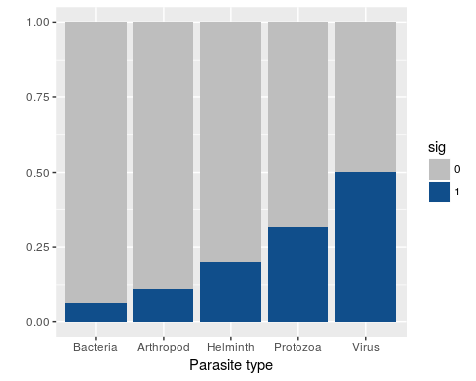

Look at proportion of significant, neg. z scores by transmission mode

sig.z<-NULL #note all significant z scores are negative (checked independently)  
for (i in unique(nri.flat$tmode)){  
 tmp<-subset(nri.flat,tmode==i)  
 sig.z<-rbind(sig.z,c(i,dim(tmp)[1],length(which(tmp$mpd.obs.p<0.05))))  
}  
sig.z<-as.data.frame(sig.z)  
names(sig.z)<-c("tmode","n","x")  
sig.z$n<-as.integer(as.character(sig.z$n))  
sig.z$x<-as.integer(as.character(sig.z$x))  
sig.z$y<-sig.z$n-sig.z$x  
prop.test(sig.z$x,sig.z$n)

##   
## 4-sample test for equality of proportions without continuity  
## correction  
##   
## data: sig.z$x out of sig.z$n  
## X-squared = 22.72, df = 3, p-value = 4.618e-05  
## alternative hypothesis: two.sided  
## sample estimates:  
## prop 1 prop 2 prop 3 prop 4   
## 0.3105096 0.2045728 0.2244898 0.2389381

sig<-NULL  
for (i in 1:dim(sig.z)[1]){  
 for(j in 1:sig.z[i,"x"]){  
 sig<-rbind(sig,c(as.character(sig.z$tmode[i]),1))  
 }  
 for(j in 1:sig.z[i,"y"]){  
 sig<-rbind(sig,c(as.character(sig.z$tmode[i]),0))  
 }  
}  
sig<-as.data.frame(sig)  
names(sig)<-c("tmode","sig")  
sig$tmode<-as.character(sig$tmode)  
sig$tmode[which(sig$tmode=="close")]<-"Close"  
sig$tmode[which(sig$tmode=="intermediate")]<-"Complex"  
sig$tmode[which(sig$tmode=="nonclose")]<-"Envir."  
sig$tmode[which(sig$tmode=="vector")]<-"Vector"  
  
sig$tmode<-factor(sig$tmode,levels=c("Close","Complex","Vector","Envir."))  
ggplot(sig,aes(x=tmode,fill=sig))+geom_bar(position="fill")+xlab("Transmission mode")+ylab("")+scale_fill_discrete(name="Significant")+scale_fill_manual(values=c("gray","dodgerblue4"))

## Scale for 'fill' is already present. Adding another scale for 'fill',  
## which will replace the existing scale.

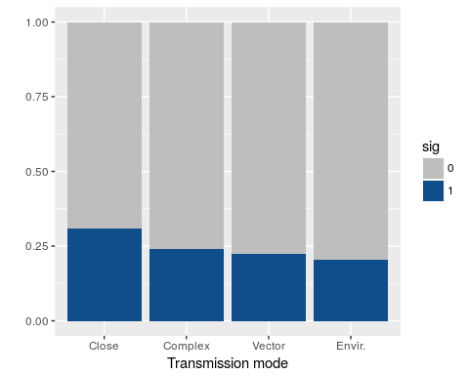

## Warning: `panel.margin` is deprecated. Please use `panel.spacing` property  
## instead

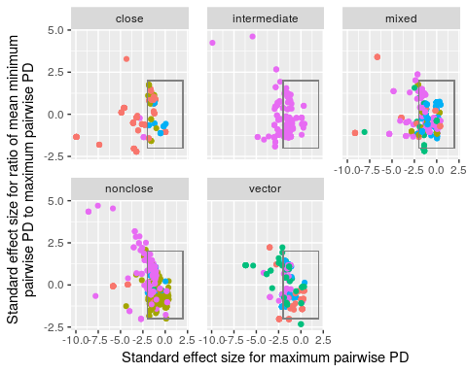

Breaking up host species by host order allows us to check if results on generalism are driven by the non-monophyletic structure of a tree with three host orders.

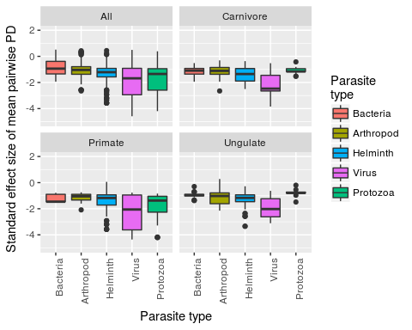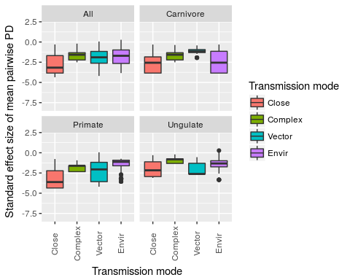

Examination of (multi-host) parasites with unique transmission modes shows there is not interaction between parasite type and transmission mode

idx.1<-which(nri6$ntaxa>1)  
idx.2<-which(nri6$n.modes==1)  
idx<-intersect(idx.1,idx.2)  
u<-nri6[idx,]  
u$tmode<-"tbd"  
for (i in 1:dim(u)[1]){  
 if (u$close[i]==1){u$tmode[i]<-"close"}  
 if (u$nonclose[i]==1){u$tmode[i]<-"nonclose"}  
 if (u$intermediate[i]==1){u$tmode[i]<-"intermediate"}  
 if (u$vector[i]==1){u$tmode[i]<-"vector"}  
}  
u$tmode<-as.factor(u$tmode)  
u$para.type<-droplevels(u$para.type)  
summary(glm(mpd.obs.z~para.type+tmode,family=gaussian,data=u))

##   
## Call:  
## glm(formula = mpd.obs.z ~ para.type + tmode, family = gaussian,   
## data = u)  
##   
## Deviance Residuals:   
## Min 1Q Median 3Q Max   
## -2.7572 -0.5193 0.1368 0.5962 2.7160   
##   
## Coefficients:  
## Estimate Std. Error t value Pr(>|t|)   
## (Intercept) -1.38848 0.09473 -14.657 < 2e-16 ***  
## para.typeBacteria -0.02975 0.11529 -0.258 0.796   
## para.typeHelminth -0.52348 0.08711 -6.009 2.56e-09 ***  
## para.typeProtozoa -0.70482 0.13271 -5.311 1.33e-07 ***  
## para.typeVirus -0.86119 0.09592 -8.979 < 2e-16 ***  
## tmodeintermediate 0.63245 0.12679 4.988 7.13e-07 ***  
## tmodenonclose 0.47936 0.08753 5.477 5.42e-08 ***  
## tmodevector 0.65274 0.08365 7.804 1.44e-14 ***  
## ---  
## Signif. codes: 0 '***' 0.001 '**' 0.01 '*' 0.05 '.' 0.1 ' ' 1  
##   
## (Dispersion parameter for gaussian family taken to be 0.7925749)  
##   
## Null deviance: 1041.50 on 1062 degrees of freedom  
## Residual deviance: 836.17 on 1055 degrees of freedom  
## AIC: 2779.5  
##   
## Number of Fisher Scoring iterations: 2

summary(glm(mpd.obs.z~para.type*(close+nonclose+intermediate+vector),data=nri6))

##   
## Call:  
## glm(formula = mpd.obs.z ~ para.type * (close + nonclose + intermediate +   
## vector), data = nri6)  
##   
## Deviance Residuals:   
## Min 1Q Median 3Q Max   
## -2.74387 -0.45424 0.07526 0.55716 2.92615   
##   
## Coefficients: (3 not defined because of singularities)  
## Estimate Std. Error t value Pr(>|t|)   
## (Intercept) -0.90707 0.20121 -4.508 7.09e-06 ***  
## para.typeBacteria -0.18796 0.26304 -0.715 0.474983   
## para.typeHelminth -1.25053 0.37423 -3.342 0.000855 ***  
## para.typeProtozoa -0.56015 0.85360 -0.656 0.511794   
## para.typeVirus -1.35938 0.24715 -5.500 4.50e-08 ***  
## close -0.15116 0.15000 -1.008 0.313744   
## nonclose -0.08394 0.18739 -0.448 0.654289   
## intermediate -0.28473 0.43039 -0.662 0.508352   
## vector 0.01337 0.87175 0.015 0.987769   
## para.typeBacteria:close 0.42060 0.21020 2.001 0.045591 *   
## para.typeHelminth:close 0.35356 0.19597 1.804 0.071419 .   
## para.typeProtozoa:close -0.48441 0.26065 -1.858 0.063310 .   
## para.typeVirus:close -0.04219 0.20230 -0.209 0.834816   
## para.typeBacteria:nonclose 0.30795 0.22744 1.354 0.175961   
## para.typeHelminth:nonclose 0.85603 0.35854 2.388 0.017094 *   
## para.typeProtozoa:nonclose -0.25201 0.87854 -0.287 0.774266   
## para.typeVirus:nonclose 0.39850 0.21507 1.853 0.064115 .   
## para.typeBacteria:intermediate NA NA NA NA   
## para.typeHelminth:intermediate 0.39757 0.44379 0.896 0.370494   
## para.typeProtozoa:intermediate 0.59629 0.48126 1.239 0.215543   
## para.typeVirus:intermediate NA NA NA NA   
## para.typeBacteria:vector -0.12510 0.88690 -0.141 0.887849   
## para.typeHelminth:vector 0.76499 0.93314 0.820 0.412468   
## para.typeProtozoa:vector NA NA NA NA   
## para.typeVirus:vector 1.07103 0.88456 1.211 0.226174   
## ---  
## Signif. codes: 0 '***' 0.001 '**' 0.01 '*' 0.05 '.' 0.1 ' ' 1  
##   
## (Dispersion parameter for gaussian family taken to be 0.7194548)  
##   
## Null deviance: 1451 on 1422 degrees of freedom  
## Residual deviance: 1008 on 1401 degrees of freedom  
## AIC: 3593.6  
##   
## Number of Fisher Scoring iterations: 2

a<-aov(mpd.obs.z~para.type*(close+nonclose+intermediate+vector),data=u)  
summary(a)

## Df Sum Sq Mean Sq F value Pr(>F)   
## para.type 4 153.9 38.46 51.542 < 2e-16 ***  
## close 1 49.7 49.71 66.612 9.43e-16 ***  
## nonclose 1 2.2 2.22 2.969 0.0852 .   
## intermediate 1 2.9 2.91 3.902 0.0485 *   
## para.type:close 3 41.1 13.71 18.376 1.27e-11 ***  
## para.type:nonclose 4 9.6 2.40 3.219 0.0123 *   
## para.type:intermediate 2 1.5 0.73 0.980 0.3756   
## Residuals 1046 780.6 0.75   
## ---  
## Signif. codes: 0 '***' 0.001 '**' 0.01 '*' 0.05 '.' 0.1 ' ' 1

idx.virus<-which(u$para.type=="Virus")  
idx.notvirus<-which(u$para.type!="Virus")  
idx.envir<-which(u$tmode=="nonclose")  
idx.notenvir<-which(u$tmode!="nonclose")  
idx.virusenvir<-intersect(idx.virus,idx.envir)  
idx.notvirusenvir<-setdiff(1:dim(u)[1],idx.virusenvir)  
#boxplot(list(u$mpd.obs.z[idx.notvirus],u$mpd.obs.z[idx.virus],u$mpd.obs.z[idx.notenvir],u$mpd.obs.z[idx.envir],u$mpd.obs.z[idx.virusenvir],u$mpd.obs.z[idx.notvirusenvir]),names=c("not virus","virus","not envir","envir","not (virus & envir)","virus & envir"))  
idx.virusnotenvir<-intersect(idx.virus,idx.notenvir)  
boxplot(list(u$mpd.obs.z,u$mpd.obs.z[idx.virusnotenvir],u$mpd.obs.z[idx.virusenvir]),names=c("all","virus (not envir)","virus (envir)"))

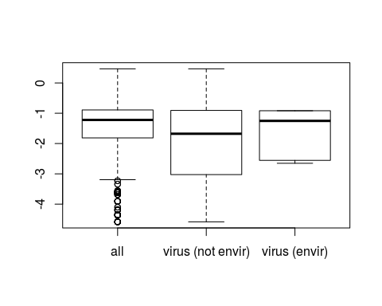

Comparison with Shan's paper

sh<-read.csv("huang_carnPSR.csv",header=T)# Table S1  
#look by host order  
d.carn<-subset(d,Group=="carnivores")  
H.metrics<-as.data.frame(table(d.carn$HostCorrectedName))  
names(H.metrics)<-c("host.name","n.records")  
H.metrics$n.para<-0  
for (i in 1:dim(H.metrics)[1]){  
 p.set<-unique(d.carn$ParasiteCorrectedName[which(d.carn$HostCorrectedName==H.metrics$host.name[i])])  
 H.metrics$n.para[i]<-length(p.set)  
}  
library(picante)  
mtree2[[1]]$tip.label<-orig.tip.label  
my.ed<-evol.distinct(mtree2[[1]],type="equal.splits")  
names(my.ed)<-c("host.name","ed")  
H.metrics<-merge(H.metrics,my.ed)  
H.metrics$singleton<-ifelse(H.metrics$n.para==1,1,0)  
H.order.binom.tmp<-subset(d.carn,select=c("HostCorrectedName","Group"))  
H.order.binom.tmp<-H.order.binom.tmp[!duplicated(H.order.binom.tmp),]  
names(H.order.binom.tmp)<-c("host.name","order")  
H.metrics<-merge(H.metrics,H.order.binom.tmp)  
H.metrics$host.name<-gsub("_"," ",H.metrics$host.name)  
names(sh)[which(names(sh)=="Host.species")]<-"host.name"  
sh<-merge(sh,H.metrics,by="host.name")  
plot(sh$Reported.PSR,sh$n.para)

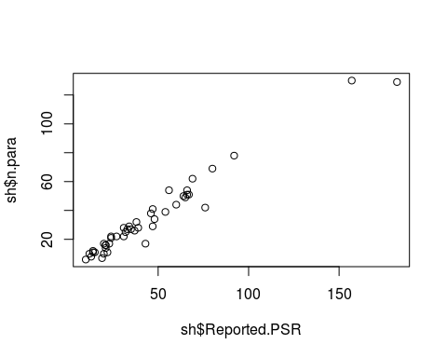

tmp<-lm(sh$Reported.PSR~sh$ed)  
#use terminal branch length  
terms<-mtree$edge[,2]<=Ntip(mtree)  
terminal.edges<-as.data.frame(cbind(mtree$tip.label[terms],mtree$edge.length[terms]))  
names(terminal.edges)<-c("host.name","tbl")  
terminal.edges$tbl<-as.numeric(as.character(terminal.edges$tbl))  
terminal.edges$host.name<-gsub("_"," ",terminal.edges$host.name)  
sh<-merge(sh,terminal.edges,by="host.name")

test phylo

data(bird.families)  
summary(bird.families)

##   
## Phylogenetic tree: bird.families   
##   
## Number of tips: 137   
## Number of nodes: 135   
## Branch lengths:  
## mean: 7.413653   
## variance: 38.49237   
## distribution summary:  
## Min. 1st Qu. Median 3rd Qu. Max.   
## 0.10 1.15 9.10 11.50 27.00   
## No root edge.  
## First ten tip labels: Struthionidae   
## Rheidae  
## Casuariidae  
## Apterygidae  
## Tinamidae  
## Cracidae  
## Megapodiidae  
## Phasianidae  
## Numididae  
## Odontophoridae  
## No node labels.

Ntip(bird.families)

## [1] 137

Nnode(bird.families)

## [1] 135

Nedge(bird.families)

## [1] 271

Parasite type by transmission mode interactions

library(sjPlot)

## Visit http://strengejacke.de/sjPlot for package-vignettes.

library(sjmisc)  
nri6$para.type<-droplevels(nri6$para.type)  
  
  
fit <- lm(mpd.obs.z ~ para.type*close + para.type*vector + para.type*intermediate + para.type*nonclose, data = nri6)  
summary(fit)

##   
## Call:  
## lm(formula = mpd.obs.z ~ para.type * close + para.type * vector +   
## para.type * intermediate + para.type * nonclose, data = nri6)  
##   
## Residuals:  
## Min 1Q Median 3Q Max   
## -2.74387 -0.45424 0.07526 0.55716 2.92615   
##   
## Coefficients: (3 not defined because of singularities)  
## Estimate Std. Error t value Pr(>|t|)   
## (Intercept) -0.90707 0.20121 -4.508 7.09e-06 ***  
## para.typeBacteria -0.18796 0.26304 -0.715 0.474983   
## para.typeHelminth -1.25053 0.37423 -3.342 0.000855 ***  
## para.typeProtozoa -0.81216 0.23239 -3.495 0.000489 ***  
## para.typeVirus -1.35938 0.24715 -5.500 4.50e-08 ***  
## close -0.15116 0.15000 -1.008 0.313744   
## vector 0.01337 0.87175 0.015 0.987769   
## intermediate -0.28473 0.43039 -0.662 0.508352   
## nonclose -0.08394 0.18739 -0.448 0.654289   
## para.typeBacteria:close 0.42060 0.21020 2.001 0.045591 *   
## para.typeHelminth:close 0.35356 0.19597 1.804 0.071419 .   
## para.typeProtozoa:close -0.48441 0.26065 -1.858 0.063310 .   
## para.typeVirus:close -0.04219 0.20230 -0.209 0.834816   
## para.typeBacteria:vector -0.12510 0.88690 -0.141 0.887849   
## para.typeHelminth:vector 0.76499 0.93314 0.820 0.412468   
## para.typeProtozoa:vector 0.25201 0.87854 0.287 0.774266   
## para.typeVirus:vector 1.07103 0.88456 1.211 0.226174   
## para.typeBacteria:intermediate NA NA NA NA   
## para.typeHelminth:intermediate 0.39757 0.44379 0.896 0.370494   
## para.typeProtozoa:intermediate 0.59629 0.48126 1.239 0.215543   
## para.typeVirus:intermediate NA NA NA NA   
## para.typeBacteria:nonclose 0.30795 0.22744 1.354 0.175961   
## para.typeHelminth:nonclose 0.85603 0.35854 2.388 0.017094 *   
## para.typeProtozoa:nonclose NA NA NA NA   
## para.typeVirus:nonclose 0.39850 0.21507 1.853 0.064115 .   
## ---  
## Signif. codes: 0 '***' 0.001 '**' 0.01 '*' 0.05 '.' 0.1 ' ' 1  
##   
## Residual standard error: 0.8482 on 1401 degrees of freedom  
## Multiple R-squared: 0.3053, Adjusted R-squared: 0.2949   
## F-statistic: 29.32 on 21 and 1401 DF, p-value: < 2.2e-16

p1<-sjp.grpfrq(nri6$mpd.obs.z,  
 nri6$para.type,  
 intr.var = nri6$close,  
 axis.titles = c("",""),  
 intr.var.labels = rep(c("0", "1"),5),   
 type = "boxplot",ylim=c(-6,2),  
 title="Close",  
 prnt.plot=F)  
  
p2<-sjp.grpfrq(nri6$mpd.obs.z,  
 nri6$para.type,  
 intr.var = nri6$nonclose,  
 axis.titles = c("",""),  
 intr.var.labels = rep(c("0", "1"),5),   
 type = "boxplot",ylim=c(-6,2),  
 title="Nonclose",  
 prnt.plot=F)  
  
p3<-sjp.grpfrq(nri6$mpd.obs.z,  
 nri6$para.type,  
 intr.var = nri6$vector,  
 axis.titles = c("",""),  
 intr.var.labels = rep(c("0", "1"),5),   
 type = "boxplot",ylim=c(-6,2),  
 title="Vector",  
 prnt.plot=F)  
  
p4<-sjp.grpfrq(nri6$mpd.obs.z,  
 nri6$para.type,  
 intr.var = nri6$intermediate,  
 axis.titles = c("",""),  
 intr.var.labels = rep(c("0", "1"),5),   
 type = "boxplot",ylim=c(-6,2),  
 title="Intermediate",  
 prnt.plot=F)  
  
sjp.grpfrq(nri6$mpd.obs.z,  
 nri6$para.type,  
 intr.var = nri6$n.modes,  
 axis.titles = c("",""),  
 intr.var.labels = rep(c("0", "1"),5),   
 type = "boxplot",ylim=c(-6,2),  
 title="Transmission modes",  
 prnt.plot=F)  
  
  
library(gridExtra)  
grid.arrange(p1$plot, p2$plot, p3$plot, p4$plot, nrow = 2)

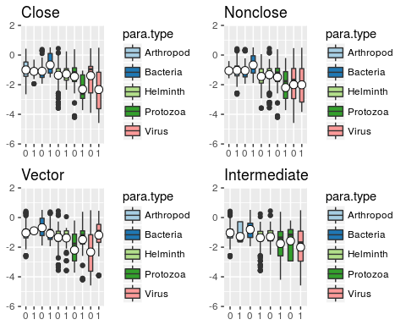

q<-aggregate(nri.flat$mpd.obs.z,by=list(nri.flat$para.type,nri.flat$tmode),FUN=mean)  
cloud(q[,3]~q[,1]*q[,2])

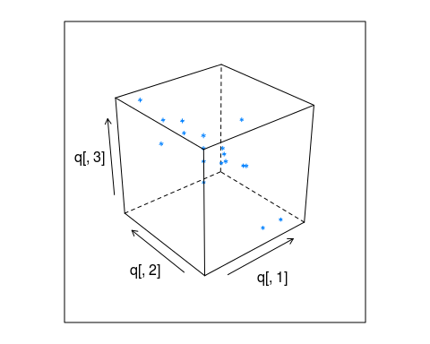

mypanel <- function(x,y,z,...) {  
 panel.wireframe(x,y,z,...)  
 panel.cloud(x,y,z,...)  
}  
wireframe(q[,3]~q[,1]*q[,2],panel=mypanel)

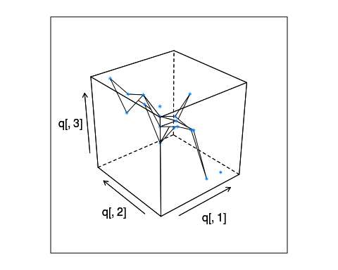

## References

1. Poulin, R. & Keeney, D. B. 2008 Host specificity under molecular and experimental scrutiny. *Trends in parasitology* **24**, 24–8.

2. Woolhouse, M. E. J. 2002 Population biology of emerging and re-emerging pathogens. *Trends Microbiol Trends Microbiol* **10**, S3–S7.

3. Farrell, M. J., Berrang-Ford, L. & Davies, T. J. 2013 The study of parasite sharing for surveillance of zoonotic diseases. *Environmental Research Letters* **8**, 015036.

4. Raberg, L., Graham, A. L. & Read, A. F. 2009 Decomposing health: tolerance and resistance to parasites in animals. *Philosophical Transactions of the Royal Society B: Biological Sciences* **364**, 37–49.

5. Poulin, R. & Mouillot, D. 2003 Parasite specialization from a phylogenetic perspective: a new index of host specificity. *Parasitology* **126**, 473–480.

6. Pedersen, A. B., Altizer, S., Poss, M., Cunningham, A. A. & Nunn, C. L. 2005 Patterns of host specificity and transmission among parasites of wild primates. *International journal for parasitology* **35**, 647–57.

7. Poulin, R., Krasnov, B. R. & Mouillot, D. 2011 Host specificity in phylogenetic and geographic space. *Trends in parasitology* **27**, 355–61.

8. Nunn, C. L. & Altizer, S. M. 2005 The global mammal parasite database: An online resource for infectious disease records in wild primates. *Evolutionary Anthropology: Issues, News, and Reviews* **14**, 1–2.

9. Stephens, P. R. et al. 2017 Global Mammal Parasite Database version 2.0. *Ecology* **In Review**.

10. Gotelli, N. J. 2000 Null model analysis of species co-occurrence patterns. *Ecology* **81**, 2606–2621.

11. Cooper, N., Griffin, R., Franz, M., Omotayo, M., Nunn, C. L. & Fryxell, J. 2012 Phylogenetic host specificity and understanding parasite sharing in primates. *Ecology letters* **15**, 1370–7.

12. Cooper, N., Rodríguez, J. & Purvis, A. 2008 A common tendency for phylogenetic overdispersion in mammalian assemblages. *Proceedings of the Royal Society of London B: Biological Sciences* **275**.

13. Ezenwa, V. O. 2004 Host social behavior and parasitic infection: a multifactorial approach. *Behavioral Ecology* **15**, 446–454. (doi:[10.1093/beheco/arh028](https://doi.org/10.1093/beheco/arh028))

14. Lee, K. A., Wikelski, M., Robinson, W. D., Robinson, T. R. & Klasing, K. C. 2008 Constitutive immune defences correlate with life-history variables in tropical birds. *Journal of Animal Ecology* **77**, 356–363. (doi:[10.1111/j.1365-2656.2007.01347.x](https://doi.org/10.1111/j.1365-2656.2007.01347.x))

15. Poulin, R. & Forbes, M. R. 2012 Meta-analysis and research on host–parasite interactions: past and future. *Evolutionary Ecology* **26**, 1169–1185. (doi:[10.1007/s10682-011-9544-0](https://doi.org/10.1007/s10682-011-9544-0))

16. Stein, A., Gerstner, K. & Kreft, H. 2014 Environmental heterogeneity as a universal driver of species richness across taxa, biomes and spatial scales. *Ecology Letters* **17**, 866–880. (doi:[10.1111/ele.12277](https://doi.org/10.1111/ele.12277))

17. R Core Team 2016 R: A Language and Environment for Statistical Computing.

18. Bininda-Emonds, O. R. P. et al. 2007 The delayed rise of present-day mammals. *Nature* **446**, 507–12.

19. Webb, C. O., Ackerly, D. D., McPeek, M. A. & Donoghue, M. J. 2002 Phylogenies and community ecology. *Annual Review of Ecology and Systematics* **33**, 475–505.

20. Kembel, S. W., Cowan, P. D., Helmus, M. R., Cornwell, W. K., Morlon, H., Ackerly, D. D., Blomberg, S. P. & Webb, C. O. 2010 Picante: {R} tools for integrating phylogenies and ecology. *Bioinformatics* **26**, 1463–1464.

21. Ulrich, W. & Gotelli, N. J. 2013 Pattern detection in null model analysis. *Oikos* **122**, 2–18. (doi:[10.1111/j.1600-0706.2012.20325.x](https://doi.org/10.1111/j.1600-0706.2012.20325.x))

22. Redding, D. W. & Mooers, A. Ø. 2006 Incorporating Evolutionary Measures into Conservation Prioritization. *Conservation Biology* **20**, 1670–1678. (doi:[10.1111/j.1523-1739.2006.00555.x](https://doi.org/10.1111/j.1523-1739.2006.00555.x))

23. Faraway, J. J. 2005 *Extending the Linear Model with R: Generalized Linear, Mixed Effects and Nonparametric Regression Models*. CRC Press.

24. Holmes, E. C. 2009 *The Evolution and Emergence of RNA Viruses*. OUP Oxford.

25. Reisen, W. K. 2013 Ecology of West Nile virus in North America. *Viruses* **5**, 2079–105.

26. Davies, T. J. & Pedersen, A. B. 2008 Phylogeny and geography predict pathogen community similarity in wild primates and humans. *Proceedings. Biological sciences / The Royal Society* **275**, 1695–701.