Exercise 00: Getting Started
Adam B. Smith | Missouri Botanical Garden
2025-03-13
This workshop will walk you through all of the fundamental steps in modeling species’ niches and distributions. This initial exercise will simply get you started in R.

Where to get files for this workshop
You can get the files for this workshop from the earthSkySea website:
- Download the zip file with materials.
- Uncompress it into a folder.
- Rename the folder if you like. In the code below and in the subsequent exercises, I call this SDM Workshop.

What do SDMs do? A brief primer
Species distribution models (SDMs) can take several forms. Complex ones use dynamic and physics-based equations to capture species’ physiological responses to the environment, other species, and other ecological processes. However, as used here, SDMs are correlative, meaning that they function by finding correlations between sites where a species is known to be present and the environment at those sites. Correlative models are widely applied because the data required to create them is often readily available in the form of museum, herbarium, and community science records.
Strictly speaking, species distribution models are intended to create maps of where a species is and where it might have been or might be in the future. Ecological niche models are models intended to tell us something about a species’ niche, such as the breadth of conditions it can occupy, or what key environmental factors a species is sensitive to. However, correlative SDMs and niche models use the same kinds of data, and have the same workflow, with just minor (but important) differences. We will get to these differences in exercises later in this tutorial.
How do SDMs work? Simply put, SDMs “map” species’ occurrences in geographic space to environmental space. In the figure below, we start in geographic space at the top left where we have occurrence data.
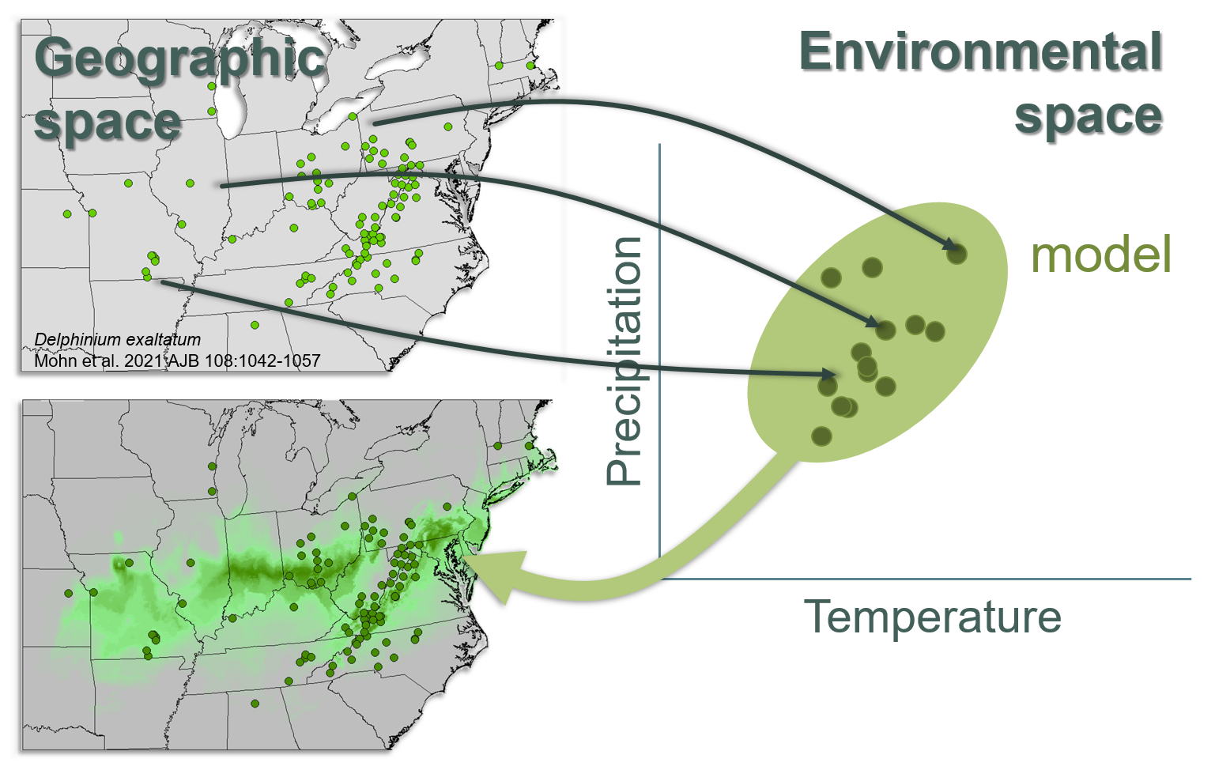
How an SDM works
Each point where we have an occurrence is represented with a point in environmental space (the graph on the right). We can then apply a correlative model. In a sense, this model “draws” a “shape” around the occurrences in environmental space. We can then use the model to find places on the map (bottom left) that have the same conditions as in the shape. In the map at the bottom, I’ve colored these areas green to indicate that they are the same conditions found within the oval in environmental space.
If you were interested in hindcasting where the species was in the past, or forecasting where it could be in the future, you could feed into the model environmental layers from those time periods and get a different map.
This is obviously a simplification, but all the rest is details (but important!).
Where are we going? SDMing is a constantly-improving field. This set of lessons does its best to present the “standard” state-of-the-art, meaning that it shows you how to do modeling using procedures that nearly everyone would agree should be used. There are numerous papers published each year that push this state-of-the-art along, but it can take a while until they are fully vetted. In general, we will not try to track these new tools but rather work with established procedures.

The SDM workflow
This workshop walks you through the creation of a modeling workflow. In some cases, the exercises take a slight detour to explain important aspects of modeling, but they largely follow the workflow.
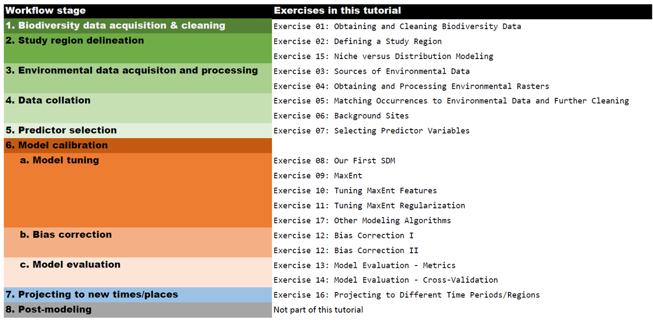
The SDM Workflow
The “post-processing” step is not covered in this tutorial because it is optional and when done, involves subsequent processing and use of models that depends on each particular study. This can include, for example, employing model predictions to identify promising sites for conservation or invasive species control (e.g., Bush et al. 2014; Callen & Miller 2015), using the maps of predicted suitability to constrain population simulation of a species’ dynamic range model through time (e.g., Castilla et al. 2024), identifying paleorefugia (e.g., Napier et al. 2019), or assessing species’ vulnerability to climate change (Salazar-Tortosa et al. 2024).

Other resources
There are several other resources I recommend for learning how to do species distribution modeling:
- Habitat Suitability modeling book by Guisan et al. (2017): This is a comprehensive book that shows you how to do SDMing in R with the BIOMOD2 package.
- wallace (Kass et al. 2018 and 2023): wallace is a point-and-click interface for SDMing. It requires you to install R and run a simple command to get started, but after that, it’s very easy to follow. wallace not only walks you through the steps but provides some guidance and citations along the way to help you make decisions. It also writes the R code in the background so you can study it or attach it to a report, for example.
- ENM2020 (Peterson et al. 2022): A series of YouTube tutorials and talks, ENM2020 is a comprehensive resource for SDMing that walks through all of the modeling steps. It also has lessons on BIOMOD2 and wallace.
- The Center for Plant Conservation’s free Applied Plant Conservation Course: This is a voluminous series of talks by experts in the field of conservation, including a sub-series on SDMs by myself, insofar as I am an expert (always double-check your sources). The SDM portion does not cover how to code or implement SDMs, but it does cover data sources, cleaning, modeling, and interpretation.

R
R is the standard platform for SDMing. You can do SDMing in other languages and some bespoke software, but R has more support for SDMing than any other platform (Kass et al. 2025).
If you haven’t already installed R, please download the installer and do so. You may also wish to run R in RStudio, which has many useful features.

Project folder
Unzip the folder with the tutorials, and if you want, rename it. Inside this folder should be subfolders with some data and other objects we’ll be using in this tutorial. If you are using RStudio, create a “Project” in this folder. All of our work will be saved in this project folder.
I highly recommend using a single folder in which to store all scripts, inputs, and outputs for a modeling single project. Otherwise, it can be very difficult to recreate a modeling project. Depending on the size of your project and the number of species you are modeling, you can end up with hundreds of files. So, you need to organize them and name them descriptively.
If you use a single folder for your project, it’s also a lot easier to transfer a project to a different computer because you can use just change the working folder of a project and run your script. If you are using RStudio, this is done automatically. Otherwise, please run this code:
# set working directory (Windows)
setwd('C:/Ecology/SDM Workshop')
# set working directory (Mac)
setwd('/Users/<username>/Ecology/SDM Workshop')
# get current working directory
getwd()

R Packages
You can install packages using the code below or by using the RStudio interface. However, the code below is a bit safer because it will not install the packages if they are already on your system, which can break the packages.
Installing a package you already have on your computer can create problems. So, the code below will try to load the package, and if it can’t, it will install it then load it. Once the packages are installed, we can just use library(packageName) to load it. You will only need to run this code chunk once (even if you restart R).
# install and load packages
packages <- c(
'cowplot',
'enmSdmX', # omnibus is installed with enmSdmX
'gecko',
'geodata',
'ggplot2',
'predicts',
'rgbif',
'scales',
'terra'
)
for (thisPackage in packages) {
if (!do.call(require, list(thisPackage))) {
install.packages(thisPackage)
}
}
These packages contain some powerful tools!
- cowplot combines ggplots.
- enmSdmX provides a suite of functions for GIS operations and modeling niches and distributions.
- gecko fetches a variety of rasterized data relevant to species’ threats
- geodata fetches geographic and environmental data from the Internet.
- ggplot2 creates plots that require less manual manipulation than the base plot() function to look good.
- rbgif fetches biodiversity data from GBIF
- omnibus has handy helper functions.
- predicts has handy SDMing tools.
- scales contains a helpful function for creating transparency when plotting.
- terra handles raster and spatial vector data.
You should be all set–see the next exercise to get started!

Literature cited
Guisan, A, Thuiller, W, and Zimmermann, NE. 2017. Habitat Suitability and Distribution Models With Applications in R. Cambridge University Press. DOI: 10.1017/9781139028271.
Kass JM, Vilela B, Aiello-Lammens ME, Muscarella R, Merow C, Anderson RP. 2018. Wallace: A flexible platform for reproducible modeling of species niches and distributions built for community expansion. Methods in Ecology and Evolution 9:1151-1156. DOI: 10.1111/2041-210X.12945
Kass JM, Pinilla-Buitrago GE, Paz A, Johnson BA, Grisales-Betancur V, Meenan SI, Attali D, Broennimann O, Galante PJ, Maitner BS, Owens HL, Varela S, Aiello-Lammens ME, Merow C, Blair ME, Anderson RP. 2023. wallace 2: a shiny app for modeling species niches and distributions redesigned to facilitate expansion via module contributions. Ecography 2023:e06547. DOI: 10.1111/ecog.06547
Kass, JM, Smith, AB, Warren, DL, Vignali, S, Schmitt, S, Aiello-Lammens, ME, de Andrade, AFA, Arle, E, Barbosa, AM, Broennimann, O, Cobos, ME, Gueguen, M, Guisan, A, Merow, C, Naimi, B, Nenzen, H, Nobis, MP, Ondo, I, Osorio-Olvera, L, Owens, HL, Pinilla-Buitrago, G, Robertson, M, Sanchez-Tapia, A, Thuiller, W, Valavi R, Velazco, SJE, Zizka, A, Zurrell, D. 2025. Achieving higher standards in species distribution modeling by leveraging the diversity of available software Ecography DOI: 101111/ecog07346
DOI: 101017/9781139028271
Peterson, A.T., Aiello-Lammens, M., Guiseppe, A., et al. 2022. ENM2020: A free online course and set of resources on modeling species’ niches and distributions. Biodiversity Informatics 17:1-5. DOI: 10.17161/bi.v17i.15016

