Exercise 01: Obtaining and Cleaning Biodiversity Data
Adam B. Smith | Missouri Botanical Garden
In this first exercise you will learn:
- From where to obtain biodiversity data;
- What aspects of data are relevant to distribution modeling;
- How to download data;
- How to inspect biodiversity data;
- How to clean or flag biodiversity data for:
  - Nomenclatural error and taxonomic uncertainty;
  - Error in geographic coordinates;
  - Errors in dates;
  - And lots of other things that arise when using data from many different sources collected in a non-standardized manner; and that
  - Biodiversity data can be weird.
A note on time: Obtaining biodiversity data and cleaning it can comprise a lot of time–roughly 50-80% of the time you spend “modeling” a species–you can spend weeks/months on this step! It’s a laborious process, but worthwhile, since you want to be able to trust the output!
Biodiversity data encompasses anything that represents biological diversity, but here we will specifically explore methods for specimen-based “point” records which represent particular places on a map where an organism was collected or observed. Point records are the fundamental type of data used in distribution and niche modeling.
We will be modeling one of the best species on Earth, the Colombian ground squirrel, Urocitellus colombianos.
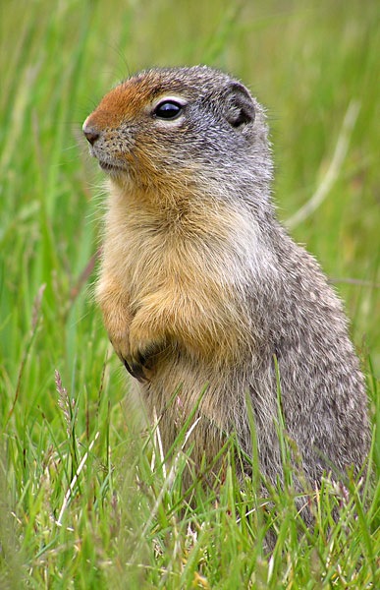
Urocitellus colombianos (CC-BY 3.0)

1 Obtaining raw biodiversity data
Unfortunately there is no single data portal for all biodiversity data… in fact, there are quite a few attempts to create “one-stop shops” for this kind of data. So where should you go? There are two strategies, both with downsides. You could go to just a single database, preferably the one that best covers the taxon/region of interest. However, many databases are incomplete, so you might end up missing a lot of records by relying on just one. But many databases share data, too, so you risk including duplicate records by using more than one!
There are scores of sites where you can download some data relevant to distribution modeling. You can find an abbreviated, haphazardly amassed list in the Opportunistic Database of Biodiversity Databases.
There we’ve organized portals by taxonomic identity–note that general portals that offer data for any taxon are listed last and are almost always worth visiting. Also note that many millions of specimens have yet to be digitized or at least submitted to these large data clearinghouses. So if you’re interested in a particular species and want to get as comprehensive as coverage as possible, it is likely worth your time to contact state and regional source (herbaria, museums, etc.). Small institutions often have spreadsheets of their holdings with data that they are willing to share if you contact them, but these data are rarely incorporated into larger portals, although there is increasing effort to do so.
We are going to use just one database, the Global Biodiversity Information Facility, or GBIF.
GBIF is the proverbial “top predator” occurrence database that attempts to aggregate all of the world’s occurrence data (i.e., specimens and sightings).
If GBIF aggregates all biodiversity data, why not just go to GBIF instead of checking multiple sources? Politely said, much of the data in GBIF has quality problems so a lot of it is less useful in the end. Likewise, many of the databases contributing data on to GBIF (called GBIF “nodes”) don’t do so in real time, so there may be records in the country-level nodes that aren’t in GBIF. Also, some nodes use different fields which are very useful for cleaning this kind of data and yet absent from GBIF. Also, GBIF
You can use the package rgbif to download data directly into R. We’ll do it by hand, though, because it illustrates several important issues.
- In your working folder, create a sub-folder named Species Records - GBIF.
- Go to https://www.gbif.org/. Save a link to this website in the GBIF folder. This is good practice for any data set you obtain online.
Ensure you can relocate the source of each data set you use in case you need to get an updated version or cite the source. For databases that get updated constantly (e.g., biodiversity databases), I often record the date I downloaded the data so I know what “version” I got.
- At this point it will help to create an account (link on the upper right). You will not receive spam from them.
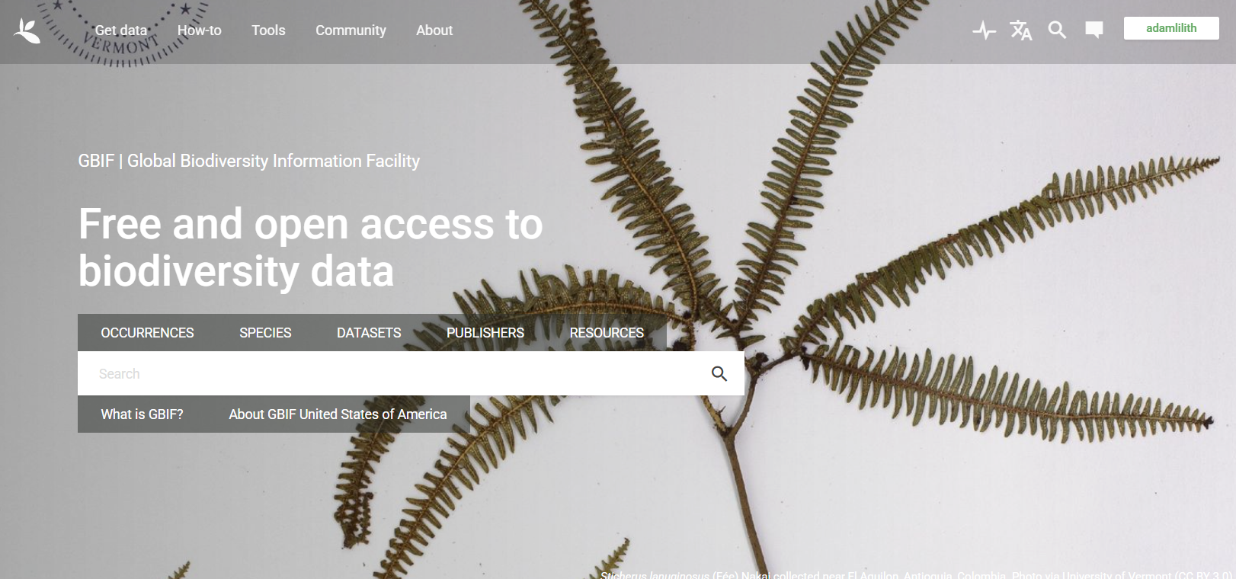
GBIF home page
- Click “Occurrences”. In the box on the left, enter the name of the species we will be modeling: I want to show you what happens if you search for a synonym, instead of an “accepted” species name. So, search for “Spermophilus columbiansus” (not “Urocitellus columbianus”). Click “Yes” in answer to the question that pops up: “Do you wish to limit your search to this taxon only?”
- Notice on the left side under the “Scientific Name” section it indicates that did search for Spermophilus columbiansus, but it also returns results for Urocitellis columbianus. GBIF attempts to do synonym-checking for you, but it may not always get everything right, especially for poorly-known taxa. So it can pay to search using different synonyms.You will see a list of synonyms that GBIF uses for your species. Note that a search for “Citellus columbianus” returns just a few records–so GBIF does not seem to be adequately linking these names.
Check with taxonomic authorities like specialists in the taxon you’re interested in or online. For plants, the World Flora Online is the authoritative list. For other taxa, Encyclopedia of Life is a good general source, but there are also specialized databases (see the “Taxonomic Name Resolution Services” tab in the ODBD). Ensure the data provider either includes synonymy in the searches or do separate searches for each synonym.
- Click “Download” (top right). Select “Darwin Core Archive”. Note that right away you are provided a DOI for the search. You can (later) go to you profile on GBIF and ensure it will not be downloaded. However, this is really only useful if you wish to use the data in a study (vs. a workshop), so I do not suggest doing this now.
- You will get an email notice when the data are ready. Save your results to the Occurrences - GBIF folder. Notice the download page on GBIF has a “Cite As” link. This enables you or someone else to download the exact same data again. This is important for reproducibility because these databases are constantly being updated.
- Unzip the files into the same folder. The one named occurrence has the data we’re seeking. The others contain metadata and information on usage rights.
- Open the file in Excel. Look around if you want. Then save the file using Save As... in CSV (comma-separated value) format.
Why do we need open the file in Excel and save it in a different format? Because sometimes GBIF files are corrupted in a way that causes columns to shift over, so you get, for example, numbers where there should be species names. I don’t know why this happens, but this is one of the few ways I have found that fixes the problem. Note though, that if your file is exceedingly large, Excel won’t be able to open all rows. In these cases, you can use the fread() function in the data.table package to read the files.
This data is in Darwin Core format (Wieczorek et al. 2012). Darwin Core is a set of biodiversity data standards that are used to enable sharing of biodiversity databases. It provides a set list of agreed-upon fields each with acceptable data formats. Not all Darwin Core database will have all of these fields, and they might also include non-core fields.
In this table, the most relevant fields for distribution modeling include:
- references: A URL with a web page for the observation/specimen. Often missing for some taxa, and sometimes inaccessible unless you have rights to access the database, but nonetheless useful for double-checking the record.
- license: License – Can you use it? Under what circumstances?
- species: Species name as given in database
- decimalLongitude and decimalLatitude: Longitude and latitude of the observation
- coordinateUncertaintyInMeters: Uncertainty in the coordinates (we’ll ignore coordinatePrecision, though it could also be used)
- hasGeospatialIssues: Flags records with potential issues in their coordinates or other geographic fields.
- basisOfRecord: Record type (specimen, observation, etc.)
- countryCode, stateProvince, county, and municipality: Country, state/province, and county and “city” (or equivalent) of collection
- locality and verbatimLocality: Useful in case you need to double-check the coordinates or retroactively assign coordinates to a record
- year, month, and day: Year, month, and day of collection/observation
- institutionCode and recordedBy: Institution where the original record resides (i.e., the museum of herbarium specimen) and the original collector/obser

2 Collating “raw” specimen data
In the section you just completed, you downloaded data from GBIF. But now that you’ve done that, I am going to suggest you do something frustrating–don’t use it. The reason I ask is because the code below assumes that your data looks like mine. GBIF is updated regularly, so it may simply not be the same. You are free to use the data you did download, but I suggest this only if you’re comfortable with R and can see what steps to skip or how to address issues that appear in your data and not mine. In the following steps, I will show you how to use the data I downloaded.
Setup: You only need to do this part if you started “fresh” (not from Exercise 00):
# Set working folder. Only necessary if you are not using RStudio.
# Please change the path to the one that is appropriate to your system.
setwd('C:/Ecology/SDM Workshop')
library(cowplot) # combining ggplots
library(enmSdmX) # SDMing
library(geodata) # geographic data
library(ggplot2) # plotting
library(omnibus) # helper functions
library(scales) # transparency/rescaling
library(terra) # GIS
Processing occurrence data: We will subset the data to have the fields listed above. First, let’s load the data into R:
Use this code if you want to use the data that I downloaded:
# Specify the UTF-8 encoding to accommodate non-Roman characters.
records <- read.csv('./Backups/Occurrences - GBIF/occurrence.csv', fileEncoding = 'UTF-8')
… and use this code if you want to use the data you downloaded:
# Specify the UTF-8 encoding to accommodate non-Roman characters.
records <- read.csv('./Occurrences - GBIF/occurrence.csv', fileEncoding = 'UTF-8')
columnsToKeep <- c(
'gbifID',
'license',
'species',
'basisOfRecord',
'decimalLongitude',
'decimalLatitude',
'coordinateUncertaintyInMeters',
'year',
'month',
'day',
'countryCode',
'stateProvince',
'county',
'locality',
'verbatimLocality',
'institutionCode',
'recordedBy',
'references'
)
records <- records[ , columnsToKeep]
Let’s look at the 6 records at the top of the data frame:
head(records)
## gbifID license species basisOfRecord
## 1 919447013 CC0_1_0 Urocitellus columbianus PRESERVED_SPECIMEN
## 2 919446041 CC0_1_0 Urocitellus columbianus PRESERVED_SPECIMEN
## 3 919445037 CC0_1_0 Urocitellus columbianus PRESERVED_SPECIMEN
## 4 919444769 CC0_1_0 Urocitellus columbianus PRESERVED_SPECIMEN
## 5 919442886 CC0_1_0 Urocitellus columbianus PRESERVED_SPECIMEN
## 6 919436011 CC0_1_0 Urocitellus columbianus PRESERVED_SPECIMEN
## decimalLongitude decimalLatitude
## 1 -112.8808 47.5017
## 2 -112.8808 47.5017
## 3 -117.3342 52.2020
## 4 -112.8808 47.5017
## 5 -117.3342 52.2020
## 6 -112.9936 47.6225
## coordinateUncertaintyInMeters year month day countryCode
## 1 1164 1945 6 29 US
## 2 1164 1945 6 28 US
## 3 6086 1956 7 29 CA
## 4 1164 1945 6 29 US
## 5 6086 1956 7 29 CA
## 6 187 1958 7 17 US
## stateProvince county
## 1 Montana Lewis and Clark
## 2 Montana Lewis and Clark
## 3 Alberta
## 4 Montana Lewis and Clark
## 5 Alberta
## 6 Montana Lewis and Clark
## locality
## 1 Sec. 9, T20N, R10W
## 2 Sec. 9, T20N, R10W
## 3 Columbia Ice Field, Jasper National Park
## 4 Sec. 9, T20N, R10W
## 5 Columbia Ice Field, Jasper National Park
## 6 Bear Lake
## verbatimLocality
## 1 North and Central America | United States | Montana | Lewis and Clark County | Sec. 9, T20N, R10W
## 2 North and Central America | United States | Montana | Lewis and Clark County | Sec. 9, T20N, R10W
## 3 North and Central America | Canada | Alberta Province | Columbia Ice Field, Jasper National Park
## 4 North and Central America | United States | Montana | Lewis and Clark County | Sec. 9, T20N, R10W
## 5 North and Central America | Canada | Alberta Province | Columbia Ice Field, Jasper National Park
## 6 North and Central America | United States | Montana | Lewis and Clark County | Bear Lake
## institutionCode recordedBy
## 1 MSU Lloyd C. Hulbert
## 2 MSU Lloyd C. Hulbert
## 3 MSU Ken Sandy
## 4 MSU Lloyd C. Hulbert
## 5 MSU James Meehan
## 6 MSU Albert Berish
## references
## 1 http://portal.vertnet.org/o/msu/mr?id=mr-2438
## 2 http://portal.vertnet.org/o/msu/mr?id=mr-2434
## 3 http://portal.vertnet.org/o/msu/mr?id=mr-2378
## 4 http://portal.vertnet.org/o/msu/mr?id=mr-2437
## 5 http://portal.vertnet.org/o/msu/mr?id=mr-2379
## 6 http://portal.vertnet.org/o/msu/mr?id=mr-3910
How many records do we have?
nrow(records)
## [1] 2011
You will likely have a different number of records than me because GBIF is constantly updated. But, you will mostly likely have thousands of records! But not all of these are usable owing to various issues. The next section shows how to address these issues to produce a clean version of the data set.
Before we continue, let’s save our records.
# create output folder
dirCreate('./Occurrences - GBIF')
# save
write.csv(records,
'./Occurrences - GBIF/00 Species Records - Raw Data.csv',
row.names = FALSE
)
Notice three things:
- We prepended a version number on the file name. Why prefix the file with “00”? It can literally take months to create a reliable, cleaned data set. The process is iterative because you’ll find errors that you didn’t observe at first but which must be addressed before the step you’re currently taking. The entire process involves many steps and issues always arise that you didn’t anticipate.
For example, I often find that “notes” fields indicate some specimens were held in captivity, being grown in a greenhouse, etc., which makes their use in distribution/niche modeling dubious, such as a plant bought from a store (and georeferenced to the store’s address!). Saving versions enables you to go back without having to lose all of your work. Later we’ll make versions “01”, “02”, etc.
- We included a description of the cleaning stage in the file name. You can’t back up effectively if you don’t know what step to go back to!
- We put the version number on the front of the file name. This makes it sort in sequential order when viewed on your computer. I also used two digits–since sometimes operating systems sort “1” then “10”, “11”, “12”, etc. then “2”, “20”, etc.
Cleaning species’ data is a very iterative process. Labeling files with version numbers and a description of the cleaning procedure taken in that step enables you to backtrack to a given point then start again without having to restart from scratch.

3 Cleaning biodiversity data
Biodiversity data can be messy. In this section we’ll pare down the data set to something that is intended to be more reliable. Specifically, we’re looking to:
- Avoid false identifications
- Use only specimens collected in a period relevant to the climate data we’ll be utilizing
- Have reliable location certainty

3.1 Removing unusable specimens
Misidentifications are a special concern because a specimen that was identified as the species of interest, but wasn’t really that species, may falsely indicate that the species of interest prefers the habitat represented by the record. Short of having a taxonomic authority actually inspect each specimen, it’s usually not possible to know with certainty that identifications are accurate (and even experts can be unsure). Nonetheless, let’s remove any records that may be especially subject to misidentifications.
In general there are three kinds of biodiversity records:
- Specimens collected and identified by a professional and deposited in a museum or herbarium. These are the most reliable because they offer potential for checking the original identification.
- Observational records by experts in the taxon. These are usually also good, but because no one else can verify an observation (unless it was recorded), they’re of lesser quality. In general though, I would use them if you can verify the observer was a trained specialist and the species is easy to identify given the means by which it was observed.
- Community science data, often collected by interested people of various skill. These can be reliable for some easily-identified species, but unreliable for rare species few people have experience seeing. Again, since they are observations they are inherently irreproducible. However, community science databases usually include photos or recordings contributors took of the species. The link to this media is often included in data downloads, enabling you to visually inspect what the contributor thought they saw.
Not all records are reliably identified. Take steps to minimize this problem, especially for taxa that would be hard to identify. If possible, show an expert on the species a map of the records you obtained. They can often identify odd records that were probably misidentified or mis-geolocated.
In our case we’re going to take a conservative approach and exclude observational data (including video) from the records.
Note the column named basisOfRecord. Look at the values this field takes:
unique(records$basisOfRecord)
## [1] "PRESERVED_SPECIMEN" "HUMAN_OBSERVATION"
## [3] "MATERIAL_CITATION" "OCCURRENCE"
## [5] "MACHINE_OBSERVATION"
Let’s retain only records that are specimens or observations by humans:
# retain specimens and observations
records <- records[records$basisOfRecord %in% c('PRESERVED_SPECIMEN', 'HUMAN_OBSERvATION'), ]
nrow(records)
## [1] 1968
We’ve lost a few records. Save your results!
# Save records:
write.csv(records,
'./Occurrences - GBIF/01 Species Records - Observations and Specimens.rds',
row.names = FALSE
)

3.2 Dates
Later we will be matching these records to climate data that was calculated for the period 1970-2000. Since climate is constantly changing, we will generally want to keep records that have only been collected across this time period. First, though let’s look at the distribution of years in which our specimens were collected.
# examine distribution of records
hist(records$year,
breaks = 30,
xlab = 'Collection year',
ylab = 'Number of records',
main = 'Collection year (all years)'
)
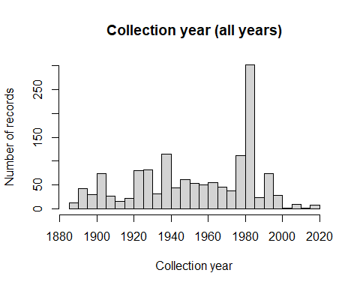
Sometimes peaks and troughs in collection activity correspond to activity and inactivity of a single avid collector. Let’s retain just records collected from 1970 to 2000.
# subset records to desired dates
records <- records[records$year >= 1970 & records$year <= 2000, ]
# examine distribution of records
hist(records$year,
breaks = 30,
xlab = 'Collection year',
ylab = 'Number of records',
main = 'Collection year (1970-2000)'
)
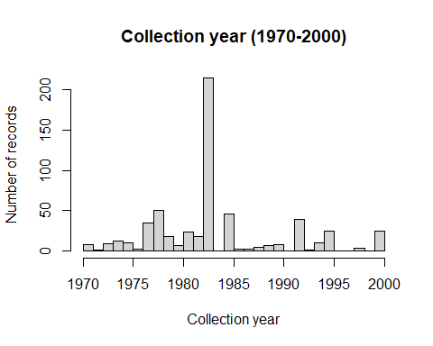
nrow(records)
## [1] 1112
How many records do we stil have?
nrow(records)
## [1] 1112
write.csv(records,
'./Occurrences - GBIF/02 Species Records - Retain Records between 1970-2000.csv',
row.names = FALSE
)

3.3 Removing geographic outliers
Ensuring locational reliability is the most troublesome step, but very important because wrongly-placed records can mislead a model. Again, short of having been at the collection site when the specimen was collected, you can’t verify location. Even the specimen tag may be wrong–I’ve seen tags with place names plus verbal descriptions of directions to get to those places, and the two were tens of miles apart from one another. Sometimes, for specimens with vague locality information, the record is georeferenced to the center of a geographic area (e.g., a county–though sometimes up to a continent!). So the most we can do is reduce the chance that records are incorrectly geolocated.
First, let’s keep just the records that do not have a missing value for longitude or latitude:
keeps <- complete.cases(records[ , c('decimalLongitude', 'decimalLatitude')])
records <- records[keeps, ]
nrow(records)
## [1] 511
Notice how many records we lost so far. The data I am using started with >2000 records, and is now down to about a quarter of that size. Note, though, that many of these records without coordinates do have locality descriptions. If you’re needing more records, I would start by georeferencing these records using standard methods if you can. See Chapman & Wieczorek (2023) for more information on how to do this.
Let’s plot these records on a map. We will need to make the records into a spatial object that we can plot on a map.
To do this, we will need to coerce the records into a SpatVector object, which is an R object that keeps “vector”-type data (i.e., like a shapefile). We will need to tell R what the coordinate reference system is, which relates how to map the coordinates onto Earth. GBIF data (and most other occurrence data) uses unprojected (WGS84) coordinates. The coordinate reference system for WGS84 is long and not easy to type out. But, we can use a shortcut in the getCRS function in the enmSdmX package.
records <- vect(
records,
geom = c('decimalLongitude', 'decimalLatitude'),
crs = getCRS('WGS84'),
keepgeom = TRUE
)
Something to note here–in the command above we put longitude first then latitude second. This is because longitude represents the “x” coordinate and latitude the “y”, and in common parlance we usually say “x-y coordinates” (for example). However, in common parlance, we also often say “latitude-longitude”, which is like saying “y-x”. Don’t do this. Stick with “x-y” in your code… put longitude first and latitude second, unless a function says to do it differently.
plot(records)
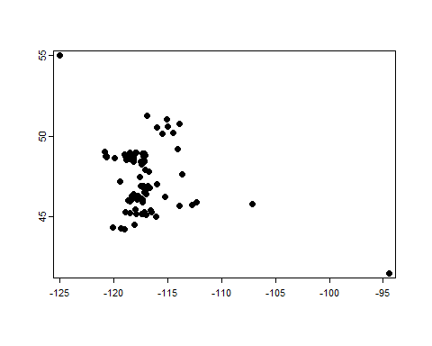
This is interesting, but not really helpful because it lacks context. Let’s plot these points on a map of Canada, the US, and Mexico. We will use outlines of countries and states from the Global Administrative Areas Database (GADM), accessed through functions in the geodata package.
Let’s download spatial vectors for each country.
# create folder for country borders
dirCreate('./Political - GADM') # could also use dir.create()
# download outlines of Canada, US, and Mexico
countries <- c('CAN', 'USA', 'MEX')
northAmerica <- gadm(countries, level = 2, resolution = 2, path='./Political - GADM')
# save this for later use
saveRDS(northAmerica, file = './Political - GADM/North America.rds')
NB: I have found that on occasion the server that hosts this data can be down (typically during wildfire season in California).
Now, let’s combine the shapes into a single map and plot the records.
plot(records)
plot(northAmerica, col = 'gray90', border = 'gray', add = TRUE)
plot(records, pch = 21, bg = 'mediumseagreen', add = TRUE)
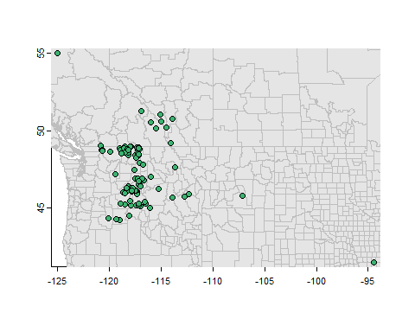
(Why do we plot the records first, North America second, then the records again? Because this sets the plot region for everything else. If we had plotted North America first, we’d see a map of all of North America, and the records would be crowded together.)
What do you see? What stands out? Does everything make sense? (Please note that I am making this tutorial from data I downloaded in early 2025. Your data may be different.)
One issue that could occur (but doesn’t in my data) is the occurrence of at least one record in the Gulf of Guinea at coordinate (0, 0). This happens When someone entering the coordinate data found no coordinates for this record, and so used zero to indicate “no data”. But this is obviously an error–zero does not mean no data! If you were to map all known biodiversity records you would probably find (0, 0) is the most biodiverse place on Earth. (Nerd note: The location at longitude/latitude 0,0 is called “Null Island”. But there’s no island there.)
What else do you see that may be concerning? How about those records far from the large cluster of records? It’s possible that the species was there, but it seems suspicious. Let’s look more closely at the records in the northwestern corner and southeastern corner, plus the one that is second-most east.
# Select northwestern-most record:
northwest <- which.max(records$decimalLatitude)
northwesternRecord <- records[northwest]
# Select eastern-most records:
eastern <- which(records$decimalLongitude > -110)
easternRecords <- records[eastern]
# Map them to double-check:
plot(records)
plot(northAmerica, col = 'gray90', border = 'gray', add = TRUE)
plot(records, pch = 21, bg = 'mediumseagreen', add = TRUE)
plot(northwesternRecord, pch = 22, cex = 1.4, bg = 'red', add = TRUE)
plot(easternRecords, pch = 22, cex = 1.4, bg = 'yellow', add = TRUE)
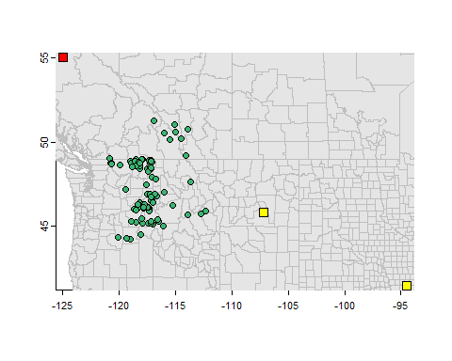
Take home: Closely examine maps of specimen records to ensure a terrestrial species’ records aren’t in the water, for example.
Let’s examine the record in the northwest.
as.data.frame(northwesternRecord)
## gbifID license species basisOfRecord
## 1 3329069486 CC_BY_4_0 Urocitellus columbianus PRESERVED_SPECIMEN
## decimalLongitude decimalLatitude coordinateUncertaintyInMeters year month day
## 1 -125.0024 55.0013 1e+06 1983 7 25
## countryCode stateProvince county locality verbatimLocality institutionCode
## 1 CA Bc UVIC
## recordedBy references
## 1 UVic Biology Department
This record does not give us much to go on… there is nothing in the locality or verbatimLocality fields, which could help us determine if it were a legitimate specimen. And the references field is also missing a link we could use to see the original specimen record before it was ported to GBIF. However, the coordinateUncertaintyInMeters field indicates that the specimen was georeferenced with an uncertainty of 1000 km! We will be removing these kinds of records later.
Now, let’s look at the other two records:
as.data.frame(easternRecords)
## gbifID license species basisOfRecord
## 1 4947681748 CC_BY_NC_4_0 Urocitellus columbianus PRESERVED_SPECIMEN
## 2 4947671081 CC_BY_NC_4_0 Urocitellus columbianus PRESERVED_SPECIMEN
## decimalLongitude decimalLatitude coordinateUncertaintyInMeters year month day
## 1 -94.4667 41.5167 301 1986 4 1
## 2 -107.1833 45.8333 301 1993 6 29
## countryCode stateProvince county locality
## 1 US Iowa Adams County 2 mi N Council
## 2 US Montana Lake County Point Pleasant Creek
## verbatimLocality
## 1 2 mi N Council, Adams Co., Idaho
## 2 T24N, R17W, sec 19, elev 3210 ft, Point Pleasant Creek, Lake Co., Montana
## institutionCode recordedBy
## 1 CRCM Collector(s): unknown
## 2 CRCM Collector(s): unknown
## references
## 1 http://arctos.database.museum/guid/CRCM:Mamm:8533
## 2 http://arctos.database.museum/guid/CRCM:Mamm:24490
If you’re familiar with US geography, the first thing that will strike you is that the top record’s stateProvince field says “Iowa”, but the verbatimLocality field says it was collected in Idaho. Of these, Idaho is definitely the more reasonable. So how did it get in Iowa? Well, there is also an Adams County in Iowa. In the county next to it is the town of Council Bluffs, so maybe the georeferencer misread the description and did their best from that. We could re-georeference this specimen to its likely locality, but that would require a lot more to learn about proper georeferencing (see Chapman & Wieczorek 2023), so for expediency, we’ll just remove this record.
The record from Montana seems OK based on this metadata, but it is also far from the body of points. The institution is the “CRMC”, or the Charles R. Conner Museum, which has a small collection of vertebrate specimens. By itself, we can’t really say why we would remove it, other than it’s “far” from the others. Perhaps contacting someone at that museum would help if they would be willing to check the specimen (for misidentification, for example) or to look in field notebooks to ensure the locality was correct. For now, we’ll keep this one.
Let’s remove the record located in Iowa and the one in the northwest:
# Remove geographic outliers:
records <- records[-northwest]
records <- records[records$stateProvince != 'Iowa']
# Map:
plot(records)
plot(northAmerica, col = 'gray90', border = 'gray', add = TRUE)
plot(records, pch = 21, bg = 'mediumseagreen', add = TRUE)
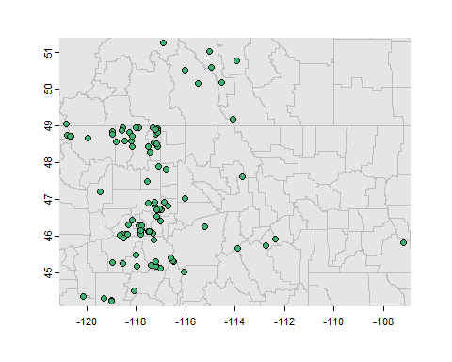
Note that this procedure does not detect “pernicious” geographic outliers. These are records that appear like they are part of the range, but are placed in the wrong location (e.g., on top of a mountain or in a lake).
How well do these records represent the species’ actual range? It’s tempting to see if a range map exists and compare it to the points. In general this is a good idea, but realize that the range map was originally drawn from biodiversity collections so isn’t an independent test of points’ validity. For this particular species there is indeed a range map available from the IUCN. The actual file is large because it contains all the world’s mammals, so I’ve included the range map just for this species in the folder Urocitellus columbianus.
# load and plot IUCN range polygon
rangeMap <- vect(
'./Urocitellus columbianus/urocitellusColumbianus_iucnRangeMap.shp'
)
plot(records)
plot(northAmerica, col = 'gray90', border = 'gray', add = TRUE)
plot(rangeMap, col = alpha('khaki', 0.8), add = TRUE)
plot(records, pch = 21, bg = 'mediumseagreen', add = TRUE)
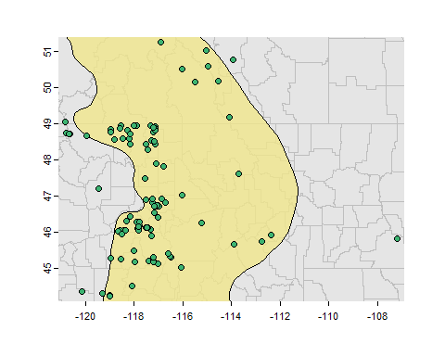
There are several points that fall outside the range map. Some of them are probably OK given its coarse nature. However, that one on the east side does seem suspiciously out of place. Let’s remove it, acknowledging that if this were a real research study, we should follow up.
eastern <- which.max(records$decimalLongitude)
records <- records[-eastern]
# Save:
saveRDS(records,
'./Occurrences - GBIF/03 Species Records - Removed Geographic Outliers.rds'
)
Note that we’re using saveRDS() now, instead of the write.csv() function, because the object is a SpatVector, which cannot be saved as a CSV without losing its geographic attributes.
One additional note: The range map seems to cover a much wider area than the occurrence data. This is concerning because if the species does occupy a broader set of environments than the occurrences indicate, then we’d “miss” parts of the niche and likely underestimate the true distribution of the species.
plot(rangeMap, col = alpha('khaki', 0.8))
plot(northAmerica, border = 'gray', add = TRUE)
plot(records, pch = 21, bg = 'mediumseagreen', add = TRUE)
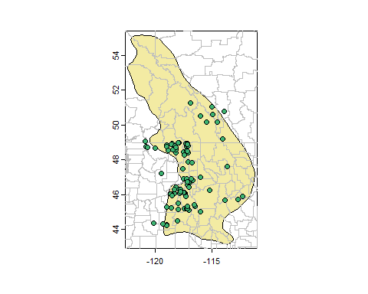
This is indeed a concern. When you have finished this tutorial, please mount an expedition to British Colombia to survey ground squirrels.
##Removing records with large spatial uncertainty
Many records were obtained before the advent of GPS. As a result, they have been georeferenced post-de facto by someone who was not the collector. Depending on the institution doing the georeferencing, this may have been done with or without accounting for uncertainty in interpretation of the locality description where the specimen was collected. There is a standard methodology for assessing error around points, and if this was practiced, then the value can be found in the coordUnceraintyInMeters field. These values represent the best guess of the radius of a circle around the coordinate in which the specimen was actually likely to have been collected. Let’s look at the distribution of errors around coordinates.
hist(records$coordinateUncertaintyInMeters,
breaks = 100,
xlab = 'Coordinate uncertainty (m)',
ylab = 'Number of records',
main = 'Coordinate uncertainty',
col = 'red'
)
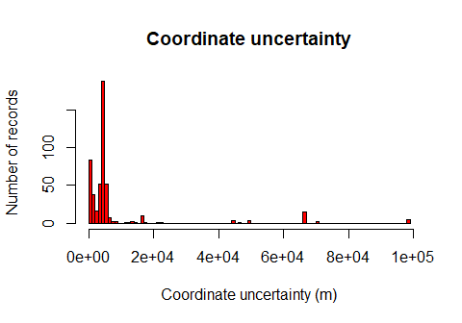
Most points have errors <5 km, but at least one has much larger errors. Large errors in coordinates arise when a collector simply named a general place (e.g., “eastern Oregon”) which the georeferencer then had to interpret.
The most conservative way to ensure locational accuracy of records is to use only those records with a coordinate uncertainty less than some predetermined value. A fairly comprehensive paper by Graham et al. (2008) found that across a wide range of species and modeling algorithms errors in coordinates up to ~10 km had no appreciable effect on model performance. Since then, others have noted that the effect of positional error depends on spatial autocorrelation of the environment around each point–we’ll explore this later.
First, let’s see where records occur with errors >5000 m or have no stated uncertainty.
# Records with large or missing uncertainty
recordsUncertain <- records[
records$coordinateUncertaintyInMeters > 5000 |
is.na(records$coordinateUncertaintyInMeters), ]
plot(records)
plot(northAmerica, col = 'gray90', border = 'gray', add = TRUE)
plot(rangeMap, col = 'khaki', add = TRUE)
points(records, pch = 21, bg = 'mediumseagreen')
points(recordsUncertain, pch = 22, bg = 'red')
legend('bottomleft',
legend = c('OK', 'Uncertain'),
pch = c(21, 22),
pt.bg = c('mediumseagreen', 'red')
)
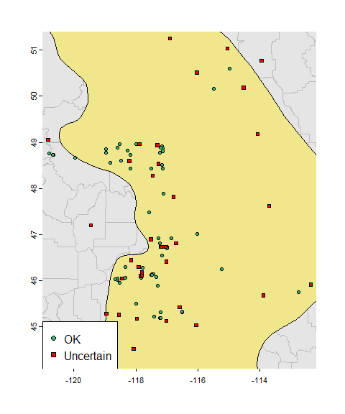
There seem to be quite a few records with no associated uncertainty or large uncertainty!
We will still have quite a few records if we remove these uncertain points, so let’s be cautious and do that. This is especially warranted for species that live in the mountains like the Columbian Ground Squirrel. In montane environments, if a record is displaced just a few hundred meters away from its true location, elevation (and thus climate) can change dramatically! Thus, it’s wise to be extra cautious when modeling montane species for this reason. That said, here we’ll use 5 km as a cutoff because our climate data has cells that are ~18 km across. Normally you’d probably be using much finer-resolution climate data, in which case you’d use a correspondingly smaller cutoff.
nrow(records)
## [1] 508
records <- records[records$coordinateUncertaintyInMeters <= 5000, ]
nrow(records)
## [1] 378
Note that the opposite problem can also occur–some records may be listed with an unbelievably small coordinate error (i.e., a few centimeters or less). This doesn’t seem to be the problem in our case, though:
head(sort(unique(records$coordinateUncertaintyInMeters)))
## [1] 84 90 210 301 475 520
This does not seem to be the case here, but it’s important to check.
Let’s creat a final map of the records we’ll be using.
# Map final set of cleaned records
plot(rangeMap, col = alpha('khaki', 0.8), main = 'Cleaned Dataset')
plot(northAmerica, border = 'gray', add=TRUE)
plot(records, pch = 21, bg = 'mediumseagreen', add = TRUE)
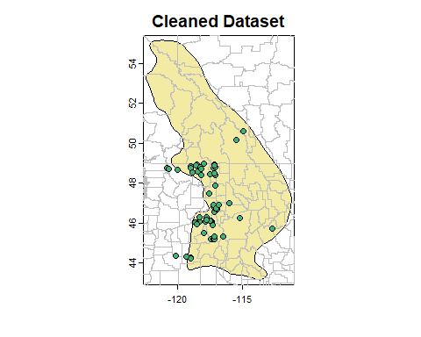

3.3.1 Save, save, save!
saveRDS(records,
'./Occurrences - GBIF/04 Species Records - Retained Records with Coord Uncertainty lte 5000 m.rds'
)

3.3.2 Other methods for checking coordinate uncertainty and outliers
There are many other methods for checking coordinate uncertainty:
- Matching the stated tertiary administrative unit (county/parish/district) to the one in which the coordinate actually lies. Matching administrative units can be very helpful but it’s arduous because of the many ways in which place names can be written (e.g., “Sedgwick County”, “Sedgwick Cty”, “Sedg.”). At best it takes a combination of machine-assisted manual checking and at worst a lot of manual checking. So for today we’ll skip this and rely on other methods. If you do check records by comparing the stated administrative unit to the administrative unit in which the coordinate lies, be aware:
- Many databases automatically populate fields pertaining to country, state/province, etc. based on the coordinates. So checking using these fields will only confirm what was already demonstrated.
- It might have been hard for collectors to correctly identify the county/parish/district they were in if the collection occurred near the border. I was once helping collect small mammals and, based on my calculations from the topo map, found that the county line ran across our picnic table.
- Counties, parishes, and districts may have changed borders and names over the years.
- Diacritics (e.g., a place name written with “a” versus “a”) can make machine-matching difficult. Tools in the stringr package can help.
- Methods exist for using imprecisely-georeferenced records (e.g., Smith et al. 2023, Bombi & D’Amen 2011). This can be valuable because discarding imprecise records risks undersampling portions of the species environmental and geographic range.
- Matching the stated elevation of collection with the elevation of the record’s coordinate. Presumably they’d be close to one another.
- Looking for outliers in environmental space. We’ll do this in a later exercise.

3.3.3 Other issues
If you work with a set of occurrence data long enough, you will discover its weirdnesses. It’s hard to say what these are. But, for example, I once found an herbarium record georeferenced to the location of the wedding where it was used in a bouquet–and then realized I had officiated that wedding!
Here are some things to be aware of: * Records used in experiments, or grown in greenhouses, hothouses, shadehouses, gardens, arboreta, zoos, and so on. I’m listing the possibilities I can think of because they make good keywords to use in a search for such records. Keep in mind that if records are from location where English may not be spoken, you may need to search for the equivalent of these terms in the appropriate language(s). * Records georeferenced to a store in which the specimen was bought. Search for words like “bought”, “store” , “purchase”, and ”sale” or ”sold”. Again, you may need to use non-English equivalents. Observations uploaded to a community science site on a date different from the date of observation. * Misspellings. For example, a colleague of mine found”Myotis” (a bat) was mistakenly included in his data set of “Microtis” (voles). * Swapped coordinates (longitude-vs-latitude, or using or missing a negative sign in front of a coordinate). I once heard of a collector who went from North to South America to search for what would have been an amazingly disjunct population of a species–only to learn that the latitude coordinate mistakenly had a minus sign in front of it.

4 Reflection
- How many records did you start with and how many did you end up with?
- What kind of unreliable records did your species have?
- How did you handle records that had unreliable geolocations?
- What other aspects of the data might be an issue? How would you find “pernicious” errors (records that at first glance appear legitimate but are not actually valid)?

