Exercise 02: Defining a Study Region
Adam B. Smith | Missouri Botanical Garden
2025-01-31
In this exercise you learn how to choose a study region, the areal extent of the place you’re interested in. Later we’ll modify this study region to meet certain objectives. In general there are two kinds of areas you’ll need to define when modeling the niche/distribution of a species:
- The calibration region, from which we draw data to calibrate the models. This includes presence data and data on absences, if we have them. However, absences are hard to validate, so often we use “background” sites instead, which I will explain later.
- A projection region to which to project the model. Sometimes this is the same as the calibration region, but if you’re projecting model under climate scenarios, then the climate that the species currently prefers may move to locations very far away from the current range of the species. As a result, the projection region can be much larger than the calibration region. But it can also be smaller, depending on what your study goals are! Hence unless you have an a priori projection region in which you’re interested, it’s easiest to start by defining a projection region that encompasses both of these areas then work backwards from there.
Properly selecting a calibration region can take quite a bit of thought. Later, we’ll discuss this in more detail. But for now, what we want is a region that encompasses the species’ occurrences plus areas that are “relevant” to the distribution of the species. By that, I mean areas from which absence data (if we had it) would be meaningfully informative. For example, it’s quite possible this species could live in parts of northern Japan. However, it can’t disperse there. So, including Japan would be mis-informing the model about what kinds of conditions the species could inhabit.
There are many ways to define a study region–using the area delineated by buffers around occurrences is probably the most common method, but here we’ll use another common approach based on ecoregions.

1 Restarting R
If you are continuing from the previous exercise, you can skip this part. However, if you restarted R, you will need to attach packages and load other data objects. In that case, please run this code.
library(cowplot) # combining ggplots
library(enmSdmX) # SDMing
library(geodata) # geographic data
library(ggplot2) # plotting
library(omnibus) # helper functions
library(scales) # transparency/rescaling
library(terra) # GIS
# Working folder... may not be needed if you are using RStudio.
# Set to the proper path for your computer/project.
setwd('C:/Folder Name/SDM Workshop')
# Occurrences:
records <- readRDS('./Occurrences - GBIF/04 Species Records - Retained Records with Coord Uncertainty lte 5000 m.rds')
# Range map:
rangeMap <- vect('./Urocitellus columbianus - IUCN/urocitellusColumbianus_iucnRangeMap.shp')
# North America:
northAmerica <- vect('./Political - GADM/North America.rds')

2 Defining a study region
There are many different ways to define a study region. These include using administrative areas (usually a bad idea because they’re not “natural” units), ecoregions, dispersal barriers, or using a simple buffer. In our case, we’re lucky enough to have a range map. There are issues with it, but for simplicity, we’ll define our study region using buffer drawn around the range map.
For this tutorial, we’ll use a buffer of 400 km. However, in your own work you may want to explore how the size of this buffer changes your models. In my experience, you have to change buffer sizes by quite a bit (e.g., increasing them geometrically: 20 km, 40 km, 80 km, 160 km, etc.) to see a difference.
# Create buffer. Units are in meters.
studyRegion <- buffer(rangeMap, width = 400000)
# Plot species records and ecoregions:
plot(studyRegion) # set plotting extent
plot(northAmerica, col = 'gray90', border = 'gray', add = TRUE)
plot(studyRegion, col = alpha('khaki', 0.5), add = TRUE)
plot(records, pch = 21, bg = 'mediumseagreen', add = TRUE)
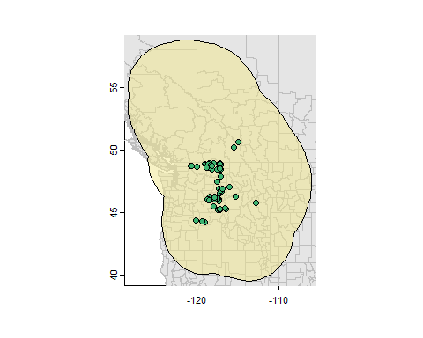
Note that it extends a bit into the ocean. This is OK.
Let’s save this for future use.
# Create folder:
dirCreate('./Study Region')
# Save:
saveRDS(ecoStudyRegion, './Study Region/Study Region.rds')

3 Reflection
- How well is the presumed range (the range polygon) covered by the presence records? What are the implications of incomplete coverage for modeling?
- How else might you define a study region for this species? What other data sources could you use?

