Exercise 04: Obtaining and Processing Environmental Rasters
Adam B. Smith | Missouri Botanical Garden
2025-01-31
In this exercise you learn how to obtain climate rasters from a particular data soucre and then to crop them to your study region. We will be using the WORLDCLIM climate data set. WORLDCLIM is a set of climate rasters created by Robert Hijmans and colleagues Fick & Hijmans 2017. The dataset was created by interpolating records from thousands of weather stations across the world. The “base” WORLDCLIM dataset comprises rasters representing the mean precipitation, average minimum temperature, and average maximum temperature of each month of each month, averaged across many years.
WORLDCLIM is available in several spatial resolutions, with cell sizes from 10 arcmin, or about 18 km at the equator to 30 arcsec, or about 1 km at the equator. We will be using the 10 arcmin rasters because they are much faster to process in R. However in your own work, you should use rasters with resolutions that best match the spatial uncertainty in your records, while at the same time best capturing important environmental gradients. For example, montane environments change sharply across short distances, so fine-resolution rasters are appropriate. Ergo, we should not be using 10 arcmin rasters for the Columbian ground squirrel! But for the sake of expediency, we’ll sacrifice accuracy.
The geodata package provides a very useful set of functions for downloading geographic data (country borders, environmental data, etc.). We’ll be using that to get the data in R. However, you can also download WORLDCLIM data directly from the WORLDCLIM website.

1 Restarting R
If you are continuing from the previous exercise, you can skip this part. However, if you restarted R, you will need to attach packages and load other data objects. In that case, please run this code.
library(cowplot) # combining ggplots
library(enmSdmX) # SDMing
library(geodata) # geographic data
library(ggplot2) # plotting
library(omnibus) # helper functions
library(scales) # transparency/rescaling
library(terra) # GIS
# Working folder... may not be needed if you are using RStudio.
# Set to the proper path for your computer/project.
setwd('C:/Folder Name/SDM Workshop')
# Occurrences:
records <- readRDS('./Occurrences - GBIF/04 Species Records - Retained Records with Coord Uncertainty lte 5000 m.rds')
# Range map:
rangeMap <- vect('./Urocitellus columbianus Range Map - IUCN/urocitellusColumbianus_iucnRangeMap.shp')
# North America:
northAmerica <- vect('./Political - GADM/North America.rds')
# Study region
studyRegion <- readRDS('./Study Region/Study Region.rds')

2 Obtaining and preparing elevation rasters
We’ll start by clipping a raster that represents elevation. We will not be using it as a predictor, but elevation is often helpful for examining the veracity of occurrences (i.e., is a valley species’ occurrence mistakenly put on a mountaintop?) and for making visually pleasing maps. The elevation data in this raster was derived from a laser instrument mounted on a Space Shuttle mission, the Shuttle Radar Topography Mission (SRTM), and has been made available (after corrections) from the Consultative Group on International Agricultural Research (CGIAR). To ensure we recall this (e.g., when writing a paper many months from now), we’ll create a folder with the source in its name.
# Create folder in which to save elevation raster:
dirCreate('./Elevation - CGIAR-SRTM')
# download
globalElevation <- elevation_global(res = 10, path = './Elevation - CGIAR-SRTM')
Note: If this does not work for you because the geodata server that has the elevation data is down, you can get the elevation raster from the backup folder:
globalElevation <- rast('./Backup/Elevation - CGIAR-SRTM/wc2.1_10m/wc2.1_10m_elev.tif')
What did we get?
# metadata about the raster
globalElevation
## class : SpatRaster
## dimensions : 1080, 2160, 1 (nrow, ncol, nlyr)
## resolution : 0.1666667, 0.1666667 (x, y)
## extent : -180, 180, -90, 90 (xmin, xmax, ymin, ymax)
## coord. ref. : lon/lat WGS 84
## source : wc2.1_10m_elev.tif
## name : wc2.1_10m_elev
## min value : -352
## max value : 6251
# plot
plot(globalElevation)
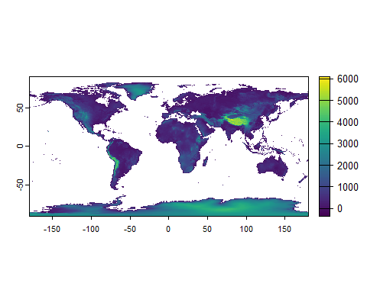
Let’s crop this to the region we’re interested in, which we define roughly as the bounding box of the study region we defined in the previous lesson.
# Crop by ecoregions:
elevation <- crop(globalElevation, studyRegion)
# Rename with units:
names(elevation) <- 'elevation_m'
# Save
writeRaster(elevation, './Elevation - CGIAR-SRTM/elevation.tif', overwrite = TRUE)
# plot
plot(elevation, main = 'Elevation (m)')
plot(records, pch = 21, bg = 'red', add = TRUE)
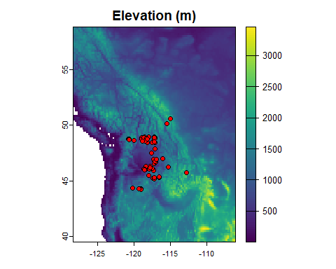
The crop() function clips the raster to the extent of the study region, discarding the portion outside. Then, we save the raster. The remainder of the scripts in this section do the exact same thing, except that they cycle through sets of rasters. They will do this very quickly because we’re using coarse-resolution (10-arcmin) rasters.

2.1 Downloading WORLDCLIM climate data
# Create the folder in which to save the data:
dirCreate('./Climate Rasters - WORLDCLIM') # omnibus package
# Download
wc <- worldclim_global(var = 'bio', res = 10, path = './Climate Rasters - WORLDCLIM')
If the geodata server is down, you can get the rasters using:
wc <- rast('./Backups/Climate Rasters - WORLDCLIM/climate/wc2.1_10m/wc2.1_10m_bio_', paste0(1:19), 'tif'))

2.2 Exploring WORLDCLIM data
Let’s look at the current climate layers. To make this easier, we will rename the rasters. Right now, each has a rather ungainly name like wc2.1_10m_bio_1. You can see this in the raster metadata:
# raster metadata
wc
## class : SpatRaster
## dimensions : 1080, 2160, 19 (nrow, ncol, nlyr)
## resolution : 0.1666667, 0.1666667 (x, y)
## extent : -180, 180, -90, 90 (xmin, xmax, ymin, ymax)
## coord. ref. : lon/lat WGS 84
## sources : wc2.1_10m_bio_1.tif
## wc2.1_10m_bio_2.tif
## wc2.1_10m_bio_3.tif
## ... and 16 more sources
## names : wc2.1~bio_1, wc2.1~bio_2, wc2.1~bio_3, wc2.1~bio_4, wc2.1~bio_5, wc2.1~bio_6, ...
## min values : -54.72435, 1.00000, 9.131122, 0.000, -29.68600, -72.50025, ...
## max values : 30.98764, 21.14754, 100.000000, 2363.846, 48.08275, 26.30000, ...
# another way to see the names
names(wc)
## [1] "wc2.1_10m_bio_1" "wc2.1_10m_bio_2"
## [3] "wc2.1_10m_bio_3" "wc2.1_10m_bio_4"
## [5] "wc2.1_10m_bio_5" "wc2.1_10m_bio_6"
## [7] "wc2.1_10m_bio_7" "wc2.1_10m_bio_8"
## [9] "wc2.1_10m_bio_9" "wc2.1_10m_bio_10"
## [11] "wc2.1_10m_bio_11" "wc2.1_10m_bio_12"
## [13] "wc2.1_10m_bio_13" "wc2.1_10m_bio_14"
## [15] "wc2.1_10m_bio_15" "wc2.1_10m_bio_16"
## [17] "wc2.1_10m_bio_17" "wc2.1_10m_bio_18"
## [19] "wc2.1_10m_bio_19"
Notice that this “raster” is actually a “stack” of rasters… 19 to be exact. Each one represents one of the BIOCLIM variables, which were invented in the 1980s in the context of the first formal species distribution modeling algorithm.
Let’s rename the rasters using bio as a prefix and the number of the variable thereafter:
# rename BIOCLIM variables
names(wc) <- paste0('bio', 1:19)
names(wc)
## [1] "bio1" "bio2" "bio3" "bio4"
## [5] "bio5" "bio6" "bio7" "bio8"
## [9] "bio9" "bio10" "bio11" "bio12"
## [13] "bio13" "bio14" "bio15" "bio16"
## [17] "bio17" "bio18" "bio19"
To familiarize ourselves with these rasters, let’s look at mean annual temperature (MAT) for the current time period. In the BIOCLIM system, this is variable #1.
bio1 <- wc[['bio1']]
bio1
## class : SpatRaster
## dimensions : 1080, 2160, 1 (nrow, ncol, nlyr)
## resolution : 0.1666667, 0.1666667 (x, y)
## extent : -180, 180, -90, 90 (xmin, xmax, ymin, ymax)
## coord. ref. : lon/lat WGS 84
## source : wc2.1_10m_bio_1.tif
## name : bio1
## min value : -54.72435
## max value : 30.98764
This is the contents of the bio raster–you can see that it is 1080 cells high by 1080 cells wide. It also has a resolution of 0.1667 or 1/6th of a degree (= 10 arcmin). The extent covers the entire world, from -180 longitude to 180 longitude (the International Date Line) and from 90 degrees north (the North Pole) to 90 degrees south (the South Pole). The raster uses the WGS84 coordinate system (a model of the Earth for designating locations–more on this later). The name of the raster in R is bio1. Finally, R shows you the minimum and maximum values for the raster across all cells.
Let’s plot the raster.
plot(bio1, main = 'MAT')
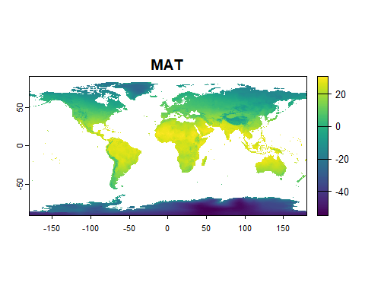
This raster represents the average temperature across 1980 to 2010.
Now, let’s look at total annual precipitation (TAP), which is BIOCLIM variable #12.
tap <- wc[['bio12']]
plot(tap, main = 'TAP')
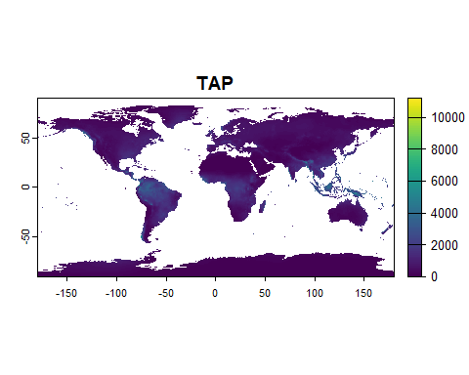
The units for most precipitation variables in WORLDCLIM is millimeters, so the map of MAP represents precipitation ranging from no precipitation to >10 m per year!
Now let’s look at all of the BIOCLIM layers together (or most of them).
# Plot all BIOCLIM variables
plot(wc)
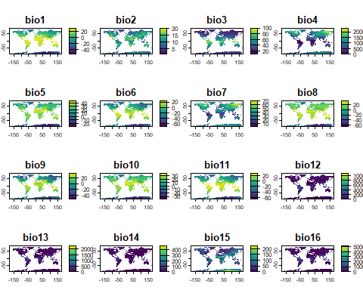
Note that by default, just the first 16 maps are shown.
The world maps are nice, but our focal species does not occur everywhere! Before we model, we’ll want to crop the rasters to the appropriate spatial extent, choose which among them we want to use, and do some further preparation.

2.3 Crop BIOCLIM rasters to the study region
Now we will clip the rasters to the study region to make them more manageable. We’ll call them “currentClim” because they represent present-day climate.
# Crop and plot WORLDCLIM rasters to study region:
currentClim <- crop(wc, studyRegion)
plot(currentClim)
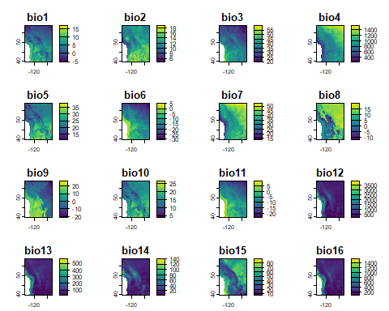
Finally, let’s save the rasters:
# Save cropped rasters:
writeRaster(currentClim, './Climate Rasters - WORLDCLIM/currentClim.tif', overwrite = TRUE)
Aside #1: The proper citation of the BIOCLIM variables is below (which I ascertained through communication with Trevor Booth, who was involved with their creation). Note that this is the citation of the variables, not the actual source of whatever raster data set that has these variables. In our case, WORLDCLIM is the source. Other sources of climate rasters may also provide the BIOCLIM variables.
Booth, T.H., Nix, H.A., Busby, J.R., and Hutchinson, M.F. 2014. BIOCLIM: The first species distribution modeling package, its early applications and relevance to most current MaxEnt studies. Diversity and Distributions 20:1-9. DOI: 10.1111/ddi.12144
Aside #2: You can easily find the definitions of the BIOCLIM rasters by doing a web search for “WORLDCLIM BIOCLIM”. The top-most search is always the WORLDCLIM page with these definitions.
Aside #3: If we can easily download rasters using functions in geodata, why don’t we just do that every time we run a script, rather than save the rasters? This is certainly possible. However, on occasion servers are down (the WORLDCLIM one is, sometimes), and data sets change versions while old ones are retired. In the past, for example, it was extremely hard to find the elevation raster for WORLDCLIM from the website, so if you were able to find it, it was quite a relief! Save yourself the regret, and save intermediate products as you go.

2.4 Obtain and crop future WORLDCLIM BIOCLIM rasters
We will be wanting to project our SDM into a future climate to ascertain how climate change might affect this species.
For our future climate layers we’ll be using the same WORLDCLIM data source, which provides the same BIOCLIM variables for future climate scenarios. There are many different options, but we will focus simply on climate for the period 2061-2080 under SSP 585 from the GISS-E2-1-H global circulation model. You can see other possibilities from the WORLCLIM website or from ?cmip6_world.
These rasters are from the “6th Coupled Model Intercomparison Project” (CMIP6) of the 6th Assessment Report of the IPCC. This was a global effort to create a suite of climate models for use in the report. Note that some of the CMIP6 models are known to run “hot”, meaning the temperatures they predict for the present are much higher than they should be. No climate model is accurate, and there are ways to de-bias these projections. However, care should be taken when using these “hot” models Hausfather et al. 2022. Strangely, I have not found an official list of these “hot” models, but Zeke Hausfather, the first author of the paper cited above, reported them on Twitter/X:
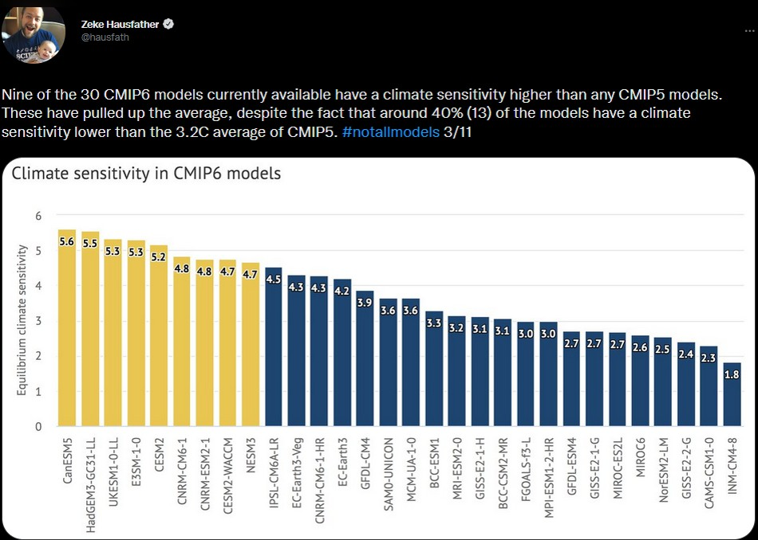
Hot models
Note that GISS-E2-1-H is in the middle of the “non-hot” pack of models.
Which climate models should you use for your own studies? Aside from the hot models, none of these models is inherently more accurate than the others on a global scale. Here, “accurate” refers to the model’s ability to recreate historical climate. However, different models are differently able to recreate historical climate for certain regions of the world, and this varies by region and model. Li et al. 2022 assess climate models’ ability to predict precipitation correctly, which is harder to predict than temperature, so it’s a good index of overall “accuracy” of the climate model.
If you need to choose a subset, selecting a set of models that bracket possible outcomes may be best. Choose, for example, climate models that predict wetter and drier conditions, and models that predict “very-hot” and “just-normal-hot” conditions.
Now let’s obtain and crop the rasters representing the forecast for the 2070s.
# Download future climate rasters
wcFut <- cmip6_world('GISS-E2-1-H', ssp = 585, time = '2061-2080', var = 'bio', res = 10, path = './Climate Rasters - WORLDCLIM')
If the server is down, you can get these from:
wcFut <- rast(paste0(workDir, '/Backups/Climate Rasters - WORLDCLIM/climate/wc2.1_10m/wc2.1_10m_bioc_GISS-E2-1-H_ssp585_2061-2080.tif'))
Now, let’s crop the rasters to the study region:
# Crop:
futureClim <- crop(wcFut, studyRegion)
# Rename the rasters. These *must* have the same names as the present-day rasters.
names(futureClim) <- paste0('bio', 1:19)
# Save:
writeRaster(futureClim, './Climate Rasters - WORLDCLIM/futureClim.tif', overwrite = TRUE)

2.5 Change in climate
Let’s look at how climate changes in this scenario by plotting rasters showing change in MAT and TAP. Change in temperature should always be calculated using subtraction, but change in precipitation can be calculated using subtraction or division.
# change rasters for MAT and TAP
deltaBio1 <- futureClim[['bio1']] - currentClim[['bio1']]
deltaBio12 <- futureClim[['bio12']] / currentClim[['bio12']]
deltas <- c(deltaBio1, deltaBio12)
names(deltas) <- c('deltaBio1', 'deltaBio12')
plot(deltas)
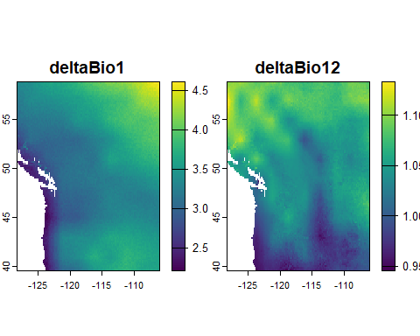
On the left, positive values indicate cells where it is expected to get warmer. You can see that in this region, it’s indeed projected to get hotter everywhere. On the left, values >1 indicate where it’s projected to get wetter, and values <1 where it’s projected to get drier. Here, it is projected to get wetter in the north and drier in the south.

3 A note on raster formats and processing
The terra package can handle many different types of rasters. Many people prefer the GeoTIFF format because it is has a small size on the disk and because it can be opened by many GIS programs. Small file size reduces loading time.
R and terra are good at many things, but rasters can be very big in memory and require a lot of time to process. The main aspects of rasters that affect processing time are:
- Size (number of cells wide by long)
- How many rasters are to be processed
- Number of cells that have data (are not NA)
- Data type of the cells (integer and usually faster/smaller in memory, and floating-point numbers slower/larger)
We are using the 10-arcmin (~18-km) resolution WORLDCLIM rasters specifically because R can handle them quickly. Normally you should use rasters with smaller cell sizes to capture finer-scale local variation in climate, provided the precision of the species’ occurrences are much less than the given resolution.
You can also process rasters outside R in ArcGIS, QGIS, or GRASS, for example, but then you lose the advantages of having your workflow all in one script. However, if you have very large rasters, the fasterRaster package connects R with GRASS GIS to do processing much faster. However, for small- and medium-sized rasters, terra will almost always be faster, so you should start there.
If you’re familiar with the sf package for handling spatial vectors (i.e., “shapefiles”), you may be asking why we are not using it. The answer is that terra has in-built support for vectors, and so to make things simpler, I’m presenting only those functions. However, sf can be used within the SDM workflow. You will just have to do some conversions between the two package object types as you go along.

4 Reflection
- Under what conditions would you choose to work with high-resolution (small cell size) versus low-resolution (large cell size) rasters?
- What non-climatic variables might be important to modeling any particular species in which you’re interested? Are these kinds of data available?

