Exercise 05: Matching Occurrences to Environmental Data and Further Cleaning
Adam B. Smith | Missouri Botanical Garden
2025-01-31
To generate an SDM, we will ultimately need to create a “data frame” (basically, a “spreadsheet” in R) with occurrences and the climates to which they are matched. Along the way, we can inspect for outliers in environmental space.
We’ve already scrutinized our species’ data for erroneous records in geographic space. However, what may appear legitimate on a map may not actually be legitimate. Consider a species that lives in the lowlands. It may have a record that falls inside its range when viewed on our computer screen, but on closer inspection the point actually falls on a mountaintop due to a georeferencing error. These are “pernicious” errors that cannot be easily avoided. One way to help catch them (and geographic outliers) is to examine the species’ distribution in environmental space.
In this lesson, we will:
- Match the species’ occurrences to climate associated with their locations; and
- Inspect occurrences for environmental outliers.

1 Restarting R
If you are continuing from the previous exercise, you can skip this part. However, if you restarted R, you will need to attach packages and load other data objects. In that case, please run this code.
library(cowplot) # combining ggplots
library(enmSdmX) # SDMing
library(geodata) # geographic data
library(ggplot2) # plotting
library(omnibus) # helper functions
library(scales) # transparency/rescaling
library(terra) # GIS
# Working folder... may not be needed if you are using RStudio.
# Set to the proper path for your computer/project.
setwd('C:/Folder Name/SDM Workshop')
# Occurrences:
records <- readRDS('./Occurrences - GBIF/04 Species Records - Retained Records with Coord Uncertainty lte 5000 m.rds')
# Range map:
rangeMap <- vect('./Urocitellus columbianus Range Map - IUCN/urocitellusColumbianus_iucnRangeMap.shp')
# North America:
northAmerica <- vect('./Political - GADM/North America.rds')
# Study region
studyRegion <- readRDS('./Study Region/Study Region.rds')
# Elevation and climate rasters:
elevation <- rast('./Elevation - CGIAR-SRTM/elevation.tif')
currentClim <- rast('./Climate Rasters - WORLDCLIM/currentClim.tif')
futureClim <- rast('./Climate Rasters - WORLDCLIM/futureClim.tif')

2 Matching environmental data to records
We extract the raster values at each record location and add them to the records.
# match species' records with elevation and climate
elevSpecies <- extract(elevation, records, ID = FALSE)
envSpecies <- extract(currentClim, records, ID = FALSE)
These are tables with values, with one row per occurrence:
head(elevSpecies)
## elevation_m
## 1 650
## 2 249
## 3 847
## 4 249
## 5 796
## 6 249
head(envSpecies)
## bio1 bio2 bio3 bio4
## 1 7.834354 12.64921 35.58746 819.9264
## 2 11.565761 12.90919 38.06673 778.3749
## 3 7.862292 12.81213 37.71933 736.7910
## 4 11.565761 12.90919 38.06673 778.3749
## 5 8.325021 12.26587 36.74948 735.5801
## 6 11.565761 12.90919 38.06673 778.3749
## bio5 bio6 bio7 bio8
## 1 28.42325 -7.12075 35.544 -1.57829165
## 2 31.50175 -2.41025 33.912 2.69312501
## 3 28.49575 -5.47125 33.967 -0.49704170
## 4 31.50175 -2.41025 33.912 2.69312501
## 5 28.57400 -4.80300 33.377 -0.07104164
## 6 31.50175 -2.41025 33.912 2.69312501
## bio9 bio10 bio11 bio12 bio13
## 1 17.47400 17.88600 -2.3029583 435 56
## 2 20.85317 21.43458 2.2004583 395 53
## 3 16.83388 17.06521 -0.9294583 652 83
## 4 20.85317 21.43458 2.2004583 395 53
## 5 17.22325 17.43125 -0.5281250 592 77
## 6 20.85317 21.43458 2.2004583 395 53
## bio14 bio15 bio16 bio17 bio18 bio19
## 1 22 29.58838 149 72 89 132
## 2 13 38.30775 144 47 52 127
## 3 24 36.87917 243 86 97 226
## 4 13 38.30775 144 47 52 127
## 5 23 36.49984 219 76 87 198
## 6 13 38.30775 144 47 52 127
Now, we need to combine the species’ records with this climate data. This would be easy if the cbind() function worked for SpatVectors, but at the time I made this tutorial, it did not. So, we’ll have to use a for loop and add columns one-by-one.
# add elevation
records$elevation_m <- elevSpecies$elevation_m
# add BIOCLIM variables
for (bio in 1:19) {
records$DUMMY <- envSpecies[ , paste0('bio', bio)] # add column
names(records)[ncol(records)] <- paste0('bio', bio) # rename column
}
head(records)
## gbifID license
## 1 812656799 CC0_1_0
## 2 4947692604 CC_BY_NC_4_0
## 3 4947692394 CC_BY_NC_4_0
## 4 4947692313 CC_BY_NC_4_0
## 5 4947692104 CC_BY_NC_4_0
## 6 4947692055 CC_BY_NC_4_0
## species
## 1 Urocitellus columbianus
## 2 Urocitellus columbianus
## 3 Urocitellus columbianus
## 4 Urocitellus columbianus
## 5 Urocitellus columbianus
## 6 Urocitellus columbianus
## basisOfRecord decimalLongitude
## 1 PRESERVED_SPECIMEN -118.1700
## 2 PRESERVED_SPECIMEN -118.3430
## 3 PRESERVED_SPECIMEN -116.8686
## 4 PRESERVED_SPECIMEN -118.3430
## 5 PRESERVED_SPECIMEN -117.0601
## 6 PRESERVED_SPECIMEN -118.3430
## decimalLatitude
## 1 48.42865
## 2 46.06458
## 3 46.92012
## 4 46.06458
## 5 46.73842
## 6 46.06458
## coordinateUncertaintyInMeters year month
## 1 2105 1974 6
## 2 4977 1983 5
## 3 90 1985 4
## 4 4977 1983 4
## 5 2069 1977 5
## 6 4977 1983 4
## day countryCode stateProvince
## 1 19 US Washington
## 2 3 US Washington
## 3 3 US Idaho
## 4 28 US Washington
## 5 14 US Washington
## 6 21 US Washington
## county
## 1 Stevens
## 2 Walla Walla County
## 3 Latah County
## 4 Walla Walla County
## 5 Whitman County
## 6 Walla Walla County
## locality
## 1 Roosevelt Lake, E shore, nr Rice
## 2 N Fort Walla Walla City Park, Walla Walla
## 3 Gold Creek Ranch, 1 mi E of Potlach on Hwy. 6
## 4 N Fort Walla Walla City Park, Walla Walla
## 5 1.7 mi E, 1.3 mi N of Sunshine
## 6 N Fort Walla Walla City Park, Walla Walla
## verbatimLocality
## 1 USA | Washington | Stevens
## 2 N Fort Walla Walla City Park, Walla Walla, Walla Walla Co., Washington
## 3 Gold Creek Ranch, 1 mi E of Potlach on Hwy. 6, Latah Co., Idaho
## 4 N Fort Walla Walla City Park, Walla Walla, Walla Walla Co., Washington
## 5 1.7 mi E, 1.3 mi N of Sunshine, elev. 2540 ft, Whitman Co., Washington
## 6 N Fort Walla Walla City Park, Walla Walla, Walla Walla Co., Washington
## institutionCode recordedBy
## 1 PSM University of Washington
## 2 CRCM Collector(s): unknown
## 3 CRCM Collector(s): unknown
## 4 CRCM Collector(s): unknown
## 5 CRCM Collector(s): unknown
## 6 CRCM Collector(s): unknown
## references
## 1 http://portal.vertnet.org/o/psm/bird?id=Mammal-20325
## 2 http://arctos.database.museum/guid/CRCM:Mamm:24969
## 3 http://arctos.database.museum/guid/CRCM:Mamm:8594
## 4 http://arctos.database.museum/guid/CRCM:Mamm:24932
## 5 http://arctos.database.museum/guid/CRCM:Mamm:8470
## 6 http://arctos.database.museum/guid/CRCM:Mamm:24870
## elevation_m bio1 bio2 bio3
## 1 650 7.834354 12.64921 35.58746
## 2 249 11.565761 12.90919 38.06673
## 3 847 7.862292 12.81213 37.71933
## 4 249 11.565761 12.90919 38.06673
## 5 796 8.325021 12.26587 36.74948
## 6 249 11.565761 12.90919 38.06673
## bio4 bio5 bio6 bio7
## 1 819.9264 28.42325 -7.12075 35.544
## 2 778.3749 31.50175 -2.41025 33.912
## 3 736.7910 28.49575 -5.47125 33.967
## 4 778.3749 31.50175 -2.41025 33.912
## 5 735.5801 28.57400 -4.80300 33.377
## 6 778.3749 31.50175 -2.41025 33.912
## bio8 bio9 bio10 bio11
## 1 -1.57829165 17.47400 17.88600 -2.3029583
## 2 2.69312501 20.85317 21.43458 2.2004583
## 3 -0.49704170 16.83388 17.06521 -0.9294583
## 4 2.69312501 20.85317 21.43458 2.2004583
## 5 -0.07104164 17.22325 17.43125 -0.5281250
## 6 2.69312501 20.85317 21.43458 2.2004583
## bio12 bio13 bio14 bio15 bio16 bio17
## 1 435 56 22 29.58838 149 72
## 2 395 53 13 38.30775 144 47
## 3 652 83 24 36.87917 243 86
## 4 395 53 13 38.30775 144 47
## 5 592 77 23 36.49984 219 76
## 6 395 53 13 38.30775 144 47
## bio18 bio19
## 1 89 132
## 2 52 127
## 3 97 226
## 4 52 127
## 5 87 198
## 6 52 127
Sometimes you’ll find a record that falls in a place where it should not (e.g., a terrestrial species in the water). This may be an error, but sometimes not… Raster data represents the world with rectangular-ish cells, and a record may have legitimately been made in the “corner” of a cell that was in a valid habitat yet falls into an invalid habitat in the raster data set. For our purposes, let’s remove any records that might have NA’s as environmental data (i.e., fall into the water). (In our case none do, but it’s good to check.)
# names of all environmental variables
envVars <- c(
'elevation_m', # elevation
paste0('bio', 1:19) # BIOCLIM variables
)
# keep only rows with no NAs in them
nrow(records)
## [1] 378
recordsDf <- as.data.frame(records)
ok <- which(complete.cases(recordsDf[ , envVars]))
records <- records[ok, ]
nrow(records)
## [1] 378
When I run this, I lose no records, but this is always a good thing to check!

3 Outliers in environmental space

3.1 Outliers in 1-dimensional space
Now, let’s examine the distribution of records in 1- and 2-dimensional environmental space. Anything that seems excessive should be scrutinized because there is a chance it was mis-located or inhabiting a specific microenvironment that our coarse-grained climate data cannot capture. There are many variables we could use to examine environmental location. Here we’ll use elevation plus mean annual temperature (MAT) and total annual precipitation (TAP) since they represent “gestalt” variables.
# plot in 1-D environmental space
par(mfrow = c(1, 3))
hist(
records$elevation_m,
breaks = 20,
xlab = 'Elevation (m)',
main = 'Elevation of Presences'
)
hist(
records$bio1,
breaks = 20,
xlab = 'MAT (deg C)',
main = 'MAT of Presences'
)
hist(
records$bio12,
breaks = 20,
xlab = 'TAP (mm)',
main = 'MAP of Presences'
)
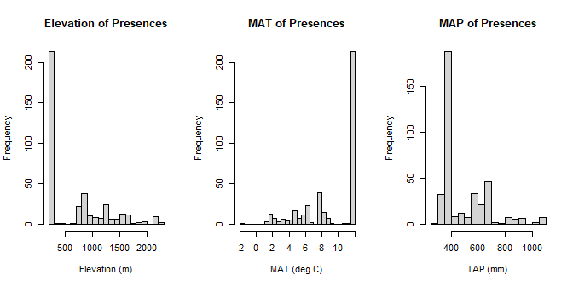
If you have a lot of records, you can simply remove those that are, say, in the outermost 0.5% quantiles or farther than, say, 3 SD from the next-nearest point. Beware, though that this could exclude legitimate records that tell you a lot about the limits of the species’ environmental preferences.
Note that there are a relatively large number of records with the same values of elevation, MAT, and TAP. This might reflect either highly suitable climate/elevation or an over-concentration of collection effort in those locations (i.e., bias!). We’ll examine this later.
Overall, though, there don’t seem to be any obvious outliers. However, if there were, you should: * Locate those records on a map. Do they represent likely habitat? * Examine the metadata associated with the records. Do they have large coordinate uncertainty? Were they collected under odd circumstances? Were they correctly identified? Do any notes indicate something informative (e.g., caught in a sheltered cove? Were they Georeferenced to the zoo or botanical garden the organism was living in)?

3.2 Outliers in 2-dimensional environmental space
Sometimes a record can fall within the range of each variable and yet be an outlier in 2- or higher-dimensional environmental space. Let’s look for these records.
par(mfrow = c(1, 3), pty = 's')
plot(records$bio1,
records$bio12,
xlab = 'MAT (deg C)',
ylab = 'TAP (mm)',
main = '',
col = 'red'
)
plot(records$elevation_m,
records$bio1,
xlab = 'Elevation (m)',
ylab = 'MAT (deg C)',
main = '',
col = 'red'
)
plot(records$elevation_m,
records$bio12,
xlab = 'Elevation (m)',
ylab = 'TAP (mm)',
main ='',
col = 'red'
)
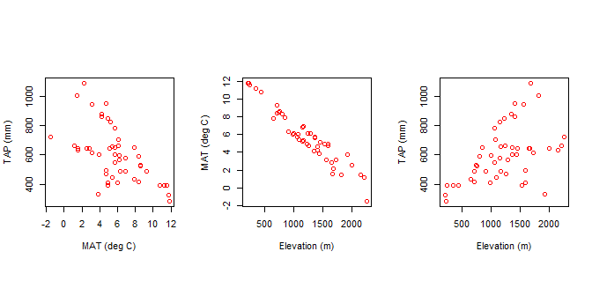
Again, there don’t seem to be obvious outliers, but again, if there were, we shuld check them. Let’s save the records with their associated environmental values.
saveRDS(records,
'./Occurrences - GBIF/05 Species Records - Matched with WORLDCLIM.rds'
)

4 Remove all but one record per cell
Our occurrence data has many duplicates in cells in the environmental rasters. Duplicates occur when a collector obtains more than one specimen at a site. They also occur when more than one site in a cell was surveyed. Having more than one record per cell isn’t necessarily bad–it might actually reflect favorable environment. But it could also conflate sampling effort with favorabiliity of the habitat.
For plants it is common for collectors to obtain duplicates of a single individual or multiple individuals at a site, then disperse these duplicates these to other herbaria. GBIF does not necessarily know these are the same plant, but this (this is not GBIF’s fault: there’s no standardized way to know, but GBIF does has a “cluster” tool that helps flag records that might be duplicated). Frustratingly, herbarium specimens at different institutions can be retroactively georeferenced to different locations because of the various manners in which locality descriptions can be interpreted! One way to address this might be to remove all but one record for each unique combination of collector (or collector number) and sample date. We’re getting beyond this tutorial here, but I wanted to bring this to you attention.
This all said, it is standard practice to remove all but one record per cell to reduce the effects of sampling bias on models. The enmSdmX package contains a function elimCellDuplicates() to do this:
# remove all but one record per cell
nrow(records) # number of starting records
## [1] 378
# remove spatial duplicates, using elevation raster as a "template"
recordsNoDups <- elimCellDuplicates(records, rast=elevation)
nrow(recordsNoDups) # number or ending records
## [1] 48
How many records do we have left? (Recall we started by downloading 1000s of records!) What effect does this have on the distribution of environmental variables among records?
par(mfrow = c(2, 3))
elevRange <- range(records$elevation_m)
hist(records$elevation_m,
breaks = 20,
xlab = 'Elevation (m)',
main = 'Elevation\n(all records)',
xlim = elevRange
)
matRange <- range(records$bio1)
hist(records$bio1,
breaks = 20,
xlab = 'MAT (deg C)',
main = 'MAT\n(all records)',
xlim = matRange
)
tapRange <- range(records$bio12)
hist(records$bio12,
breaks = 20,
xlab = 'TAP (mm)',
main = 'TAP\n(all records)',
xlim = tapRange
)
hist(recordsNoDups$elevation_m,
breaks = 20,
xlab = 'Elevation (m)',
main = 'Elevation\n(1 record / cell)',
xlim = elevRange
)
hist(recordsNoDups$bio1,
breaks = 20,
xlab = 'MAT (deg C)',
main = 'MAT\n(1 record / cell)',
xlim = matRange
)
hist(recordsNoDups$bio12,
breaks = 20,
xlab = 'TAP (mm)',
main = 'TAP\n(1 record / cell)',
xlim = tapRange
)
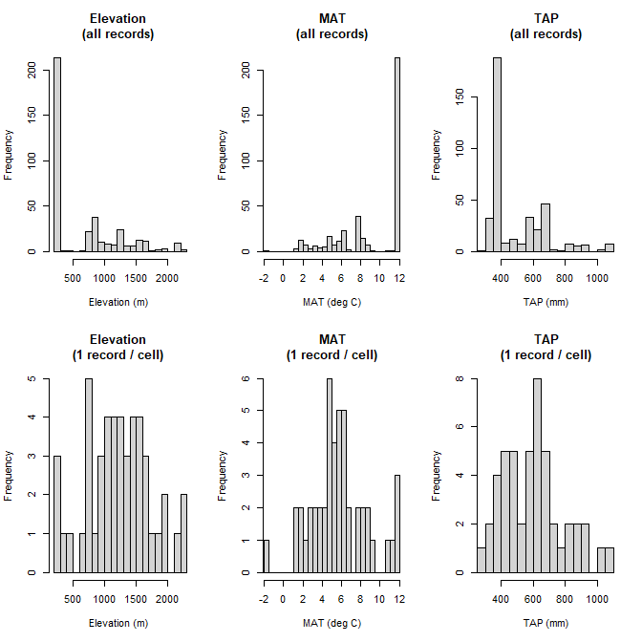
You can see that thinning the data to one occurrence per cell tends to even out the distribution of environmental values. Recalling that SDMs do their computational work in environmental space, you can see how this might affect the model.
Finally, let’s save the thinned records to use for modeling.
saveRDS(recordsNoDups,
'./Occurrences - GBIF/06 Species Records - Eliminated All But One Record Per Cell.rds'
)

5 Other tools for cleaning biodiversity data
Several R packages have been developed to flag potentially erroneous records. These include:
- biogeo Robertson et al. 2016: Mismatches between the coordinate location and recorded administrative area of collection, outlier detection, flagging of terrestrial records that occur in water.
- bRacatus Robertson et al. 2016: Calculates an index of the validity of an occurrence.
- coordinateCleaner Zizka et al. 2019: Flags records that may have been geolocated to the center of an administrative area, may have been put in the wrong hemisphere (relative to other points), outlier detection, and have formatting issues.
Of course, expert opinion and common sense should be the final check on the validity of occurrence records.

6 Reflection
- What methods can you use to identify outliers in geographic and environmental space? How can you use one kind of space to identify outliers in the other?
- What effect did removing cell outliers have on the distribution of environmental variables across the species’ presences? What effect do you think this will have on models?
- We removed duplicates in each cell, but should we have done this? What do duplicates represent, better habitat or more sampling effort? How could you tell? (Note that the answers will depend on your situation, and may be unknowable!)

