Exercise 06: Background Sites
Adam B. Smith | Missouri Botanical Garden
2025-01-31
Ideally you would have data from surveys that indicated not only the presence but also the absence of a species. Unfortunately, absences are not usually recorded in biodiversity databases–and if they were, they’d be subject to the problem of false absence when a species was really there but not recorded. Also, recall the resolution of our environmental data is about 12 km. This means that you would be asserting that a species is absent from everywhere within a 12-km cell to which you assign “absence” to. So, even if you had absence data, it might not be applicable at the scale at which you are conducting your analysis. Even though background sites statistically “stand in” for absences, they can fall on known presence and absence sites–this is actually legitimate! In a later lesson, I’ll we’ll learn why this is OK.
Here we will:
- Develop a set of background sites which statistically are similar to absences.
- Differentiate between absences, background sites, and pseudoabsences.
- Discuss how many background sites are necessary to generate a robust model.

1 Restarting R
If you are continuing from the previous exercise, you can skip this part. However, if you restarted R, you will need to attach packages and load other data objects. In that case, please run this code.
library(cowplot) # combining ggplots
library(enmSdmX) # SDMing
library(geodata) # geographic data
library(ggplot2) # plotting
library(omnibus) # helper functions
library(scales) # transparency/rescaling
library(terra) # GIS
# Working folder... may not be needed if you are using RStudio.
# Set to the proper path for your computer/project.
setwd('C:/Folder Name/SDM Workshop')
# Occurrences:
recordsNoDups <- readRDS('./Occurrences - GBIF/06 Species Records - Eliminated All But One Record Per Cell.rds')
# Range map:
rangeMap <- vect('./Urocitellus columbianus - Range Map IUCN/urocitellusColumbianus_iucnRangeMap.shp')
# North America:
northAmerica <- vect('./Political - GADM/North America.rds')
# Study region:
studyRegion <- readRDS('./Study Region/Study Region.rds')
# Elevation and climate rasters:
elevation <- rast('./Elevation - CGIAR-SRTM/elevation.tif')
currentClim <- rast('./Climate Rasters - WORLDCLIM/currentClim.tif')
futureClim <- rast('./Climate Rasters - WORLDCLIM/futureClim.tif')
Most papers on SDMs that use MaxEnt employ 10,000 background sites, so we will start from there. In some cases, this is not possible because the number of non-NA cells in the environmental rasters is <10,000. In this case, it’s OK to use as many as you can get.
Initially, we’ll use background sites randomly placed across the study region. We’ll generate more than 10,000 points that because some of them could fall into the ocean. These will be removed later.
# generate 11,000 background sites (10% more than needed)
randomBg <- spatSample(studyRegion, 11000)
nrow(randomBg)
## [1] 11000
corner(randomBg) # omnibus package
## class : SpatVector
## geometry : points
## dimensions : 5, 5 (geometries, attributes)
## extent : -123.8914, -112.2283, 39.84998, 57.64089 (xmin, xmax, ymin, ymax)
## coord. ref. : lon/lat WGS 84
## names : id_no
## type : <num>
## values : 4.247e+04
## 4.247e+04
## 4.247e+04
## binomial presence origin
## <chr> <int> <int>
## Spermophilus columb~ 1 1
## Spermophilus columb~ 1 1
## Spermophilus columb~ 1 1
## seasonal
## <int>
## 1
## 1
## 1
Let’s create a map of the sites. We’ll make the land a dark color so we can see where the sites that fall into the water are.
plot(northAmerica, col = 'gray40', border = 'gray20', ext = studyRegion)
plot(studyRegion, col = alpha('khaki', 0.5), add = TRUE)
plot(randomBg, pch = '.', add = TRUE)
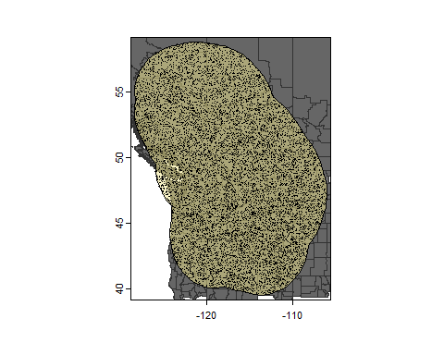
Now, let’s get the environmental values of the cells in which each point falls.
# stack environmental rasters
env <- c(elevation, currentClim)
# extract values
randomBgEnv <- extract(env, randomBg, ID = FALSE)
# add coordinates
coords <- crds(randomBg)
colnames(coords) <- c('longitude', 'latitude')
randomBgEnv <- cbind(coords, randomBgEnv)
# examine the first 6 rows (1 row per point)
head(randomBgEnv)
## longitude latitude elevation_m
## 1 -123.8914 45.83795 210
## 2 -112.2283 39.84998 1899
## 3 -123.3792 57.64089 1245
## 4 -112.5699 48.65173 1217
## 5 -115.9914 44.12774 1257
## 6 -116.7647 44.84005 1338
## bio1 bio2 bio3 bio4
## 1 9.7510118 9.185095 51.23933 347.6382
## 2 8.3457813 15.744854 38.40653 910.9816
## 3 -0.8036042 11.126208 29.66336 965.4133
## 4 6.9408541 14.310208 37.32668 855.9145
## 5 6.8717289 16.136292 41.09718 823.4490
## 6 6.6861668 15.621625 40.57170 815.2997
## bio5 bio6 bio7 bio8
## 1 19.85931 1.933438 17.92587 6.296951
## 2 31.28200 -9.713250 40.99525 6.842333
## 3 18.12600 -19.382250 37.50825 11.067083
## 4 27.53100 -10.806750 38.33775 15.450292
## 5 29.92050 -9.343250 39.26375 -2.255417
## 6 29.30800 -9.195750 38.50375 -2.202750
## bio9 bio10 bio11 bio12
## 1 13.871451 14.36188 5.941851 2259
## 2 19.945375 19.94538 -2.477583 361
## 3 -6.360542 11.06708 -12.100708 602
## 4 -3.270417 17.81842 -3.270417 339
## 5 16.739750 17.04967 -3.233583 561
## 6 16.713167 16.80946 -3.121583 551
## bio13 bio14 bio15 bio16 bio17 bio18
## 1 356 41 61.91145 1028 167 176
## 2 36 23 12.90210 101 76 76
## 3 118 23 66.15535 303 73 303
## 4 66 10 64.26036 160 35 145
## 5 83 15 48.18926 237 64 71
## 6 75 17 38.55338 209 68 84
## bio19
## 1 957
## 2 87
## 3 77
## 4 35
## 5 221
## 6 197
What about the points that fall in the water? These should have NA values across the entire row. We will now remove these.
# which rows have no NAs?
keeps <- which(complete.cases(randomBgEnv))
# keep just these points/rows
randomBg <- randomBg[keeps, ]
randomBgEnv <- randomBgEnv[keeps, ]
nrow(randomBgEnv)
## [1] 10895
We should be left with a bit more than 10,000 rows, which we’ll subset to get our desired number of occurrences.
# random sample
n <- nrow(randomBg)
keeps <- sample(n, 10000)
# keep just these points/rows
randomBg <- randomBg[keeps, ]
randomBgEnv <- randomBgEnv[keeps, ]
nrow(randomBg)
## [1] 10000
dirCreate('./Background Sites') # omnibus package
saveRDS(randomBgEnv,
file = './Background Sites/Random Background Sites across Study Region.rds'
)

1.0.1 “Background sites” versus “pseudoabsences”
In the past, it was common to use pseudoabsence sites, which were sites chosen in a manner that recreated expected patterns of absence. For example, they might locate pseudoabsence sites a certain distance or farther from known occurrences. This can yield reasonable results, but it relies on a strong assumption about where absences are. And, if we knew where absences were, why would be modeling? Also, for MaxEnt, it is actually statistically invalid to use absence or pseudoabsence data.
Please note that I am differentiating “pseudoabsences” from “background sites,” but not all people discriminate this way. So just because you read a paper that used what they call “pseudoabsence sites” with MaxEnt, does not mean that it is invalid on that account–you need to assess how their sites were chosen. If a site could have landed on a known presence, then it’s likely a background set of points.

1.0.2 Number of background sites
As noted, most studies employing MaxEnt (and other algorithms) use 10,000 background sites, largely because it was the default number of sites in the original MaxEnt software. However, this number can and should be different in some cases: * The environmental rasters may have <10,000 non-NA cells.
Above, we chosen background sites using the study region polygon to constrain them. However, we could have chosen them using the environmental rasters (which would have included cells in the “corners” around the study region polygon, too). Let’s do that to illustrate the difference:
# random sample from the raster
# displays a warning
randomBgRast <- spatSample(env, 15000, as.points = TRUE)
You should have received a warning indicating that fewer points were selected than were available. This is because the raster has fewer than 15000 cells. Moreover, some of these are in the water, so we would be left with even fewer points.
plot(elevation)
plot(randomBgRast, pch = '.', add = TRUE)
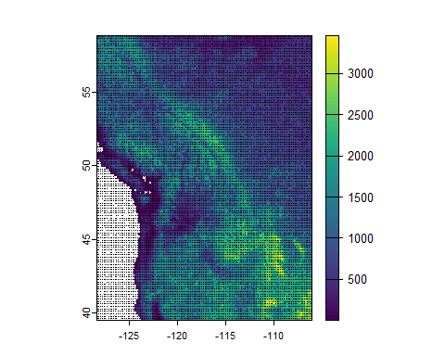
When you are selecting background points from a raster, and the raster has fewer than 10,000 non-NA cells, it’s generally OK to use as many as you can get. After all, all of the relevant cells are in the background sites!
- The species inhabits very rare microhabitats.
If a species inhabits uncommon habitats, and the environmental data you are using has enough resolution to display these habitats, then 10,000 sites may not be enough to capture them. In these cases, the model may not be specific enough–i.e., it could “miss” the species’ preferences because it was only able to “see” common conditions, not the specific conditions the species prefers (Guevara et al. 2018). To ameliorate these issues, use several times more background sites than usual (e.g., 20,000, 40,000, etc.). Examine the environmental values in these sets to ensure they capture the rare habitats.
- Tree-based methods should have the same number of background sites as occurrences.
We will discuss “tree-based” modeling algorithms later, but these include random forests and gradient boosting machines/boosted regression trees. For these methods, use the same number of background sites as you have occurrence sites (Barbet-Massin et al. 2012). If you are familiar with tree-based methods, you will wonder about what this does to the stochastic nature of the output, especially if the number of occurrences is low. The answer is that it can create a lot of variance. In this case (and in almost all cases, actually, even if you have a lot of occurrences), you would want to calibrate your model several times and take the average to account for the non-deterministic nature of the trees (Sillero & Barbosa 2021).

1.0.3 What if you have absence or absence-like data?
Sometimes you are lucky enough to possess detection/non-detection data. In these cases, if at least some sites have been visited more than once and you recorded detection/non-detection each time, then you probably should use occupancy-detection models (ODMs), which explicitly account for the problem of non-detection. ODMs are a variant of SDMs, except that SDMs typically don’t explicitly model the detection process (we will see soon how they can be modified to account for biased data).
Sometimes, you actually have presence/absence data where you can really assert that absences are “true,” and your environmental data match the scale at which you assert absence of the species. In this case, you can use SDMs they are presented here. However, don’t use MaxEnt because it assume that the non-presence data is background data. Nearly any other algorithm can handle this data in a statistically valid manner (see the last exercise in this series). The nice thing about this kind of data is that the output of a model can be interpreted as the probability of presence, whereas for cases where you have background sites, it’s correlated with the probability of presence (assuming the model is accurate).
And sometimes, you have valid absence data in some areas/times but not others (e.g., scoring of presence/absence in quadrats spread across a portion of the species’ range, but not all of the range). In these cases, integrated SDMs, which combine different data types, are the way to go (Koshkina et al. 2017).

2 Reflection
- What is the difference between true absences, background sites, and pseudoabsences? What assumptions does using each of these require?
- Under what circumstances is it OK or advisable to use more or fewer than 10,000 background sites?

