Exercise 10: Tuning MaxEnt Features
Adam B. Smith | Missouri Botanical Garden
2025-01-31
MaxEnt includes its own “tuning” procedures to help alleviate over-fitting to data and account for the complexity in the modeled response. While generally robust, these procedures were refined using a particular (though large) data set. So the model tuning done behind the scenes by MaxEnt may fit most circumstances fairly well but aren’t guaranteed to work well for any particular species. Here we will explore tuning MaxEnt by selection of feature functions. The next exercise will tackle turning regularization.

1 Restarting R
If you are continuing from the previous exercise, you can skip this part. However, if you restarted R, you will need to attach packages and load other data objects. In that case, please run this code.
library(cowplot) # combining ggplots
library(enmSdmX) # SDMing
library(geodata) # geographic data
library(ggplot2) # plotting
library(omnibus) # helper functions
library(scales) # transparency/rescaling
library(terra) # GIS
# Working folder... may not be needed if you are using RStudio.
# Set to the proper path for your computer/project.
setwd('C:/Folder Name/SDM Workshop')
# Occurrences:
recordsNoDups <- readRDS('./Occurrences - GBIF/06 Species Records - Eliminated All But One Record Per Cell.rds')
# Range map:
rangeMap <- vect('./Urocitellus columbianus Range Map - IUCN/urocitellusColumbianus_iucnRangeMap.shp')
# North America:
northAmerica <- vect('./Political - GADM/North America.rds')
# Study region:
studyRegion <- readRDS('./Study Region/Study Region.rds')
# Elevation and climate rasters:
elevation <- rast('./Elevation - CGIAR-SRTM/elevation.tif')
currentClim <- rast('./Climate Rasters - WORLDCLIM/currentClim.tif')
futureClim <- rast('./Climate Rasters - WORLDCLIM/futureClim.tif')
# Variables:
predictors <- readRDS('./Selected Predictors.rds')
# Background sites:
randomBgEnv <- readRDS('./Background Sites/Random Background Sites across Study Region.rds')
# Predictors:
predictors <- readRDS('./Selected Predictors.rds')
# Background and presence sites:
trainDataRandomBg <- readRDS('./Collated Occurrences & BG Sites/Random BG.rds')
# Models:
simpleModel <- readRDS('./Models/Simple Model.rds')
# Model predictions:
simpleMap <- rast('./Models/simple_model_1970_2000.tif'))

2 Feature selection
During the fitting procedure Maxent uses several “feature” functions to capture the shape of the species-environment relationship. Features are akin the single terms in a polynomial regression. For example, there are linear features, quadratic features, and two-way interaction features. There are is also a step-function feature and a “hinge” feature which models either a non-changing response followed by a linear increase/decrease or a linear increase/decrease followed by a non-changing response. Finally, there is a categorical feature for categorical variables, which acts like a simple addition/subtraction to the main intercept term. By default, MaxEnt will attempt to use all but threshold features (thresholds are special cases of hinges), though the actual mix of functions depends on the number of presences available to the model.
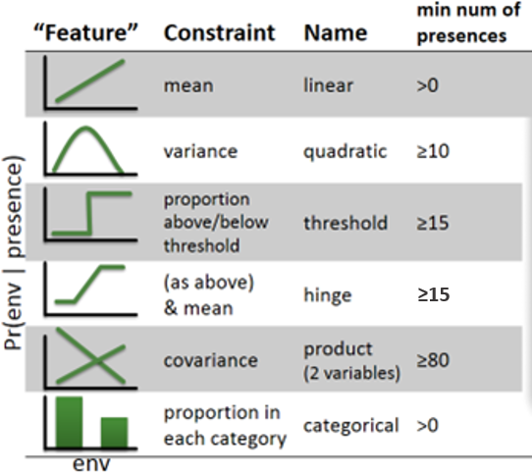
Called “features” in machine learning, these functions act as individual model terms in a MaxEnt model. Some features are used only if the required number of occurrences is sufficient.
Let’s look at the effect these features have on the estimate of environmental suitability. We will do this by plotting response functions, which show the change in estimated environmental suitability as the variable of interest is changed and the others are held constant. We’ll use the median value across the species’ presences as the “constant” value and vary the focal variable from its minimum to its maximum across the study region. We’ll be using the simple” model from Exercise 8 to make predictions.
To do this, we’ll make a series of data frames. Each column will have values of a predictor. For a given predictor, that column’s values will be the same across all rows except for the focal variable, which will go from its lowest to its highest value.
# get min/max value of each predictor across study region
minMaxClim <- minmax(currentClim)
minPred <- minMaxClim[1, ]
maxPred <- minMaxClim[2, ]
# get median value of each predictor across species' thinned presences
medianVal <- apply(randomBgEnv[ , predictors], 2, median)
# make data frame with each cell value equal to median value of each predictor
env <- as.data.frame(medianVal)
env <- t(env)
env <- env[rep(1, 100), ]
env <- as.data.frame(env) # coerce from matrix to data frame
rownames(env) <- NULL
head(env)
## bio1 bio7 bio15 bio18
## 1 4.117188 37.04137 40.68584 147
## 2 4.117188 37.04137 40.68584 147
## 3 4.117188 37.04137 40.68584 147
## 4 4.117188 37.04137 40.68584 147
## 5 4.117188 37.04137 40.68584 147
## 6 4.117188 37.04137 40.68584 147
# convert occurrence points to a data frame
recordsEnv <- as.data.frame(recordsNoDups)
### create plots of response functions for each predictor
responses <- list() # will store one plot per element
# for each predictor...
for (pred in predictors) {
# make copy of data frame
thisEnv <- env
# now vary focal predictor from min to max value...
# all other predictors keep median value
thisEnv[ , pred] <- seq(minPred[pred], maxPred[pred], length.out = 100)
# make prediction using this data frame
prediction <- predictEnmSdm(simpleModel, thisEnv)
thisEnv$prediction <- prediction
# plot
responses[[length(responses) + 1]] <-
ggplot(thisEnv, aes(x = .data[[pred]], y = prediction)) +
geom_line() + # response line
geom_rug(data = recordsEnv, aes(x = .data[[pred]], y = .data[[pred]]), sides = 't', color = 'red') + # occurrences rug plot
geom_rug(data = randomBgEnv, aes(x = .data[[pred]], y = .data[[pred]]), sides = 'b') + # background rug plot
ylim(0, 1) + # y-axis limits
xlab(pred) + # x-axis title
ylab('Predicted suitability') + # y-axis title
ggtitle(pred) + # plot title
theme(
legend.position = 'none' # no legend
)
}
# combine plots
simpleResponses <- plot_grid(plotlist = responses, nrow = 2)
# display
print(simpleResponses)
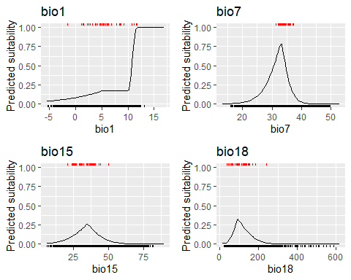
Each plot shows environmental suitability as that particular variable is varied. The red tick marks at the top (the “rug” plot) show the distribution of occurrences and the black rug at the bottom the background sites–in other words, the environment across the landscape. Recall that the predicted response is proportional to the ratio of the density of the presences to the background sites at a given environmental condition. You can see this somewhat by visually comparing the density of the red occurrence ticks to the black background ticks. But recall that there is overlap in some values, so some ticks may represent several or even many sites.
As you interpret the responses keep in mind that we kept all other variables at their median value. If there are interactions between variables then the response here may not be indicative of the overall response of the species to that variable. We did allow for interactions in this model, but as I’ll show you below, they actually had no effect (i.e., their coefficients are 0).
How do the response curves look? They’re… weird. These response curves are the combination of linear, quadratic, and hinge features, which together can make for some complex shapes. What do we expect? In most cases, assuming the species inhabits all of its suitable environment, we would expect to see two different types of response. First, we might expect to see a hump-shaped response, i.e, a “Goldilocks” response, where too hot/wet/dry/cold is bad and some place in the middle is just right. We do see hints of hump shapes for BIOs 7, 15, and 18, but not BIO1. In some cases, we might expect to see an increasing response that does not come “down”. An example of this might be when a species has no problem living in conditions where precipitation is the same every month (i.e., precipitation variability, BIO15, is 0), so suitability would not necessarily be equal to 0 at the lowest value of BIO15.
The response for BIO1, mean annual temperature, shows that as things get warmer, environmental suitability increases. In fact, it shows that there’s no limit–if the response were extrapolated out to 100C, say, the species would still be loving it, at least according to the model. That’s obviously not realistic. But why does the model respond in this manner? If you look at the previous exercise (“Exercise 09: MaxEnt”), you will see that the the Columbian ground squirrel has a preponderance of occurrences at the hot end of BIO1. This might be indicative of the species actually liking hot places, but it might also be due to overcollecting of warm sites. In the next exercise we will deal with this issue. It’s also indicative of the fact that the species occupies some of the hottest conditions in our study region–in an sense, there’s no hotter environments we gave to the model to “pull suitability down” at the hot end.

3 Selecting response curves
In the above exercise, we used a model that was trained using the default features in MaxEnt (linear, quadratic, interaction, and hinge–plus categorical, if any of our predictors had been categorical). However, we can manually turn these features on or off to adjust how the model trues to fit to the data. Let’s do that now by removing hinge features, which are partly responsible for the “sharp” edges in the response functions. We’ll 1) calibrate a new model, then 2) re-generate response curves. We’ll plot the new responses from the even “simpler” model on the same graphs as the ones from the “simple” model so we can more easily compare them.
# calibrate even simpler model
simplerModel <- trainMaxEnt(
data = trainDataRandomBg,
presBg = 'presBg',
preds = predictors,
regMult = 1,
classes = 'lpq', # l = linear, p = product, q = quadratic
testClasses = FALSE
)
# save
saveRDS(simplerModel, './Models/Simpler Model.rds')
# burn predictions to a raster
simplerMap <- predictEnmSdm(
simplerModel,
currentClim
)
names(simplerMap) <- 'simpler_model'
writeRaster(simplerMap, './Models/simpler_model_1970_2000.tif', overwrite = TRUE)
### create plots of response functions for each predictor
responses <- list() # will store one plot per element
# for each predictor...
for (pred in predictors) {
# make copy of data frame
thisEnv <- env
# now vary focal predictor from min to max value...
# all other predictors keep median value
thisEnv[ , pred] <- seq(minPred[pred], maxPred[pred], length.out = 100)
# make prediction using this data frame
simplePrediction <- predictEnmSdm(simpleModel, thisEnv)
simplerPrediction <- predictEnmSdm(simplerModel, thisEnv)
thisEnv$simplePrediction <- simplePrediction
thisEnv$simplerPrediction <- simplerPrediction
# plot
responses[[length(responses) + 1]] <-
ggplot(thisEnv) +
geom_line(mapping = aes(x = .data[[pred]], y = simplePrediction)) + # simple model
geom_line(mapping = aes(x = .data[[pred]], y = simplerPrediction), color = 'blue', linetype = 'dotted') + # simpler model
geom_rug(data = recordsEnv, aes(x = .data[[pred]], y = .data[[pred]]), sides = 't', color = 'red') + # occurrences rug plot
geom_rug(data = randomBgEnv, aes(x = .data[[pred]], y = .data[[pred]]), sides = 'b') + # background rug plot
ylim(0, 1) + # y-axis limits
xlab(pred) + # x-axis title
ylab('Predicted suitability') + # y-axis title
ggtitle(pred) + # plot title
theme(
legend.position = 'none' # no legend
)
}
# combine plots
simplerResponses <- plot_grid(plotlist = responses, nrow = 2)
# display
print(simplerResponses)
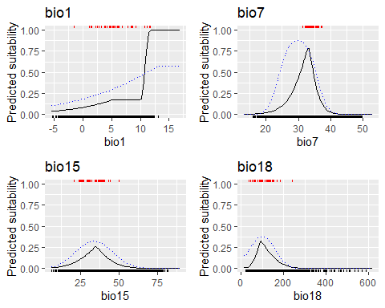
Here, the black, solid lines are the same ones as before from the model with linear, quadratic, product, and hinge features, whereas the blue, dotted line is from the model lacking hinge features. To my eye, the responses from this new model look more biologically realistic, although we still have the potential issue with suitability increasing (but never decreasing) as mean annual temperature (BIO1) increases.
So how do we select the best set of features? Luckily :), the trainMaxEnt() function, by default, cycles through all possible combinations of features. Also by default, linear features will appear in every model, although you can turn this off by setting the forceLinear argument to FALSE.
Let’s use the awesome power of a fully operational function to calibrate a MaxEnt model that cycles through all possible combinations of features. The best model is chosen using AICc. We will call this the “complex” model, even though function selects the most parsimonious model, which may actually be rather simple. Our code is nearly the same as before, except for the arguments in the trainMaxEnt() function.
# calibrate even simpler model
complexModel <- trainMaxEnt(
data = trainDataRandomBg,
presBg = 'presBg',
preds = predictors,
regMult = 1,
verbose = TRUE
)
##
## regMult classes numClasses numCoeff
## 1 1 lq 2 7
## 2 1 lpq 3 7
## 3 1 lqh 3 26
## 4 1 lpqh 4 26
## 5 1 lh 2 27
## 6 1 lph 3 27
## 7 1 l 1 4
## 8 1 lp 2 4
## logLik AICc deltaAICc relLike aicWeight
## 1 -368 752 0.0 1.00e+00 5.00e-01
## 2 -368 752 0.0 1.00e+00 5.00e-01
## 3 -347 812 60.0 9.57e-14 4.79e-14
## 4 -347 812 60.0 9.57e-14 4.79e-14
## 5 -347 823 70.9 4.01e-16 2.01e-16
## 6 -347 823 70.9 4.01e-16 2.01e-16
## 7 -418 845 92.5 8.21e-21 4.11e-21
## 8 -418 845 92.5 8.21e-21 4.11e-21
##
# burn predictions to a raster
complexMap <- predictEnmSdm(
complexModel,
currentClim
)
names(complexMap) <- 'complex_model'
### create plots of response functions for each predictor
responses <- list() # will store one plot per element
# for each predictor...
for (pred in predictors) {
# make copy of data frame
thisEnv <- env
# now vary focal predictor from min to max value...
# all other predictors keep median value
thisEnv[ , pred] <- seq(minPred[pred], maxPred[pred], length.out = 100)
# make prediction using this data frame
simplePrediction <- predictEnmSdm(simpleModel, thisEnv)
simplerPrediction <- predictEnmSdm(simplerModel, thisEnv)
complexPrediction <- predictEnmSdm(complexModel, thisEnv)
thisEnv$simplePrediction <- simplePrediction
thisEnv$simplerPrediction <- simplerPrediction
thisEnv$complexPrediction <- complexPrediction
# plot
responses[[length(responses) + 1]] <-
ggplot(thisEnv) +
geom_line(mapping = aes(x = .data[[pred]], y = simplePrediction)) + # simple model
geom_line(mapping = aes(x = .data[[pred]], y = simplerPrediction), color = 'blue', linetype = 'dotted') + # simpler model
geom_line(mapping = aes(x = .data[[pred]], y = complexPrediction), color = 'red', linetype = 'dashed') + # simpler model
geom_rug(data = recordsEnv, aes(x = .data[[pred]], y = .data[[pred]]), sides = 't', color = 'red') + # occurrences rug plot
geom_rug(data = randomBgEnv, aes(x = .data[[pred]], y = .data[[pred]]), sides = 'b') + # background rug plot
ylim(0, 1) + # y-axis limits
xlab(pred) + # x-axis title
ylab('Predicted suitability') + # y-axis title
ggtitle(pred) + # plot title
theme(
legend.position = 'none' # no legend
)
}
# combine plots
complexResponses <- plot_grid(plotlist = responses, nrow = 2)
# display
print(complexResponses)
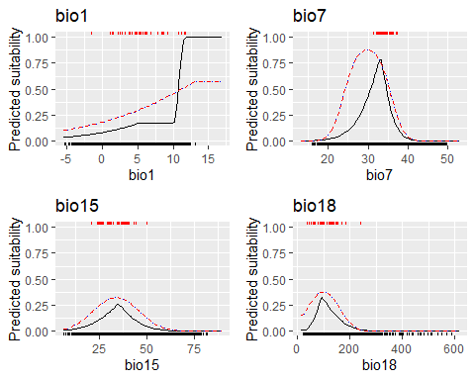
Again, black solid lines are the “simple” model, red dashed the even “simpler” model without interaction terms, and the blue dashed the “complex” model.
Guess what! The most parsimonious model was the model(s) with linear, quadratic, and product terms–ergo, our “simpler” model. You can see this in the table above, where models that were evaluated are ranked by AICc. The two best models are tied in AICc. The model on the top has just linear (l) and quadratic (q) terms, whereas the one under it has these plus product (p) terms. Since they have the same AICc, this suggests to me that our simpler model assigned the coefficient associated with product terms a value of 0, effectively removing them.
You may be interested in looking at the actual coefficients of the MaxEnt model. You can see them by using modelName@lambdas (for example, simpleModel@lambdas). However, they are not very human-readable. I am posting here a tutorial by Peter Wilson who very helpfully deciphers how to interpret these values.
Finally, let’s examine the maps. We already know the “complex” model’s map will be the same as the “simpler” model’s map, so we’ll just plot the “simple” and “simpler” model maps.
# plot
par(mfrow = c(1, 2))
plot(simpleMap, range = c(0, 1), main = 'Simple')
plot(recordsNoDups, pch = 1, col = 'red', add = TRUE)
plot(simplerMap, range = c(0, 1), main = 'Simpler')
plot(recordsNoDups, pch = 1, col = 'red', add = TRUE)
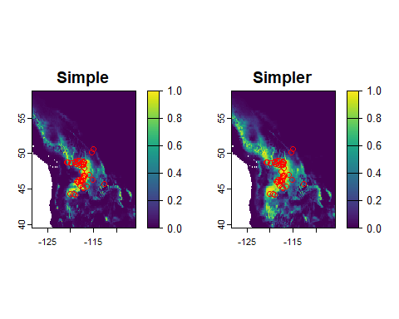
The “simpler” model predicts a wider area of suitable area because its response curves are wider (compare the response curve plots above).

3.1 Reflection
- Under what conditions do you expect monotonically increasing/decreasing responses to an environmental variable? Would you ever expect a multi-modal, or U-shaped response? What about a rally “jagged” response curve? Would we ever expect to see this?
- The monotonically increasing response to BIO1 is troublesome. How could we adjust the selection of background sites to address this issue? What would this adjustment imply about the environments the species could “access” via dispersal?

