Exercise 12: Bias Correction I
Adam B. Smith | Missouri Botanical Garden
2025-01-31
Biased data produces biased model. Occurrence records can display bias because they represent the haphazard collation of collectors and observers who were conducting their research for their–not your–purposes. As a result, specimens tend to be located near roads, universities, herbaria, airports, and cities. This geographic bias can cause records to be biased in environmental space where the model actually operates. Likewise, collectors might bias collections towards environments that are nice to work in or offer a higher chance of supporting their species of interest. This is a direct form of bias that also affects model output.
This exercise is broken into two sections because it is fairly long. In this exercise and the subsequent one, you will learn:
- How bias arises in biodiversity data, especially in “unstructured” data collected by different groups of people for different purposes.
- Five methods for correcting for bias in sampling of presence sites. These include
- Using target background sites in place of random background sites
- Using a bias grid that reflects probability of sampling to generate background sites
- Geographic thinning of occurrences (next exercise)
- Environmental thinning of occurrences (next exercise)
- Site-weighting of occurrences (next exercise)
Before we start, I want to set your expectations: we will not produce better models (in my opinion) compared to the ones we already have. Part of the issue is that we have very unbalanced data on the Columbian ground squirrel. You likely recall that we have few occurrences in Canada, and if there is an extreme imbalance (i.e., bias), then it’s likely no bias-correction technique can fully work. But, our purpose is to learn how to apply these corrections, whether they work for this particular species or not.

1 Restarting R
If you are continuing from the previous exercise, you can skip this part. However, if you restarted R, you will need to attach packages and load other data objects. In that case, please run this code.
library(cowplot) # combining ggplots
library(enmSdmX) # SDMing
library(geodata) # geographic data
library(ggplot2) # plotting
library(omnibus) # helper functions
library(scales) # transparency/rescaling
library(terra) # GIS
# Working folder... may not be needed if you are using RStudio.
# Set to the proper path for your computer/project.
setwd('C:/Folder Name/SDM Workshop')
# Occurrences:
recordsNoDups <- readRDS('./Occurrences - GBIF/06 Species Records - Eliminated All But One Record Per Cell.rds')
# Range map:
rangeMap <- vect('./Urocitellus columbianus Range Map - IUCN/urocitellusColumbianus_iucnRangeMap.shp')
# North America:
northAmerica <- vect('./Political - GADM/North America.rds')
# Study region:
studyRegion <- readRDS('./Study Region/Study Region.rds')
# Elevation and climate rasters:
elevation <- rast('./Elevation - CGIAR-SRTM/elevation.tif')
currentClim <- rast('./Climate Rasters - WORLDCLIM/currentClim.tif')
futureClim <- rast('./Climate Rasters - WORLDCLIM/futureClim.tif')
# Variables
predictors <- readRDS('./Selected Predictors.rds')
# Background sites
randomBgEnv <- readRDS('./Background Sites/Random Background Sites across Study Region.rds')
# Predictors
predictors <- readRDS('./Selected Predictors.rds')
# Background and presence sites
trainDataRandomBg <- readRDS('./Collated Occurrences & BG Sites/Random BG.rds')
# Models:
simpleModel <- readRDS('./Models/Simple Model.rds')
simplerModel <- readRDS('./Models/Simpler Model.rds')
baseModel <- readRDS('./Models/Base Model.rds')
# Model predictions:
simpleMap <- rast('./Models/simple_model_1970_2000.tif'))
simplerMap <- rast('./Models/simpler_model_1970_2000.tif'))
baseMap <- rast('./Models/base_model_1970_2000.tif')

2 Bias
Please examine the map below. This was taken on January 29th, 2025 from the GBIF website, and it displays the density of occurrences of all species in GBIF with coordinates. What do you see? 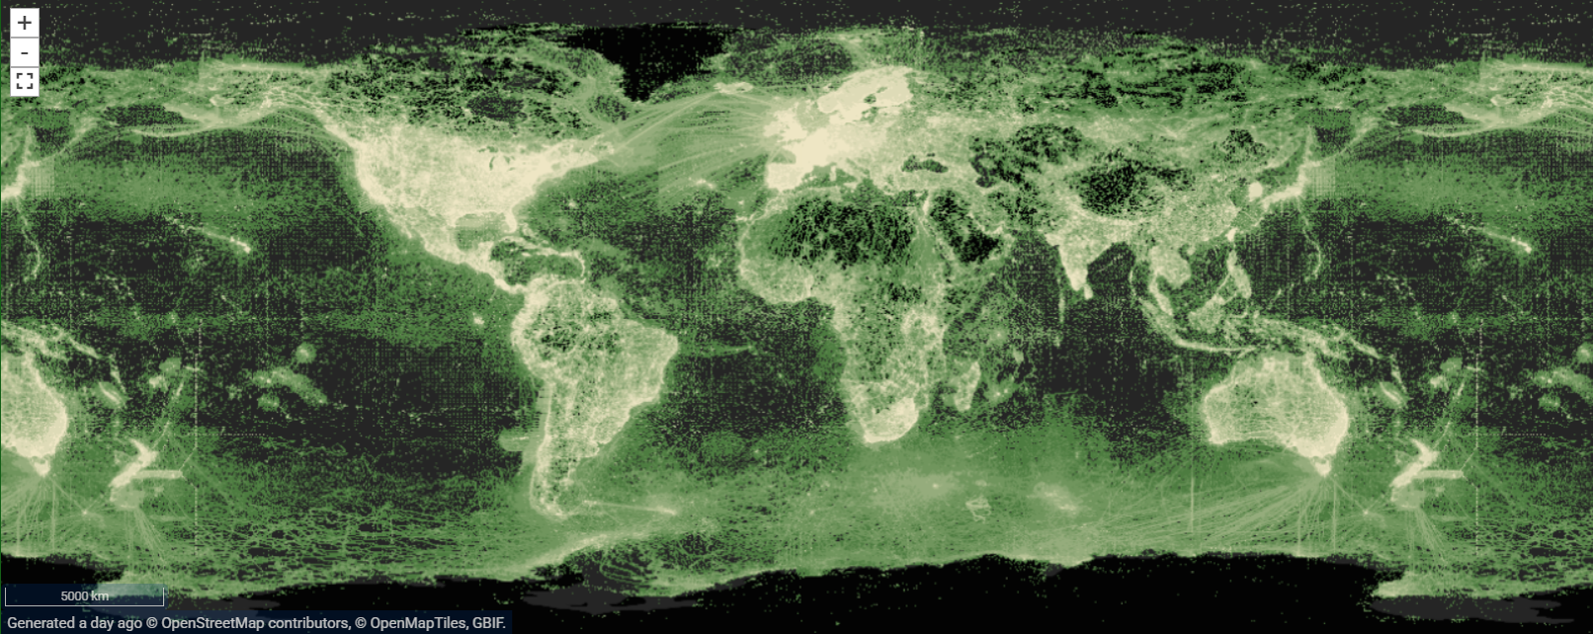
Let’s zoom in a bit to the Pacific northwest, where the Columbian ground squirrel resides. 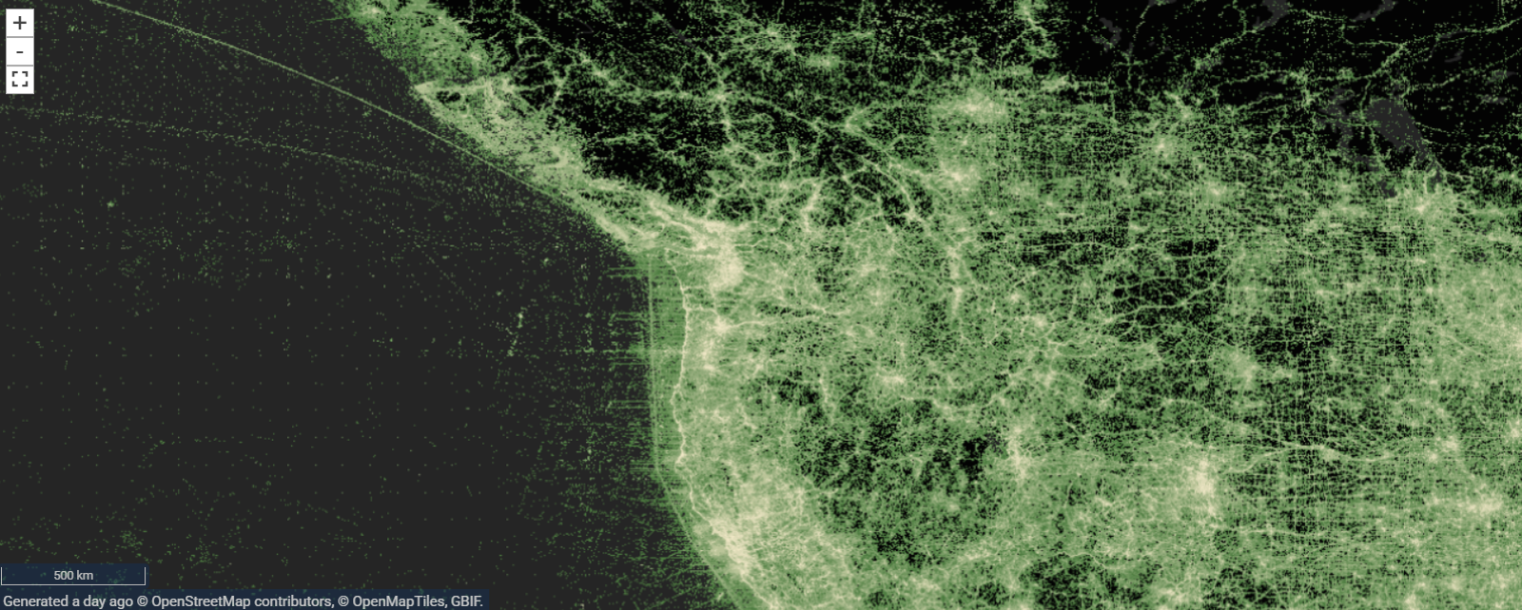
And now, let’s zoom in one more time… 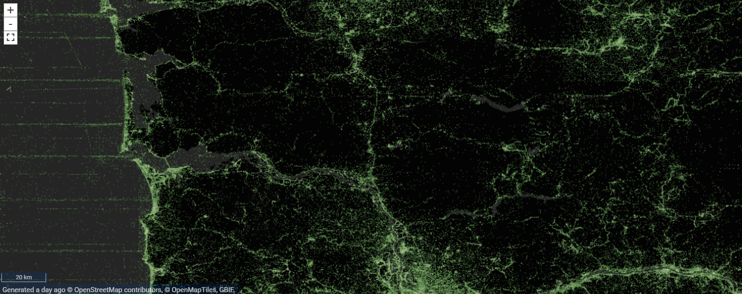
This map demarcates 1) land; 2) water; and 3) the density of occurrences. That’s it. It does not display cities or roads or anything human-made or any natural landforms other than the delineation of the land/water interface. And yet, as you can see, you could use it to identify where roads and cities are. In the image immediately above, the wavy line running roughly vertically is the I-5 interstate highway linking the bright area in the south, which is Portland, Oregon, to the bright area in the north, which is Seattle. As is evident, the density of occurrence records is extremely high along roads and in areas people inhabit. In other words, occurrence data can be extremely non-random and thus biased.
SDMs do their work in environmental space, not geographic space, but if human observations of species are biased in geography, then they may also be biased environmentally. This can cause us to misestimate species’ relationships to their environments.
Turning to the Columbian ground squirrel, let’s look at the distribution of records in geographic and environmental space.
par(mfrow = c(1, 2), pty = 's')
# plot in geographic space
plot(rangeMap, col = alpha('khaki', 0.3), main = 'Geographic Space')
plot(northAmerica, border = 'gray80', add = TRUE)
plot(recordsNoDups, pch = 21, bg = alpha('mediumseagreen', 0.8), add = TRUE)
# plot in environmental space
plot(randomBgEnv$bio1,
randomBgEnv$bio12,
pch = 16,
col = alpha('darkgray', 0.5),
xlab = 'MAT (deg C)',
ylab = 'TAP (mm)',
main = 'Environmental Space'
)
points(recordsNoDups$bio1,
recordsNoDups$bio12,
col = alpha('black', 0.35),
bg = alpha('mediumseagreen', 0.35),
pch = 21
)
legend('topleft',
legend = c('Background', 'Occurrences'),
col = c('darkgray', 'mediumseagreen'),
pch = 16,
cex = 0.6
)
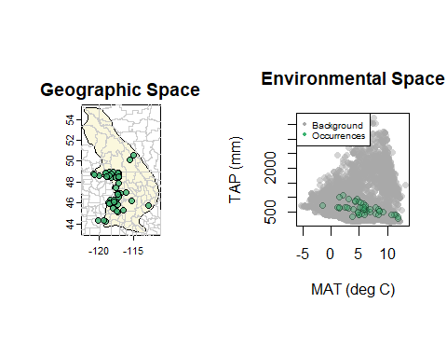
Where are our data biased? Obviously, we seem to lacking records from the Canadian portion of the range (if you’re not familiar with this portion of the world, Canada is the part that lies above the horizontal line bisecting the map). The bis seems rather extreme–it appears the species resides there, but we have very little data to model its response in the area lacking records. Honestly, in this case we would suggest 1) looking for more records; and if that didn’t help; 2) just interpreting the model output for the US-portion of the range; or 3) using a method that can actually integrate the range map and occurrences (Merow et al. 2017). As an aside, I have found this sudden disparity in sampling intensity to be common across political borders because different countries have different resources and ability or willingness to mobilize researchers and collections. But we’re here to learn regardless of how well these particular models work, so we’ll forge ahead.
How does this bias in geographic space translate into bias in environmental space, where SDMs do their calculations? What would we expect the plot of environmental space to look like if we had less biased data?
The sections below outline different methods for bias correction. None of them work in all situations, and in some cases, may even make results more biased than not correcting for bias.
To make this more frustrating, please realize that we often do not know the real pattern of the underlying bias–i.e., in the images above we can see that people tend to observe species near roads and in places where they live. We could actually build a model of this bias based on distance to road, road traffic, and human population density. But, some species do prefer to live in areas inhabited by humans, and roadsides can provide important habitat for some species. In other words, the “bias” we think we see in our data may in fact be a true signal.
Very unfortunately, this leads to the conclusion that in the absence of unbiased data, we cannot assess how well our bias correction methods worked, or if they made things worse. (And if we had unbiased data, we would probably not need to apply bias correction!) So what should you do?
In my experience, I start by implementing the model to the highest standards I can, which includes applying bias correction(s). I have never produced a workable, believable model in this way on the first try. But it provides me a model against which to compare subsequent models where I “break” some of the rules, including those related to bias correction.

3 Method 1: Bias correction using target background sites
So far we’ve used randomly located background sites to train MaxEnt. However, this presumes that presence sites were sampled such that each real presence had an equal probability of being sampled–i.e., in an unbiased manner. One way to correct for bias in presences is to include the same kind of bias in background sites. The two biases then cancel one another out.
Most relevant citation: Phillips, S.J., Dudik, M., Elith, J., Graham, C.H., Lehmann, A., Leathwick, J., and Ferrier, S. 2009. Sample selection bias and presence-only distribution models: Implications for background and pseudo-absence data. Ecological Applications 19:181-197. DOI: 10.1890/07-2153.1
Phillips et al. (2009) propose using target background sites, which are presences of other species that could have been recorded give the methods used to observe the focal species. For our case, a likely suitable set of species would include other ground squirrels that in theory could be caught using the same methods we would use to catch a Colombian ground squirrel (e.g., a Tomohawk live-trap). This includes genera from Urocitellus plus Ammospermophilus, Callospermophilus, Poliocitellus, Xerospermophilus, Ictidomys, and Otospermophilus. Normally we would also want to subject these sites to the same data-cleaning procedures we used for our focal species, but for expediency we’ll just use them as-is.
I will show you how to use the rgbif package to download these records, but fetching this data can take several tens of minutes. Rather, I recommend you actually use the pre-downloaded files in the Background Sites folder. I’ve included the code below to download the points, but feel free to skip it and go to the next chunk of code.
library(rgbif) # you may need to install this
# get only points within the bounding box specified by the study region
extent <- ext(studyRegion)
extent <- as.vector(extent)
xExtent <- extent[1:2]
yExtent <- extent[3:4]
xExtent <- paste(xExtent, collapse = ',')
yExtent <- paste(yExtent, collapse = ',')
# obtain GBIF data for other ground squirrels
targetRecords <- occ_search(
scientificName = c(
'Urocitellus',
'Ammospermophilus',
'Callospermophilus',
'Poliocitellus',
'Xerospermophilus',
'Ictidomys',
'Otospermophilus'
),
hasCoordinate = TRUE,
basisOfRecord = 'PRESERVED_SPECIMEN',
year = '1970,2000',
hasGeospatialIssue = FALSE,
fields = 'minimal',
decimalLongitude = '-129,-105',
decimalLatitude = '39,59',
limit = 10000
)
# cycle through each genus and get just coordinates
if (exists('targetSites')) rm(targetSites)
for (i in seq_along(targetRecords)) {
# get this genus' coordinates
thisGenusCoords <- data.frame(
longitude = targetRecords[[i]]$data$decimalLongitude,
latitude = targetRecords[[i]]$data$decimalLatitude
)
# add to data frame with all target coordinates
targetSites <- if (exists('targetSites')) {
rbind(targetSites, thisGenusCoords)
} else {
thisGenusCoords
}
}
# look at top 6 rows
head(targetSites)
# retain only target points in our study region polygon
targetSites <- vect(targetSites, geom = c('longitude', 'latitude'), crs = getCRS('WGS84'))
inStudyRegion <- extract(studyRegion, targetSites)
keeps <- complete.cases(inStudyRegion$binomial)
targetSites <- targetSites[keeps]
# extract environmental data at target background sites
targetEnv <- extract(currentClim, targetSites, ID = FALSE)
# remove target background sites with no environmental data (fall in ocean)
completes <- complete.cases(targetEnv)
targetSites <- targetSites[completes]
targetEnv <- targetEnv[completes, ]
# combine coordinates and environmental data
for (i in 1:ncol(targetEnv)) {
targetSites$DUMMY <- targetEnv[ , i]
names(targetSites)[ncol(targetSites)] <- names(targetEnv)[i]
}
# how many target records do we have?
nrow(targetSites)
# save target background sites
saveRDS(targetSites, './Background Sites/Target Background from Ground Squirrels from GBIF.rds')
Restart here if you did not execute the previous chunk of code.
targetSites <- readRDS('./Backups/Background Sites/Target Background from Ground Squirrels from GBIF.rds')
saveRDS(targetSites, './Background Sites/Target Background from Ground Squirrels from GBIF.rds'))
Let’s compare the random versus target background in geographic space.
# plot background sites on map
par(pty = 's')
plot(studyRegion, border = NA)
plot(northAmerica, col = 'white', add = TRUE)
plot(rangeMap, add = TRUE, col = alpha('khaki', 0.8))
# random background
# convert to spatial points object and plot
rangSites <- vect(
randomBgEnv,
geom = c('longitude', 'latitude'),
crs = getCRS('WGS84')
)
plot(rangSites, pch = '.', add = TRUE)
# target background
plot(targetSites, bg = alpha('orange', 0.4), pch = 24, add = TRUE)
# presences
plot(recordsNoDups, pch = 21, bg = alpha('mediumseagreen', 0.5), add = TRUE)
legend('topright',
legend = c('Random', 'Target', 'Species'),
pch = c(16, 24, 21),
pt.cex = c(0.2, 1, 1),
pt.bg = c(NA, 'orange', 'mediumseagreen'),
bg = 'white',
xpd = NA
)
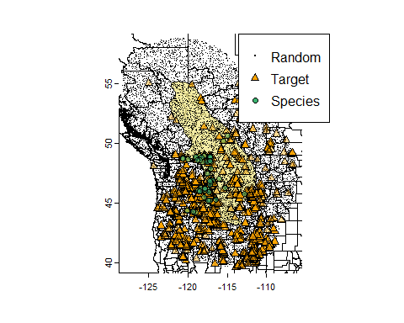
You can see that the other ground squirrels are also sparse north of the US-Canadian border. But–maybe their ranges actually stop near the Canadian-US border? (In this case, collectively they don’t, but this would be a good thing to check!) So, prima facie, this seems to be a good target group because it has the same general bias we see for the focal species.
Now let’s examine the distribution of target background sites in environmental space.
# convert occurrences and target background sites to data frames
recordsNoDupsEnv <- as.data.frame(recordsNoDups)
targetEnv <- as.data.frame(targetSites)
ggplot() +
geom_point(
data = randomBgEnv,
mapping = aes(x = bio1, y = bio12), shape = 16, color = 'gray'
) +
geom_point(
data = targetEnv,
mapping = aes(x = bio1, y = bio12), shape = 24, fill = 'orange'
) +
geom_point(
data = recordsNoDupsEnv,
mapping = aes(x = bio1, y = bio12), shape = 21, fill = 'mediumseagreen'
) +
xlab('MAT (deg C)') + ylab('TAP (mm)')
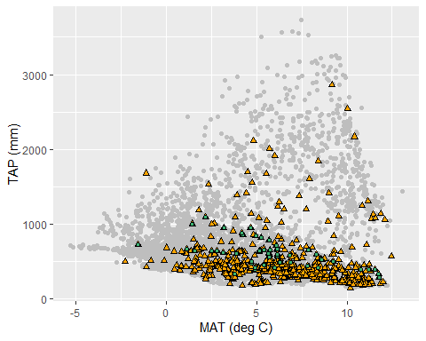
Here, the gray dots represent the random background sites, the orange triangles the target backgrounds, and the green circles occurrences of the Columbian ground squirrel. You can see that the target points have a restricted distribution compared to the random sites, and it more closely matches that of the Columbian ground squirrel occurrences. This is a good time to recall that SDMs do their calculations in environmental space. Thus, our model will attempt to draw a “shape” around the occurrences, using their density relative to the background sites–whichever group we choose–as a guide.
How do you think the sparsity of target sites in certain environments will affect predictions into these environments? Let’s find out!
# make training data frame with predictors and vector of 1/0 for presence/background
trainPres <- as.data.frame(recordsNoDups)
trainPres <- trainPres[ , predictors]
# convert target sites to a data frame
targetBg <- as.data.frame(targetSites)
targetBg <- targetBg[ , predictors]
# combine environmental data from occurrences and target sites
trainData <- rbind(trainPres, targetBg)
# vector of 1/0 for presence/background
presBg <- data.frame(
presBg = c(
rep(1, nrow(recordsNoDups)),
rep(0, nrow(targetSites))
)
)
targetTrainData <- cbind(presBg, trainData)
head(targetTrainData)
## presBg bio1 bio7 bio15 bio18
## 1 1 7.834354 35.54400 29.58838 89
## 2 1 11.565761 33.91200 38.30775 52
## 3 1 7.862292 33.96700 36.87917 97
## 4 1 8.325021 33.37700 36.49984 87
## 5 1 3.169385 32.06650 34.00864 169
## 6 1 11.760344 34.56125 38.06900 44
# We will just use single regularization multiplier value to speed things up.
# You can try adding the argument `cores = 2` (or more), to make this faster, but it may not work on all systems.
targetBgModel <- trainMaxEnt(
data = targetTrainData,
resp = 'presBg',
preds = predictors,
regMult = 1
)
# save model
saveRDS(targetBgModel,'./Models/Target Background Model.rds')
# burn raster
targetBgMap <- predictEnmSdm(targetBgModel, currentClim[[predictors]])
# save raster
writeRaster(targetBgMap, './Models/target_bg_model_1970_2000.tif', overwrite = TRUE)
Now, let’s examine the map and compare it to that from the one created by using the random background sites.
par(mfrow = c(1, 2))
# random background model
plot(baseMap, range = c(0, 1), main = 'Random BG')
plot(rangeMap, border = 'white', add = TRUE)
# target background model
plot(targetBgMap, range = c(0, 1), main = 'Target BG')
plot(rangeMap, border = 'white', add = TRUE)
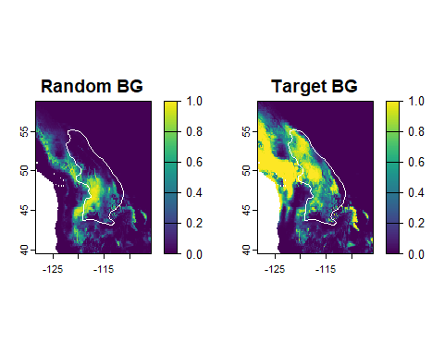
The target background model seems to have addressed the issue we had with few samples in Canada! But, it obviously also created its own problem by overextending into the coastal areas and overemphasizing some other areas that are probably not part of the species’ range. This is a good illustration of how bias correction can work and fail at the same time.
Let’s explore a bit to see if there is a variable that might be drawing the model into the coastal areas.
# plot predictors we used in the model
plot(currentClim[[predictors]])
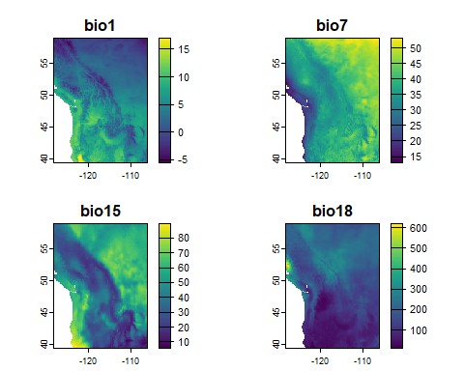
BIOs 7, 15, and 18 all have some patterns that have high or low values near the coast, but no one of them recreates the pattern we see in the target background model prediction. This suggests to me that the issue may be in a higher-order interaction, i.e., in how the variables interact in the model. This is harder to diagnose because environmental space is multidmensional. We’ll stop here, though, and proceed to the next method of bias correction.

3.1 Reflection
Compare your efforts to correct for bias using target background sites.
- Where do the species’ records seem biased in geographic and environmental space? What might be the cause of this bias?
- Do you think the target background approach was able to correct for the bias?
- What other effects did using the target background sites have on the model prediction? Were these desirable?

4 Method 2: Bias background bias correction
Related to the target background technique is use of a bias map from which background sites are drawn. The background sites are drawn with a probability proportional to the cells’ values. The values are generated in a manner that presumably reflects the sampling bias in the presence sites. How can you generate a bias map? It depends on the species–often bias maps reflect factors expected to correlate with the probability that an area was surveyed for the species. For example, cell values might reflect distance to roads, human population density, etc.
Very relevant citations: Elith, J., M. Kearney, and S. Phillips. 2010. The art of modeling range-shifting species. Methods in Ecology and Evolution 1:330-342.DOI: 10.1111/j.2041-210X.2010.00036.x
Here we’ll use a road density map that is part of the SPECTRE data set on biodiversity threat layers from Branco et al. (2025), with the expectation that survey effort is a function of vehicular access. Note that since places with high densities of people tend to have dense road networks, using roads may also account indirectly for a sampling effect from population density. However, we could also combine a raster of population and road density to create a combined bias layer.
To download this data, we can use the gecko package. The code below tests to see if you have this already installed, and if not, installs and it.
if (!require(gecko)) {
install.packages('gecko')
library(gecko)
}
Now, we’ll download the road density raster for the bounding box around our study region. First, we’ll calculate the bounds of the bounding box. Note that downloading the data for even this small region can take a few minutes.
# get extent of study region
extent <- ext(studyRegion)
extent <- as.vector(extent)
# create output folder
dirCreate('./Road Density - Spectre') # omnibus package
# fetch road density raster
# raster #5 is road density... see SPECTRE website dashboard for others
roadDensity_m_per_km2 <- spectre.area(
index = 5,
ext = extent,
filepath = './Road Density - Spectre'
)
If the server is not working, you can fetch this raster from the Backups folder:
roadDensity_m_per_km2 <- rast('./Backups/Road Density - Spectre/ROAD_DENSITY_-128.390696403402_-105.992940144053_39.5583081947415_58.7510243558915.tif')
This raster does not have the minimum and maximum values associated with its metadata. This is not a problem, but it would be nice to see them. Let’s correct that.
roadDensity_m_per_km2 <- setMinMax(roadDensity_m_per_km2)
roadDensity_m_per_km2
## class : SpatRaster
## dimensions : 2303, 2688, 1 (nrow, ncol, nlyr)
## resolution : 0.008333333, 0.008333333 (x, y)
## extent : -128.3917, -105.9917, 39.55833, 58.75 (xmin, xmax, ymin, ymax)
## coord. ref. : lon/lat WGS 84
## source : ROAD_DENSITY_-128.390696403402_-105.992940144053_39.5583081947415_58.7510243558915.tif
## name : ROAD_DENSITY_-128.390696403402~5583081947415_58.7510243558915
## min value : 0.00
## max value : 28783.41
How do we use this? There are two ways. First, MaxEnt can directly use a “bias” layer, but we will not explore that here. Second, we can draw from the bias layer background sites in proportion to the underlying values in the raster. Recall the background sites act statistically somewhat like absence sites. Putting more “absence-like” sites in environments that are likely to be overly sampled downweights them, hopefully correcting their bias. Let’s do that now, but before we do, let’s take a look at the road density raster.
plot(roadDensity_m_per_km2, main = 'Road density (m/km2))')
plot(rangeMap, border = 'white', add = TRUE)
plot(recordsNoDups, pch = 1, col = 'red', add = TRUE)
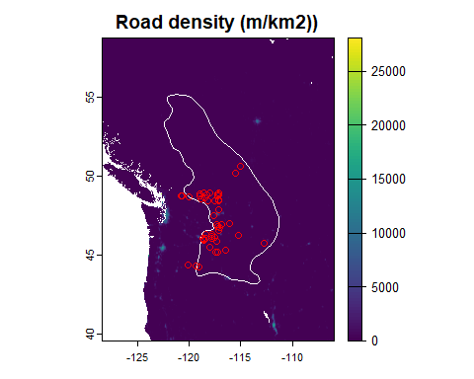
The map represents length of roads per unit area (m of road / km2). You can see that there are a few places with extremely high road density, but most places have relatively few roads. Given the extreme imbalance in road density, if we used this for bias correction, we’d likey end up putting almost all of the weight on just a few places. This might over-correct the model. Let’s plot this again, but on a log scale.
log10RoadDensity <- log10(roadDensity_m_per_km2 + 1.1)
plot(log10RoadDensity, main = 'log10(road density)')
plot(rangeMap, border = 'white', add = TRUE)
plot(recordsNoDups, pch = 1, col = 'red', add = TRUE)
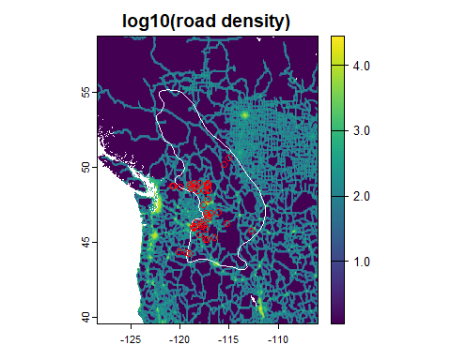
This seems more reasonable. Using the (unlogged) road density might be a better approach. First, we’ll need to mask the road density raster so only cells inside the study region are chosen.
If you read the code above carefully, you’ll see we added 1.1 to the raster before taking the log. Normally, where values can equal 0, we would add 1 to obviate taking the log of 0, which will cause the stock market to crash. But why 1.1? Because, below we sample cells in proportion to their logged value. Since the log of 1 is 0, we would force the procedure to completely avoid cells that have no roads in them. This seems a bit extreme, so I used 1.1, which yields a small positive value.
# force cells outside study region to NA
log10RoadDensityMasked <- mask(log10RoadDensity, studyRegion)
# plot
plot(log10RoadDensityMasked, main = 'log10(road density) masked')
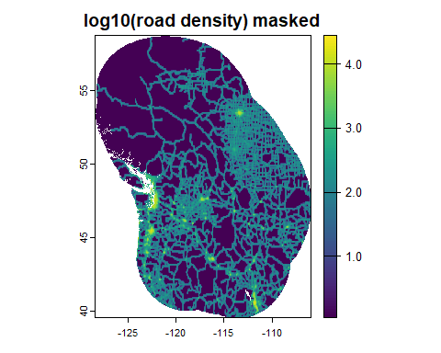
Now, let’s sample sites from these cells in proportion to their logged value.
# sample from cells with replacement in proportion to cell values
biasSites <- sampleRast(log10RoadDensityMasked, 11000, prob = TRUE)
head(biasSites)
## x y
## [1,] -123.6191 46.50793
## [2,] -110.4048 47.23760
## [3,] -115.3443 41.01359
## [4,] -106.7722 47.39539
## [5,] -116.3290 53.59815
## [6,] -116.7569 47.52004
# convert to spatial vector
biasSites <- vect(biasSites, crs = getCRS('WGS84'))
# extract values so we can discard points that are outside study region
inStudyRegion <- extract(studyRegion, biasSites)
# remove points that are in NA cells
keeps <- which(!is.na(inStudyRegion$binomial))
keeps <- sample(keeps, 10000) # retain only 10000
biasSites <- biasSites[keeps]
# map the sites
plot(log10RoadDensityMasked, main = 'Bias sites')
plot(biasSites, pch = ',', add = TRUE)
plot(rangeMap, border = 'white', add = TRUE)
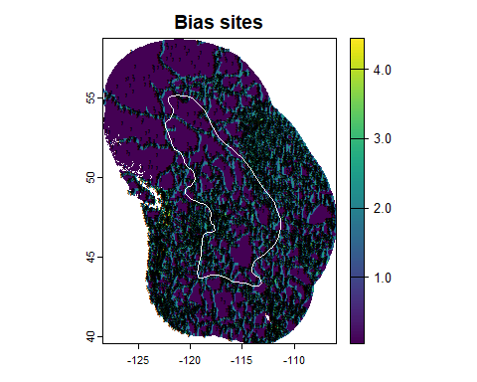
Most of our background sites are near roads. Let’s extract environmental values at these sites, combine them with the occurrences, and calibrate our model!
# extract environmental values at bias sites
biasEnv <- extract(currentClim[[predictors]], biasSites, ID = FALSE)
# combine with values at occurrence sites
recordsEnv <- as.data.frame(recordsNoDups)
recordsEnvTrain <- recordsEnv[, predictors]
trainDataBiasBg <- rbind(recordsEnvTrain, biasEnv)
# add vector of 1/0 for presence/background
presBg <- data.frame(
presBg = c(
rep(1, nrow(recordsEnv)),
rep(0, nrow(biasEnv))
)
)
trainDataBiasBg <- cbind(presBg, trainDataBiasBg)
# calibrate model... just using regularization value of 1 to speed this up
biasModel <- trainMaxEnt(
data = trainDataBiasBg,
resp = 'presBg',
preds = predictors,
regMult = 1
)
# write the prediction raster
biasMap <- predictEnmSdm(biasModel, currentClim)
names(biasMap) <- 'road_bias_model'
# save model and raster
saveRDS(biasModel, './Models/Bias Model.rds')
writeRaster(biasMap, './Models/bias_model_1970_2000.tif', overwrite = TRUE)
And of course, we want to compare our new model with the “base” model!
par(mfrow = c(1, 2)) # one row, two columns of plots
# base model
plot(baseMap, range = c(0, 1), main = 'Base Model')
plot(rangeMap, border = 'white', add = TRUE)
plot(recordsNoDups, pch = 1, col = 'red', add = TRUE)
# bias model
plot(biasMap, range = c(0, 1), main = 'Bias Model')
plot(rangeMap, border = 'white', add = TRUE)
plot(recordsNoDups, pch = 1, col = 'red', add = TRUE)
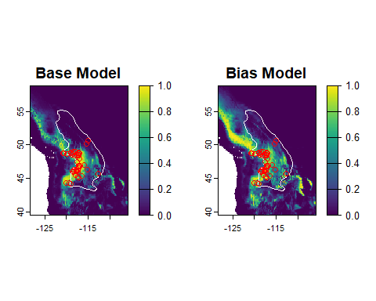
The road-density bias model seems to have “filled out” some of the undersampled(?) portion of the range in the east, but it also seems to overpredict the species’ range even more than the base model.

4.0.1 Reflection
- How do the target background and bias background approaches compare? How do they compare to the model using random background sites? Overall, which seems best?
- What other types of data could you use to reflect bias in sampling?
We will continue with the next methods for bias correction in the subsequent exercise.

