Exercise 12: Bias Correction II
Adam B. Smith | Missouri Botanical Garden
2025-01-31
This exercise continues demonstration of several bias-correcting techniques. Here, we will cover:
- Geographic thinning of occurrences
- Environmental thinning of occurrences
- Site-weighting of occurrences

1 Restarting R
If you are continuing from the previous exercise, you can skip this part. However, if you restarted R, you will need to attach packages and load other data objects. In that case, please run this code.
library(cowplot) # combining ggplots
library(enmSdmX) # SDMing
library(geodata) # geographic data
library(ggplot2) # plotting
library(omnibus) # helper functions
library(scales) # transparency/rescaling
library(terra) # GIS
# Working folder... may not be needed if you are using RStudio.
# Set to the proper path for your computer/project.
setwd('C:/Folder Name/SDM Workshop')
# Occurrences:
recordsNoDups <- readRDS('./Occurrences - GBIF/06 Species Records - Eliminated All But One Record Per Cell.rds')
# Range map:
rangeMap <- vect('./Urocitellus columbianus Range Map - IUCN/urocitellusColumbianus_iucnRangeMap.shp')
# North America:
northAmerica <- vect('./Political - GADM/North America.rds')
# Study region:
studyRegion <- readRDS('./Study Region/Study Region.rds')
# Elevation and climate rasters:
elevation <- rast('./Elevation - CGIAR-SRTM/elevation.tif')
currentClim <- rast('./Climate Rasters - WORLDCLIM/currentClim.tif')
futureClim <- rast('./Climate Rasters - WORLDCLIM/futureClim.tif')
# Variables
predictors <- readRDS('./Selected Predictors.rds')
# Background sites
randomBgEnv <- readRDS('./Background Sites/Random Background Sites across Study Region.rds')
# Predictors
predictors <- readRDS('./Selected Predictors.rds')
# Background and presence sites
trainDataRandomBg <- readRDS('./Collated Occurrences & BG Sites/Random BG.rds')
# Models:
simpleModel <- readRDS('./Models/Simple Model.rds')
simplerModel <- readRDS('./Models/Simpler Model.rds')
baseModel <- readRDS('./Models/Base Model.rds')
targetBgModel <- readRDS('./Models/Target Background Model.rds')
biasModel <- readRDS('./Models/Bias Model.rds')
# Model predictions:
simpleMap <- rast('./Models/simple_model_1970_2000.tif'))
simplerMap <- rast('./Models/simpler_model_1970_2000.tif'))
baseMap <- rast('./Models/base_model_1970_2000.tif')
targetBgMap <- rast('./Models/target_bg_model_1970_2000.tif')
biasMap <- rast('./Models/bias_model_1970_2000.tif')

2 Method 3: Geographic thinning of records
Sometimes the only way to remove aggregations of records is to discard some. Records can be thinned in geographic or environmental space. In this portion of the exercise we’ll thin records in geographic space.
Very relevant citation: Aiello-Lammens, M. A., Boria, R. A., Radosavljevic, A., Vilela, B., and Anderson, R. P. 2015. spThin: an R package for spatial thinning of species occurrence records for use in ecological niche models. Ecography 38:541-545 DOI: 10.1111/ecog.01132
The general idea behind geographic thinning is that bias arises from clusters of occurrence sin geographic space, which leads to bias in environmental space. Clusters can arise when people sample in certain places more than others. So, geographic thinning seeks to alleviate clustering by randomly or deterministically removing sites so that the remainder are more even in dispersion.
Note that we already did some geographic thinning by removing all but one record per cell. This can correct for within-cell clustering of sites, but not between-cell clustering.
When implementing geographic thinning, a very important question is, How close is too close? That is, if we select from among clustered occurrences so that only one if left, how far away from occurrence we keep should we look for sites to discard? The real answer to this is that the distance should be chosen to reflect the characteristic distance at which occurrences are clustered because of biased sampling. For example, in sampling small mammals, collectors often operate in a several-hundred meter area. Assuming the exact location of capture of each animal was recorded (usually it’s not–just the general site location, but let’s assume just for moment), using a threshold of several hundred meters would correct for within-site bias. But, an individual collector might then relocate to another site close to the first, meaning sites themselves would be non-randomly placed. Moreover, different collectors can aggregate intentionally or unintentionally near areas easy to access and collect from, or close to where they live. You can see how objectively setting the threshold distance for geographic thinning can be hard.
Let’s proceed anyway, first by examining the distribution of pairwise distances so we can get an idea of the magnitude of distances we’re talking about.
# compute pairwise distances
# NB we have to specify we want R to use the terra version of this function
# because there are other packages that have a function of this same name
dists <- terra::distance(recordsNoDups)
dists <- as.matrix(dists)
diag(dists) <- NA
# histogram of distances
hist(dists / 1000,
breaks = 20,
xlab = 'Inter-point Distance (km)',
main = 'Pairwise Distances between Occurrences',
cex.main = 0.7
)
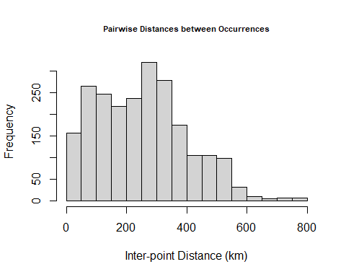
Notice that the number of distances initially increases, peaks ~300 km, then declines. We could stratify by thinning points so they’re no closer than half this distance (~150 km). Initially I did indeed try this but found that it removed so many points that the predictions were much worse… since our goal is to demonstrate removal of bias (and presumably production of better models), let’s use a distance of about a quarter of this size (30 km) so we have more points remaining. In a real workflow, you might try several different distances.
We can thin the records using the geoThin() function from the enmSdmX package, which removes records less than the given distance apart. Note that if you have a lot of occurrences, this function can be very slow because it’s (almost) deterministic. If you have a large number of records, you can instead use geoThinApprox(), which randomly selects from clusters of sites those to keep.
# thinning distance in meters
minDist <- 30000
# thin records
recordsGeogThin <- geoThin(
x = recordsNoDups,
minDist = minDist
)
# how many did we lose?
nrow(recordsNoDups)
## [1] 48
nrow(recordsGeogThin)
## [1] 20
# save records!
saveRDS(recordsGeogThin, './Occurrences - GBIF/06 Species Records - Randomly Thinned Presences.rds')
We lost quite a few records! However, the species is in theory still model-able. (A rule of thumb suggests you generally need ~30 or more occurrences–but realize that this really depends on the representativeness of the data. For example in our case, if we had 1000 occurrences below the Canadian-US border and few above, that large sample size would still result in a very biased model.) Let’s see which sites we retained and how they fall in environmental space.
par(mfrow = c(1, 2), pty = 's', cex.main = 0.7)
# plot in geographic space
plot(studyRegion, border = NA)
plot(northAmerica, border = 'gray', col = 'gray40', add = TRUE)
plot(rangeMap, add = TRUE)
plot(recordsNoDups, pch = 21, bg = 'mediumseagreen', add = TRUE)
plot(recordsGeogThin, pch = 23, bg = 'red', add = TRUE)
# plot in environmental space
plot(randomBgEnv$bio1,
randomBgEnv$bio12,
pch = 16,
col = alpha('darkgray', 0.5),
xlab = 'MAT (deg C)',
ylab = 'TAP (mm)',
main = 'Environmental Space'
)
points(recordsNoDups$bio1,
recordsNoDups$bio12,
col = alpha('black', 0.35),
bg = alpha('mediumseagreen', 0.35),
pch = 21
)
points(recordsGeogThin$bio1,
recordsGeogThin$bio12,
col = alpha('black', 0.35),
bg = alpha('red', 0.35),
pch = 23
)
legend('topleft',
legend = c('Random BG', 'Unthinned occs.', 'Geog thinned occs.'),
col = c('gray', 'black', 'black'),
pt.bg = c(NA, 'mediumseagreen', 'red'),
pch = c(16, 21, 23),
cex = 0.6
)
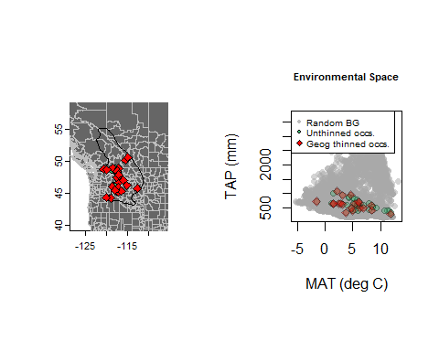
It’s difficult to see in the map, but there are some occurrences that we indeed removed. Their removal is more evident in environmental space.
Now, let’s model. Note that we’ll be using the random background sites (i.e., not the target sites or sites from the bias grid) since the occurrences have presumably had their bias removed.
In the code below, we combine the thinned records with the random background sites, not the other sets of background sites we created above. The presences have (presumably) have had their bias removed, so we can use the random background set.
# collate data from thinned occurrences and random background sites
trainPresGeogThin <- as.data.frame(recordsGeogThin)
trainPresGeogThin <- trainPresGeogThin[ , predictors]
# combine occurrence and background environments
trainDataGeogThin <- rbind(
trainPresGeogThin,
randomBgEnv[ , predictors]
)
# vector of 1/0 for presence/background
presBg <- data.frame(
presBg = c(
rep(1, nrow(trainPresGeogThin)),
rep(0, nrow(randomBgEnv))
)
)
trainDataGeogThin <- cbind(presBg, trainDataGeogThin)
# model species... just using regularization value of 1 to speed things up
geogThinModel <- trainMaxEnt(
trainDataGeogThin,
resp = 'presBg',
preds = predictors,
regMult = 1,
verbose = TRUE
)
##
## regMult classes numClasses numCoeff
## 1 1 lq 2 5
## 2 1 lpq 3 5
## 3 1 l 1 4
## 4 1 lp 2 4
## 5 1 lqh 3 11
## 6 1 lpqh 4 11
## 7 1 lh 2 16
## 8 1 lph 3 16
## logLik AICc deltaAICc relLike aicWeight
## 1 -170 355 0.00 1.00e+00 4.88e-01
## 2 -170 355 0.00 1.00e+00 4.88e-01
## 3 -176 362 7.37 2.52e-02 1.23e-02
## 4 -176 362 7.37 2.52e-02 1.23e-02
## 5 -159 373 18.06 1.20e-04 5.84e-05
## 6 -159 373 18.06 1.20e-04 5.84e-05
## 7 -159 531 176.11 5.73e-39 2.80e-39
## 8 -159 531 176.11 5.73e-39 2.80e-39
##
One thing you should notice here is that simpler models (fewer feature classes–just linear and quadratic in the top model) and coefficients (5 in the best model) were favored. This seems somewhat reasonable given that we have less data, but it might also be an issue because the model may not be flexible enough to capture the species’ real response to the environment. Recall that in MaxEnt, different features become active only when a given number of occurrence is available:
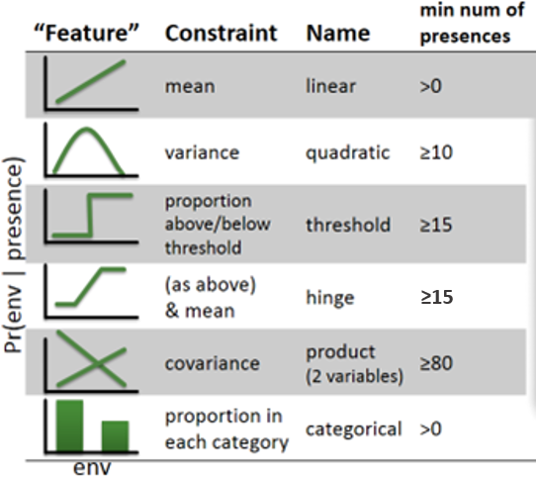
MaxEnt feature functions
Since our occurrence data has only 20 occurrences, we have no models with product (interaction) features, which require at least 80 sites. Models with product features do seem to appear in the tuning table output by trainMaxEnt(), though, but when MaxEnt did its magic, it did not actually implement product features in these models. You can infer this by comparing the statistics for the top and second-top model, which are exactly the same. The second-best model, though, presumably also used product features, but adding them made no difference to the model. Let’s save our model and examine the map it creates.
# save model
saveRDS(geogThinModel, './Models/Geographically Thinned Model.rds')
# write raster
# NB by subsetting the raster stack to the predictors we used, we gain some speed
geogThinMap <- predictEnmSdm(geogThinModel, currentClim[[predictors]])
writeRaster(geogThinMap, './Models/geog_thin_model_1970_2000.tif', overwrite = TRUE)
par(mfrow = c(1, 2))
# base model
plot(baseMap, range = c(0, 1), main = 'Base Model')
plot(rangeMap, border = 'white', add = TRUE)
plot(recordsNoDups, pch = 1, col = 'red', add = TRUE)
# geographically thinned model
plot(geogThinMap, range = c(0, 1), main = 'Geog. thinned')
plot(rangeMap, border = 'white', add = TRUE)
plot(recordsNoDups, pch = 1, col = 'red', add = TRUE)
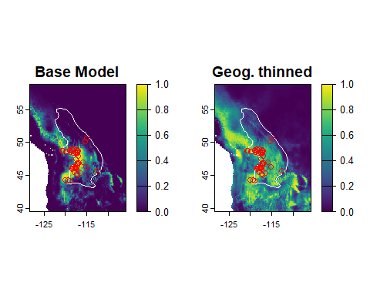
The estimated environmental suitability is now much more evenly spread across the species’ range. Unfortunately, this made things worse!

2.0.1 Reflection
- Thinning records costs you data–was it worth it?
- What effect does record thinning have on the model output? Across the three methods explored here, which seems to have worked best, if any?

3 Method 4: Environmental thinning of records
A fourth option is to thin in environmental space. Most bias probably exists because of geographic processes–collectors tend to collect near their place of abode, near roads, etc. In turn, this leads to bias in environmental space. Thus, geographic bias is the original bias creating the bias in the space the model actually works with. However, sometimes bias can be more environmentally based than geographically based. For example, collectors might target climates that are easier to work in (less hot, less cold, etc.). I have seen this occur for specimens of some small mammals of California for which have very few records in the agriculturally-dominated, hotter Central Valley, even though these species certainly exist there. Even if the original bias is in geographic space, thinning environmentally might make more sense than geographic thinning since the model actually works in environmental, not geographic space.
Most relevant citation: Varela, S., Anderson, R.P., Garcia-Valdis, R., and Fernandez-Gonzalez. 2014. Environmental filters reduce the effects of sampling bias and improve predictions of ecological niche models. Ecography 37:1084-1091.DOI: 10.1111/j.1600-0587.2013.00441.x
Here we’ll thin in multidimensional environmental space by condensing the predictors to two axes using principal components analysis. We’ll then divide this space into cells, and choose just one record per bin to represent the species. Other ways to do this may also work (e.g., using a set minimum pairwise environmental distance between records, as we used with geographic distance).
# Calculate PCA on environmental variables
# using "cor = TRUE" because predictors aren't on same scale.
pca <- princomp(randomBgEnv[ , predictors], cor = TRUE)
# plot
par(mfrow = c(1, 2), pty = 's')
plot(pca, main = 'Variances explained by axes', cex.main = 0.7)
biplot(pca, main = 'Biplot', cex = 0.6)
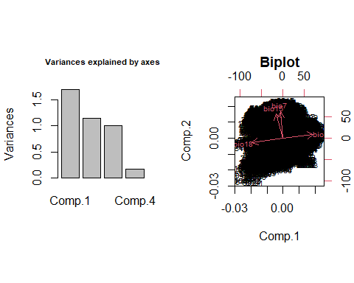
You can see most of the variation in our predictors is explained by the first two axes. Now let’s examine the distribution of records in PCA (environmental) space.
# predict PC values at species' presences
recordsEnv <- as.data.frame(recordsNoDups)
speciesPca <- predict(pca, newdata = recordsEnv)
# plot background and occurrences in PCA space
par(pty = 's')
plot(pca$scores[ , 1:2],
col = alpha('darkgray', 0.2),
pch = 16,
main ='Biplot',
xlab = 'PC1',
ylab = 'PC2'
)
# demarcate "bin" lines on plot
numBins <- 20
minPC1 <- min(pca$scores[ , 1])
maxPC1 <- max(pca$scores[ , 1])
minPC2 <- min(pca$scores[ , 2])
maxPC2 <- max(pca$scores[ , 2])
# subtracting/adding a very small number to outer bin boundaries
# so later when we divide occurrences into bins we ensure all
# are included
# eps() is from the omnibus package and returns the smallest number
# your computer can think of
pc1s <- seq(minPC1 - eps(), maxPC1 + eps(), length.out = numBins + 1)
pc2s <- seq(minPC2 - eps(), maxPC2 + eps(), length.out = numBins + 1)
# vertical lines
for (pc1 in pc1s) {
abline(v = pc1, lwd = 0.5, col = alpha('black', 0.3))
}
# horizontal lines
for (pc2 in pc2s) {
abline(h = pc2, lwd = 0.5, col = alpha('black', 0.3))
}
# occurrences
points(speciesPca[ , 1:2],
pch = 21,
bg = 'mediumseagreen'
)
legend('topleft',
legend = c('Background', 'Presence'),
col = c('gray', 'black'),
pch = c(16, 21),
pt.bg = c(NA, 'mediumseagreen')
)
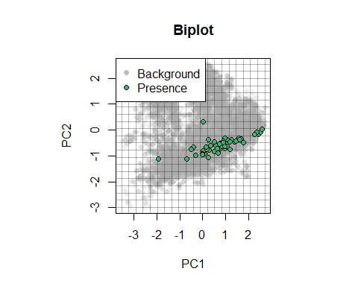
Now we’ll create a 2D histogram using the bins of the PC axes, tally the number of records in each cell, then randomly select one from each cell for modeling.
# matrix to store number of points in each environmental "cell"
env <- matrix(0, nrow = numBins)
# data frame for new records
envThinRecords <- data.frame()
# find records in each environmental cell and randomly select one
for (countPC1 in 1:numBins) {
for (countPC2 in 1:numBins) {
# get index of record(s) in this cell
recordsInCell <- which(
speciesPca[ , 1] > pc1s[countPC1] &
speciesPca[ , 1] <= pc1s[countPC1 + 1] &
speciesPca[ , 2] > pc2s[countPC2] &
speciesPca[ , 2] <= pc2s[countPC2 + 1]
)
# if there is >1 record, select one randomly
if (length(recordsInCell) > 0) {
chosenRecord <- if (length(recordsInCell) == 1) {
recordsInCell
} else {
sample(recordsInCell, 1)
}
# retain chosen record
envThinRecords <- rbind(envThinRecords, recordsEnv[chosenRecord, ])
}
}
}
# predict PCA scores at thinned presence sites
envThinRecordsPCA <- predict(pca, envThinRecords)
# plot background and occurrences in PCA space
par(pty = 's')
plot(pca$scores[ , 1:2],
col = alpha('darkgray', 0.2),
pch = 16,
main ='Biplot',
xlab = 'PC1',
ylab = 'PC2'
)
# vertical lines
for (pc1 in pc1s) {
abline(v = pc1, lwd = 0.5, col = alpha('black', 0.3))
}
# horizontal lines
for (pc2 in pc2s) {
abline(h = pc2, lwd = 0.5, col = alpha('black', 0.3))
}
# occurrences
points(speciesPca[ , 1:2],
pch = 21,
bg = 'mediumseagreen'
)
points(envThinRecordsPCA[ , 1:2],
pch = 23,
bg = 'red'
)
legend('topleft',
legend = c('Background', 'Presence'),
col = c('black', 'black', 'black'),
pch = c(1, 21, 23),
pt.bg = c(NA, 'mediumseagreen', 'red')
)
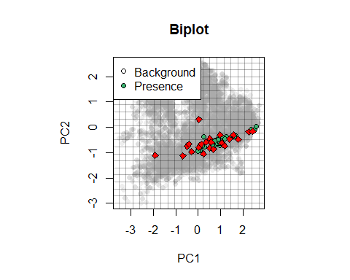
You can see that the thinned records more evenly represent the conditions experienced by the species within its range. Now let’s train a model using the environmentally-thinned records. But–how many did we lose?
nrow(recordsNoDups)
## [1] 48
nrow(envThinRecords)
## [1] 22
Again, we lost quite a few. We could persist by selecting smaller bins in which to thin records, but since this gives is a number of occurrences that is commensurate with what we got in geographic thinning, let’s proceed by calibrating our model, burning the raster, and saving the output. Again, we use the random background sites for this model because the thinning presumably eliminated the bias.
# collate data from thinned occurrences and random background sites
trainPresEnvThin <- as.data.frame(envThinRecords)
trainPresEnvThin <- trainPresEnvThin[ , predictors]
# combine occurrence and background environments
trainDataEnvThin <- rbind(
trainPresEnvThin,
randomBgEnv[ , predictors]
)
# vector of 1/0 for presence/background
presBg <- data.frame(
presBg = c(
rep(1, nrow(trainPresEnvThin)),
rep(0, nrow(randomBgEnv))
)
)
trainDataEnvThin <- cbind(presBg, trainDataEnvThin)
# model species... just using regularization value of 1 to speed things up
envThinModel <- trainMaxEnt(
trainDataEnvThin,
resp = 'presBg',
preds = predictors,
regMult = 1,
verbose = TRUE
)
##
## regMult classes numClasses numCoeff
## 1 1 lq 2 5
## 2 1 lpq 3 5
## 3 1 l 1 3
## 4 1 lp 2 3
## 5 1 lqh 3 17
## 6 1 lpqh 4 17
## logLik AICc deltaAICc relLike aicWeight
## 1 -185 385 0 1.00e+00 4.99e-01
## 2 -185 385 0 1.00e+00 4.99e-01
## 3 -195 397 12 2.49e-03 1.24e-03
## 4 -195 397 12 2.49e-03 1.24e-03
## 5 -171 528 144 5.91e-32 2.95e-32
## 6 -171 528 144 5.91e-32 2.95e-32
##
# save model
saveRDS(envThinModel, './Models/Environmentally Thinned Model.rds')
# write raster
# NB by subsetting the raster stack to the predictors we used, we gain some speed
envThinMap <- predictEnmSdm(envThinModel, currentClim[[predictors]])
writeRaster(envThinMap, './Models/env_thin_model_1970_2000.tif', overwrite = TRUE)
par(mfrow = c(1, 2))
# base model
plot(baseMap, range = c(0, 1), main = 'Base Model')
plot(rangeMap, border = 'white', add = TRUE)
plot(recordsNoDups, pch = 1, col = 'red', add = TRUE)
# environmentally thinned model
plot(envThinMap, range = c(0, 1), main = 'Env. thinned')
plot(rangeMap, border = 'white', add = TRUE)
plot(recordsNoDups, pch = 1, col = 'red', add = TRUE)
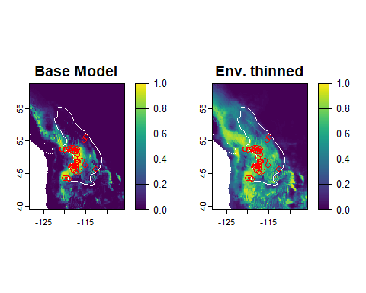
Again, we did a good job of making a worse model!

3.1 Reflection
- Compare the maps of points thinned geographically to the points thinned environmentally. How are they different and how the same?
- Why do the environmentally thinned points seem to be more spatially clustered? Which thinning process better reflects the environmental preferences of the species in the northern part of its range?
- Which do you think did a better job, thinning geographically or environmentally?

4 Method 5: Site-weighting
Some modeling methods allow users to specify the statistical “weight” of an occurrence, or is influence on the model. By weighing occurrences (or background sites or absences) differently, we can alter how they affect the model and thus correct for bias, so long as the weights we assign reflect that bias. We can’t do this with MaxEnt, though, because MaxEnt does not allow us to supply a vector of weights. However, nearly every other SDM algorithm does, and the train*XYZ*() functions in enmSdmX allow this. So, we’ll illustrate using the generalized linear modeling (GLM) algorithm.
Most relevant citation: Stolar, J. and Seton, S.E. 2015. Accounting for spatially biased sampling effort in presence-only species distribution models. Diversity and Distributions 21:595-608.DOI: 10.1111/ddi.12279
There are various ways we could use to calculate weights. For example, we could use the values in the road density raster we worked with above. Here, we’ll use the inverse of the mean pairwise distance between an occurrence and all other occurrences. Occurrences close to others will be down-weighted more than others. This is very similar conceptually to geographic thinning in that thinning simply down-weights the influence of some occurrences to zero. With site-weighting, we don’t actually discard any specimens (yeh!).
To calculate weights, we’ll use the weightByDist() function in enmSdmX. This function assumes that if two occurrences were at the same exact location, they should each get a weight of 1/2. If three occurrences were at the same location, then they would each get a weight of 1/3, and so on. Now, consider two occurrences very close to one another, but not at the exact sample place. In this case, we might assign each a weight of a little more than 1/2 because they’re not entirely redundant. If the occurrences were separated by more distance, then their weights should increase up to a point where they’d each get a weight of 1, which would occur when they’re entirely “independent.” The trick is defining the distance at which independence occurs. We could, for example, use a variogram, or maybe some measure of the characteristic scale of spatial autocorrelation in samples (e.g., estimated using target background sites). Here, we’ll use the same 30 km we used for geographic thinning to define the distance beyond which occurrences should be considered independent.
# calculate weights
w <- weightByDist(recordsNoDups, maxDist = 30000)
# histogram
hist(w, xlab = 'Weight', main = 'Occurence weights')
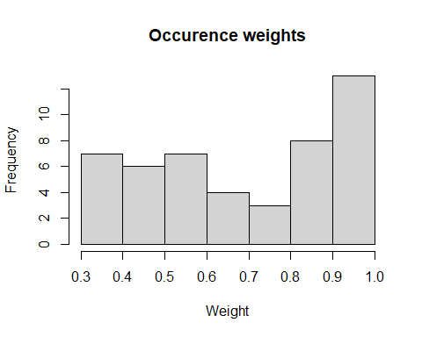
# map
plot(studyRegion, border = NA, main = 'Occurrence weighting')
plot(northAmerica, border = 'gray40', col = 'gray30', add = TRUE)
plot(rangeMap, border = 'white', add = TRUE)
plot(recordsNoDups, pch = 21, bg = alpha('mediumseagreen', 0.5), cex = 2 * w, add = TRUE)
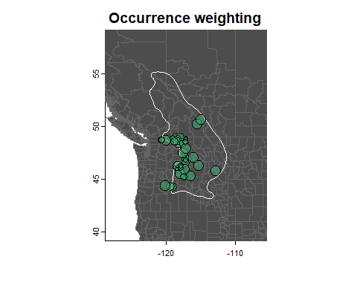 In this map, the size of each occurrence is proportionate to its weight. You can see that occurrences close to one another are smaller because they have less weight. Let’s collate our training data, calibrate the model, burn the raster, save everything, and create a map.
Note that MaxEnt cannot accept a weights argument, so we can’t use site-level weighting with MaxEnt. However, nearly every other SDM algorithm can, so we’ll apply the generalized linear modeling (GLM) algorithm using trainGLM(), which can accept a weights argument.
# collate data from thinned occurrences and random background sites
trainPresEnv <- as.data.frame(recordsNoDups)
trainPresEnv <- trainPresEnv[ , predictors]
# combine occurrence and background environments
trainDataEnvWeighted <- rbind(
trainPresEnv,
randomBgEnv[ , predictors]
)
# vector of 1/0 for presence/background
presBg <- data.frame(
presBg = c(
rep(1, nrow(trainPresEnv)),
rep(0, nrow(randomBgEnv))
)
)
trainDataEnvWeighted <- cbind(presBg, trainDataEnvWeighted)
# model species... just using regularization value of 1 to speed things up
weightedModel <- trainGLM(
trainDataEnvWeighted,
resp = 'presBg',
preds = predictors
)
The trainGLM() function first constructs a set of simple models with linear, linear + quadratic, and linear + two-way interaction terms for each variable and pair of variables (for interaction terms). It then ranks the models by AICc, and constructs a “full” model using the top set of terms, so long as there are at least 10 occurrences per coefficeint to be estimated (ignoring the intercept). It then cycles through all possible sub-models of the full model, and returns the one with the lowest AICc.
# save model
saveRDS(weightedModel, './Models/Weighted Model.rds')
# write raster
# NB by subsetting the raster stack to the predictors we used, we gain some speed
weightedMap <- predictEnmSdm(weightedModel, currentClim[[predictors]])
writeRaster(envThinMap, './Models/weighted_model_1970_2000.tif', overwrite = TRUE)
par(mfrow = c(1, 2))
# base model
plot(baseMap, range = c(0, 1), main = 'Base Model')
plot(rangeMap, border = 'white', add = TRUE)
plot(recordsNoDups, pch = 1, col = 'red', add = TRUE)
# environmentally thinned model
plot(weightedMap, range = c(0, 1), main = 'Weighted Model')
plot(rangeMap, border = 'white', add = TRUE)
plot(recordsNoDups, pch = 1, col = 'red', add = TRUE)
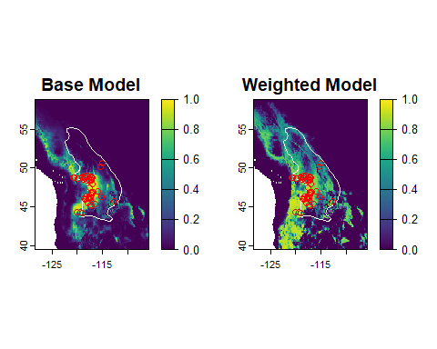
Like the others, the site-weighted model seems to create new issues!

5 Underview
Let’s take a look at all of the bias-correction maps at once, plus the original “uncorrected” map we made in a previous tutorial.
par(mfrow = c(3, 2))
# uncorrected map
plot(baseMap, range = c(0, 1), main = 'Base Model')
plot(rangeMap, border = 'white', add = TRUE)
# correction with target background
plot(targetBgMap, range = c(0, 1), main = 'Target BG')
plot(rangeMap, border = 'white', add = TRUE)
# correction with background reflecting road density
plot(biasMap, range = c(0, 1), main = 'Road density')
plot(rangeMap, border = 'white', add = TRUE)
# correction by geographic thinning
plot(geogThinMap, range = c(0, 1), main = 'Geog. thinning')
plot(rangeMap, border = 'white', add = TRUE)
# correction by environmental thinning
plot(envThinMap, range = c(0, 1), main = 'Env. thinning')
plot(rangeMap, border = 'white', add = TRUE)
# site-level weighting
plot(weightedMap, range = c(0, 1), main = 'Weighted')
plot(rangeMap, border = 'white', add = TRUE)
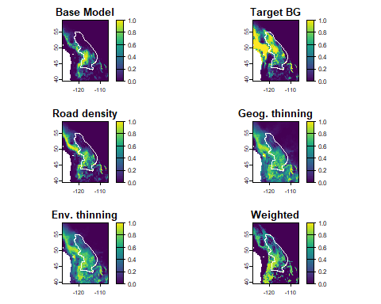
So which technique is best? None seem very good, at least for this species, likely because we’re missing occurrences from the northern part of the species’ range. If I were charged with modeling this species “for real”, I would, in this order:
- Go back to the original data and see if I could georeference occurrences we discarded accurately enough they could be retained, with special focus on occurrences north of the border. If I could not georeference them more accurately (e.g., I could only get them to a county-level, say), I would apply the “nearest environmental point” method (Smith et al. 2023; open-access pre-print; or just email me: adam.smith@mobot.org). The other two solutions below are secondary to getting good representation across the species’ range.
- Statistically integrate unbiased data sets into the model. Such data could comprise, say, stratified random camera-trap sampling of a portion of the species’ range. This is an advanced technique that requires knowledge of Bayesian methods and programming, but I want to mention it because in some cases we do have systematically collected, unbiased data for a portion of a species’ range. This can help stabilize otherwise biased coefficients (Koshkina et al. 2017).
- Relatedly, integrate the range map into the modeling. Assuming we have some trust in its veracity, we can use the range map as an offset o improve model predictions (Merow et al. 2017). In this particular case, this might be the best bet because of the paucity of occurrences in Canada.
- Try adding more variables. As we have seen, all of the bias-correction models, plus the uncorrected model, tend to predict high suitability outside the range. These areas are often contiguous with the suitable areas in the range, so it does not seem likely that they are unoccupied due to dispersal limitation. As we discussed in the exercise on selecting predictors, the more predictors you use, the more the model has a way to say “no” to an area.
Special note: In following tutorials we’ll explore how to evaluate the performance of models. Researchers almost always rely on these performance statistics to tell them which bias correction technique is best. However, I firmly believe that visual inspection of maps–just like visual inspection of residuals in normal linear regression–is a very important part of model evaluation. Thus, we’ve explored here the effects of bias correction using just our eyes. After all, if you’re test data is also biased, you can’t trust metrics of model performance calculated on them to evaluate your model without bias!
A final note: There have been very few systematic explorations of the ability of different bias correction techniques for correcting bias. Of note, Fourcade et al. (2014) conducted the most comprehensive evaluation, albeit with just three species (two real and one simulated). They induced four kinds of bias in their data then tested the ability of five bias correction techniques, including spatial filtering and environmental filtering as we explored here. If you read the abstract and even the paper you might be left with the impression that no technique works well more than 50% of the time, but geographic filtering is still the most dependable method. However, if you carefully examine the large table in that paper you’ll see that the real message should be that spatial filtering makes models worse the majority of the time! (And on average other techniques are even worse than that!)
So what should you do? Bias is obviously a problem, so it should be addressed. But the field of distribution and niche modeling has yet to develop universally applicable techniques for bias correction. While unsatisfactory, this is the nature of science–we find what we know and along the way we don’t know.

