Exercise 13: Model Evaluation - Metrics
Adam B. Smith | Missouri Botanical Garden
2025-01-31
Thus far we’ve been using the “non-parametric eyeball” test to assess how well our models were performing. This may seem ill-advised given how statistically quantitative ecology has become. However, visual inspection of output maps is one of the most important kinds of model evaluation, subjective though it may be. In many cases I’ve found model evaluation metrics are very similar between models that produce very different maps. Likewise, model metrics can only tell you how good the model is in locations where you have test sites. As we’ve been seeing with the Columbian ground squirrel, we have few occurrences in Canada, so even if we were to make a model with high statistical accuracy, we’d only really be able to say it was accurate in the portion of the US where we have an adequate number of occurrences for testing. So don’t eschew your eyeball test!
We’ll be looking at two kinds of evaluation metrics:
- Threshold-dependent metrics which use a cut-off value to divide predictions into presences (1s) and absence (0s), and
- Threshold-independent metrics which generally evaluate the ability of the raw predictions (ranging between 0 to 1) to reflect the propensity of the species to be present or absent at sites.
Metrics of model accuracy can be classified into whether they represent:
- A model’s discrimination capacity, or ability to correctly classify presences versus absences; and
- A model’s calibration accuracy, which can either reflect:
- how well the model output estimates the probability of presence; or
- how accurately the model estimates coefficients.
All threshold-dependent metrics are measures of discrimination, whereas threshold-independent metrics can be either.
One final word before we really start–statistical significance tests are rarely applied to SDMs. Part of the reason may be that the data is spatially autocorrelated (i.e., the issue we were trying to resolve with bias correction), which makes traditional statistical significance tests unreliable.

1 Restarting R
If you are continuing from the previous exercise, you can skip this part. However, if you restarted R, you will need to attach packages and load other data objects. In that case, please run this code.
library(cowplot) # combining ggplots
library(enmSdmX) # SDMing
library(geodata) # geographic data
library(ggplot2) # plotting
library(omnibus) # helper functions
library(scales) # transparency/rescaling
library(terra) # GIS
# Working folder... may not be needed if you are using RStudio.
# Set to the proper path for your computer/project.
setwd('C:/Folder Name/SDM Workshop')
# Occurrences:
recordsNoDups <- readRDS('./Occurrences - GBIF/06 Species Records - Eliminated All But One Record Per Cell.rds')
# Range map:
rangeMap <- vect('./Urocitellus columbianus Range Map - IUCN/urocitellusColumbianus_iucnRangeMap.shp')
# North America:
northAmerica <- vect('./Political - GADM/North America.rds')
# Study region:
studyRegion <- readRDS('./Study Region/Study Region.rds')
# Elevation and climate rasters:
elevation <- rast('./Elevation - CGIAR-SRTM/elevation.tif')
currentClim <- rast('./Climate Rasters - WORLDCLIM/currentClim.tif')
futureClim <- rast('./Climate Rasters - WORLDCLIM/futureClim.tif')
# Variables
predictors <- readRDS('./Selected Predictors.rds')
# Background sites
randomBgEnv <- readRDS('./Background Sites/Random Background Sites across Study Region.rds')
# Predictors
predictors <- readRDS('./Selected Predictors.rds')
# Background and presence sites
trainDataRandomBg <- readRDS('./Collated Occurrences & BG Sites/Random BG.rds')
# Models:
simpleModel <- readRDS('./Models/Simple Model.rds')
simplerModel <- readRDS('./Models/Simpler Model.rds')
baseModel <- readRDS('./Models/Base Model.rds')
targetBgModel <- readRDS('./Models/Target Background Model.rds')
biasModel <- readRDS('./Models/Bias Model.rds')
geogThinModel <- readRDS('./Models/Geographically Thinned Model.rds')
envThinModel <- readRDS('./Models/Environmentally Thinned Model.rds')
weightedModel <- readRDS('./Models/Weighted Model.rds')
# Model predictions:
simpleMap <- rast('./Models/simple_model_1970_2000.tif'))
simplerMap <- rast('./Models/simpler_model_1970_2000.tif'))
baseMap <- rast('./Models/base_model_1970_2000.tif')
targetBgMap <- rast('./Models/target_bg_model_1970_2000.tif')
biasMap <- rast('./Models/bias_model_1970_2000.tif')
geogThinMap <- rast('./Models/geog_thin_model_1970_2000.tif')
envThinMap <- rast('./Models/env_thin_model_1970_2000.tif')
weightedMap <- rast('./Models/weighted_model_1970_2000.tif')

2 Threshold-dependent metrics of model performance
Threshold-dependent metrics require a rule to divide predictions into presences (1s) and absences (0s). A priori you might assume that a value of 0.5 is best, but recall that the prediction from a model trained using background sites at best can only be guaranteed to correlate with the true probability of presence. This means a predicted value of 0.5 does not necessarily correspond to a probability of presence of 0.5. There are many ways to choose thresholds.
Thresholds are often evaluated according to their ability to produce good presence and absence predictions. Often, the ability of a model to produce good predictions is based on one or two of these metrics:
- Sensitivity is the proportion of test presences that are correctly predicted to be present. Specificity is the proportion of test absences (or background sites) correctly predicted to be absences.
Note that specificity is ambiguous if background sites are used in place of true absences because background sites are not absences and can even land on a known or unknown presence. We’ll be exploring how well three of the most commonly-used thresholds perform in terms of their sensitivity (and specificity).
We will be evaluating the “base” model (the one we did not apply bias correction to). To do this, we’ll need predictions at the occurrence sites and the (random) background sites. There are two ways to get these. First, we could using predictEnmSdm() (or more generally, predict()) and supply the function the data frames for occurrences and background sites. Second, we could use the spatial vector representation of the occurrences and background sites to extract values from the prediction raster. Both result in the same outcome, but we’ll do the first method here.
# convert occurrence spatial vector to data frame
recordsEnv <- as.data.frame(recordsNoDups)
# make predictions to occurrences and to background sites
predsOccs <- predictEnmSdm(baseModel, recordsEnv)
predsBGs <- predictEnmSdm(baseModel, randomBgEnv)
head(predsOccs)
## [1] 0.7747550 0.9671990 0.9637437 0.9811288
## [5] 0.6793263 0.9006759
head(predsBGs)
## [1] 6.749558e-02 8.794810e-04 1.128431e-01
## [4] 1.007030e-01 1.478165e-01 2.370314e-06
You can see that even in just these few values that predictions at presence sites are higher than at background sites.

2.1 Minimum training presence threshold
Description: The smallest predicted value across all of the training presences.
This threshold guarantees every training presence is predicted to be “present”. However, this threshold is often very optimistic and predicts a very wide area is inhabited.
mtp <- min(predsOccs)
mtp
## [1] 0.01427475
What proportion of presences did we correctly predict as present?
# sensitivity (true positive rate)
sum(predsOccs >= mtp) / length(predsOccs)
## [1] 1
Sure enough, since we set the threshold at the lowest value across presences, we correctly predicted them all to be presences! What proportion of background sites did we predict to be present?
# specificity (true negative rate)
sum(predsBGs < mtp) / length(predsBGs)
## [1] 0.5088
So, across the study region, we would predict that about 51% of the area is inhabited by the species.
I walked us through the code above because it helps understand the thresholds and accuracy metrics of you can see how these calculations are done. However, the threshold and accuracy metrics are calculable using the evalThreshold() and evalThersholdStats() functions in enmSdmX:
# threshold
mtp <- evalThreshold(predsOccs, predsBGs, at = 'minPres')
mtp
## minPres
## 0.01427475
# accuracy
evalThresholdStats(mtp, predsOccs, predsBGs)
## threshold sensitivity specificity
## 0.014274747 1.000000000 0.508800000
## ccr ppp npp
## 0.511146497 0.009677419 1.000000000
## mr
## 0.488853503
The output returns a series of accuracy metrics:
- The threshold value
- Sensitivity
- Specificity
- CCR: Correct classification rate, or the proportion of occurrences and background sites you correctly predicted to be presences or absences
- PPP: Positive predictive power, or the number of correctly-predicted presences to the total number of presence predictions across occurrences and absences (background) sites
- NPP: Negative predictive power, or the number of correctly-predicted absences (background sites) to the total number of absence predictions across occurrences and background sites
- MR: Misclassification rate, or the proportion of predictions that are wrong
This is quite a few metrics, but in SDMing, only sensitivity and specificity are used often.

2.2 Thershold that achieves a user-specified sensitivity rate against the training data
Description: For the minimum training presence threshold, we chose the value that was the lowest across all occurrence sites. This ensured that we had a sensitivity rate of 100%. However, this can lead to an overly optimistic rate of presence predictions. We might be amenable to being just a bit wrong when demarcating presences from absences. You can set the desired rate of sensitivity and use the threshold that achieves that (or nearly so, given rounding error). Typically in SDMing, researchers use a target sensitivity rate of 0.95 (5% of the presences will be incorrectly classified as absences) or 0.9 (10% will be incorrect).
# calculate thresholds
sens0.95 <- evalThreshold(predsOccs, predsBGs, at = 'sensitivity', sensitivity = 0.95)
sens0.90 <- evalThreshold(predsOccs, predsBGs, at = 'sensitivity') # default is 0.9
Let’s compare the accuracy of these two thresholds and the minimum training presence threshold:
# combine threshold values (MTP, Se = 0.95, and Se = 0.9)
tholds <- c(mtp, sens0.95, sens0.90)
# evaluate threshold accuracy
evalThresholdStats(tholds, predsOccs, predsBGs)
## threshold sensitivity specificity
## [1,] 0.01427475 1.0000000 0.5088
## [2,] 0.06480676 0.9791667 0.6456
## [3,] 0.33243397 0.9166667 0.8290
## ccr ppp npp
## [1,] 0.5111465 0.009677419 1.0000000
## [2,] 0.6471935 0.013088276 0.9998451
## [3,] 0.8294188 0.025085519 0.9995177
## mr
## [1,] 0.4888535
## [2,] 0.3528065
## [3,] 0.1705812
You can see that as the threshold increases, the proportion of occurrence sites we correctly predict (sensitivity) diminishes. However, the proportion of background sites we predict as absence (specificity) grows.

2.3 Threshold that minimizes the difference between sensitivity and specificity
Description: This threshold is the value that most equalizes sensitivity and specificity, or the true positive and true negative rates.
# the ESS threshold
mdss <- evalThreshold(predsOccs, predsBGs, at = 'mdss')
mdss
## mdss
## 0.429
Note that this threshold is quite a bit higher than the minimum training presence threshold. How accurate is it? We could calculate this manually the same way we did with the previous threshold, but we can also use the evalThresholdStats() function to do it for us.
# accuracy of the given threshold
evalThresholdStats(mdss, predsOccs, predsBGs)
## threshold sensitivity specificity
## 0.42900000 0.85416667 0.86370000
## ccr ppp npp
## 0.86365446 0.02920228 0.99919019
## mr
## 0.13634554
As expected, the sensitivity rate is lower than for the minimum training threshold, but the specificty rate is higher.

2.4 Threshold that maximizes the sum of sensitivity and specificity
Description: This threshold maximizes the correct classification rate.
Assuming test occurrences and background sites are sampled from the landscape in a representative manner (i.e., unbiased), the threshold value that maximizes the sum of sensitivity and specificity will be the same regardless of whether true absences or background sites are use (Liu et al. 2013. As a result of this property, this threshold is frequenctly used in SDMing (although everyone seems to ignore the requirement for test sites to be sampeled without bias).
# the ESS threshold
msss <- evalThreshold(predsOccs, predsBGs, at = 'msss')
msss
## msss
## 0.409
# accuracy of the given threshold
evalThresholdStats(msss, predsOccs, predsBGs)
## threshold sensitivity specificity
## 0.4090000 0.8958333 0.8541000
## ccr ppp npp
## 0.8542994 0.0286285 0.9994149
## mr
## 0.1457006
I’ve been walking us through these thresholds one-by-one because it helps to explain them that way. However, you can calculate them all at once using:
# calculate thresholds
tholds <- evalThreshold(predsOccs, predsBGs)
tholds
## msss mdss minPres
## 0.40900000 0.42900000 0.01427475
## prevalence sensitivity
## 0.00477707 0.33243397
# evaluate thresholds
evalThresholdStats(tholds, predsOccs, predsBGs)
## threshold sensitivity specificity
## [1,] 0.40900000 0.8958333 0.8541
## [2,] 0.42900000 0.8541667 0.8637
## [3,] 0.01427475 1.0000000 0.5088
## [4,] 0.00477707 1.0000000 0.4323
## [5,] 0.33243397 0.9166667 0.8290
## ccr ppp npp
## [1,] 0.8542994 0.028628495 0.9994149
## [2,] 0.8636545 0.029202279 0.9991902
## [3,] 0.5111465 0.009677419 1.0000000
## [4,] 0.4350119 0.008384279 1.0000000
## [5,] 0.8294188 0.025085519 0.9995177
## mr
## [1,] 0.1457006
## [2,] 0.1363455
## [3,] 0.4888535
## [4,] 0.5649881
## [5,] 0.1705812
The “prevalence” threshold is the one that uses the proportion of occurrence sites relative to all sites combined as a threshold. It is rarely used when background sites are employed, but more relevant when you have true absences.
Now, let’s see what the maps look like when they’re thresholded.
par(mfrow = c(2, 3))
# unthresholded
plot(baseMap, main = 'Unthresholded')
plot(rangeMap, border = 'red', add = TRUE)
# MTP
plot(baseMap >= mtp, main = 'Min. Train Pres.')
plot(rangeMap, border = 'red', add = TRUE)
# Se 0.95
plot(baseMap >= sens0.95, main = 'Se = 0.95')
plot(rangeMap, border = 'red', add = TRUE)
# Se 0.90
plot(baseMap >= sens0.90, main = 'Se = 0.90')
plot(rangeMap, border = 'red', add = TRUE)
# MDSS
plot(baseMap >= mdss, main = 'Min Diff Se & Sp')
plot(rangeMap, border = 'red', add = TRUE)
# MSSS
plot(baseMap >= msss, main = 'Max Se + Sp')
plot(rangeMap, border = 'red', add = TRUE)
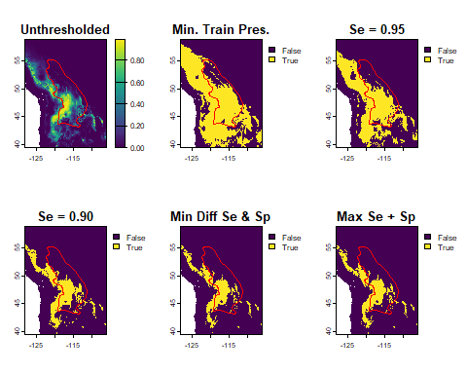
As you might expect, using a lower threshold causes more of the map to be predicted as “present.”
Should you threshold? Sometimes, your intended use of the prediction maps requires you to delineate presence from absence. For example, maybe you want to predict species richness, so need to say definitely if a species is in a particular place or not so you can count it. In this case, you could threshold the maps and add them together to get richness (but see Calabrese et al. 2014).
However, thresholding throws a lot of information away–a site that is barely above the threshold looks the same as a site far above the threshold, obscuring differences in slightly suitable from highly suitable habitat. So, in general, it is advisable not to threshold if you can.
But what if you are still needing to classify environmental suitability in a manner that is visually simple? You can use multi-threshold maps to simplify predictions without loosing too much information. For example:
# create a matrix for reclassification
rcl <- matrix(
c(
0, mtp, 0,
mtp, sens0.95, 1,
sens0.95, sens0.90, 2,
sens0.90, 1, 3
),
byrow = TRUE, ncol = 3
)
# apply thresholds to map
multiThresholdMap <- classify(baseMap, rcl)
# map
cols <- c('gray', 'darkgreen', 'forestgreen', 'chartreuse')
plot(multiThresholdMap, col = cols, main = 'Multiple Threshholds')
plot(rangeMap, add = TRUE)
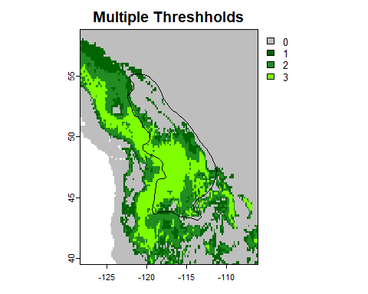
This map conveys more information than one with a single threshold and is often good for communication.

2.5 Reflection
Which threshold seems best? This is just a single example, but based on what you see, do you think thresholding in general is advised?

3 Threshold-independent metrics
Threshold-independent metrics do not apply thresholds. They evaluate raw model predictions to determine how well a model performs.

3.1 Area under the receiver-operator characteristic curve (AUC)
AUC was developed in World War II to measure the effectiveness of radar in detecting enemy planes. It is essentially a series of threshold-dependent metrics summed across multiple thresholds. We’ll explain AUC in terms of its calculation with presences and background sites (versus absences), but it can also be calculated with presences and absences.
To see how AUC works, consider the frequency of predictions at presence and background sites for our species. We will bin them to make visualization easier.
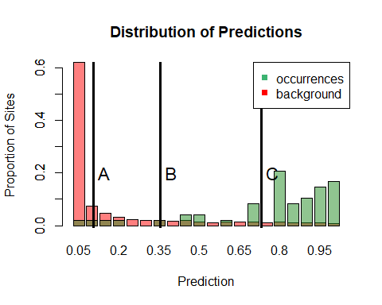
You can see that the predicted values for the presences and background sites overlap to some extent. I’ve drawn three hypothetical thresholds at A, B, and C. Regardless of which we choose, it would cause the presences to the left of the line to be incorrectly designated as absences and background sites to the right of the line to be designated as presences. We can thus calculate the sensitivity (true positive rate) and false positive rate (= 1 - specificity) for a series of thresholds.
The idea behind AUC is that we can calculate sensitivty and the false psoitive rate for a series of thresholds from 0 to 1, then plot one against the other: 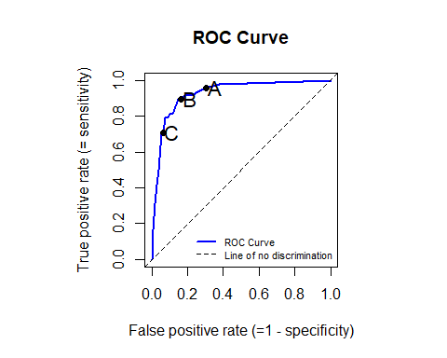
When the model is accurate across a range of thresholds, the line is “drawn” toward the top left side where sensitivity is high and the false positive rate is low. I’ve labeled the locations where our thresholds were from the previous graph. Note that these are the values of sensitivity and the false positive rate at those thresholds, not the thresholds themselves. Threshold C is our highest threshold–you can see that when we have a high value, we predict presences less well (low sensitivity), but are less likely to call an absence (or background site) a presence (low false negative rate).
The area under this curve, or AUC, integrates across all of the thresholds. As a result, the area is used as a metric of model performance. This area has a range from 0 to 1:
0 to 0.5: Model performs worse than random
0.5: Model performs no better or worse than random
0.5 to 1: Model performs better than random
The AUC also has a probabilistic interpretation: it represents the probability that a randomly drawn presence site has a higher predicted value than a randomly drawn absence/background site. It is thus inherently a rank-based statistic because it doesn’t “care” how much higher the prediction of a presence is over an absence. In this respect AUC is a metric of a model’s discrimination capacity.
AUC is the most widely-used model performance metric. However, when calculated using background sites in place of true absences it can be very misleading. For good models it has a maximum value of 1 - a/2, where a is the proportion of the landscape occupied by the species. Typically you will not know this, so an AUC value of 0.6, which is just above random, may or may not be “high” depending on a. This also means you can’t compare AUC calculated with background sites across species since a will vary by species (Smith 2013).
More perniciously, bad models can cause AUC to surpass the threshold 1 - a/2. This would seem to be a good thing–higher values of AUC are better. But AUC calculated with background sites is apparent AUC… the AUC you’re really interested in AUC calculated with presences and true absences (which are rarely available). For bad models as apparent AUC increases real AUC declines… so your model can actually become worse as it appears to become better (Smith 2013)!
As a result of these issues, there is no objective value of AUC that is “good” or “bad”, except that AUC values >0 are better than random and <0.5 worse. You might encounter studies that divide AUC values into “excellent”, “good” and “poor” ranges, or report their AUCs to show that they are relatively high (near 1). But unless they calculated AUC with true absences, these are all misleading.
Note, though that AUC calculated with presences and true absences should be OK!
Despite all of this, let’s do see how to calculate AUC:
# AUC
auc <- evalAUC(predsOccs, predsBGs)
auc
## [1] 0.9329792
Thus, for our model, there is on average a 93% chance that a randomly chosen occurrence site has a higher prediction than a randomly chosen background site.

3.2 The continuous Boyce index (CBI)
A lesser-used but likely more sensitive measure of model performance is the continuous Boyce index, which is a variant of the (non-continuous) Boyce Index. BI and CBI are measures of a model’s calibration accuracy.
Original Boyce Index: Boyce, M.S., Vernier, P.R., Nielsen, S.E., and Schmiegelow, F.K.A. 2002. Evaluating resource selection functions. Ecological Modeling 157:281-300.DOI: 10.1016/S0304-3800(02)00200-4
Continuous Boyce Index: Hirzel, A.H., Le Lay, G., Helfer, V., Randin, C., and Guisan, A. 2006. Evaluating the ability of habitat suitability models to predict species presences. Ecological Modeling 199:142-152. DOI: 10.1016/j.ecolmodel.2006.05.017
I’ll first explain the (non-continuous) Boyce index, BI. To calculate BI, we first examine the distribution of predictions taken from across the landscape. Ergo, we take these values:
plot(baseMap)
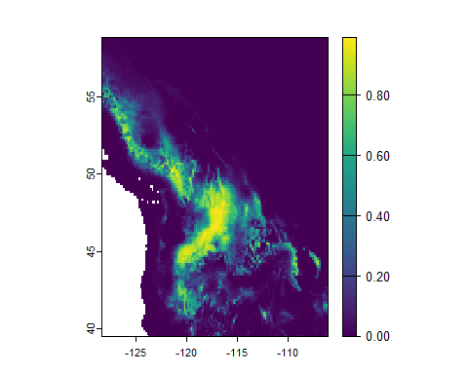
…and bin them into a histogram:
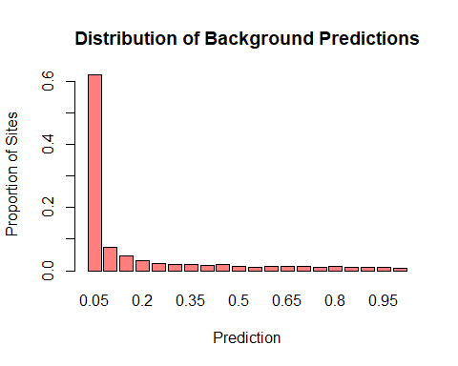
BI uses the distribution of predictions across background sites the expected values of predictions across all occurrences on the landscape. In other words, if a particular bin has, say, 60% of the predicted values, then our null expectation is that about 60% of the test presence predictions will also be in that bin. We then compares the actual distribution of predictions at test presence sites (=P) to the expected distribution across the landscape (=E). On other words, we divide the height of the green bars by the height of the red bars:
# plot distribution of predictions at presences and background sites
labels <- round(seq(0, 1, length.out = 21), 2)
barplot(bgDistrib,
col = alpha('red', 0.5),
names.arg = labels[2:21],
ylab = 'Proportion of Sites',
xlab = 'Prediction',
main = 'Distribution of Predictions'
)
barplot(presDistrib, col = alpha('forestgreen', 0.5), add = TRUE)
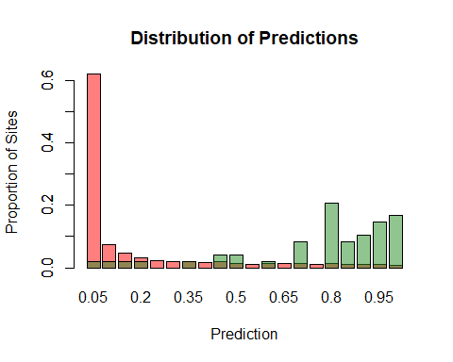
To get the P/R ratio. We can plot these by bin number: 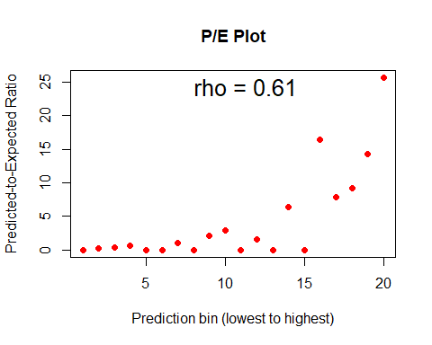
Each dot here represents the ratio of the green bars to the red bars in the graph that is above this one.
To get BI, we calculate the rank correlation coefficient between P/E and the rank of the bin (from the first bin with the lowest prediction class to the highest bin with the highest prediction class). In our case, this is equal to 0.61. Since CBI is a correlation, values near 1 are “good”, near 0 close to random, and <0 “bad”. This is how we calculate the (non-continuous) Boyce index.
The continous Boyce index, or CBI, is calculated in the same way, except that we use partially overlapping bins for its calculation. We can forgo walking through these complicated steps and simply use the evalContBoyce() function in enmSdmX:
# CBI
cbi <- evalContBoyce(predsOccs, predsBGs)
cbi
## [1] 0.9427831
For our “base” model, we get a fairly high value of CBI (close to 1). This means that the model’s output correlates highly with the true probabiliy of presence. On other words, this is a great model! But recall the map–it’s probably not that great of a model. Good modeling relies on statistical measures of accuracy and common sense.

3.3 Which metrics should we use?
I’ve covered the most common metrics of SDM accuracy here. In general, they can be classified into whether they indicate discrimination and calibration accuracy. Which should you use? You should probably use several, but I would emphasize the one(s) that reflect how you are actually going to use your model output. For example, if you were to threshold your maps, I would report sensitivity measrures. If you were to use your (un-thresholded) map to rank sites for conservation priority, AUC would be the appropriate metric (so long as you keep in mind its limitations). And if you used the model output in a manner analogous to the probability of presence, then CBI is a good metric.

3.4 Reflection
- When would metrics of discriminatory accuracy be favored over calibration accuracy? When would calibration be favored?
- Do high values of performance metrics mean a model is reliable? Do low values?

