Exercise 15: Niche versus Distribution Modeling
Adam B. Smith | Missouri Botanical Garden
2025-01-31
For the past many years species distribution modeling has been synonymous with ecological niche modeling, though there have been debates over which is the better term (Warren 2012, McInery & Etienne 2013, Warren 2013). However, concurrent with this debate is a parallel dialog that makes a working distinction between ecological niche models (ENMs) and species distribution models (SDMs; Barve et al. 2011; Peterson et al. 2011. Under this distinction, SDMs model the distribution of a species, while ENMs model the niche. The two are related, but they are also fundamentally different for reasons that appear esoteric at first but have important consequences for modeling.
Consider a species that only existed on the mainland:
No species is an island.
No species is an island.
Suppose we wanted to model the distribution of a species that only occurred on the mainland. Should we include the island as part of the region from which we draw background sites? It depends! If we are interested in modeling the distribution of the species, including the island would inform the model that the island’s environment is available to the species but the species has been unable to inhabit it. Thus, the model would be more likely to predict the species is absent from the island. If we were interested in modeling the geographphic projection of the environmental niche of the species, then we should probably not include the island in the background set if the species has not been able to disperse there to “sample” its environment.
Although I’ve illustrated the issue with and island/mainland situation, the same kind of situation can occur when non-insular/mainland systems–i.e., for niche models, sites should be considered in the background only if the species has been able to “sample” (through dispersal) their environments. Jorge Soberon has conceptualized this issue using what he calls the biotic/abiotic/movement or BAM diagram (Soberon 2007; Soberon & Nakamura 2009.
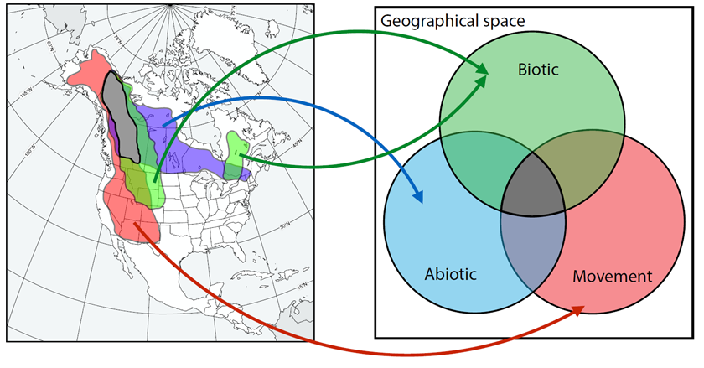
BAM Diagram
Here, each circle represents either 1) the biotic conditions under which the species can thrive; 2) abiotic conditions under which it can thrive; or 3) the geographic areas to which the species has the capability of moving. The figure above is from Sanin & Anderson 2018, where they focus on North American warblers, and map the biotic component based on vegetation types each species prefers, the abiotic components using ENMs with climatic predictors, and the movement component based on estimated dispersal distance.
Although simple, this conceptualization has some deeply important aspects:
- The fundamental niche is represented by A.
- The realized niche is represented by the intersection of A and B.
- The place where one can actually find the species is represented by the intersection of B, A, and M.
- The species could live in sink populations that are found within M but outside either A or B.
ENMing/SDMing is all about estimating A, the abiotic niche (though one could use biotic predictors to similtaneously or additionally estimate B).
What about B, the conditions under which biotic conditions allow the species to exist. How do we account for this in our ENM/SDM? You could, for example, use the presence/absence of any other species with which your focal species interacts as a predictor layer–but this would require unequivocal knowledge the other species’ distributions, which are also generally unknown andf likely depend on their own B’s (and As and Ms). Accounting for interspecific interactions is an evolving issue in distribution/niche modeling, and although a wide variety of papers have attempted to address the issue, to date there is no widely-applicable accepted method.
Owing to the difficulty of the issue of estimating B, most niche modeling is conducted on the basis of the Eltonian noise hypothesis, which posits that biotic interactions determine whether a species is present at fine scales, but not coarse scales. The general reasoning is that within a large area a species can usually find some habitats that are not also occupied by a competitor/predator/parasite. As a result, across large areas, a species can persist and so be counted as “present” when the spatial grain of analysis is coarse. Obliviously this is a strong assumption!
In the exercises so far we have been focused on modeling the distribution of our species–i.e., our focus has been on creating an SDM with a believable and well-performing spatial output. The niche of a species can also be expressed in geographic space since, after all, occupied areas (usually) have environmental conditions in which a species can thrive. Of course, we can make a distinction between the realized and fundamental niche, but in general we can assume that occupied places fall within both kinds of niches. So let’s see how our species’ SDM and ENM differ.

1 Restarting R
If you are continuing from the previous exercise, you can skip this part. However, if you restarted R, you will need to attach packages and load other data objects. In that case, please run this code.
library(cowplot) # combining ggplots
library(enmSdmX) # SDMing
library(geodata) # geographic data
library(gecko) # GIS data
library(ggplot2) # plotting
library(predicts)# SDMing
library(omnibus) # helper functions
library(rgbif) # access GBIF biodiversity data
library(scales) # transparency/rescaling
library(terra) # GIS
# Working folder... may not be needed if you are using RStudio.
# Set to the proper path for your computer/project.
setwd('C:/Folder Name/SDM Workshop')
# Occurrences:
recordsNoDups <- readRDS('./Occurrences - GBIF/06 Species Records - Eliminated All But One Record Per Cell.rds')
# Range map:
rangeMap <- vect('./Urocitellus columbianus Range Map - IUCN/urocitellusColumbianus_iucnRangeMap.shp')
# North America:
northAmerica <- vect('./Political - GADM/North America.rds')
# Study region:
studyRegion <- readRDS('./Study Region/Study Region.rds')
# Elevation and climate rasters:
elevation <- rast('./Elevation - CGIAR-SRTM/elevation.tif')
currentClim <- rast('./Climate Rasters - WORLDCLIM/currentClim.tif')
futureClim <- rast('./Climate Rasters - WORLDCLIM/futureClim.tif')
# Variables
predictors <- readRDS('./Selected Predictors.rds')
# Background sites
randomBgEnv <- readRDS('./Background Sites/Random Background Sites across Study Region.rds')
# Predictors
predictors <- readRDS('./Selected Predictors.rds')
# Background and presence sites
trainDataRandomBg <- readRDS('./Collated Occurrences & BG Sites/Random BG.rds')
# Models:
simpleModel <- readRDS('./Models/Simple Model.rds')
simplerModel <- readRDS('./Models/Simpler Model.rds')
baseModel <- readRDS('./Models/Base Model.rds')
# Model predictions:
simpleMap <- rast('./Models/simple_model_1970_2000.tif'))
simplerMap <- rast('./Models/simpler_model_1970_2000.tif'))
baseMap <- rast('./Models/base_model_1970_2000.tif')

2 ENM versus SDM
Recall that the practical distinction between an ENM and a SDM is that the former only includes background sites within the geographic space defined by M from the BAM diagram. Thus, we need to know to where the species has (and has had) the ability to disperse. How do we do that? In general there is no shortcut since every species has its own mode of dispersal. However, you could choose background sites from:
- An area defined by a buffer of a set distance from each known presence. This is what we did to define our study region.
- All ecoregions known to be occupied by the species.
- An area defined by the known presences of the species plus sister species which presumably share niche characteristics of the focal species (e.g., Qiao et al. 2017).
- An area defined by a dispersal-based model (e.g., Machado-Stredel et al. 2021).
For simplicity, let’s explore the first option some more. In Exercise 2, we defined our study region by creating a buffer of 200 km around the range map. If we take the assertion that niche models should only use environments the species has been able to access through dispersal, this is an assertion that our species has been able to disperse (but not necessarily colonize) up to 200 km away from it’s current range. This is quite a trek for such a small animal, awesome though it may be!
Let’s build some alternative models where we vary the size of the buffer used to delineate the area from which we draw background sites. If you are doing this in a study, I suggest using powers of 2; i.e., 20 km, 40 km, 80 km, 160 km, etc., because smaller gradations will typically not yield as noticable differences.
# buffer sizes
bufferSizes_km <- c(20, 40, 80, 160)
# convert occurrences to data frame
recordsEnv <- as.data.frame(recordsEnv)
recordsEnv <- recordsEnv[ , predictors]
# pre-define variables to store output
buffers <- list() # stores buffer vector polygons
predictions <- list() # stores prediction rasters
# for each buffer size...
for (i in seq_along(bufferSizes_km)) {
bufferSize_km <- bufferSizes_km[i]
say('Modeling with buffer of ', bufferSize_km, ' km...')
# create buffer
thisBuffer <- buffer(rangeMap, bufferSize_km * 1000)
# remember buffer
buffers[[i]] <- thisBuffer
# draw background sites
bgSites <- spatSample(thisBuffer, 12000)
# extract climate
bgEnv <- extract(currentClim[[predictors]], bgSites, ID = FALSE)
# remove NAs
bgEnv <- bgEnv[complete.cases(bgEnv), ]
if (nrow(bgEnv) > 10000) bgEnv <- bgEnv[sample(10000), ]
# merge occurrences and background sites
trainData <- rbind(recordsEnv, bgEnv)
# add 1/0 vector for presence/background
presBg <- data.frame(
presBg = c(
rep(1, nrow(recordsEnv)),
rep(0, nrow(bgEnv))
)
)
trainData <- cbind(presBg, trainData)
# using regularization multipler of 1 for expediency
# using linear, product, quadratic features for expediency
model <- trainMaxEnt(
trainData,
resp = 'presBg',
preds = predictors,
regMult = 1,
classes = 'lpq'
)
# burn raster
prediction <- predictEnmSdm(model, currentClim)
names(prediction) <- paste0('buffer_', bufferSize_km, '_km')
# remember
predictions[[i]] <- prediction
}
## Modeling with buffer of 20 km...
## Modeling with buffer of 40 km...
## Modeling with buffer of 80 km...
## Modeling with buffer of 160 km...
Now, let’s examine the maps.
par(mfrow = c(2, 2))
for (i in seq_along(bufferSizes_km)) {
bufferSize_km <- bufferSizes_km[i]
main <- paste('Buffer ', bufferSize_km, ' km')
plot(predictions[[i]], range = c(0, 1), main = main)
plot(rangeMap, border = 'white', add = TRUE)
plot(recordsNoDups, pch = 1, col = 'red', add = TRUE)
}
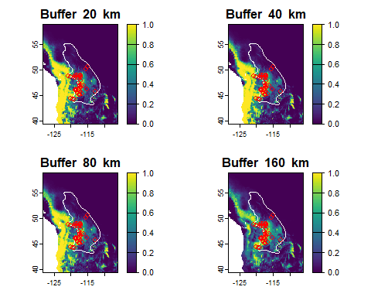
You can see that the extent of the areas from which we draw background sites affects the model predictions. Namely, smaller buffers seem to allow the model to predict high suitability outside of the range. Why? This likely happens because there are no background sites far from the range to act as absences and thus dissuade the model from predicting high levels of suitability there.
But is this “wrong”? Not necessarily–remember that the goal of ENMs is to estimate the species’ niche, not its distribution. It seems possible the species could live at least somewhat outside of its current range, but perhaps is restricted from doing so by other species (or niche axes we did not include in our model).

2.1 Reflection
- If you were projecting a species’ response to climate change, which model type (SDM or ENM) should you use?
- How might you estimate M (in the BAM diagram)? Do you think it is possible to estimate A?

