Exercise 19: The SDM Workflow
Adam B. Smith | Missouri Botanical Garden
2025-02-19
Congratulations, you’ve graduated! You should have a good idea of the detailed work involved in the general workflow of an SDM-based analysis, but I think it is helpful to circle back to get a broad picture.
Here is the workflow we presented in Exercise 00: 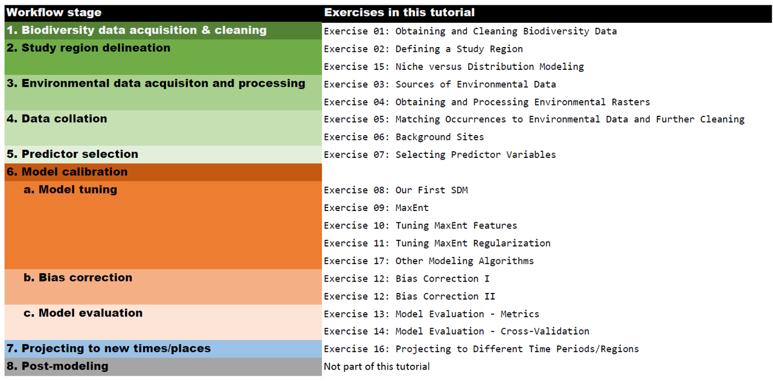
This shows you what a “final” version of a workflow will usually look like. In reality, your actual work will appear something like this: 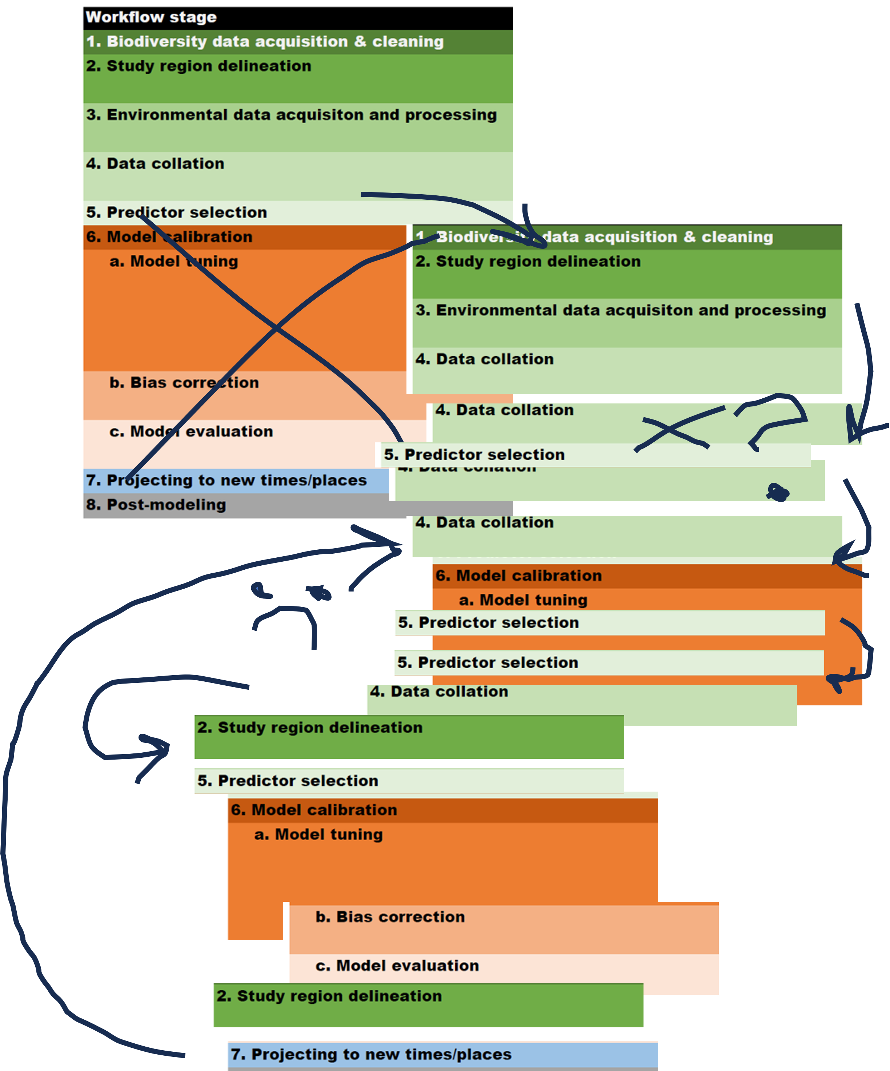
Ergo, it will be highly disrupted by what you find along the way as you are modeling and making decisions, for some of which there may be no satisfying answer.
Personally, I have never made a satisfying model the first time–I believe my minimum is about 10 tries, which required going back to previous steps to re-assess the validity and effect of decisions I made.

Top 8 rules for SDMing
What can you learn from this? Here are my suggestions:
- Organize your input and output files. You could end up with tens to hundreds of them. Use a very descriptive naming system so you know exactly what each one is. Use folders. Name them descriptively, too. Inside each folder include a link to the source, articles, PDFs of emails, etc. to document their source, issues, and version.
- Version your files. You will likely have to try different variations of the same step several times. Have a naming and a version system that tells you what is what. For example, here are files I used to model Big Bluestem, a dominant grass of the Great Plains:
sdm_00_compile_occurrence_and_environmental_data.r
sdm_01_select_predictors.r
sdm_02a_bernoulli_model_DEPRECATED.r
sdm_02b_n_mixture_multivariate_model,r
sdm_02c_n_mixture_bivariate_models_for_term_assessment.r
sdm_02d_n_mixture_multivariate_model_with_stable_terms.r
These files sort nicely on a computer because I use the “00”, “01”, “02”, etc. numeric series in the first part of their names. At a glance, I can easily see that they all pertain to the SDM part of the analysis (there are other files I am not showing). And I can see what code in each file does without actually opening the file. You will notice that I have three “02” files. This is because I was not getting a plausible model on the first attempt, so tried a second algorithm, but that didn’t work either. So, I backed up and tried a series of simple, bivariate models, and from the ones that worked, constructed a biologiclaly and statistically plausible multivariate model. I did not remove the code I had, in case I wanted to go back to it or needed to recall what I’d already tried. Later, when I am sure I do not want to use one of the models I tried, I can add something like “DEPRECATED” to the end of the file name and in the header of the actual file, with a note as to why it should not be used.
You can also use a version control system like Git for versioning files, but it can be hard to “pluck” a section of working code from a file that you created months ago and have “committed” over several times since then.
If you need to make multiple versions of other files (e.g., a file with specimen data that you clean), version them, too.
- Organize your code into “chunks” (steps). As you can see, there are a lot of steps in modeling. Avoid “spaghetti” code, which is code that tries to do everything at once, and in a convoluted way. It’s a lot easier to modularize code into “chunks” that each do one job (e.g., data collation, data cleaning, etc.–see the workflow diagram above). If a chunk takes a long time to run, save the output so you don’t need to recreate it every time you run the code.
Break code into chunks that can be run one-after-the-other and in a manner that depends only on the code above it (i.e., you needn’t jump around to different chunks to get a particular chunk to work). Put all of the library() you need to run all of the chunks at the top of code document. This is what I put in the “setup” chunk at the start of every file:
#############
### setup ###
#############
rm(list = ls())
library(data.table)
library(elevatr)
library(enmSdmX)
library(lubridate)
library(omnibus)
library(sf)
library(terra)
###############################
### collate occurrence data ###
###############################
<code here>
##################################
### collate environmental data ###
##################################
<code here>
- Include an informative header in each file. Yes, at this moment, all of your files are where they should be in the same folder, and you know what each one does. But you can’t necessarily ensure they will stay that way. If you’re doing things right, you will eventually post this code as part of your research output. Someone may stumble across it someday and copy it, or pass it along to someone else, at which point it can be separated from its original context. You want them to be able to go back to the source. Here is an example of a standard header I use for every code file I create:
### CLIMATIC NICHE ESTIMATION OF THE PENASCO LEAST CHIPMUNK (Tamias minimus atristriatus)
### Adam B. Smith*^, Kelley L. Erickson*, Jennifer Frey, Fiona McKibben, and Erik Beever
### * Missouri Botanical Garden | ^ adam.smith@mobot.org
###
### This code prepares the inputs for modeling the climatic niche of the Penasco Least Chipmunk. Inputs are explained at the start of each chunk. All outputs are written to the project folder.
###
### CONTENTS ###
### setup ###
### prepare basemaps ###
### subspecies modeling: define study region ###
### subspecies modeling: extract cell centers for study region
### subspecies modeling: prepare land cover data ###
### subspecies modeling: collate PRISM weather data for centers of PRISM cells ###
What’s going on here? The first three lines:
### CLIMATIC NICHE ESTIMATION OF THE PENASCO LEAST CHIPMUNK (Tamias minimus atristriatus)
### Adam B. Smith*^, Kelley L. Erickson*, Jennifer Frey, Fiona McKibben, and Erik Beever
### * Missouri Botanical Garden | ^ adam.smith@mobot.org
tells me exactly what project this file belongs to, and what the project is about. The second and third list the authors. If this code becomes part of an article (which it will), I will eventually include the article citation, too.
At the start of every file I create a “contents” section:
### CONTENTS ###
### setup ###
### prepare basemaps ###
### subspecies modeling: define study region ###
### subspecies modeling: extract cell centers for study region
### subspecies modeling: prepare land cover data ###
### subspecies modeling: collate PRISM weather data for centers of PRISM cells ###
This allows me to see what the chunks in the code do without scrolling down through all of them.
Lower in the file, I demarcate each section using hashes. These chunk titles exactly match the chunk title in the contents. For example, in the contents I have this chunk listed:
### subspecies modeling: prepare land cover data ###
Later in the code, I have this chunk demarcated with hashes.
####################################################
### subspecies modeling: prepare land cover data ###
####################################################
This enables me to find the chunk easily: I just copy the chunk name in the contents and “Find” it. Demarcating chunks with hashes in this manner makes it easiy to spot if I am scrolling through code.
- Explain. The worst person you need to collaborate with is yourself 6 months ago. You will not believe the horrible things you say about that person if you don’t document your code. When you document code, explain the “why/inputs/outputs” of a chunk. Explaining line-by-line is overkill and doesn’t explain the big picture. (In these tutorials I have usually documented each code line because I assume many people are only passingly familiar with R, so would appreciate the help).
At the start of each chunk, explain what it does and any inputs. For example:
####################################################
### subspecies modeling: prepare land cover data ###
####################################################
# This chunk prepares the land cover raster for the northern portion of the stud region provided by Fiona McKibben, which depicts natural land classes at 1-m resolution. The raster will be trimmed and classes assigned as per her email to Adam Smith on 2024-02-26. The same predictors she used in her thesis will be prepared from the raster (Table 10 on p. 198 of McKibben 2022 Master's Thesis).
- Write code like Hemingway, not Shakespeare. The Bard is famous to this day for his baroque insight into the human condition. But he would have been a horrible programmer. His code would have been hard to read and even harder to debug. Write code like Hemingway. Use short statements. If they have to be long, use multiple lines and indent. Which of these is easier to understand and debug?
glmModel<-trainGLM(data=trainDataRandomBg,resp='presBg',method='brglmFit',scale=T,verbose=T)
glmModel <- trainGLM(data = trainDataRandomBg, resp = 'presBg', method = 'brglmFit', scale = TRUE, verbose = TRUE)
glmModel <- trainGLM(
data = trainDataRandomBg,
resp = 'presBg',
method = 'brglmFit', # Firth's correction
scale = TRUE, # center and scale data
verbose = TRUE
)
Andforgoodnesssakes,usespaces!!!!! The computer usually doesn’t care if you don’t have spaces, but your brain does. Write code for humans.
- Write code for reproducibility. Please recall the “real” workflow I showed you above. Your workflow will look similar to that as you develop it, but in the end, it should look like the “idealized” version. To make the idealized version, you will need to start fresh many times. Near the top of your code, flush your workspace using rm(list = ls()) (see the examine immediately above). This clears anything you have in memory out, ensuring that if your code works, it works because it had everything it needed to work.
What about rmarkdown or Quarto? These are great tools, and you can use them to write your code and document your thoughts along the way. I highly recommend them. But at some point, if you need to run many models for a long time (days, or longer), they can get in the way because errors aren’t displayed in their full glory when you are knitting these kinds of documents. But if you are running just a few species using simple models and minimal post-processing, then they can really help organize your process.
- Use your common sense. No matter how high an AUC score your model gets, it doesn’t beat your common sense. In the literature on SDMing you will not find many cases where people report actually using their common sense (though I believe they do), but it should trump (I hate that word) any any metrics of model accuracy. I have emphasized visual inspection of maps and response curves in these tutorials because I personally believe they are good tools for utilizing your common sense and biological knowledge. You should ask:
- Does the map look reasonable?
- Do response curves look reasonable? For example, U-shaped response curves are generally unexpected because for most cases, species should have a “Goldilocks” area where they find conditions just right. Sometimes, it’s also reasonable to find trends that are just increasing or decreasing trends. But U-shaped trends are unexpected.
- Do interactions between variables make sense?
And that’s all!

