CS5224 Project Final Report - Group 28
Professor: Dr. Anandha Gopalan
Student Name: Muhammad Fariz Bin Mohammad Yusri (A0249554U), Ng Jun Wei (A0252142U), Peng Siang Ling (A0319335A), Rasyiqah Bte Shaik Mohamed Salim (A0204205Y), Tan Hua Swen (A0216984R), Tseng Yung Yi (A0318929M)

1. Motivation and Objective:
Small-and-medium-sized enterprises (SMEs) account for 99% of global firms and over 50% of value added, yet they face persistent hurdles in digital adoption. Limited financial resources and a shortage of specialised technical talent, particularly in data analytics, create a significant capability gap. According to McKinsey & Company, this results in a stark productivity deficit: SMEs operate at only 60% of the productivity level of large firms in advanced economies, and as low as 29% in emerging markets. Having such major barriers to digitalisation limits SMEs’ growth and long-term competitiveness.
Our platform addresses these challenges through an integrated analytics platform with a chatbot interface, enabling retail SMEs to access business intelligence and predictive analytics without requiring advanced technical expertise. By offering user-friendly interfaces and predefined analytical models, the platform supports SMEs to make well-grounded, data-driven decisions. This cloud-based solution reduces technical barriers and costs, helping SMEs sustain their competitiveness in the digital economy.
2. User Journey for SaaS Application:
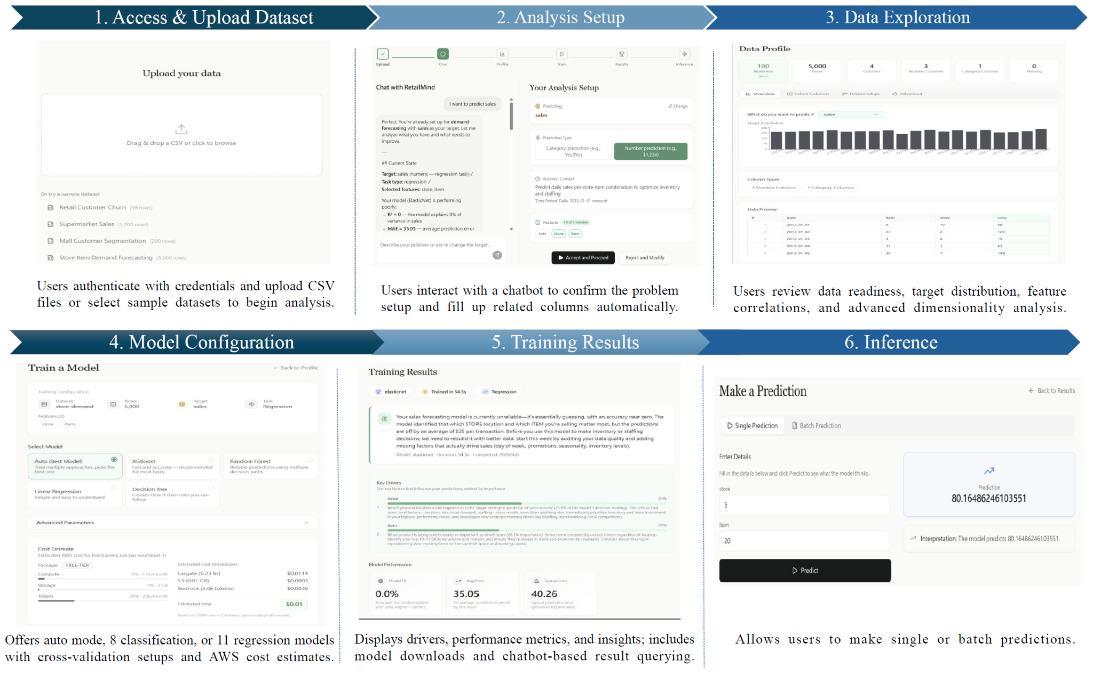
3. Business Model (Pricing Strategies):
3.1. Pricing Strategies
Our platform adopts a hybrid pricing model that combines tiered subscription plans with usage-based resource allocation. The Free plan supports trial users and micro retailers with single-user access, the Growth plan targets SMEs with collaboration for up to three users, and the Pro plan enables scaling retailers with unlimited user access and expanded analytical capacity. Each plan includes baseline allocations of compute capacity, storage, and chatbot interaction tokens to support AI-assisted problem diagnosis and analytics. When usage exceeds these quotas, additional consumption is billed on a pay-per-use basis, ensuring predictable costs while allowing flexible scalability.
Model and analytics capabilities are also tiered. The Free tier provides access to a subset of core ML models with basic feature importance analysis. The Growth tier expands access to additional models from the supported algorithm families with enhanced evaluation and explainability features. The Pro tier offers full access to 19 models across classification and regression tasks, along with automated hyperparameter tuning via randomised cross-validation. This tiered structure enables businesses to adopt progressively more advanced analytics as their data and analytical needs grow.
3.2. Competitor Cost Comparison (on-cloud)
Table 1 compares RetailMind against Amazon SageMaker AI and RoboFlow across eight dimensions relevant to retail SME adoption. Although both platforms offer ML capabilities, neither is purpose-built for retail analytics. Both platforms also present pricing strategies that introduce financial uncertainty for budget-constrained businesses.

Dimension | RetailMind | SageMaker AI | RoboFlow
Pricing model | Tiered subscription + usage quotas for overages | Pay-as-you-use | Subscription + credit system for overages
Entry cost | Free tier available for trial users and micro retailers | Free tier usage available for the first 2 months, with additional charges based on vCPU and memory usage | Free tier available, but service is limited to vision models only
Cost predictability | High  - Fixed monthly subscription  - Transparent costs for potential overages before usage | Low  - Session hours and processing/ training hours are charged separately → easy to overspend | Medium  - Base subscription tier pricings are predictable  - Auto-billing for actual resources and overages used during training
Representative cost example | Growth plan  - 3 users  - 100 jobs per month  - ~$5.95 | Pay-per-use  - 3 data scientists; 1 notebook instance, 2 hours per day, 20 days per month, 6 training jobs per month  - $9.67 base cost per month | Core plan  - 3 users  - 15 credits per month  - $99 per month
Target domain | Retail SME analytics | General-purpose ML  - Can be used in any domain, but requires data preparation and knowledge of the AWS ecosystem | Computer vision models only
Technical barrier | Low  - Chatbot-driven framing → no ML expertise required | Medium  - No-code interface, but users need to handle data preparation themselves and how to operate within AWS | High  - Add and annotate your own data  - Build your own workflow  - Deploy your own model
Multi-user support | Up to 3 (Growth plan)  Unlimited (Pro plan) | Per-user session charges  - Cost scales according to team size | Plan dependent  - 2 users (Free/public)  - 3 users (Core)  - Unlimited (Enterprise)
Data residency | Singapore region (ap-southeast-1)  - Data stays in-country | Configurable, but requires explicit setup in AWS before usage due to broader AWS ecosystem dependencies | Not configurable for most plans  - US-hosted by default
Idle cost | Near zero  - Serverless architecture scales to zero when not in use | Zero if logged out  - If analysts forget to log out or leave the session running, per-hour session fees are charged | Fixed monthly base subscription regardless of usage
Table 1: Cost Comparisons between Competitor Platforms
As shown, RetailMind is the only platform among the three which offers domain-specific retail analytics, predictable and transparent fixed-tier pricing, guaranteed Singapore data residency, and near-zero idle costs. These factors are critical for SMEs with limited technical expertise and financial planning capacity.
3.3. Strategic Infrastructure Rationale (On-premise)

Component | On-premise spec | Software | Est. CapEx | Operational Considerations
Compute  Lambda, ECS, Step Functions | Dell PowerEdge R660  2× Intel Xeon Gold · 64-core · 256 GB RAM · dual 10G NIC | Kubernetes + Knative  Argo Workflows (pipelines) | $12k-15k | Always on, fixed cost regardless of usage
Storage  S3, DynamoDB, ECR | 4× 4TB NVMe U.2 RAID-10  ~7.2 TB usable, optional HDD cold tier | MinIO (S3-compatible)  ScyllaDB Alternator (DynamoDB API) · Harbor (registry) | $5k-9k | No per-request cost
AI Inference  Bedrock / Claude 3 Haiku | GPU server: NVIDIA L40S 48GB | vLLM  Llama 3.1 70B / Mistral 22B | $15k-18k | Cannot match Claude's quality  Token cost = $0 after hardware is paid off
Networking & API  VPC, API Gateway, CloudFront | Fortinet FortiGate 100F & Cisco Catalyst 9200 48-port switch, 10G uplinks | Kong Gateway OSS  Nginx (edge cache/CDN), pfSense or OPNsense (firewall/VLANs) | $8k-15k | Higher latency for distant users (no global PoPs)
Authority & Identity  Cognito | Shared on the compute node  No dedicated hardware needed | Keycloak  OIDC/OAuth2 compatible, Postgres-backed, needs HA config for prod | $0 | Ops burden: managing Keycloak DB + HA
Observability  CloudWatch | Shared on the compute node  Reserve ~8 cores, 32 GB RAM for observability stack | Prometheus (metrics) + Grafana (dashboards) + Loki (logs) | $0
UPS & Power | APC Smart-UPS 3000VA  rack PDU, cable management |  | $2k-5k | Replacement batteries
Table 2: On-premise Estimated Price Breakdown

An on-premises deployment would require an initial capital expenditure of approximately $42,000–$62,000, with ongoing operational costs for electricity, cooling, and maintenance in Singapore estimated at $400–$800 per month, excluding colocation fees. Considering these financial commitments and the system’s scalability requirements, a cloud-based deployment model is more suitable for the current platform.
This decision is primarily driven by operational agility and model capability advantages. Cloud providers manage core infrastructure components such as power, cooling, and hardware lifecycle, allowing the development team to focus on business analytics and AI development. In addition, managed AI services provide immediate access to advanced models without requiring significant hardware investment, enabling higher performance and faster scalability compared to an on-premises environment.
4. Architecture & Implementation
Our SaaS platform, RetailMind, leverages a serverless-first architecture deployed on AWS infrastructure within the Asia Pacific (Singapore) region. The system is designed with multi-availability zone replication to ensure high availability while maintaining data residency within Singapore's borders for compliance and security requirements/concerns.
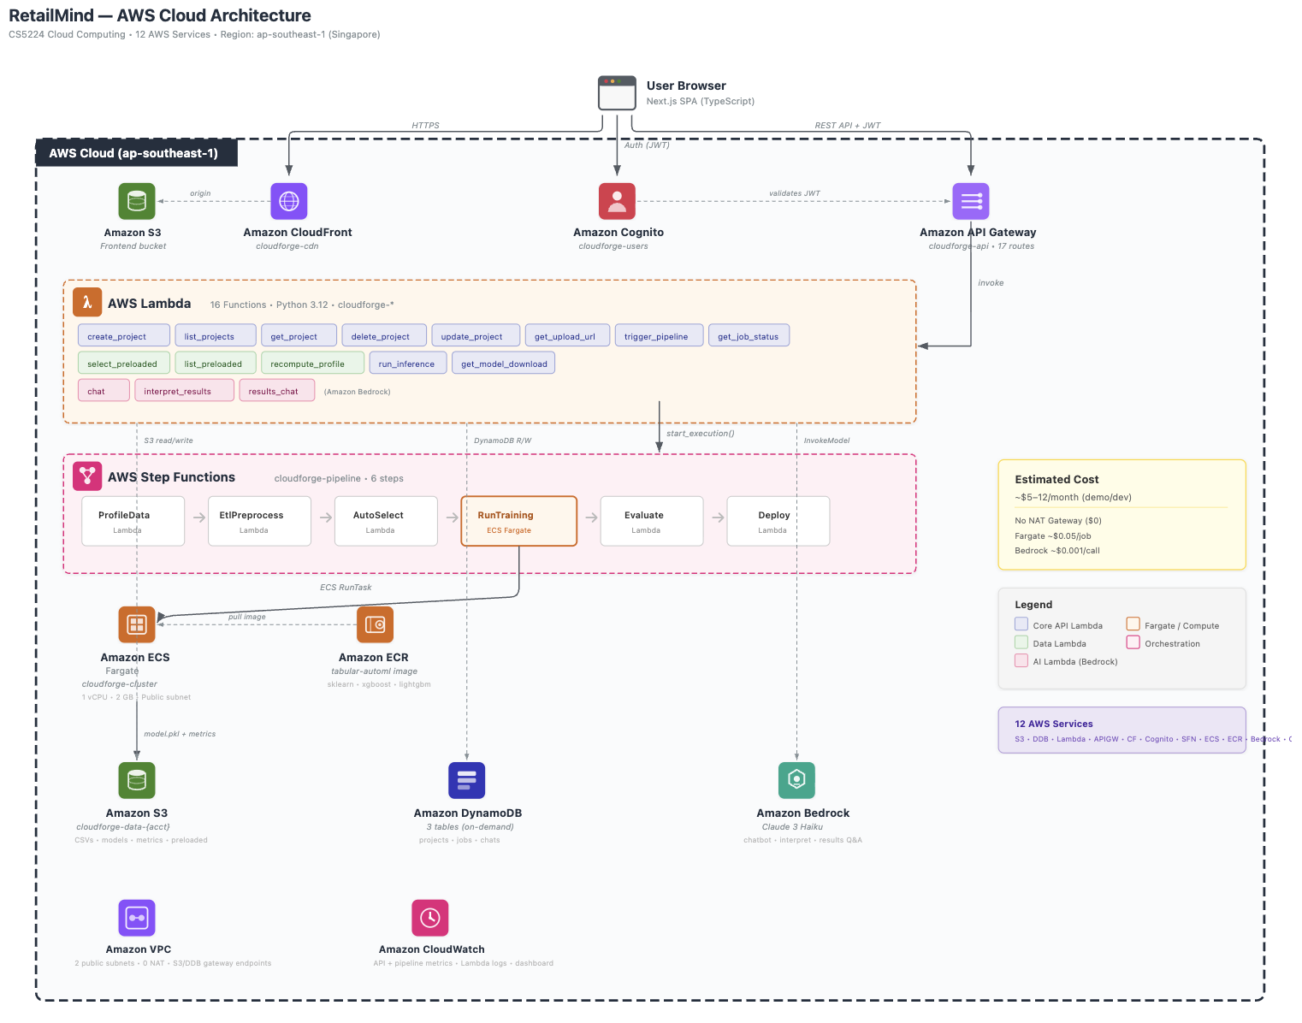
Figure 2: AWS Cloud Architecture
4.1. System Design and Architectural Rationale
We utilise a serverless architecture for two key reasons: Firstly, as we are first starting with this application, metrics to predict usage and scaling are unreliable, and it is difficult for us to estimate baseline traffic levels or peak workloads. A serverless platform lets us scale compute resources on demand and allows us to handle sudden spikes without manual configuration. Secondly, a serverless application is ideal for our business solution as it is an event-driven workload. We do not require continuous 24/7 compute resources as our ML operations (uploading data, requesting model training and generating visualisation) occur only when triggered by user actions.
We may decide to migrate to a server-based architecture once we have established usage metrics and a baseline usage rate that helps us to generate autoscaling policies on EC2, as well as get a better estimate of cost metrics to compare the cost of serverless to server-based.
4.2. Core Components and Services

Service | Primary Function | Rationale for Selection
Amazon Cognito | User authentication and authorisation | Built-in security, scalability, and compliance
CloudFront + S3 | Frontend React app delivery (static hosting) | Better control over configuration and costs
API Gateway | Single HTTPs entry point and routes requests to lambda functions | Centralized security, throttling, and monitoring
AWS Lambda | Backend API layer (this contains all our application routes and logic) | Cost-effective for short-duration requests
AWS Step Functions | ML Workflow Orchestration | Stateful management of ML pipelines with built-in retry logic
AWS Fargate | Containerised python workers for ML model training (>15 mins job) | No server management, automatic scaling, pay-per-use
Amazon S3 | Store user-uploaded CSVs, model artifacts, and preprocessing outputs | Virtually unlimited scalability, integrated with AWS ecosystem
DynamoDB | Project metadata, job status/metrics, and chat session history | NoSQL flexibility, serverless scaling, lower latency for metadata queries
Amazon Bedrock | Conversational AI (chatbot) and business insight generation | Regional availability with integrated AWS security
EventBridge | Event routing and scheduled retraining triggers | Native ECS integration, serverless cron, zero cost
Table 3: Core Services
4.3. Architecture Implementation
The overall architecture is event-driven, enabling asynchronous processing to handle long-running ML training tasks without blocking the user interface. The frontend uses Next.js webpage served via CloudFront, with backend logic handled by AWS Lambda acting as the API layer, where API calls are routed through Amazon API Gateway. Users will authenticate through Amazon Cognito. We separate the data storage into Amazon S3 for user-uploaded datasets and ML model artefacts (e.g., plots, learned weights/parameters) as well as Amazon DynamoDB for structured metadata. We use AWS Fargate containers to handle long-running ML training jobs, which will be triggered via AWS Step Functions.

AWS Lambda serves as our backend API layer, allowing us to auto-scale and have a pay-per-use flexibility in our application. This keeps our costs low as we do not need a server. As our application may run long-running ML models that exceed 15 minutes, we instead run ML model training jobs as Python containers (scikit-learn) on AWS Fargate, which will be triggered and managed by AWS Step Functions. Step Functions orchestrates the task lifecycle, ensuring that the Fargate container is provisioned, executed, and its results are logged before transitioning to the next state. This allows us to scale automatically (and to zero if idle), which may be useful as this is a new application and we are uncertain about potential traffic flows. As Lambda and Fargate (used purely as a background ML worker) are scaled on demand, we do not need a Load Balancer, unlike when running fixed servers.
4.4. ML Algorithms
The platform supports 19 models across 8 algorithm families. For classification tasks, it offers Logistic Regression, Decision Tree, Random Forest, Gradient Boosting, XGBoost, LightGBM, K-Nearest Neighbours, and Support Vector Machine. For regression tasks, it extends the linear family with Ridge, Lasso, and ElasticNet alongside the standard Linear Regression, and mirrors the remaining classifiers with their regression counterparts: Decision Tree, Random Forest, Gradient Boosting, XGBoost, LightGBM, KNN, and SVR. Each model is paired with a hyperparameter search grid for auto-tuning via randomised cross-validation.
5. Evaluation of the cloud architecture
To ensure that our SaaS product can bridge the data capability gap for SMEs, its performance must be efficient and also cost-effective. Our product’s AWS-based architecture can be evaluated with five key metrics, which will be discussed in Sections 5.1 to 5.4, and 5.5 specifying the business evaluation.
5.1. Architecture Quality
As we are utilising a serverless-first design, we assess the integrity and efficiency of the platform compared to traditional always-on servers. We identified the following performance metrics to evaluate our architecture performance:

Performance Metrics | Concurrent Users | Result
API Latency | Time for API Gateway and | ~ 52ms (warm)  ~ 820ms (cold)
Chatbot and Visualisation Response Time | Monitoring the end-to-end duration for Claude Haiku to generate natural language insights and visualisation metadata. | ~ 4-8s
ML Job Startup time | Time between job request and Fargate task start | ~ 25s (warm)  ~ 60s (cold)
Table 4: Architecture Quality Metrics

5.2. Scalability and Reliability
To evaluate the platform's scalability, we stress-tested both the CloudFront CDN and API Gateway endpoints at levels ranging from 1 to 100 concurrent requests. The CloudFront frontend maintained a perfect success rate with latency scaling predictably from 87ms to 352ms, which confirms that our edge caching is working as intended. Similarly, our lightweight API endpoints stayed under 420ms, proving that the serverless Lambda architecture scales automatically without any need for manual tuning. We observed some performance degradation on the DynamoDB-backed List Projects endpoint at 50 or more concurrent requests. This was due to Lambda throttling limits on our demo account, a standard configuration hurdle that can be fixed smoothly in production by increasing reserved concurrent execution limits.
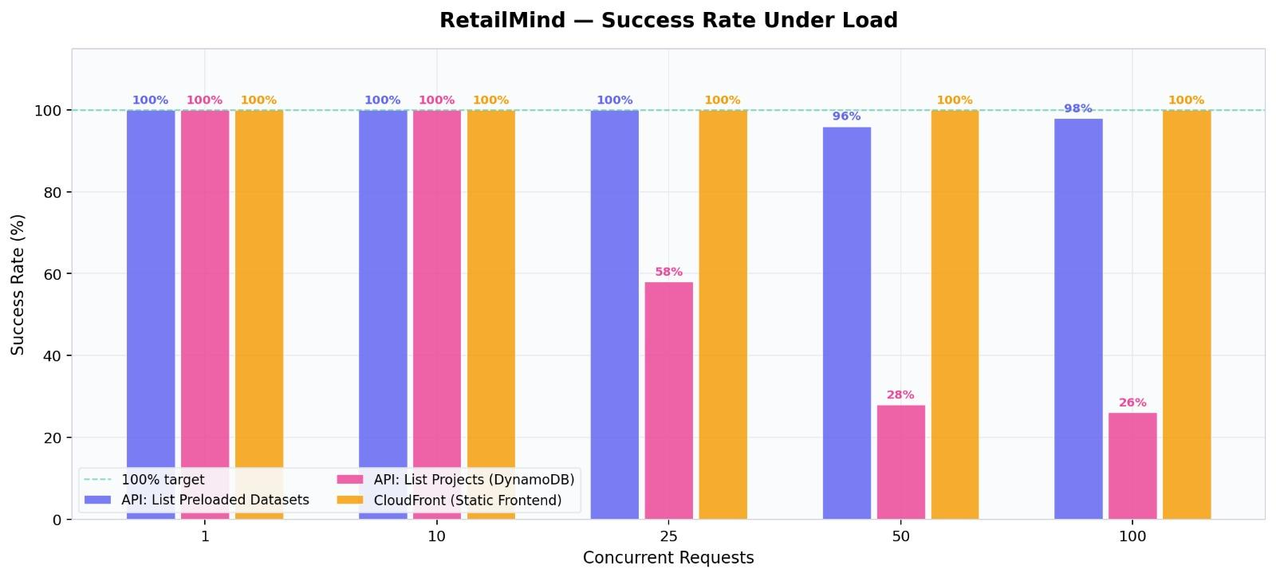
Figure 3: Success Rate Under Load
5.3. Security
Since the platform may process confidential data from SMEs, demonstrating the effectiveness of our security architecture is crucial to establishing and maintaining user trust. Our security testing involved 17 different scenarios focused on authentication, data isolation, and input validation. The platform successfully rejected every request that used a missing, empty, or invalid JWT token. We also confirmed that users are strictly isolated, meaning they cannot access or modify projects belonging to other tenants. One training endpoint did return a 500 error instead of a 403 during an unauthorized access attempt; while the request was still successfully blocked, we have flagged this for more graceful error handling. SQL injection attempts in URL paths are inherently safe as DynamoDB's key-value lookups have no SQL layer to exploit, and any malformed project ID simply resolves to a 404. XSS payloads stored in user input are neutralized by React's automatic output escaping. Overall, response times remained within our target thresholds, with standard reads averaging 122ms and generative chat responses through Claude Haiku averaging 4.8 seconds.
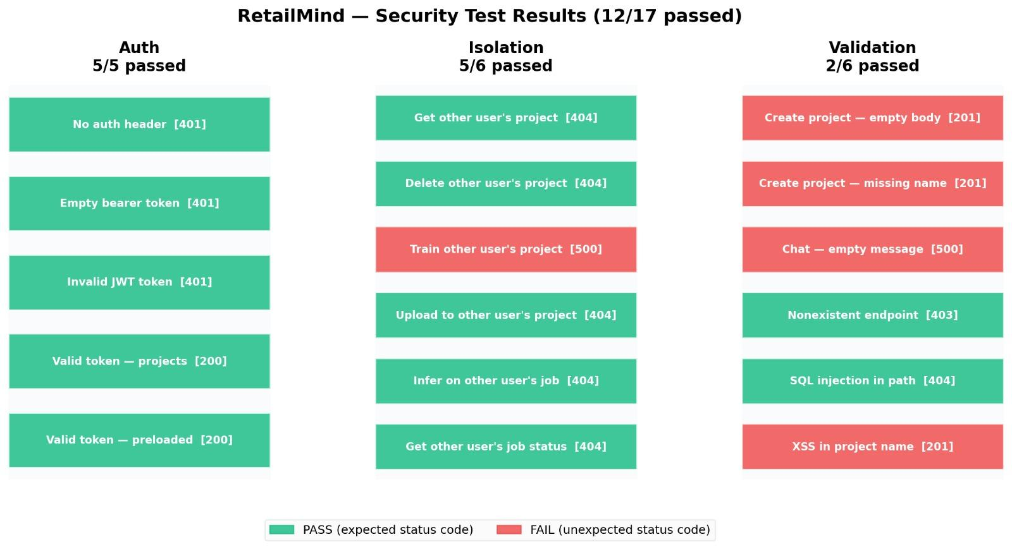
Figure 4: Security Test Results
5.4. AWS Infrastructure Cost Breakdown
To estimate the monthly infrastructure cost of RetailMind, we assume that each user would complete one project per month, with each project corresponding to one training job. The following assumptions are based on the six-stage user journey detailed, from which we estimated each project to generate approximately 15 API calls (2 each for login and data upload, use case selection, problem refinement, and dashboard loading, 3 in total for training trigger and job status polling, and 2 each for cost/quota, and results retrieval). Each project will also invoke seven Amazon Bedrock calls (3 during conversational problem refinement, 2 for AI-generated dashboard insights, and 2 for results interpretation). In terms of storage, each project would store approximately 15MB on Amazon S3, comprising a 10MB raw CSV dataset, a 3MB model artefact, and 2MB of metrics and visualisation outputs. Lastly, each project would generate approximately 30 DynamoDB reads (average 2 reads each for 15 API calls) and 10 writes (to cover project creation, job records, chat history, and stored results). The table below details the approximate monthly infrastructure cost for each load.
Service | Light load | Medium load | Heavy load | Remarks/Calculation basis
 | 10 users, 10 jobs | 100 users, 100 jobs | 1000 users, 500 jobs
VPC | $0 | $0 | $0 | No NAT gateway used
DynamoDB | $0 | $0 | $0
S3 | $0.00412 | $0.0392 | $0.387
Lambda | $0 | $0 | $0
API Gateway | ~ $0.001 | ~ $0.01 | $0.06
Cognito | 0 | 0 | 0
CloudFront | 0 | 0 | $0
Step Functions | 0 | 0 | $0.05
ECS Fargate | ~$0.50 | ~$5 | ~$50 | $0.05/job
ECR | ~$0.20 | ~$0.20 | ~$0.20
Bedrock | $0.07 | $0.70 | $7 | ~$0.001/call (from architecture diagram)
CloudWatch | $0 | $0 | $0
Total | ~$0.80 | ~$5.95 | ~$57.70
Table 5: Table summarising AWS Infrastructure Cost Breakdown

5.5. Business-level Key Performance Indicators (KPIs)
To quantify RetailMind’s competitive edge, we benchmarked our platform against Roboflow and Amazon SageMaker (similar in terms of the functions). Focusing on reducing technical barriers and accelerating decision-making, we surveyed 6 users for testing across three key metrics: Zero-training Time-to-Insight (TTI), Intent Alignment, and Recommendation Actionability. The quantitative results are summarised in Tables 6 and 7.

Test Metric | Definition
Zero-training time-to-insight | The time required for a new user to go from login to their first insight without a manual to guide them.
Intent Alignment | The ability of the chatbot to understand business intent and provide reasonable predictive outputs. Tested via 3 distinct business queries, scoring from 0 (does not understand) to 5 (fully understands and provides reasonable outputs)
Recommendation Actionability | To what extent do the results include concrete, actionable business suggestions (i.e., “Suggested Next Steps” and “Key Business Takeaways”). Content analysis scored from 0 (no actions) to 5 (fully expressed suggestions).
Table 6: Test Metrics and Definition

Quantitative Test Metric | RetailMind | Roboflow | Amazon SageMaker
Zero-training time-to-insight | ~ 08:30 min | ~ 08:10 min | ~ 09:15 min
Intent Alignment | 4.25/5 | 2.6/5 | 5/5  *Requires a technical background to achieve the result
Recommendation Actionability | 4.5/5 | 0/5 | 4/5
Table 7: Quantitative Test Metrics Results on 6 users

Beyond the quantitative metrics, our qualitative assessment highlights how RetailMind specifically addresses the resource constraints of retail SMEs. These insights explain the reason behind our test results:

Expertise Gap Bridging through Automation: Retail SME datasets frequently contain missing values and inconsistent data types. While Amazon SageMaker achieves a higher intent alignment score, it imposes some technical barriers, requiring users to possess coding skills and cloud architecture knowledge for data preparation and model training. Similarly, Roboflow, despite having a chatbot interface to guide users through building the workflow, still relies heavily on technical jargon in the conversation and alienates non-technical users. RetailMind stands out against other competitors in allowing users to “learn by doing”. From data preprocessing to model training, every stage is guided by an intuitive interface and a conversational AI that simplifies complex data science tasks into an interactive experience.

Retail-Specific Intelligence: Unlike general-purpose AI, RetailMind is engineered with a retail-specific knowledge base that allows the system to speak the business language. While Amazon SageMaker provides a high-performance toolbox, users must manually build the retail context from scratch (i.e., defining KPIs and clearing the industry-specific data anomalies). In contrast, RetailMind understands the business terms and provides the pre-tuned inferences. On the other hand, while Roboflow advances in visual computation (e.g., shelf-monitoring or foot traffic), the vast majority of SME management decisions depend on structured transactional data (e.g., sales forecasting and membership ROI). RetailMind bridges this gap by focusing on a structured dataset and directly driving profitability.

Unified All-in-One Ecosystem: A major pain point with SageMaker is its fragmented architecture, where tasks are separated into siloed sections that do not intuitively communicate. This disjointed workflow significantly increases the cognitive load on the user. In comparison, RetailMind advances in unifying the entire user journey, allowing a new user to onboard more effortlessly, as well as allowing a more straightforward process for users who focus on the “data to decision-making” process more than other sections.
6. Conclusion and Possible Future Work
RetailMind has demonstrated the potential to address the critical gaps within the SME landscape through this cloud-native, retail-specific analytics platform. Built on a serverless AWS architecture, the platform achieves near-zero idle cost, predictable tiered pricing and competitive security posture. These characteristics well filled in the financial and technical gap that prevent most SMEs from data-driven decision-making adoption.
Several directions could further strengthen RetailMind’s capabilities and market reach. This includes: (1.) Improve Input Validation and Error Handling. Several validation test cases incorrectly returned 201 instead of rejecting the malformed inputs such as empty request bodies, missing fields, and XSS payloads. Additionally, one training endpoint returned 500 instead of 403 during an unauthorized access attempt. Both issues should be addressed for production deployment. (2.) Multi-Region Expansion. The current architecture is anchored to ap-southeast-1for Singapore data residency. As the user base grows, deploying to additional AWS regions would reduce latency for users in other potential markets while preserving local compliance requirements. (3.) Migration to Server-Based Architecture. Once reliable usage metrics are established, a partial migration from fully serverless to EC2-backed autoscaling for ML training layer may offer better cost efficiency at high sustained loads, particularly for heavy-load scenarios as outlined in Section 5.4.

7. Code Explanation and AI Declaration
Code base can be accessed through this Github repository: Group28_repo.
The following AI tools were used throughout the project:
- Claude 3 Haiku: used to develop the “chatbot and recommendation” features within the application
- Claude Opus: assisted with debugging and supporting the application development process.
- GPT-4.5: used to refine and improve the clarity of expressions in the report.
All content, structural design, and implementation decisions were conceived and developed by our group.

How Digital Services Empower SMEs and Start-Ups: https://itif.org/publications/2025/08/27/how-digital-services-empower-smes-and-start-ups/
Specific calculations and cost breakdown
User evaluation record: CS5224_user evaluation

