Bug Report:

- Analysis setup shall include non-feature targets (i.e., this case total price earned = price per unit * total amount)
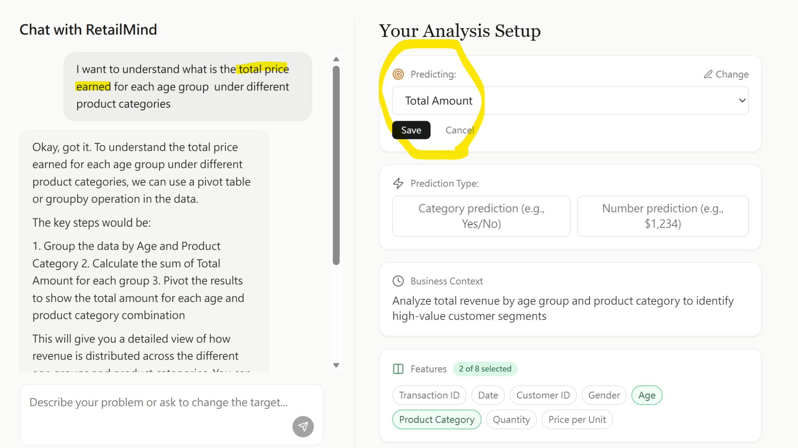

- Bar chart padding - can allow users to specify? (i.e., x axis group a bar for every xxx unit)
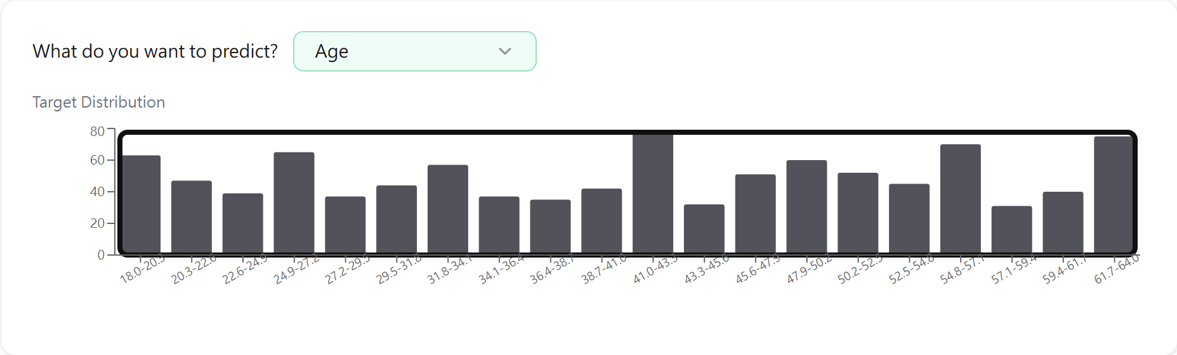

- Category columns → check logic (for my current test dataset shall be 2 categorical columns)
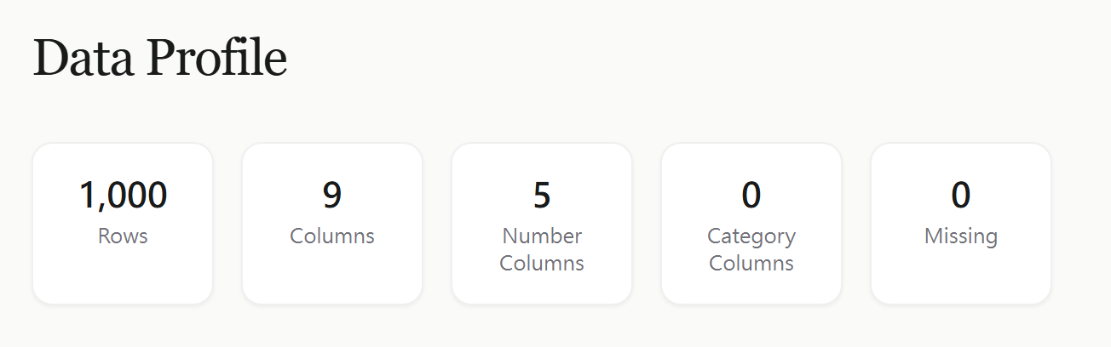

- Auto Feature Selection button:
  - Did not remember the original business query and output the expected features
  - Turning off selection button → shall have all columns ticked (including target feature)
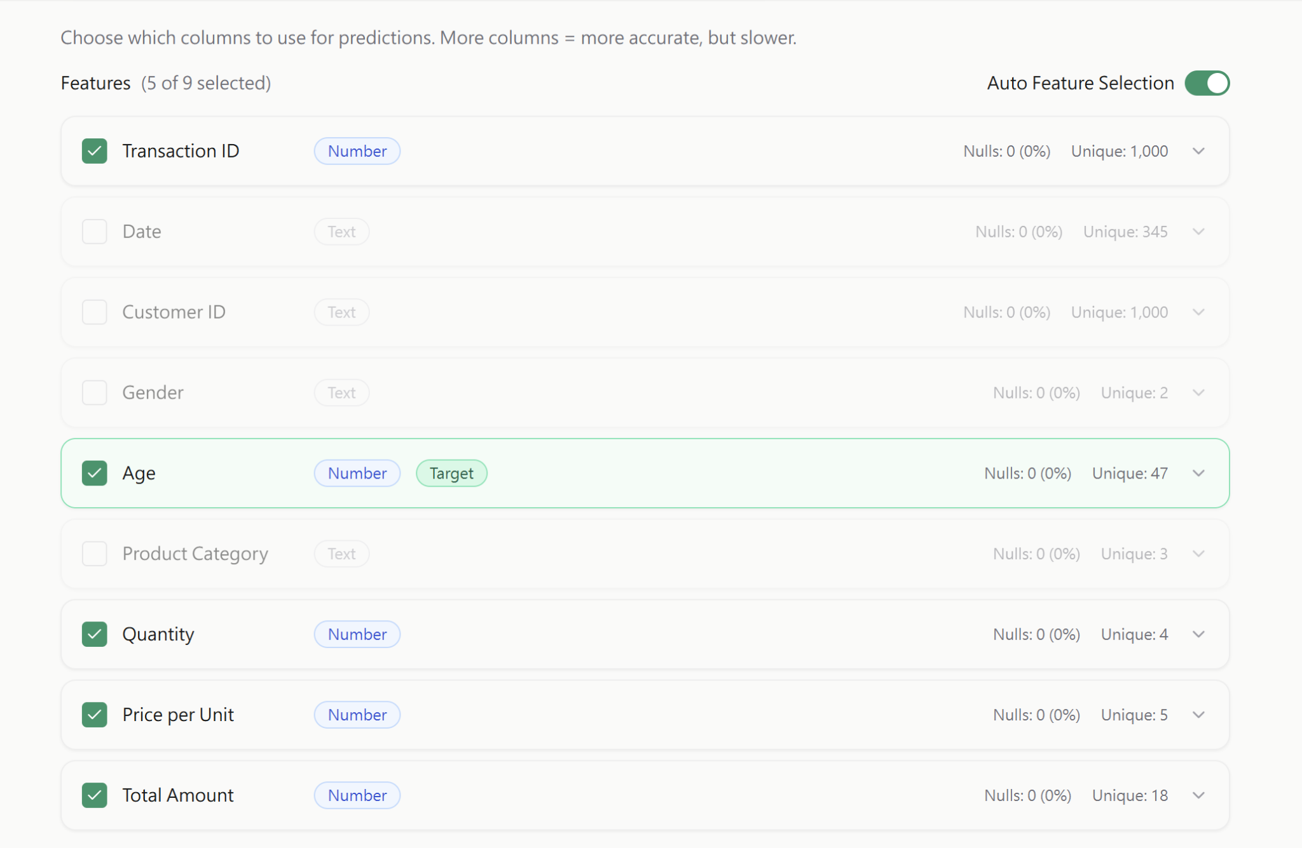

- Cost Estimate not hard-code available?
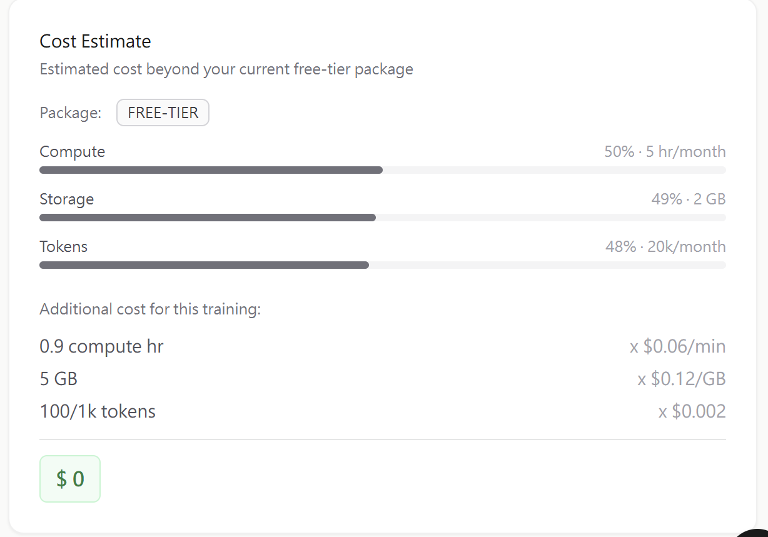

- Add a “Back to Profile” button under Train section

- Fix pie chart label (either label Male (46%) be visible with Female (54%), or have a table specify the numbers at the side)
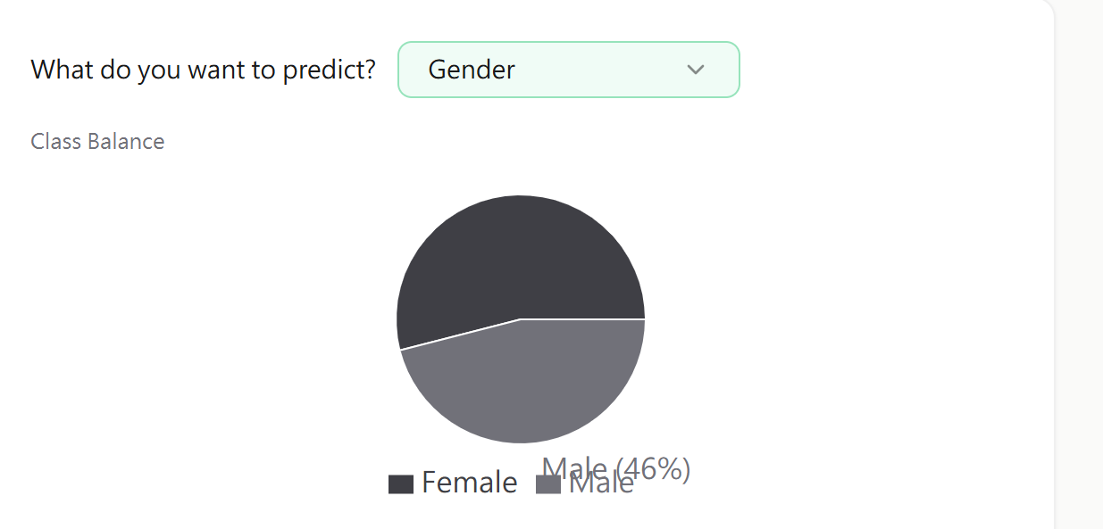

- Remove in chatbot
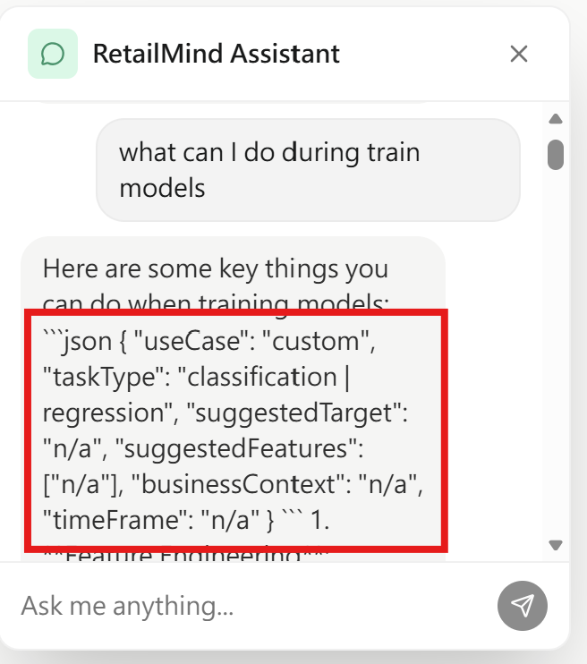

- Make a prediction:
  - clarify interpretation (in this case, the interpretation ideally shall be: The model predicts the spending score for age = 20 and annual income = 10000k as 46 out of 100 with a 100% confidence)
  - Prediction score and confidence score looks hardcoded
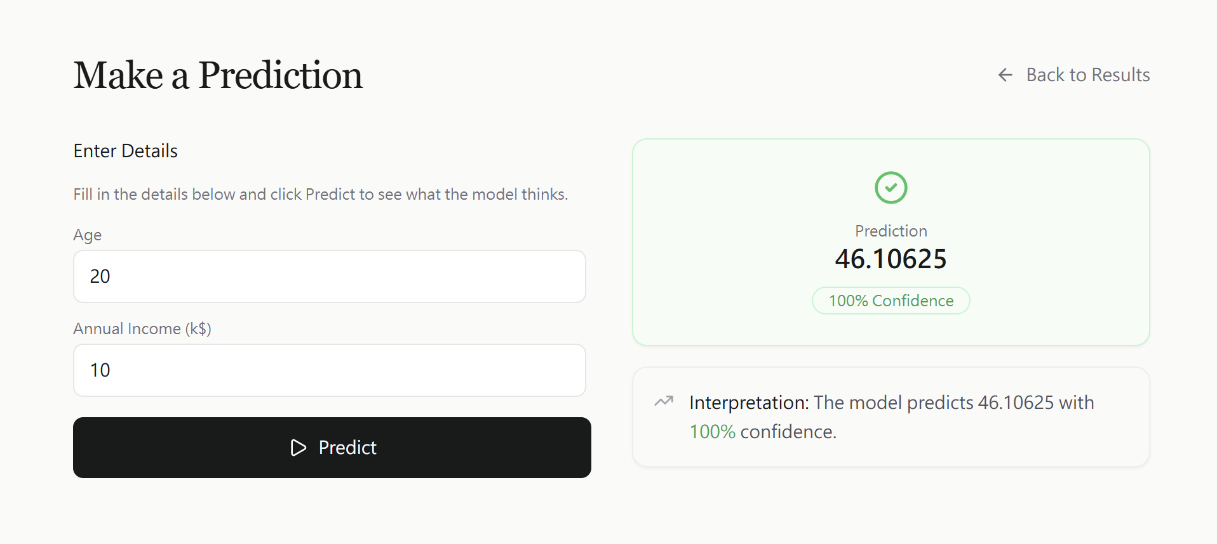

- Task classification in Training stage
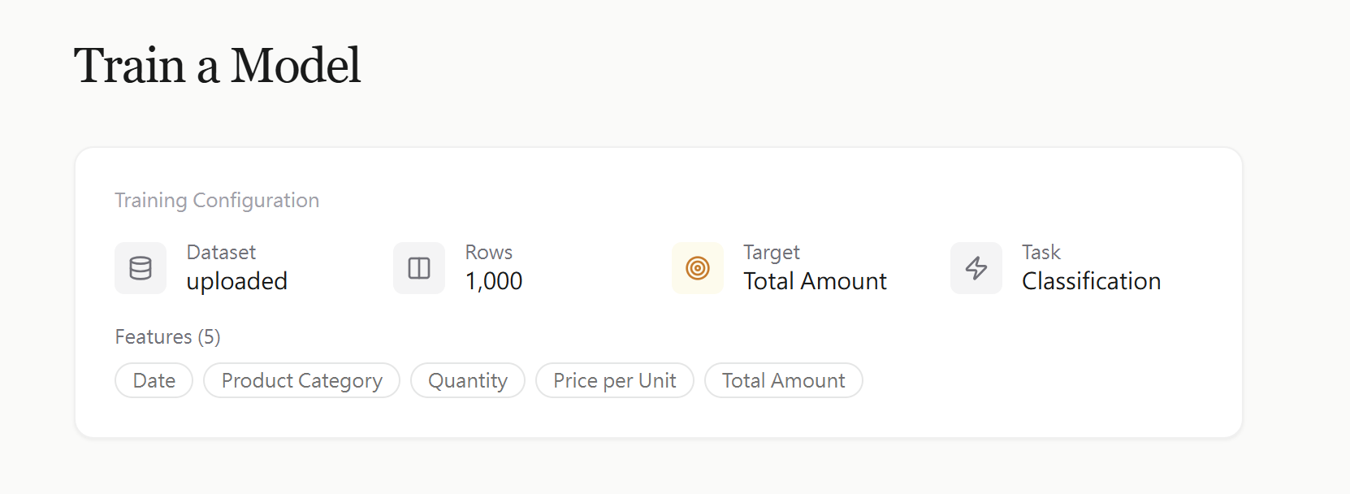
- The input question was: Predict the total amount for “Beauty” products in year 2027
- Training task: shall be regression not classification
- Train duration looks hardcoded (36.7s) -> does not match the exact time
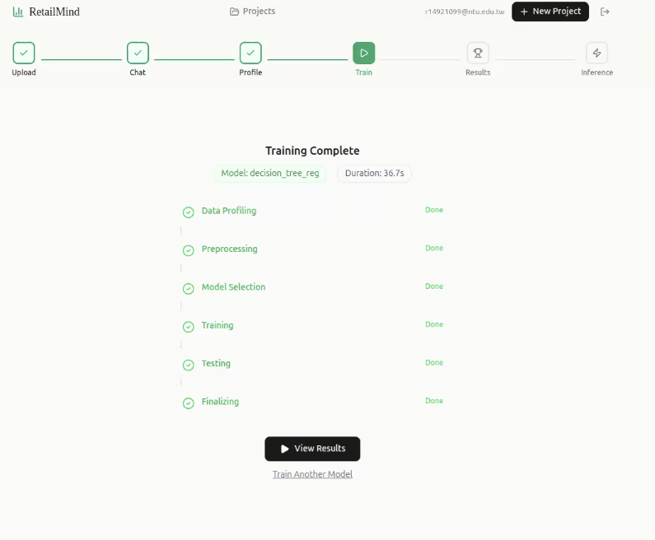
- Feature importance:
- shall output all features (? not only one
- Model performance looks hardcoded
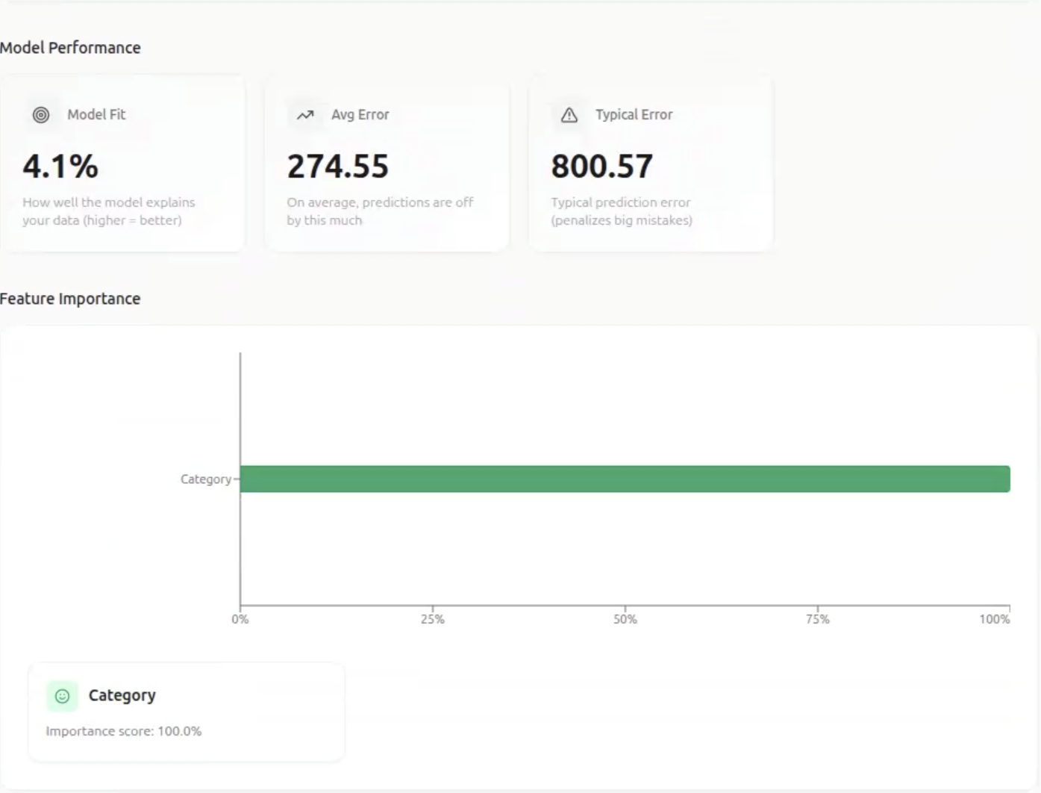

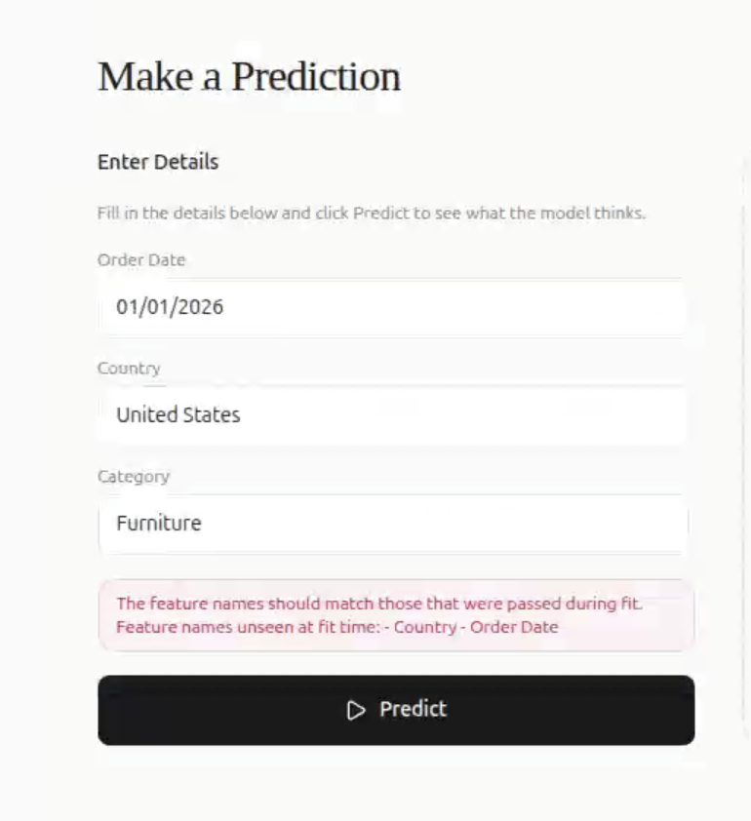
- Cannot find feature names (checked feature input same as dataset)

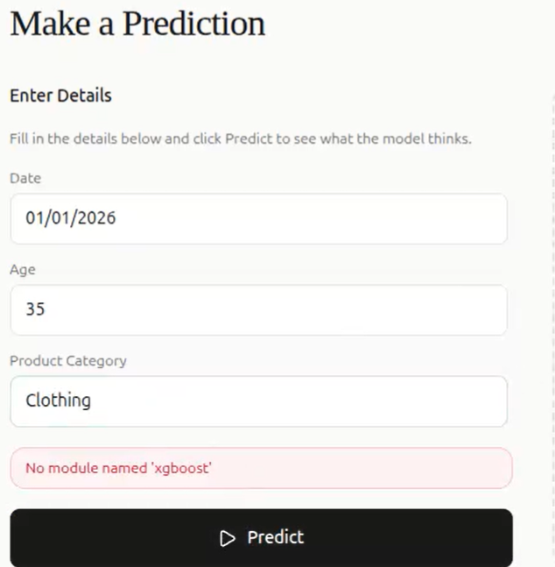

- Can be drop down menu?

