GlassCasino: Secure, fair iGaming in a decentralized age

Adam Hodson  
L3 BSc Computer Science ProjectDurham Univeristy, UK  
qvhf99@durham.ac.uk

*Abstract* —

Background: -

Aims: -

Method: -

Results: -

Conclusions: -

*Keywords* — Blockchain, Ethereum, Smart Contracts, MATIC, iGaming, gambling, Web3, Vue, Solidity

# **Introduction**

In recent years, blockchain technologies have exploded in popularity. Particularly during the 2020-2021 COVID-19 pandemic where we saw a sharp rise in interest in these technologies; largely credited to NFTs (Dowling, 2021). The industry is now far beyond scope of an “electronic cash system” proposed in the seminal paper on blockchain (Nakamoto, 2008) as recently interest now lies in how classical, centralized systems and networks can be moved to incorporate blockchain to harness its various advantages.

This project considers one of the practical applications of blockchain as a replacement for the status quo in the industry of iGaming (internet-based chance games). We aim to use to use blockchain technologies to create a transparent, cryptographically secure, and fair gaming platform. This will consist of a user interface, blockchain-based assets, and a backend server to manage tasks that still cannot be done on-chain.

## **Background**

A blockchain is fundamentally a widely distributed ledger of transactions. It is backed by a consensus algorithm to stop bad actors from manipulating the transaction history for their benefit. A group of transactions is grouped into a ‘block’ with a unique identifier in the form of a hash. This hash, along with the transactions in the block, is used to create the next hash. For a new block to be added to the chain, consensus must be reached that it is valid by all nodes on the network. From this it is obvious that the longest, valid chain on the network is the source of truth.

Figure 1 – The block structure used in Bitcoin (Nakamoto 2008).

The consensus algorithm proposed by Nakamoto in his 2008 paper is Proof-of-Work (PoW). Bitcoin’s PoW algorithm works by incrementing a nonce value in the block until a value is found that satisfies the hash. Since editing the block would change the hash (and thus create the need to re-validate it) we end up with an immutable chain of validated transactions. To attack the network, the attacker would have to control more than half of the nodes of the network as otherwise the non-malicious nodes chain will outpace the attacker’s chain. The act of validating a block is called mining and is often a pooled effort due to the enormous amount of computing power required. Miners are rewarded with ‘coins’ which are then traded around the network in the blocks’ transactions, thus forming a currency.

However, PoW is slowly falling out of favor in the industry due to severe bottlenecking as the blocks’ hash difficulty is raised and the high energy consumption (Li et al., 2019) raising environmental concerns. More modern blockchain projects like ADA or ADA are backed by Proof of Stake (PoS) consensus protocols. It is more sustainable in terms of energy consumption and is less vulnerable to malicious miners attacking the network (Nguyen et al., 2019). This is because blocks can only be validated by miners who have staked that much in a coin. This discourages powering up the most powerful computers en-masse and instead encourages investment into the cryptocurrency to be a validator.

Second generation blockchains like Ethereum (ETH) introduced the concept of a ‘smart contract’ (Buterin, 2014). This effectively allows Turing-complete programs to be written and deployed to the network. In this regard, Ethereum is more of a distribute state machine than a distributed ledger as each node on the Ethereum network runs an instance of the EVM to allow them to process the operations of a smart contract. This allows for anyone to deploy a smart contract with their own code, run it and receive completely deterministic results in a trustless decentralized network. This is an incredibly powerful concept and has countless possible applications that are only just beginning to be explored.

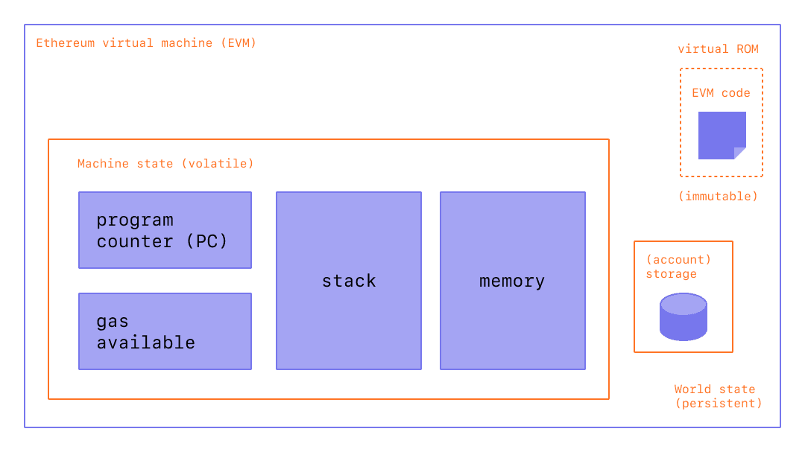

Figure 2 – Diagram of the Ethereum virtual machine (EVM)

# **Related Work**

## **Ethereum**

Ethereum forms the backbone of much of the work this project is built on in the form of smart contracts. Ethereum mart contracts are usually written in a high-level language called Solidity which is a classic curly-braced language. This was built for developer QoL as the EVM can, as a Turing machine does, only complete simple bitwise operations like AND, XOR, etc. with some extra blockchain specific operations like KECCAK256 among others. This means much work has been done to build tooling and interpreters to turn this high-level code into EVM-compatible bytecode.

Ethereum relies on two things: its primary token ETH and the concept of gas. ETH is sometimes called the Ethereum networks gas token. All chains implementing smart contracts follow suit with this concept. Gas is a way of measuring how much compute power a particular operation on a particular smart contract will require. The invoker of the transaction will pay a certain amount of ETH to perform their transaction on the network.

Ethereum was not built with scalability in mind and thus as a PoW, bloated network with uncapped gas fees it often leads to incredibly high fees to perform even simple operations as users bid each other up to get the miners to process their transaction in the next available block. Ethereum’s second major flaw is its impractically low TPS (transactions per second) of ~15 across the whole network. Bitcoin suffers a similar issue with ~6 TPS. For reference a centralized payment provider like Visa can handle ~24000 TPS. This severely limits the practical applications of Ethereum in real-time applications like gaming.

The planned 2.0 upgrade should help to fix both these issues but for now, new dApp (decentralized apps) developers are looking towards alternatives.

## **Avalanche**

Avalanche is a high-performance, scalable, customizable, and secure blockchain platform (Sekniqi et al., 2020). It introduces a new consensus protocol called Snow, which is part of a family of leaderless Byzantine fault tolerance protocols (Rocket et al., 2019). Touting ~3400 TPS under heavy load with ~1.35 second transaction confirmation times it is the current fastest smart contract platform available for use by developers today. This new consensus protocol is also very secure and resilient to a 51% attack.

The avalanche network consists of three chains: X, P and C. For *exchanging*, building *platforms* and deploying/running *contracts* respectively. In simple terms this means exchanges aren’t bogged down by slow smart contracts and vice-versa as each chain is validated by a subnet of validators which all have a stake in the primary network. The C-Chain (Contract chain) is built on the Ethereum virtual machine meaning most Ethereum smart contracts will work effortlessly.

However, Avalanche lacks support for Chainlink VRF (Verifiable random function) which, as the name implies, is quite essential to building chance-based games in a trustless network.

## **Polygon – MATIC**

TODO

## **Chainlink VRF**

TODO

## **Decentral Games**

TODO

## **Axie Infinity**

TODO

# **Solution**

## **Project Outline**

Traditionally, the only thing stopping a casino (online or physical) from cheating the player is its own reputation, as casinos that cheat will lose business. Online casinos can conceal this cheating as their games run on centralized servers where the user will only ever see the outcome of the game and not how it was calculated. This is not the case with a blockchain-based platform thus giving even a new platform instant-legitimacy and creating a viable alternative to much disliked and distrusted giants of the iGaming industry.

This is where our project begins, the industry currently suffers from distrust due to centralization of the games themselves, with 45.5% of users complaining about ‘unfair software’, 59.1% complaining about not being paid properly and, 25.8% ‘not being paid at all’ (Gainsbury et al., 2013, p. 241). A blockchain-based iGaming platform solves these issues completely if the games’ smart contracts are built to be robust, secure and understandable and the blockchain they are based on is reliable and secure.

In this work, we build a platform called GlassCasino to play online multiplayer casino games that run entirely on-chain to reap the benefits stated earlier. The blockchain of choice for our project is the MATIC network from Polygon as discussed in Section II. With high TPS, low gas fees, sleek inter-op with Ethereum and Chainlink VRF support it makes no compromises aside from it being relatively young.

|  |  |  |  |
| --- | --- | --- | --- |
|  | Ethereum (ETH) | Avalanche (AVAX) | Polygon (MATIC) |
| Market cap ($USD) |  |  |  |
| Average TPS |  |  |  |
| Gas price ($USD) |  |  |  |
| ChainLink VRF Support? | **Yes** | Not publicly available | **Yes** |
| ETH interop | **Native** |  |  |

Figure 3 – Comparison of prospective blockchains for our platform (as of 20/10/2021)

TODO - finish explanation of technologies + include diagrams of architecture of platform and smart contracts IO

## **Deliverables**

##### **References**

Buterin, V. (2014). A next-generation smart contract and decentralized application platform. *Etherum*, *January*.

Dowling, M. (2021). Fertile LAND: Pricing non-fungible tokens. *Finance Research Letters*. https://doi.org/10.1016/j.frl.2021.102096

Gainsbury, S., Parke, J., & Suhonen, N. (2013). Consumer attitudes towards Internet gambling: Perceptions of responsible gambling policies, consumer protection, and regulation of online gambling sites. *Computers in Human Behavior*, *29*(1). https://doi.org/10.1016/j.chb.2012.08.010

Li, J., Li, N., Peng, J., Cui, H., & Wu, Z. (2019). Energy consumption of cryptocurrency mining: A study of electricity consumption in mining cryptocurrencies. *Energy*, *168*. https://doi.org/10.1016/j.energy.2018.11.046

Nakamoto, S. (2008). *Bitcoin: A Peer-to-Peer Electronic Cash System*.

Nguyen, C. T., Hoang, D. T., Nguyen, D. N., Niyato, D., Nguyen, H. T., & Dutkiewicz, E. (2019). Proof-of-Stake Consensus Mechanisms for Future Blockchain Networks: Fundamentals, Applications and Opportunities. *IEEE Access*, *7*. https://doi.org/10.1109/ACCESS.2019.2925010

Rocket, T., Yin, M., Sekniqi, K., van Renesse, R., & Sirer, E. G. (2019). *Scalable and Probabilistic Leaderless BFT Consensus through Metastability*. http://arxiv.org/abs/1906.08936

Sekniqi, K., Laine, D., Buttolph, S., & Sirer, E. G. (2020). *Avalanche Platform Whitepaper*. https://assets.website-files.com/5d80307810123f5ffbb34d6e/6008d7bbf8b10d1eb01e7e16_Avalanche%20Platform%20Whitepaper.pdf