**CIS 480 Project – Injection 2**

**Injection**

* Good Morning Team Again! I want to make sure how much our systems and networks are secure. It is always a good idea to find the vulnerabilities and patching them before our enemies discover and exploit them. I do not want to see your heads rolling. You are my ROCKSTARS! I will need to check available services on our e-commerce server. Please address the following injection by Wednesday midnight. Thanks –CIO
* To learn how to scan networks and ports, go to the following sites.
  + <https://www.tutorialspoint.com/nmap-cheat-sheet>
  + <https://www.stationx.net/nmap-cheat-sheet/>
  + <http://www.cyberciti.biz/networking/nmap-command-examples-tutorials/>
* Login to the Proxmox server and start Vyos (router), Kali, and e-commerce server.

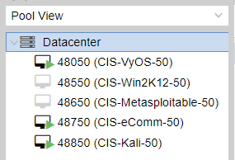

* Each team needs to designate an account for the team and use it to address the injections. Everyone in the team can login to the account using the same credentails and work together.
* Scan the network and identify the IP address of the e-commerce server. You do not need to access the server at all for the project.
* Scan the e-commerce server and detect the version of the services that are running.
* Provide your response to this injection at the end of this document.
* Follow the naming convention for the file. Use this format: CIS480Prj-classX-injY-teamZ.docx, where X is 1 for sec01 and 2 for sec76, Y is injection number, and Z is your team number on the team roster.)
* Everyone needs to participate. At the end, peer evaluation will be requested.
* One submission per team by the leader.
* Schedule

|  |  |  |  |
| --- | --- | --- | --- |
| **Weeks** | **Injections** | **Post** | **Due (midnight)** |
|  | Injection 1 – Introduce the team | Mon, 7th | Tue, 8th |
|  | Injection 2 – Scan the network | Tue, 8th | Wed, 9th |
|  | Injection 3 – Break into the target | Wed, 9th | Fri, 11th |
|  | Injection 4 – File transfer | Wed, 9th | Fri, 11th |
|  | Injection 5 – Treasure hunt | Thur, 10th | Sat, 12th |

**Response to Injection 2**

1. Team members: *Addison Phillips, Ryan Spillman, Noah Leon*

2. A screenshot for the IP address of the server.

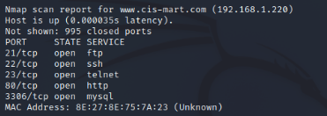

3. A screenshot that displays the version of the services that are running on the server.

