Electrostatic Field Methods

Amber03 with Explicit TIP3P Water

Reaction Field Electrostatics

Hybrid Solvent Reaction Field Electrostatics and Solute Coulomb Field
<Body text to begin here.>

Amber03 with Poisson-Boltzmann Continuum Solvent
Solutions to the LPBE were calculated using APBS’s multigrid solver. For both one-dimensional and two-dimensional umbrella-sampling strategies, each frame was examined using APBS, and a Boltzmann-weighted average field for each system was calculated based on the dihedral probability distributions previously described. A two-stage manual focusing strategy (APBS keyword “mg-manual”) was used, in which the system was centered in a 240 Å x 240 Å x 240 Å box with 97 grid points in each dimension and a single Debye-Huckle boundary condition at 300 K. A cubic B-spline was used to map the discretized atomic point charges to the grid. Ion concentrations of 0.150 M +1 charge ions of radius 2.0 Å and 0.150 M -1 charge ions of radius 2.0 Å were included to account for buffer in solution. We used the molecular surface model (“srfm mol”) with a surface sphere density of 10.0 (“sdens 10.0”). The solvent dielectric was 78.0, appropriate for bulk water. The choice of protein dielectric is significantly more ambiguous, with values typically ranging from 2 to 40.²⁶ When all interactions are treated explicitly (permanent dipole moments, induced dipole moments (polarizability), and explicit solvent), a protein dielectric of one is most appropriate. Since we have directly modeled structural fluctuations but not polarizability, we chose an interior dielectric of 2.0. Because the calculated field scales linearly with the interior dielectric chosen, and thus the choice of interior dielectric to be used is by no means well defined,²⁹ we are less concerned with the value of the protein dielectric, since an “ideal” dielectric value can be extrapolated from the slope of the fit to experimental data (vida infra).
The first-stage box provided the boundary conditions for the second-stage box, and various strategies for constructing second-stage boxes were examined. Different combinations of box center locations, box dimensions, and the number of grid points were examined, as described in the Introduction. By translating the box away from the solvent and towards the protein, we hoped to reduce how often the discontinuity in dielectric environment occurs in the second-stage calculation. The remaining parameters used were identical to those of the first-stage box.
Three different box centers were used: the Cδ atom of the cyanocysteine side chain (i.e nitrile carbon), the center of mass of the entire system (excluding water), and the center of mass of the RalGDS protein containing the thiocyanate probe (excluding water). These boxes will be referred to as NCδ, system center of mass, and RalGDS center of mass, respectively. Representative snapshots of each box are shown in Figure 1-1 for the nitrile probe positioned at RalGDS N27C_{SCN} (black: 60 Å system center of mass; red: 10 Å NCδ; green: 10 Å system center of mass; and blue: 10 Å RalGDS center of mass). The position of the nitrile Cδ was selected as the center of the NCδ box. The center of the system center of mass box was selected as a point along the vector between the furthest of the nitrile Cδ and Nε and the center of mass of the Rap/RalGDS system. If the distance to the center of mass of the system and the furthest of the nitrile atoms was less than 45% of the smallest box dimension (90% of half the smallest dimension), then system center of mass was the center of mass of Rap/RalGDS system. Otherwise, the box center was translated 45% of the smallest box dimension toward the center of mass of the Rap/RalGDS system. This treatment ensures that the entirety of the Cδ-Nε bond vector is always within the box. RalGDS center of mass was treated in the same manner, expect it used only the center of mass of the RalGDS part of the protein. In the case of calculations conducted on SCN-containing RalGDS monomer structures, RalGDS center of mass and system center of mass were identical.
Six sets of box size and grid dimensions were used. The 30 Å box and 60 Å box were centered on system center of mass. The other four boxes were each centered on NCδ, system center of mass, and RalGDS center of mass, with four different sets of grid spacings (GS), for a total of 14 calculations per frame (excluding the first-stage box calculations): two 19³ Å³ boxes with 161 and 193 grid points in each dimension with a GS of 0.119 Å/grid point and 0.099 Å/grid point respectively; two 10³ Å³ boxes with 161 and 193 grid points in each dimension with a GS of 0.062 Å/grid point and 0.052 Å/grid point respectively; a 30 Å x 45 Å x 40 Å box with 129 x 193 x 161 grid points in each dimension with a GS of (0.234, 0.234, 0.250) Å/grid point; and a 60 Å x 45 Å x 40 Å box with 257 x 193 x 161 grid points in each dimension with a GS of (0.234, 0.234, 0.250) Å/grid point. Box sizes will be referred to as the 10 Å box, 19 Å box, 30 Å box, and 60 Å box, respectively, while grid dimensions will be referred to as 161 grid points, 193 grid points, 129 grid points, and 257 grid points, respectively.
The reaction field method was used for the 10 Å box and 19 Å box using 193 grid points for each as well as for the 60 Å box. The system parameters are identical to those previously described for the first term in equation 5. For the second term in equation 5, the solvent and interior dielectric were both set to 2.0. The analytic Coulomb protein field was taken using the typical Coulomb field expression with a dielectric value of 2.0 and projecting the electrostatic field vector along the nitrile bond vector. This was done for the NCδ box location, system center of mass box location, and RalGDS box location. In total, 7 additional calculations were carried out per frame (excluding the first-stage box calculations).
The field along the nitrile bond length was calculated by examining the potential gradient along the bond vector. This was done by inserting 11 dummy atoms with charge, mass, and radius of zero, evenly spaced along the nitrile bond length. The potential at each of these dummy atoms was interpolated from the nearest grid points using a linear spline with the “write atompot flat” keyword in APBS. It was observed that the potential changed linearly within ~0.3 Å of the bond midpoint, so the central five dummy atoms were used to determine a first order polynomial of potential versus position, and the electrostatic field at the bond midpoint was taken as the negative of the slope.
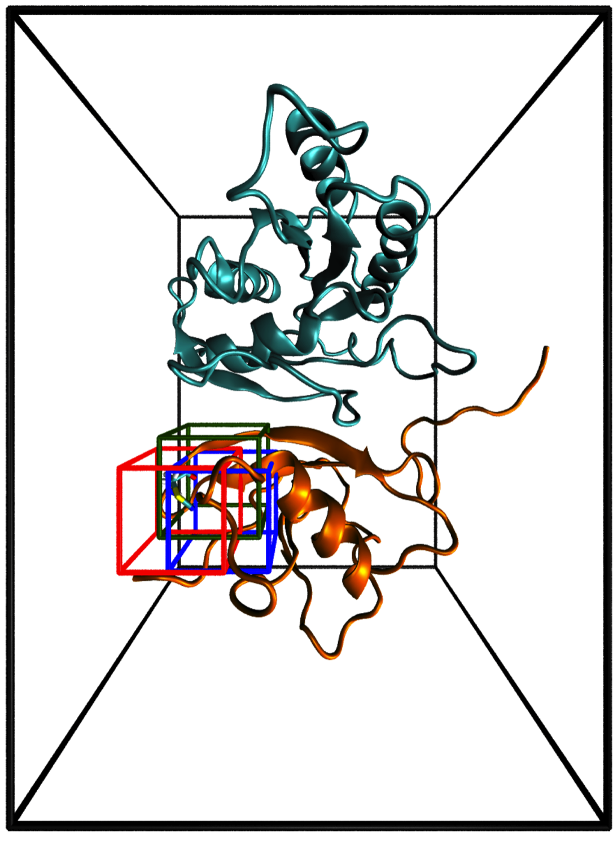

Figure 1-1: Representation of Second-Stage Box Positions
A representative snapshot of the WT Rap-RalGDS N27C_{SCN} protein complex demonstrating the position and sizes of the boxes used to calculate electrostatic fields in APBS. Black: 60 Å system center of mass; red: 10 Å NCδ; green: 10 Å system center of mass; blue: 10 Å RalGDS center of mass.

Reaction Field Method
<Body text to begin here.>

Grid spacing and size
<Body text to begin here.>

Box Location
<Body text to begin here.>

Amber03 with Poisson-Boltzmann Continuum Solvent and Select Explicit TIP3P Water Molecules

5 Å Water Sphere Around the Vibrational Chromophore
<Body text to begin here.>

Single Water Molecule Nearest the Vibrational Chromophore
<Body text to begin here.>

Water Molecular Hydrogen Bonding to the Vibrational Chromophore
<Body text to begin here.>

AMOEBA

Poisson-Boltzmann Continuum Solvent
<Body text to begin here.>

Explicit AMOEBA Water
<Body text to begin here.>

Charge Penetration Field Corrections
<Body text to begin here.>

