Barracuda CloudGen WAF on the AWS Cloud

Quick Start Reference Deployment

July 2020

<Reese Pitman, Partner organization>

<Troy Ameigh, AWS Quick Start team>  
<Brett Wolmarans, Barrcuda team>

Visit our [GitHub repository](https://github.com/aws-quickstart/tbd) for source files and to post feedback,   
report bugs, or submit feature ideas for this Quick Start.

Contents

Overview 2

Barracuda CloudGen WAF on AWS 2

Cost and licenses 2

Architecture 3

Planning the deployment 5

Specialized knowledge 5

AWS account 5

Technical requirements 5

Deployment options 7

Deployment steps 7

Step 1. Sign in to your AWS account 7

Step 2. Subscribe to the Barracuda CloudGen WAF for AWS AMI 7

Step 3. Launch the Quick Start 8

Option 1: Parameters for deploying <software> into a new VPC 9

Option 2: Parameters for deploying Barracuda CloudGen WAF for AWS into an existing VPC 10

Step 4. Test the deployment 12

Best practices for using <software> on AWS 13

Security 13

<Other useful information> 13

FAQ 13

Send us feedback 13

Additional resources 14

Document revisions 14

This Quick Start was created by Barracuda Networks in collaboration with Amazon Web Services (AWS).

[Quick Starts](http://aws.amazon.com/quickstart/) are automated reference deployments that use AWS CloudFormation templates to deploy key technologies on AWS, following AWS best practices.

# Overview

This Quick Start reference deployment guide provides step-by-step instructions for deploying the Barracuda CloudGen WAF on the AWS Cloud.

This Quick Start is for users who use WAFs to protect applications hosted in AWS. Typically, organizations deploy the Barracuda WAF to protect web-facing applications they are either deploying in or migrating to AWS. The Barracuda WAF is designed to offer a highly-configurable set of controls, enabling easier migration and security for formerly on-premises workloads now deployed in AWS. It operates as a Reverse Proxy, inspecting traffic in both directions, so it also provides Data Loss Prevention features.

Please know that we may share who uses AWS Quick Starts with the AWS Partner Network (APN) Partner that collaborated with AWS on the content of the Quick Start.

## Barracuda CloudGen WAF on AWS

The WAF runs on the M4 and M5 families of EC2 instances

## Cost and licenses

You are responsible for the cost of the AWS services used while running this Quick Start reference deployment. There is no additional cost for using the Quick Start.

The AWS CloudFormation template for this Quick Start includes configuration parameters that you can customize. Some of these settings, such as instance type, affect the cost of deployment. For cost estimates, see the pricing pages for each AWS service you will use. Prices are subject to change.

**Tip:** After you deploy the Quick Start, we recommend that you enable the [AWS Cost and Usage Report](https://docs.aws.amazon.com/awsaccountbilling/latest/aboutv2/billing-reports-gettingstarted-turnonreports.html). This report delivers billing metrics to an Amazon Simple Storage Service (Amazon S3) bucket in your account. It provides cost estimates based on usage throughout each month and finalizes the data at the end of the month. For more information about the report, see the [AWS documentation](https://docs.aws.amazon.com/awsaccountbilling/latest/aboutv2/billing-reports-costusage.html).

This Quick Start requires a license for Barracuda CloudGen WAF for AWS. There are multiple licensing options to choose from. For those with existing Barracuda WAF Licenses, a Bring Your Own License option can be found at the following link [BYOL](https://aws.amazon.com/marketplace/pp/Barracuda-Networks-Inc-Barracuda-CloudGen-WAF-for-/B014GEC986). There is also a Pay As You Go option which can be found at the following link [PAYG](https://aws.amazon.com/marketplace/pp/B014GEC526?qid=1592267518468&sr=0-3&ref_=srh_res_product_title). To use the Quick Start in your production environment, sign up for a license at one of the above links before you launch the Quick Start. If you selected the BYOL option place the license key in an S3 bucket and remember its location.

If you don’t have a license, you can deploy the Quick Start with a trial license available in the PAYG option above.. The trial license gives you 30 days of free usage, including usage in a production environment. After this time, you can upgrade to a production license by following the instructions at the [marketplace](https://aws.amazon.com/marketplace/pp/B014GEC526?qid=1588809962120&sr=0-2&ref_=srh_res_product_title)

The Quick Start requires a subscription to the Amazon Machine Image (AMI) for Barracuda CloudGen WAF for AWS; you will add this AMI to your account by clicking on one of the Licensing options above and following the subscription process.

# Architecture

Deploying this Quick Start for a new virtual private cloud (VPC) with **default parameters** builds the following Barracuda CloudGen WAF for AWS environment in the AWS Cloud.

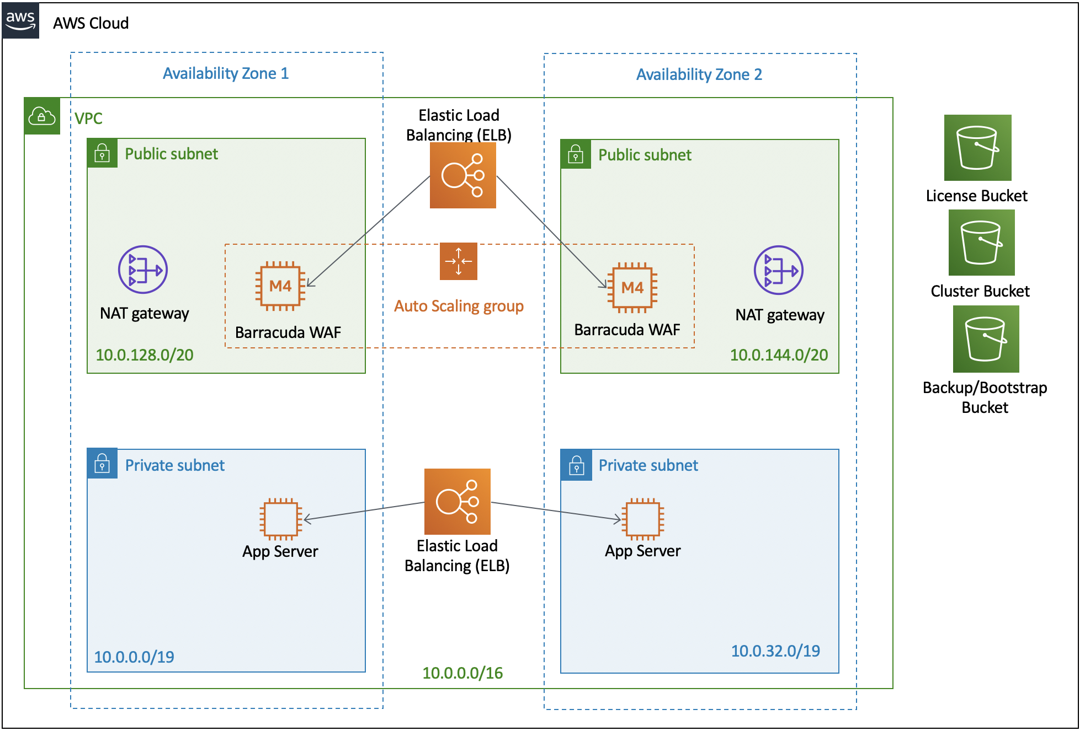

Figure 1: Quick Start architecture for Barracuda CloudGen WAF for AWS

As shown in Figure 1, the Quick Start sets up the following:

* A highly available architecture that spans two Availability Zones.*
* A VPC configured with public and private subnets, according to AWS best practices, to provide you with your own virtual network on AWS.*
* In the public subnets:
* A Network Load Balancer pointing to 2 WAF instances
* 2 Barracuda WAF instances

**\*** The template that deploys the Quick Start into an existing VPC skips the components marked by asterisks and prompts you for your existing VPC configuration.

# Planning the deployment

## Specialized knowledge

This Quick Start assumes familiarity with networking, firewalls, web security.

This deployment guide also requires a moderate level of familiarity with AWS services. If you’re new to AWS, visit the [Getting Started Resource Center](https://aws.amazon.com/getting-started/) and the [AWS Training and Certification website](https://aws.amazon.com/training/). These sites provide materials for learning how to design, deploy, and operate your infrastructure and applications on the AWS Cloud.

## AWS account

If you don’t already have an AWS account, create one at [https://aws.amazon.com](https://aws.amazon.com/) by following the on-screen instructions. Part of the sign-up process involves receiving a phone call and entering a PIN using the phone keypad.

Your AWS account is automatically signed up for all AWS services. You are charged only for the services you use.

## Technical requirements

Before you launch the Quick Start, your account must be configured as specified in the following table. Otherwise, deployment might fail.

|  |  |  |  |  |  |  |  |  |  |  |  |  |  |  |  |  |  |  |  |
| --- | --- | --- | --- | --- | --- | --- | --- | --- | --- | --- | --- | --- | --- | --- | --- | --- | --- | --- | --- |
| [Resources](http://docs.aws.amazon.com/general/latest/gr/aws_service_limits.html) | If necessary, request [service quota increases](https://console.aws.amazon.com/servicequotas/home?region=us-east-2#!/) for the following resources. You might need to do this if an existing deployment uses these resources, and you might exceed the default quotas with this deployment. The [Service Quotas console](https://console.aws.amazon.com/servicequotas/home?region=us-east-2#!/) displays your usage and quotas for some aspects of some services. For more information, see the [AWS documentation](https://docs.aws.amazon.com/servicequotas/latest/userguide/intro.html).   |  |  | | --- | --- | | Resource | This deployment uses | | VPCs | 1 | | Elastic IP addresses | 2 | | AWS Identity and Access Management (IAM) security groups | 1 | | IAM roles | 1 | | Auto Scaling groups | 1 | | Application Load Balancers | 1 | | M4.large instances | 2 | |  |  | |
| [Regions](https://aws.amazon.com/about-aws/global-infrastructure/) | This deployment includes Barracuda Cloud Gen WAF AMIs which are only available in the following regions. s-east-1, us-east-2, us-west-1, us-west-2, sa-east-1, eu-central-1, eu-west-1, eu-west-2, ap-southeast-1, ap-southeast-2, ap-northeast-1, ap-northeast-2, and ap-south-1. For a current list of supported Regions, see [Service Endpoints and Quotas](https://docs.aws.amazon.com/general/latest/gr/aws-service-information.html) in the AWS documentation. |
| [Key pair](https://docs.aws.amazon.com/AWSEC2/latest/UserGuide/ec2-key-pairs.html) | Make sure that at least one Amazon EC2 key pair exists in your AWS account in the Region where you plan to deploy the Quick Start. Make note of the key pair name. You need it during deployment. To create a key pair, follow the [instructions in the AWS documentation](https://docs.aws.amazon.com/AWSEC2/latest/UserGuide/ec2-key-pairs.html).  For testing or proof-of-concept purposes, we recommend creating a new key pair instead of using one that’s already being used by a production instance. |
| [IAM permissions](https://docs.aws.amazon.com/IAM/latest/UserGuide/access_policies_job-functions.html) | Before launching the Quick Start, you must log in to the AWS Management Console with IAM permissions for the resources and actions the templates deploy. The *AdministratorAccess* managed policy within IAM provides sufficient permissions, although your organization may choose to use a custom policy with more restrictions. |

## Deployment options

This Quick Start provides two deployment options:

* Deploy Barracuda CloudGen WAF for AWS into a new VPC (end-to-end deployment). This option builds a new AWS environment consisting of the VPC, subnets, NAT gateways, security groups, and other infrastructure components. It then deploys the Barracuda Cloud Gen WAF into this new VPC.
* Deploy Barracuda CloudGen WAF for AWS into an existing VPC. This option provisions Barracuda CloudGen WAF for AWS in your existing AWS infrastructure.

The Quick Start provides separate templates for these options. It also lets you configure Classless Inter-Domain Routing (CIDR) blocks, instance types, and Barracuda CloudGen WAF for AWS settings, as discussed later in this guide.

# Deployment steps

## Step 1. Sign in to your AWS account

1. Sign in to your AWS account at <https://aws.amazon.com> with an IAM user role that has the necessary permissions. For details, see Planning the deployment earlier in this guide.
2. Make sure that your AWS account is configured correctly, as discussed in the Technical requirements section.

## Step 2. Subscribe to the Barracuda CloudGen WAF for AWS AMI

This Quick Start requires a subscription to the AMI for Barracuda Cloud Gen WAF in AWS Marketplace.

1. Sign in to your AWS account.
2. Open the page for the [Barracuda CloudGen WAF Pay As you Go](https://aws.amazon.com/marketplace/pp/B014GEC526?qid=1590536656862&sr=0-2&ref_=srh_res_product_title) for AWS AMI in AWS Marketplace, and then choose **Continue to Subscribe**.
3. Review the terms and conditions for software usage, and then choose **Accept Terms**.

A confirmation page loads, and an email confirmation is sent to the account owner. For detailed subscription instructions, see the [AWS Marketplace documentation](https://aws.amazon.com/marketplace/help/200799470).

1. When the subscription process is complete, exit out of AWS Marketplace without further action. **Do not** provision the software from AWS Marketplace—the Quick Start deploys the AMI for you.

## Step 3. Launch the Quick Start

**Note:** You are responsible for the cost of the AWS services used while running this Quick Start reference deployment. There is no additional cost for using this Quick Start. For full details, see the pricing pages for each AWS service used by this Quick Start. Prices are subject to change.

1. Sign in to your AWS account, and choose one of the following options to launch the AWS CloudFormation template. For help with choosing an option, see deployment options earlier in this guide.

|  |  |
| --- | --- |
|  |  |
| Deploy Barracuda CloudGen WAF  for AWS - BYOL  into a new VPC | Deploy Barracuda CloudGen WAF  for AWS - BYOL  into an existing VPC |
|  |  |
| Deploy Barracuda CloudGen WAF  for AWS - PAYG  into a new VPC | Deploy Barracuda CloudGen WAF  for AWS - PAYG  into an existing VPC |

**Important:** If you’re deploying Barracuda CloudGen WAF for AWS into an existing VPC, make sure that your VPC has two public subnets in different Availability Zones for the WAF instances, and that the subnets aren’t shared. This Quick Start doesn’t support [shared subnets](https://docs.aws.amazon.com/vpc/latest/userguide/vpc-sharing.html).

Also, make sure that the domain name option in the DHCP options is configured as explained in the [Amazon VPC documentation](http://docs.aws.amazon.com/AmazonVPC/latest/UserGuide/VPC_DHCP_Options.html). You provide your VPC settings when you launch the Quick Start.

Each deployment takes about 7 minutes to complete.

1. Check the AWS Region that’s displayed in the upper-right corner of the navigation bar, and change it if necessary. This is where the network infrastructure for Barracuda CloudGen WAF for AWS will be built. The template is launched in the us-west-2 Region by default.
2. On the **Create stack** page, keep the default setting for the template URL, and then choose **Next**.
3. On the **Specify stack details** page, create a stack name if needed. Review the parameters for the template. Provide values for the parameters that require input. For all other parameters, review the default settings and customize them as necessary.

In the following tables, parameters are listed by category and described separately for the two deployment options:

* Parameters for deploying Barracuda CloudGen WAF for AWS into a new VPC
* Parameters for deploying Barracuda CloudGen WAF for AWS into an existing VPC

When you finish reviewing and customizing the parameters, choose **Next**.

### Option 1: Parameters for deploying Barracuda Cloud Gen WAF into a new VPC

[View template](https://s3.amazonaws.com/quickstart-reference/)

*VPC network configuration:*

|  |  |  |
| --- | --- | --- |
| Parameter label (name) | Default | Description |
| VPC CIDR (VPCCIDR) | 192.168.0.0/16 | CIDR block for the VPC. |
| Private subnet 1 CIDR (PrivateSubnet1CIDR) | 192.168.10.0/24 | CIDR block for the private subnet located in Availability Zone 1. |
| Private subnet 2 CIDR (PrivateSubnet2CIDR) | 192.168.11.0/24 | CIDR block for the private subnet located in Availability Zone 2. |
| Public subnet 1 CIDR (PublicSubnet1CIDR) | 192.168.20.0/24 | CIDR block for the public subnet located in Availability Zone 1. |
| Public subnet 2 CIDR (PublicSubnet2CIDR) | 1092.168.21.0/20 | CIDR block for the public subnet located in Availability Zone 2. |
|  |  |  |

*Amazon EC2 configuration:*

|  |  |  |
| --- | --- | --- |
| Parameter label (name) | Default | Description |
| Key pair name (KeyPairName) | *Requires input* | Enter the public/private key pair you created in your preferred AWS Region; see the Technical requirements section. |
| License Bucket (LicenseBUcket) | *Optional* | The S3 Bucket you have stored your BYOL license file. |

*AWS Quick Start configuration:*

|  |  |  |
| --- | --- | --- |
| Parameter label (name) | Default | Description |
| Quick Start S3 bucket name (QSS3BucketName) | aws-quickstart | The S3 bucket that you created for your copy of Quick Start assets. Use this if you decide to customize the Quick Start. This bucket name can include numbers, lowercase letters, uppercase letters, and hyphens but should not start or end with a hyphen. |
| Quick Start S3 key prefix (QSS3KeyPrefix) | quickstart- Barracuda-CloudGen-WAF/ | The [S3 key name prefix](https://docs.aws.amazon.com/AmazonS3/latest/dev/UsingMetadata.html) that is used to simulate a folder for your copy of Quick Start assets. Use this if you decide to customize the Quick Start. This prefix can include numbers, lowercase letters, uppercase letters, hyphens, and forward slashes. |

### Option 2: Parameters for deploying Barracuda CloudGen WAF for AWS into an existing VPC

[View template](https://s3.amazonaws.com/quickstart-reference/)

*Network configuration:*

|  |  |  |
| --- | --- | --- |
| Parameter label (name) | Default | Description |
| VPC ID (VPCID) | *Requires input* | Enter the ID of your existing VPC (e.g., vpc-0343606e). |
| Public subnet 1 ID (PublicSubnet1ID) | *Requires input* | Enter the ID of the private subnet in Availability Zone 1 in your existing VPC (e.g., subnet-a0246dcd). |
| Public subnet 2 ID (PublicSubnet2ID) | *Requires input* | Enter the ID of the private subnet in Availability Zone 2 in your existing VPC (e.g., subnet-b58c3d67). |

*Amazon EC2 configuration:*

|  |  |  |
| --- | --- | --- |
| Parameter label (name) | Default | Description |
| Key pair name (KeyPairName) | *Requires input* | Enter the public/private key pair you created in your preferred AWS Region; see the Technical requirements section. |
| License Bucket (LicenseBUcket) | *Optional* | The S3 Bucket you have stored your BYOL license file. |

*AWS Quick Start configuration:*

|  |  |  |
| --- | --- | --- |
| Parameter label (name) | Default | Description |
| Quick Start S3 bucket name (QSS3BucketName) | aws-quickstart | The S3 bucket that you created for your copy of Quick Start assets. Use this if you decide to customize the Quick Start. This bucket name can include numbers, lowercase letters, uppercase letters, and hyphens but should not start or end with a hyphen. |
| Quick Start S3 key prefix (QSS3KeyPrefix) | quickstart- Barracuda-CloudGen-WAF/ | The [S3 key name prefix](https://docs.aws.amazon.com/AmazonS3/latest/dev/UsingMetadata.html) that is used to simulate a folder for your copy of Quick Start assets. Use this if you decide to customize the Quick Start. This prefix can include numbers, lowercase letters, uppercase letters, hyphens, and forward slashes. |

1. On the options page, you can [specify tags](https://docs.aws.amazon.com/AWSCloudFormation/latest/UserGuide/aws-properties-resource-tags.html) (key-value pairs) for resources in your stack and [set advanced options](https://docs.aws.amazon.com/AWSCloudFormation/latest/UserGuide/cfn-console-add-tags.html). When you’re done, choose **Next**.
2. On the **Review** page, review and confirm the template settings. Under **Capabilities**, select the two check boxes to acknowledge that the template creates IAM resources and might require the ability to automatically expand macros.
3. Choose **Create stack** to deploy the stack.
4. Monitor the status of the stack. When the status is **CREATE_COMPLETE**, the Barracuda CloudGen WAF for AWS cluster is ready.
5. Use the URLs displayed in the **Outputs** tab for the stack, as shown in Figure 2, to view the resources that were created.

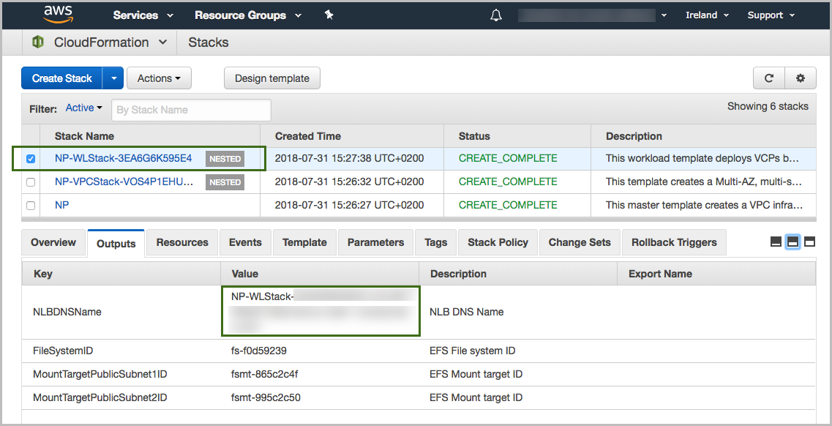

Figure 2: <software> outputs after successful deployment

## Step 4. Test the deployment

Log in to the Barracuda Cloud Gen WAF admin console.

# Best practices for using Barracuda Cloud Gen WAF on AWS



##### Cluster for High Availability (HA) and redundancy

Due to the 24/7 nature of web traffic, it is important that any deployments in line with the data path have added redundancy. The Barracuda Web Application Firewalls configured in HA clusters will automatically synchronize security and network configurations between the clusters to provide seamless failover in response to disruptions. This is achieved by creating an autoscaling group of WAF clusters. IF you are using the BYOL template you will need licenses for the max number of instances you anticipate on scaling to. For more information on clustering, see [High Availability](https://campus.barracuda.com/doc/4259911/).

# Security

The Barracuda Web Application Firewall provides features to implement user authentication and access control. You can create a virtual private network (VPN) tunnel to control user access to websites. The user-access features allow you to specify who can access your websites and what access privileges each user has. By combining these with SSL encryption, you can create a secure VPN tunnel to your websites.

Authentication can be implemented only for HTTP or HTTPS services. The authentication process requires users to provide a valid name and password to gain access. A validated user has qualified access to the website; that is, the data and services this user can access depend on his or her authorization privileges.

# FAQ

**Q.** I encountered a **CREATE_FAILED** error when I launched the Quick Start.

**A.** If AWS CloudFormation fails to create the stack, we recommend that you relaunch the template with **Rollback on failure** set to **No**. (This setting is under **Advanced** in the AWS CloudFormation console, **Options** page.) With this setting, the stack’s state is retained and the instance is left running, so you can troubleshoot the issue. (For Windows, look at the log files in %ProgramFiles%\Amazon\EC2ConfigService and C:\cfn\log.)

**Important:** When you set **Rollback on failure** to **No**, you continue to incur AWS charges for this stack. Please make sure to delete the stack when you finish troubleshooting.

For additional information, see [Troubleshooting AWS CloudFormation](https://docs.aws.amazon.com/AWSCloudFormation/latest/UserGuide/troubleshooting.html) on the AWS website.

**Q.** I encountered a size limitation error when I deployed the AWS CloudFormation templates.

**A.** We recommend that you launch the Quick Start templates from the links in this guide or from another S3 bucket. If you deploy the templates from a local copy on your computer or from a location other than an S3 bucket, you might encounter template size limitations. For more information about AWS CloudFormation quotas, see the [AWS documentation](http://docs.aws.amazon.com/AWSCloudFormation/latest/UserGuide/cloudformation-limits.html).

# Send us feedback

To post feedback, submit feature ideas, or report bugs, use the **Issues** section of the [GitHub repository](https://github.com/aws-quickstart/tbd) for this Quick Start. If you’d like to submit code, please review the [Quick Start Contributor’s Guide](https://aws-quickstart.github.io/).

# Additional resources

AWS resources

* [Getting Started Resource Center](https://aws.amazon.com/getting-started/)
* [AWS General Reference](https://docs.aws.amazon.com/general/latest/gr/)
* [AWS Glossary](https://docs.aws.amazon.com/general/latest/gr/glos-chap.html)

AWS services

* [AWS CloudFormation](https://docs.aws.amazon.com/cloudformation/)
* [Amazon EBS](https://docs.aws.amazon.com/AWSEC2/latest/UserGuide/AmazonEBS.html)
* [Amazon EC2](https://docs.aws.amazon.com/ec2/)
* [IAM](https://docs.aws.amazon.com/iam/)
* [Amazon VPC](https://docs.aws.amazon.com/vpc/)

Barracuda CloudGen WAF for AWS documentation

* [Barracuda CloudGen WAF](https://www.barracuda.com/aws)

Other Quick Start reference deployments

* [AWS Quick Start home page](https://aws.amazon.com/quickstart/)

# Document revisions

|  |  |  |
| --- | --- | --- |
| Date | Change | In sections |
| July 2020 | Initial publication | — |

© 2020, Amazon Web Services, Inc. or its affiliates, and <partner organization>. All rights reserved.

**Notices**

This document is provided for informational purposes only. It represents AWS’s current product offerings and practices as of the date of issue of this document, which are subject to change without notice. Customers are responsible for making their own independent assessment of the information in this document and any use of AWS’s products or services, each of which is provided “as is” without warranty of any kind, whether express or implied. This document does not create any warranties, representations, contractual commitments, conditions or assurances from AWS, its affiliates, suppliers or licensors. The responsibilities and liabilities of AWS to its customers are controlled by AWS agreements, and this document is not part of, nor does it modify, any agreement between AWS and its customers.

The software included with this paper is licensed under the Apache License, Version 2.0 (the "License"). You may not use this file except in compliance with the License. A copy of the License is located at <http://aws.amazon.com/apache2.0/> or in the "license" file accompanying this file. This code is distributed on an "AS IS" BASIS, WITHOUT WARRANTIES OR CONDITIONS OF ANY KIND, either express or implied. See the License for the specific language governing permissions and limitations under the License.