BIG-IP VE on the AWS Cloud

Quick Start Reference Deployment

July 2018

*F5 Networks, Inc.*

*AWS Quick Start Reference Team*

Contents

Overview 2

BIG-IP VE on AWS 2

Costs and Licenses 3

Architecture 3

Prerequisites 5

Specialized Knowledge 5

Technical Requirements 5

Deployment Options 5

Deployment Steps 6

Step 1. Prepare Your AWS Account 6

Step 2. Subscribe to the BIG-IP VE AMI 6

Step 3. Launch the Quick Start 7

Step 4. Test the Deployment 10

Best Practices Using BIG-IP VE on AWS 15

Security 15

Other Useful Information 16

Troubleshooting 16

Git Repository 16

Additional Resources 16

Document Revisions 17

This Quick Start deployment guide was created by Amazon Web Services (AWS) in partnership with F5 Networks, Inc.

[Quick Starts](http://aws.amazon.com/quickstart/) are automated reference deployments that use AWS CloudFormation templates to deploy key technologies on AWS, following AWS best practices.

## Overview

This Quick Start reference deployment guide provides step-by-step instructions for deploying an auto-scaled BIG-IP Virtual Edition (VE) solution on the Amazon Web Services (AWS) Cloud.

You can use this solution as a baseline, to build and test a proof of concept, or to create a production-ready solution. You can use the reference architecture to extend on-premises applications or deploy new applications on AWS, by using the rich features of BIG-IP VE.

### BIG-IP VE on AWS

BIG-IP Virtual Edition (VE) is the industry-leading application delivery & security services platform that is built to ensure speed, availability, and security for business-critical applications and networks. It enables intelligent L4-L7 load balancing & traffic management, robust network and web application firewalls, simplified application access, and unrivaled availability. You can learn more at <https://f5.com/products/deployment-methods/virtual-editions>.

This solution includes BIG-IP Local Traffic Manager (LTM), which provides advanced traffic management.

In this solution, the auto-scaled BIG-IP VE instances automatically discover auto-scaled cloud web applications, by using a feature called "service discovery."

You can customize this Quick Start by changing the configuration parameters. This QuickStart deploys a full working stack that you can inspect and use as a reference. For more information, see <https://support.f5.com/csp/knowledge-center/software>.

In addition to this Quick Start, F5 provides several other CloudFormation templates you can use to create BIG-IP VE solutions in AWS. These templates are actively maintained and supported for customers with an active support contract and can also be used as a reference architecture for custom deployment. For more information, see <https://github.com/F5Networks/f5-aws-cloudformation>.

### Costs and Licenses

You are responsible for the cost of the AWS services used while running this Quick Start reference deployment. There is no additional cost for using the Quick Start.

The AWS CloudFormation template for this Quick Start includes configuration parameters that you can customize. Some of these settings, such as instance type, will affect the cost of deployment. For cost estimates, see the pricing pages for each AWS service you will be using. Prices are subject to change.

In AWS, you can choose your BIG-IP VE image based on:

* PAYG (Pay As You Go) or BYOL (Bring Your Own License)
* Throughput (25 Mbps, 200 Mbps, 1 Gbps, 5 Gbps)
* And image (Good, Better, and Best)

## Architecture

Deploying this Quick Start for a new virtual private cloud (VPC) with **default parameters** builds the following BIG-IP VE environment in the AWS Cloud.

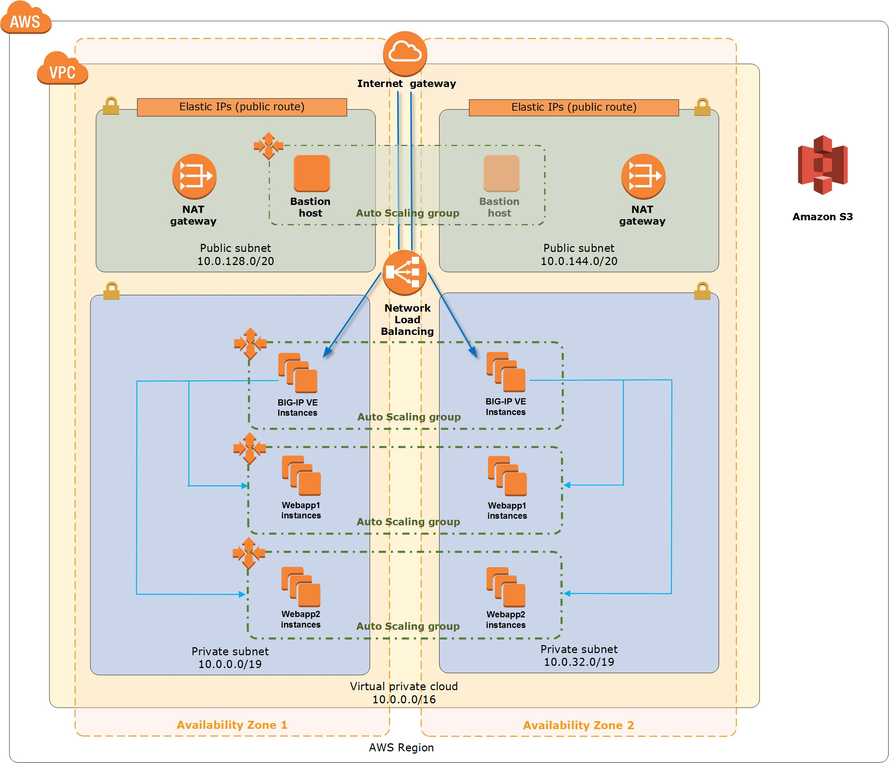

Figure 1: Quick Start architecture for BIG-IP VE on AWS

The Quick Start sets up the following:

* A highly available architecture that spans two Availability Zones. *
* A VPC configured with public and private subnets according to AWS best practices, to provide you with your own virtual network on AWS. *
* An internet gateway to allow access to the internet. This gateway is used by the bastion hosts to send and receive traffic. *
* In the public subnets, managed NAT gateways to allow outbound internet access for resources in the private subnets. *
* In the public subnets, a Linux bastion host in an Auto Scaling group to allow inbound Secure Shell (SSH) access to EC2 instances in public and private subnets. *
* A Network Load Balancer that provides inbound access to the BIG-IP VE Auto Scaling group via HTTPS load balancing over port 443.
* In the private subnets, BIG-IP VE instances in an Auto Scaling group, in Active/Active status; the BIG-IP VE instances filter and load balance the traffic to the auto-scaled web application instances and keep track of those instances by using the "service discovery" tool.
* In the private subnets, two simple web applications in two separate Auto Scaling groups, named Webapp1 and Webapp2; these web applications simulate a Multi-AZ web application farm that receives traffic from BIG-IP VE.

**\*** The template that deploys the Quick Start into an existing VPC skips the tasks marked by asterisks and prompts you for your existing VPC configuration.

Please take note that when the parameter “Deploy Demo Web App” is set to “No”, the web application instances will not be deployed.

In addition, we also set the parameters for the auto scale to 1 for both the BIG-IP and Web Applications. As a result, the deployment creates only 1 instance for the BIG-IP and Web Application in the respective auto scale groups. You can scale up the instances by changing the values for min, max and desired capacity of the respective auto scale groups.

## Prerequisites

### Specialized Knowledge

Before you deploy this Quick Start, we recommend that you become familiar with the following AWS services. (If you are new to AWS, see [Getting Started with AWS](https://aws.amazon.com/getting-started/).)

* [Amazon EC2](https://aws.amazon.com/documentation/ec2/)
* [Amazon EBS](https://docs.aws.amazon.com/AWSEC2/latest/UserGuide/AmazonEBS.html)
* [Amazon VPC](https://aws.amazon.com/documentation/vpc/)
* [AWS CloudFormation](https://aws.amazon.com/documentation/cloudformation/)
* Auto S[caling](https://aws.amazon.com/documentation/autoscaling/)

### Technical Requirements

To deploy this solution, you must have:

* A key pair in AWS.
* Access to two availability zones from a chosen region.
* The ability to create IAM roles. IAM roles are required for BIG-IP VE to interact with the AWS environment.

## Deployment Options

This Quick Start provides two deployment options:

* **Deploy BIG-IP VE into a new VPC** (end-to-end deployment). This option builds a new AWS environment consisting of the VPC, subnets, NAT gateways, security groups, bastion hosts, and other infrastructure components, and then deploys BIG-IP VE into this new VPC.
* **Deploy BIG-IP VE into an existing VPC**. This option provisions BIG-IP VE in your existing AWS infrastructure.

The Quick Start provides separate templates for these options. It also lets you configure CIDR blocks, instance types, and BIG-IP VE settings, as discussed later in this guide.

## Deployment Steps

### Step 1. Prepare Your AWS Account

1. If you don’t already have an AWS account, create one at <https://aws.amazon.com> by following the on-screen instructions.
2. Use the region selector in the navigation bar to choose the AWS Region where you want to deploy BIG-IP VE on AWS.
3. Create a [key pair](https://docs.aws.amazon.com/AWSEC2/latest/UserGuide/ec2-key-pairs.html) in your preferred region.
4. If necessary, [request a service limit increase](https://console.aws.amazon.com/support/home#/case/create?issueType=service-limit-increase&limitType=service-code-) for the Amazon EC2 <type> instance type. You might need to do this if you already have an existing deployment that uses this instance type, and you think you might exceed the [default limit](http://docs.aws.amazon.com/AWSEC2/latest/UserGuide/ec2-resource-limits.html) with this deployment.

### Step 2. Subscribe to the BIG-IP VE AMI

1. Log in to the AWS Marketplace at <https://aws.amazon.com/marketplace>.
2. Open the page for **F5 BIG-IP Virtual Edition – GOOD – (Hourly, 25 Mbps)**, and choose **Continue**. You can choose any of the PAYG/hourly images, though this is the recommended one.
3. Use the **Manual Launch** option to launch the AMI into your account on Amazon EC2. This involves accepting the terms of the license agreement and receiving confirmation email. For detailed instructions, see the [AWS Marketplace documentation](https://aws.amazon.com/marketplace/help/200799470).
4. In the Quick Start template, select the throughput and license type option that matches the image you selected in step 2. For example, select **25 Mbps** and **Good**.

### Step 3. Launch the Quick Start

**Note** You are responsible for the cost of the AWS services used while running this Quick Start reference deployment. There is no additional cost for using this Quick Start. For full details, see the pricing pages for each AWS service you will be using in this Quick Start. Prices are subject to change.

1. Choose one of the following options to launch the AWS CloudFormation template into your AWS account. For help choosing an option, see deployment options earlier in this guide.

|  |  |
| --- | --- |
| Option 1  [**Launch**](https://console.aws.amazon.com/cloudformation/home?region=us-east-2#cstack=sn%7EOracle-Database%7Cturl%7Ehttps://s3.amazonaws.com/quickstart-reference/)  Deploy BIG-IP VE into a  new VPC on AWS | Option 2  [**Launch**](https://console.aws.amazon.com/cloudformation/home?region=us-east-2#cstack=sn%7EOracle-Database%7Cturl%7Ehttps://s3.amazonaws.com/quickstart-reference/)  Deploy BIG-IP VE into an existing VPC on AWS |

**Important** If you’re deploying BIG-IP VE into an existing VPC, make sure that your VPC has two private subnets in different Availability Zones for the database instances. These subnets require [NAT gateways or NAT instances](http://docs.aws.amazon.com/AmazonVPC/latest/UserGuide/vpc-nat.html) in their route tables, to allow the instances to download packages and software without exposing them to the internet. You will also need the domain name option configured in the DHCP options as explained in the [Amazon VPC documentation](http://docs.aws.amazon.com/AmazonVPC/latest/UserGuide/VPC_DHCP_Options.html). You will be prompted for your VPC settings when you launch the Quick Start.

Each deployment takes about 30 minutes to complete.

1. Check the region that’s displayed in the upper-right corner of the navigation bar, and change it if necessary. This is where the network infrastructure for BIG-IP VE will be built. The template is launched in the US East (Ohio) Region by default.
2. On the **Select Template** page, keep the default setting for the template URL, and then choose **Next**.
3. On the **Specify Details** page, change the stack name if needed. Review the parameters for the template. Provide values for the parameters that require input. For all other parameters, review the default settings and customize them as necessary. When you finish reviewing and customizing the parameters, choose **Next**.

In the following tables, parameters are listed by category and described separately for the two deployment options:

* Parameters for deploying BIG-IP VE into a new VPC
* Parameters for deploying BIG-IP VE into an existing VPC
* **Option 1: Parameters for deploying BIG-IP VE into a new VPC**

[View template](https://s3.amazonaws.com/quickstart-reference/)

*<The following parameter tables are generated automatically from the templates. Don’t enter the parameter information manually. The information below is provided only as an example. We recommend that you use these group and parameter labels if you’re providing similar functionality in your CloudFormation templates.>*

*VPC Network Configuration:*

|  |  |  |
| --- | --- | --- |
| Parameter label (name) | Default | Description |
| Availability Zones (AvailabilityZones) | *Requires input* | The list of Availability Zones to use for the subnets in the VPC. The Quick Start uses two Availability Zones from your list and preserves the logical order you specify. |
| VPC CIDR (VPCCIDR) | 10.0.0.0/16 | The CIDR block for the VPC. |
| Private Subnet 1 CIDR (PrivateSubnet1CIDR) | 10.0.0.0/19 | The CIDR block for the private subnet located in Availability Zone 1. |
| Private Subnet 2 CIDR (PrivateSubnet2CIDR) | 10.0.32.0/19 | The CIDR block for the private subnet located in Availability Zone 2. |
| Public Subnet 1 CIDR (PublicSubnet1CIDR) | 10.0.128.0/20 | The CIDR block for the public (DMZ) subnet located in Availability Zone 1. |
| Public Subnet 2 CIDR (PublicSubnet2CIDR) | 10.0.144.0/20 | The CIDR block for the public (DMZ) subnet located in Availability Zone 2. |
| Permitted IP range (AccessCIDR) | *Requires input* | The CIDR IP range that is permitted to access the Bastion host. We recommend that you set this value to a trusted IP range. For example, you might want to grant only your corporate network access to the software. |

*Amazon EC2 Configuration:*

|  |  |  |
| --- | --- | --- |
| Parameter label (name) | Default | Description |
| Key Name (KeyPairName) | *Requires input* | A public/private key pair, which allows you to connect securely to your instance after it launches. When you created an AWS account, this is the key pair you created in your preferred region. |

*AWS Quick Start Configuration:*

|  |  |  |
| --- | --- | --- |
| Parameter label (name) | Default | Description |
| Quick Start S3 Bucket Name (QSS3BucketName) | quickstart-reference | The S3 bucket you have created for your copy of Quick Start assets, if you decide to customize or extend the Quick Start for your own use. The bucket name can include numbers, lowercase letters, uppercase letters, and hyphens, but should not start or end with a hyphen. |
| Quick Start S3 Key Prefix (QSS3KeyPrefix) | atlassian/bitbucket/latest/ | The [S3 key name prefix](https://docs.aws.amazon.com/AmazonS3/latest/dev/UsingMetadata.html) used to simulate a folder for your copy of Quick Start assets, if you decide to customize or extend the Quick Start for your own use. This prefix can include numbers, lowercase letters, uppercase letters, hyphens, and forward slashes. |

* **Option 2: Parameters for deploying BIG-IP VE into an existing VPC**

[View template](https://s3.amazonaws.com/quickstart-reference/)

*<The following parameter tables are generated automatically from the templates. Don’t enter the parameter information manually. The information below is provided only as an example. We recommend that you use these group and parameter labels if you are providing similar functionality in your CloudFormation templates.>*

*Network Configuration:*

|  |  |  |
| --- | --- | --- |
| Parameter label (name) | Default | Description |
| VPC ID (VPCID) | *Requires input* | The ID of your existing VPC (e.g., vpc-0343606e). |
| Private Subnet 1 ID (PrivateSubnet1ID) | *Requires input* | The ID of the private subnet in Availability Zone 1 in your existing VPC (e.g., subnet-a0246dcd). |
| Private Subnet 2 ID (PrivateSubnet2ID) | *Requires input* | The ID of the private subnet in Availability Zone 2 in your existing VPC (e.g., subnet-b58c3d67). |
| Bastion Security  Group ID  (BastionSecurityGroupID) | *Requires input* | The ID of the bastion security group in your existing VPC (e.g., sg-7f16e910). |

*Amazon EC2 Configuration:*

|  |  |  |
| --- | --- | --- |
| Parameter label (name) | Default | Description |
| Key Pair Name (KeyPairName) | *Requires input* | A public/private key pair, which allows you to connect securely to your instance after it launches. When you created an AWS account, this is the key pair you created in your preferred region. |

1. On the **Options** page, you can [specify tags](https://docs.aws.amazon.com/AWSCloudFormation/latest/UserGuide/aws-properties-resource-tags.html) (key-value pairs) for resources in your stack and [set advanced options](https://docs.aws.amazon.com/AWSCloudFormation/latest/UserGuide/cfn-console-add-tags.html). When you’re done, choose **Next**.
2. On the **Review** page, review and confirm the template settings. Under **Capabilities**, select the check box to acknowledge that the template will create IAM resources.
3. Choose **Create** to deploy the stack.
4. Monitor the status of the stack. When the status is **CREATE_COMPLETE**, the BIG-IP VE cluster is ready.
5. Use the URL displayed in the Value column corresponding to the Key “AppUrl” from the **Outputs** tab of the master stack.
6. Wait approximately 8-10 minutes before using the URL to access the WebApp through BIG-IP VE.

### Step 4. Test the Deployment

When the solution is successfully deployed, traffic goes through an AWS ELB, to BIG-IP VE instances in an Auto Scaling group, and then to web servers, which are also in another Auto Scaling group.

We refer the web servers in this deployment as WebApp1 and WebApp2 for . They are differentiated by the background color and "version" of the application.

WebApp1 is running version f5-demo-app:0.0.1 and has a blue background.

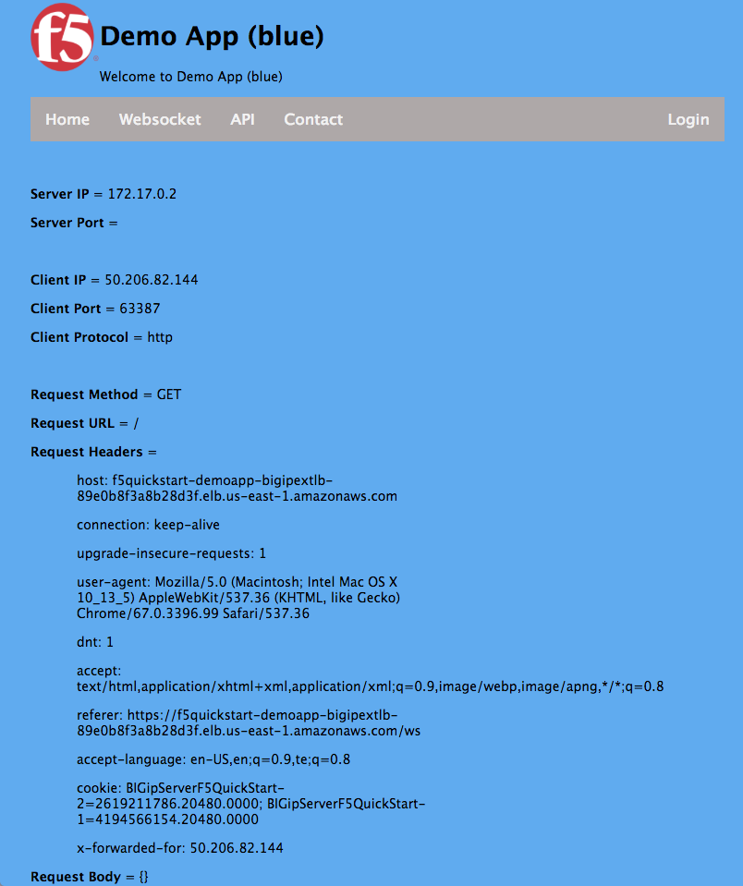

Figure 2: WebApp1 (f5-demo-app:0.0.1)

WebApp2 is running version f5-demo-app:0.0.2 and has a green background.

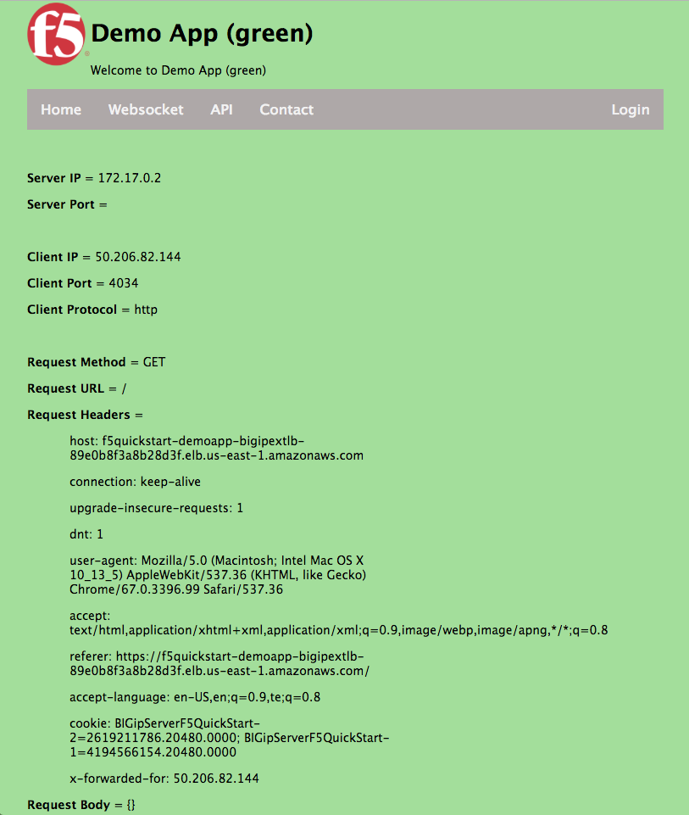

Figure 3: WebApp2 (f5-demo-app:0.0.2)

Before you can test, you must wait for all resources to be up and running.

Even though the CloudFormation stack status shows “CREATE_COMPLETE” for all of the nested stacks, you cannot immediately access the web applications. The BIG-IP VE instances take 8-10 minutes to boot, have the configuration applied, and pass all health checks. The BIG-IP VE instances can provide application services only after they clear the system status and instance status checks as illustrated in Figure 4. This takes approximately 8-10 mins.

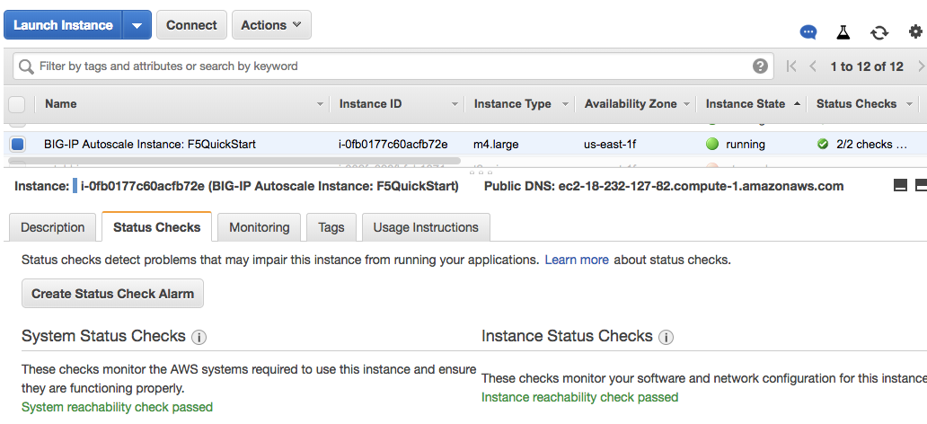

Figure 4: BIG-IP VE Status

To test the deployment, you will compare WebApp1 and WebApp2.

To find the DNS name you need to use to connect to the web servers, copy the value of the key “AppUrl” in the Outputs tab of the master stack as shown in Figure 5.

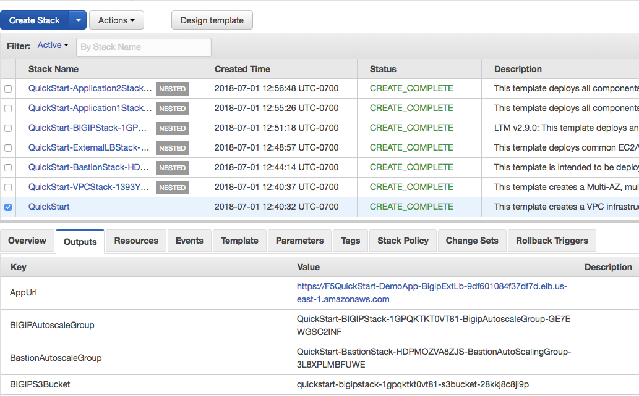

Figure 5: DNS name to access the Web Application

Enter this URL in a web browser. The chrome browser displays a certificate error page as shown below in Figure 6. Click the “Advanced” link in the page and you will see the page expand as shown in Figure 7. In order to access the web application, click the link highlighted in the red box in Figure 7.

**Connect to the BIG-IP VE**

1. Because you cannot access the BIG-IP VE instance from outside the AWS VPC, use a Linux Bastion host to connect to BIG-IP VE. We can connect to BIG-IP VE either through GUI or through a CLI shell. In this deployment guide, we provide steps to connect to the BIG-IP VE through the GUI.
2. Go to EC2 Console "Auto Scaling Groups" Page and select the auto scaling group that filters out when “BastionStack” is entered in the filter bar.
3. Click on the Auto Scaling Group's "Instances" tab and click on the instance that has "BastionStack" in the Launch Configuration Name column. Locate the "IPv4 Public IP" in the "Description" Tab of that instance.
4. Similarly, search for “BIG-IP” in the Auto Scaling Groups page. Click on the "Instances" tab found below that shows up when the Auto scaling group corresponding to the BIG-IP is selected. Select the instance that shows “Scale in” for the “protected from” column. Figure 8 shows the instance that need to be selected. Locate the "IPv4 Private IP" in the "Description" Tab for the instance.

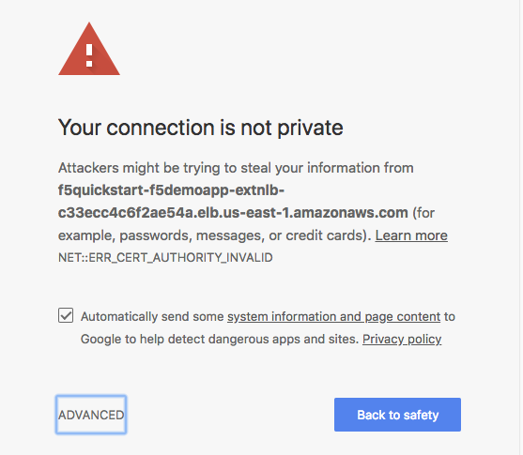

Figure 6: Certificate error page

1. From your desktop shell, create an SSH tunnel.

ssh -i <key-pair>.pem username@BASTION-HOST-PUBLIC-IP -L 8443:BIG-IP-PRIVATE-IP:8443

For example: if ubuntu is used for LinuxBastion

ssh -I my-key.pem [ubuntu@18.210.123.250](mailto:ubuntu@18.210.123.250) -L 8443:10.0.11.228:8443

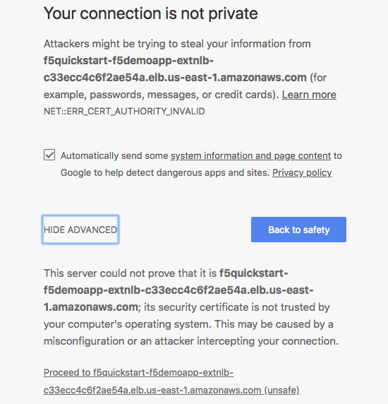

Figure 7: Access the Web Application

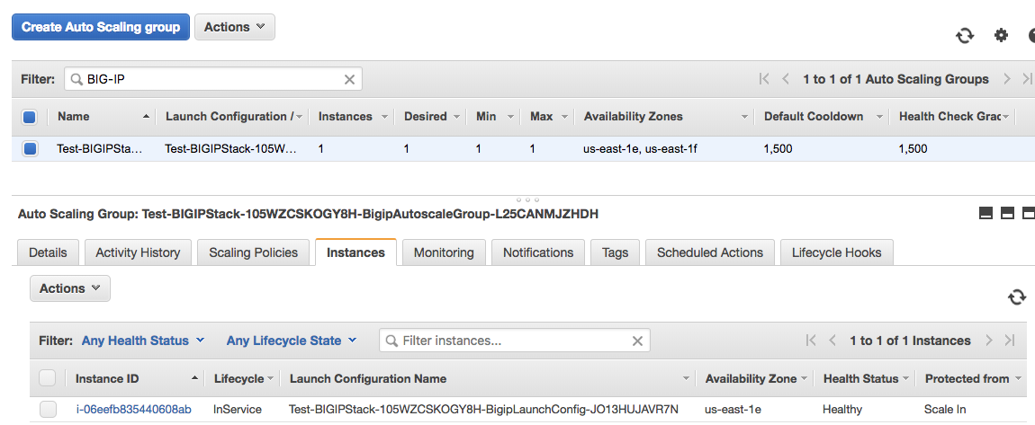

Figure 8: BIG-IP Selection for the Login

1. You can now open a chrome browser from your desktop:

https://localhost:8443

1. You will see a similar certificate error page as shown in Figure 6. Follow the same steps as you did earlier.
2. Login:

Username: quickstart, password: instance_id of BIG-IP VE in AWS

1. Change the password for the user “quickstart” by selecting System -> Users in the menu. When you update the change, you will be logged out. Log back in again with the new password.
2. Now you can test the deployment.

**Test 1: Evaluate the URI routing policy**

1. While viewing WebApp1 (with the blue background), click on the **API** tab.
2. Notice that it turns green. Requests are being directed to the WebApp2 (in this case, it’s the green pool but in practice, it would be another service).
3. You can see this via inspecting statistics in the BIG-IP VE:
4. In the BIG-IP, Select Local Traffic -> Pools -> Statistics
5. This test shows that both the Web Apps are up and running.
6. Click any other tab to return to WebApp1.

**Test 2: Evaluate blue green scenario- Upgrade from version f5-demo-app:0.0.1 to f5-demo-app:0.0.2**

In this test, you will evaluate the blue-green upgrade. In our case, the default is pointed to WebApp1. After the upgrade, the default is WebApp2. Upgrade from version f5-demo-app:0.0.1 to f5-demo-app:0.0.2 by the following steps

1. Select or navigate to iApps -> Application Services -> Applications -> F5QuickStart-1_sd -> Reconfigure
2. Change the value for field: ***"What is the tag value on your cloud provider for the members of this pool?"*** from "f5-demo-app-0.0.1" to "f5-demo-app-0.0.2"
3. When you enter the DNS name for the Application in the browser, the WebApp2 (f5-demo-app:0.0.2 with the green background) is displayed. Note that Pool 1 is now pointing at the second Auto Scale Group (green).
4. This test shows that the site was successfully upgraded.

**Test 3: Evaluate the service discovery feature in the BIG-IP**

In the BIG-IP, we use service discovery feature to add/discard new application instances in an auto scaling group to/from a pool when the application instances scale up/down.

1. In the Big-IP, select Local Traffic -> Pools
2. You will see two pools. In this Quick Start deployment, we have f5quickstart-1 and f5quickstart-2
3. Click on each of the pools and select members tab. You will see one application instance in each.
4. Go to EC2 Console "Auto Scaling Groups" Page and filter the auto scale groups by Application1.
5. Select the Auto scaling group for Application1 and select edit in Actions drop down menu.
6. In the details tab below, change the rows “Desired Capacity” and “Max” from 1 to 2. Click on the Save button in the right top corner of the details tab window.
7. In the EC2 console “Instances”, you will notice a new instance for the Application f5-demo-app-0.0.1 is spun up.
8. Wait till the instance is completely created by checking its status in the EC2 Console for instances
9. In BIG-IP, check for the members corresponding to the f5quickstart-1 pool. You will see a new instance with an ip address that matches the private ip of the new instance that spun up in AWS.
10. Similarly, you can do the same for the Application2 auto scaling group following steps 4-9.
11. The service discovery uses tags for the discovery/removal. In this deployment, we used Application (key), Application1PoolTagValue (value) and Application2PoolTagValue (value) parameters for the service discovery.

## Best Practices Using BIG-IP VE on AWS

BIG-IP VE is similar to BIG-IP; refer to BIG-IP documentation for best practices.

There are a few configuration details that apply to BIG-IP VE. For more information, see: [*http://clouddocs.f5.com/cloud/public/v1/aws/AWS_users.html*](http://clouddocs.f5.com/cloud/public/v1/aws/AWS_users.html)

## Security

For details about securing BIG-IP VE in AWS, see: <https://github.com/F5Networks/f5-aws-cloudformation/tree/master/supported/solutions/autoscale/ltm>

## Other Useful Information

## Troubleshooting

**Q.** I encountered a CREATE_FAILED error when I launched the Quick Start.

**A.** If AWS CloudFormation fails to create the stack, we recommend that you relaunch the template with **Rollback on failure** set to **No**. (This setting is under **Advanced** in the AWS CloudFormation console, **Options** page.) With this setting, the stack’s state will be retained and the instance will be left running, so you can troubleshoot the issue. (Look at the log files in %ProgramFiles%\Amazon\EC2ConfigService and C:\cfn\log.)

**Important** When you set **Rollback on failure** to **No**, you will continue to incur AWS charges for this stack. Please make sure to delete the stack when you finish troubleshooting.

For additional information, see [Troubleshooting AWS CloudFormation](https://docs.aws.amazon.com/AWSCloudFormation/latest/UserGuide/troubleshooting.html) on the AWS website.

**Q.** I encountered a size limitation error when I deployed the AWS Cloudformation templates.

**A.** We recommend that you launch the Quick Start templates from the location we’ve provided or from another S3 bucket. If you deploy the templates from a local copy on your computer or from a non-S3 location, you might encounter template size limitations when you create the stack. For more information about AWS CloudFormation limits, see the [AWS documentation](http://docs.aws.amazon.com/AWSCloudFormation/latest/UserGuide/cloudformation-limits.html).

## Git Repository

You can visit our [GitHub repository](https://github.com/aws-quickstart/tbd) to download the templates and scripts for this Quick Start, to post your comments, and to share your customizations with others.

## Additional Resources

*Additional reading, with full URLs. Revise the following as appropriate.*

**AWS services**

* Amazon EBS  
  <https://docs.aws.amazon.com/AWSEC2/latest/UserGuide/AmazonEBS.html>
* Amazon EC2  
  <https://aws.amazon.com/documentation/ec2/>
* Amazon VPC  
  <https://aws.amazon.com/documentation/vpc/>
* AWS CloudFormation  
  <https://aws.amazon.com/documentation/cloudformation/>
* Elastic Load Balancing  
  <https://aws.amazon.com/documentation/elastic-load-balancing/>
* Auto Scaling  
  <https://aws.amazon.com/documentation/autoscaling/>

**BIG-IP VE documentation**

* Cloud-Init and BIG-IP VE  
  <http://clouddocs.f5.com/cloud/public/v1/cloudinit.html>
* BIG-IP VE in AWS documentation  
  <http://clouddocs.f5.com/cloud/public/v1/aws_index.html>

**Quick Start reference deployments**

* AWS Quick Start home page  
  <https://aws.amazon.com/quickstart/>

## Document Revisions

|  |  |  |
| --- | --- | --- |
| Date | Change | In sections |
| July 2018 | Initial publication | — |

© 2018, Amazon Web Services, Inc. or its affiliates, and F5 Networks Inc. All rights reserved.

**Notices**

This document is provided for informational purposes only. It represents AWS’s current product offerings and practices as of the date of issue of this document, which are subject to change without notice. Customers are responsible for making their own independent assessment of the information in this document and any use of AWS’s products or services, each of which is provided “as is” without warranty of any kind, whether express or implied. This document does not create any warranties, representations, contractual commitments, conditions or assurances from AWS, its affiliates, suppliers or licensors. The responsibilities and liabilities of AWS to its customers are controlled by AWS agreements, and this document is not part of, nor does it modify, any agreement between AWS and its customers.

The software included with this paper is licensed under the Apache License, Version 2.0 (the "License"). You may not use this file except in compliance with the License. A copy of the License is located at <http://aws.amazon.com/apache2.0/> or in the "license" file accompanying this file. This code is distributed on an "AS IS" BASIS, WITHOUT WARRANTIES OR CONDITIONS OF ANY KIND, either express or implied. See the License for the specific language governing permissions and limitations under the License.