PlateSpin Migrate Server on the AWS Cloud

Quick Start Reference Deployment

February 2019

<Name(s), Micro Focus>

<Name(s)>, AWS Quick Start team

Visit our [GitHub repository](https://github.com/aws-quickstart/tbd) for source files and to post feedback,   
report bugs, or submit feature ideas for this Quick Start.

Contents

Overview 1

PlateSpin Migrate Server On AWS 1

Cost and licenses 1

Architecture 1

Planning the deployment 1

Specialized knowledge 1

AWS account 1

Technical requirements 1

Deployment options 1

Deployment steps 1

Step 1. Sign in to your AWS account 1

Step 2. Launch the Quick Start 1

Option 1: Parameters for deploying <software> into a new VPC 1

Option 2: Parameters for deploying <software> into an existing VPC 1

Step 3. Test the Deployment 1

Best practices for using <software> on AWS 1

Security 1

<Other useful information> 1

FAQ 1

Send us feedback 1

Additional resources 1

Document revisions 1

Style Guide 1

Terminology and usage 1

Bullet lists 1

Numbered lists for procedures 1

Tips, notes, and warnings 1

Graphics 1

Tables 1

References 1

Code 1

This Quick Start was created by Micro Focus in collaboration with Amazon Web Services (AWS).

[Quick Starts](http://aws.amazon.com/quickstart/) are automated reference deployments that use AWS CloudFormation templates to deploy key technologies on AWS, following AWS best practices.

# Overview

This Quick Start reference deployment guide provides step-by-step instructions for deploying PlateSpin Migrate Server on the AWS Cloud.

This Quick Start is for users who wants to quickly and easily deploy PlateSpin Migrate Server on AWS Cloud.

## PlateSpin Migrate Server On AWS

<Lorem ipsum dolor sit amet, consectetur adipiscing elit, sed do eiusmod tempor incididunt ut labore et dolore magna aliqua.>

PlateSpin Migrate enables you to migrate heterogeneous workloads across x86-based physical, virtual, and cloud infrastructures in your data center. It decouples the workload infrastructure from its software (operating system, applications, and data) to allow any-to-any migrations.

It automates the migration of workloads among physical, virtual machine, and cloud. The supported cloud platforms include Amazon Web Services (AWS), Microsoft Azure, VMware vCloud Director, and VMware Cloud on AWS.

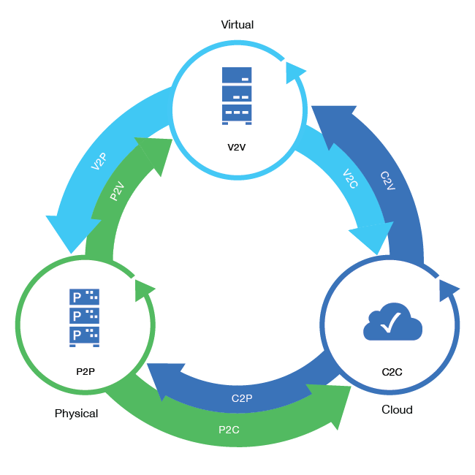

With PlateSpin Migrate, you can do the following:

* Easily discover workloads and hosts in your environment.
* Efficiently configure, execute, and test workload even before the actual cutover.
* Continuously monitor the status of workload migration.
* Dramatically increase the migration speed and success ratios, which help reduce the costs for your migration projects

This Quick Start uses AWS CloudFormation templates to automate the deployment and configuration of PlateSpin Migrate on AWS.

## Cost and licenses

You are responsible for the cost of the AWS services used while running this Quick Start reference deployment. There is no additional cost for using the Quick Start.

The AWS CloudFormation template for this Quick Start includes configuration parameters that you can customize. Some of these settings, such as instance type, will affect the cost of deployment. For cost estimates, see the pricing pages for each AWS service you will be using. Prices are subject to change.

**Tip** After you deploy the Quick Start, we recommend that you enable the [AWS Cost and Usage Report](https://docs.aws.amazon.com/awsaccountbilling/latest/aboutv2/billing-reports-gettingstarted-turnonreports.html) to track costs associated with the Quick Start. This report delivers billing metrics to an S3 bucket in your account. It provides cost estimates based on usage throughout each month, and finalizes the data at the end of the month. For more information about the report, see the [AWS documentation](https://docs.aws.amazon.com/awsaccountbilling/latest/aboutv2/billing-reports-costusage.html).

This deployment uses a Bring Your Own License (BYOL) model for PlateSpin Migrate Server. You must already own licenses for PlateSpin Migrate Server. For more information about PlateSpin Migrate licenses, see [PlateSpin Migrate Product Licensing](https://www.microfocus.com/documentation/platespin/platespin-migrate-2019-2/migrate-user/mig-license.html) in the [PlateSpin Migrate User guide](https://www.microfocus.com/documentation/platespin/platespin-migrate-2019-2/migrate-user/bookinfo.html).

# Architecture

Deploying this Quick Start for a new virtual private cloud (VPC) with **default parameters** builds the following PlateSpin Migrate Server environment in the AWS Cloud.

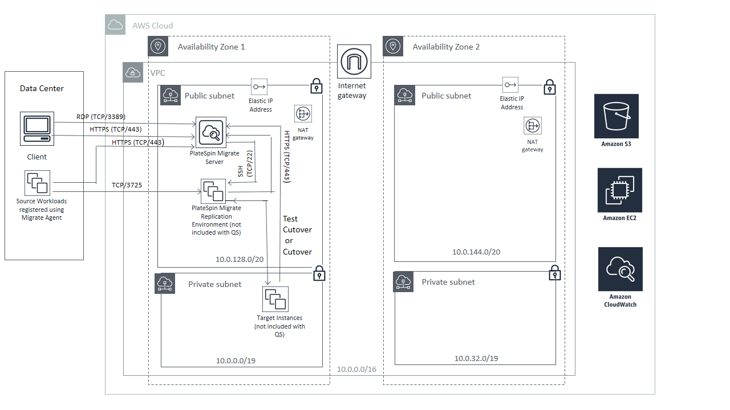

Figure 1: Quick Start architecture for PlateSpin Migrate Server on AWS

The Quick Start sets up the following:

* A highly available architecture that spans two Availability Zones.*
* A VPC configured with public and private subnets according to AWS best practices, to provide you with your own virtual network on AWS.*
* An internet gateway to allow access to the internet. This gateway is used by the PlateSpin Migrate Server to send and receive traffic.*
* In the public subnets, managed NAT gateways to allow outbound internet access for resources in the private subnets.*
* In one of the public subnets, an EC2 instance with a fully configured PlateSpin Migrate Server instance setup on a Windows Server.
* A Security group for the Migrate Server instance to restrict access to HTTPS – 443.
* A Security group for the Target Workloads in AWS to restrict access to only necessary protocols and ports such as SSH -22, HTTPS - 443, TCP - 3725
* An AWS IAM role with a policy having fine-grained permissions required to perform PlateSpin Migrate conversions to AWS.

**\*** The template that deploys the Quick Start into an existing VPC skips the components marked by asterisks and prompts you for your existing VPC configuration.

# Planning the deployment

## Specialized knowledge

This Quick Start assumes familiarity with the working of PlateSpin Migrate Server to perform migrations.

This deployment guide also requires a moderate level of familiarity with AWS services. If you’re new to AWS, visit the [Getting Started Resource Center](https://aws.amazon.com/getting-started/) and the [AWS Training and Certification website](https://aws.amazon.com/training/) for materials and programs that can help you develop the skills to design, deploy, and operate your infrastructure and applications on the AWS Cloud.

## AWS account

If you don’t already have an AWS account, create one at [https://aws.amazon.com](https://aws.amazon.com/) by following the on-screen instructions. Part of the sign-up process involves receiving a phone call and entering a PIN using the phone keypad.

Your AWS account is automatically signed up for all AWS services. You are charged only for the services you use.

## Technical requirements

Before you launch the Quick Start, your account must be configured as specified in the following table. Otherwise, deployment might fail.

|  |  |  |  |  |  |  |  |  |  |  |  |
| --- | --- | --- | --- | --- | --- | --- | --- | --- | --- | --- | --- |
| [Resources](http://docs.aws.amazon.com/general/latest/gr/aws_service_limits.html) | If necessary, request [service limit increases](https://console.aws.amazon.com/support/home#/case/create?issueType=service-limit-increase&limitType=service-code-) for the following resources. You might need to do this if you already have an existing deployment that uses these resources, and you think you might exceed the default limits with this deployment. For default limits, see the [AWS documentation](https://docs.aws.amazon.com/).  [AWS Trusted Advisor](https://console.aws.amazon.com/trustedadvisor/home?#/category/service-limits) offers a service limits check that displays your usage and limits for some aspects of some services.   |  |  | | --- | --- | | Resource | This deployment uses | | VPCs | 1 | | Elastic IP addresses | * For NAT gateways - 2 * For Migrate Server - 1 (Optional) | | IAM roles | 1 | | Amazon EC2 instances | 1 | |
| [Regions](https://aws.amazon.com/about-aws/global-infrastructure/) | This deployment is currently not supported in Amazon Government Cloud Regions. For a current list of supported regions, see [AWS Regions and Endpoints](https://docs.aws.amazon.com/general/latest/gr/rande.html#elasticfilesystem-region) in the AWS documentation. |
| [Key pair](https://docs.aws.amazon.com/AWSEC2/latest/UserGuide/ec2-key-pairs.html) | Make sure that at least one Amazon EC2 key pair exists in your AWS account in the region where you are planning to deploy the Quick Start. Make note of the key pair name. You’ll be prompted for this information during deployment. To create a key pair, follow the [instructions in the AWS documentation](https://docs.aws.amazon.com/AWSEC2/latest/UserGuide/ec2-key-pairs.html).  If you’re deploying the Quick Start for testing or proof-of-concept purposes, we recommend that you create a new key pair instead of specifying a key pair that’s already being used by a production instance. |
| [IAM permissions](https://docs.aws.amazon.com/IAM/latest/UserGuide/access_policies_job-functions.html) | To deploy the Quick Start, you must log in to the AWS Management Console with IAM permissions for the resources and actions the templates will deploy. The *AdministratorAccess* managed policy within IAM provides sufficient permissions, although your organization may choose to use a custom policy with more restrictions. |
| [S3 buckets](http://docs.aws.amazon.com/AWSCloudFormation/latest/UserGuide/aws-properties-s3-bucket.html) | Unique S3 bucket names are automatically generated based on the account number and region. If you delete a stack, **the logging buckets are not deleted** (to support security review). If you plan to re-deploy this Quick Start in the same region, you must first manually delete the S3 buckets that were created during the previous deployment; **otherwise, the re-deployment will fail**. |

## Deployment options

This Quick Start provides two deployment options:

* Deploy PlateSpin Migrate Server into a new VPC (end-to-end deployment). This option builds a new AWS environment consisting of the VPC, subnets, NAT gateways, security groups, bastion hosts, and other infrastructure components, and then deploys PlateSpin Migrate Server into this new VPC.
* Deploy PlateSpin Migrate Server into an existing VPC. This option provisions PlateSpin Migrate Server in your existing AWS infrastructure.

The Quick Start provides separate templates for these options. It also lets you configure CIDR blocks, instance types, and PlateSpin Migrate Server settings, as discussed later in this guide.

# Deployment steps

## Step 1. Sign in to your AWS account

1. Sign in to your AWS account at <https://aws.amazon.com> with an IAM user role that has the necessary permissions. For details, see Planning the deployment earlier in this guide.
2. Make sure that your AWS account is configured correctly, as discussed in the Technical requirements section.
3. Use the region selector in the navigation bar to choose the AWS Region where you want to deploy PlateSpin Migrate Server on AWS.

**Note** This deployment is currently not supported in Amazon Government Cloud Regions.

1. Select the key pair that you created earlier. In the navigation pane of the [Amazon EC2 console](https://console.aws.amazon.com/ec2/), choose **Key Pairs**, and then choose your key pair from the list.
2. This Quick Start uses the PlateSpin Migrate AMI to deploy the PlateSpin Migrate server in the selected region.

## Step 2. Launch the Quick Start

**Notes** The instructions in this section reflect the older version of the AWS CloudFormation console. If you’re using the redesigned console, some of the user interface elements might be different.

You are responsible for the cost of the AWS services used while running this Quick Start reference deployment. There is no additional cost for using this Quick Start. For full details, see the pricing pages for each AWS service you will be using in this Quick Start. Prices are subject to change.

1. Choose one of the following options to launch the AWS CloudFormation template into your AWS account. For help choosing an option, see deployment options earlier in this guide.

|  |  |
| --- | --- |
|  |  |
| Deploy PlateSpin Migrate Server into a  new VPC on AWS | Deploy PlateSpin Migrate Server into an  existing VPC on AWS |

**Important** If you’re deploying PlateSpin Migrate Server into an existing VPC, make sure that your VPC has one public subnet for the PlateSpin Migrate Server instance. You will be prompted for your VPC settings when you launch the Quick Start.

Each deployment takes about 45 mins to complete.

1. Check the region that’s displayed in the upper-right corner of the navigation bar, and change it if necessary. This is where the network infrastructure for PlateSpin Migrate Server will be built. The template is launched in the US East (Ohio) Region by default.
2. On the **Select Template** page, keep the default setting for the template URL, and then choose **Next**.
3. On the **Specify Details** page, change the stack name if needed. Review the parameters for the template. Provide values for the parameters that require input. For all other parameters, review the default settings and customize them as necessary.

In the following tables, parameters are listed by category and described separately for the two deployment options:

* Parameters for deploying PlateSpin Migrate Server into a new VPC
* Parameters for deploying PlateSpin Migrate Server into an existing VPC

When you finish reviewing and customizing the parameters, choose **Next**.

### Option 1: Parameters for deploying PlateSpin Migrate Server into a new VPC

[View template](https://s3.amazonaws.com/quickstart-reference/)

*Availability Zone configuration:*

|  |  |  |
| --- | --- | --- |
| Parameter label (name) | Default | Description |
| Availability Zones (AvailabilityZones) | *Requires input* | The list of Availability Zones to use for the subnets in the VPC. Select any two. This Quick Start uses the first two zones from your selected list. |

*Network configuration:*

|  |  |  |
| --- | --- | --- |
| Parameter label (name) | Default | Description |
| VPC CIDR (VPCCIDR) | 10.0.0.0/16 | The CIDR block for the VPC. This CIDR block must be in the form x.x.x.x/16-28. |
| Public subnet 1 CIDR (PublicSubnet1CIDR) | 10.0.128.0/20 | The CIDR block for the public DMZ subnet 1 located in Availability Zone 1. |
| Public subnet 2 CIDR (PublicSubnet2CIDR) | 10.0.144.0/20 | The CIDR block for the public DMZ subnet 2 located in Availability Zone 2. |
| Private subnet 1 CIDR (PrivateSubnet1CIDR) | 10.0.0.0/19 | The CIDR block for the private subnet 1 located in Availability Zone 1. |
| Private subnet 2 CIDR (PrivateSubnet2CIDR) | 10.0.32.0/19 | The CIDR block for the private subnet 2 located in Availability Zone 2. |

*Amazon EC2 configuration:*

|  |  |  |
| --- | --- | --- |
| Parameter label (name) | Default | Description |
| Key pair name (KeyPairName) | *Requires input* | The name of an existing EC2 key pair, which allows you to securely connect to your instance after it launches. This is the key pair you created in your preferred region; see the Technical requirements section. |
| Migrate server instance type (MigrateServerInstanceType) | T2.large | The EC2 instance type for your PlateSpin Migrate Server instance. |
| Assign elastic IP (AssignElasticIP) | *Optional* | By default, a persistent public IP address (EIP) is created and associated for the Migrate server. Choose No to request a public IP address from Amazon's public IP address pool. |
| Migrate server host name (MigrateServerHostName) | *Optional* | The name for your PlateSpin Migrate server instance. Maximum number of allowed characters is 15. Leave blank to automatically generate the instance name based on the stack name. |
| Migrate server admin username (MigrateServerAdminUsername) | *Requires input* | The username for the Migrate server admin account. |
| Migrate server admin password (MigrateServerAdminPassword) | *Requires input* | The password for the Migrate server admin account. It must be at least 8 characters containing letters, numbers and symbols. |
| Migrate server access CIDR (ServerAccessCIDR) | *Requires input* | The CIDR range from which the PlateSpin Migrate server Web UI and services can be accessed through HTTPS. For example, to get full access, specify 0.0.0.0/0. |
| Migrate server host access CIDR (HostAccessCIDR) | *Requires input* | The CIDR range from which the PlateSpin Migrate server instance can be accessed through RDP. For example, to get full access, specify 0.0.0.0/0. |
| Email ID (SNSTopicMailID) | *Requires input* | The email ID to which AWS CloudWatch alarm notifications about the PlateSpin Migrate Server instance will be sent. |

*AWS Quick Start configuration:*

**Note** We recommend that you keep the default settings for the following two parameters, unless you are customizing the Quick Start templates for your own deployment projects. Changing the settings of these parameters will automatically update code references to point to a new Quick Start location. For additional details, see the [AWS Quick Start Contributor’s Guide](https://aws-quickstart.github.io/option1.html).

|  |  |  |
| --- | --- | --- |
| Parameter label (name) | Default | Description |
| Quick Start S3 bucket name (QSS3BucketName) | aws-quickstart-migrate | The name of the S3 bucket that stores the Quick Start assets. The bucket name can include numbers, lowercase letters, uppercase letters, and hyphens, but should not start or end with a hyphen. |
| Quick Start S3 key prefix (QSS3KeyPrefix) | Platespin-migrate | The S3 key name prefix for the Quick Start assets. This prefix can include numbers, lowercase letters, uppercase letters, hyphens, and forward slashes. |

### Option 2: Parameters for deploying PlateSpin Migrate Server into an existing VPC

[View template](https://s3.amazonaws.com/quickstart-reference/)

*Network configuration:*

|  |  |  |
| --- | --- | --- |
| Parameter label (name) | Default | Description |
| VPC ID (VPCID) | *Requires input* | The ID of your existing VPC to launch the PlateSpin Migrate Server instance. |
| Public subnet ID (PublicSubnetID) | *Requires input* | The ID of the public subnet in your existing VPC for launching the PlateSpin Migrate server instance. |

*Amazon EC2 configuration:*

|  |  |  |
| --- | --- | --- |
| Parameter label (name) | Default | Description |
| Key pair name (KeyPairName) | *Requires input* | The name of an existing EC2 key pair, which allows you to securely connect to your instance after it launches. This is the key pair you created in your preferred region; see the Technical requirements section. |
| Migrate server instance type (MigrateServerInstanceType) | T2.large | The EC2 instance type for your PlateSpin Migrate Server instance. |
| Assign elastic IP (AssignElasticIP) | *Optional* | By default, a persistent public IP address (EIP) is created and associated for the Migrate server. Choose No to request a public IP address from Amazon's public IP address pool. |
| Migrate server host name (MigrateServerHostName) | *Optional* | The name for your PlateSpin Migrate server instance. Maximum number of allowed characters is 15. Leave blank to automatically generate the instance name based on the stack name. |
| Migrate server admin username (MigrateServerAdminUsername) | *Requires input* | The username for the Migrate server admin account. |
| Migrate server admin password (MigrateServerAdminPassword) | *Requires input* | The password for the Migrate server admin account. It must be at least 8 characters containing letters, numbers and symbols. |
| Migrate server access CIDR (ServerAccessCIDR) | *Requires input* | The CIDR range from which the PlateSpin Migrate server Web UI and services can be accessed through HTTPS. For example, to get full access, specify 0.0.0.0/0. |
| Migrate server host access CIDR (HostAccessCIDR) | *Requires input* | The CIDR range from which the PlateSpin Migrate server instance can be accessed through RDP. For example, to get full access, specify 0.0.0.0/0. |
| Email ID (SNSTopicMailID) | *Requires input* | The email ID to which AWS CloudWatch alarm notifications about the PlateSpin Migrate Server instance will be sent. |

*AWS Quick Start configuration:*

**Note** We recommend that you keep the default settings for the following two parameters, unless you are customizing the Quick Start templates for your own deployment projects. Changing the settings of these parameters will automatically update code references to point to a new Quick Start location. For additional details, see the [AWS Quick Start Contributor’s Guide](https://aws-quickstart.github.io/option1.html).

|  |  |  |
| --- | --- | --- |
| Parameter label (name) | Default | Description |
| Quick Start S3 bucket name (QSS3BucketName) | aws-quickstart-migrate | The name of the S3 bucket that stores the Quick Start assets. The bucket name can include numbers, lowercase letters, uppercase letters, and hyphens, but should not start or end with a hyphen. |
| Quick Start S3 key prefix (QSS3KeyPrefix) | Platespin-migrate | The S3 key name prefix for the Quick Start assets. This prefix can include numbers, lowercase letters, uppercase letters, hyphens, and forward slashes. |

1. On the **Options** page, you can [specify tags](https://docs.aws.amazon.com/AWSCloudFormation/latest/UserGuide/aws-properties-resource-tags.html) (key-value pairs) for resources in your stack and [set advanced options](https://docs.aws.amazon.com/AWSCloudFormation/latest/UserGuide/cfn-console-add-tags.html). When you’re done, choose **Next**.
2. On the **Review** page, review and confirm the template settings. Under **Capabilities**, select the two check boxes to acknowledge that the template will create IAM resources and that it might require the capability to auto-expand macros.
3. Choose **Create** to deploy the stack.
4. Monitor the status of the stack. When the status is **CREATE_COMPLETE**, the PlateSpin Migrate Server cluster is ready.
5. Use the URLs displayed in the **Outputs** tab for the stack to view the resources that were created.

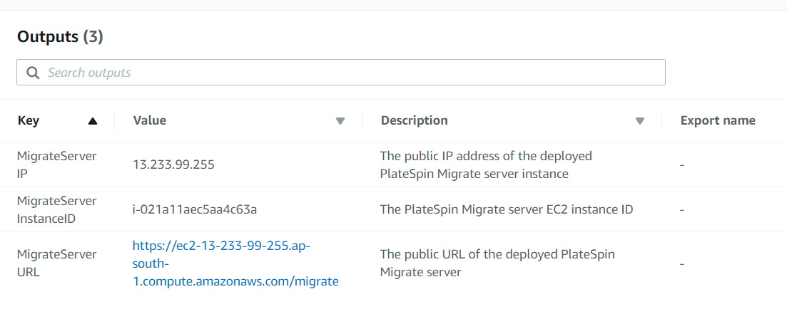

Figure 2: PlateSpin Migrate Server outputs after successful deployment

## Step 3. Test the Deployment

<Lorem ipsum dolor sit amet, consectetur adipiscing elit, sed do eiusmod tempor incididunt ut labore et dolore magna aliqua.>

To connect to the PlateSpin Migrate Server instance deployed in AWS, you must first use the AWS Console to retrieve the password for logging in to the instance.

**Retrieve Instance Password**

1. In the **Resources** tab of the WorkloadStack, click the MigrateServerInstance ID to launch the instance in AWS Console.
2. Select the instance, and from the Actions menu, choose **Get Windows Password**. Choose **Continue.**
3. Choose **Browse**, select your key pair file that you previously created, and choose **Open.**
4. Choose **Decrypt Password** toretrieve the password to log in to the Migrate Server instance.
5. Note down the displayed password. You will use this password for logging in to the PlateSpin Migrate Server instance in AWS Cloud.

**Connect to PlateSpin Migrate Server Instance Deployed in AWS Cloud**

1. In the **Output** tab of the master stack, click the value of the URL to launch the PlateSpin Migrate Web Interface.
2. Log in to theweb interface using the Administrator user and specify the password that you retrieved in <#password>.
3. Add the PlateSpin Migrate Server license.
4. Use PlateSpin Migrate to perform migrations of workload. See Working with PlateSpin Migrate Server Instance on AWS Cloud.

# Best practices for using PlateSpin Migrate Server on AWS

The best practices that apply to using PlateSpin Migrate Server in your data center also apply to using PlateSpin Migrate Sever on AWS. You must adopt the best practices when you configure migration jobs to AWS to help prevent the failure of the migration job to AWS. For more information, see [Best Practices for Configuring a Migration Job to Amazon Web Services](https://wwwtest.microfocus.com/documentation/platespin/platespin-migrate-2019-2/migrate-user/t41zwpluw8lm.html).

<Lorem ipsum dolor sit amet, consectetur adipiscing elit, sed do eiusmod tempor incididunt ut labore et dolore magna aliqua.>

# Security

<Lorem ipsum dolor sit amet, consectetur adipiscing elit, sed do eiusmod tempor incididunt ut labore et dolore magna aliqua.>

To help you safeguard your data and increase security, PlateSpin Migrate recommends some security best practices. For more information, see [Security and Privacy](https://wwwtest.microfocus.com/documentation/platespin/platespin-migrate-2019-2/migrate-user/security.html).

# <Other useful information>

<Lorem ipsum dolor sit amet, consectetur adipiscing elit, sed do eiusmod tempor incididunt ut labore et dolore magna aliqua.>

# FAQ

**Q.** I encountered a CREATE_FAILED error when I launched the Quick Start.

**A.** If AWS CloudFormation fails to create the stack, we recommend that you relaunch the template with **Rollback on failure** set to **No**. (This setting is under **Advanced** in the AWS CloudFormation console, **Options** page.) With this setting, the stack’s state will be retained and the instance will be left running, so you can troubleshoot the issue. (For Windows, look at the log files in %ProgramFiles%\Amazon\EC2ConfigService and C:\cfn\log.)

**Important** When you set **Rollback on failure** to **No**, you will continue to incur AWS charges for this stack. Please make sure to delete the stack when you finish troubleshooting.

For additional information, see [Troubleshooting AWS CloudFormation](https://docs.aws.amazon.com/AWSCloudFormation/latest/UserGuide/troubleshooting.html) on the AWS website.

**Q.** I encountered a size limitation error when I deployed the AWS CloudFormation templates.

**A.** We recommend that you launch the Quick Start templates from the links in this guide or from another S3 bucket. If you deploy the templates from a local copy on your computer or from a non-S3 location, you might encounter template size limitations when you create the stack. For more information about AWS CloudFormation limits, see the [AWS documentation](http://docs.aws.amazon.com/AWSCloudFormation/latest/UserGuide/cloudformation-limits.html).

# Send us feedback

To post feedback, submit feature ideas, or report bugs, use the **Issues** section of the [GitHub repository](https://github.com/aws-quickstart/tbd) for this Quick Start. If you’d like to submit code, please review the [Quick Start Contributor’s Guide](https://aws-quickstart.github.io/).

# Additional resources

AWS resources

* [Getting Started Resource Center](https://aws.amazon.com/getting-started/)
* [AWS General Reference](https://docs.aws.amazon.com/general/latest/gr/)
* [AWS Glossary](https://docs.aws.amazon.com/general/latest/gr/glos-chap.html)

AWS services

* [AWS CloudFormation](https://docs.aws.amazon.com/cloudformation/)
* [Amazon EBS](https://docs.aws.amazon.com/AWSEC2/latest/UserGuide/AmazonEBS.html)
* [Amazon EC2](https://docs.aws.amazon.com/ec2/)
* [IAM](https://docs.aws.amazon.com/iam/)
* [Amazon VPC](https://docs.aws.amazon.com/vpc/)

PlateSpin Migrate documentation

* https://www.microfocus.com/documentation/platespin/platespin-migrate/

Other Quick Start reference deployments

* [AWS Quick Start home page](https://aws.amazon.com/quickstart/)

# Document revisions

|  |  |  |
| --- | --- | --- |
| Date | Change | In sections |
| <month> 2019 | <Lorem ipsum dolor sit amet, consectetur adipiscing elit, sed do eiusmod tempor incididunt ut labore et dolore magna aliqua.> | <links to revised sections> |
| <month> 2019 | Initial publication | — |

© 2019, Amazon Web Services, Inc. or its affiliates, and <partner organization>. All rights reserved.

**Notices**

This document is provided for informational purposes only. It represents AWS’s current product offerings and practices as of the date of issue of this document, which are subject to change without notice. Customers are responsible for making their own independent assessment of the information in this document and any use of AWS’s products or services, each of which is provided “as is” without warranty of any kind, whether express or implied. This document does not create any warranties, representations, contractual commitments, conditions or assurances from AWS, its affiliates, suppliers or licensors. The responsibilities and liabilities of AWS to its customers are controlled by AWS agreements, and this document is not part of, nor does it modify, any agreement between AWS and its customers.

The software included with this paper is licensed under the Apache License, Version 2.0 (the "License"). You may not use this file except in compliance with the License. A copy of the License is located at <http://aws.amazon.com/apache2.0/> or in the "license" file accompanying this file. This code is distributed on an "AS IS" BASIS, WITHOUT WARRANTIES OR CONDITIONS OF ANY KIND, either express or implied. See the License for the specific language governing permissions and limitations under the License.

# Style Guide

Delete this section after following these guidelines.

## Terminology and usage

* For a word list and usage guidelines for AWS content, see the [AWS Usage Dictionary](https://alpha-docs-aws.amazon.com/awsstyleguide/latest/styleguide/dictionary.html) (internal AWS use only).
* For AWS service names and allowed variations, see the [AWS Service Names](https://w.amazon.com/bin/view/AWSDocs/editing/service-names/) wiki page (internal AWS use only).

## Bullet lists

* Use the **List Bullet** style instead of using the bullets control on the Word ribbon.
* Use the **List Paragraph** style for additional paragraphs under the bullet.
* Use nested bullet lists sparingly.
* Use the **List Bullet 2** style for second-level bulleted lists.
* Keep both first-level and second-level lists short. Three to seven items is a good rule of thumb to follow.
* Manually change the spacing after the last item to 14 pt.

## Numbered lists for procedures

1. Use a numbered list only when there’s a sequence (of steps, or priorities, etc.) involved. (Note that we’re using a numbered list in this section to illustrate formatting, but this information would require bullets, not numbers.)
2. Use the **List Number** style instead of using the numbered list control on the Word ribbon.
3. Use the **List Paragraph** style for additional paragraphs under the number.
4. Use nested lists sparingly.
5. Use the **List Number 2** style for second-level numbered lists.
6. Manually change the spacing after the last item to 14 pt.

## Tips, notes, and warnings

Use the **Note** style, which provides the following formatting. Change “Note” to “Tip” or “Warning” as needed.

**Note** You are responsible for all costs incurred by your use of the AWS services used while running this Quick Start Reference Deployment. See the pricing pages of the specific AWS services you will be using for full details.

## Graphics

* Use the **Picture** style, which centers the illustration.
* Below the figure, add the figure caption using the **Caption** style. Specify the number in the format **Figure *n*: Caption**. Use sentence capitalization for captions (that is, just capitalize the first word and any proper nouns).
* For architecture diagrams, use our [PowerPoint template](https://github.com/aws-quickstart/quickstart-examples/raw/master/doc/Quick%20Start%20architecture%20diagram.pptx) template and the [AWS simple icons](https://aws.amazon.com/architecture/icons/), and send us the source file.
* For screenshots:
* Use where the UI is confusing or complex. Avoid using screenshots for login screens or any UI that’s self-explanatory.
* Crop screenshots to the smallest useful size, centering on the topic of discussion but showing just enough surrounding area to establish context.
* Blur all personal information.
* Fill in values when displaying settings.
* If capturing a browser screen, try making the window smaller to decrease the width of the image and to minimize the need to resize it.
* Highlight hard-to-find elements with a green arrow or rectangle with no shadows. Or send us the screenshot without highlighting and let us know where we need to add it.
* Provide an explanation in text. Don’t rely on screenshots alone to convey information.
* For detailed guidelines, see [Art](https://alpha-docs-aws.amazon.com/awsstyleguide/latest/styleguide/graphics.html) in the *AWS Style Guide* (internal AWS use only).

## Tables

* Create a table in Word (**Insert** > **Table**), and apply the **AWS** table style from the menu on the **Table Tools**, **Design** tab. There’s also an **AWS wide** style if you need a wider table.
* Use the **Table text** style for the contents of the table.
* Add boldface for headings.
* Turn on the **Repeat Header Rows** option on the **Table Tools**, **Layout** tab.

|  |  |  |  |  |
| --- | --- | --- | --- | --- |
|  | January | February | March | April |
| North | Red | Green | Blue | Black |
| South | Red | Green | Blue | Black |
| East | Red | Green | Blue | Black |
| West | Red | Green | Blue | Black |

## References

* Use the **Hyperlink** style.
* Use the title of the paper or website as link text. Don’t use phrases like “click here” or “this website” for your links.
* In some cases, you might want to shorten the link text and weave it into the sentence, e.g., “Create a [key pair](http://docs.aws.amazon.com/AWSEC2/latest/UserGuide/ec2-key-pairs.html) in your preferred region.”
* Don’t display the URL in text unless you’re linking to a home page or to a main section under the home page.
* When providing information from other sources, be sure to use your own words. Use short quotations if necessary. It’s OK to use text from the AWS documentation.

## Code

For code that appears within a sentence, use the Code Inline style.

For code blocks, use the **Code Snippet** style:

"Conditions": {

"GovCloudCondition": {

"Fn::Equals": [

{

"Ref": "AWS::Region"

},

"us-gov-west-1"

]

}

},

In the HTML version of the deployment guide, we can use syntax highlighting for selected languages, including JSON, PowerShell, Bash, and Python. The PDF format doesn’t support syntax highlighting.