PlateSpin Migrate Server on the AWS Cloud

Quick Start Reference Deployment

November 2018

***Micro Focus***

*AWS Quick Start Team*

Contents

Quick Links 1

Overview 1

PlateSpin Migrate Server on AWS 1

Costs and Licenses 1

Architecture 1

Prerequisites 1

Technical Requirements 1

Specialized Knowledge 1

Deployment Options 1

Deployment Steps 1

Step 1. Prepare Your AWS Account 1

Step 2. Launch the Quick Start 1

Step 3. Testing the Deployment 1

Best Practices Using PlateSpin Migrate Server on AWS 1

Security 1

<Other Useful Information> 1

FAQ 1

GitHub Repository 1

Additional Resources 1

Document Revisions 1

Style Guide 1

Terminology and usage 1

Bullet lists 1

Numbered lists for procedures 1

Tips, Notes, Warnings 1

Figures 1

Tables 1

References 1

Code 1

Sidebars 1

Colors 1

This Quick Start was created by Micro Focus in collaboration with Amazon Web Services (AWS).

[Quick Starts](http://aws.amazon.com/quickstart/) are automated reference deployments that use AWS CloudFormation templates to deploy key technologies on AWS, following AWS best practices.

## Quick Links

The links in this section are for your convenience. Before you launch the Quick Start, please review the architecture, security, and other considerations discussed in this guide.

* If you have an AWS account, and you’re already familiar with AWS services and PlateSpin Migrate, you can launch the Quick Start to build the architecture shown in Figure 1 in a new or existing virtual private cloud (VPC). The deployment takes approximately about 5-10 mins to create the stack. If you’re new to AWS or to PlateSpin Migrate, please review the implementation details and follow the step-by-step instructions provided later in this guide.

[**View template**](https://s3.amazonaws.com/quickstart-reference/rest-of-url)

**(for new VPC)**

[**Launch  
(for**](https://console.aws.amazon.com/cloudformation/home?region=us-west-2#cstack=sn%7Estack-name%7Cturl%7Ehttps://s3.amazonaws.com/quickstart-reference/rest-of-url) **existing VPC)**

[**Launch  
(for**](https://console.aws.amazon.com/cloudformation/home?region=us-west-2#cstack=sn%7Estack-name%7Cturl%7Ehttps://s3.amazonaws.com/quickstart-reference/rest-of-url) **new VPC)**

* If you want to take a look under the covers, you can view the AWS CloudFormation templates that automate the deployment.

## Overview

[**View template**](https://s3.amazonaws.com/quickstart-reference/rest-of-url)

**(for new VPC)**

[**View template**](https://s3.amazonaws.com/quickstart-reference/rest-of-url)

**(for existing VPC)**

This Quick Start reference deployment guide provides step-by-step instructions for deploying PlateSpin Migrate Server on the AWS Cloud.

This Quick Start is for users who wants to quickly and easily deploy PlateSpin Migrate Server on AWS Cloud.

### PlateSpin Migrate Server on AWS

PlateSpin Migrate enables you to migrate heterogeneous workloads across x86-based physical, virtual, image, and cloud infrastructures in your data center. It decouples the workload infrastructure from its software (operating system, applications, and data) to allow any-to-any migrations. Migrate provides tools to easily discover workloads and hosts in your environment. You can efficiently configure, execute, and test workload even before the actual cutover, and also monitor the status of workload migration. With Migrate, you can dramatically increase the migration speed and success ratios, which help reduce the costs for your migration projects.

PlateSpin Migrate automates the migration of workloads among physical, virtual machine, volume imaging, and cloud. The supported cloud platforms include Amazon Web Services (AWS), Microsoft Azure, VMware vCloud Director, and VMware Cloud on AWS.

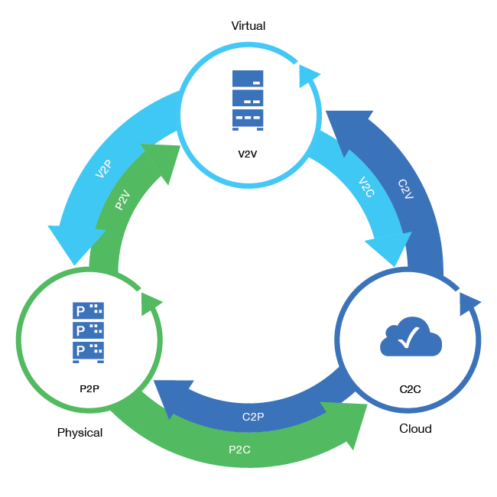

PlateSpin Migrate Web Interface supports automated cloud-to-cloud (C2C) migration of workloads. For migrations using a cloud-based PlateSpin Migrate Server and public IP addresses, Migrate does not require site-to-site VPN connections between any of the participating locations: source cloud, target cloud, and data center.

This Quick Start uses AWS CloudFormation templates to automate the deployment and configuration of PlateSpin Migrate on AWS.

### Costs and Licenses

You are responsible for the cost of the AWS services used while running this Quick Start reference deployment. There is no additional cost for using the Quick Start.

The AWS CloudFormation template for this Quick Start includes configuration parameters that you can customize. Some of these settings, such as instance type, will affect the cost of deployment. For cost estimates, see the pricing pages for each AWS service you will be using. Prices are subject to change.

**Tip** After you deploy the Quick Start, we recommend that you enable the [AWS Cost and Usage Report](https://docs.aws.amazon.com/awsaccountbilling/latest/aboutv2/billing-reports-gettingstarted-turnonreports.html) to track costs associated with the Quick Start. This report delivers billing metrics to an S3 bucket in your account. It provides cost estimates based on usage throughout each month, and finalizes the data at the end of the month. For more information about the report, see the [AWS documentation](https://docs.aws.amazon.com/awsaccountbilling/latest/aboutv2/billing-reports-costusage.html).

This deployment uses a Bring Your Own License (BYOL) model for PlateSpin Migrate Server. You must already own licenses for PlateSpin Migrate Server. For more information about PlateSpin Migrate licenses, see [PlateSpin Migrate Product Licensing](https://www.netiq.com/documentation/platespin-migrate-12-3/migrate-user/data/mig-license.html) in the [PlateSpin Migrate User guide](https://www.netiq.com/documentation/platespin-migrate-12-3/migrate-user/data/mig-license.html).

## Architecture

Deploying this Quick Start for a new virtual private cloud (VPC) with **default parameters** builds the following PlateSpin Migrate Server environment in the AWS Cloud:

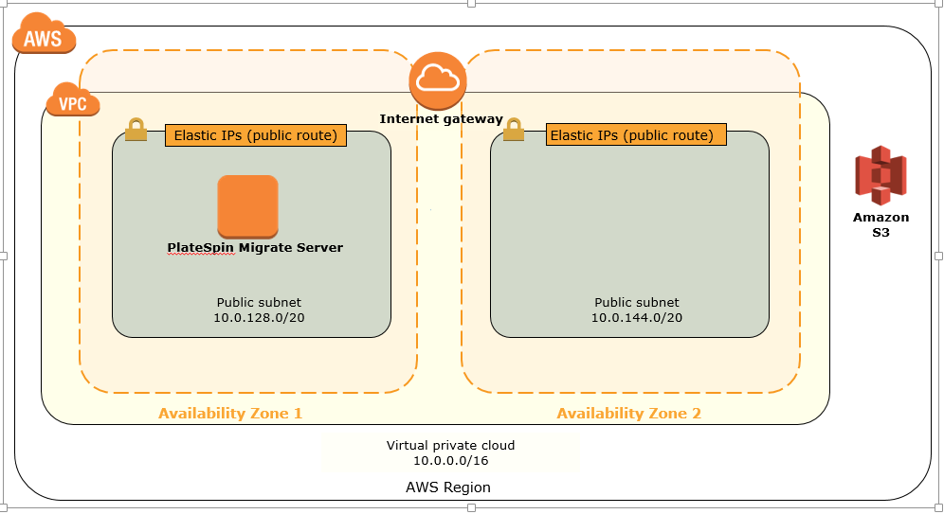

Figure 1: Quick Start architecture for PlateSpin Migrate Server on AWS

The Quick Start sets up the following:

* A highly available architecture that spans two Availability Zones.*
* A VPC configured with public subnets according to AWS best practices, to provide you with your own virtual network on AWS.*
* An internet gateway to allow access to the internet. This gateway is used by the PlateSpin Migrate Server to send and receive traffic.*
* In one of the public subnets, an EC2 instance with a fully configured PlateSpin Migrate Server instance setup on a Windows Server.
* A Security group for the Migrate Server instance to restrict access to HTTPS – 443.
* A Security group for the Target Workloads in AWS to restrict access to only necessary protocols and ports such as SSH -22, HTTPS - 443, TCP - 3725
* An AWS IAM role with a policy having fine-grained permissions required to perform PlateSpin Migrate conversions to AWS.

**\*** The template that deploys the Quick Start into an existing VPC skips the tasks marked by asterisks and prompts you for your existing VPC configuration.

## Prerequisites

### Technical Requirements

Ensure that the following prerequisites are met:

* An AWS account with the account login information readily available. To create an AWS account, go to [Amazon Web Services Console](http://aws.amazon.com).
* A PlateSpin Migrate license. See [PlateSpin Migrate Product Licensing](https://www.netiq.com/documentation/platespin-migrate-12-3/migrate-user/data/mig-license.html#web_interface_licenses).
* An Amazon private key (.pem file) to use for authentication during setup.
* If you are planning to launch this Quick Start into your own VPC, you must ensure to use a subnet with an Internet gateway to allow limited, outbound public Internet access. PlateSpin Migrate uses AWS APIs that require outbound public Internet connectivity to successfully migrate workloads to AWS.

### Specialized Knowledge

Before you deploy this Quick Start, we recommend that you become familiar with the following AWS services. (If you are new to AWS, see [Getting Started with AWS](https://aws.amazon.com/getting-started/).)

* [Amazon EC2](https://aws.amazon.com/documentation/ec2/)
* [Amazon EBS](https://docs.aws.amazon.com/AWSEC2/latest/UserGuide/AmazonEBS.html)
* [Amazon IAM](https://docs.aws.amazon.com/iam/)
* [Amazon VPC](https://aws.amazon.com/documentation/vpc/)
* [Amazon CloudFormation](https://aws.amazon.com/documentation/cloudformation/)
* [Amazon CloudWatch](https://aws.amazon.com/cloudwatch/)

## 

## Deployment Options

This Quick Start provides two deployment options:

* **Deploy PlateSpin Migrate Server into a new VPC** (end-to-end deployment). This option builds a new AWS environment consisting of the VPC, subnets, NAT gateways, security groups, and other infrastructure components, and then deploys PlateSpin Migrate Server into this new VPC.
* **Deploy PlateSpin Migrate Server into an existing VPC**. This option provisions PlateSpin Migrate Server in your existing AWS infrastructure.

The Quick Start provides separate templates for these options. It also lets you configure CIDR blocks, instance types, and PlateSpin Migrate Server settings, as discussed later in this guide.

## Deployment Steps

### Step 1. Prepare Your AWS Account

1. If you don’t already have an AWS account, create one at <https://aws.amazon.com> by following the on-screen instructions.
2. Use the region selector in the navigation bar to choose the AWS Region where you want to deploy PlateSpin Migrate Server on AWS.
3. Create a [key pair](https://docs.aws.amazon.com/AWSEC2/latest/UserGuide/ec2-key-pairs.html) in your preferred region.
4. If necessary, [request a service limit increase](https://console.aws.amazon.com/support/home#/case/create?issueType=service-limit-increase&limitType=service-code-) for the required Amazon EC2 instance type. You might need to do this if you already have an existing deployment that uses this instance type, and you think you might exceed the [default limit](http://docs.aws.amazon.com/AWSEC2/latest/UserGuide/ec2-resource-limits.html) with this deployment.

### Step 2. Launch the Quick Start

**Note** You are responsible for the cost of the AWS services used while running this Quick Start reference deployment. There is no additional cost for using this Quick Start. For full details, see the pricing pages for each AWS service you will be using in this Quick Start. Prices are subject to change.

1. Choose one of the following options to launch the AWS CloudFormation template into your AWS account. For help choosing an option, see deployment options earlier in this guide.

|  |  |
| --- | --- |
| Option 1  [**Launch**](https://console.aws.amazon.com/cloudformation/home?region=us-east-2#cstack=sn%7EOracle-Database%7Cturl%7Ehttps://s3.amazonaws.com/quickstart-reference/)  Deploy PlateSpin Migrate Server into a new VPC on AWS | Option 2  [**Launch**](https://console.aws.amazon.com/cloudformation/home?region=us-east-2#cstack=sn%7EOracle-Database%7Cturl%7Ehttps://s3.amazonaws.com/quickstart-reference/)  Deploy PlateSpin Migrate Server into an existing VPC on AWS |

**Important** If you’re deploying PlateSpin Migrate Server into an existing VPC, you will be prompted for your VPC settings when you launch the Quick Start.

Each deployment takes about 5-10 mins to complete.

1. Check the region that’s displayed in the upper-right corner of the navigation bar, and change it if necessary. This is where the network infrastructure for PlateSpin Migrate Server will be built. The template is launched in the US East (Ohio) Region by default.
2. On the **Select Template** page, keep the default setting for the template URL, and then choose **Next**.
3. On the **Specify Details** page, change the stack name if needed. Review the parameters for the template. Provide values for the parameters that require input. For all other parameters, review the default settings and customize them as necessary. When you finish reviewing and customizing the parameters, choose **Next**.

In the following tables, parameters are listed by category and described separately for the two deployment options:

* Parameters for deploying <software> into a new VPC
* Parameters for deploying <software> into an existing VPC
* **Option 1: Parameters for deploying PlateSpin Migrate Server into a new VPC**

[View template](https://s3.amazonaws.com/quickstart-reference/)

*<The following parameter tables are generated automatically from the templates. Don’t enter the parameter information manually. The information below is provided only as an example. We recommend that you use these group and parameter labels if you’re providing similar functionality in your CloudFormation templates. For parameter naming guidelines, see the* [*Contributor’s Guide*](https://aws-quickstart.github.io/naming-parms.html)*.>*

*VPC Network Configuration:*

|  |  |  |
| --- | --- | --- |
| Parameter label (name) | Default | Description |
| Availability Zones (AvailabilityZones) | *Requires input* | The list of Availability Zones to use for the subnets in the VPC. The Quick Start uses two Availability Zones from your list and preserves the logical order you specify. |
| VPC CIDR (VPCCIDR) | 10.0.0.0/16 | The CIDR block for the VPC. |
| Private Subnet 1 CIDR (PrivateSubnet1CIDR) | 10.0.0.0/19 | The CIDR block for the private subnet located in Availability Zone 1. |
| Private Subnet 2 CIDR (PrivateSubnet2CIDR) | 10.0.32.0/19 | The CIDR block for the private subnet located in Availability Zone 2. |
| Public Subnet 1 CIDR (PublicSubnet1CIDR) | 10.0.128.0/20 | The CIDR block for the public (DMZ) subnet located in Availability Zone 1. |
| Public Subnet 2 CIDR (PublicSubnet2CIDR) | 10.0.144.0/20 | The CIDR block for the public (DMZ) subnet located in Availability Zone 2. |
| Permitted IP range (AccessCIDR) | *Requires input* | The CIDR IP range that is permitted to access <software>. We recommend that you set this value to a trusted IP range. For example, you might want to grant only your corporate network access to the software. |

*Amazon EC2 Configuration:*

|  |  |  |
| --- | --- | --- |
| Parameter label (name) | Default | Description |
| Key Name (KeyPairName) | *Requires input* | A public/private key pair, which allows you to connect securely to your instance after it launches. When you created an AWS account, this is the key pair you created in your preferred region. |

*AWS Quick Start Configuration:*

|  |  |  |
| --- | --- | --- |
| Parameter label (name) | Default | Description |
| Quick Start S3 Bucket Name (QSS3BucketName) | aws-quickstart | The S3 bucket you have created for your copy of Quick Start assets, if you decide to customize or extend the Quick Start for your own use. The bucket name can include numbers, lowercase letters, uppercase letters, and hyphens, but should not start or end with a hyphen. |
| Quick Start S3 Key Prefix (QSS3KeyPrefix) | quickstart-atlassian-bitbucket/ | The [S3 key name prefix](https://docs.aws.amazon.com/AmazonS3/latest/dev/UsingMetadata.html) used to simulate a folder for your copy of Quick Start assets, if you decide to customize or extend the Quick Start for your own use. This prefix can include numbers, lowercase letters, uppercase letters, hyphens, and forward slashes. |

* **Option 2: Parameters for deploying** **PlateSpin Migrate Server into an existing VPC**

[View template](https://s3.amazonaws.com/quickstart-reference/)

*<The following parameter tables are generated automatically from the templates. Don’t enter the parameter information manually. The information below is provided only as an example. We recommend that you use these group and parameter labels if you’re providing similar functionality in your CloudFormation templates. For parameter naming guidelines, see the* [*Contributor’s Guide*](https://aws-quickstart.github.io/naming-parms.html)*.>*

*Network Configuration:*

|  |  |  |
| --- | --- | --- |
| Parameter label (name) | Default | Description |
| VPC ID (VPCID) | *Requires input* | The ID of your existing VPC (e.g., vpc-0343606e). |
| Private Subnet 1 ID (PrivateSubnet1ID) | *Requires input* | The ID of the private subnet in Availability Zone 1 in your existing VPC (e.g., subnet-a0246dcd). |
| Private Subnet 2 ID (PrivateSubnet2ID) | *Requires input* | The ID of the private subnet in Availability Zone 2 in your existing VPC (e.g., subnet-b58c3d67). |
| Bastion Security  Group ID  (BastionSecurityGroupID) | *Requires input* | The ID of the bastion security group in your existing VPC (e.g., sg-7f16e910). |

*Amazon EC2 Configuration:*

|  |  |  |
| --- | --- | --- |
| Parameter label (name) | Default | Description |
| Key Pair Name (KeyPairName) | *Requires input* | A public/private key pair, which allows you to connect securely to your instance after it launches. When you created an AWS account, this is the key pair you created in your preferred region. |

1. On the **Options** page, you can [specify tags](https://docs.aws.amazon.com/AWSCloudFormation/latest/UserGuide/aws-properties-resource-tags.html) (key-value pairs) for resources in your stack and [set advanced options](https://docs.aws.amazon.com/AWSCloudFormation/latest/UserGuide/cfn-console-add-tags.html). When you’re done, choose **Next**.
2. On the **Review** page, review and confirm the template settings. Under **Capabilities**, select the check box to acknowledge that the template will create IAM resources.
3. Choose **Create** to deploy the nested stack.

**Note** A master stack and a child workload stack are created. For new VPC deployments, a child VPC stack is also created.

1. Monitor the status of the stack. When the status is **CREATE_COMPLETE**, PlateSpin Migrate Server is deployed.
2. The PlateSpin Migrate Server Public URL is displayed in the **Output** tab.  
     
   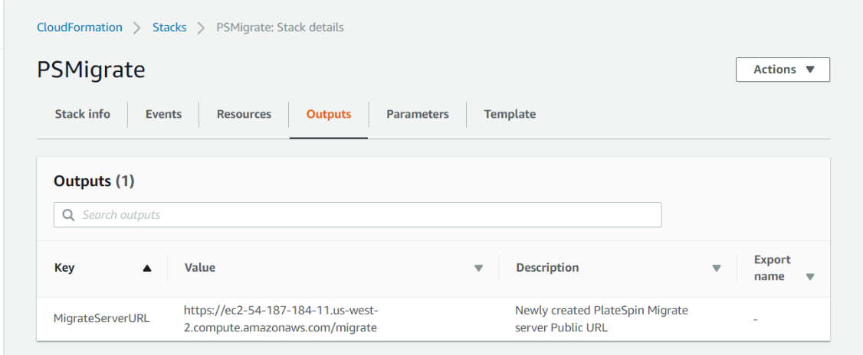
3. The Resources tab displays the resources that are part of the stack.

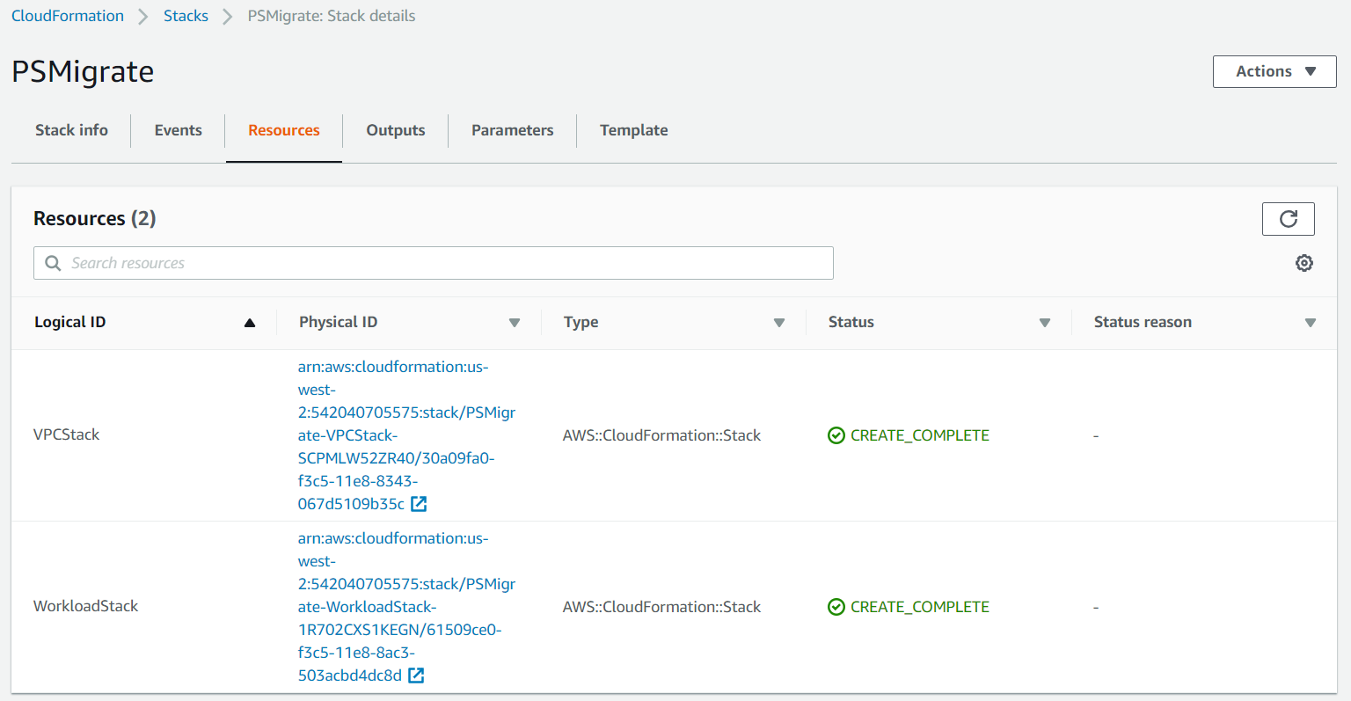

### Step 3. Testing the Deployment

To connect to the PlateSpin Migrate Server instance deployed in AWS, you must first use the AWS Console to retrieve the password for logging in to the instance.

**Retrieve Instance Password**

1. In the **Resources** tab of the WorkloadStack, click the MigrateServerInstance ID to launch the instance in AWS Console.
2. Select the instance, and from the Actions menu, choose **Get Windows Password**. Choose **Continue.**
3. Choose **Browse**, select your key pair file that you previously created, and choose **Open.**
4. Choose **Decrypt Password** toretrieve the password to log in to the Migrate Server instance.
5. Note down the displayed password. You will use this password for logging in to the PlateSpin Migrate Server instance in AWS Cloud.

**Connect to PlateSpin Migrate Server Instance Deployed in AWS Cloud**

1. In the **Output** tab of the master stack, click the value of the URL to launch the PlateSpin Migrate Web Interface.
2. Log in to theweb interface using the Administrator user and specify the password that you retrieved in <#password>.
3. Add the PlateSpin Migrate Server license.
4. Use PlateSpin Migrate to perform migrations of workload. See Working with PlateSpin Migrate Server Instance on AWS Cloud.

## Working with PlateSpin Migrate Server Instance on AWS Cloud

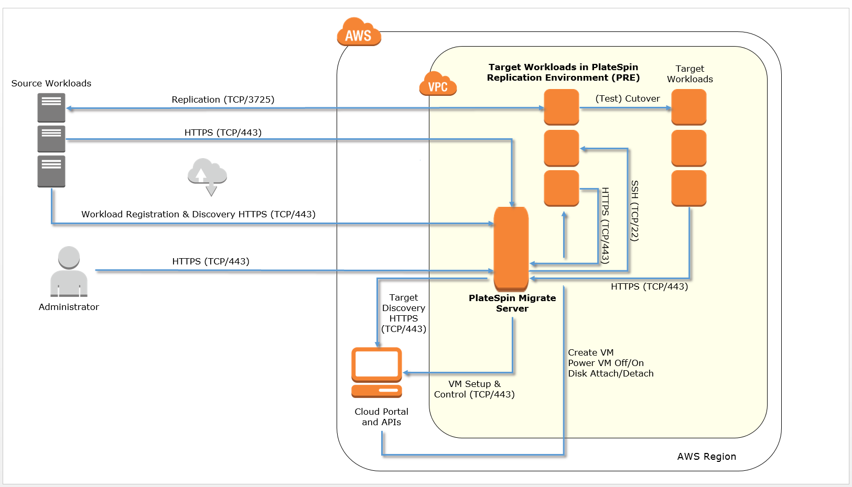

## Best Practices Using PlateSpin Migrate Server on AWS

*Provide information about best practices for using the technology on AWS, including considerations such as migrating data, backups, ensuring high performance, high availability, etc. Link to software documentation for detailed information.*

## Security

*Discussion of security-related components, considerations, responsibilities, best practices.*

## <Other Useful Information>

*Provide any other information of interest to users, especially focusing on areas where AWS or cloud usage differs from on-premises usage.*

## FAQ

*Any tips or answers to anticipated questions. This could include the following troubleshooting information. If you don’t have any other Q&A to add, change this heading to “Troubleshooting” and remove the Q/A headings below.*

**Q.** I encountered a CREATE_FAILED error when I launched the Quick Start.

**A.** If AWS CloudFormation fails to create the stack, we recommend that you relaunch the template with **Rollback on failure** set to **No**. (This setting is under **Advanced** in the AWS CloudFormation console, **Options** page.) With this setting, the stack’s state will be retained and the instance will be left running, so you can troubleshoot the issue. (Look at the log files in %ProgramFiles%\Amazon\EC2ConfigService and C:\cfn\log.)

**Important** When you set **Rollback on failure** to **No**, you will continue to incur AWS charges for this stack. Please make sure to delete the stack when you finish troubleshooting.

For additional information, see [Troubleshooting AWS CloudFormation](https://docs.aws.amazon.com/AWSCloudFormation/latest/UserGuide/troubleshooting.html) on the AWS website.

**Q.** I encountered a size limitation error when I deployed the AWS CloudFormation templates.

**A.** We recommend that you launch the Quick Start templates from the links in this guide or from another S3 bucket. If you deploy the templates from a local copy on your computer or from a non-S3 location, you might encounter template size limitations when you create the stack. For more information about AWS CloudFormation limits, see the [AWS documentation](http://docs.aws.amazon.com/AWSCloudFormation/latest/UserGuide/cloudformation-limits.html).

## GitHub Repository

You can visit our [GitHub repository](https://github.com/aws-quickstart/tbd) to download the templates and scripts for this Quick Start, to post your comments, and to share your customizations with others.

## Additional Resources

*Additional reading, with full URLs. Revise the following as appropriate.*

**AWS services**

* Amazon EBS  
  <https://docs.aws.amazon.com/AWSEC2/latest/UserGuide/AmazonEBS.html>
* Amazon EC2  
  <https://aws.amazon.com/documentation/ec2/>
* Amazon VPC  
  <https://aws.amazon.com/documentation/vpc/>
* AWS CloudFormation  
  <https://aws.amazon.com/documentation/cloudformation/>
* AWS CloudWatch  
  <https://aws.amazon.com/documentation/cloudwatch/>

**<software> documentation**

* *Links for the technology that’s deployed by the Quick Start*

**Quick Start reference deployments**

* AWS Quick Start home page  
  <https://aws.amazon.com/quickstart/>

## Document Revisions

|  |  |  |
| --- | --- | --- |
| Date | Change | In sections |
| <month> 2017 | *Brief description of change. Formatting and minor text changes don’t warrant any mention; major additions and changes do.* | *Links to revised sections* |
| <month> 2017 | Initial publication | — |

© 2018, Amazon Web Services, Inc. or its affiliates, and <partner organization>. All rights reserved.

**Notices**

This document is provided for informational purposes only. It represents AWS’s current product offerings and practices as of the date of issue of this document, which are subject to change without notice. Customers are responsible for making their own independent assessment of the information in this document and any use of AWS’s products or services, each of which is provided “as is” without warranty of any kind, whether express or implied. This document does not create any warranties, representations, contractual commitments, conditions or assurances from AWS, its affiliates, suppliers or licensors. The responsibilities and liabilities of AWS to its customers are controlled by AWS agreements, and this document is not part of, nor does it modify, any agreement between AWS and its customers.

The software included with this paper is licensed under the Apache License, Version 2.0 (the "License"). You may not use this file except in compliance with the License. A copy of the License is located at <http://aws.amazon.com/apache2.0/> or in the "license" file accompanying this file. This code is distributed on an "AS IS" BASIS, WITHOUT WARRANTIES OR CONDITIONS OF ANY KIND, either express or implied. See the License for the specific language governing permissions and limitations under the License.

# Style Guide

Delete this section after following these guidelines.

## Terminology and usage

* For a word list and usage guidelines for AWS content, see the [AWS Usage Dictionary](https://alpha-docs-aws.amazon.com/awsstyleguide/latest/styleguide/dictionary.html) (internal AWS use only).
* For AWS service names and allowed variations, see the [AWS Service Names](https://w.amazon.com/bin/view/AWSDocs/editing/service-names/) wiki page (internal AWS use only).

## Bullet lists

* Use the **List Bullet** style instead of using the bullets control on the Word ribbon.
* Use the **List Paragraph** style for additional paragraphs under the bullet.
* Use nested bullet lists sparingly.
* Use the **List Bullet 2** style for second-level bulleted lists.
* Keep both first-level and second-level lists short. Three to seven items is a good rule of thumb to follow.
* Because bullet lists have less spacing after each paragraph, consider manually changing the spacing after the last item to 14 pt.

## Numbered lists for procedures

1. Use a numbered list only when there’s a sequence (of steps, or priorities, etc.) involved.
2. Use the **List Number** style instead of using the numbered list control on the Word ribbon.
3. Use the **List Paragraph** style for additional paragraphs under the number.
4. Use nested lists sparingly.
5. Use the **List Number 2** style for second-level numbered lists.
6. Because numbered lists have less spacing after each paragraph, consider manually changing the spacing after the last item to 14 pt.

## Tips, Notes, Warnings

Use the **Note** style, which provides the following formatting. Change “Note” to “Tip” or “Warning” as needed.

**Note** You are responsible for all costs incurred by your use of the AWS services used while running this Quick Start Reference Deployment. See the pricing pages of the specific AWS services you will be using for full details.

## Figures

* Use the **Picture** style, which centers the illustration.
* Below the figure, add the figure caption using the **Caption** style. Specify the number in the format **Figure *n*: Caption**. Use sentence capitalization for captions (that is, just capitalize the first word and any proper nouns).
* For architecture diagrams, use the [Visio](https://github.com/aws-quickstart/quickstart-examples/raw/master/doc/Quick%20Start%20architecture%20diagram.vsdx) or [PowerPoint](https://github.com/aws-quickstart/quickstart-examples/raw/master/doc/Quick%20Start%20architecture%20diagram.pptx) templates we provided, and the [AWS simple icons](https://aws.amazon.com/architecture/icons/), and please send us the source file.

## Tables

* Create a table in Word (**Insert** > **Table**), and apply the **AWS** table style from the menu on the **Table Tools**, **Design** tab. There’s also an **AWS wide** style if you need a wider table.
* Use the **Table text** style for the contents of the table.
* Add boldface for headings.
* Turn on the **Repeat Header Rows** option on the **Table Tools**, **Layout** tab.

|  |  |  |  |  |
| --- | --- | --- | --- | --- |
|  | January | February | March | April |
| North | Red | Green | Blue | Black |
| South | Red | Green | Blue | Black |
| East | Red | Green | Blue | Black |
| West | Red | Green | Blue | Black |

## References

* Use the **Hyperlink** style.
* Use the title of the paper or website as link text. Don’t use phrases like “click here” or “this website” for your links.
* In some cases, you might want to shorten the link text and weave it into the sentence, e.g., “Create a [key pair](http://docs.aws.amazon.com/AWSEC2/latest/UserGuide/ec2-key-pairs.html) in your preferred region.”
* Don’t display the URL in text (unless you’re linking to a home page or to a main section under the home page), but make sure to include the full title and URL in the “Additional Resources” section.
* When providing information from other sources, be sure to use your own words. Use short quotations if necessary. It’s OK to use text from the AWS documentation.

## Code

For code that appears within a sentence, use the Code Inline style.

For code blocks, use the **Code Snippet** style:

"Conditions": {

"GovCloudCondition": {

"Fn::Equals": [

{

"Ref": "AWS::Region"

},

"us-gov-west-1"

]

}

},

In the HTML version of the deployment guide, we can use syntax highlighting for selected languages, including JSON, PowerShell, Bash, and Python. The PDF format doesn’t support syntax highlighting.

## Sidebars

**Create Sidebars with an Inset Text Box**You may have to apply a text wrap to your text box. The Square option is usually best. Avoid using multiple paragraphs.

If you want to use a sidebar to highlight content, create a text box (**Insert** > **Text Box**) and style the text inside as **Side Body**. There is no heading style, so if you want to add a heading, style it as **Side Body** and then manually apply the bold attribute.

Avoid using multiple paragraphs, because these are converted to separate text boxes in the PDF. (You can use soft returns to work around this limitation.)

## Colors

When you need to use color, select from the following color palette.

|  |  |  |  |  |  |  |
| --- | --- | --- | --- | --- | --- | --- |
|  |  |  |  |  |  |  |
| R: 242  G: 165  B: 44 | R: 178  G: 36  B: 145 | R: 0  G: 124  B: 188 | R: 139  G: 201  B: 66 | R: 0  G: 0  B: 0 | R: 166  G: 166  B: 166 | R: 89  G: 89  B: 89 |