Amazon Connect

Tele-medicine Solution



Amazon Connect: Tele-medicine Solution

###### Copyright © 2020 Amazon Web Services, Inc. and/or its aﬃliates. All rights reserved.

Amazon's trademarks and trade dress may not be used in connection with any product or service that is not Amazon's, in any manner that is likely to cause confusion among customers, or in any manner that disparages or discredits Amazon. All other trademarks not owned by Amazon are the property of their respective owners, who may or may not be aﬃliated with, connected to, or sponsored by Amazon.

Table of Contents

# What Is Amazon Connect?

Amazon Connect is an omnichannel cloud contact center. You can create personalized experiences for your customers using omnichannel communications. For example, you can dynamically oﬀer chat and voice contact, based on such factors as customer preference and estimated wait times. Agents, meanwhile, conveniently handle all customers from just one interface.

Amazon Connect is an open platform that you can integrate with other enterprise applications, such as Salesforce. In addition, you can take advantage of the AWS ecosystem to innovate new experiences for your customers.

The following diagram shows these key characteristics of Amazon Connect.

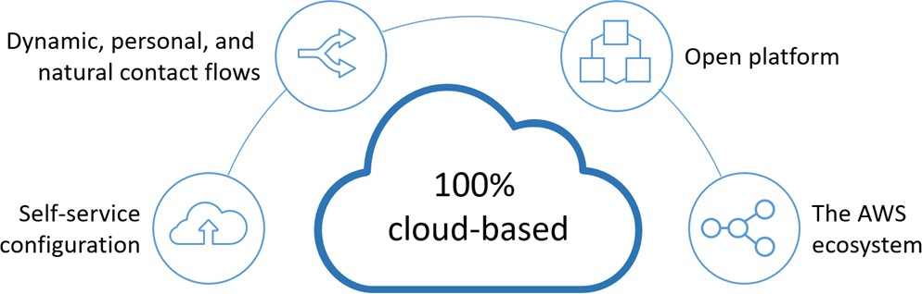

# Tele-medicine Solutions

To recreate this telemedicine solution, the following steps are required:

* Set hours of operations
* Create queue
* Import Queue Flow
* Import Contact Flow
  + Rapid Response (Call)
  + Quick Connection (Chat)
* Create a Routing Profile
* Configure Users
* Claim a Phone Number

Adding chat to your website is possible with a few easy steps. This solutions spins up an Amazon API Gateway endpoint that triggers an AWS Lambda function. This Lambda function invokes the Amazon Connect Service StartChatContact API and returns the result from that call. Once you have the StartChatContact API you can either pass that response to the prebuilt widget to get a quick implementation going or you can build your own customer chat experience by using the Amazon Connect Chat JS library.

<https://github.com/amazon-connect/amazon-connect-chat-ui-examples/tree/master/cloudformationTemplates/startChatContactAPI>

## Set hours of operations

The ﬁrst thing you need to do when you set up a queue is to specify the hours of operation. The hours may be referenced in contact ﬂows

###### To set the hours of operation for a queue

1. Choose Routing, Hours of operation.
2. To create a template, choose Add **new hours** and enter a name **Tele-medicine Hours** and description **Tele-medicine Hours of Operation**
3. For Time zone, select a value.
4. For Add new, set new hours, for this example create Sunday to Saturday from 09:00 AM to 05:00 PM.
5. Choose Save.

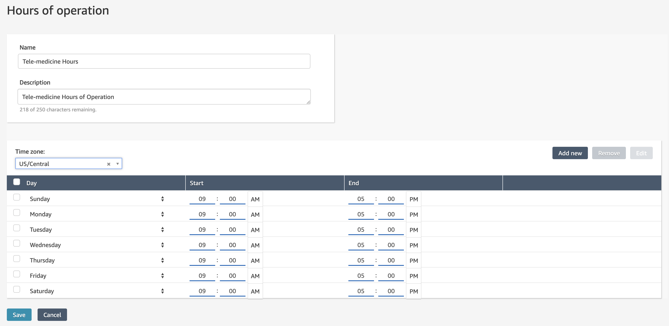

## Create a Queue

1. Choose Routing, Queues, Add new queue.
2. Add the appropriate information about your queue and choose Add new queue, in this case addition then next information
   * Name: Medicine
   * Description: Tele-Medicine Queue
   * Hours of Operations: Tele-medicine Hours
3. Click Add new queue. The queue is automatically active.

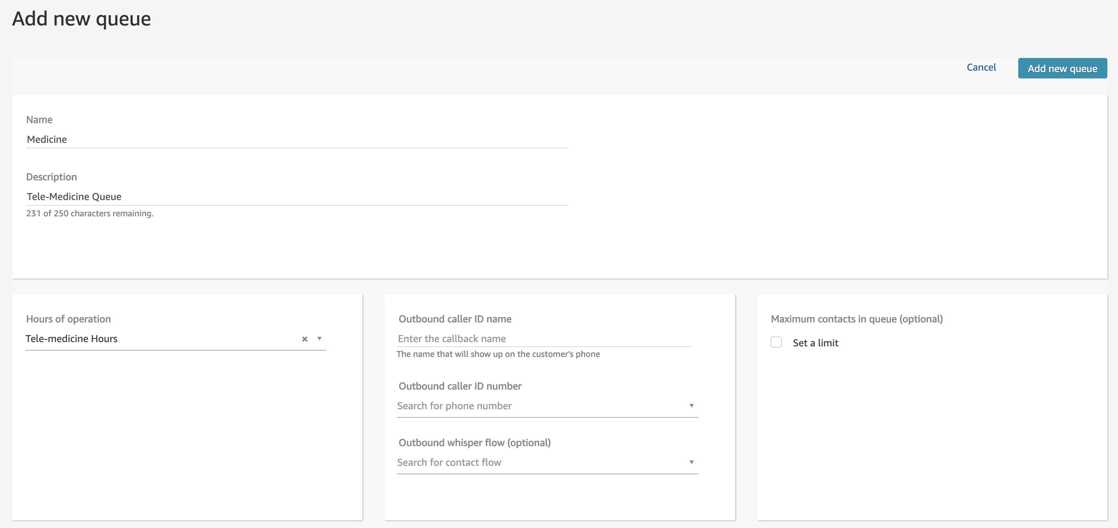

## Import the Queue Flow

1. Choose Routing, Contact Flows
2. Click combo box Create Contact Flow and select **Create Customer Queue Flow**

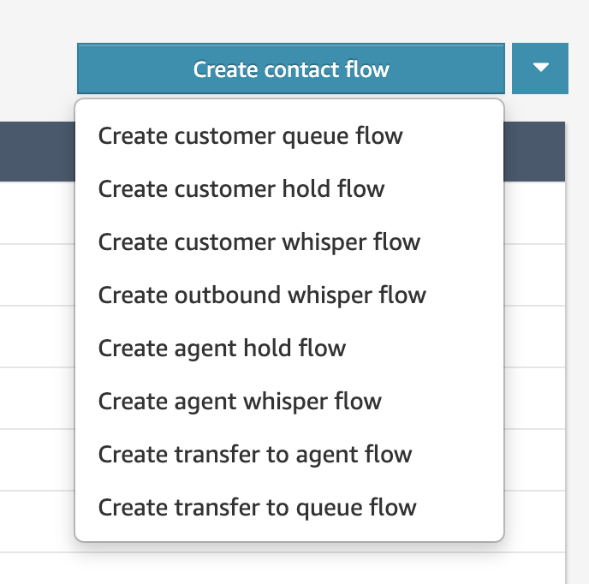

1. Click combo box save, Import flow (beta)

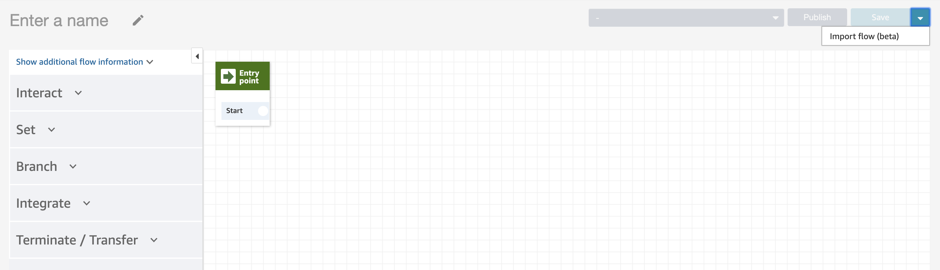

1. Select file **Tele-medicine Queue,** find this file into Tele-medicine Solutions folder and click Import

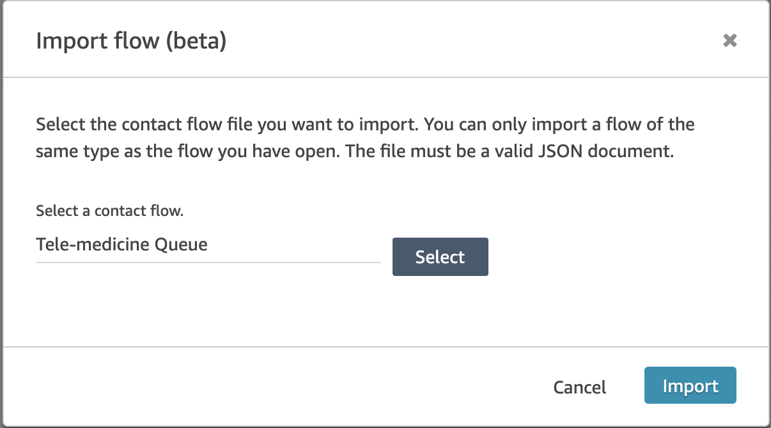

1. When you import the flow, you see the next screen

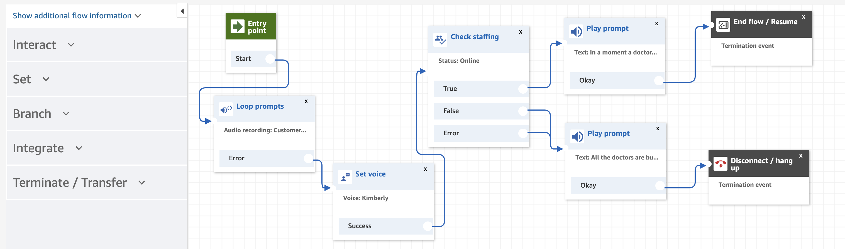

1. Please save and publish the Queue Flow.

## Import the Contact Flow

### Rapid Response (Call)

1. Choose Routing, Contact Flows and **Create Contact Flow**

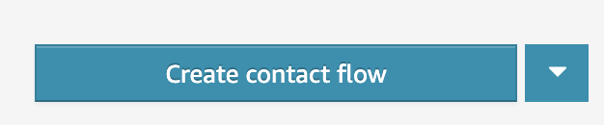

1. Click combo box save, Import flow (beta)



1. Select file **Tele-medicine Flow,** find this file into Tele-medicine Solutions folder and click Import

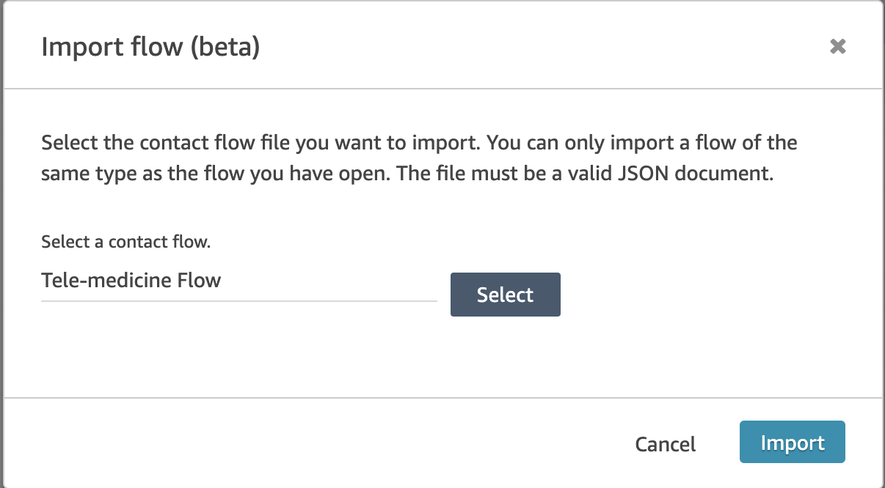

1. When you import the flow, you see the next screen

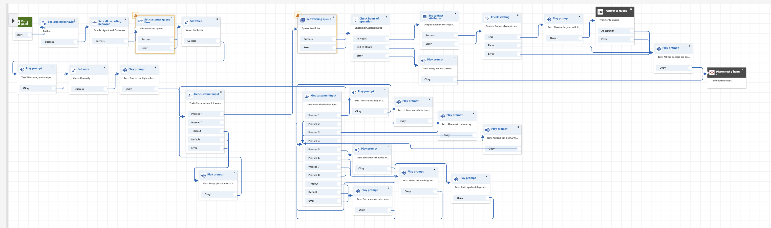

1. Please save and publish the Contact Flow.

### Quick Connection (Chat)

1. Choose Routing, Contact Flows and **Create Contact Flow**



1. Click combo box save, Import flow (beta)



1. Select file **Tele-medicine Chat,** find this file into Tele-medicine Solutions folder and click Import

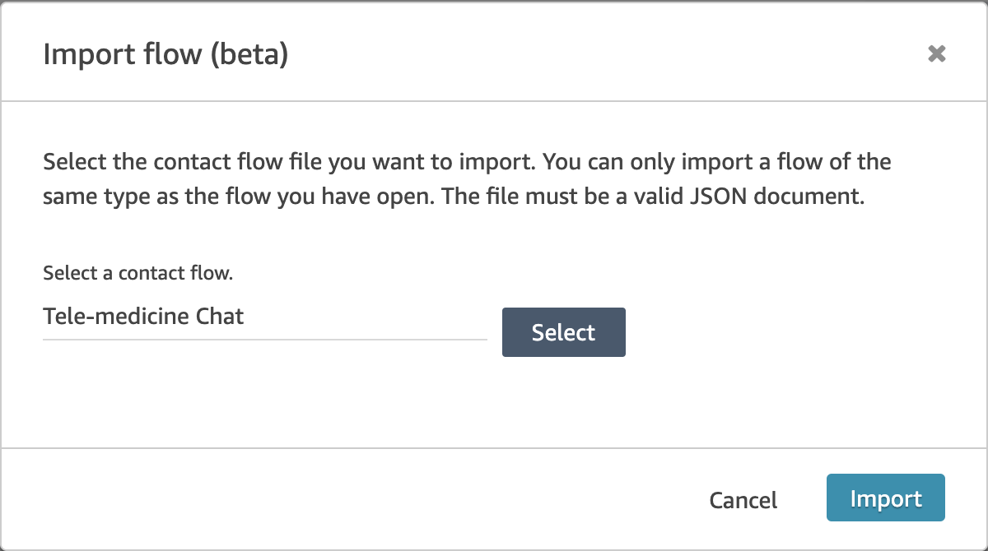

1. When you import the flow, you see the next screen

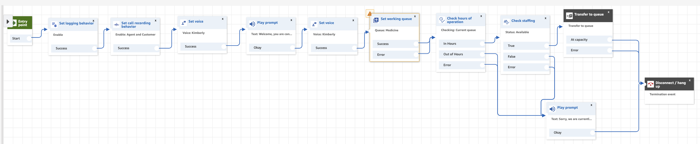

1. Please save and publish the Contact Flow

When you finish import all Queue and Contact flow you see in the Routing -> Contact flow you see 3 flow

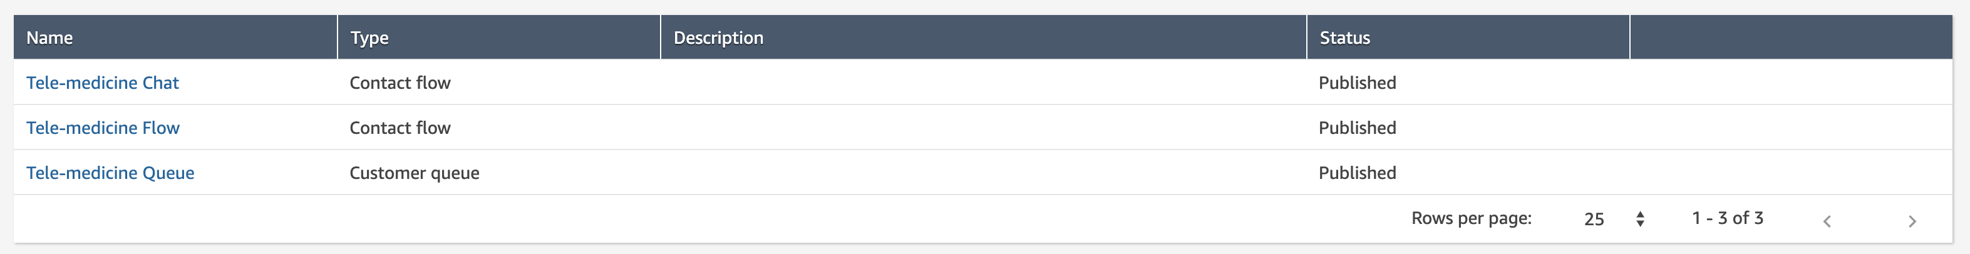

## Create a routing profile

While queues are a 'waiting area' for contacts, a routing proﬁle links queues to agents. When you create a routing proﬁle, you specify which queues will be in it. You can also specify whether one queue should be prioritized over another.

Each agent is assigned to one routing proﬁle.

###### To create a routing proﬁle

1. Choose Users, Routing proﬁles, Add new proﬁle.
2. Enter or choose the following information:

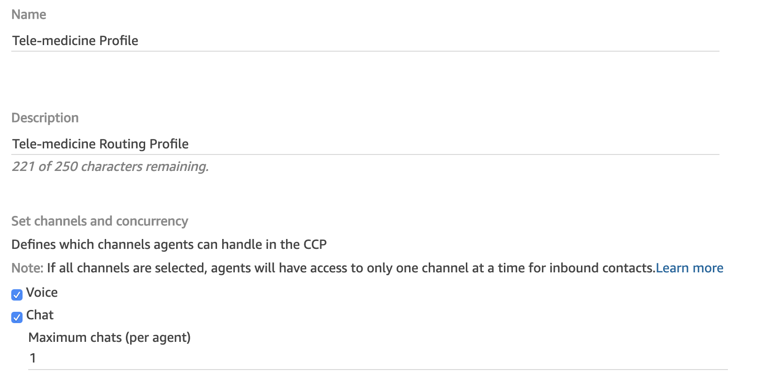

1. Under Routing proﬁle queues, enter the following information and click add queue

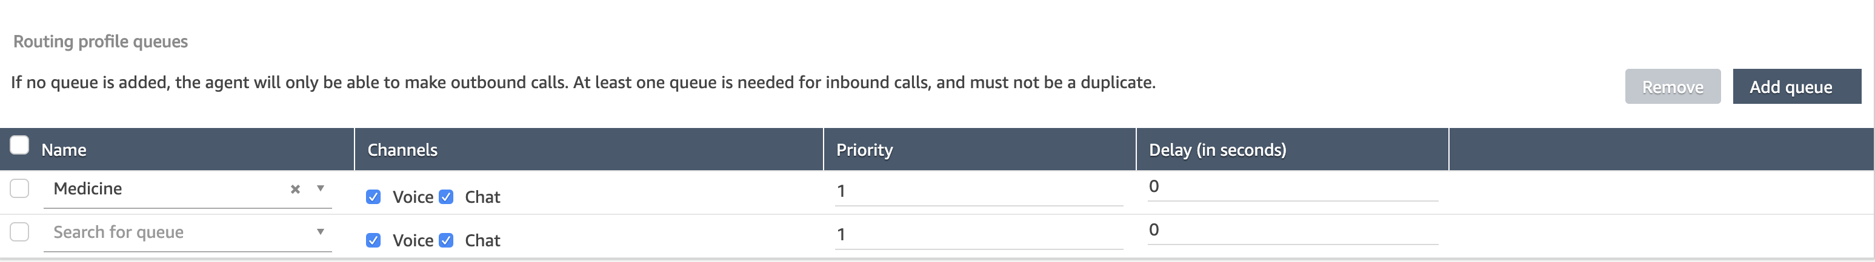

1. Under Default outbound Queue

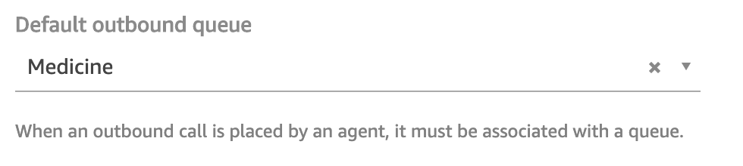

1. Choose Add new proﬁle.

## Configure Users

You can add medics and conﬁgure them with permissions that are appropriate to their roles (for example, agents or managers).

### 

### Add a user individually

1. Log in to the Amazon Connect console with an Admin account, or an account assigned to a security proﬁle that has permissions to create users.
2. Choose Users, User management.
3. Choose Add new users.
4. Choose Create and set up a new user and then choose Next.
5. Enter the name, email address, and password for the user.
6. Choose a routing proﬁle **Tele-medicine Profile** and a security proﬁle **Agent**
7. Choose Save.

## 

### Add users in bulk

Use these steps to add several users from an Excel spreadsheet (.csv)

1. Log in to the Amazon Connect console with an Admin account, or an account assigned to a security proﬁle that has permissions to create users.
2. Choose Users, User management.
3. Choose Add new users.
4. Choose Upload my users from a template (csv) and then choose Next.
5. Choose Download template.
6. Add your users to the template and upload it to Amazon Connect.

## Claim a Phone Number

In this step, you set up a phone number so that you can experiment with Amazon Connect.

1. 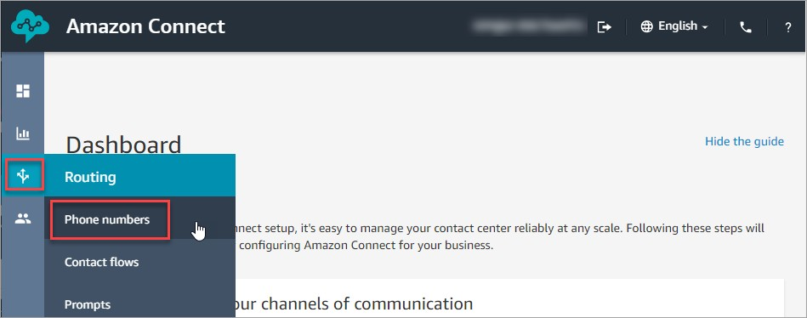On the navigation menu, choose Routing, Phone numbers.
2. On the right side of the page, choose Claim a number.

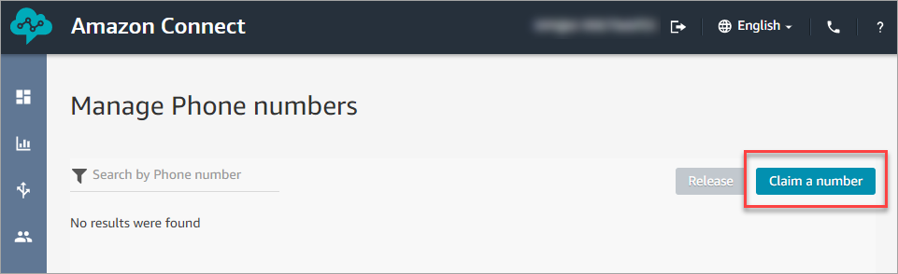

1. 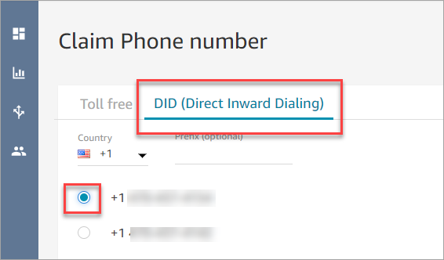Select the DID (Direct Inward Dialing) or Toll free tab. Use the drop-down arrow to choose your country/ region. When numbers are returned, choose one.
2. In the Description box, type this note: **This the number for Tele-medicine Solutions.**
3. In the Contact Flow/IVR select **Tele-medicine Flow** and chose **Save**

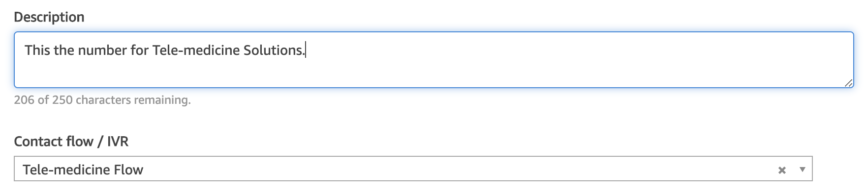

Congratulations! You set up your instance and claimed a phone number. Please call and validate functionality