

Amazon BDA Audio Metadata
Audio Filename | english/test-audio.wav
Audio Duration | 0:04:33.16
Audio Format | 8000kHz wav-file
Dominant Language | EN
Generative Language | DEFAULT

Amazon BDA Audio Custom Metadata
Categories | Customer service
Topics | lost, card, hotel, stay, discount
Issues | lost card
Intents | report lost item, receive assistance
Agent Actions | checked lost and found, found card, offered discount
Pending Actions | mail card to caller

Call Summary Highlights
Carl Lucas called Sleepaway Camp Hotel to report a lost credit card. The agent checked the lost and found, found the card, and arranged to mail it to Carl. The agent also offered a 10% discount on his next stay.

Customer Satisfaction
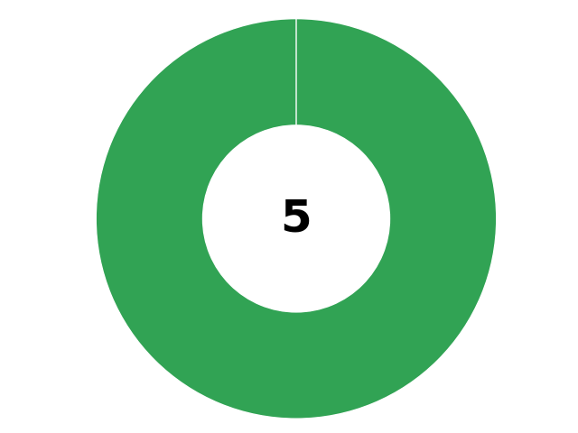

Caller Emotion
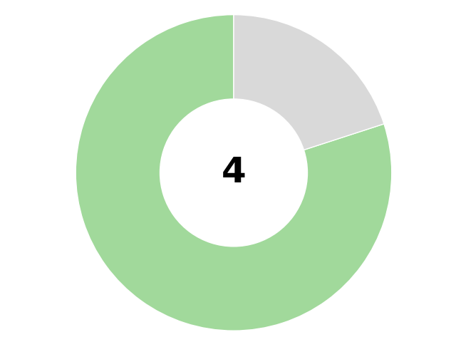

Agent Emotion

Call Success
Call Issue Resolved | ✅
Call Opening Used | ✅
Call Wrapup Used | ❌
Caller Neg Emotion | ❌

Caller Sentiment
The caller was initially concerned about the lost card but became relieved and appreciative when the agent found it and offered a discount.
Emotion Label | Relieved
End Sentiment | Very positive
Improvement | Improved

Agent Sentiment
The agent was helpful and reassuring throughout the call.
Emotion Label | Compassionate
End Sentiment | Very positive

Call Transcription
Start | Dur. | Speaker |  | Transcription
0:00:01.62 | 4.2s | spk_1 |  | [Topic 1] Hello. Sleepaway Camp Hotel. We're a cut above the competition. How can I help you?  Guardrail violence_or_threat (37%)
0:00:07.77 | 14.1s | spk_0 |  | [Topic 2] Hi there. I had just, uh, checked out of the room there a couple of days ago and I've just been looking everywhere. I cannot find the credit card that we used to pay for the hotel. So I was wondering if we may have left it in the room.
0:00:18.98 | 0.7s | spk_1 |  | Oh,
0:00:24.4 | 2.3s | spk_1 |  | OK, I'm so sorry about that, sir.
0:00:25.21 | 12.7s | spk_0 |  | Uh, wondering, I mean, it's fine, it's probably my fault anyway. I mean we could just Check it, see if we could find that card. That would be absolutely wonderful.
0:00:35.6 | 0.9s | spk_1 |  | Yeah, of course.
0:00:38.57 | 3.9s | spk_1 |  | [Topic 3] Sure, yeah. um, can I get your name and the dates that you stayed, please?
0:00:44.64 | 2.2s | spk_0 |  | Sure. My name is
0:00:49.24 | 4.3s | spk_0 |  | Carl Lucas. And uh
0:00:52.28 | 3.1s | spk_1 |  | Oh, OK. Mhm.
0:00:57.83 | 3.7s | spk_0 |  | And we stayed in room 666.
0:01:02.30 | 4.9s | spk_1 |  | OK, that's one of our most popular rooms. OK, Carl Lucas, room 666.  Guardrail sexual (32%) violence_or_threat (33%)
0:01:02.67 | 0.4s | spk_0 |  | OK.
0:01:05.83 | 0.8s | spk_0 |  | I'm paranoid.
0:01:08.52 | 5.7s | spk_1 |  | And um and what uh what dates were were you here? Did you just check out today or was this earlier?
0:01:08.90 | 0.8s | spk_0 |  | And um and
0:01:16.56 | 7.1s | spk_0 |  | This was, let me see, about 2, 2.5 days ago.
0:01:24.56 | 13.7s | spk_1 |  | 2, 2.5 days ago. OK, so that was on, you checked out on Sunday and 000 I think I see you here. You checked in on Friday, uh, on the 13th and you checked out the following Monday, correct?
0:01:35.67 | 0.0s | spk_0 |  | Uh
0:01:39.59 | 1.2s | spk_0 |  | Yeah, that sounds right.
0:01:41.22 | 12.5s | spk_1 |  | [Topic 4] OK, great. All right, um, and did you notice your card was missing today? Did you go to use it or, um, was this, uh, did you notice some charges? What, what are we dealing with here?
0:01:54.7 | 16.3s | spk_0 |  | Uh, we hadn't finished unpacking and then we just, everything was discombobulated. So we threw our cards and stuff just in the, into the briefcase with everything else with the clothes and uh when we unpacked everything and our wallets back in order, it just was not there.
0:02:06.65 | 0.6s | spk_1 |  | OK.
0:02:11.28 | 9.8s | spk_1 |  | OK, I'm so sorry about that. OK, so we're thinking it may have been lost as opposed to stolen or we're not sure. Should we be calling your bank and checking it out?
0:02:12.33 | 1.2s | spk_0 |  | I'm so sorry about that
0:02:22.71 | 16.2s | spk_0 |  | Uh, I'm, I'm thinking that, uh, Uh, I, I'm not seeing any illegitimate charges or anything like that on it so far. I mean, if you guys don't have it, we'll just call the bank, but I figured I would check there first, figure it'd be safer.
0:02:36.87 | 0.5s | spk_1 |  | Sure.
0:02:39.72 | 18.1s | spk_1 |  | [Topic 5] OK dokey. All right, give me one second. I'm just gonna, let's see, I've got the file here where we put all of our lost and found notes, uh, room 661, 662. OK, let me see. 000, can you tell me.
0:02:41.20 | 0.1s | spk_0 |  | Yeah
0:02:58.84 | 2.3s | spk_1 |  | The last four digits on the card, please?
0:03:02.81 | 3.4s | spk_0 |  | I sure can. It is 6666.
0:03:07.8 | 30.3s | spk_1 |  | OK. Oh, that's a funny coincidence. OK, great. Um, yes, we have your card here, Mr. Lucas, and um we did find it in the room, um, however, we found it, uh, the cleaner found it right up on the table. Table. So that's kind of funny. Um, she found it right up on, on the little table in the neck there. So yeah, that's funny. OK, well, um, I will go ahead and get this in the mail to you. We have the address we have on file here. Are you still on Elm Street?
0:03:24.81 | 1.3s | spk_0 |  | 00.
0:03:39.35 | 2.7s | spk_0 |  | Uh, we are, in fact, yes, we are on it.
0:03:40.95 | 27.2s | spk_1 |  | [Topic 6] OK, great, wonderful, wonderful. OK, um, we will send this out to you and just as a little, um, just a little, we're sorry for your trouble. I'd like to offer you, um, 10% off on your next stay with us. So the next time you come, I will send you an email with a little code and the next time you come you can either give the code to the booking agent or you can type it in under promos and codes online and enjoy 10% off your next stay with us.
0:04:04.19 | 1.1s | spk_0 |  | Right. And
0:04:09.3 | 2.6s | spk_0 |  | That is so sweet of you, cut above the rest indeed.
0:04:10.98 | 9.5s | spk_1 |  | 00 yes, we try. Well, thank you so much and I'm so glad we were able to figure this out for you. I will get this out in the mail for you this afternoon. Does that sound good?
0:04:12.52 | 0.3s | spk_0 |  | Oh yeah,
0:04:21.83 | 1.3s | spk_0 |  | That sounds wonderful.
0:04:23.58 | 3.2s | spk_1 |  | OK, great. Thanks so much, Mr. Lucas, and you have a nice day.
0:04:28.7 | 0.9s | spk_0 |  | Now, you too.
0:04:29.58 | 1.0s | spk_1 |  | All right, bye.
0:04:31.78 | 0.4s | spk_0 |  | Bye now.

Conversational Topics
1 | In the provided transcript, spk_1 greets the caller and introduces the Sleepaway Camp Hotel, emphasizing that they are superior to their competitors. Spk_1 then asks how they can assist the caller.
2 | In the transcript, spk_0 mentions that they recently checked out of a hotel room a couple of days ago and are unable to locate the credit card used for payment. They suspect it might have been left in the room and inquire if it can be checked. Spk_1 apologizes for the situation and assures spk_0 that they will look into it.
3 | In the transcript, spk_1 is conducting an inquiry, asking spk_0 for his name and the dates of his stay. Spk_0 provides his name as Carl Lucas and mentions that he stayed in room 666. Spk_1 acknowledges the room's popularity and confirms the details. Spk_0 then reveals he is paranoid. Spk_1 proceeds to ask about the specific dates of spk_0's stay, to which spk_0 replies that it was about 2.5 days ago. Spk_1 deduces that spk_0 checked in on Friday the 13th and checked out the following Monday, which spk_0 confirms as correct.
4 | In the conversation, spk_1 inquires if spk_0 noticed their card was missing and if there were any unauthorized charges. Spk_0 explains that during unpacking, their card went missing from their wallet. Spk_1 expresses concern and suggests that the card may have been lost rather than stolen, and asks if spk_0 should contact their bank. Spk_0 reports not seeing any illegitimate charges so far but agrees to call the bank if necessary.
5 | In the transcript, spk_1 is handling a lost and found inquiry. They mention having a file with notes about items found in rooms 661 and 662. Spk_1 asks spk_0 for the last four digits of a card, to which spk_0 responds with 6666. Spk_1 notes the coincidence of the numbers and informs spk_0 that the card was found by a cleaner on a table. Spk_1 assures spk_0 that the card will be mailed to the address on file, confirming that spk_0 still resides on Elm Street.
6 | In the transcript, spk_1 is addressing spk_0, apologizing for some trouble and offering a 10% discount on their next stay. Spk_1 explains that an email with a code will be sent, which can be used either with a booking agent or entered online under promos and codes to avail the discount. Spk_0 appreciates the gesture, calling it "cut above the rest." Spk_1 confirms that the information will be mailed that afternoon and expresses gladness that the issue was resolved. The conversation ends with both speakers exchanging pleasantries and bidding each other a nice day.

Entities Found
Elm Street (location)
Sleepaway Camp Hotel (brand)

Amazon Comprehend Sentiment
