

Amazon Transcribe Audio Source

|  |  |
| --- | --- |
| Job Name | example-call.wav |
| Audio Duration | 3m 2.89s |
| Audio Ident | Call Analytics |
| Language | en-US |
| File Format | wav |
| Sample Rate | 8000 Hz |
| Job Created | Tue 22 Mar '22 at 15:01:18 |
| Redaction Mode | PII [redacted] |
| Vocabulary Filter | basic-profanity [mask] |
| Custom Vocabulary | banking-en-us |
| Avg. Confidence | 97.77% |

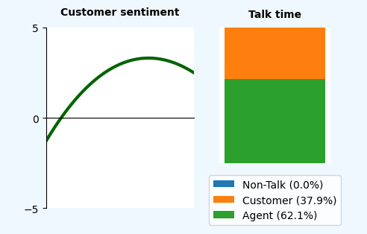

Conversation Volume Levels with Sentiment and Interruptions

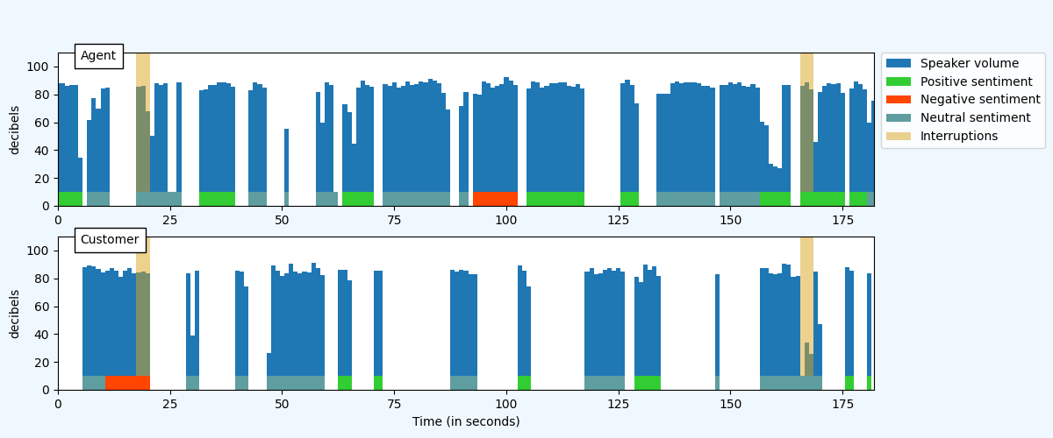

Categories Detected

|  |  |  |
| --- | --- | --- |
| Category | # | Timestamps found at |
| No_Closing_Remark |  |  |

Call Sentiment per Quarter of the call

|  |  |  |  |  |
| --- | --- | --- | --- | --- |
| Speaker | Q1 | Q2 | Q3 | Q4 |
| Agent | 2.9 | 1.0 | 2.0 | 3.8 |
| Customer | -1.3 | 2.1 | 3.3 | 2.5 |

*SENTIMENT: Range from +5 (Positive) to -5 (Negative)*

Overall Speaker Sentiment

|  |  |
| --- | --- |
| Speaker | Sentiment |
| Agent | 2.4 |
| Customer | 1.8 |

|  |  |  |
| --- | --- | --- |
| Call Summary Highlights | | |
| Issues Detected | | |
| **Speaker** | **Turn Time** | **Detected Text** |
| Customer | 0:00:11.4 | I'm trying to dock up my ship and my card fell into the water so I'm hoping to get it replaced. |
| Action Items Detected | | |
| **Speaker** | **Turn Time** | **Detected Text** |
| Agent | 0:02:14.84 | ...I will email you a confirmation is [PII].... |
| Outcomes Detected | | |
| **Speaker** | **Turn Time** | **Detected Text** |
| Agent | 0:02:28.14 | ...review we've got that card canceled, we're sending it to the [PII] and I've emailed you a confirmation.... |

Call Transcription

*WORD CONFIDENCE: >= 90% in black, >= 50% in brown, < 50% in red*

| Start | Dur. | Speaker |  | Transcription |
| --- | --- | --- | --- | --- |
| 0:00:00.4 | 5.0s | Agent |  | Thank you for calling Anchor Credit Union, the number one choice for captains worldwide, how can I help you? |
| 0:00:06.31 | 4.1s | Customer |  | Hi um Okay so I was at fisherman's terminal. |
| 0:00:07.94 | 3.4s | Agent |  | Yeah. Mhm. |
| 0:00:11.4 | 9.8s | Customer |  | **[ISSUE]** I'm trying to dock up my ship and my card fell into the water so I'm hoping to get it replaced. |
| 0:00:18.74 | 8.9s | Agent |  | **[INTERRUPTION]** Uh Not a problem. Let's see if we can get that taken care of you. Uh What's your name? |
| 0:00:29.24 | 2.4s | Customer |  | Alright [PII] |
| 0:00:32.74 | 7.0s | Agent |  | [PII] hi [PII] I'm [PII] happy to be helping you today. Um What was the billing zip code for that card? |
| 0:00:40.74 | 1.5s | Customer |  | [PII]. |
| 0:00:43.14 | 3.3s | Agent |  | Okay and do you happen to remember the last four digits of that card? |
| 0:00:47.94 | 4.8s | Customer |  | Um Either [PII]. |
| 0:00:51.64 | 0.2s | Agent |  | Mm |
| 0:00:53.44 | 6.1s | Customer |  | Alright [PII]. For something like that. Is there other information I can give you instead? |
| 0:00:58.4 | 4.0s | Agent |  | Okay no problem. How about you? Give me your date of birth? |
| 0:01:03.24 | 2.3s | Customer |  | Great, August 19, 2020. |
| 0:01:04.44 | 6.5s | Agent |  | Okay perfect and quick security question, what city were you born in? |
| 0:01:11.84 | 0.4s | Customer |  | Perfect |
| 0:01:13.96 | 13.2s | Agent |  | Okay there we go. I see that card in the system. Um Okay so you have two cards with us, Do you happen to know if it was the seaside Rewards Credit card or the day at the beach rewards Card? |
| 0:01:28.94 | 1.4s | Customer |  | day of the beaches. |
| 0:01:30.4 | 1.9s | Agent |  | Yeah yes. |
| 0:01:30.36 | 3.0s | Customer |  | The red card, It was the Red one. |
| 0:01:33.74 | 8.9s | Agent |  | Okay so I'll go ahead and get that one canceled, just in case someone fish it out the fishman terminal waters. Uh Would you like me to get another one sent to you? |
| 0:01:43.24 | 1.8s | Customer |  | That would be awesome. Thank you so much. |
| 0:01:45.64 | 12.2s | Agent |  | Great um so I have a couple of of addresses for you. I have like a home mailing address. I also have a mailbox at a fishing terminal and Alaska which one's gonna be the most convenient for you, |
| 0:01:58.84 | 7.4s | Customer |  | I'm actually in route right now to [PII]. Uh to dock up there. Can I give you a P. O. Box? |
| 0:02:06.84 | 2.3s | Agent |  | yep that will work just fine, go ahead. I'm ready when you are. |
| 0:02:09.63 | 4.4s | Customer |  | Great [PII], |
| 0:02:14.84 | 11.6s | Agent |  | Okay I've got that and **[ACTION]** I will email you a confirmation is [PII]. Still the email address for you. |
| 0:02:27.24 | 0.4s | Customer |  | correct? |
| 0:02:28.14 | 8.2s | Agent |  | Okay great so to **[OUTCOME]** review we've got that card canceled, we're sending it to the [PII] and I've emailed you a confirmation. Is that everything that you needed today? |
| 0:02:37.34 | 4.5s | Customer |  | That is also um my pronouns have changed since we spoke with last. |
| 0:02:37.64 | 5.6s | Agent |  | Mhm. Thank you for letting me know. |
| 0:02:42.54 | 7.5s | Customer |  | Is there a way that that can just be updated in your system as well today then please? |
| 0:02:46.44 | 9.0s | Agent |  | **[INTERRUPTION]** Yes, I'll do that right now. What would you prefer? Okay, that is in our system. Thank you for letting us know. Is there anything else I can help you with today? |
| 0:02:56.14 | 1.2s | Customer |  | No, that's it. Thank you. |
| 0:02:57.74 | 2.3s | Agent |  | Wonderful. Have smooth sailing down to [PII]. |
| 0:03:01.4 | 0.9s | Customer |  | Thank you. Bye. |
| 0:03:01.94 | 0.9s | Agent |  | Bye. |

Word Confidence Scores

|  |  |  |
| --- | --- | --- |
| Confidence | Count | Percentage |
| 98% - 100% | 400 | 86.58% |
| 90% - 97% | 38 | 8.23% |
| 80% - 89% | 10 | 2.16% |
| 70% - 79% | 6 | 1.3% |
| 60% - 69% | 1 | 0.22% |
| 50% - 59% | 3 | 0.65% |
| 40% - 49% | 0 | 0.0% |
| 30% - 39% | 1 | 0.22% |
| 20% - 29% | 2 | 0.43% |
| 10% - 19% | 1 | 0.22% |
| 0% - 9% | 0 | 0.0% |

