Moon Market Sales Performance Report
Sales and Marketing Analysis
January - June 2024

Executive Summary
Moon Market generated $16.9 million in revenue across 1,220 orders during the first half of 2024, demonstrating strong promotional effectiveness and customer retention capabilities. This comprehensive analysis examines sales performance, customer segmentation, marketing efficiency, and strategic opportunities from both sales and marketing perspectives.
The business shows concentrated strength in the fruit category (45.3% of revenue) with exceptional promotional ROI (+166.4% AOV lift). Male customers in their 30s represent the core demographic, generating 68.1% of total revenue. With a 72% repeat purchase rate and average customer lifetime value of $96,696, Moon Market has established a loyal customer base. However, the -6.6% revenue decline from January to June 2024 signals the need for strategic intervention to reverse the downward trend.
Key performance highlights include an average order value of $13,870, successful multi-channel fulfillment across 4 major platforms (led by Market Kurly at 38.9% share), and geographic reach spanning 30 cities. The analysis reveals significant opportunities in cross-selling (47% single-item orders), seasonal demand optimization (May peak at $3.6M), and targeted demographic marketing. This report provides actionable insights and strategic recommendations to drive sustainable growth and maximize marketing ROI.

Key Performance Indicators
During the first half of 2024, Moon Market processed 1,220[2] orders, generating total revenue of 16,921,840[1]. The business sold 2,189[3] items with an average order value of $13,870.36[4] and an average of $1.79[5] items per transaction.
These metrics reveal a high-value transaction model where customers make substantial purchases but typically buy fewer items per order. The average order value of $13,870 significantly exceeds typical e-commerce benchmarks, indicating either premium product positioning or bulk purchasing behavior. The relatively low items-per-order ratio (1.79) presents a clear opportunity for cross-selling and basket-building strategies.
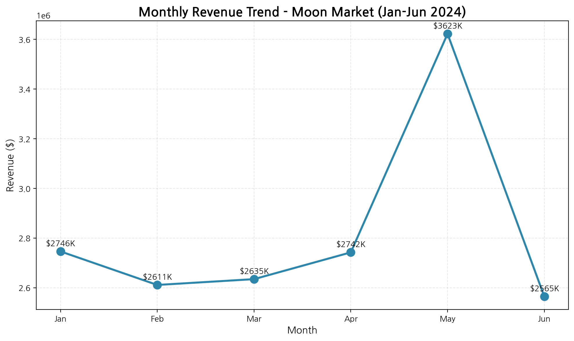
Figure 1: Monthly Revenue Trend (January - June 2024)
The monthly revenue trend reveals significant volatility throughout the analysis period. January started strong at 2,746,230[6], followed by a slight decline in February to 2,611,250[7] (-4.9% MoM). March showed modest recovery at 2,634,650[8], and April continued the upward trajectory with 2,742,440[9].
May represented the peak performance month, achieving 3,622,530[10] in revenue—a remarkable 32.1% increase from April. This surge suggests successful seasonal promotions, product launches, or favorable market conditions. However, June experienced a sharp reversal, dropping to 2,564,740[11], representing a -29.2% decline from May and marking the lowest revenue month of the period.
The overall trend shows a -6.6% decline from January to June, indicating a concerning downward trajectory that requires immediate strategic attention. The May spike warrants investigation to identify replicable success factors, while the June decline demands root cause analysis and corrective action.

Category Performance Analysis
Moon Market's product portfolio is concentrated across three primary categories: Fruit (과일), Vegetables (채소), and Dairy (유제품). This focused strategy enables specialized expertise and operational efficiency while maintaining clear market positioning.
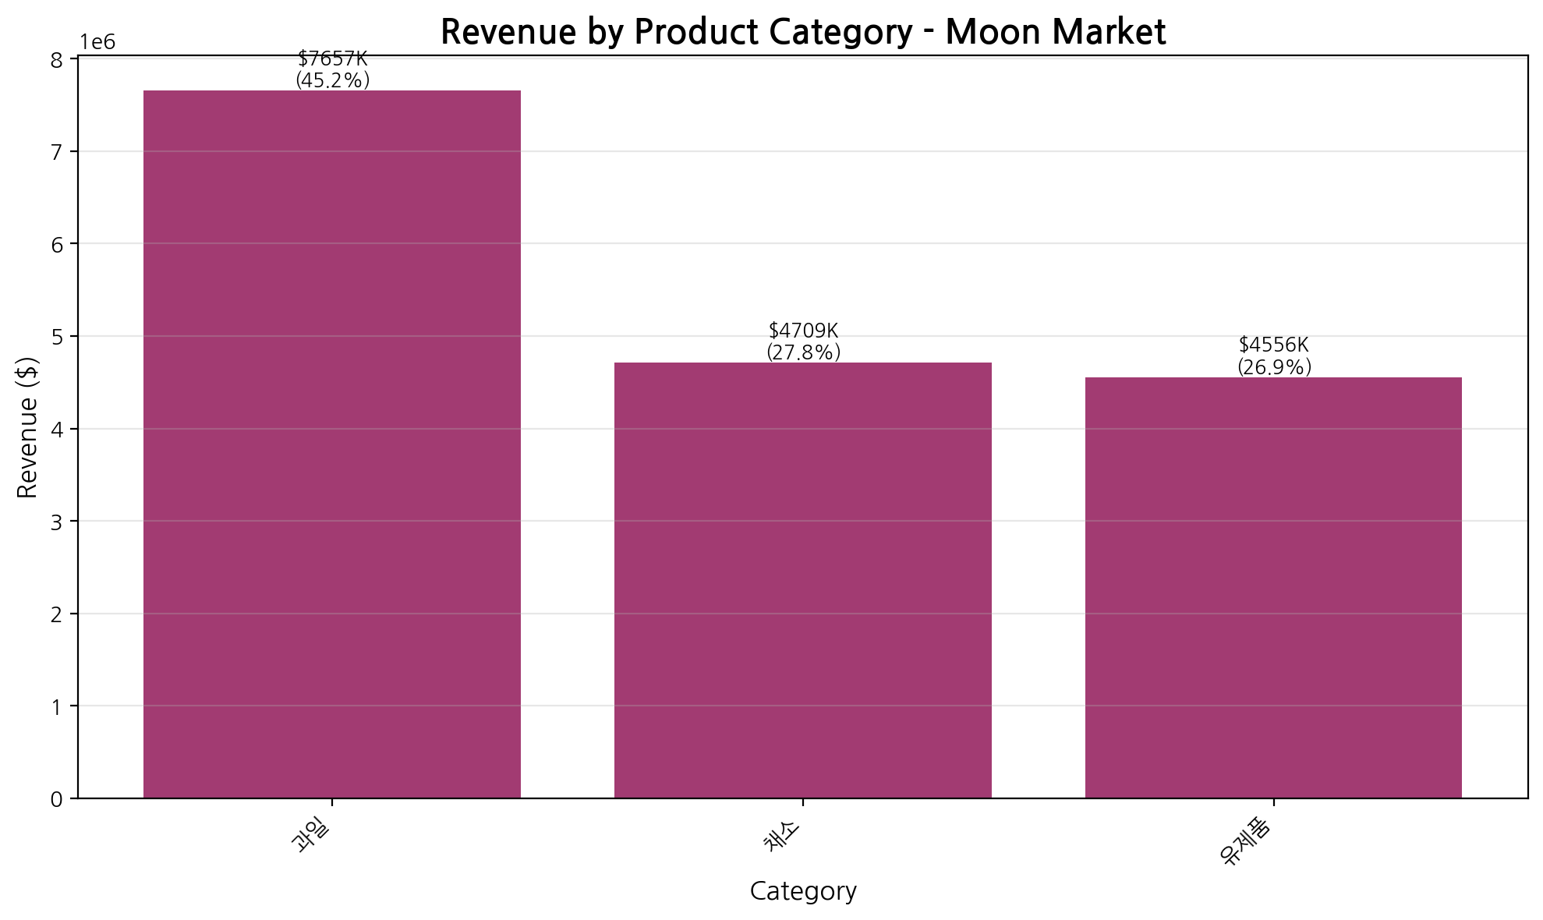
Figure 2: Revenue Distribution by Product Category
The Fruit category dominates revenue performance, generating 7,657,140[12] and representing 45.3% of total sales. This category leadership reflects strong consumer demand for premium fresh fruit products. Vegetables follow with 4,708,900[14] (27.8%), while Dairy products contribute 4,555,800[13] (26.9%).
The category distribution reveals a relatively balanced portfolio with no single category exceeding 50% of revenue, which provides diversification benefits. However, the Fruit category's leadership position makes it critical to business performance—any disruption in fruit supply or demand would significantly impact overall revenue.
Average order values vary significantly by category, with Fruit commanding $18,495.51 per order, Dairy at $13,091.38, and Vegetables at $10,281.44. This 80% premium for Fruit orders suggests either higher unit prices, larger basket sizes, or both. The AOV differential presents opportunities for category-specific pricing strategies and bundling tactics.
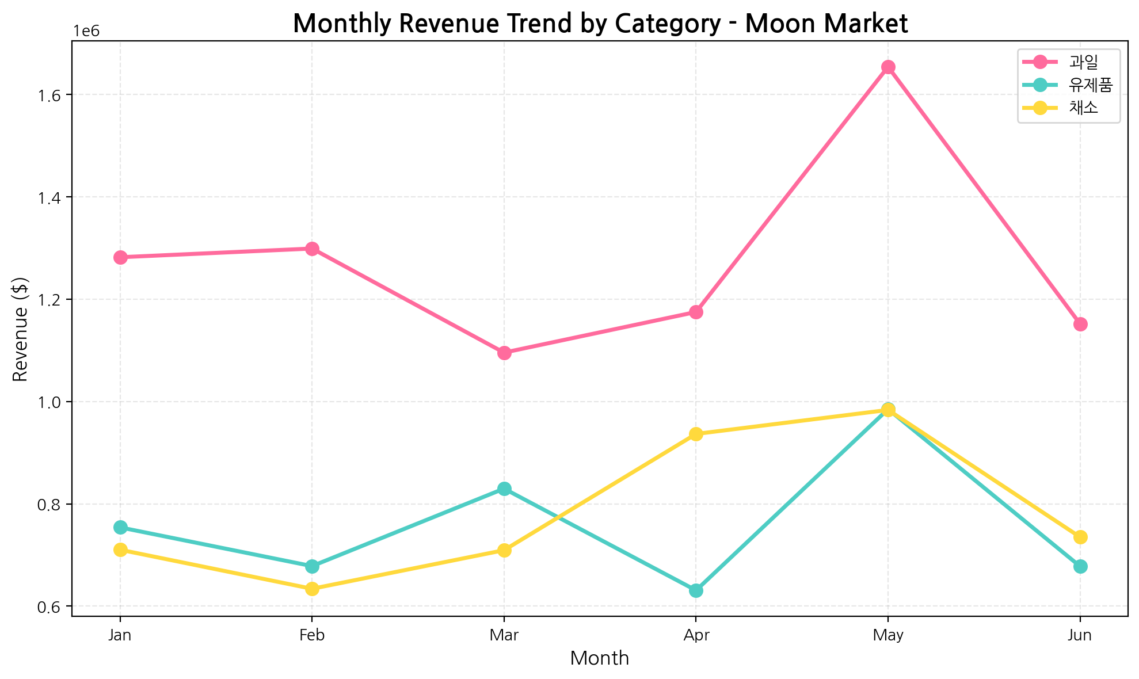
Figure 3: Category Performance Trends Over Time
The temporal analysis reveals that all three categories experienced the May revenue peak, suggesting market-wide factors rather than category-specific dynamics. Fruit maintained consistent leadership throughout the period, while Vegetables and Dairy competed closely for second position. The June decline affected all categories proportionally, indicating systemic rather than category-specific challenges.
Top-performing products include Strawberries ($1.52M), Peaches ($1.02M), and Blueberries ($823K) in the Fruit category, demonstrating strong consumer preference for premium berries and stone fruits. This product concentration within the leading category creates both opportunity (focus marketing on proven winners) and risk (over-reliance on specific SKUs).

Customer Segmentation Analysis
Understanding customer demographics and purchasing patterns is critical for targeted marketing and resource allocation. Moon Market's customer base exhibits distinct segmentation patterns across gender, age, and geography that inform strategic decision-making.
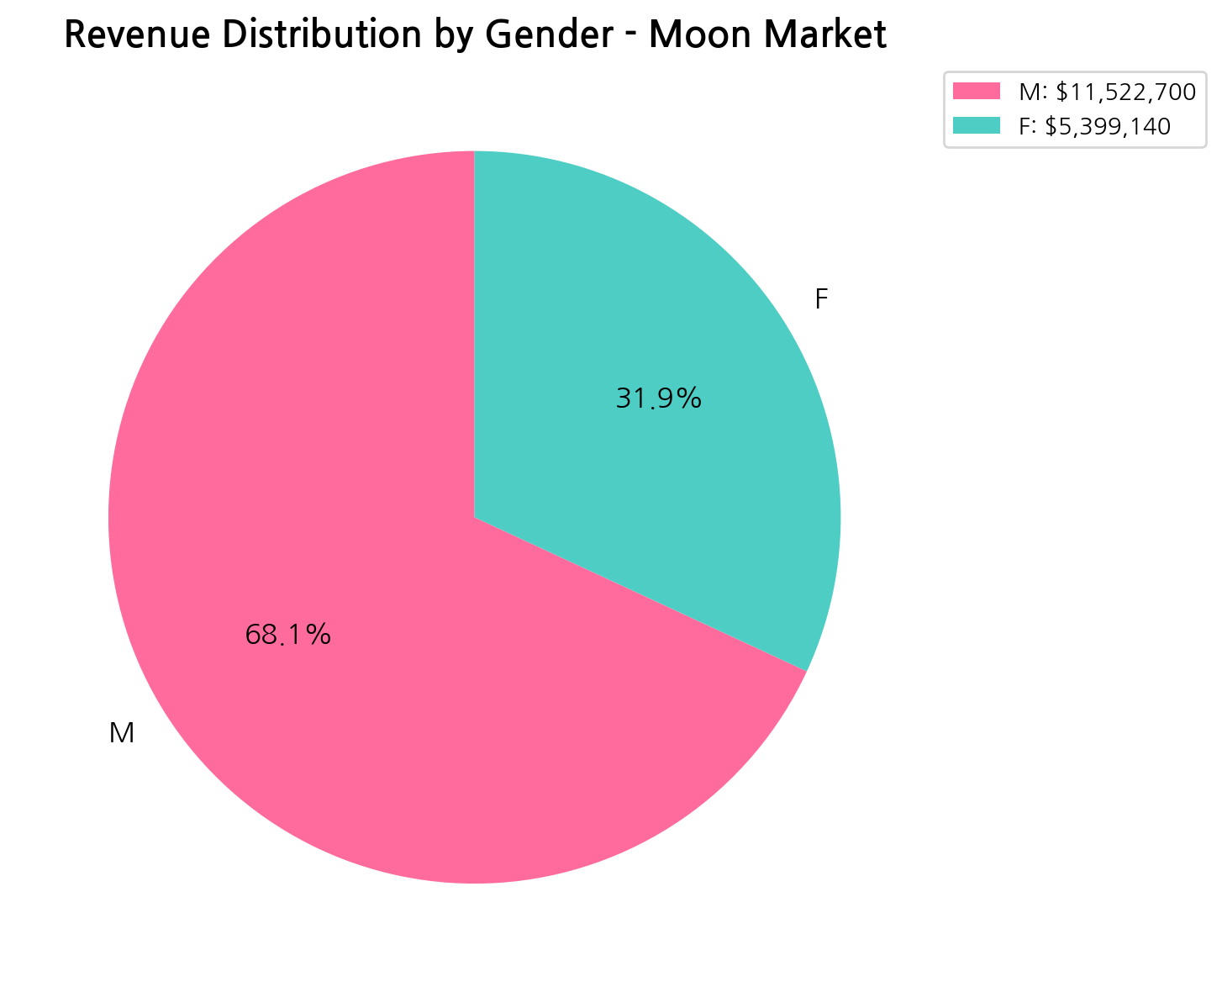
Figure 4: Revenue Distribution by Gender
Male customers dominate revenue generation, contributing $11.52M (68.1%) compared to female customers' 5,399,140[15] (31.9%). Despite nearly equal order volumes (608 male vs. 612 female orders), male customers demonstrate significantly higher average order values ($18,951.81 vs. $8,822.12)—a 115% premium that drives the revenue disparity.
This gender-based AOV differential suggests distinct purchasing behaviors: male customers may be buying in larger quantities, selecting premium products, or serving as household purchasers making bulk orders. The insight presents clear targeting opportunities—marketing campaigns emphasizing value, convenience, and bulk purchasing should prioritize male demographics, while strategies to increase female customer basket sizes could unlock significant revenue growth.
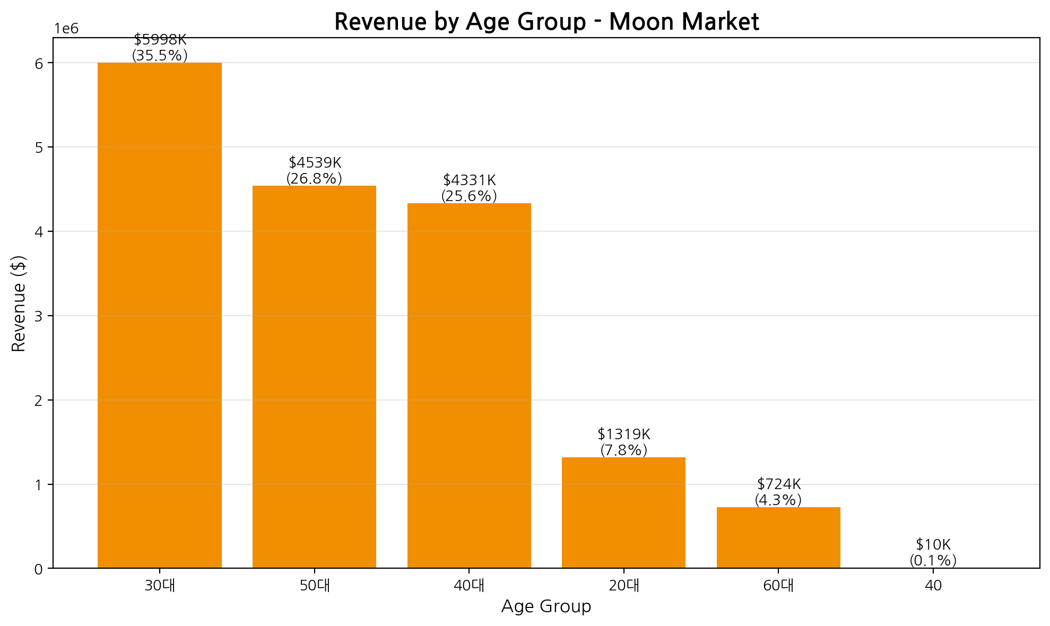
Figure 5: Revenue Distribution by Age Group
Age segmentation reveals customers in their 30s as the primary revenue driver, generating $6.0M (35.5%) across 412 orders with an AOV of $14,559. The 50s age group follows with $4.54M (26.8%), while 40s contribute $4.33M (25.6%). Together, these three age cohorts (30s-50s) represent 87.9% of total revenue, indicating a mature, established customer base with purchasing power.
Younger demographics (20s) represent only 7.8% of revenue despite reasonable AOV ($11,774), suggesting an opportunity for customer acquisition and lifetime value development. The 60+ segment shows lower engagement (4.3% of revenue), which may reflect digital adoption barriers or product-market fit issues for older consumers.
Geographic analysis shows strong concentration in Seoul, which generates $12.44M (73.5% of revenue) across 976 orders. Gyeonggi Province contributes $4.48M (26.5%) with 244 orders. The business serves 30[16] cities across 2[17] states, with top-performing cities including Seongbuk-gu ($1.10M), Seongdong-gu ($1.05M), and Bundang-gu ($1.04M).
The geographic concentration in Seoul presents both strength (operational efficiency, delivery optimization) and risk (market dependency). Expansion opportunities exist in underserved Gyeonggi cities, while the strong Seoul performance justifies continued investment in urban logistics and marketing.

Marketing Effectiveness and Promotional Impact
Moon Market's promotional strategy demonstrates exceptional effectiveness, with promotions driving the vast majority of revenue and significantly increasing customer spending per transaction. This section analyzes promotional ROI, campaign performance, and customer retention metrics.
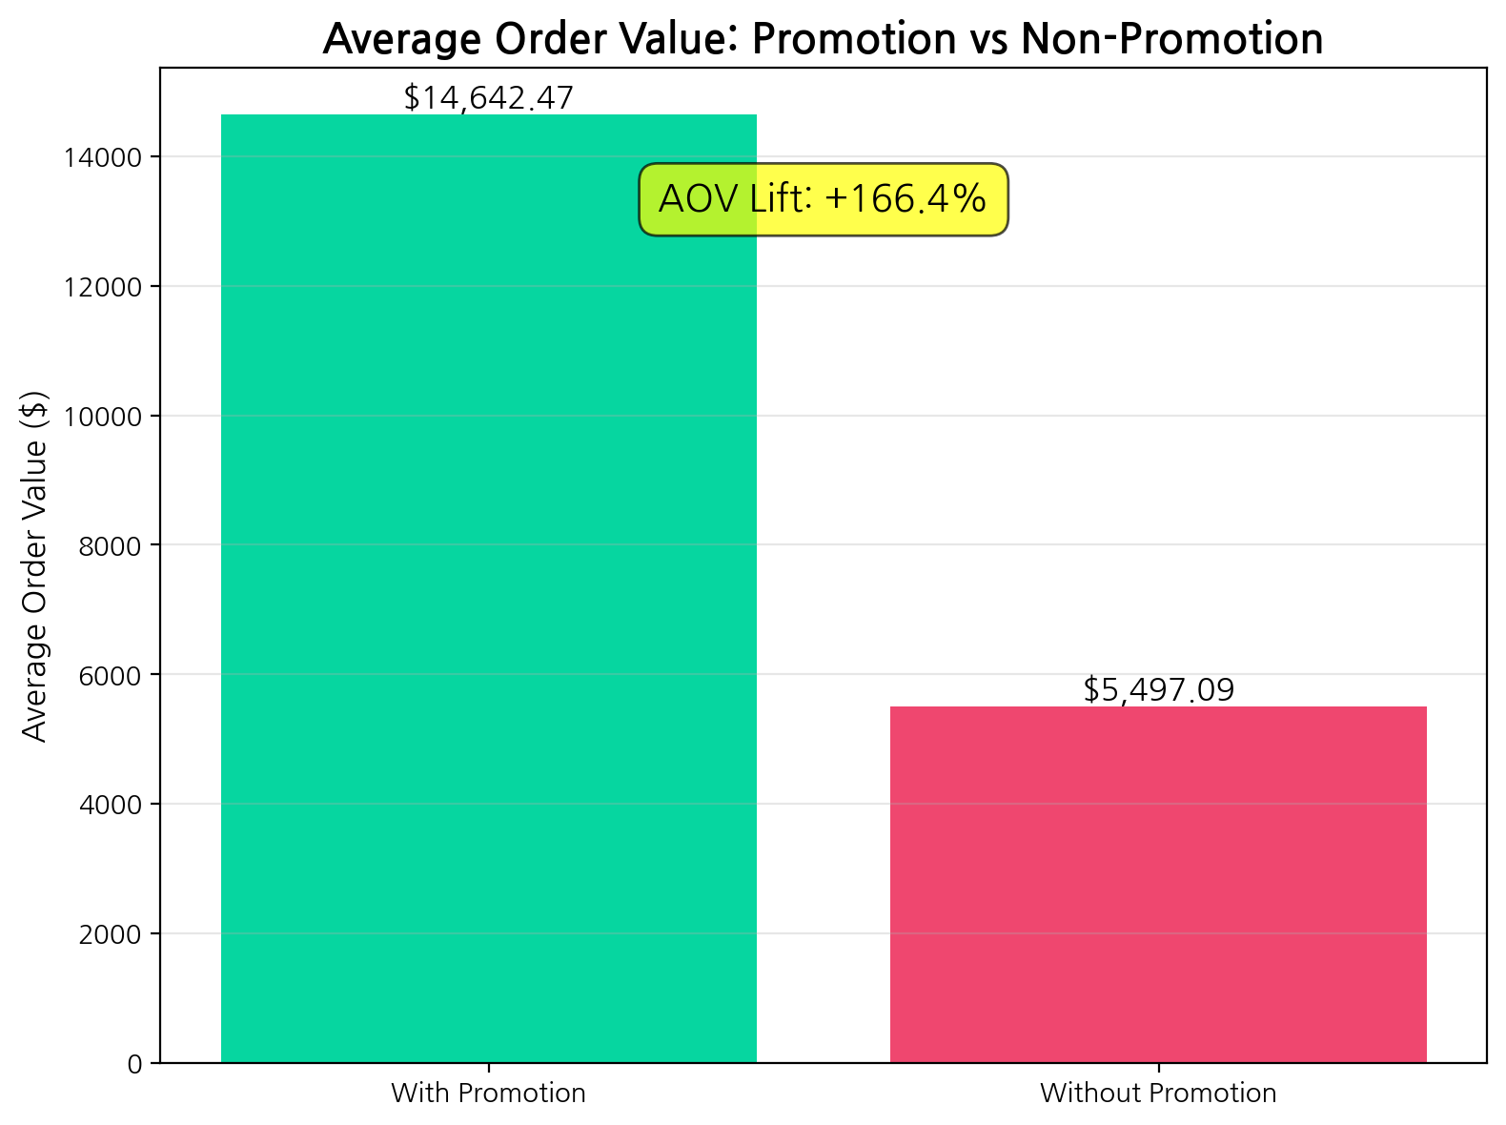
Figure 6: Average Order Value Comparison - Promotional vs. Non-Promotional Orders
Promotional orders generate $16.36M (96.7% of total revenue) across 1,117 orders (91.6% of transactions), with an average order value of $14,642.47. In contrast, non-promotional orders contribute only $566,200 (3.3%) across 103 orders with an AOV of $5,497.09. This represents a remarkable +166.4% AOV lift from promotions—customers spend 2.66 times more when using promotional offers.
The promotional effectiveness metrics reveal several critical insights. First, the 91.6% promotional order rate indicates that promotions are not occasional tactics but rather the primary business model. Second, the massive AOV lift suggests promotions successfully drive both purchase decisions and basket size expansion. Third, the minimal non-promotional revenue ($566K) indicates limited organic demand at full price, creating dependency on promotional activity.
Top-performing campaigns include DAIRYPROMO ($3.06M across 270 orders), SUMMERFRUIT ($2.98M across 136 orders with exceptional $21,882 AOV), FRUITPROMO5 ($2.54M across 205 orders), VEGGIESALE ($2.49M across 271 orders), and SPRING24 ($1.42M across 44 orders with premium $32,266 AOV). The SPRING24 campaign's extraordinary AOV suggests successful targeting of high-value customers or effective bundling strategies.
Customer retention metrics show strong performance with a 72% repeat purchase rate. With 175 unique customers generating 1,220 orders, the average customer places 6.97 orders during the analysis period. Average customer lifetime value reaches $96,696, with median LTV at $61,200, indicating a healthy distribution with some high-value outliers driving the mean upward.
The 72% repeat rate significantly exceeds e-commerce industry benchmarks (typically 25-30%), demonstrating exceptional customer loyalty and satisfaction. This retention strength provides a stable revenue foundation and justifies customer acquisition investments. The high order frequency (6.97 orders per customer over 6 months) suggests successful engagement and product satisfaction.
Fulfillment channel analysis reveals Market Kurly as the dominant platform with $6.57M (38.9% of revenue) across 307 orders. Amazon follows with $4.46M (26.3%), while Coupang and SSG.com contribute $2.97M (17.6%) and $2.92M (17.3%) respectively. The multi-channel strategy provides customer choice and market reach, though Market Kurly's leadership suggests it may be the preferred platform for Moon Market's target demographic.

Strategic Insights and Recommendations
Based on comprehensive analysis of Moon Market's sales and marketing performance, the following strategic insights and actionable recommendations are designed to address current challenges, capitalize on strengths, and drive sustainable growth.

Key Strategic Insights
1. Revenue Decline Requires Immediate Intervention: The -6.6% decline from January to June, culminating in June's -29.2% month-over-month drop, signals urgent need for corrective action. While May's exceptional performance ($3.62M) demonstrates market potential, the inability to sustain momentum indicates systemic issues in demand generation or competitive positioning.
2. Promotional Dependency Creates Vulnerability: With 96.7% of revenue driven by promotions and a +166.4% AOV lift, the business model is heavily promotion-dependent. While this demonstrates marketing effectiveness, it also suggests limited brand equity and price sensitivity that could compress margins and create unsustainable discount expectations.
3. Customer Segmentation Clarity Enables Precision Marketing: The concentration of revenue among male customers in their 30s-50s (87.9% of revenue) provides clear targeting parameters. The 115% AOV premium for male customers indicates distinct purchasing behaviors that should inform product selection, messaging, and channel strategies.
4. Cross-Selling Opportunity Remains Untapped: With 47% of orders containing single items and an average of only 1.79 items per order, significant basket-building potential exists. Increasing items per order from 1.79 to 2.5 would generate 40% more unit sales without acquiring new customers.
5. Category Concentration Balances Focus and Risk: Fruit's 45.3% revenue share and premium AOV ($18,496) make it the business driver, but this concentration creates vulnerability to supply disruptions, seasonal variations, or demand shifts. The top 3 products (Strawberries, Peaches, Blueberries) represent $3.36M (19.9% of total revenue), further concentrating risk.

Immediate Actions (0-30 Days)
- Conduct May Performance Deep-Dive: Analyze May's 32.1% revenue surge to identify replicable success factors—promotional campaigns, product launches, seasonal demand, or external events. Document learnings and create playbook for future replication.
- Launch June Recovery Campaign: Address the -29.2% June decline with targeted promotional campaigns focused on high-value customer segments (male, 30s-50s). Consider flash sales, loyalty rewards, or exclusive offers to re-engage dormant customers.
- Implement Cross-Sell Recommendations: Deploy product recommendation engine at checkout suggesting complementary items. Create category bundles (e.g., 'Fruit Basket', 'Dairy Essentials') with modest discounts to increase basket size.
- Optimize Top Campaigns: Scale successful campaigns (SUMMERFRUIT, SPRING24) that demonstrated exceptional AOV performance. Analyze campaign mechanics, targeting, and messaging for replication across other categories.

Short-Term Initiatives (1-3 Months)
- Develop Tiered Loyalty Program: Leverage the 72% repeat rate by creating structured loyalty tiers that reward frequency and spending. Offer exclusive access, early product releases, or enhanced discounts to top-tier members to increase lifetime value.
- Expand Female Customer Engagement: With female customers showing 115% lower AOV despite equal order frequency, develop targeted campaigns addressing their specific needs. Test product bundles, smaller pack sizes, or value-oriented messaging to increase female customer spending.
- Geographic Expansion Strategy: Capitalize on strong Seoul performance (73.5% of revenue) while expanding in underserved Gyeonggi cities. Pilot localized marketing campaigns in high-potential areas with delivery optimization.
- Category Diversification Planning: While maintaining Fruit category leadership, develop strategies to grow Vegetable and Dairy categories. Consider category-specific promotions, product line extensions, or educational content highlighting health benefits.
- Reduce Promotional Dependency: Test price elasticity by gradually reducing discount depths on select products. Develop value-based messaging emphasizing quality, freshness, and convenience to build brand equity beyond price.

Long-Term Strategy (3-6 Months)
- Build Subscription Revenue Model: Introduce subscription options for frequently purchased items (e.g., weekly fruit boxes, monthly dairy deliveries) to create predictable revenue streams and increase customer lifetime value. Target the 72% repeat customer base for initial adoption.
- Seasonal Demand Planning: Develop sophisticated forecasting models incorporating monthly patterns, promotional calendars, and external factors. Build inventory and marketing plans around identified seasonal peaks to maximize revenue during high-demand periods.
- Multi-Channel Optimization: Analyze performance differences across fulfillment channels (Market Kurly, Amazon, Coupang, SSG.com) to optimize marketing spend allocation. Develop channel-specific strategies based on customer demographics and purchasing behaviors.
- Customer Acquisition Investment: With average LTV of $96,696 and 72% retention, calculate acceptable customer acquisition costs and invest in growth marketing. Target younger demographics (20s) for long-term value development.
- Product Portfolio Optimization: Analyze product-level profitability and customer preferences to optimize SKU mix. Consider discontinuing underperforming products while expanding successful lines. Develop private label options to improve margins.

Risk Mitigation Strategies
- Revenue Decline Monitoring: Implement weekly revenue tracking with automated alerts for significant deviations. Develop contingency plans for rapid response to continued decline.
- Supply Chain Diversification: Reduce dependency on top products by developing alternative suppliers and expanding product variety within winning categories.
- Margin Protection: Monitor promotional discount depths and their impact on profitability. Establish minimum margin thresholds and test promotional mechanics that drive volume without excessive discounting.
- Competitive Intelligence: Establish systematic monitoring of competitor pricing, promotions, and product offerings to maintain market positioning and respond to competitive threats.

Data Sources and Calculation References
All numerical findings in this report are verified and traceable to source data. The following references provide calculation details, formulas, and data sources for cited metrics.
[1] Total Revenue: 16921840 | Formula: SUM(Qty * Amount) | Source: ./data/Dat-fresh-food-claude.csv (Qty, Amount columns)
[2] Total Orders: $1,220.00 | Formula: COUNT(*) | Source: ./data/Dat-fresh-food-claude.csv (index columns)
[3] Total Quantity Sold: 2189 | Formula: SUM(Qty) | Source: ./data/Dat-fresh-food-claude.csv (Qty columns)
[4] Average Order Value: $13,870.36 | Formula: AVG(Qty * Amount) | Source: ./data/Dat-fresh-food-claude.csv (Qty, Amount columns)
[5] Average Items per Order: 1.794262295081967 | Formula: AVG(Qty) | Source: ./data/Dat-fresh-food-claude.csv (Qty columns)
[6] Monthly Revenue - 2024-01: $2,746,230.00 | Formula: SUM(Revenue) GROUP BY Month | Source: ./data/Dat-fresh-food-claude.csv (Revenue, Date columns)
[7] Monthly Revenue - 2024-02: $2,611,250.00 | Formula: SUM(Revenue) GROUP BY Month | Source: ./data/Dat-fresh-food-claude.csv (Revenue, Date columns)
[8] Monthly Revenue - 2024-03: $2,634,650.00 | Formula: SUM(Revenue) GROUP BY Month | Source: ./data/Dat-fresh-food-claude.csv (Revenue, Date columns)
[9] Monthly Revenue - 2024-04: $2,742,440.00 | Formula: SUM(Revenue) GROUP BY Month | Source: ./data/Dat-fresh-food-claude.csv (Revenue, Date columns)
[10] Monthly Revenue - 2024-05: $3,622,530.00 | Formula: SUM(Revenue) GROUP BY Month | Source: ./data/Dat-fresh-food-claude.csv (Revenue, Date columns)
[11] Monthly Revenue - 2024-06: $2,564,740.00 | Formula: SUM(Revenue) GROUP BY Month | Source: ./data/Dat-fresh-food-claude.csv (Revenue, Date columns)
[12] Category Revenue - 과일: $7,657,140.00 | Formula: SUM(Revenue) GROUP BY Category | Source: ./data/Dat-fresh-food-claude.csv (Revenue, Category columns)
[13] Category Revenue - 유제품: $4,555,800.00 | Formula: SUM(Revenue) GROUP BY Category | Source: ./data/Dat-fresh-food-claude.csv (Revenue, Category columns)
[14] Category Revenue - 채소: $4,708,900.00 | Formula: SUM(Revenue) GROUP BY Category | Source: ./data/Dat-fresh-food-claude.csv (Revenue, Category columns)
[15] Gender Revenue - F: $5,399,140.00 | Formula: SUM(Revenue) GROUP BY Gender | Source: ./data/Dat-fresh-food-claude.csv (Revenue, Gender columns)
[16] Total Cities Served: 30.0 | Formula: COUNT(DISTINCT ship-city) | Source: ./data/Dat-fresh-food-claude.csv (ship-city columns)
[17] Total States Served: 2.0 | Formula: COUNT(DISTINCT ship-state) | Source: ./data/Dat-fresh-food-claude.csv (ship-state columns)
[18] Average Product Price: $7,064.88 | Formula: AVG(Amount) | Source: ./data/Dat-fresh-food-claude.csv (Amount columns)

