Hackathon Submission Title:
Deep Insight: Customizable Reporting Agent Platform built on AgentCore and Strands Agent
1. Problem
Not all enterprises have the same requirements when implementing agentic AI for data-driven decision-making. The choice between managed services and customizable platforms depends on specific organizational needs.When speed and simplicity are priorities, managed platforms like Quick Suite excel by delivering immediate value through pre-built agents, extensive connectors, and zero infrastructure management. Teams can focus on using AI rather than building it.
When customization and control are critical, some enterprises face different challenges. They have unique workflows that require deep modification of agent behavior and logic. They operate under regulatory or security mandates requiring data and compute to remain within their AWS environment. They have domain-specific requirements that go beyond standard analytical use cases. They have a strategic need to own and evolve their agent infrastructure as a competitive differentiator. Deep Insight addresses these scenarios by providing an open, customizable agent framework that organizations can deploy, modify, and extend in their own environment, trading the convenience of managed services for the flexibility to build exactly what their unique situation demands.

Below is the typical reporting process of companies using the Waterfall methodology. We aim to solve this problem that requires significant time and manpower using Deep Insight.

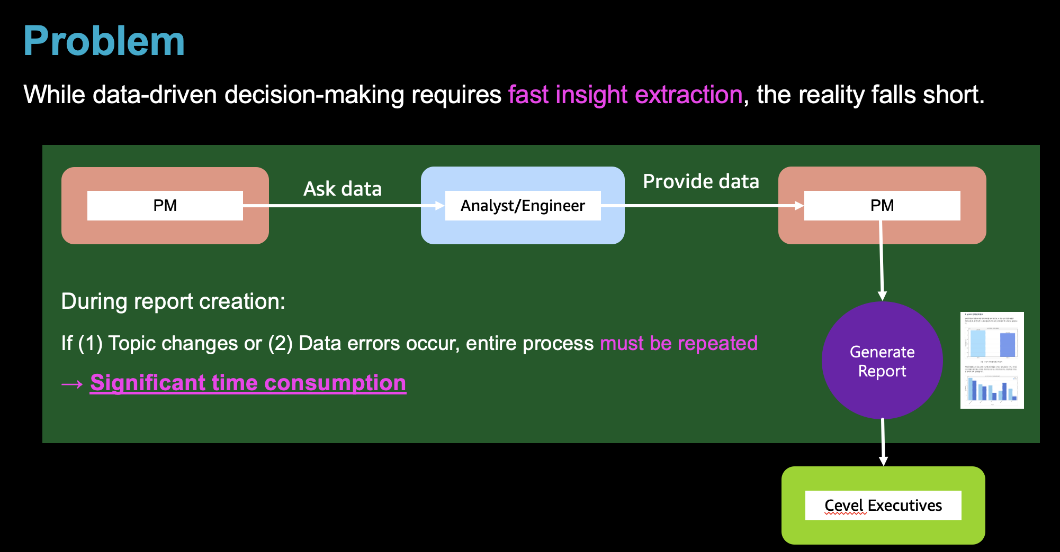

2. Quick Suite's Quick Research vs. Deep Insight Differences

We at AWS have an excellent 'managed' reporting service called QuickSight. I will compare the differences with Deep Insight, which allows customers to obtain deep integration into their own systems.

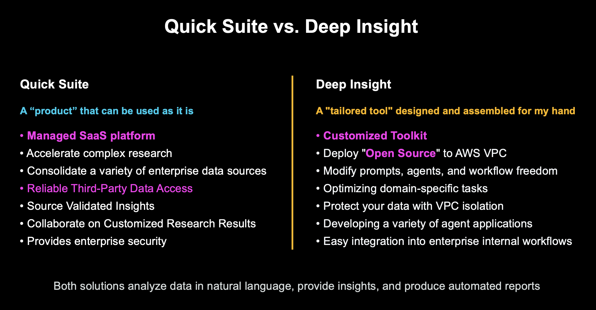
Quick Suite is a managed AI platform that rapidly addresses general-purpose needs, while Deep Insight is a solution that enables enterprises to independently customize and build multi-agent systems optimized for demanding workflows or domain-specific tasks.The solutions presented in the Quick Suite and Deep Insight are both agentic AI systems that support data-driven decision-making in enterprise environments. When queried in natural language, they analyze internal and external data to provide insights, generate automated reports, and reduce repetitive tasks. Quick Suite is delivered as a SaaS solution and is a managed service that broadly connects various apps and data through over 50 connectors and MCP/OpenAPI extensibility, allowing users to create customized agents in natural language and immediately apply them to general business tasks.
In contrast, Deep Insight is a customizable toolkit based on Strands Agents and AgentCore that deploys open-source code in customers' AWS VPC environments, enabling free modification of prompts, agents, and workflows. It's suitable for enterprises with high security and domain-specific requirements to integrate AI into their own data pipelines. Additionally, beyond automation of analysis and reporting, it provides extensibility for diverse agent applications and development. From a security perspective, Quick Suite offers enterprise-grade privacy protection and privacy settings, designed to ensure user queries are not used for model training. Deep Insight operates agent runtime and Observability services within AWS Customer VPC, isolating data to prevent leakage outside the environment, making it suitable for sensitive workloads. In summary, Quick Suite is an "all-purpose toolset ready to use immediately," while Deep Insight is a "customized tool designed and assembled to fit your hands."

3. Key Capabilities
Based on Strands Agent and AgentCore, Deep Insight autonomously performs everything from data exploration to advanced statistical analysis and pattern discovery. Multi-agents including Coordinator, Planner, Supervisor, Coder, Validator, Reporter, and Tracker collaborate to systematically decompose and execute complex tasks, deriving actionable insights across the entire business beyond simple statistics. Generated reports include calculation methods and original data sources, allowing verification of analysis result reliability. Through AgentCore Gateway, necessary MCP tools (e.g., Youtube) are used to enable connected analysis by combining with searched data. Finally, PDF reports including professional charts and visualizations are automatically generated and can be immediately provided. Most importantly, since the provided open source is deployed and used within the customer's own AWS infrastructure, the key capability is that customers can customize the existing code to build their own solutions directly. Based on this codebase, they can extend it to other agent use cases such as customer service support agents, shopping assistance agents, and log analysis agents.
4. Solution Overview
4.1. How It Works
The following shows the architecture of Deep Insight's Agentic System, which can generate insights by analyzing data with 'any' data file and 'any' prompt. Deep Insight operates from the moment users select data files already existing on the server or upload CSV files and enter analysis perspectives and purposes as prompts. Multi-agents immediately begin collaboration to perform automatic data exploration and analysis based on user analysis requirements. External data is collected by calling APIs such as Youtube through AgentCore Gateway and utilized to extract business insights. Finally, professional data analysis reports are automatically generated. The entire process runs securely within AWS Customer VPC, with verification and tracking at each step ensuring reliability and transparency of analysis results. Users can monitor progress in real-time.When analysis is complete, final reports in PDF format and data verification files can be downloaded for use. Results can also be shared by posting to internal enterprise portals or sending via email.

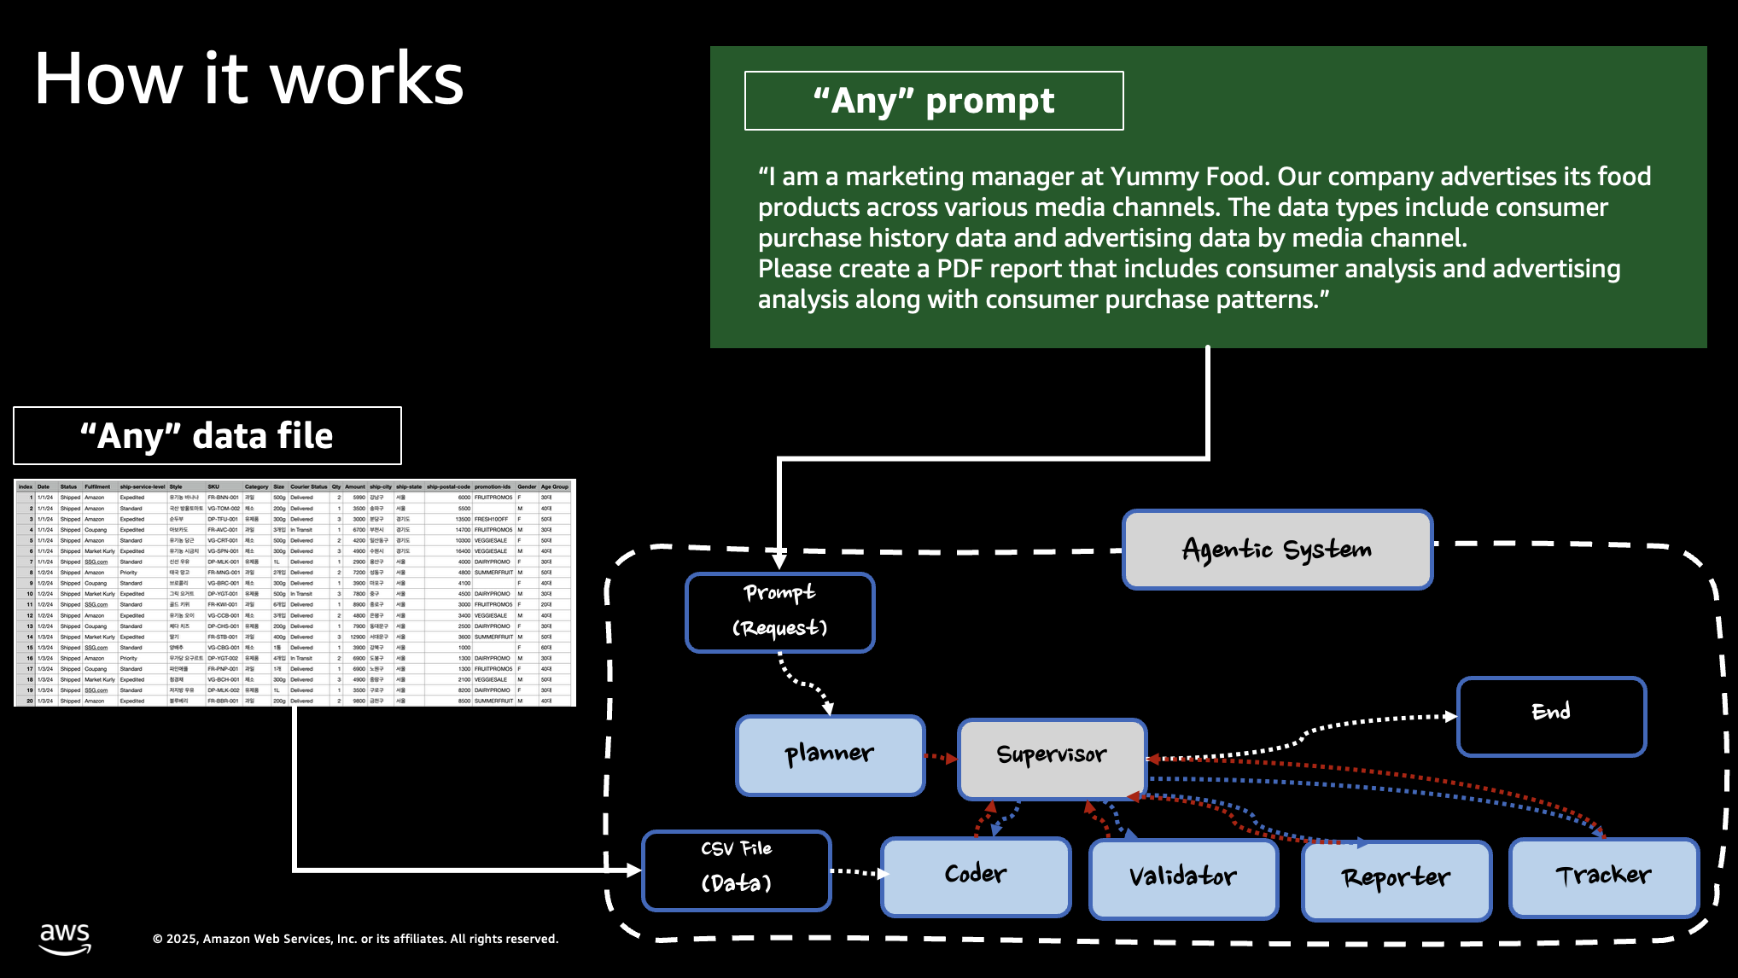
The following shows a brief description of the agents used in the Agentic System's internal hierarchical multi-agent architecture. Deep Insight consists of a hierarchical multi-agent system based on AWS Strands Agents SDK. The Coordinator understands user prompts, the Planner establishes analysis plans, and the Supervisor orchestrates the overall workflow.
In the actual work execution stage, the Coder generates and executes data analysis code, while the Validator verifies analysis results and manages quality. While the Reporter generates the final report, the Tracker tracks the entire process to ensure transparency at each stage.

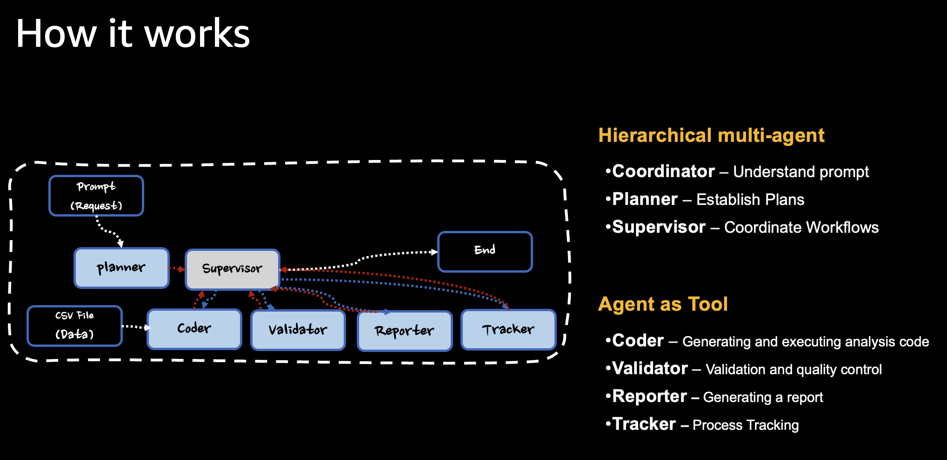

The following is an example from a food company. After running advertisements for their products on multiple advertising platforms (e.g., amazon.com, Walmart.com), they provided Deep Insight with the campaign results data file in CSV format. Along with the data, they provided a prompt: 'Please analyze the advertising campaign and the sales generated through the advertisements based on the given ad campaign data.' This shows a portion of the complete report that was generated.
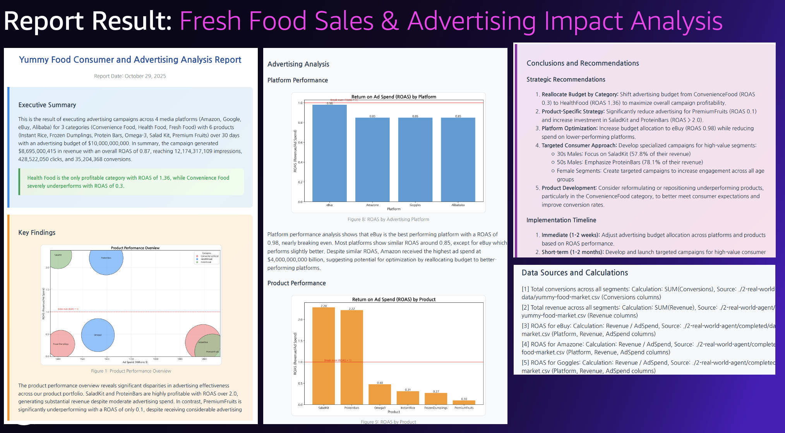

5. Business Impact
5.1. Market Opportunity
Deep Insight transforms the traditional waterfall sequential work structure into multi-agent collaboration, dramatically reducing the long time required from topic selection to final report creation. The cycle of data collection, analysis, and insight derivation through AI is automated, enabling rapid business execution and response. While typical managed services provide such automation, they have limitations in customization.
In contrast, Deep Insight allows customers to install directly in their own AWS VPC environments and freely customize. Based on open-source code, they can modify according to specific enterprise requirements and transform the current data analysis agent into Shopping agents, Log Analysis agents, Customer Support agents, etc. Through this, enterprises can accumulate know-how in utilizing Strands Agent and AgentCore and expand Agentic AI systems across various business areas.Based on this customization capability, enterprises can perform sales performance and trend analysis, target customer strategy establishment, campaign performance comparison and cause analysis, market status and technology trend analysis, etc., with simple prompts. The entire process from data analysis to campaign design, execution, and result analysis is supported, and most importantly, hidden insights that could not be found previously can be discovered.

One thing we want to highlight is when we introduced this solution and demo to customers through sales, about 70.5% of customers had an interest and expressed desired to implement it. Also customer said It was impressive from that they can gain the business insights from their data within 15miniutes using the agentic AI.

6. Production Architecture
The following demonstrates the final architecture that was developed and deployed using Strands Agent and AgentCore
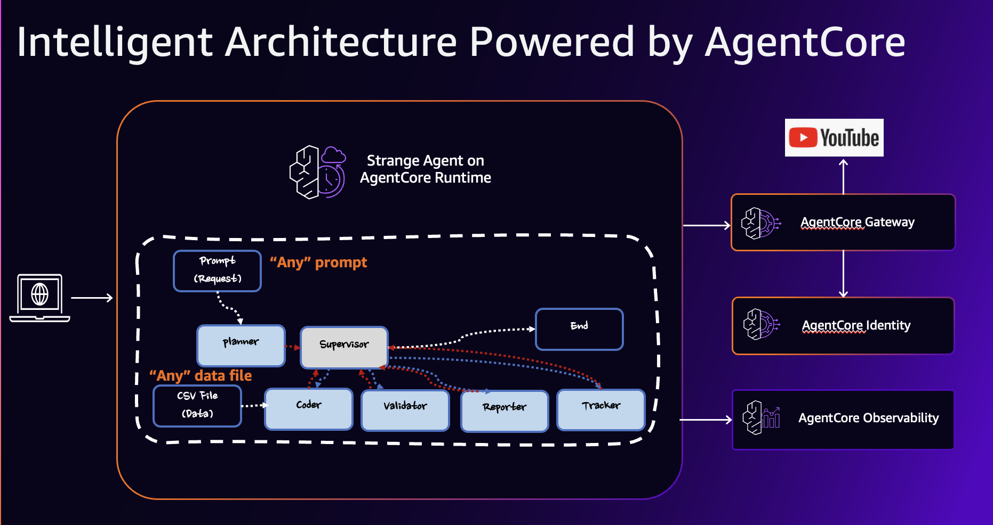

7. Conclusion
Deep Insight successfully addresses the critical gap in the agentic AI landscape by providing enterprises with a customizable, open framework that can be deployed within their own AWS environment. While managed services like Quick Suite continue to serve organizations prioritizing speed and simplicity, Deep Insight empowers enterprises with unique workflows, stringent regulatory requirements, and domain-specific needs to build and evolve their own agent infrastructure. By offering this flexibility, organizations no longer have to choose between AI capabilities and control—they can implement agentic systems that align precisely with their strategic objectives while maintaining full ownership of their data, compute resources, and competitive differentiation. This dual approach ensures that enterprises of all types can leverage agentic AI in ways that best serve their specific circumstances, whether through ready-to-use managed platforms or through customizable frameworks designed for deep integration and evolution.

