# 1. Prescriptive Sample Architecture Diagrams

## 1.1. Shared VPC Architecture

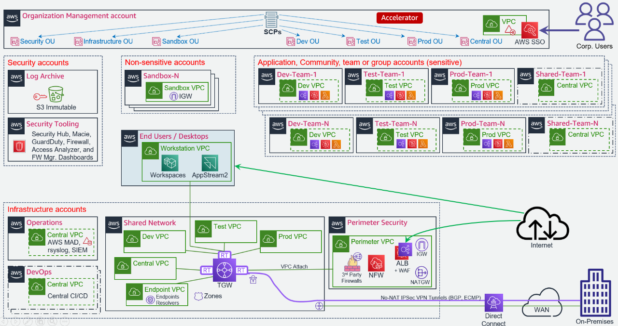

ASEA1 Diagram

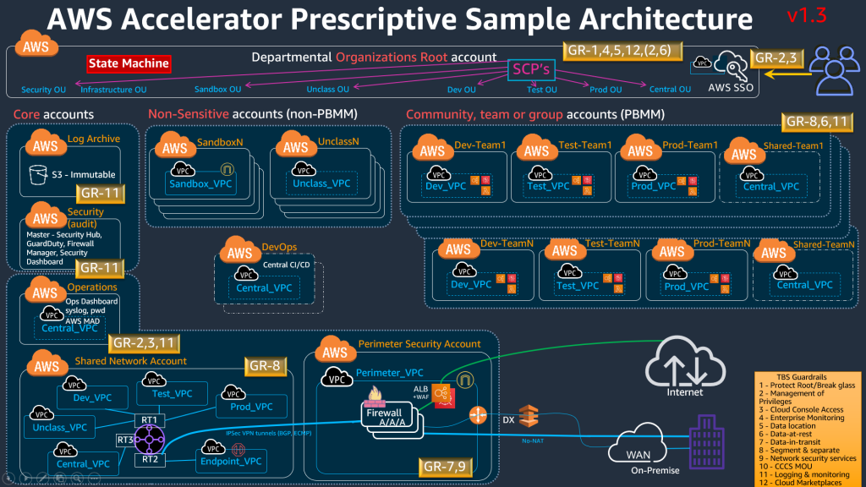

ASEA2 Diagram

## 1.2. Spoke VPC Architecture

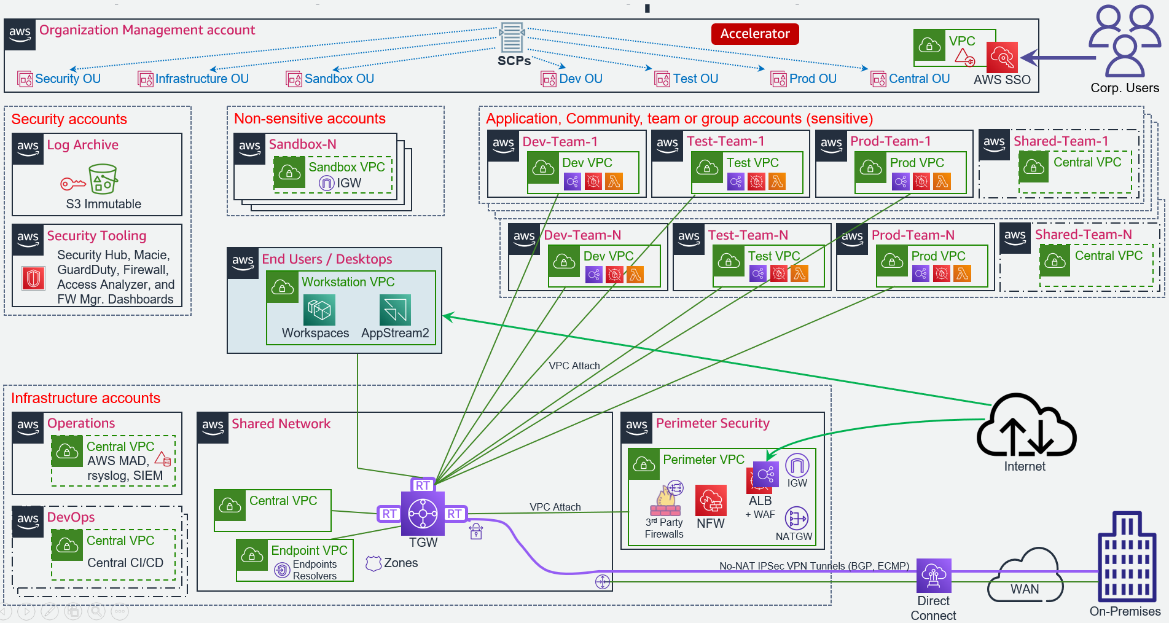

ASEA3 Diagram

## 1.3. VPC and Security Group Patterns

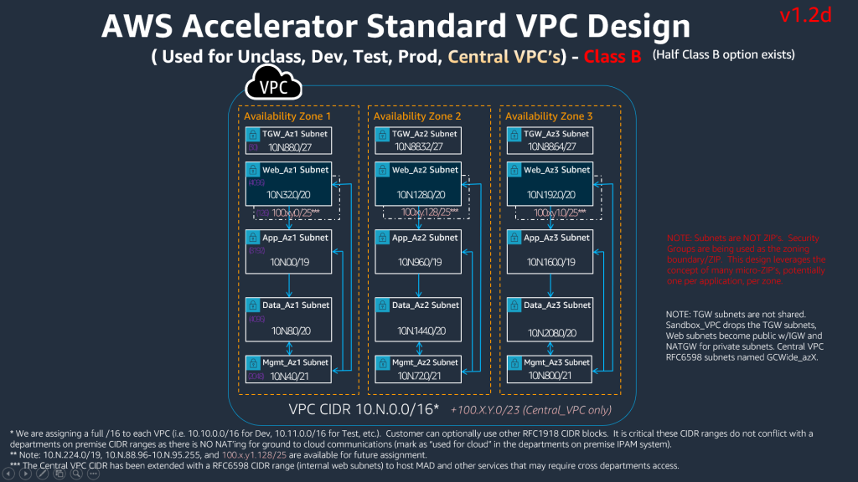

ASEA4 Diagram

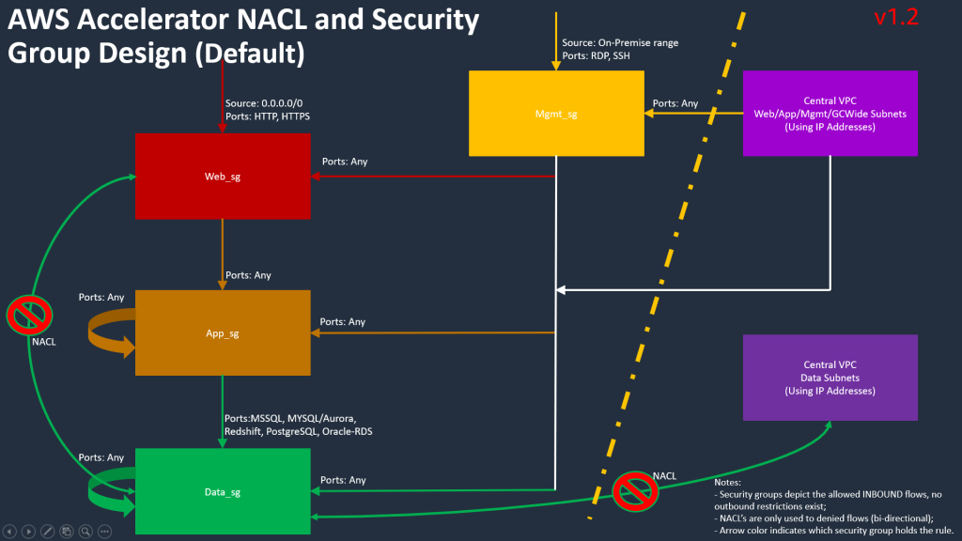

ASEA5 Diagram

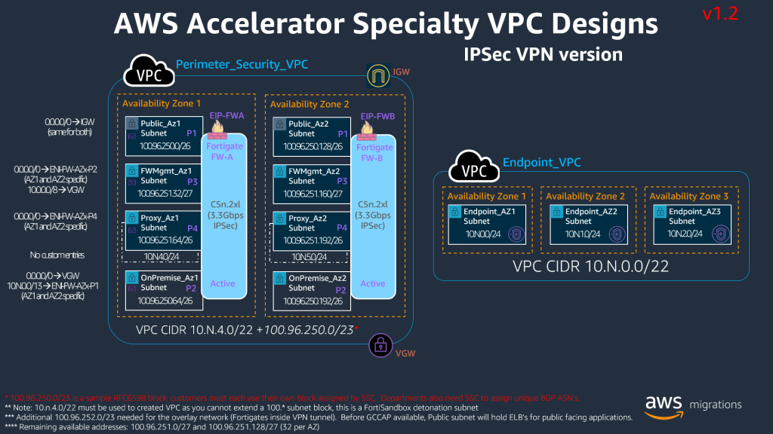

ASEA6 Diagram

## 1.4. Additional Perimeter Patterns

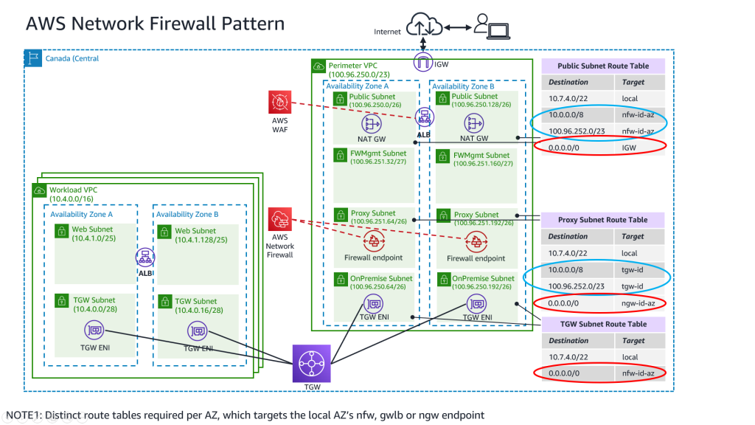

ASEA7 Diagram

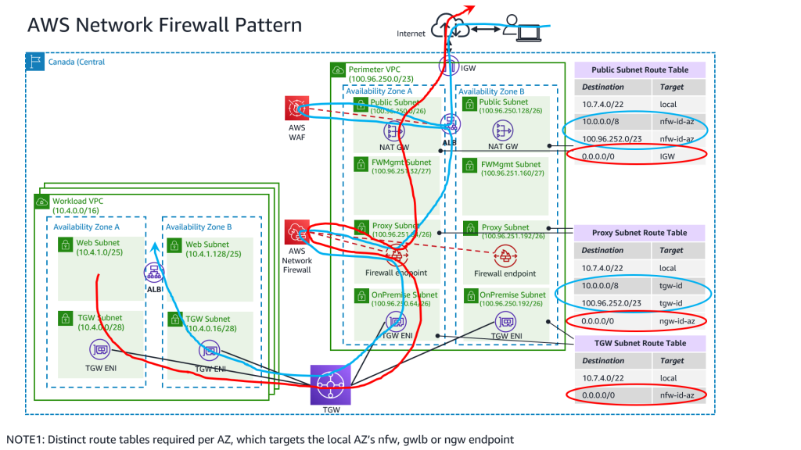

ASEA8 Diagram

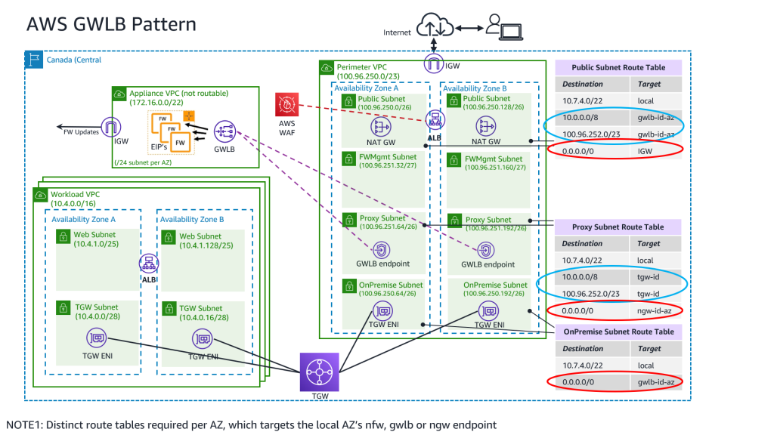

ASEA9 Diagram

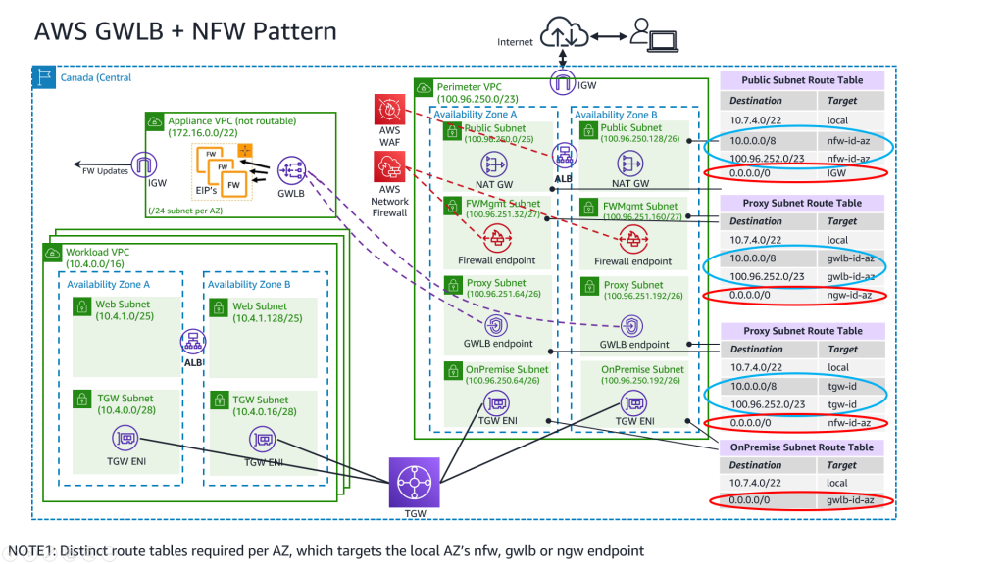

ASEA10 Diagram