Creating a Dataset

1. Click on the Name of the Project and click on “Create Dataset”

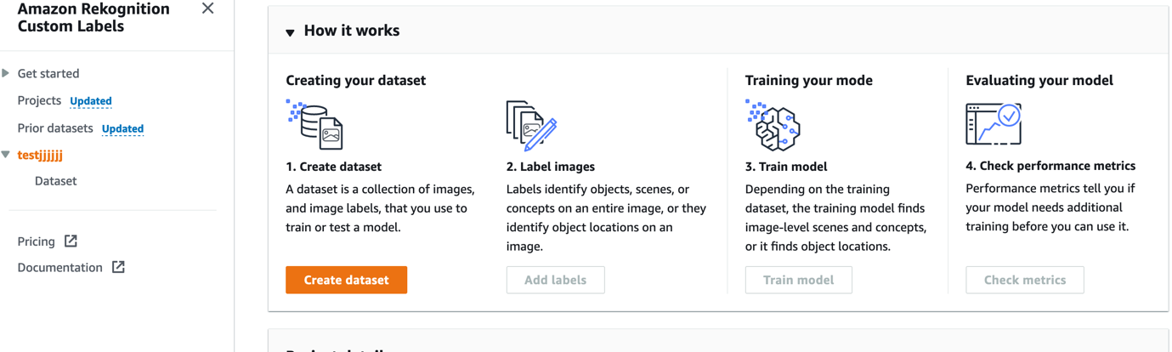

1. Select the Option “Start with a Single Dataset” for this Demo and Choose the Option “Upload Images from your Computer”

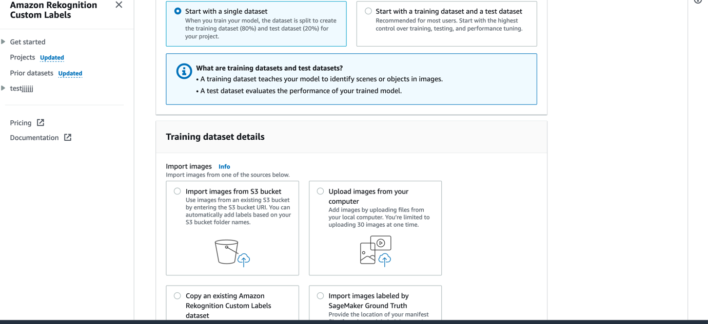

1. Download the images given in the folder “images” which includes the images of tiktok , sharechat and Moj logos collected from Internet to your local machine and then upload these images using Add Images.

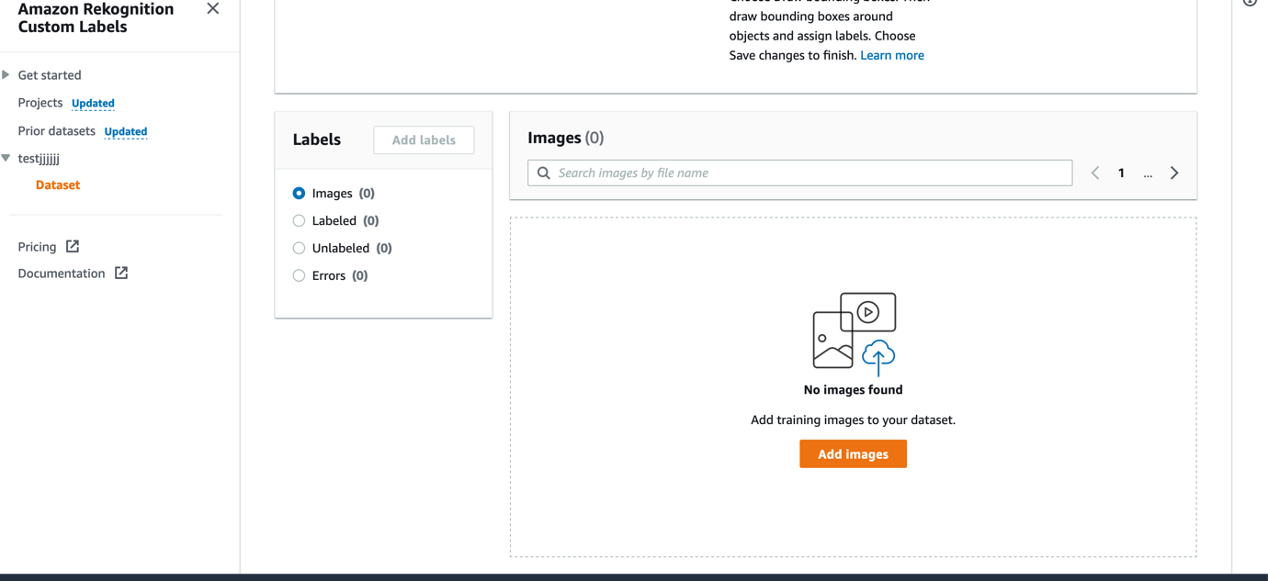

1. You will get a window like this and click on Choose Files and after selecting the files

