1. Login to AWS Console and search for Amazon Rekognition. Go to Use Custom Labels under Custom Labels.
2. Click on "Projects" on the left

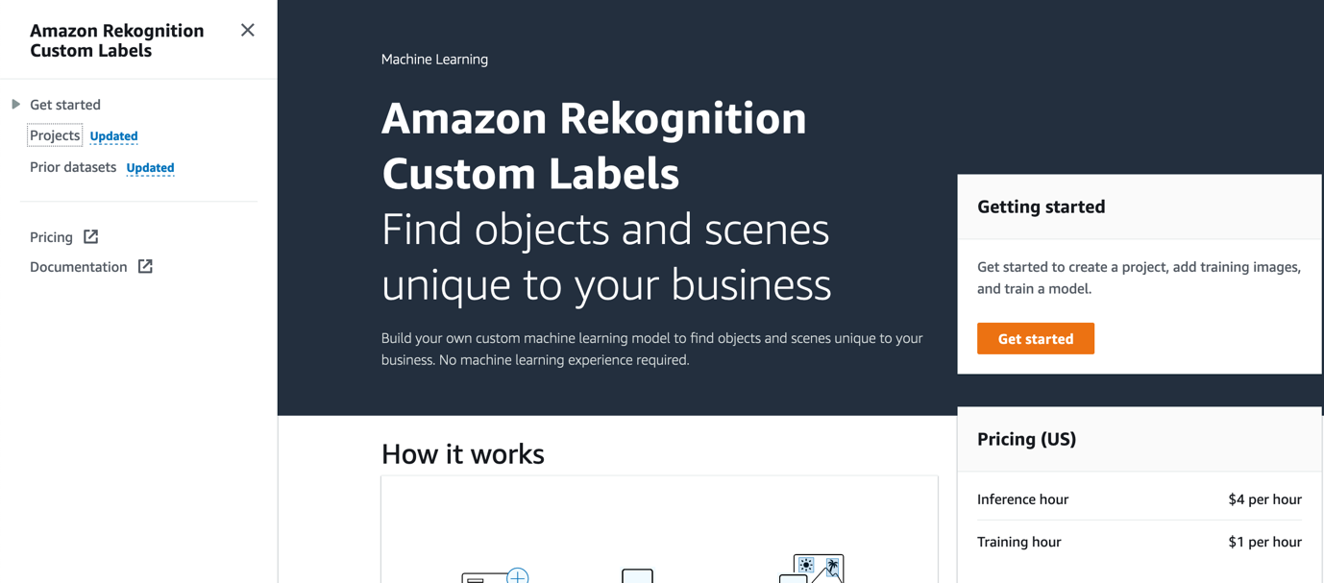

1. Click on Create Project

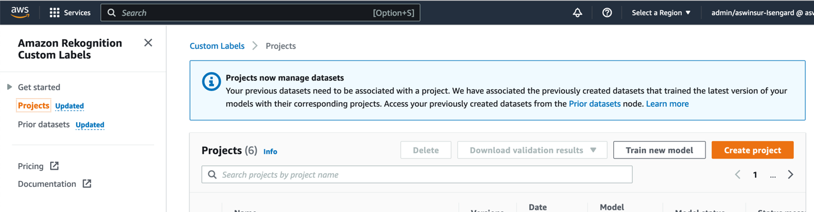

1. Give a name to the Project and click on Create Project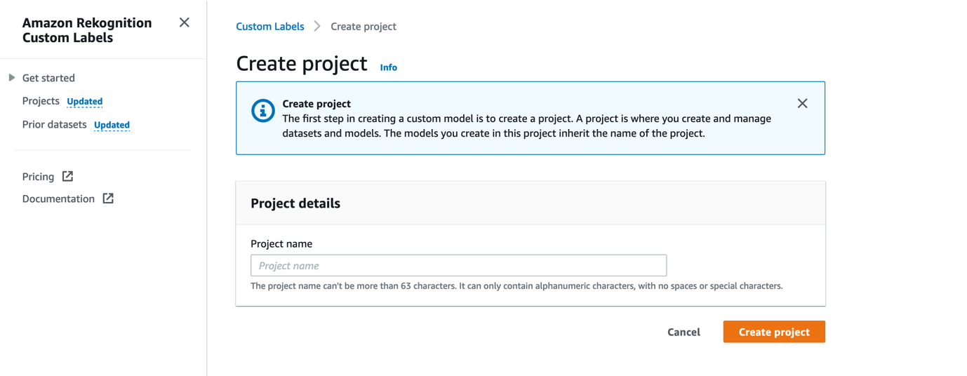

Creating a Dataset and Labelling it

1. Click on the Name of the Project and click on “Create Dataset”

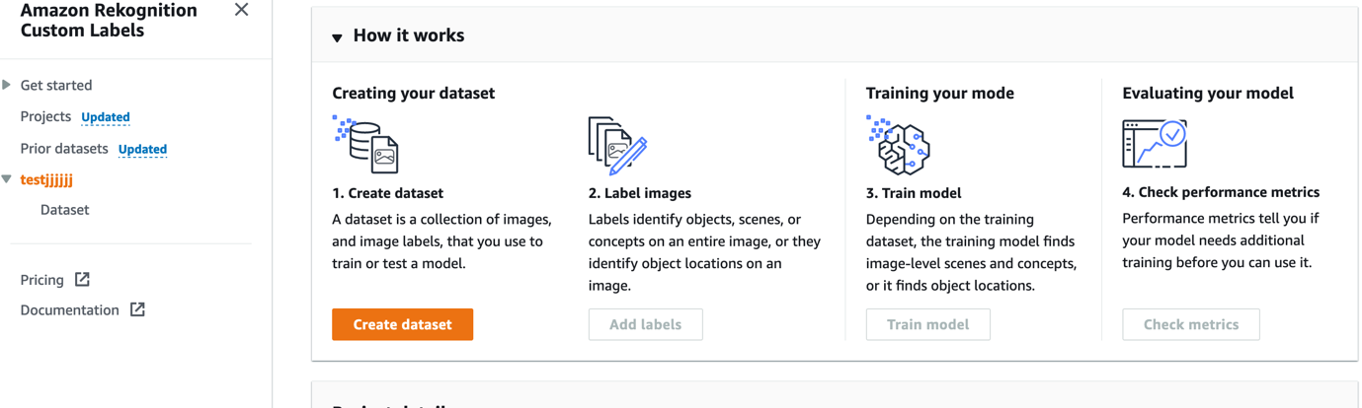

1. Select the Option “Start with a Single Dataset” for this Demo and Choose the Option “Upload Images from your Computer”

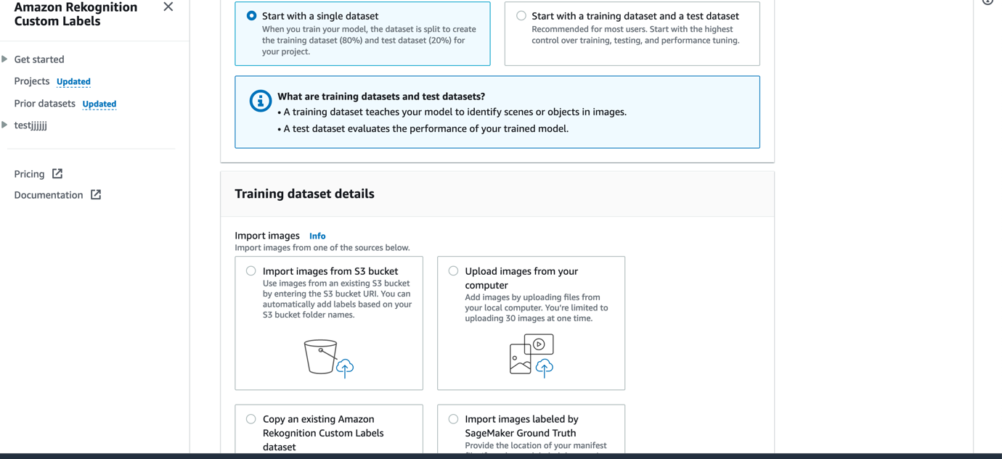

1. Download the images given in the folder “images” which includes the images of tiktok , sharechat and Moj logos collected from Internet to your local machine and then upload these images using Add Images.

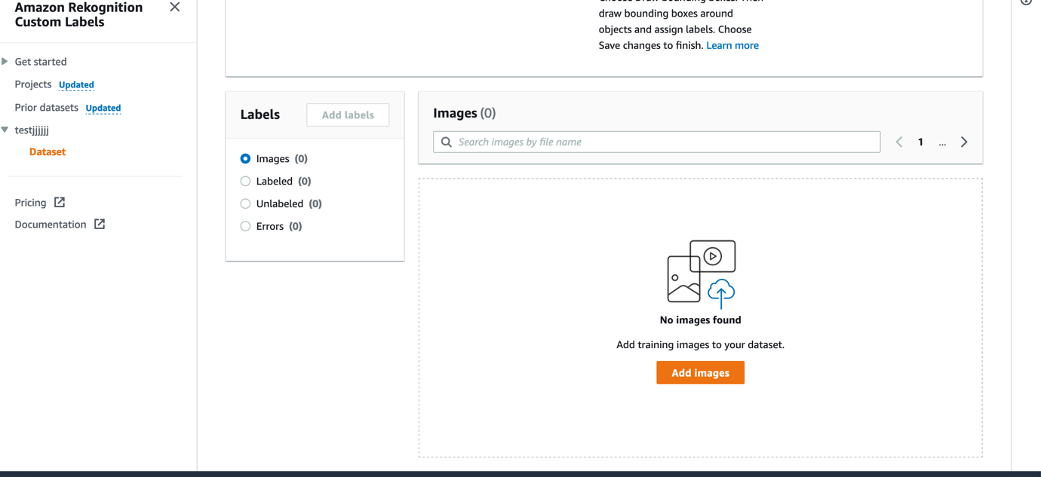

1. You will get a window like this and click on Choose Files and after selecting the files

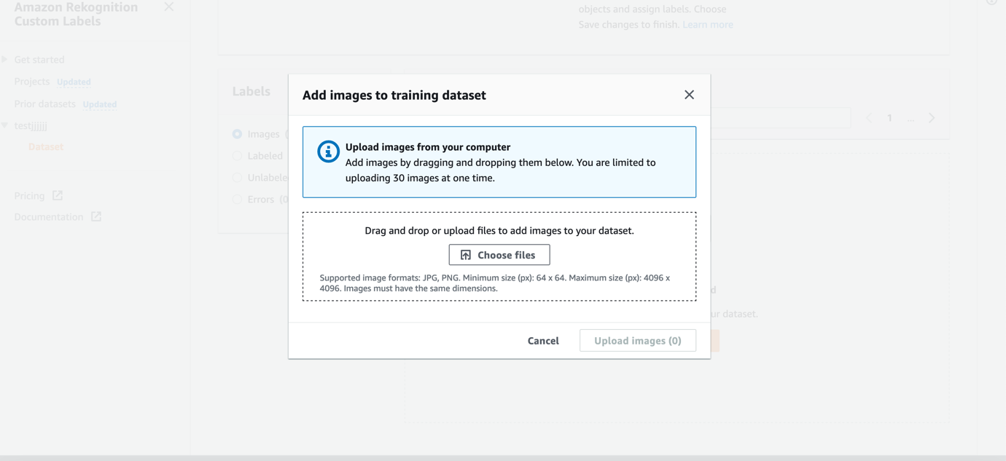

Labelling the Images

1. Click on Start Labelling

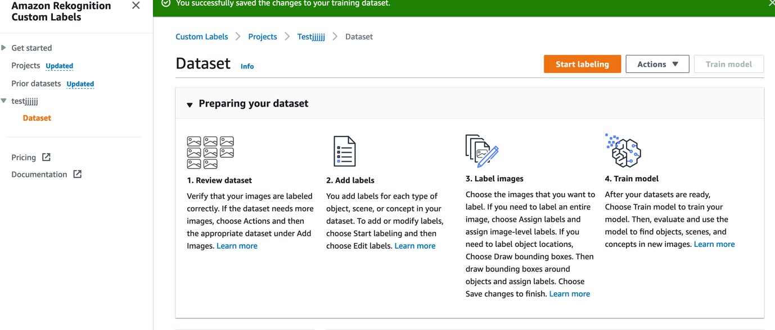

1. Click on Add Labels and add labels with Names Tiktok, Mojo and sharechat

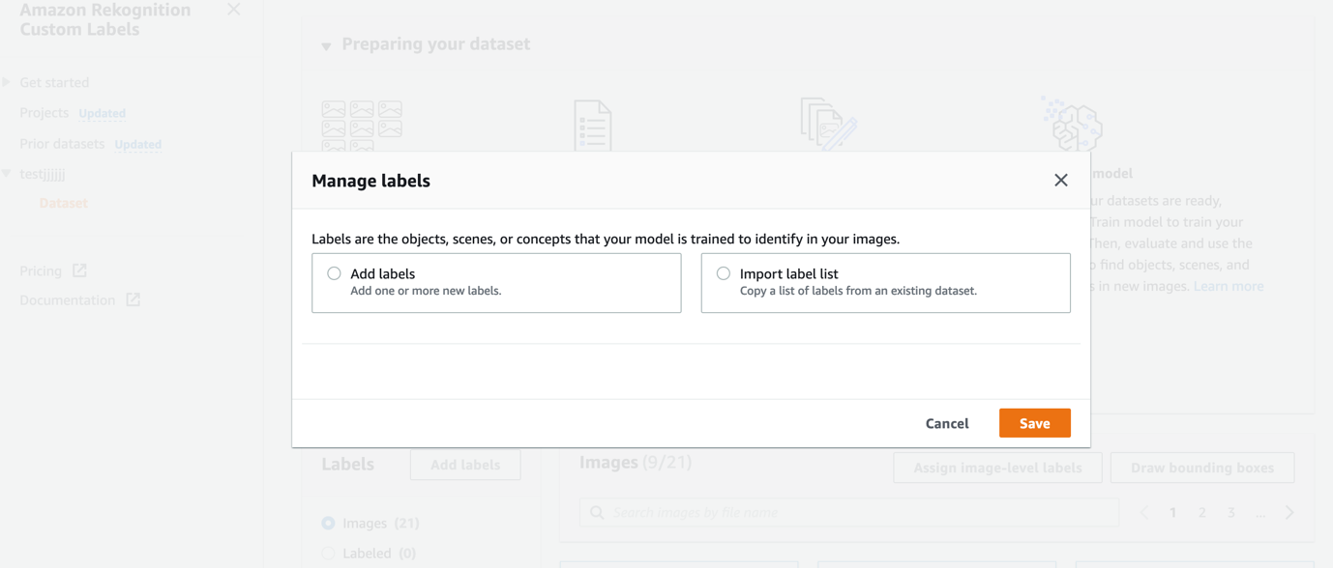

1. Select the Images and Click on Draw Bounding boxes.

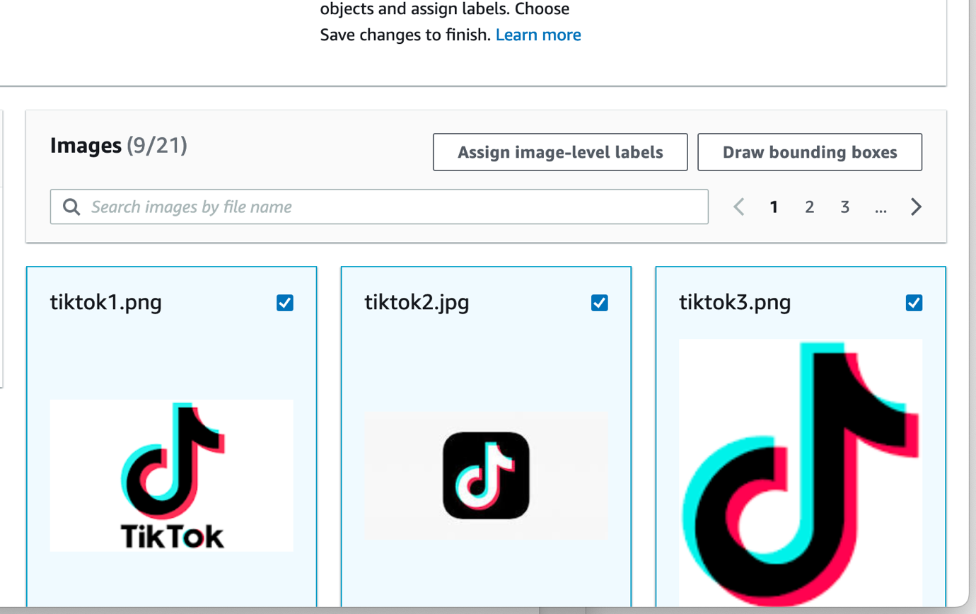

1. After drawing bounding boxes on all the images, click Done.
2. Now we will need to train our model and click on Tran model which is the third option in the screenshot. It will take some time ( 30 minutes to 24 hours ) based on the number of images.

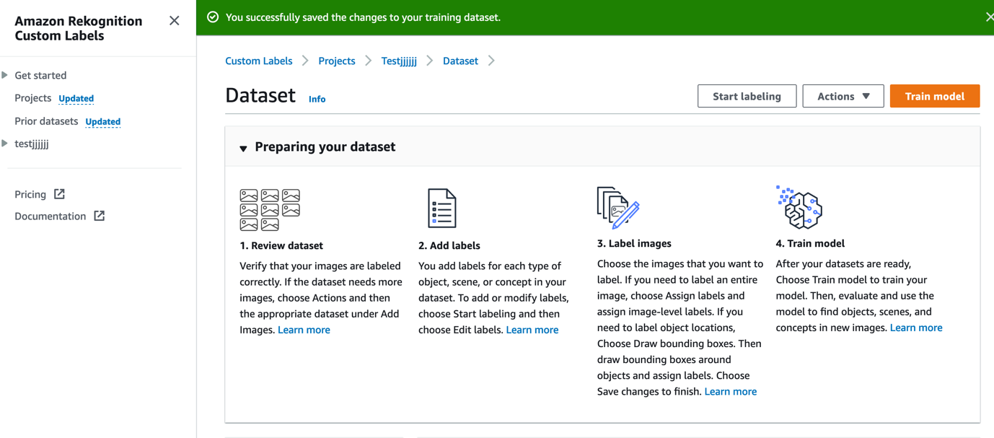

1. Now click on “Check Metrics under the “Evaluating your model to check the performance.

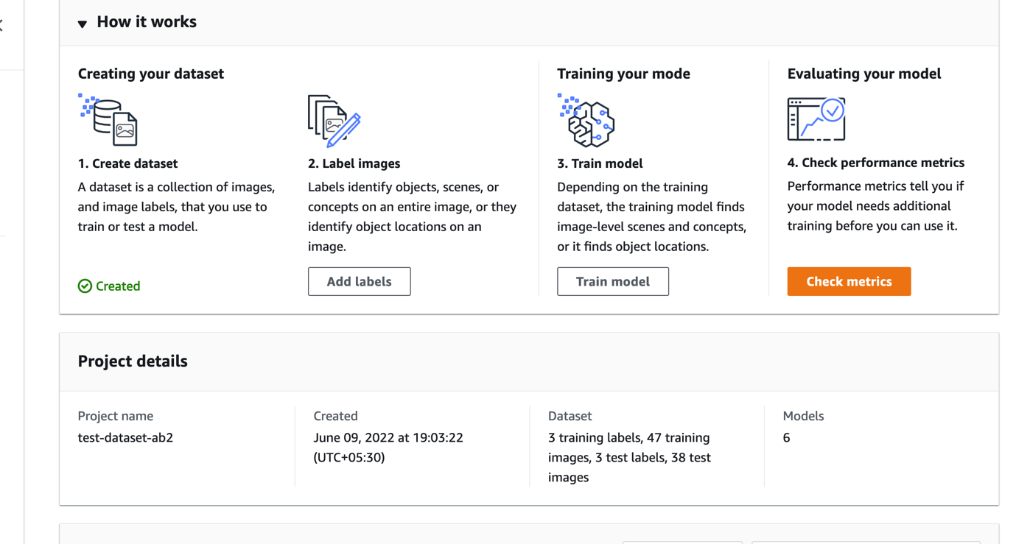

Refer: <https://docs.aws.amazon.com/rekognition/latest/customlabels-dg/im-metrics-use.html>

Now go to “Use Model” and Click on Start Model. You can choose the number of Inference units and as the number of inference unit increases, the throughout also increases.

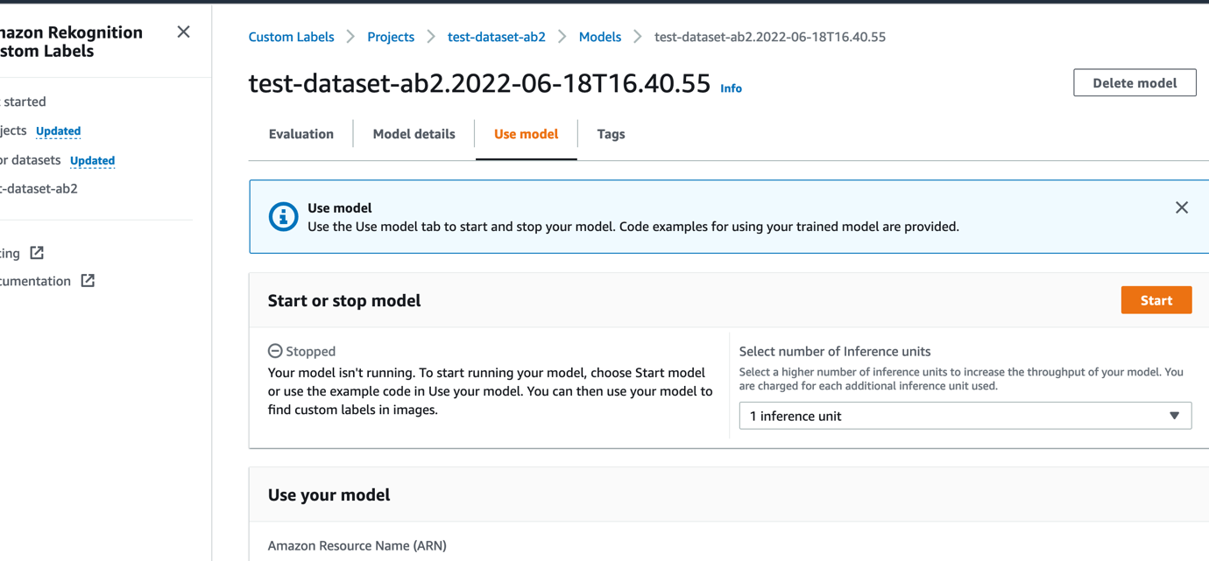

1. Now you have the model ready and running!!!

Workflow and Outputs

===================

Content Moderation

The First Lambda function Lambda1 invokes [StartContentModeration](https://docs.aws.amazon.com/rekognition/latest/APIReference/API_StartContentModeration.html) API and based on the size of the video it take some time for the Content Moderation job to finish. Once it is finished it generates a JobID and that is passed to Simple Notification Service to Trigger the next Lambda function that invokes the [GetContentModeration](https://docs.aws.amazon.com/rekognition/latest/APIReference/API_GetContentModeration.html) API. Lambda1 itself has the function to create an Elemental Media convert job to convert the video into frames that will be required to run a custom Rekognition model.

Please find the JobID output from the Lambda function

{

"JobId": "3ffd9326c88e8194b35cf102644a2b8fb587684a2617820ad0fe593ac75ae525",

"ResponseMetadata": {

"RequestId": "7029e5f9-24f7-4b99-9ac3-4e44806af6da",

"HTTPStatusCode": 200,

"HTTPHeaders": {

"x-amzn-requestid": "7029e5f9-24f7-4b99-9ac3-4e44806af6da",

"content-type": "application/x-amz-json-1.1",

"content-length": "76",

"date": "Thu, 22 Sep 2022 09:02:57 GMT"

},

"RetryAttempts": 0

}

}

2. As mentioned, Once the JobID is generated the SNS triggers the second Lambda function Lambda2 and it invokes the GetContentModeration API. I have quoted the sample output of the function when the video contains the Moderation Labels and when a moderation label is detected the Video is moved to a different Destination bucket which is further passed for a human review.

[{

"Timestamp": 66,

"ModerationLabel": {

"Confidence": 98.96820831298828,

"Name": "Barechested Male",

"ParentName": "Suggestive"

}

}, {

"Timestamp": 66,

"ModerationLabel": {

"Confidence": 98.96820831298828,

"Name": "Suggestive",

"ParentName": ""

}

}, {

"Timestamp": 566,

"ModerationLabel": {

"Confidence": 97.36837768554688,

"Name": "Barechested Male",

"ParentName": "Suggestive"

}

}, {

"Timestamp": 566,

"ModerationLabel": {

"Confidence": 97.36837768554688,

"Name": "Suggestive",

"ParentName": ""

}

]

Custom Modelling -Part2

1. Lambda1 will also convert the Video into frames. The video will be saved onto an intermediate bucket with mp4 extension added to its name and also the first frame of the video will be saved as <videoname>.0000000.jpg. This image is passed to the Custom Rekognition model for Label detection. (Here only first frame is considered as the Platform logo will be present on all the frames of the video)
2. Whenever an input frame comes to the intermediate bucket another Lambda function , Lambda3 is triggered and it will invoke DetectCustomLabels API call.

Given below is the output of this Lambda function

{'CustomLabels': [{'Name': 'sharechat', 'Confidence': 92.1469955444336, 'Geometry': {'BoundingBox': {'Width': 0.06157999858260155, 'Height': 0.06356000155210495, 'Left': 0.15749000012874603, 'Top': 0.05685000121593475}}}], 'ResponseMetadata': {'RequestId': '88c29f8a-5365-4428-a555-35265dacae0a', 'HTTPStatusCode': 200, 'HTTPHeaders': {'x-amzn-requestid': '88c29f8a-5365-4428-a555-35265dacae0a', 'content-type': 'application/x-amz-json-1.1', 'content-length': '208', 'date': 'Sat, 18 Jun 2022 13:09:19 GMT'}, 'RetryAttempts': 0}}

So if any of the trained logos (Moj, sharechat or tiktok ) detected the video is moved to another Bucket