**Setting up Amazon WorkMail and Inbound Rules:**

1. Open the Amazon WorkMail console at <https://console.aws.amazon.com/workmail>
2. Click the button Create Organization
3. In Organization settings, in the Email domain section, choose the ‘Free test domain’
4. Enter the Alias(domain) here ex: email-bot (if you have your own domain, please choose external domain in previous step)
5. Leave the advanced setting as it is and click on ‘Create organization’
6. It will take up to 2 mins to create the domain and you would see the message like this in the console

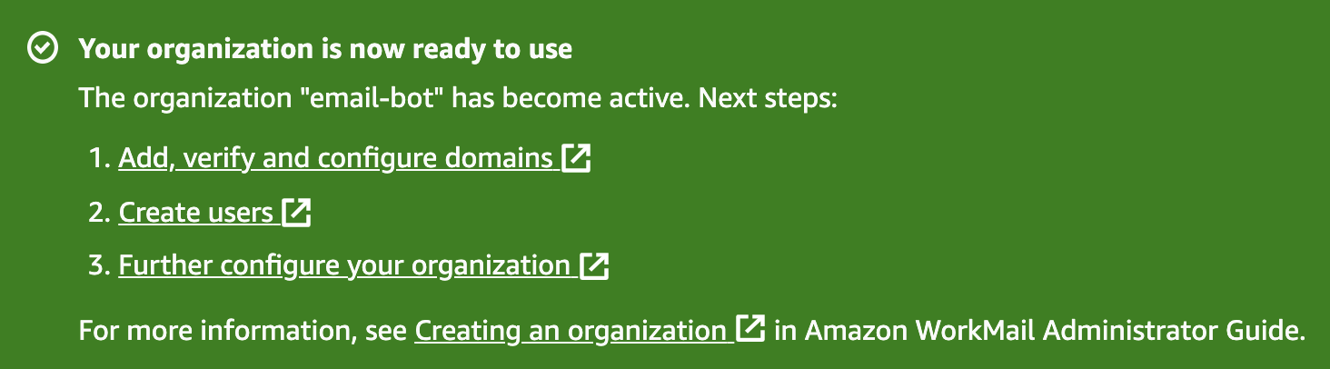

1. Click on the domain newly created and click on the name of the domain hyperlink.
2. Click on Crete user in ‘WorkMail Users’ section
3. Enter the new user information in which all the customer will send the email for the request and click the button ‘Next Step’

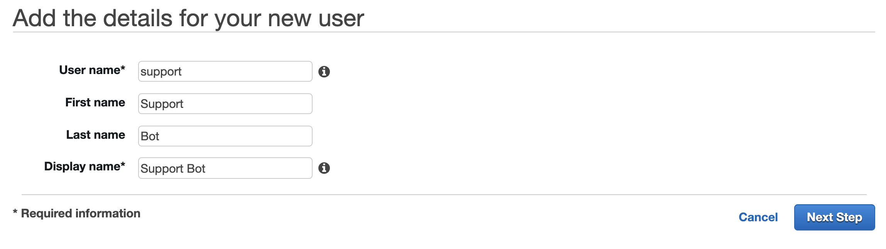

1. Setup the password for this user and click add user and you can see the status ‘Enabled’ for this user with email address ‘support@email-bot.awsapps.com’
2. Click on ‘Organization Settings’ from the menu and in General section you will see the web-application link for your email.

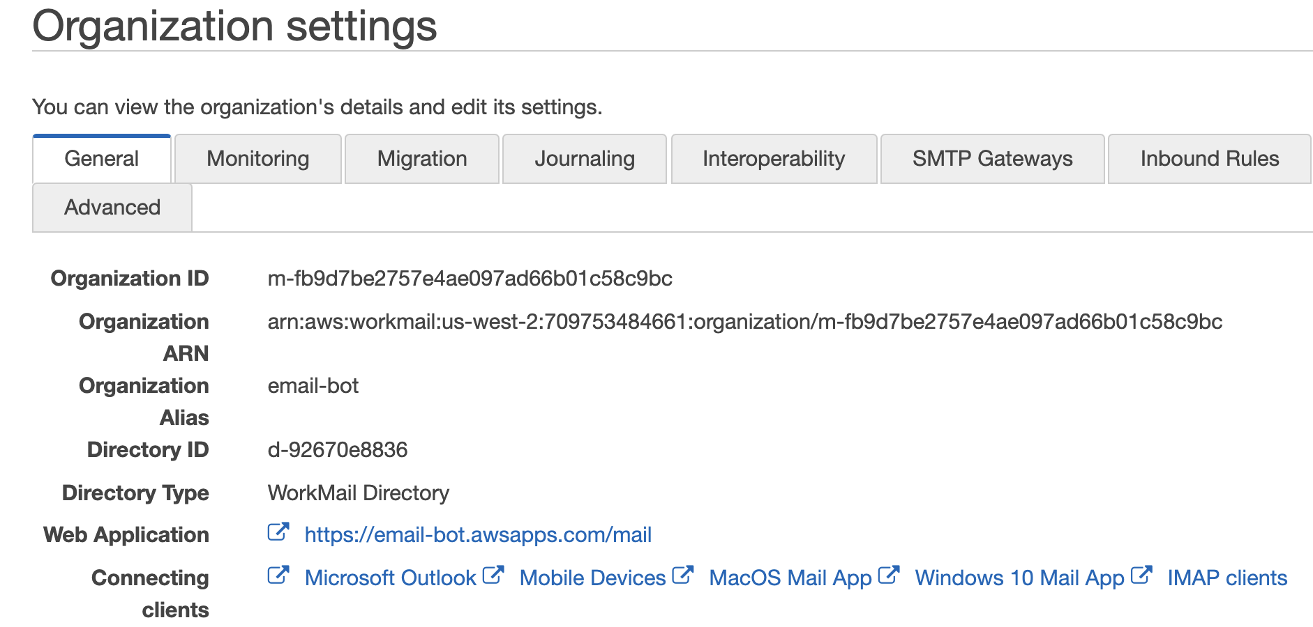

1. Click on that web-application URL to login and enter the username and password and Sign In

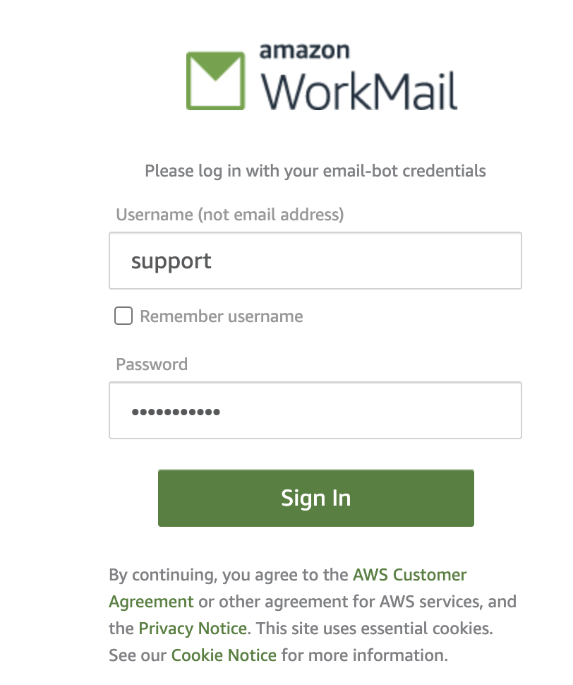

1. You will see your Email inbox web page

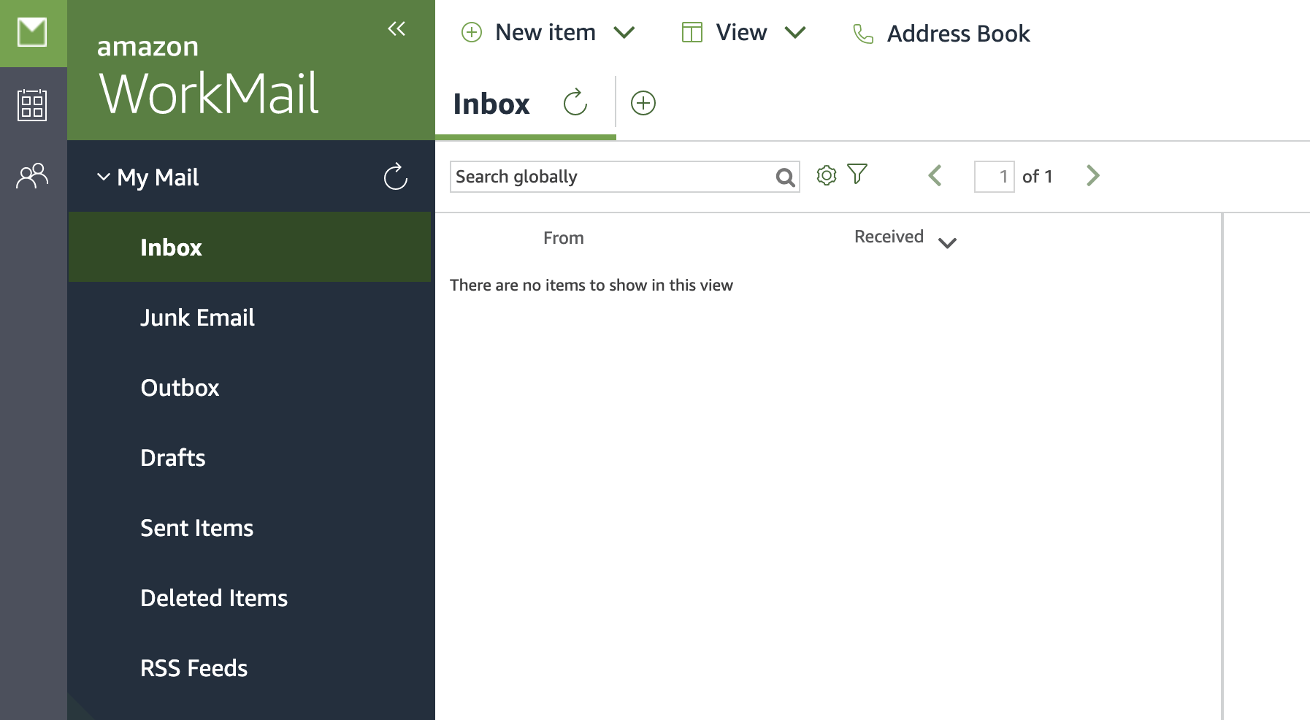

1. Test this new email box by sending email from your personal email id.

**Setting up Inbound Rules:**

1. Click on ‘Organization Settings’ and choose the ‘Inbound Rules’ menu
2. Click the button ‘Create rule’
3. Enter the Rule Name and Select the action ‘Run Lambda’ and choose ‘Custom Lambda function’ and enter the lambda function ARN to be invoked upon receiving the email.

