Creating Sagemaker Notebook instance:

1. Open the SageMaker console at <https://console.aws.amazon.com/sagemaker/>.
2. Choose **Notebook instances**, then choose **Create notebook instance**.
3. On the **Create notebook instance** page, provide the following information:
   1. For **Notebook instance name**, type a name for your notebook instance.
   2. For **Notebook instance type**, choose an instance size suitable for your use case. Skip the additional/advanced configuration and move to setting up IAM Role.
   3. For **IAM role**, select **Create a new role**. If you choose **Create a new role**, SageMaker creates an IAM role named AmazonSageMaker-ExecutionRole-*YYYYMMDD*T*HHmmSS*. The AWS managed policy AmazonSageMakerFullAccess is attached to the role. The role provides permissions that allow the notebook instance to call SageMaker and Amazon S3.
   4. Now ppdate the IAM Role with the permission to execute comprehend classifications.

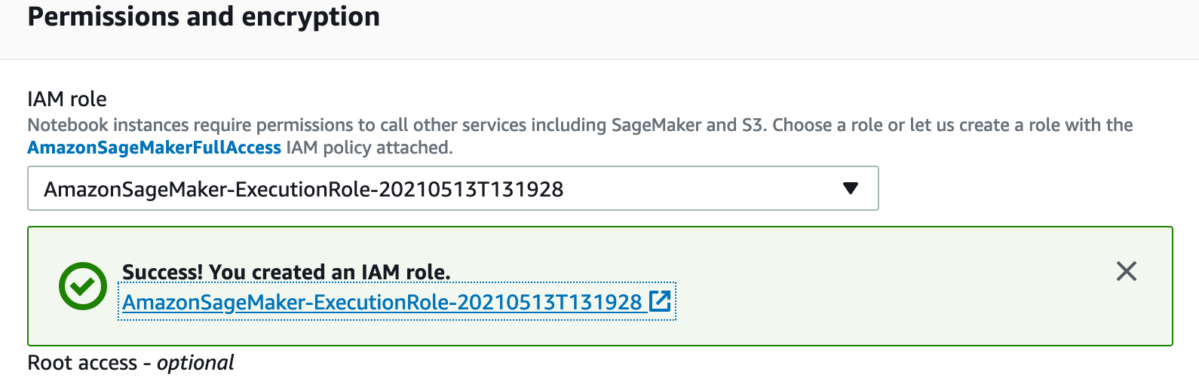

Click on the role you created and it will be redirected to IAM console with role selected. Click on **Attach policies** and select the policy ‘ComprehendFullAccess’ and click attach policy.

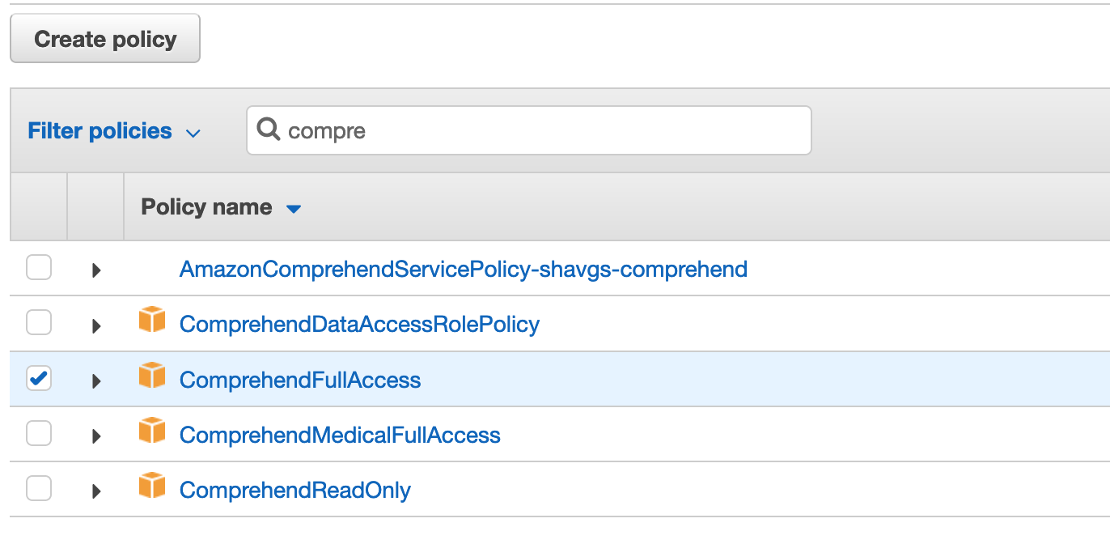

Also, update the sagemaker execution policy with IAM Passrole as below and update the policy.

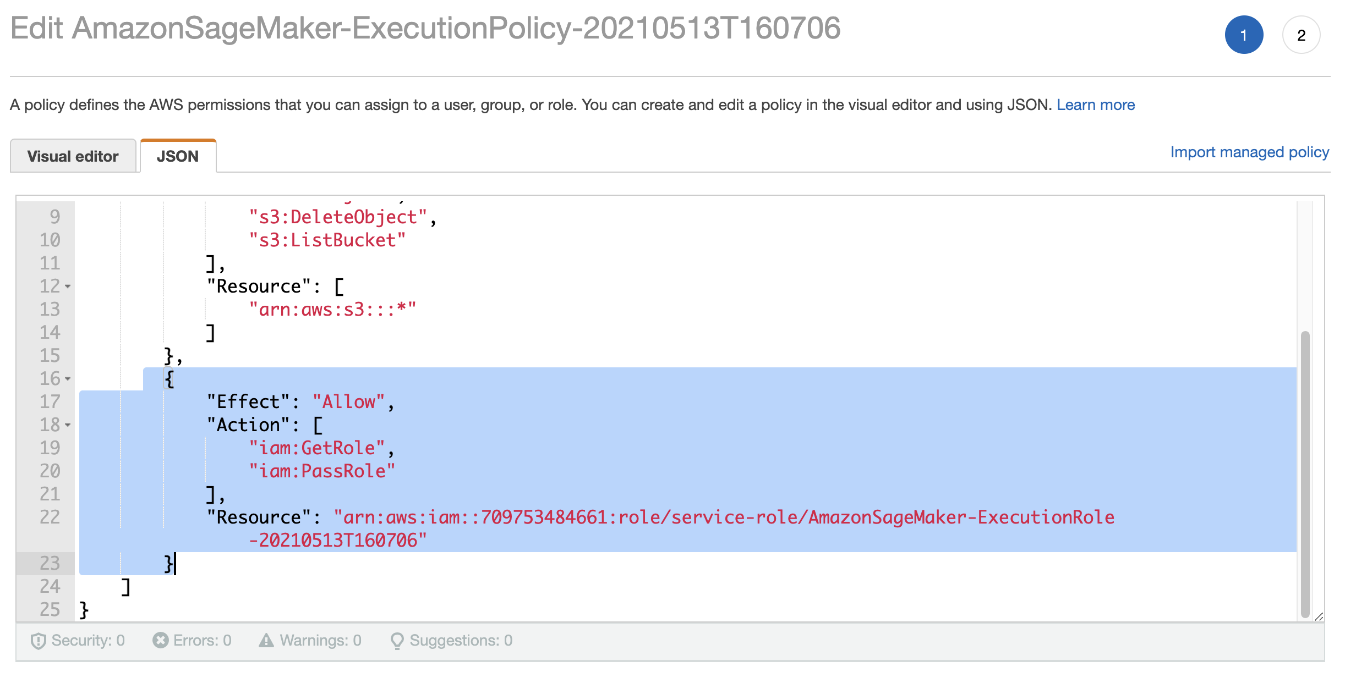

Now click on **Trust relationships** menu and click Edit trust relationship

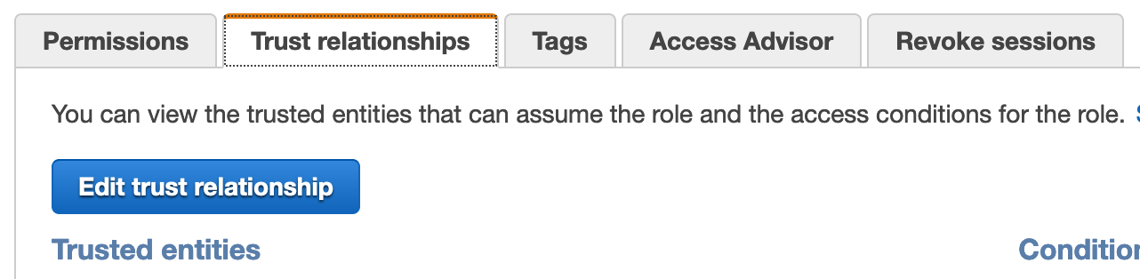

And add service ‘comprehend.amazonaws.com’ as below and update the policy

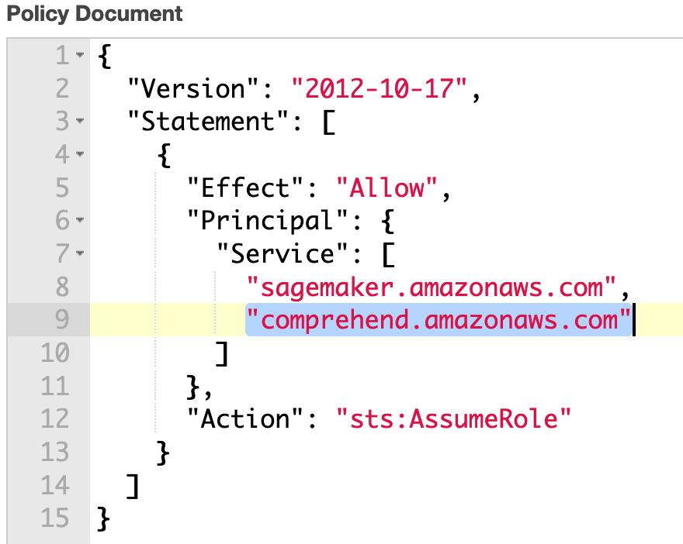

* 1. Leave the remaining setup as it is in SageMaker Notbook instsance Setup
  2. Choose **Create notebook instance**.

In a few minutes, Amazon SageMaker launches an ML compute instance—in this case, a notebook instance—and attaches an ML storage volume to it. The notebook instance has a preconfigured Jupyter notebook server and a set of Anaconda libraries.

1. When the status of the notebook instance is InService, in the console, the notebook instance is ready to use. Choose **Open Jupyter** next to the notebook name to open the classic Jupyter dashboard.
2. Click on New -> Terminal

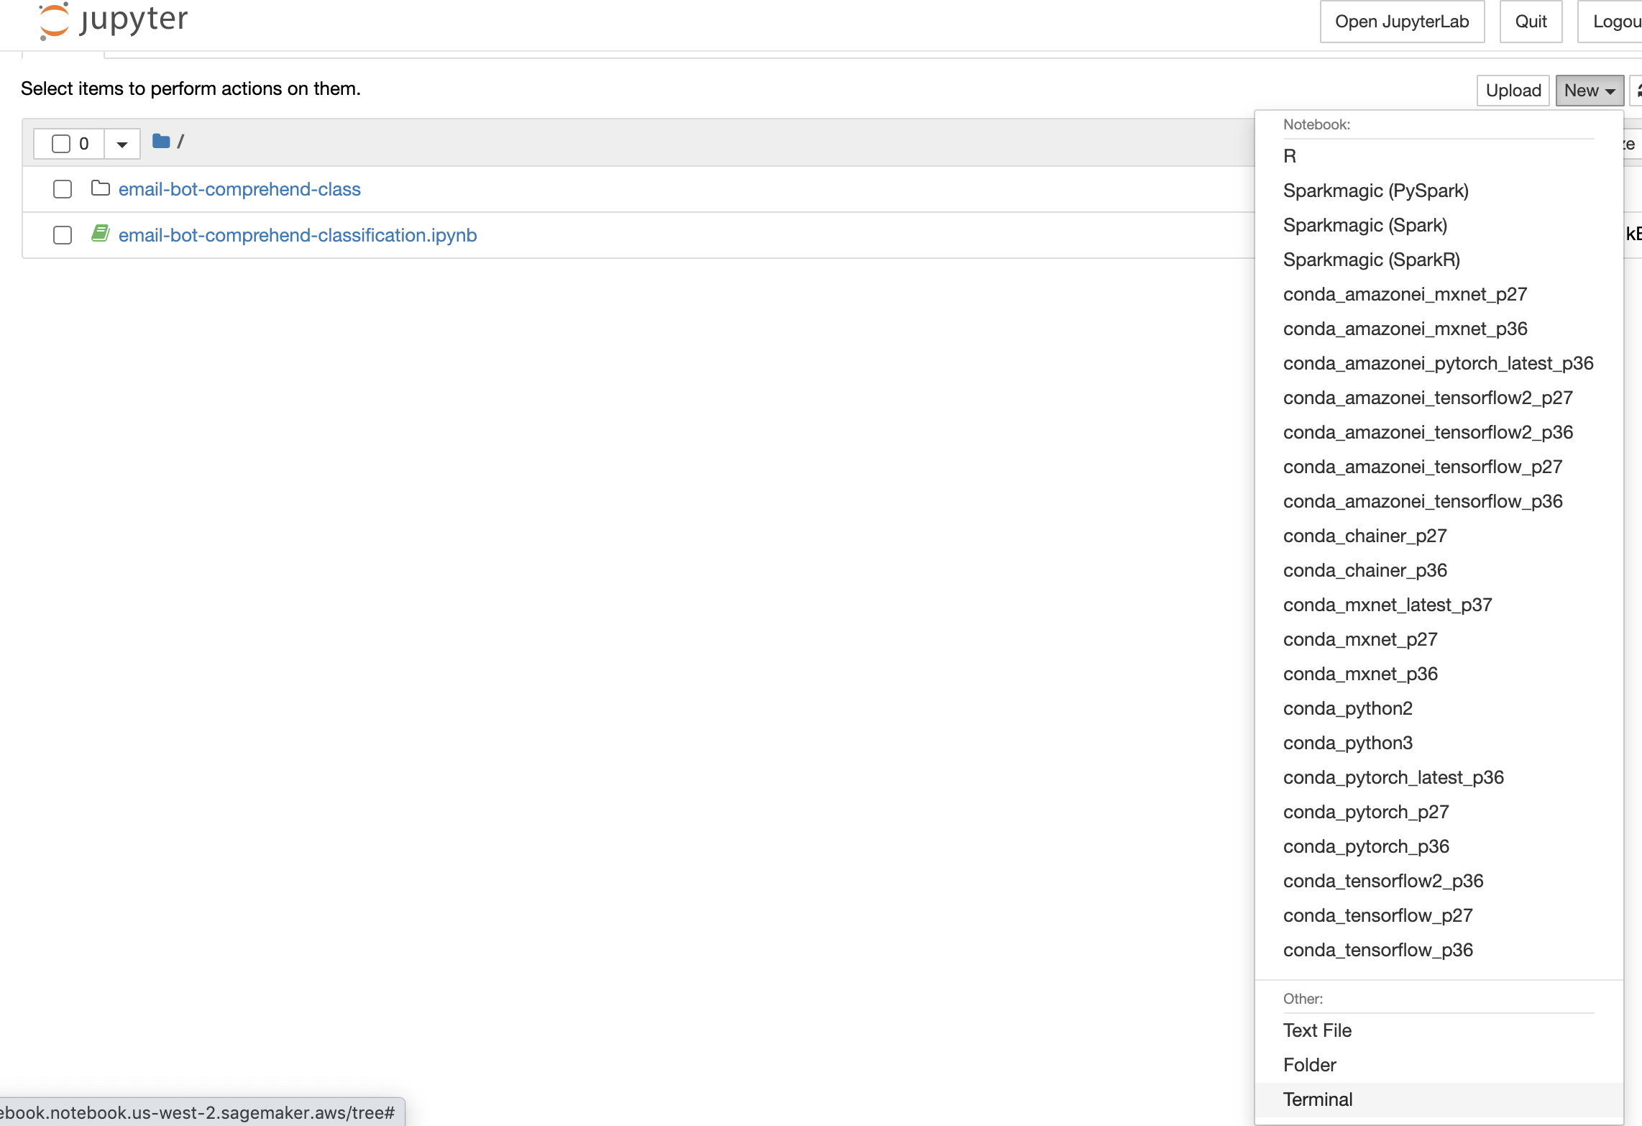

1. download the ipython notebook to be used for comprehend custom classification training.

!cd SageMaker

!wget <https://raw.githubusercontent.com/god441347/email-bot-comprehend-class/main/email-bot-comprehend-classification.ipynb>

1. You can see the .ipynb file downloaded and click [email-bot-comprehend-classification.ipynb](https://email-bot-notebook.notebook.us-west-2.sagemaker.aws/notebooks/email-bot-comprehend-classification.ipynb) to open the notebook

