Skills-based agent with governed MCP tools reference architecture
Serve an AI agent and its tools to MCP clients from Amazon Bedrock AgentCore, with every call signed, authorized and logged
Prepared by AWS Professional Services | Version: 1.0 | Status: Example | Owner: Platform team | Audience: Builders who host agents for MCP clients such as Claude Code, Codex and Kiro | Classification: Public example | Date: 2026-10-16
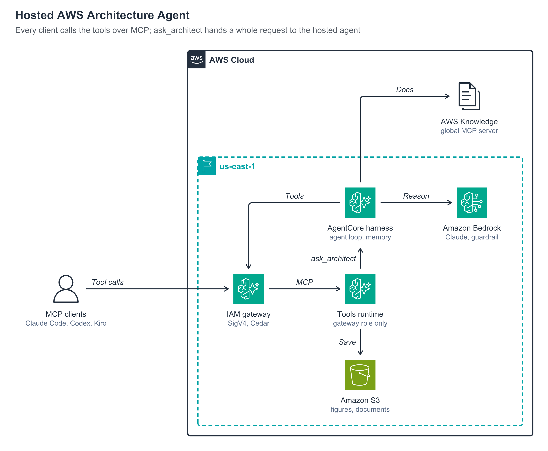
Figure 1. MCP clients call the tools through an AgentCore Gateway; ask_architect hands a whole request to the AgentCore harness

How it works
- Tool calls: a Model Context Protocol (MCP) client signs each call with the caller's AWS credentials through the MCP Proxy for AWS, and the AgentCore Gateway checks it against a default-deny Cedar policy and a per-caller rate limit.
- MCP: the gateway forwards the call to the MCP server on AgentCore Runtime, which only the gateway role may invoke.
- Save: the tools render diagrams, run layout checks and build documents, upload the files to Amazon S3 and return presigned links.
- ask_architect: for a whole request, the tools runtime runs one turn of the AgentCore harness on its pinned endpoint.
- Reason: the harness reasons with a Claude model on Amazon Bedrock, with a guardrail on every request, and keeps context in AgentCore Memory.
- Tools and Docs: the harness calls the same tools through the gateway and reads AWS documentation from the AWS Knowledge MCP Server.

Services used
- Amazon Bedrock AgentCore: the harness, the MCP tools runtime, the gateway, Policy, Memory and Evaluations.
- Amazon Bedrock: the Claude model and the guardrail.
- Amazon S3: generated figures and documents, expiring after 30 days.
- AWS IAM: one role per component, each scoped to what it calls.
- Amazon CloudWatch: traces, alarms, a dashboard and a canary.

Considerations
- Security: keep the harness on SigV4 only, because any caller of a harness can override its model, prompt and tools for a call; users reach it through the gateway.
- Cost: model tokens are most of the cost of a turn; see Amazon Bedrock pricing and Amazon Bedrock AgentCore pricing.
- Operations: promote a new agent version to the pinned endpoint only after it passes an evaluation, and alarm on errors, throttles and slow tool calls.

