Ad Spend Efficiency Analysis: CTR, Conversion Rate and ROAS by Media, Category and Product
Yummy Food Market — September 2025 Advertising Performance Review

Executive Summary
This report analyzes the full September 2025 advertising dataset for Yummy Food Market — 720 daily records spanning 4 media channels, 3 product categories and 6 SKUs — to determine where advertising spend is being used efficiently and where budget is misallocated. Across the month, total ad spend of 388,296,000 KRW [1] generated 1,316,606,500 KRW [2] in ad-attributed revenue, a blended ROAS of 3.39 against a breakeven of 1.0. Every single daily record cleared breakeven, so the core finding is not that spend is being lost outright, but that it is unevenly allocated: roughly 45.42% [3] of total spend sits in channels performing below the blended ROAS baseline, while a clear high-efficiency pocket (Amazon x Health Food, ROAS 8.41 [4] ) receives less than 1% of budget.
The single clearest waste pocket is Neiba: it absorbs 27.79% [5] of total spend but returns only 19.27% [6] of total revenue, driven by an unusual funnel pattern — Neiba's click-through rate (3.21% [7] ) is nearly double the blended baseline (1.80% [8] ), yet its conversion rate (2.13% [9] ) is less than half the blended baseline (4.67% [10] ). This signature (high CTR, low CVR) points to a post-click problem — landing page relevance, price presentation or checkout friction — rather than a creative or targeting problem. At the other extreme, Kuppang converts a below-average CTR into the best ROAS in the portfolio (4.14 ) by driving a conversion rate of 6.79% [11] , and the Amazon x Health Food combination reaches a ROAS of 8.41 on just 3,594,000 KRW [12] of spend.
Based on these validated patterns, this report proposes three prioritized strategies: (1) reallocating a portion of Neiba's budget into the higher-performing Kuppang/Kulsam channels at the same total spend, (2) fixing Neiba's post-click funnel rather than abandoning its traffic, and (3) scaling the under-funded Amazon x Health Food pocket. Together these actions target upside in the tens to hundreds of millions of KRW without requiring incremental budget, and are described below with priority, expected impact, effort, risk and the metrics needed to monitor execution.

Data & Methodology
This section defines the dataset scope, the metric formulas used throughout the report, and the thresholds applied so that every subsequent number can be traced back to a transparent calculation.

Dataset Scope
The source file yummy-food-market.csv contains 720 rows representing a complete daily grid: 4 media channels x 6 products x 30 days (September 1-30, 2025). Columns were mapped using column_definitions.json to confirm units and currency semantics. The dataset was profiled before analysis: no duplicate rows, no missing values, and all 720 media x product x day combinations present. The 4 media channels are Kuppang, Neiba, Amazon and Kulsam; the 6 products roll up into 3 categories — Convenience Food (Instant Rice Set, Frozen Dumplings), Health Food (Protein Bar, Omega-3) and Fresh Food (Salad Kit, Premium Fruit).

Metric Formulas
All ratio metrics are computed from summed numerators and denominators (not row-averaged percentages) to produce correctly weighted blended figures:
- CTR (Click-Through Rate) = Clicks / Impressions x 100
- CVR (Conversion Rate) = Conversions / Clicks x 100
- ROAS (Return on Ad Spend) = Ad-Attributed Revenue / Ad Spend
- CPC (Cost per Click) = Ad Spend / Clicks
- CPA (Cost per Acquisition) = Ad Spend / Conversions
- AOV (Average Order Value) = Ad-Attributed Revenue / Conversions

Thresholds and Breakeven Definition
Breakeven ROAS is defined as 1.0 (ad spend returns an equal amount of revenue), which is margin-unadjusted because no COGS or gross-margin field exists in the dataset or column_definitions.json; this is stated explicitly as a limitation later in the report. A minimum-spend / minimum-impression threshold for statistical stability was considered for the product-level ranking, but was found unnecessary: every product aggregates over 120 rows (4 media x 30 days) with no missing or zero-spend rows, so all SKU-level figures are already stable monthly aggregates. The blended ROAS of 3.39 is used as the primary efficiency baseline against which each media, category and product segment is compared; a secondary top-2-media blended ROAS of 3.99 is used as a more ambitious reallocation target.

Overall Performance Baseline
Before breaking performance down by media, category and product, this section establishes the blended benchmark that every segment is measured against. All segment-level comparisons later in the report reference these totals.
Metric | Value
Total Impressions | 77,961,417
Total Clicks | 1,401,947
Total Conversions | 65,509
Total Ad Spend (KRW) | 388,296,000 [1]
Total Ad-Attributed Revenue (KRW) | 1,316,606,500 [2]
Blended CTR | 1.80%
Blended CVR | 4.67%
Blended ROAS (breakeven = 1.00) | 3.39
Blended CPC (KRW) | 277.0 [35]
Blended CPA (KRW) | 5,927.4 [36]
Blended AOV (KRW) | 20,098.1
The portfolio is profitable in aggregate, returning 3.39 KRW of ad-attributed revenue for every 1 KRW of spend. However, this blended figure masks substantial variance across media and categories, which the following sections quantify in detail.

Performance by Media
Media channel is the dimension with the widest efficiency spread in the dataset, making it the primary lever for budget reallocation. The table below ranks all four channels by ROAS alongside their spend and revenue shares.
Media | CTR | CVR | ROAS | Spend Share | Revenue Share | Share Gap (pp)
Kuppang | 1.36% | 6.79% | 4.14 | 41.62% | 50.86% | +9.24
Kulsam | 1.80% | 5.35% | 3.51 | 12.96% | 13.40% | +0.44
Amazon | 1.20% | 6.39% | 3.17 | 17.63% | 16.48% | -1.15
Neiba | 3.21% | 2.13% | 2.35 | 27.79% | 19.27% | -8.52
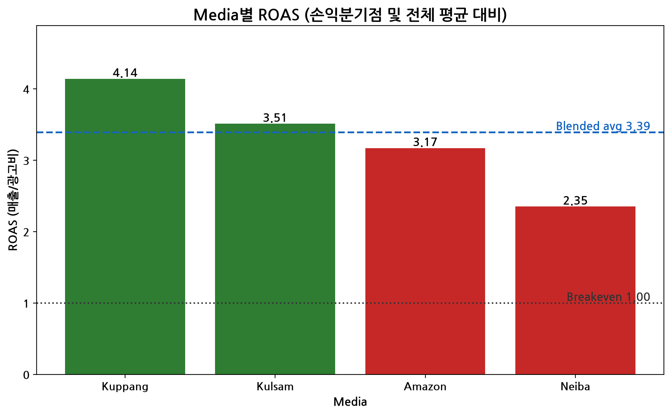
Figure 1: ROAS by media channel against the breakeven line (ROAS=1.0) and the blended baseline (3.39 [13]).
Kuppang is the strongest channel by ROAS (4.14 ) and is also under-funded relative to its efficiency: it earns 50.86% [14] of total revenue from only 41.62% [15] of total spend, a positive share gap of +9.24pp. Neiba sits at the opposite end, with the lowest ROAS (2.35 [16] ) and a negative share gap of -8.52pp — it consumes 27.79% [5] of spend while returning only 19.27% [6] of revenue. Amazon also trails the blended baseline (ROAS 3.17 vs. 3.39 [13] ), with a smaller negative gap of -1.15pp.
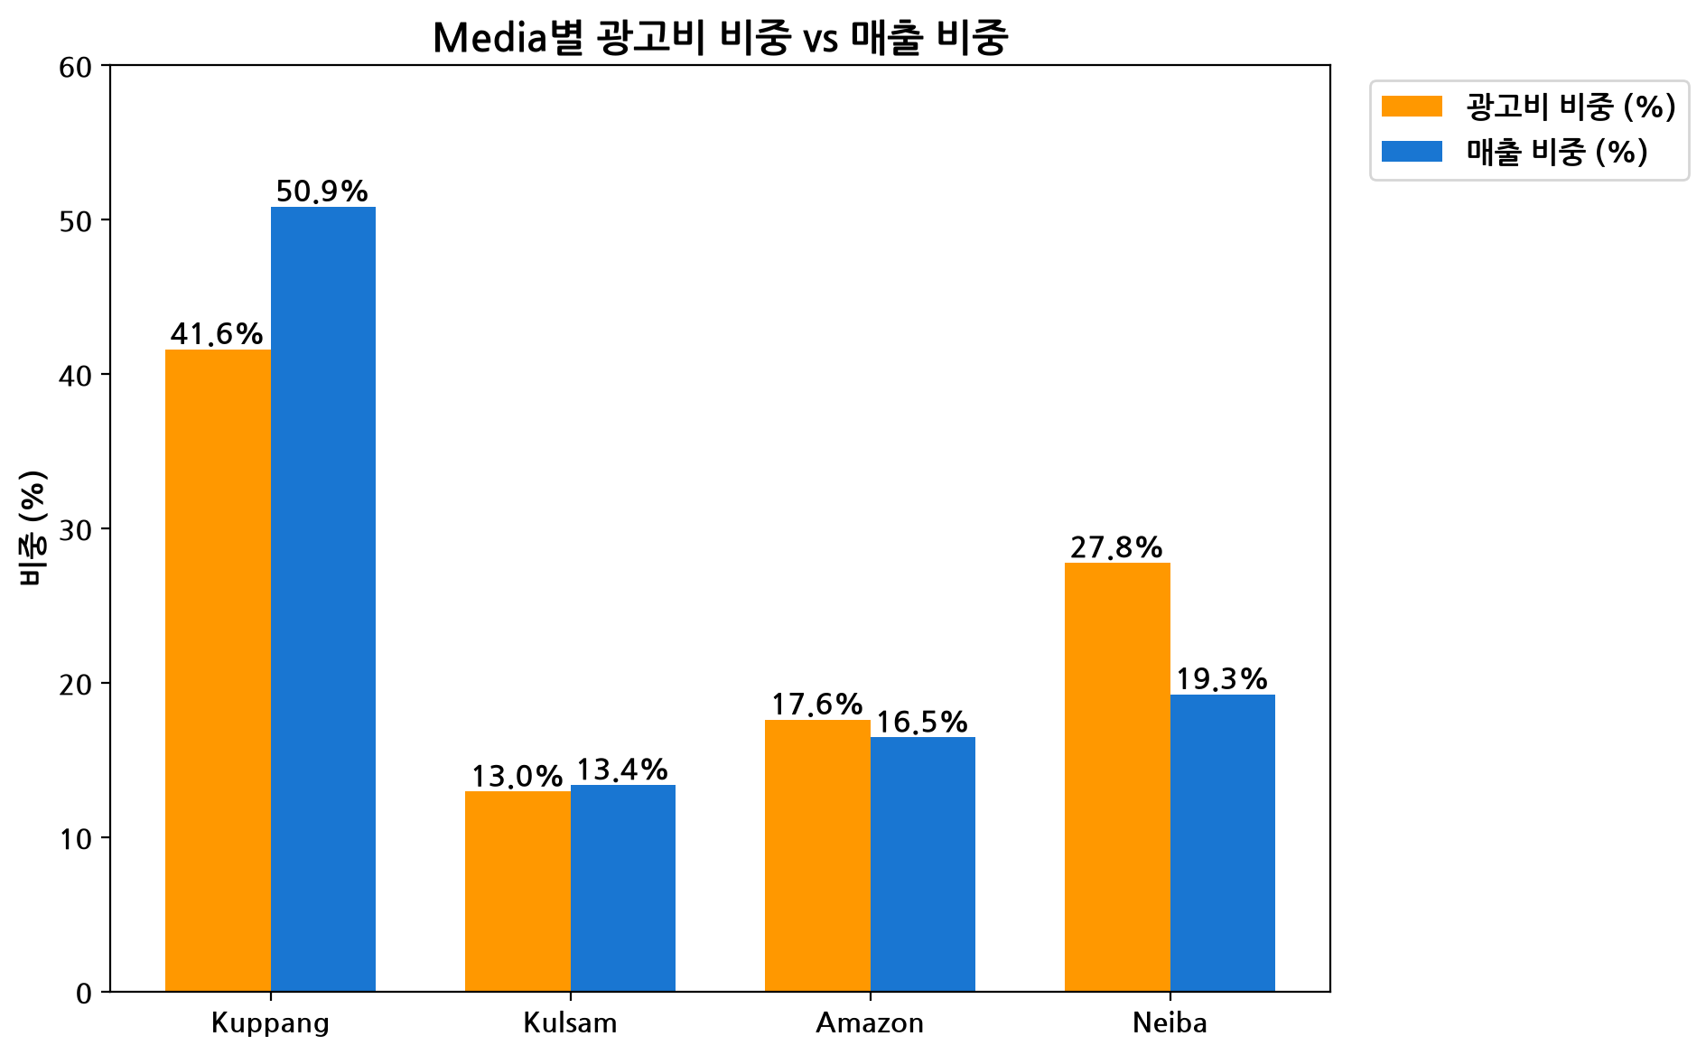
Figure 2: Spend share vs. revenue share by media channel — bars diverging above the diagonal indicate efficient, under-funded channels; bars diverging below indicate over-funded, inefficient channels.
This chart visually confirms the budget misallocation: Kuppang's revenue bar clearly exceeds its spend bar, while Neiba's spend bar clearly exceeds its revenue bar. Combined, Neiba and Amazon — the two channels performing below the blended ROAS of 3.39 [13] — account for 45.42% [3] of total ad spend (176,375,000 KRW ), which is the practical ceiling on how much budget could be considered for reallocation without touching the already-efficient channels.

Performance by Category
Category-level performance is far more balanced than media-level performance, suggesting that product category is not where the main efficiency problem lies — the table below confirms all three categories cluster closely around the blended ROAS baseline.
Category | CTR | CVR | ROAS | Spend Share | Revenue Share
Fresh Food | 1.80% | 4.80% | 3.49 | 38.28% | 39.41%
Health Food | 1.89% | 4.37% | 3.35 | 25.87% | 25.59%
Convenience Food | 1.76% | 4.68% | 3.31 | 35.84% | 35.01%
No category shows a large spend/revenue share gap: Fresh Food leads modestly (ROAS 3.49 [17] , gap +1.13pp), while Health Food (ROAS 3.35 [18] ) and Convenience Food (ROAS 3.31 [19] ) trail only slightly and sit close to the blended baseline of 3.39 [13] . This indicates that category-level budget shifts would have a much smaller impact than media-level shifts — the efficiency problem is concentrated in channel choice, not in which products are advertised, and is explored further in the cross-dimensional analysis below.

Performance by Product
At the SKU level, all six products aggregate over a full 120 rows (4 media x 30 days) with no missing or zero-spend rows, so no minimum-spend exclusion threshold was required — every figure below is already a stable monthly aggregate. The table ranks products by ROAS.
Product | Category | CTR | CVR | ROAS | Ad Spend (KRW)
Premium Fruit | Fresh Food | 1.88% | 4.62% | 3.85 | 65,025,000 [37]
Omega-3 | Health Food | 1.90% | 4.39% | 3.53 | 50,211,000
Instant Rice Set | Convenience Food | 1.75% | 4.67% | 3.45 | 69,531,000
Salad Kit | Fresh Food | 1.78% | 4.85% | 3.21 | 83,630,000 [38]
Protein Bar | Health Food | - | 4.36% | 3.18 | 50,251,000
Frozen Dumplings | Convenience Food | 1.77% | 4.69% | 3.17 | 69,648,000
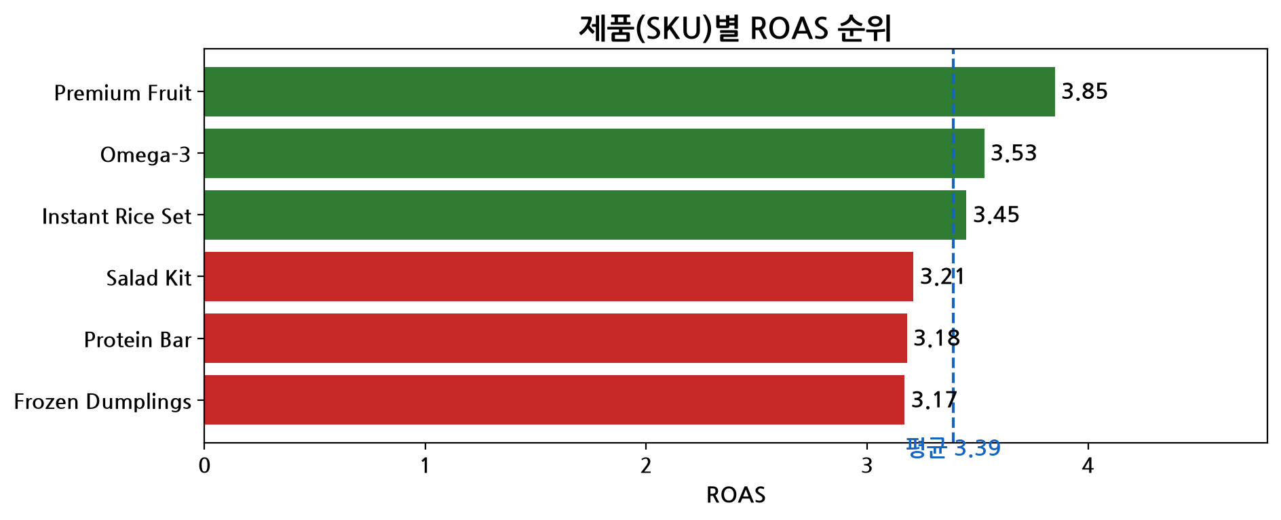
Figure 3: Product ROAS ranking across all six SKUs.
Premium Fruit is the top-performing SKU (ROAS 3.85 [20] ), while Frozen Dumplings is the weakest (ROAS 3.17 [21] ) — a gap of roughly 0.68 ROAS points, far narrower than the media-level spread (4.14 vs. 2.35 [16] ). This reinforces that the dominant efficiency lever in this dataset is media channel selection, not product selection: even the weakest product, Frozen Dumplings, still clears the 1.0 breakeven by a wide margin.

Cross-Dimensional & Funnel Diagnosis
Media and category performance on their own do not reveal exactly where spend is most efficient or most wasted. This section cross-tabulates media x category and media x product, then applies a funnel lens (CTR vs. CVR vs. ROAS) to each channel to diagnose the root cause of under- and over-performance.

Media x Category: Best and Worst Combinations
The most granular cut of the data reveals pockets of extreme efficiency and extreme inefficiency that are hidden when media and category are viewed separately.
Media x Category | Ad Spend (KRW) | Revenue (KRW) | ROAS
Amazon x Health Food (best) | 3,594,000 [12] | 30,220,600 | 8.41
Neiba x Health Food (worst) | 35,880,000 [23] | 79,028,700 | 2.20
Amazon x Health Food is the single best-performing combination in the dataset (ROAS 8.41 [4] ) but receives only 3,594,000 KRW [12] of spend — under 1% of the total 388,296,000 KRW [1] budget. At the other extreme, Neiba x Health Food is the single worst combination (ROAS 2.20 [22] ) on 35,880,000 KRW [23] of spend. At the media x product level, the pattern repeats: Amazon x Premium Fruit reaches a ROAS of 9.58 [24] , while Neiba x Protein Bar is the weakest pairing at ROAS 2.08 on 17,951,000 KRW [25] of spend.
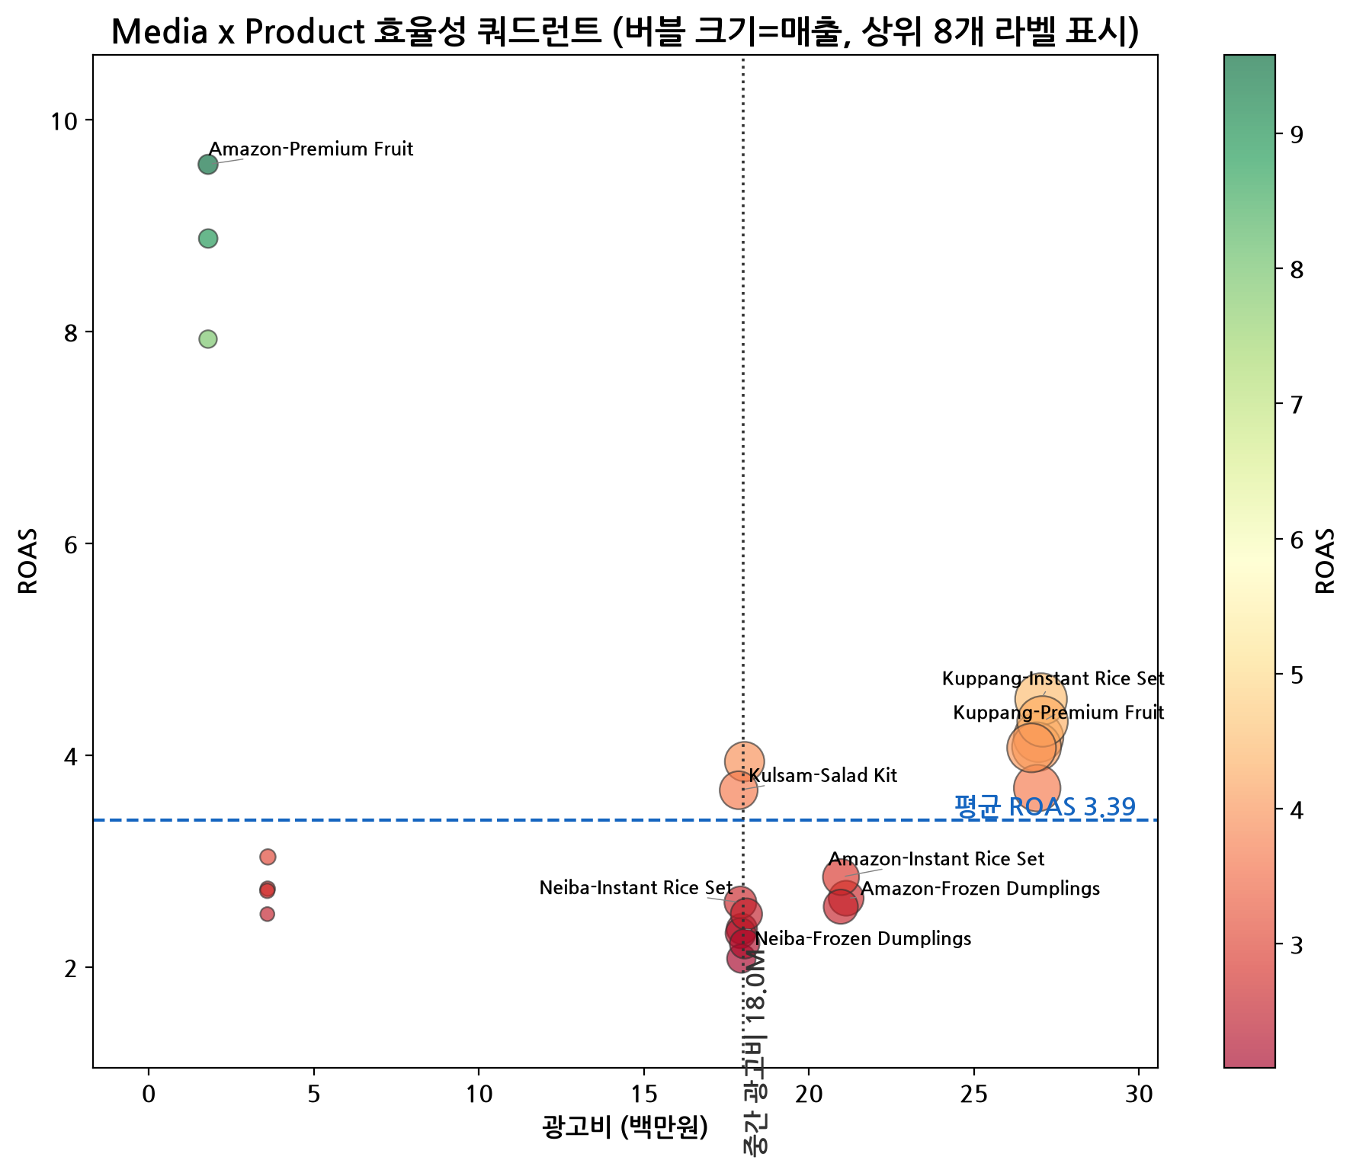
Figure 4 [26]: Efficiency quadrant — spend (x-axis) vs. ROAS (y-axis), bubble size = revenue, for each media x product combination.
The quadrant chart makes the allocation problem visible at a glance: the small, high-ROAS Amazon bubbles sit in the top-left (high efficiency, low spend) — the under-funded pocket — while the larger Neiba bubbles cluster in the bottom-right (lower ROAS, relatively high spend) — the over-funded pocket.

Funnel Diagnosis
Comparing each channel's CTR and CVR against the blended baseline (CTR 1.80% , CVR 4.67% [10] ) isolates exactly which stage of the funnel is breaking down for each channel.
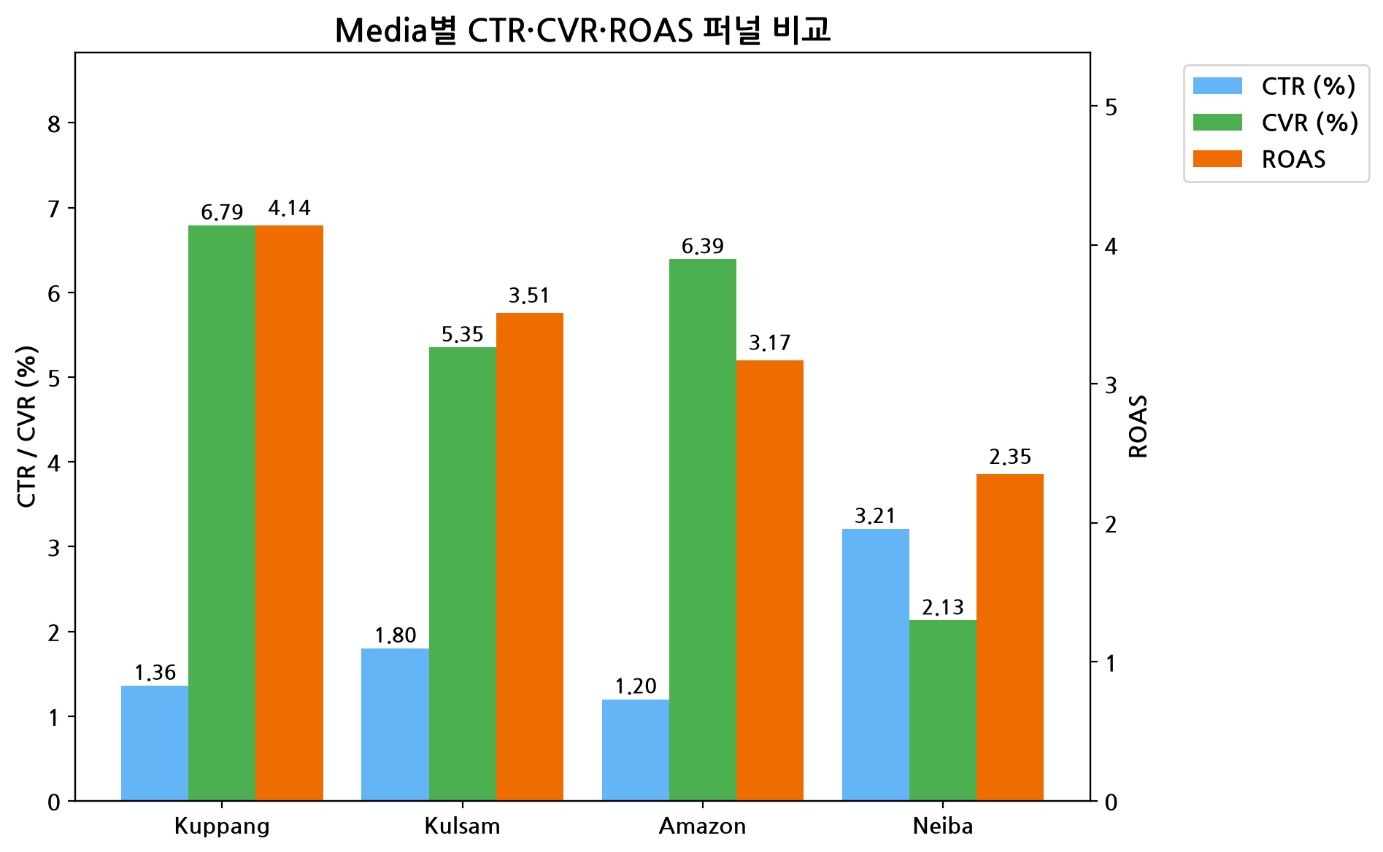
Figure 5: CTR, CVR and ROAS comparison by media channel against the blended baseline.
Neiba shows a distinctive HIGH-CTR / LOW-CVR pattern: CTR of 3.21% [7] is nearly double the blended baseline, but CVR of 2.13% [9] is less than half the baseline of 4.67% [10] . Because the ads are clearly earning clicks, this points to a post-click problem — landing page relevance, price presentation or checkout friction — not a creative or targeting problem. Kuppang shows the opposite signature: a below-baseline CTR of 1.36% [27] paired with an above-baseline CVR of 6.79% [11] , which is why it achieves the best ROAS (4.14 ) despite attracting fewer clicks per impression. Amazon follows a similar low-CTR/high-CVR pattern (CTR 1.20% [28] , CVR 6.39% [29] ), with its ROAS varying sharply by category — excellent in Health Food (8.41 [4] ) but much weaker in Convenience Food, which caps its overall channel ROAS at 3.17 [30] .

Saturation and Headroom Check
To determine whether underperforming channels are simply starved of spend (headroom) or whether efficiency degrades further with more spend (saturation), the correlation between daily spend and daily ROAS was tested per channel.
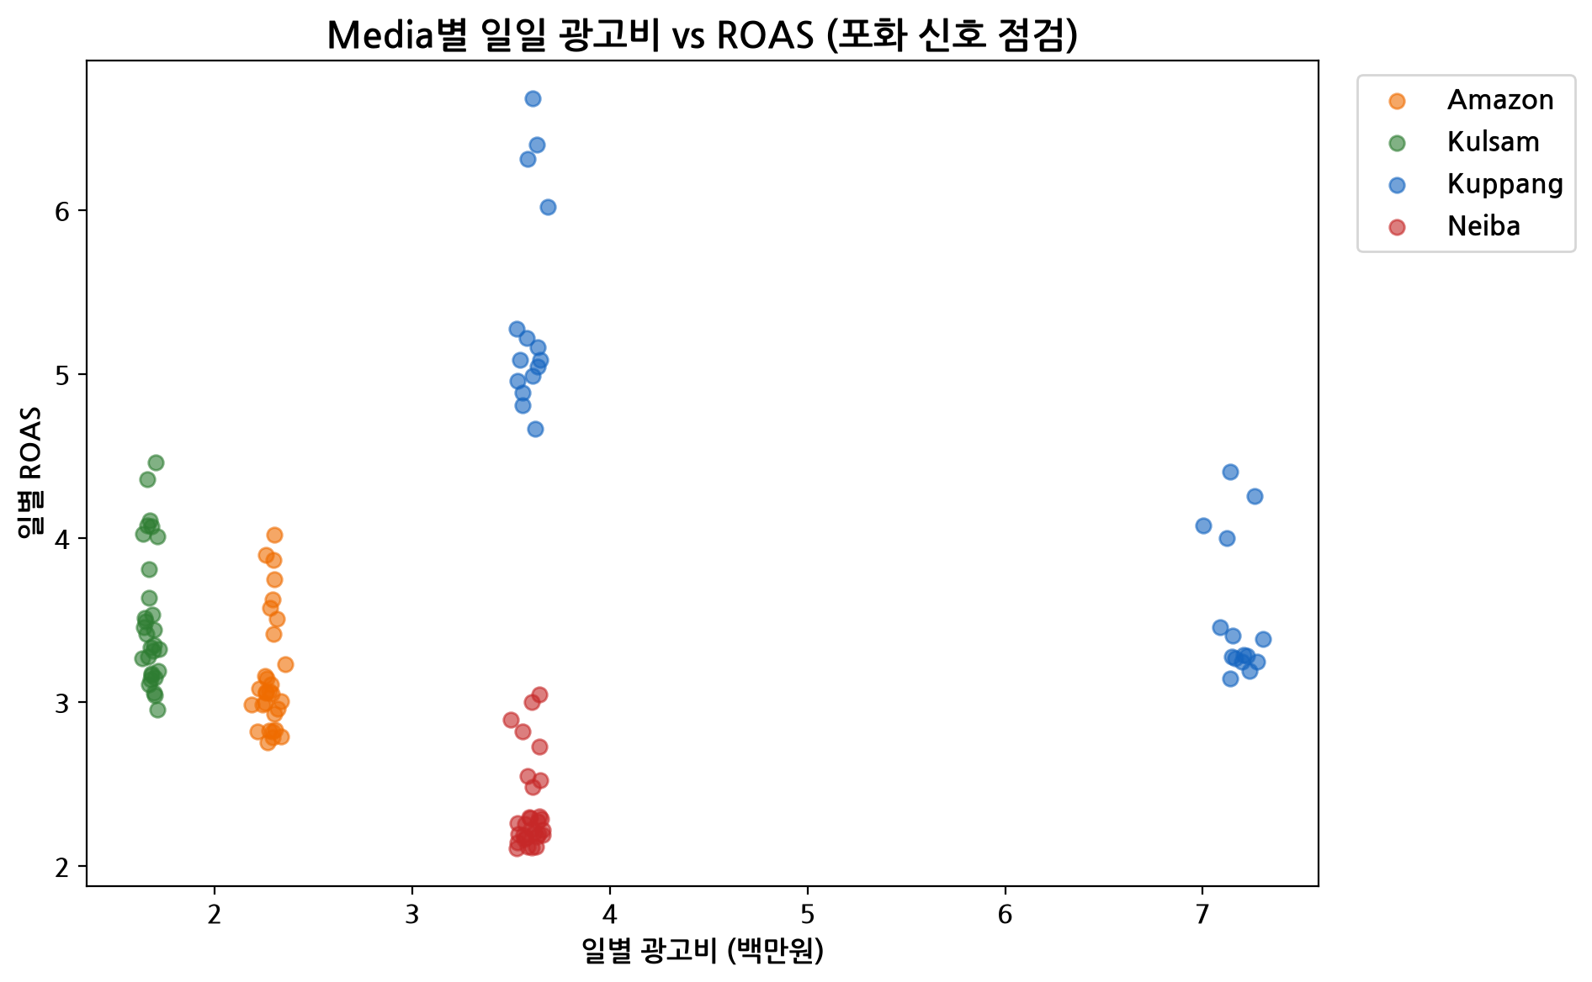
Figure 6: Daily ad spend vs. daily ROAS by media channel, testing for saturation (negative correlation) or headroom (no correlation).
Kuppang shows a strong negative correlation between daily spend and daily ROAS (-0.868 [31] , statistically significant), indicating diminishing returns at higher daily spend levels — a genuine saturation signal that caps how aggressively Kuppang's budget can be scaled. Neiba, in contrast, shows a negligible correlation (0.018 [32] , not statistically significant), which confirms Neiba's low ROAS is not a function of how much is spent day to day — it is structurally capped by its low conversion rate, reinforcing the funnel diagnosis above rather than a simple under/over-spend story.

Where Spend Works vs. Where It Is Wasted
This section quantifies, in KRW terms, how much of the budget is efficiently deployed and how much is relatively wasted, and checks whether the picture changes over the course of the month.

Temporal Pattern Check
Before quantifying waste, it is worth confirming that the inefficiency is structural rather than a one-off calendar effect.
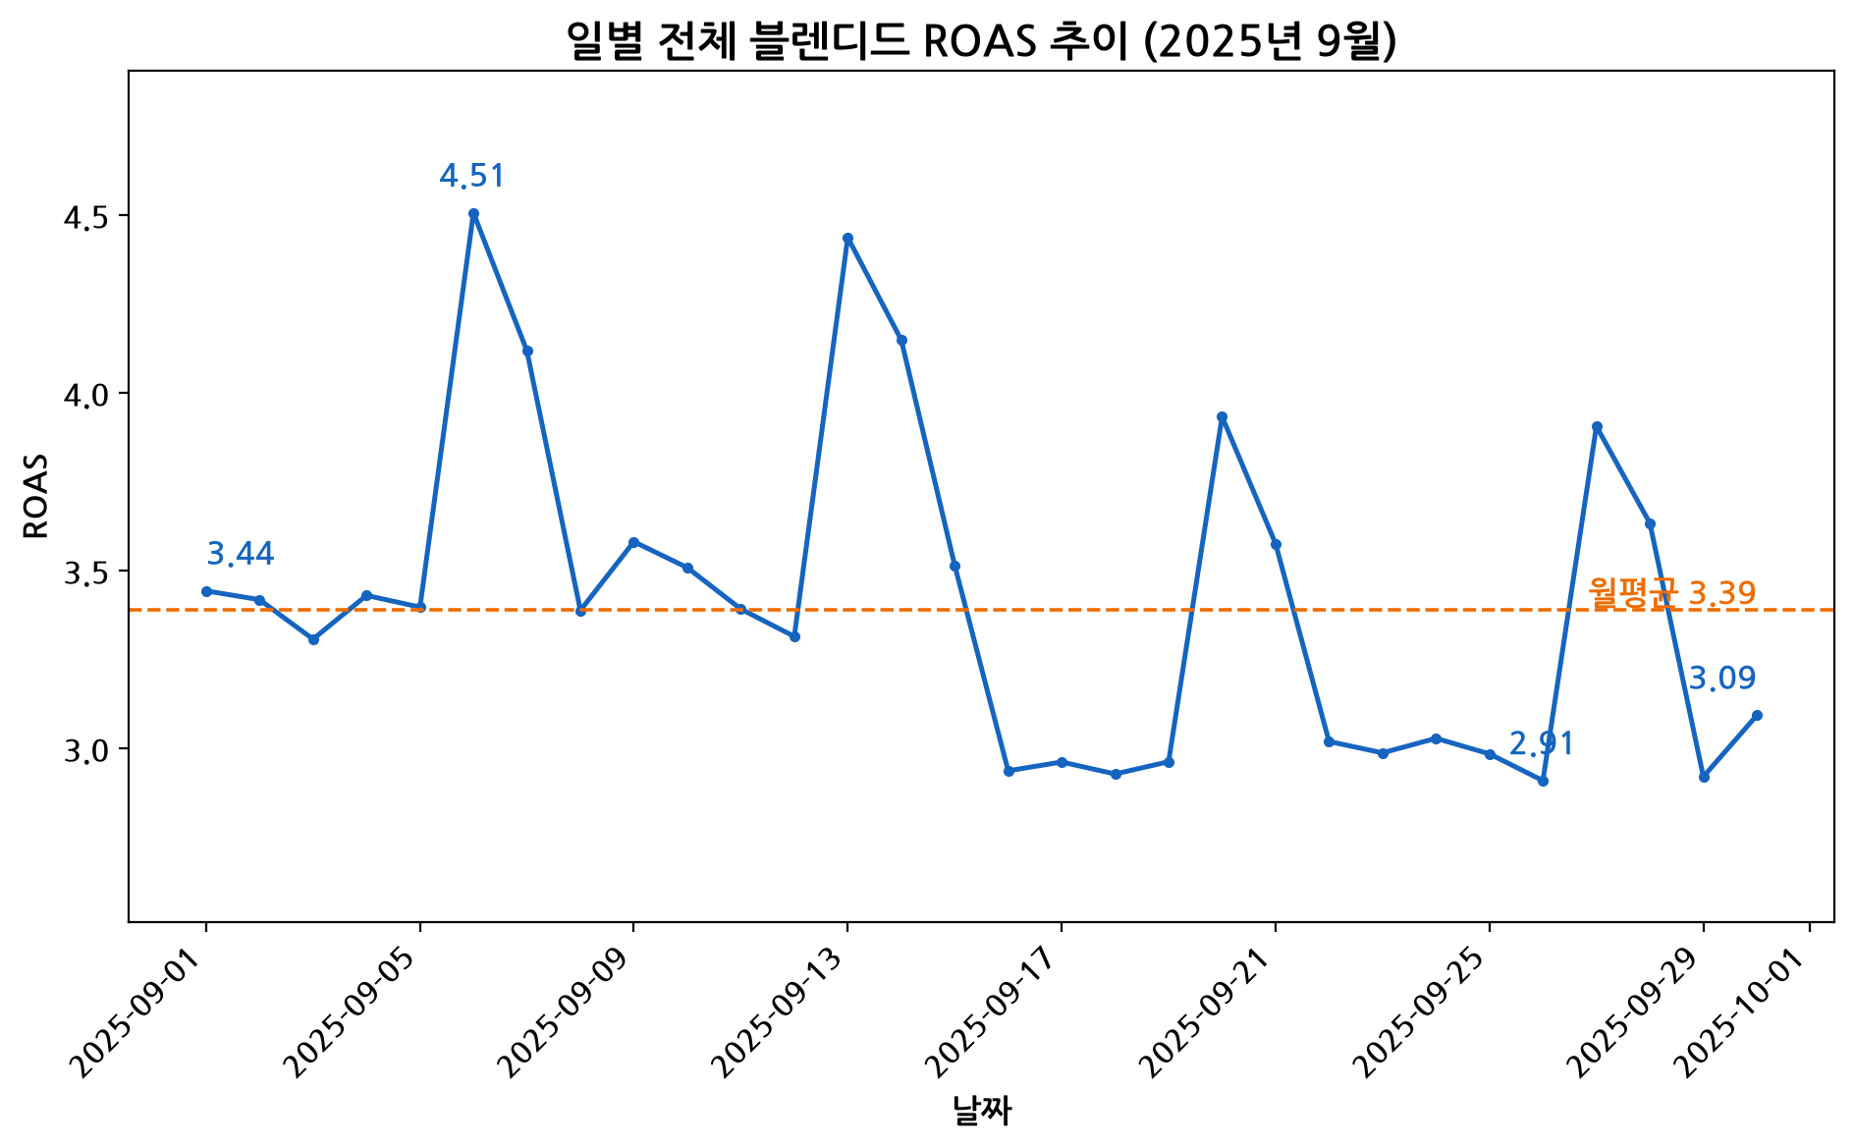
Figure 7: Daily blended ROAS trend across September 2025.
Daily blended ROAS ranged from 2.91 to 4.51 across the month with no material trend: the first-half average (3.66) was close to the second-half average (3.19), showing the variation is day-to-day noise around a stable level rather than a drift driven by seasonality or calendar effects. This supports treating the channel-level inefficiency identified above as structural (a channel/product mix issue) rather than a timing issue.

Quantifying Wasted / Under-Allocated Spend
Breakeven (ROAS = 1.0) is cleared by every one of the 720 rows in the dataset — there are zero row-level instances of spend producing a true loss. 'Waste' in this dataset is therefore not spend that loses money outright, but spend that earns a lower return than it could if redeployed — an opportunity cost against the blended ROAS baseline of 3.39 [13] , and this framing distinction is carried through the strategies below.
Metric | Value
Rows below true breakeven (ROAS < 1.0) | 0 / 720
Spend in channels below blended ROAS baseline (Neiba + Amazon) | 176,375,000 KRW
Underperforming spend as % of total spend | 45.42%
Best-performing channel ROAS (Kuppang) | 4.14
Blended ROAS of top-2 media (Kuppang + Kulsam) | 3.99
Neiba total spend | 107,925,000 KRW [33]
Revenue upside if Neiba reaches blended ROAS (3.39 [13]) | 112,282,325 KRW [34]
Revenue upside if Neiba reaches top-2-media ROAS (3.99 [26]) | 177,176,012 KRW
In total, 176,375,000 KRW — 45.42% [3] of the entire monthly budget — sits in Neiba and Amazon, the two channels performing below the blended ROAS baseline. Neiba alone represents 107,925,000 KRW [33] of spend; optimizing it to merely the blended baseline (ROAS 3.39 [13] ) would unlock an estimated 112,282,325 KRW [34] in additional revenue at the same spend level, while optimizing it to the top-2-media level (ROAS 3.99 [26] ) would unlock 177,176,012 KRW . These figures anchor the three strategies proposed in the next section, each of which captures a different, achievable slice of this upside.

Proposed Strategies to Improve Ad Spend Efficiency
Three strategies are proposed, each targeting a distinct, validated inefficiency identified above: channel-level misallocation, a funnel breakdown within a single channel, and an under-funded high-efficiency pocket. Each is specified with a recommended action, target segment, rationale, priority, expected impact, effort/risk, and the metrics to monitor during rollout.

Strategy 1: Reallocate Spend from Neiba to Kuppang/Kulsam
This strategy captures the largest and most immediately actionable upside by moving budget within the existing total spend, requiring no incremental investment.
Recommended Action | Shift 50% of Neiba's monthly ad budget (53,962,500 KRW [39] ) into Kuppang and Kulsam, in proportion to their current spend split, keeping total portfolio spend unchanged.
Target Media | From: Neiba (ROAS 2.35 [16] ). To: Kuppang + Kulsam (blended ROAS 3.99 [26] ).
Rationale | Neiba is the lowest-ROAS channel (2.35 [16] ) and consumes 27.79% [5] of spend while returning only 19.27% [6] of revenue — a -8.52pp share gap. Kuppang and Kulsam together achieve a blended ROAS of 3.99 [26] , the strongest pairing in the portfolio. Moving money from a 2.35x channel to a 3.99x channel at the same total spend mechanically raises blended revenue.
Priority | HIGH
Expected Impact | Approximately +88,607,181 KRW [40] in net revenue at the same total spend level (no budget increase required).
Effort / Risk | Low-to-medium effort (budget reallocation within existing channel relationships, no new creative or landing page work). Risk: reallocating too aggressively or too quickly could run into short-term delivery/auction constraints on Kuppang and Kulsam; a phased 50% shift (rather than 100%) mitigates this.
Success Metrics to Monitor | Weekly blended ROAS; Kuppang/Kulsam incremental spend absorption rate and ROAS stability as volume increases (watch for the same saturation signal seen in Kuppang's -0.868 spend-ROAS correlation); Neiba's residual ROAS after the cut.

Strategy 2: Fix Neiba's Post-Click Funnel
Rather than treating Neiba purely as budget to be cut, this strategy addresses the root cause behind its low ROAS, since its traffic quality (CTR) is actually strong.
Recommended Action | Run A/B tests on Neiba-specific landing pages, price presentation and checkout flow to close the gap between Neiba's conversion rate (2.13% [9] ) and the blended baseline (4.67% [10] ). Target CVR: 4.67% [10] .
Target Media/Category | Neiba, all categories, with priority on Convenience Food and Fresh Food where Neiba's category-level ROAS is weakest (2.49 and 2.36 respectively per the media x category breakdown).
Rationale | Neiba's CTR (3.21% [7] ) is nearly double the blended baseline, proving the ads themselves attract strong click interest — the problem is not creative or targeting. Its CVR (2.13% [9] ) is less than half the baseline (4.67% [10] ), which is a post-click symptom (landing page relevance, price display, or checkout friction) rather than a traffic-quality problem.
Priority | MEDIUM
Expected Impact | Lifting Neiba's CVR to the blended baseline (4.67% [10] ) at current click volume would add an estimated 302,400,680 KRW [41] in revenue with no change in spend — the largest single upside figure in this report, though it depends on successful landing-page/checkout optimization rather than a simple budget shift.
Effort / Risk | Medium-to-high effort (requires UX/landing-page design, pricing-presentation testing, and a structured A/B testing program over multiple weeks). Risk: CVR gains from funnel fixes are typically incremental rather than immediate, and the full 302,400,680 KRW [41] upside should be treated as a ceiling, not a guaranteed near-term result.
Success Metrics to Monitor | Neiba conversion rate (weekly), Neiba ROAS, landing-page bounce/exit rate, checkout completion rate, A/B test statistical significance before rolling out winning variants broadly.

Strategy 3: Scale Up Amazon x Health Food
This strategy targets the most efficient but most under-funded pocket identified in the cross-dimensional analysis, converting proven high efficiency into incremental revenue.
Recommended Action | Double the Amazon x Health Food budget from 3,594,000 KRW [12] to 7,188,000 KRW, while monitoring ROAS closely as spend scales.
Target Media/Category | Amazon x Health Food (covering Protein Bar and Omega-3 within the Amazon channel).
Rationale | Amazon x Health Food is the single best-performing media x category combination in the dataset, with a ROAS of 8.41 [4] — more than double the blended baseline of 3.39 [13] — yet it receives less than 1% of total ad spend. This is a textbook under-funded high-efficiency pocket.
Priority | MEDIUM-HIGH
Expected Impact | Even under a conservative assumption that ROAS moderates to 70% of its current extreme level as spend scales (a standard diminishing-returns adjustment), the incremental 3,594,000 KRW [12] of spend is estimated to generate approximately 21,154,420 KRW [42] in incremental revenue (implied ROAS ~5.89), the smallest of the three upside estimates in absolute KRW terms but the highest implied ROAS of any strategy.
Effort / Risk | Low effort (a straightforward budget increase within an existing, already-proven channel x category pairing). Risk: the current ROAS of 8.41 is measured on a very small spend base (3,594,000 KRW [12] ), so it is statistically the least stable of the segments analyzed and could regress toward the Amazon channel average (3.17 [30] ) as volume scales — hence the conservative 70%-moderation assumption built into the impact estimate.
Success Metrics to Monitor | Amazon x Health Food ROAS at each spend-doubling step (scale gradually rather than in one jump); Amazon channel overall ROAS (3.17 [30] ) as a floor/sanity check; incremental CPA and CPC as volume increases.

Implementation Roadmap
The three strategies are sequenced to deliver the fastest, lowest-risk wins first, while longer-lead-time funnel work runs in parallel rather than blocking the budget reallocation.
Phase | Timeline | Action | Owner Focus
Phase 1  (Weeks 1-2) | Immediate | Begin Strategy 1: shift an initial 25% of Neiba's budget into Kuppang/Kulsam; begin Strategy 3: increase Amazon x Health Food spend by a smaller first increment (e.g. +50%) rather than a full doubling, to validate ROAS holds at scale. | Media buying / paid media team
Phase 2  (Weeks 2-4) | Short-term | Complete the remaining shift to the full 50% Neiba-to-Kuppang/Kulsam reallocation (Strategy 1) if Phase 1 results hold; launch first A/B test for Neiba landing page and price presentation (Strategy 2). | Media buying + UX/CRO team
Phase 3  (Weeks 4-8) | Medium-term | Iterate on Neiba funnel A/B tests (Strategy 2); complete the second increment of Amazon x Health Food scale-up toward the full doubling (Strategy 3) if ROAS remains above the Amazon channel floor of 3.17 [30]. | UX/CRO team + media buying
Phase 4  (Month 2+) | Ongoing | Re-run the full media/category/product analysis monthly to re-rank channels, confirm Neiba's CVR has moved toward the 4.67% [10] target, and re-evaluate reallocation and scale-up decisions with fresh data. | Analytics / marketing leadership
This phased approach deliberately avoids a one-time 100% budget swing on either Neiba (to protect against unforeseen delivery effects) or Amazon x Health Food (to validate that its exceptional ROAS of 8.41 is not simply an artifact of its very small current spend base before committing the full incremental budget).

Limitations and Assumptions
Two methodology-level qualifications, flagged during independent validation, should be kept in mind when acting on the figures in this report.
- Waste definition: 'Wasted spend' in this report is defined as relative inefficiency against the blended ROAS baseline (3.39 [13] ), not spend that generates an absolute loss. Every one of the 720 rows in the dataset clears true breakeven (ROAS = 1.0), so the 45.42% [3] underperforming-spend figure and the strategy upside estimates represent opportunity cost — foregone incremental revenue from a better allocation — rather than money that was lost outright. This is a valid capital-allocation framing, but it should not be read as evidence that any channel is unprofitable.
- Breakeven definition: Breakeven ROAS = 1.0 is margin-unadjusted, because no COGS or gross-margin field exists in the dataset or column_definitions.json. A margin-adjusted breakeven (ROAS = 1 / gross margin %) would be a stricter and more financially accurate threshold; all breakeven and 'profitability' statements in this report should be read as revenue-based, not margin-based.
- Attribution: All revenue figures are ad-attributed revenue as recorded in the source dataset. The analysis assumes this attribution is already last-touch or platform-reported and consistent across media channels; no cross-channel attribution modeling (e.g., multi-touch) was performed, so channel comparisons assume each platform's attributed revenue is directly comparable to the others.
- Threshold scope: No minimum-spend or minimum-impression exclusion was applied at the product level because the dataset is a complete, balanced grid (4 media x 6 products x 30 days, no missing combos); this may not hold for future datasets with sparser coverage, in which case a minimum-spend threshold should be reintroduced.
- Saturation estimates: the spend-ROAS correlation analysis is based on only 30 daily observations per channel within a single month; the Kuppang saturation signal (-0.868 [31] ) and Neiba's lack of correlation (0.018 [32] ) describe within-month variation only and should be re-validated with additional months of data before being treated as a permanent channel ceiling.

References
[1] Total ad spend over Sep 2025 (KRW): SUM(Ad Cost)
[2] Total ad-attributed revenue over Sep 2025 (KRW): SUM(Revenue)
[3] Underperforming media spend as % of total ad spend: underperforming_media_spend / SUM(Ad Cost) * 100
[4] Amazon x Health Food combo ROAS (current, highly efficient): SUM(Revenue)/SUM(Ad Cost) WHERE Media=Amazon AND Category=Health Food
[5] Neiba share of total ad spend (%): SUM(Ad Cost for Media)/SUM(Ad Cost total)*100
[6] Neiba share of total ad-attributed revenue (%): SUM(Revenue for Media)/SUM(Revenue total)*100
[7] Neiba CTR (%): SUM(Clicks)/SUM(Impressions)*100 grouped by Media
[8] Fresh Food category CTR (%): SUM(Clicks)/SUM(Impressions)*100 grouped by Category
[9] Neiba conversion rate (%): SUM(Conversions)/SUM(Clicks)*100 grouped by Media
[10] Target CVR for Neiba if lifted to blended-baseline CVR (%): SUM(Conversions)/SUM(Clicks)*100 across all media
[11] Kuppang conversion rate (%): SUM(Conversions)/SUM(Clicks)*100 grouped by Media
[12] Proposed incremental ad spend (KRW) to double Amazon x Health Food budget: Amazon_HealthFood Ad Cost * (2.0 - 1)
[13] Blended overall ROAS across all 720 rows: SUM(Revenue)/SUM(Ad Cost)
[14] Kuppang share of total ad-attributed revenue (%): SUM(Revenue for Media)/SUM(Revenue total)*100
[15] Kuppang share of total ad spend (%): SUM(Ad Cost for Media)/SUM(Ad Cost total)*100
[16] Neiba ROAS: SUM(Revenue)/SUM(Ad Cost) grouped by Media
[17] Fresh Food category ROAS: SUM(Revenue)/SUM(Ad Cost) grouped by Category
[18] Health Food category ROAS: SUM(Revenue)/SUM(Ad Cost) grouped by Category
[19] Convenience Food category ROAS: SUM(Revenue)/SUM(Ad Cost) grouped by Category
[20] Premium Fruit product ROAS: SUM(Revenue)/SUM(Ad Cost) grouped by Product
[21] Frozen Dumplings product ROAS: SUM(Revenue)/SUM(Ad Cost) grouped by Product
[22] Lowest-ROAS Media x Category combo: Neiba x Health Food: SUM(Revenue)/SUM(Ad Cost) grouped by Media,Category
[23] Ad spend on lowest-ROAS combo: Neiba x Health Food (KRW): SUM(Ad Cost) grouped by Media,Category
[24] Highest-ROAS Media x Product combo: Amazon x Premium Fruit: SUM(Revenue)/SUM(Ad Cost) grouped by Media,Product
[25] Ad spend on lowest-ROAS Media x Product combo: Neiba x Protein Bar (KRW): SUM(Ad Cost) grouped by Media,Product
[26] Blended ROAS of top-2 media by ROAS (Kuppang, Kulsam): SUM(Revenue of top-2 media)/SUM(Ad Cost of top-2 media)
[27] Kuppang CTR (%): SUM(Clicks)/SUM(Impressions)*100 grouped by Media
[28] Amazon CTR (%): SUM(Clicks)/SUM(Impressions)*100 grouped by Media
[29] Amazon conversion rate (%): SUM(Conversions)/SUM(Clicks)*100 grouped by Media
[30] Amazon ROAS: SUM(Revenue)/SUM(Ad Cost) grouped by Media
[31] Correlation between daily ad spend and daily ROAS for Kuppang: CORR(daily Ad Cost, daily ROAS) WHERE Media=Kuppang
[32] Correlation between daily ad spend and daily ROAS for Neiba: CORR(daily Ad Cost, daily ROAS) WHERE Media=Neiba
[33] Neiba total ad spend (KRW): SUM(Ad Cost) WHERE Media=Neiba
[34] Estimated revenue upside (KRW) if Neiba's spend were reallocated/optimized to blended-ROAS efficiency: Neiba Ad Cost * blended ROAS - Neiba Revenue
[35] Blended overall CPC (KRW): SUM(Ad Cost)/SUM(Clicks)
[36] Blended overall CPA (KRW): SUM(Ad Cost)/SUM(Conversions)
[37] Premium Fruit total ad spend over Sep 2025 (KRW): SUM(Ad Cost) grouped by Product
[38] Salad Kit total ad spend over Sep 2025 (KRW): SUM(Ad Cost) grouped by Product
[39] Ad spend amount proposed to reallocate from Neiba to Kuppang/Kulsam (50% of Neiba's spend): Neiba Ad Cost * 0.5
[40] Estimated net revenue impact (KRW) of Strategy 1 reallocation, same total spend: realloc_amounttop2_media_blended_ROAS - realloc_amountNeiba_ROAS
[41] Estimated revenue upside (KRW) if Neiba's CVR were lifted to blended baseline (4.67%) at current click volume: Neiba Clicks blended CVR Neiba AOV - Neiba Revenue
[42] Conservative estimated incremental revenue (KRW) from doubling Amazon x Health Food spend, assuming ROAS moderates to 70% of current extreme level at scale: incremental_spend (current_ROAS 0.7)

