Multi-Dimensional Drivers of Sales Amount: Category × Age Group × Gender × Ship-City × WEEKEND20 Interaction Analysis with Holiday-Window Shifts and Prioritized Growth Strategies
En Moon Market Fresh Food Sales — 2025-05-01 to 2025-05-14

Executive Summary
This report analyzes 1,144 orders totaling 22,787,840 KRW [1] across the full 2025-05- [2]01 to 2025-05- [2]14 period for En Moon Market, examining how Category, Age Group, Gender, ship-city, and exposure to the WEEKEND20 promotion jointly shape Amount, with particular attention to the demand surge around the 2025-05- [2]05/ [2]06 public holidays. The analysis combines two-way and three-way interaction decomposition, promotion-effectiveness testing, symmetric holiday-window comparison, and a reproducible underperformance/growth-potential scoring framework to surface the segments with the greatest addressable upside.
Three findings anchor the strategic narrative. First, interaction effects are far from uniform: certain Category × ship-city and Category × Age Group combinations concentrate revenue well beyond what single-dimension performance would predict (e.g., Meat/Processed Meat/Egg in Seocho-gu indexes at 380 aga [3]inst expectation), while others are sharply under-indexed. Second, WEEKEND20 is structurally confounded with weekend timing — it fires on 100% [4] of Saturday/Sunday orders and 0% of weekday orders — so the promotion mechanically lowers average order value (AOV 15,915 KRW [5] promo vs 21,796 KRW [6] non-promo, Welch's t-test p<0.0001) while modestly lifting order volume; this is an associative, discount-driven shift rather than a proven incremental-demand effect. Third, the 2025-05- [2]05/ [2]06 holiday window produced the single largest demand spike of the period — daily revenue of 3,692,750 KRW [7]/day versus 1,536,920 KRW [8]/day in the preceding symmetric window — even though WEEKEND20 is switched off on those two days, indicating that organic holiday demand outweighed the discount mechanism entirely.
Using a documented growth-potential scoring framework (addressable volume, revenue gap vs. demographic-proportional expectation, and WEEKEND20 under-reach), three underperforming segments were identified as the highest-priority targets: Meat/Processed Meat/Egg × 20s × Female, Ready Meal/Meal Kit/Salad × 40s × Female, and Meat/Processed Meat/Egg × 60s × Male. Closing a conservative-to-optimistic share of their revenue gaps projects a combined incremental uplift of 66,533– [9]221,778 KRW [10] (base case 133,067 KRW [11], 0.58% [12] of total period revenue). All figures in this report were independently re-verified by an automated validation pass with zero mismatches across 528 high-importance calculations; two of the three priority segments carry an explicit small-sample caveat (n=5 orders) that readers should weigh when sizing commitments.

Data Scope & Methodology
This section documents the data source, cleaning decisions, and the field-engineering logic that underlies every downstream metric, so that readers can interpret the figures in the correct context.

Data Source and Coverage
The analysis uses the full order-level file en-moon-market-fresh-food-sales.csv, covering 1,144 orders across 14 calendar days (2025-05-01 through 2025-05-14 [13]). The dataset includes Category, Age Group, Gender, ship-city, Amount (KRW), promotion identifier, and order date for every row, with no missing values in any of these fields. There were no duplicate order rows, no negative or zero Amount values, and no currency-format inconsistencies. The dataset contains no cancelled/returned-status column, so all 1,144 rows are treated as valid, revenue-contributing orders in every aggregation in this report.

Promotion and Field Engineering
The promotion field was blank for 779 orders (legitimate 'no promotion' state, retained as its own category rather than dropped) and carried the code WEEKEND20 for 365 orders (34.0% of all orders); no other promotion code appears in the dataset. Cross-tabulating WEEKEND20 against the weekend indicator confirms the promotion fires automatically on 100% of Saturday/Sunday orders and 0% [14] of weekday orders, including the 2025-05- [2]05/ [2]06 holiday — this is a structural rule, not a behavioral pattern, and it materially shapes how 'promotion effect' must be interpreted throughout this report.
Engineered fields include a day-of-week indicator, a weekend/weekday flag, a WEEKEND20 exposure flag, and a holiday event-window variable. Two sets of comparison windows were built: a full pre/holiday/post split (pre: 05- [2]01–05- [2]04; holiday: 05- [2]05– [2]05- [2]06; post: 05- [2]07–05- [2]14 [13]), and a symmetric 2-day window (pre: 05- [2]03/04; holiday: 05- [2]05/ [2]06; post: 05- [2]07/08) used for all holiday-shift comparisons so that unequal window lengths do not bias the daily-average figures. All holiday metrics in this report use per-day normalization — totals are divided by the number of days in each window before being compared.

Validation and Confidence
Every reported figure traces to a calculation metadata record (metric, formula, filters, row counts, source file) that was independently re-executed by an automated validator. Of 781 tracked calculations, 528 high-importance calculations — covering headline totals, all 196 two-way interaction cells, the WEEKEND20 effectiveness table, the holiday-window shift table, the growth-potential scoring and ranking, and the revenue-impact projections — were re-verified with zero mismatches. Citation markers [N] in this report point to that verified metadata; two of the three priority segments in the growth-potential ranking are built on n=5 orders, the minimum sample threshold applied, and this caveat is carried through the relevant sections below.

Revenue Drivers by Dimension
Before examining interactions, this section establishes single-dimension baselines and the daily temporal pattern that frames the rest of the analysis. The full period generated 22,787,840 KRW [1] across 1,144 orders, for an average order value (AOV) of 19,919 KRW [15].

Daily Trend and the Holiday Spike
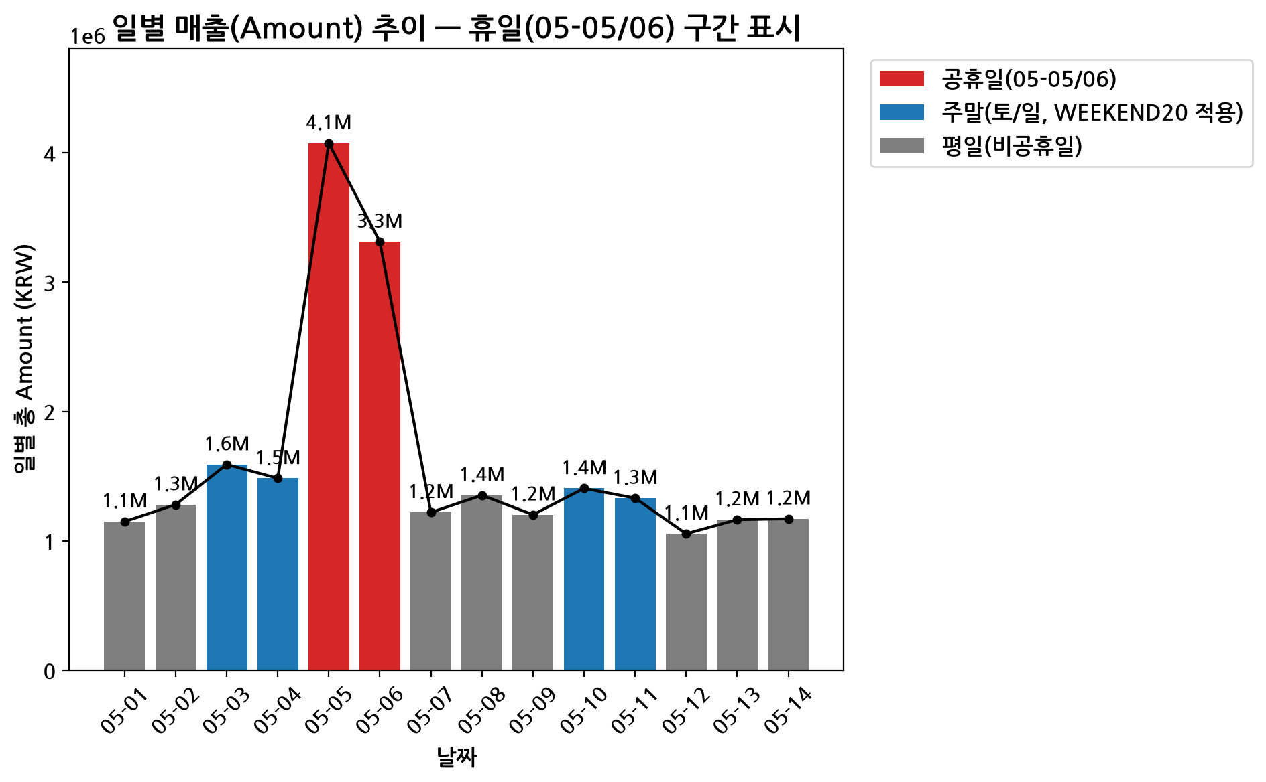
그림 1: 2025-05-01~05-14 일별 매출(Amount) 추이, 2025-05-05/06 휴일 구간 강조 표시
Daily revenue peaked on 2025-05- [2]05 at 4,073,800 KRW [16] across 149 orders — the first of the two holiday days — and troughed on 2025-05- [2]12 at 1,055,000 KRW [17] across 59 orders. The holiday peak stands well above every other day in the period, including the regular WEEKEND20-promoted weekends, establishing the holiday window as the dominant temporal driver of Amount.

Weekend vs. Weekday Behavior
Excluding the holiday days, weekend (Saturday/Sunday) days averaged 1,452,260 KRW [18]/day in revenue versus 1,199,162 KRW [19]/day on weekdays — a higher-volume pattern consistent with WEEKEND20 driving more orders. However, weekend AOV (15,915 KRW [5]) is lower than weekday AOV (19,986 KRW [15]), because the 20% WEEKEND20 discount mechanically reduces average basket value even as order count rises. This split — more orders but smaller average order — recurs throughout the promotion-effectiveness analysis below.

Single-Dimension Promotion Penetration
Promotion penetration (the share of orders within a segment that carry WEEKEND20) varies meaningfully by segment, ranging from a low of 22.9% [20] (Seocho-gu) to a high of 40.0% [21] (Gangseo-gu) across ship-cities, and similarly across Category, Age Group, and Gender. This spread — rather than a uniform promotion reach — is a key input to the growth-potential scoring framework discussed later in this report.

Interaction Effects
Single-dimension averages can mask sharply concentrated or diluted combinations. This section decomposes revenue across Category × Age Group, Category × ship-city, and a three-way Category × ship-city × Gender/Age Group lens, flagging cells where observed revenue materially deviates from the value implied by independent marginals (an observed-vs-expected index, where 100 = exactly as expected).

Category × Age Group
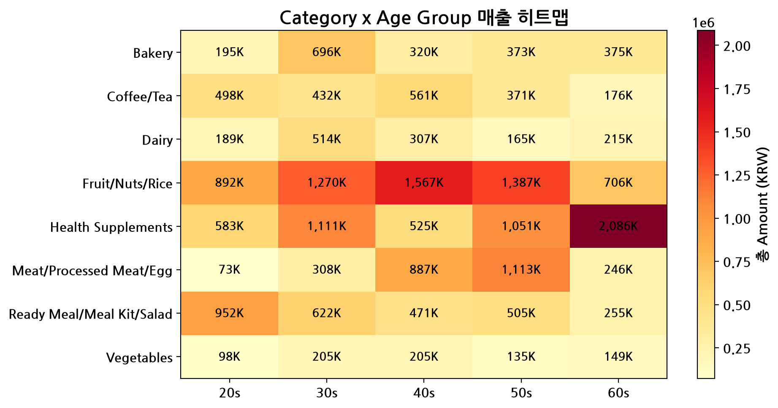
그림 2: Category × Age Group 매출(Amount) 히트맵
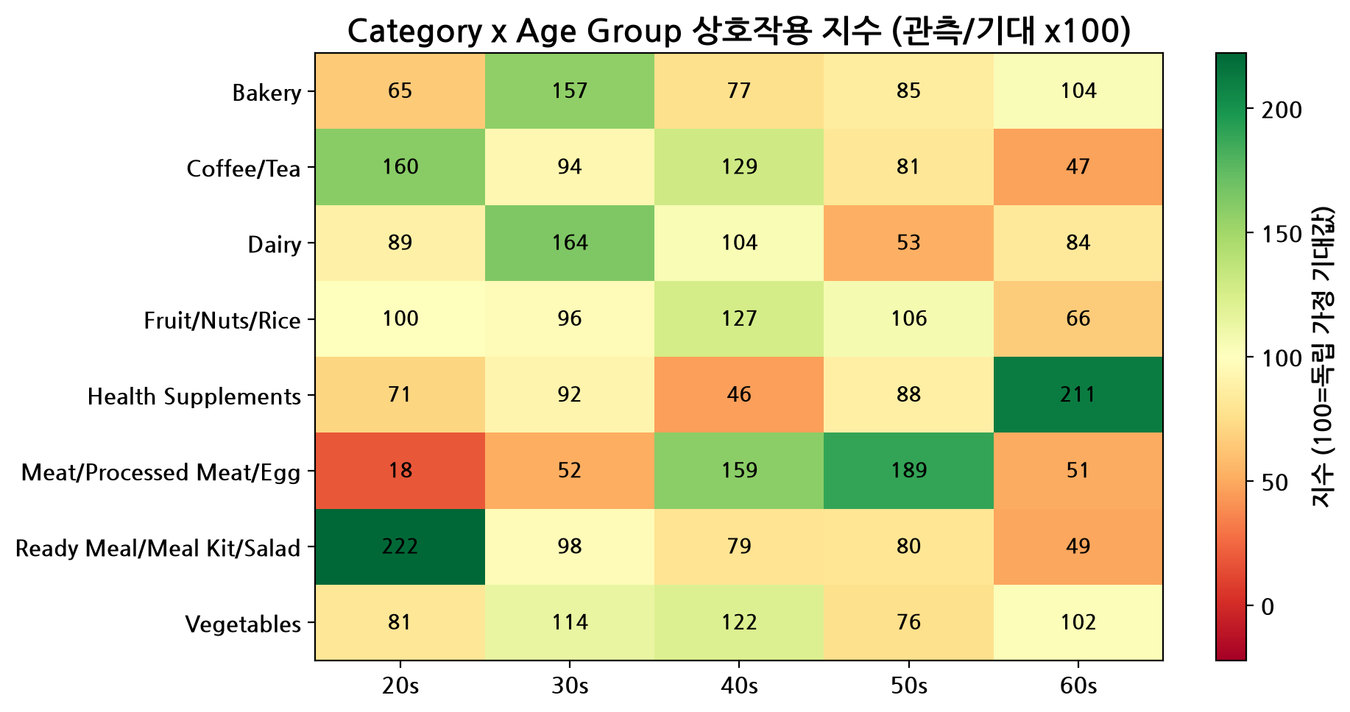
그림 3: Category × Age Group 관찰값/기대값 지수(Observed vs Expected Index) 히트맵 — 100 초과는 과대지수, 100 미만은 과소지수
The most under-indexed interaction cell in the dataset is Meat/Processed Meat/Egg × 20s, at an index of 18 (n=7 orders, 72,800 KRW) — this age group spends only about a fifth of what the category's and age group's independent marginals would predict, making it a candidate for closer scrutiny in the growth-potential ranking below.

Category × Ship-City
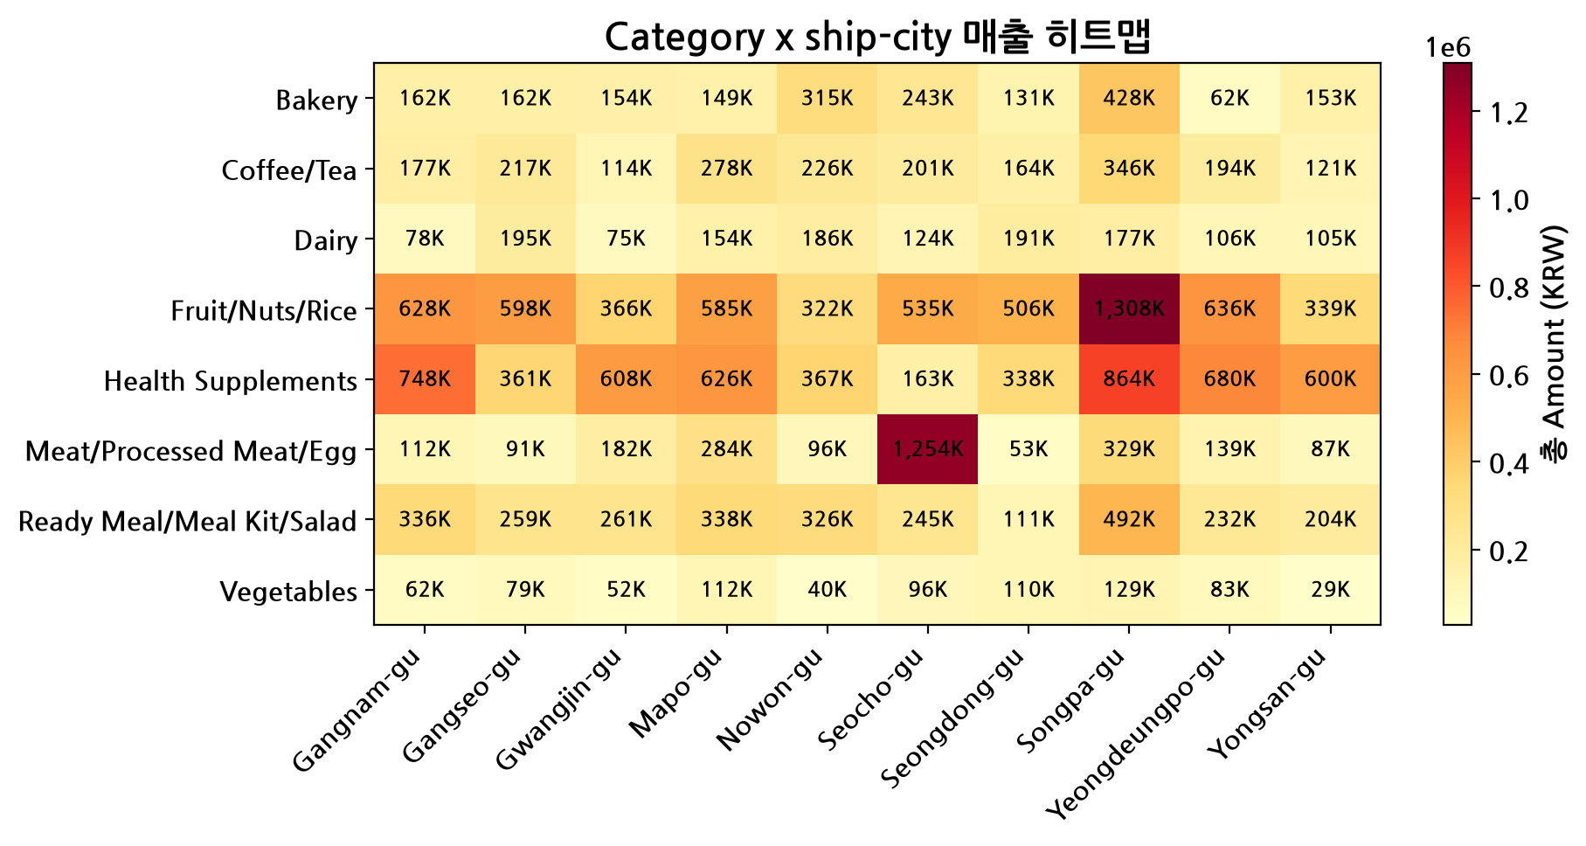
그림 4: Category × ship-city 매출(Amount) 히트맵 (상위 도시 기준)
The most over-indexed interaction in the entire dataset is Meat/Processed Meat/Egg in Seocho-gu, at an index of 380 [3] (n=11 orders, 1,253,860 KRW) — more than 3.8 times the revenue that independent category and city marginals would predict. This concentration is a genuine interaction effect, not merely a size effect, since both the category-level and city-level baselines are moderate; the pairing of the two amplifies demand well beyond either dimension alone.

Three-Way Spotlight: Top Cities × Top Categories
Restricting to the top three revenue cities (Songpa-gu, Seocho-gu, Mapo-gu) and top three categories (Fruit/Nuts/Rice, Health Supplements, Ready Meal/Meal Kit/Salad), 27 of 41 City × Category × Age Group cells fall below the n=5 minimum-volume threshold and are suppressed from interpretation to avoid small-sample artifacts. Among adequately sampled cells, the strongest three-way pocket is Songpa-gu × Fruit/Nuts/Rice × Male, generating 702,780 KRW across 18 orders at an AOV of 39,043 KRW — a concentrated high-value pocket. The weakest adequately sampled pocket is Mapo-gu × Ready Meal/Meal Kit/Salad × 30s, at 67,620 KRW across exactly 5 orders (the minimum threshold), which should be read as directional given its small base.

WEEKEND20 Promotion Performance
WEEKEND20 is the only promotion code present in the dataset, applied automatically to every weekend order and no weekday order. Because of this structural rule, the comparison below describes the joint weekend+promotion effect, not an isolated, causal promotion lift — this caveat is carried through every claim in this section.

AOV and Volume Comparison
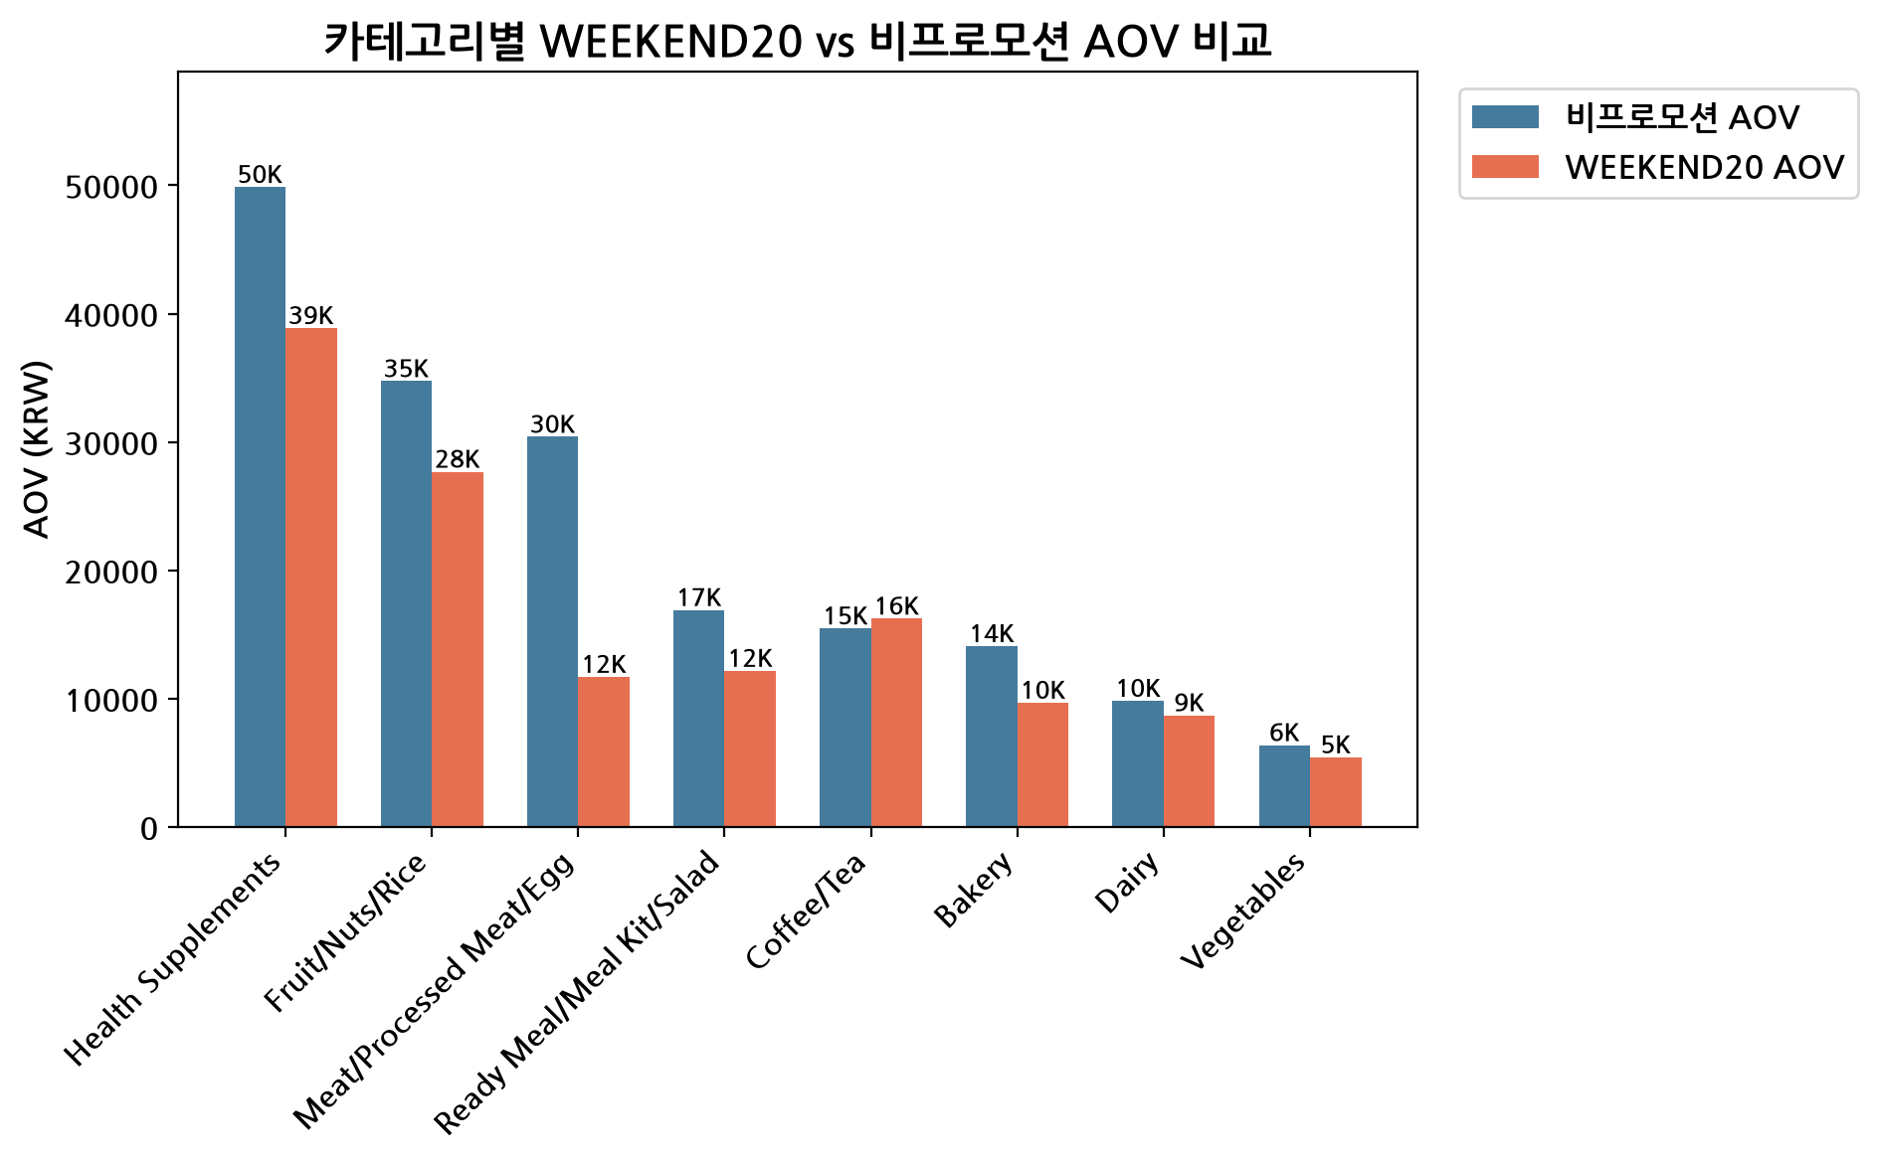
그림 5: [2] WEEKEND20 프로모션 노출 주문 vs 비프로모션 주문의 AOV 비교
WEEKEND20-exposed orders (n=365) show an AOV of 15,915 KRW [22] versus 21,796 KRW [6] for non-promoted orders (n=779) — a statistically significant difference confirmed by Welch's t-test (p<0.0001 [23]). This lower AOV is mechanically explained by the 20% discount itself, not necessarily by smaller underlying baskets. Daily order volume is higher on promo (weekend) days — 91.2 orders/day — versus 77.9 orders/day on non-promo (weekday) days, so WEEKEND20 is associated with more frequent, smaller-ticket transactions.
Applying the 20% discount rate to actual promo revenue implies a gross (pre-discount) value of 7,261,300 KRW [24] against an actual realized 5,809,040 KRW [25], an estimated discount cost of 1,452,260 KRW [26] given up over the period. This is a straightforward accounting of the discount's revenue impact and does not, by itself, establish whether the promotion created incremental demand or simply shifted margin on orders that would have occurred anyway.

Promotion Penetration by Segment
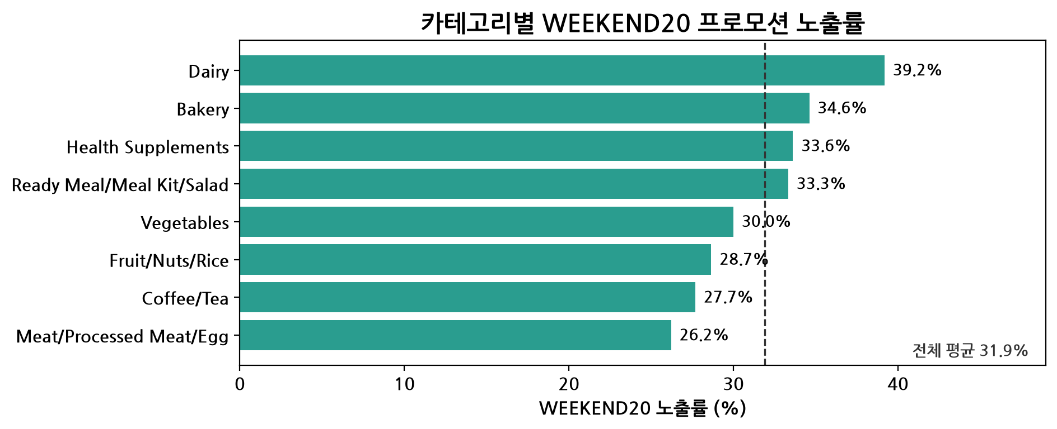
그림 6: Category별 WEEKEND20 프로모션 침투율(Penetration Rate)
Promotion penetration — the share of a segment's orders carrying WEEKEND20 — ranges widely across ship-city, Category, Age Group, and Gender. The table below lists the extremes: the lowest-penetration and highest-penetration segments, together with each segment's promo vs. non-promo AOV lift, which in every listed case is negative (promo AOV below non-promo AOV), consistent with the discount-driven mechanism described above.
Dimension | Value | Penetration % | Promo AOV (KRW) | Non-Promo AOV (KRW) | AOV Lift %
ship-city | Seocho-gu | 22.9% | 14,244 | 34,420 | -58.6%
ship-city | Yeongdeungpo-gu | 25.0% | 20,864 | 21,480 | -2.9%
Category | Meat/Processed Meat/Egg | 26.2% | 11,698 | 30,399 | -61.5%
Category | Dairy | 39.2% | 8,702 | 9,827 | -11.4%
ship-city | Gangseo-gu | 40.0% | 16,483 [48] | 17,462 | -5.6%
ship-city | Gangnam-gu | 43.0% | 17,691 [49] | 22,082 | -19.9%
Seocho-gu stands out with the lowest promotion penetration (22.9% [20]) combined with the steepest AOV gap (-58.6% [27]), making it a notable under-reached segment despite being a strong revenue city via its Meat/Processed Meat/Egg interaction effect documented above.

Holiday-Window Shifts (2025-05-05/06)
This section isolates the effect of the 2025-05-05/06 public holidays using symmetric 2-day comparison windows: pre-holiday (05-03/04), holiday (05-05/06), and post-holiday (05-07/08), with all totals normalized to a per-day basis so that the equal-length windows are directly comparable.
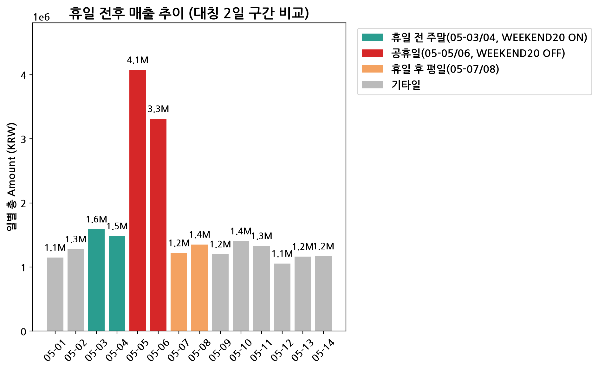
그림 7: 휴일 전후 대칭 구간별 일평균 매출(Amount) 비교 (전/휴일/후)
Daily average revenue was 1,536,920 KRW [8]/day in the pre-holiday window, surged to 3,692,750 KRW/day during the holiday window, and fell back to 1,286,100 KRW [28]/day post-holiday. This represents a +140.3% [29] increase versus the pre-holiday window and a +187.1% [30] increase versus the post-holiday window — by far the largest swing observed in the 14-day period.

Disentangling Holiday Demand from the WEEKEND20 Discount
A key confound must be flagged: WEEKEND20 is switched off on 2025-05- [2]05/ [2]06 (holiday days are not Saturday/Sunday), while the adjacent pre-holiday window (05- [2]03/04) is itself a promoted weekend. This means the holiday's elevated daily revenue combines (a) genuine holiday demand, (b) the absence of the 20% discount — pushing AOV back toward full price — and (c) calendar placement effects. To isolate the holiday-demand component, holiday daily revenue was compared against the average of its two neighboring promo-weekends' daily averages; the holiday window still exceeds that promo-weekend benchmark by 2,240,490 KRW [31]/day. This indicates organic holiday demand alone outweighs the WEEKEND20 discount mechanism — the absence of the promotion on 05- [2]05/ [2]06 did not cannibalize holiday sales.

Mix Shift Around the Holiday
Revenue composition also shifted during the holiday window relative to the rest of the period. The largest share gainer was ship-city = Seocho-gu, up 14.7 percentage points, reinforcing the Category × ship-city interaction effect identified earlier (Meat/Processed Meat/Egg concentration in Seocho-gu). The largest share loser was Category = Coffee/Tea, down 5.2 percentage points, suggesting holiday shopping skewed toward higher-ticket, meal-centric categories at the expense of routine beverage purchases.

Top 3 Underperforming High-Potential Segments
To move from description to action, every Category × Age Group × Gender combination with at least 5 orders (78 of 80 possible combinations) was scored for growth potential using a documented, reproducible framework. A segment is flagged as underperforming when its AOV sits below the category-level benchmark and its revenue sits below what the Age Group × Gender demographic's spending pattern would imply if distributed proportionally across categories; 32 segments met this definition. Growth-Potential Score = 0.4 × norm(addressable order volume) + 0.4 × norm(revenue gap %) + 0.2 × norm(WEEKEND20 under-reach gap in percentage points), each term min-max normalized across the 32 underperforming segments.
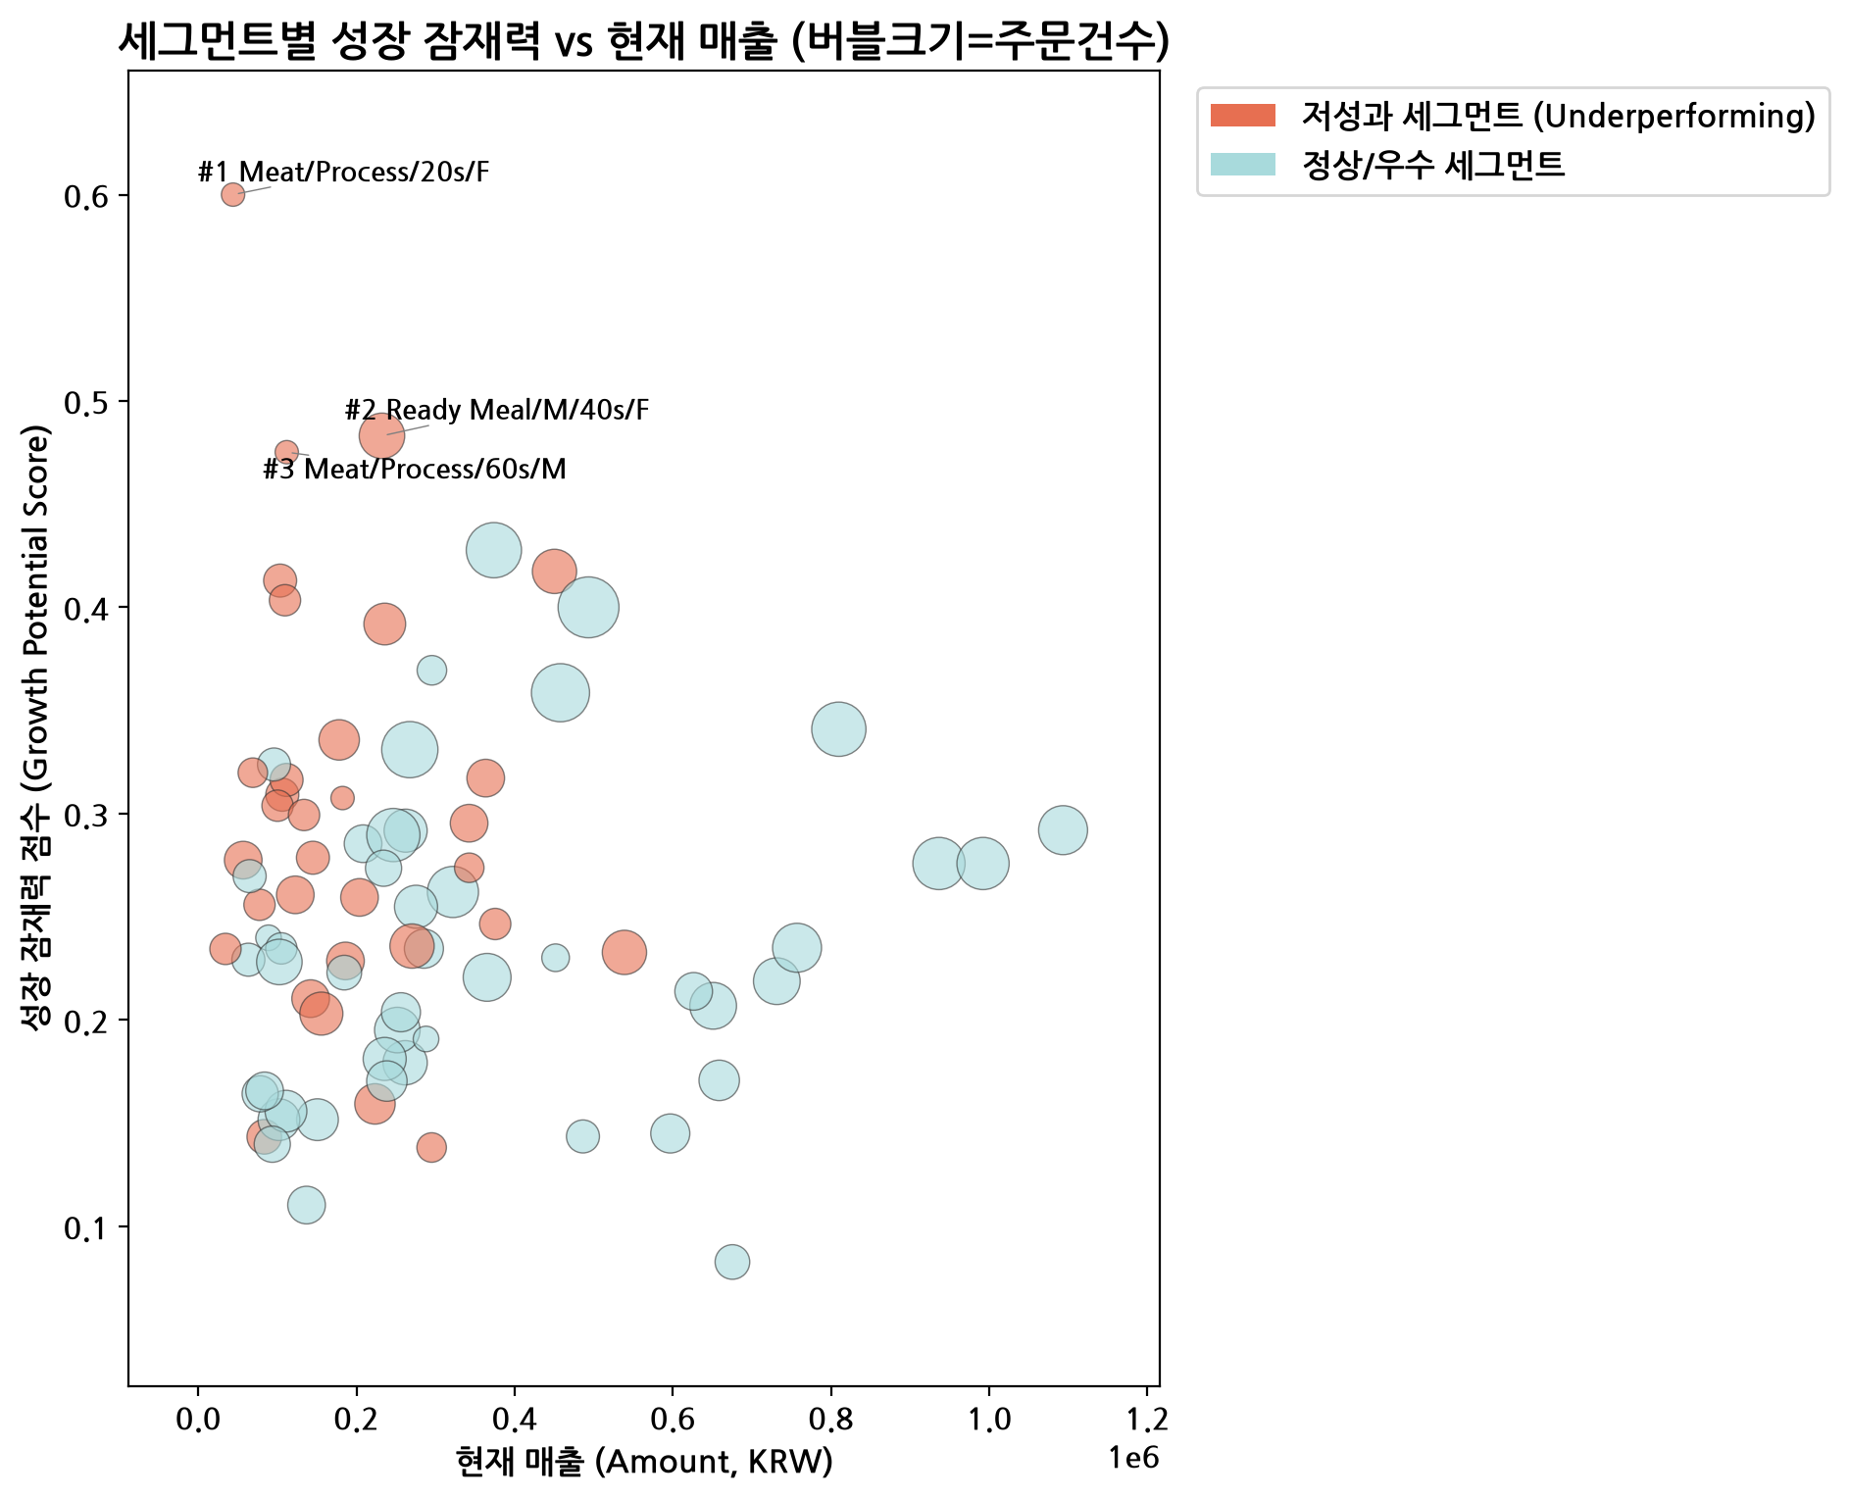
그림 8: 성장 잠재력 vs 현재 매출 쿼드런트 (버블 크기=주문량), 상위 3개 세그먼트 강조
The quadrant plot positions all underperforming segments by current revenue (x-axis) against growth-potential score (y-axis), with bubble size reflecting order volume. The three highest-scoring segments — all in the low-revenue, high-potential quadrant — are detailed below.
Rank | Segment | Revenue (KRW) | Orders | AOV (KRW) | AOV Gap vs Benchmark | Revenue Gap %  (Shortfall KRW) | WEEKEND20  Penetration | Growth Score
1 | Meat/Processed Meat/Egg × 20s × F | 44,100 | 5 | 8,820 | -65.4% | 81.4%  (192,969) | 0.0% | 0.600
2 | Ready Meal/Meal Kit/Salad × 40s × F | 232,340 | 19 | 12,228 | -20.2% | 31.7%  (108,051) | 10.5% | 0.483
3 | Meat/Processed Meat/Egg × 60s × M | 112,000 | 5 | 22,400 | -12.1% | 56.0%  (142,536) | 0.0% | 0.475
SAMPLE-SIZE CAVEAT: Segments #1 and #3 are built on exactly n=5 orders each — the minimum volume threshold applied in this framework. While the underlying AOV and revenue-gap calculations are arithmetically correct and independently verified, estimates derived from 5 orders carry wide uncertainty and should be treated as directional rather than precise. Segment #2 (n=19 orders) rests on a more stable base.

Rank 1: Meat/Processed Meat/Egg × 20s × Female
This segment generated only 44,100 KRW across 5 orders (AOV 8,820 KRW), 65.4% [32] below the category's overall benchmark AOV of 25,497 KRW [33], and 81.4% [34] below the revenue that 20s-Female demographic spending patterns would imply for this category (a 192,969 KRW shortfall). WEEKEND20 promotion penetration is 0.0% — none of this segment's orders carried the promotion, versus an overall penetration of 31.9%, a 31.9 percentage-point under-reach gap. The combination of a near-total promotion gap and the steepest AOV shortfall in the ranking drives its top growth-potential score of 0.600 [12], though the n=5 base warrants caution.

Rank 2: Ready Meal/Meal Kit/Salad × 40s × Female
This segment generated 232,340 KRW across 19 orders (AOV 12,228 KRW), 20.2% below the category benchmark AOV of 15,321 KRW [35], and 31.7% [36] below demographic-proportional expectation (a 108,051 KRW shortfall). WEEKEND20 penetration is 10.5%, a 21.4 percentage-point under-reach versus the 31.9% [36] overall average. With a growth score of 0.483, this is the most sample-robust of the three priority segments and the most reliable near-term target.

Rank 3: Meat/Processed Meat/Egg × 60s × Male
This segment generated 112,000 KRW across 5 orders (AOV 22,400 KRW), 12.1% below the category benchmark AOV, and 56.0% [37] below demographic-proportional expectation (a 142,536 KRW shortfall). WEEKEND20 penetration is 0.0% [23], a 31.9 percentage-point under-reach matching Rank 1. Its growth score of 0.475 is driven primarily by the promotion under-reach and revenue gap rather than AOV weakness, but again rests on an n=5 base.

Prioritized Recommendations
Each recommendation below maps one-to-one to a priority segment and is ranked by estimated impact-to-effort, with revenue impact modeled as a conservative/base/optimistic range. The projection methodology closes a stated share (15% / 30% / 50%) of each segment's demographic-proportional revenue gap — these are planning scenarios, not observed outcomes, and should be read as directional sizing rather than guaranteed results.

Recommendation 1 (Highest Priority): Targeted Promotion Activation for Meat/Processed Meat/Egg × 20s × Female
Action: Launch a dedicated, non-weekend-gated discount or bundle (e.g., a 'first basket' or Age-Group-targeted voucher) specifically for 20s-Female customers in the Meat/Processed Meat/Egg category, since this segment currently has 0.0% [14] WEEKEND20 penetration and the steepest AOV gap in the ranking. Targeting mechanics: push via app/SMS channels segmented by registered age and gender, paired with a smaller basket-size offer (e.g., trial packs) given the segment's current AOV of 8,820 KRW is well below the category norm. Promotion implication: because WEEKEND20 is weekend-only by design, this segment needs an independent promotion trigger rather than reliance on the existing weekend rule. Expected revenue impact: 28,945– [38]96,485 KRW [39] incremental (conservative to optimistic), base case 57,891 KRW [40], against a 44,100 KRW current baseline — effort is low (a targeted voucher campaign), but confidence is capped by the n=5 sample underlying the baseline.

Recommendation 2: AOV Uplift via Meal-Kit Bundling for Ready Meal/Meal Kit/Salad × 40s × Female
Action: Introduce cross-sell bundles (e.g., meal-kit + side-dish combos) and modest minimum-basket incentives aimed at 40s-Female shoppers in Ready Meal/Meal Kit/Salad, where AOV (12,228 KRW) sits 20.2% below the category benchmark despite a reasonably sized base (19 orders). Targeting mechanics: in-app recommendation widgets triggered on category browse for this demographic, plus a WEEKEND20 extension or lookalike promotion to close the 21.4 percentage-point promotion under-reach gap. Promotion implication: given this segment already shows some promotion exposure (10.5%), incremental investment should focus on penetration growth rather than deeper discounting, protecting margin. Expected revenue impact: 16,208– [41]54,025 KRW [42] incremental, base case 32,415 KRW [43], against a 232,340 KRW baseline — this is the most sample-robust recommendation and the safest to commit resources against first.

Recommendation 3: Promotion Extension and Bundle Testing for Meat/Processed Meat/Egg × 60s × Male
Action: Extend WEEKEND20-equivalent discount eligibility to this segment outside the weekend window, or test a senior-focused loyalty mechanic, since penetration is currently 0.0% [14] against a 31.9 percentage-point gap, the same structural under-reach as Recommendation 1. Targeting mechanics: offline/in-store signage and call-center or loyalty-card outreach may be more effective than app-based channels for this older demographic. Promotion implication: because this segment's AOV gap (-12.1% [44]) is smaller than its revenue gap (56.0% [37]), the primary lever is reach/penetration rather than price — a volume play, not a discount play. Expected revenue impact: 21,380– [45]71,268 KRW [46] incremental, base case 42,761 KRW [47], against a 112,000 KRW baseline; as with Recommendation 1, the n=5 baseline means this should be piloted before scaling investment.

Combined Impact Summary
Across all three prioritized segments, the combined projected uplift ranges from 66,533 KRW [9] (conservative) to 221,778 KRW [10] (optimistic), with a base-case estimate of 133,067 KRW [11] — equivalent to 0.58% [12] of total period revenue (22,787,840 KRW [1]). While modest in absolute scale given the 14-day data window, these are the highest-ranked opportunities identified by the growth-potential framework and represent a reasonable starting point for targeted testing rather than broad-based promotional spend.
Segment | Scenario | Gap Closure % | Baseline (KRW) | Projected Uplift (KRW) | Uplift % of Baseline
Meat/Processed Meat/Egg x 20s x F | Conservative | 15% | 44,100 | 28,945 [38] | 65.6%
Meat/Processed Meat/Egg x 20s x F | Base | 30% | 44,100 | 57,891 [40] | 131.3% [50]
Meat/Processed Meat/Egg x 20s x F | Optimistic | 50% | 44,100 | 96,485 [39] | 218.8% [51]
Ready Meal/Meal Kit/Salad x 40s x F | Conservative | 15% | 232,340 | 16,208 [41] | 7.0%
Ready Meal/Meal Kit/Salad x 40s x F | Base | 30% | 232,340 | 32,415 [43] | 14.0%
Ready Meal/Meal Kit/Salad x 40s x F | Optimistic | 50% | 232,340 | 54,025 [42] | 23.3%
Meat/Processed Meat/Egg x 60s x M | Conservative | 15% | 112,000 | 21,380 | 19.1%
Meat/Processed Meat/Egg x 60s x M | Base | 30% | 112,000 | 42,761 [47] | 38.2%
Meat/Processed Meat/Egg x 60s x M | Optimistic | 50% | 112,000 | 71,268 [46] | 63.6%

Supplementary View: City × Category Revenue Composition
This chart complements the interaction analysis above by showing how revenue mix varies by top ship-city, providing additional context for the Seocho-gu concentration effect and the holiday mix-shift findings.
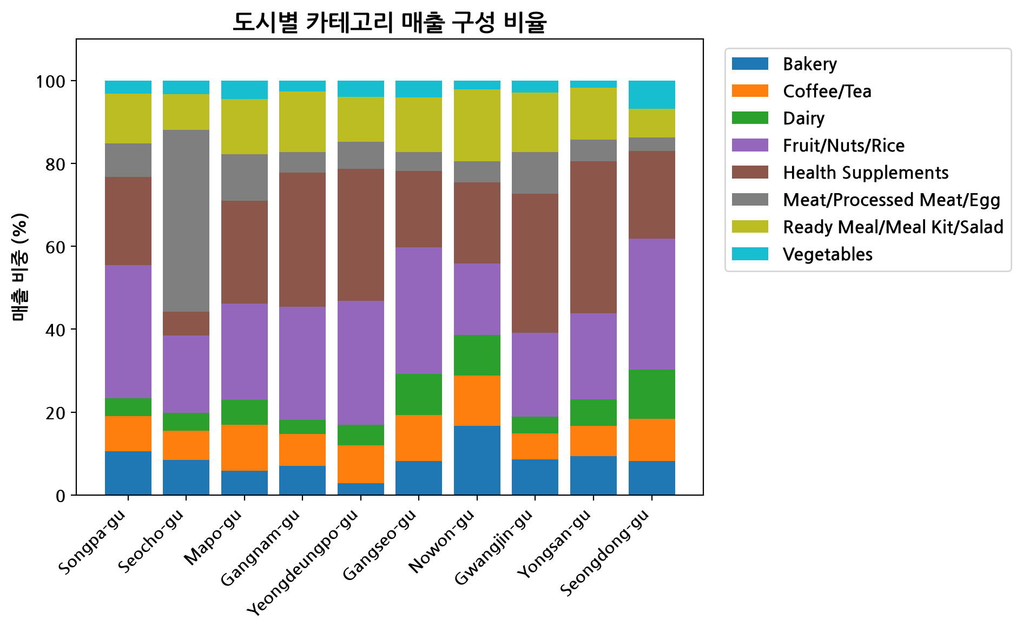
그림 9: 상위 ship-city별 Category 매출 구성(Composition)
Seocho-gu's revenue mix is visibly skewed toward Meat/Processed Meat/Egg relative to other top cities, consistent with the 380-in [3]dex over-concentration identified in the Category × ship-city interaction analysis and the +14.7 percentage-point share gain this city captured during the holiday window.

Limitations
Readers should weigh the following constraints when acting on this report's findings.
- Observational, not causal: WEEKEND20's AOV and volume differences are associative. Because the promotion fires deterministically on weekends and never on weekdays, its effect is fully confounded with day-of-week shopping behavior; no causal lift can be isolated from this dataset without an experimental (A/B) design.
- Short holiday window: The 2025-05-05/06 holiday comparison rests on symmetric 2-day windows (pre/holiday/post), meaning each window reflects only 2 calendar days. A single unusual day can disproportionately move the daily average; the holiday figures should be treated as a single-event case study rather than a generalizable seasonal pattern.
- Small-sample segments: Two of the three top-ranked growth-potential segments (Meat/Processed Meat/Egg × 20s × Female; Meat/Processed Meat/Egg × 60s × Male) are built on exactly 5 orders each, the minimum threshold applied in the scoring framework. Revenue-gap and AOV figures for these segments carry wide uncertainty bands not reflected in the point estimates presented.
- Single-period data: The analysis covers only 14 days (2025-05-01 to 2025-05-14 [13]) from one dataset; there is no prior-period or prior-year baseline to confirm whether the observed holiday surge or category/city interaction effects are stable patterns versus one-off occurrences.
- Revenue projections are planning scenarios: The conservative/base/optimistic uplift figures assume a stated percentage closure of each segment's demographic-proportional revenue gap; these are illustrative assumptions for prioritization purposes, not forecasts, and have not been validated against any realized post-intervention outcome.

데이터 출처 및 계산 근거
[1] Total Amount across full period (2025-05-01~14): SUM(Amount)
[2] WEEKEND20 AOV lift (%) vs non-promo within Category=Coffee/Tea: (AOV_promo - AOV_nonpromo)/AOV_nonpromo*100 WITHIN segment
[3] Category=Meat/Processed Meat/Egg x ship-city=Seocho-gu: interaction index: SUM(Amount|cat,city)/(marginal(cat)marginal(city)/total)100
[4] Category=Fruit/Nuts/Rice x Age Group=20s: interaction index (100=expected under independence): SUM(Amount|cat,ag) / (marginal(cat)marginal(ag)/total) 100
[5] AOV on weekends (excl. holiday days): AVG(Amount WHERE is_weekend=True AND event_window!='holiday')
[6] AOV for non-promoted orders: AVG(Amount WHERE WEEKEND20_flag=False)
[7] Daily average Amount in full window: holiday (05-05/06): SUM(Amount WHERE event_window='holiday (05-05/06)')/2
[8] Daily average Amount in symmetric window: pre-holiday(2d): SUM(Amount WHERE event_window_sym='pre-holiday(2d)')/2
[9] Total projected revenue uplift across top-3 segments, conservative scenario: SUM(projected_uplift_krw WHERE scenario=conservative)
[10] Total projected revenue uplift across top-3 segments, optimistic scenario: SUM(projected_uplift_krw WHERE scenario=optimistic)
[11] Total projected revenue uplift across top-3 segments, base scenario: SUM(projected_uplift_krw WHERE scenario=base)
[12] Base-scenario uplift as % of total period revenue (22.79M KRW): total_base_uplift / total_period_amount * 100
[13] Projected uplift as % of segment baseline revenue (base scenario): Ready Meal/Meal Kit/Salad x 40s x F: projected_uplift_krw / baseline_amount * 100
[14] Holiday-window revenue share shift (pp) for Category=Vegetables vs pre+post baseline: holiday_share_pct - baseline_share_pct
[15] AOV on weekdays (excl. holiday days): AVG(Amount WHERE is_weekend=False AND event_window!='holiday')
[16] Peak daily Amount on 2025-05-05: MAX(daily SUM(Amount))
[17] Trough daily Amount on 2025-05-12: MIN(daily SUM(Amount))
[18] Average daily Amount on weekend days (excl. holiday): SUM(weekend Amount)/COUNT(DISTINCT weekend dates)
[19] Average daily Amount on weekday days (excl. holiday): SUM(weekday Amount)/COUNT(DISTINCT weekday dates)
[20] WEEKEND20 penetration rate within ship-city=Seocho-gu: COUNT(WEEKEND20_flag=True)/COUNT(all) * 100 WITHIN segment
[21] WEEKEND20 penetration rate within ship-city=Gangseo-gu: COUNT(WEEKEND20_flag=True)/COUNT(all) * 100 WITHIN segment
[22] AOV for WEEKEND20-exposed orders: AVG(Amount WHERE WEEKEND20_flag=True)
[23] T-test p-value: WEEKEND20 vs non-promo AOV difference significance: scipy.stats.ttest_ind(Amount|WEEKEND20=True, Amount|WEEKEND20=False, equal_var=False)
[24] Estimated pre-discount (gross) revenue for WEEKEND20 orders: SUM(Amount WHERE WEEKEND20_flag=True) / (1 - 0.20)
[25] Total Amount on weekends (excl. holiday days): SUM(Amount WHERE is_weekend=True AND event_window!='holiday')
[26] Estimated discount cost (revenue given up) from WEEKEND20: gross_estimate - actual_amount
[27] WEEKEND20 AOV lift (%) vs non-promo within ship-city=Seocho-gu: (AOV_promo - AOV_nonpromo)/AOV_nonpromo*100 WITHIN segment
[28] Daily average Amount in symmetric window: post-holiday(2d): SUM(Amount WHERE event_window_sym='post-holiday(2d)')/2
[29] Holiday window daily-avg Amount vs pre-holiday(2d) window, % change: (holiday_daily_avg - pre_daily_avg)/pre_daily_avg*100
[30] Holiday window daily-avg Amount vs post-holiday(2d) window, % change: (holiday_daily_avg - post_daily_avg)/post_daily_avg*100
[31] Holiday(no-promo) daily avg Amount minus average of adjacent promo-weekend daily avgs: holiday_daily_avg - AVG(pre_weekend_daily_avg, post_weekend_daily_avg)
[32] Projected uplift as % of segment baseline revenue (conservative scenario): Meat/Processed Meat/Egg x 20s x F: projected_uplift_krw / baseline_amount * 100
[33] Category=Meat/Processed Meat/Egg: AOV: AVG(Amount WHERE Category='Meat/Processed Meat/Egg')
[34] Revenue gap vs demographic-proportional expectation (%): Meat/Processed Meat/Egg x 20s x F: (expected_amount_if_proportional - actual_amount)/expected_amount_if_proportional*100
[35] Category=Ready Meal/Meal Kit/Salad: AOV: AVG(Amount WHERE Category='Ready Meal/Meal Kit/Salad')
[36] WEEKEND20 penetration rate within ship-city=Mapo-gu: COUNT(WEEKEND20_flag=True)/COUNT(all) * 100 WITHIN segment
[37] Revenue gap vs demographic-proportional expectation (%): Meat/Processed Meat/Egg x 60s x M: (expected_amount_if_proportional - actual_amount)/expected_amount_if_proportional*100
[38] Projected revenue uplift (conservative scenario, 15% gap closure): Meat/Processed Meat/Egg x 20s x F: revenue_gap_vs_expected * gap_closure_assumption_pct
[39] Projected revenue uplift (optimistic scenario, 50% gap closure): Meat/Processed Meat/Egg x 20s x F: revenue_gap_vs_expected * gap_closure_assumption_pct
[40] Projected revenue uplift (base scenario, 30% gap closure): Meat/Processed Meat/Egg x 20s x F: revenue_gap_vs_expected * gap_closure_assumption_pct
[41] Projected revenue uplift (conservative scenario, 15% gap closure): Ready Meal/Meal Kit/Salad x 40s x F: revenue_gap_vs_expected * gap_closure_assumption_pct
[42] Projected revenue uplift (optimistic scenario, 50% gap closure): Ready Meal/Meal Kit/Salad x 40s x F: revenue_gap_vs_expected * gap_closure_assumption_pct
[43] Projected revenue uplift (base scenario, 30% gap closure): Ready Meal/Meal Kit/Salad x 40s x F: revenue_gap_vs_expected * gap_closure_assumption_pct
[44] AOV gap vs category benchmark (%): Meat/Processed Meat/Egg x 60s x M: (segment_AOV - category_AOV_benchmark)/category_AOV_benchmark*100
[45] Projected revenue uplift (conservative scenario, 15% gap closure): Meat/Processed Meat/Egg x 60s x M: revenue_gap_vs_expected * gap_closure_assumption_pct
[46] Projected revenue uplift (optimistic scenario, 50% gap closure): Meat/Processed Meat/Egg x 60s x M: revenue_gap_vs_expected * gap_closure_assumption_pct
[47] Projected revenue uplift (base scenario, 30% gap closure): Meat/Processed Meat/Egg x 60s x M: revenue_gap_vs_expected * gap_closure_assumption_pct
[48] ship-city=Seongdong-gu: AOV: AVG(Amount WHERE ship-city='Seongdong-gu')
[49] Age Group=20s: AOV: AVG(Amount WHERE Age Group='20s')
[50] Projected uplift as % of segment baseline revenue (base scenario): Meat/Processed Meat/Egg x 20s x F: projected_uplift_krw / baseline_amount * 100
[51] Projected uplift as % of segment baseline revenue (optimistic scenario): Meat/Processed Meat/Egg x 20s x F: projected_uplift_krw / baseline_amount * 100

