Car Design Space Explorer - Demo Guide

Car Design Space Explorer — Demo Guide
A multi-agent AI system for automotive aerodynamic design exploration. Ask natural-language questions about car body designs and get aerodynamic predictions, cost estimates, structural analysis, 3D geometry generation, and flow visualizations — coordinated across five specialized AI agents on Amazon Bedrock AgentCore.
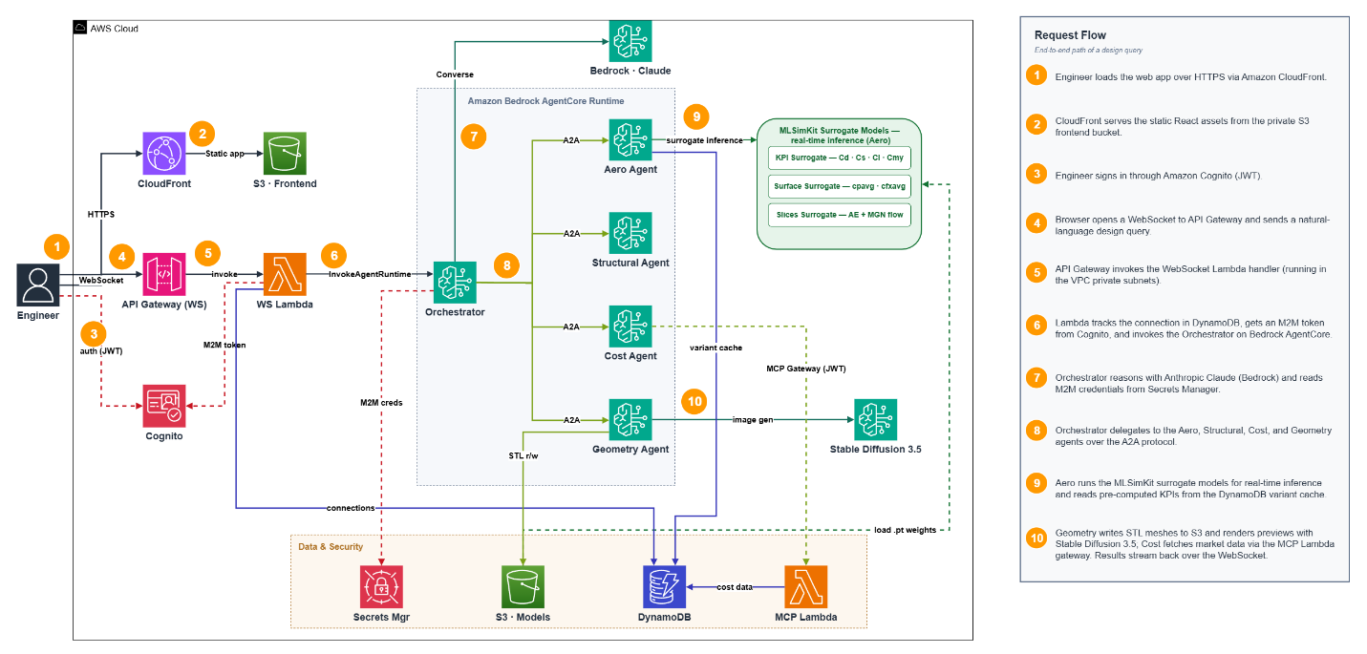
Architecture

1. Access
Open the Frontend URL in a modern browser (Chrome/Edge/Firefox/Safari), sign in with the credentials above, and you’ll land on the chat interface with a 3D viewer panel. (The WebSocket endpoint is used automatically by the app — you don’t need to enter it.)

2. What you can do
The system understands questions about 355 WindsorML car body variants (referenced as run_0 … run_354) plus designs you generate on the fly:
- Aerodynamics — drag (Cd), side force (Cs), lift (Cl), yaw moment (Cmy)
- Ranking & comparison — find or compare the best variants by a metric
- Surface visualization — pressure and friction heatmaps
- Flow visualization — velocity cross-section slices
- Structural — weight, stiffness, feasibility
- Cost — manufacturing cost estimates by material
- Geometry generation — create a parametric car from parameters
- Geometry modification — add a spoiler, mirrors, diffuser, etc.

3. Suggested demo flow (copy-paste prompts)
Run these in order for a smooth first experience. Send one prompt at a time and wait for the full response before sending the next (see Tips below).

A. Rank by aerodynamics (fast, single agent)
Compare the top 5 variants by drag coefficient
Returns a ranked table of the lowest-drag variants.

B. Look at a specific variant
Which variant has the lowest Cd value?

C. Visualize airflow on a known variant
Show the surface pressure heatmap for run_05
The image appears in the viewer panel. (Surface/flow visualization works best on run_N variants, e.g. run_05.)

D. Generate a new design from parameters
Generate a sports car design with these parameters: Ride Height: 0.040m, Diffuser Angle: 12°, Rear Slant: 30°, Front Overhang: 0.750m, Boat Tail Angle: 10°. Ensure it has visible wheels and a defined cabin. What would be the expected aerodynamic performance?
A 3D model is generated and loaded into the viewer, with predicted aero KPIs. Try sedan, SUV, or hatchback instead of sports car for different silhouettes.

E. Full engineering pipeline on a variant
Estimate the manufacturing cost for run_01 using aluminum
This chains structural metrics → cost estimation automatically.

F. Modify a design
Add a rear spoiler to the above design to reduce lift

4. Tips for the best experience
- One question at a time. Wait for a response to finish before sending the next message. Sending several in quick succession on the same session can cross up responses.
- Be patient on multi-step queries. A single ranking is fast (a few seconds); a generate-then-analyze pipeline can take 30–60 seconds as multiple agents collaborate.
- Reference variants by ID (run_0 to run_354) for the pre-computed dataset, or generate your own and refer to it as “the above design.”
- Use the viewer tabs to switch between the 3D model, surface heatmaps, and chat.

5. Good things to try / talking points
- Ask it to explain a tradeoff: “Which has lower drag, run_50 or run_120, and why?”
- Generate then iterate: create a design, then ask to add a spoiler or change a parameter.
- Compare materials: cost in aluminum vs steel for the same variant.
- The aerodynamic numbers come from ML surrogate models (MLSimKit) trained on CFD data — so predictions are near-instant instead of hours of simulation.

6. Known limitations (so nothing surprises you)
- Generated 3D bodies are simplified simulation meshes, not styling models. They look geometric/blocky on purpose — they’re the aerodynamic body used for surrogate prediction, similar to the reference bodies used in automotive CFD.
- Aero values are relative surrogate outputs for comparing designs, not certified production figures.
- Surface/flow visualizations are most reliable on the original run_N variants.
- If a response seems to misfire, start a fresh chat (reload the page) and resend a single query.

7. How it works (one-paragraph version)
Your question goes over a WebSocket to a Lambda, which invokes an Orchestrator agent on Amazon Bedrock AgentCore. The orchestrator routes the request over the A2A protocol to the right specialist(s) — Aero (ML surrogate KPI/flow prediction), Structural, Cost (via an MCP Gateway), and Geometry (parametric STL generation + Amazon Nova Canvas previews) — then synthesizes a single answer with tables, images, and a 3D model. See architecture.png for the full picture.

