# Executive Summary

This executive summary provides an overview of our response to the Request for Proposal (RFP) issued by FrieslandCampina. The purpose of this RFP is to select one of the hyperscalers in the market for the transformation to S/4 with RISE and BTP in the Optimus program. We appreciate the opportunity to present our expertise, capabilities, and solutions to meet your specific requirements.

With ‘’Expedition 2030’’, FrieslandCampina has sharpened its strategy focused on improving profitability and driving sustainable growth in order to strengthen its leading position within the dairy industry. Key elements to execute on this strategy are business group focus combined with a competitive supply chain and lower overhead costs. An improved and enhanced SAP S/4 system aligned to these strategic objectives that enables process improvement, process transformation and new capabilities is needed.

Achieving a clean core will be a key objective in FrieslandCampina’s new S/4 transformation project. SAP BTP services will play a pivotal role in achieving this. AWS offers seamless integration of SAP RISE and BTP services with a wide range of complementary AWS services. At the time of this RFP’s submission, SAP enabled RISE in 32 AWS Regions, and [BTP in 9 AWS Regions](https://discovery-center.cloud.sap/viewServices?regions=all&provider=aws), the most of all hyperscalers. SAP also only deploys all BTP services on AWS. This provides FrieslandCampina with the additional benefit of leveraging the private, secure, low-latency- AWS backbone to consume all SAP BTP services, eliminating the need to connect to any other hyperscaler for BTP services.

We often see with AWS’s customers SAP cloud transformations, that the journey does not end with the transformation itself. Instead, the agility gained during this process is used as a lever to accelerate digital transformation and drive continuous innovation within the organization. [Coca-Cola İçecek](https://aws.amazon.com/solutions/case-studies/coca-cola-icecek/) (CCI), for example, not only saved up to 60% on their SAP infrastructure costs by migrating towards AWS, but also used AWS as a driving force for innovation. For CCI this led to 20% lower energy costs and 6% lower water consumption[1] bringing them closer to their sustainability goals.

In AWS’s response to this RFP we will show the AWS accelerators and best practices that will help FrieslandCampina achieve similar outcomes, enable continuous innovation, optimize supply chain and drive sustainability initiatives using AWS offerings like AWS Supply Chain and AWS Sustainability tools. We have outlined how AWS envisions to co-develop, -innovate and -invest with FrieslandCampina in the Optimus program in order to achieve the transformation objectives.

In the co- investment section, you will find the investment of **$25.000 in credits** for the S/4 transformation and **$2.570.000 in customer cash** (or different capacity when preferred) for the transformation to S/4 with RISE an BTP

In summary, AWS is the ideal hyperscaler partner to support FrieslandCampina in its Optimus program and beyond, providing the necessary technology, expertise, and financial backing to ensure a successful transformation to S/4 HANA with RISE and BTP

We hope you enjoy reading this document, and are happy to provide any additional content per your request.

# Why SAP and SAP customers trust AWS

SAP customers trust AWS to support their mission critical applications because at Amazon we humbly know a thing or two about operating and innovating within a real business at scale.

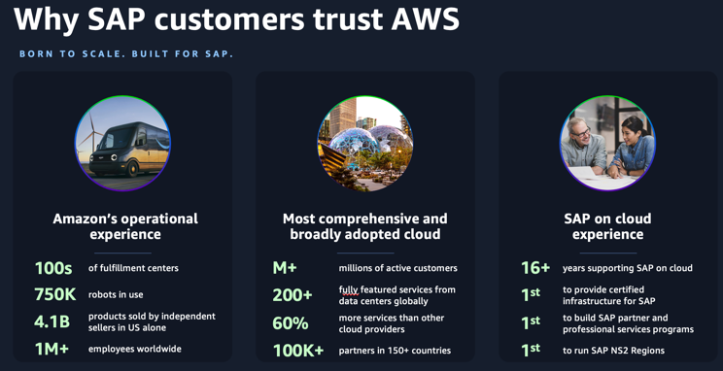

Amazon's flagship Amazon.com business is a prime example of operating at a level of scale and complexity that few have witnessed. Leveraging AWS technologies and the resources of over 1 million employees, 100's of fulfillment centers, and over 750,000 robots, Amazon facilitates billions of financial transactions and delivers billions of packages to satisfied customers around the world.

AWS was founded to meet Amazon's growing compute and storage needs, and in the past 17 years, it has become the world's most comprehensive and broadly adopted cloud, offering 200+ services from data centers worldwide. AWS is the world's most secure, extensive, and reliable Global Cloud Infrastructure, delivering cloud services to millions of customers with a relentless focus on innovation.

These aren’t just *our* opinions – independent analysts agree. The famous [Gartner “Magic Quadrant for Strategic Cloud Platform Services” report](https://aws.amazon.com/resources/analyst-reports/gartner/global-mq-ardm-23-magic-quadrant-for-strategic-cloud-platform-services/?trk=5b366b4c-27fd-4b41-93cb-3195213bc9f6&sc_channel=el) has validated this leadership, naming AWS as “leader” for 13 consecutive years. We believe this report validates AWS’s leadership to innovate and set standards for cloud computing.

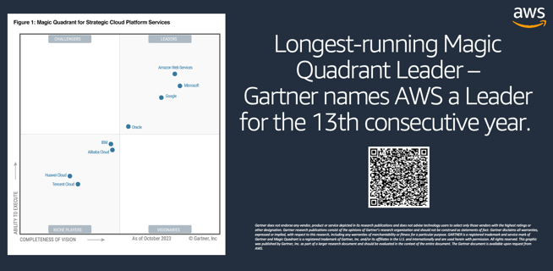

But simply running one of the world’s largest companies and being the leading cloud provider aren’t the only reasons why SAP customers trust AWS. It’s our commitment to innovation that drive SAP customers to choose AWS. We have unmatched experience and a history of providing innovative industry-firsts to SAP customers, including being first to support SAP as a customer in the cloud back in 2008, the first to provide certified infrastructure for SAP, the first to host SAP SaaS offering and automate SAP cloud deployment, the first to build dedicated SAP partner and professional services programs, and even the first to run SAP NS2 Regions.

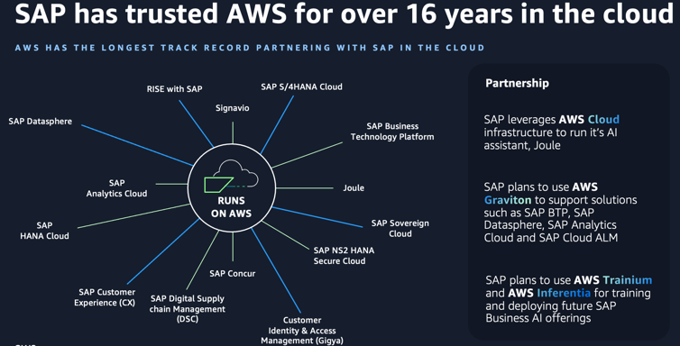

SAP has trusted AWS to power SAP workloads in the cloud for over 16 years, far longer than any other cloud service provider. Today, SAP chooses AWS to power their own cloud services and customer-facing offerings, including RISE with SAP, S/4HANA Cloud, SAP Concur, Signavio, and it’s AWS that drives SAP’s Business AI offerings including Joule.

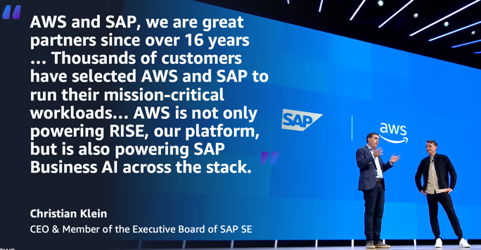

We’ve been able to help thousands of customers achieve positive outcomes and become the proven cloud for SAP workloads in large part due to our extensive and enduring partnership with SAP. This combination of operating and innovating at scale at Amazon, offering the world’s most comprehensive and broadly adopted cloud, and our consistent track record of innovating for SAP customers is what has made AWS the proven cloud to innovate for any SAP workload.

# Defining the Industry-Leading Cloud Platform

Friesland Campina’s SAP systems are arguably the most mission critical component of its entire IT landscape and ensuring business continuity is top priority. Running a business at the scale of Amazon requires the highest resilience, performance, and security standards. In this section we discuss how AWS caters to these dimensions and explain what’s unique about our underlying architecture design principles and how they are recognized by SAP in its RISE and Business Technology Platform (BTP) offering.

* 1. **Why cloud infrastructure design matters**

*“Everything fails, all the time…”* – Werner Vogels, Amazon CTO

AWS supports our Amazon businesses and to ensure business continuity we architect our infrastructure and services with the mindset that things *can* break. Our approach is unique and results in AWS delivering the highest network availability of any cloud provider – 3.4x higher than our closest competitor.

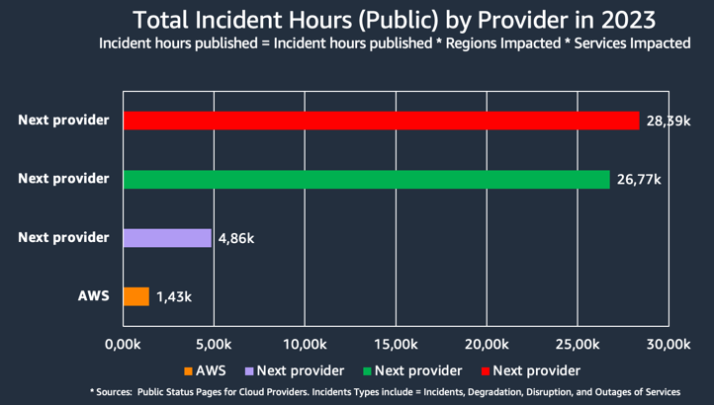

What makes our approach unique is our battle-hardened infrastructure design. To explain: AWS has the concept of a Region, which is a physical location around the world where we cluster data centers. We call each group of logical data centers an Availability Zone (AZ). Each AWS Region consists of a minimum of three, isolated, and physically separate AZs within a geographic area.

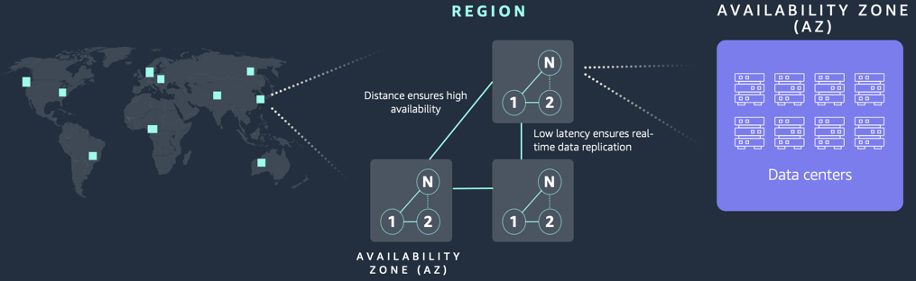

Unlike other cloud providers, who often define a Region as a single data center, the multiple AZ design of every AWS Region offers advantages for customers. AZs give customers the ability to operate production applications and databases that are more highly available, fault tolerant, and scalable than would be possible from a single data center. Each AZ has independent power, cooling, and physical security and is connected via redundant, ultra-low-latency networks. AWS customers focused on high availability can design their applications to run in multiple AZs to achieve even greater fault-tolerance. AWS infrastructure Regions meet the highest levels of security, compliance, and data protection.

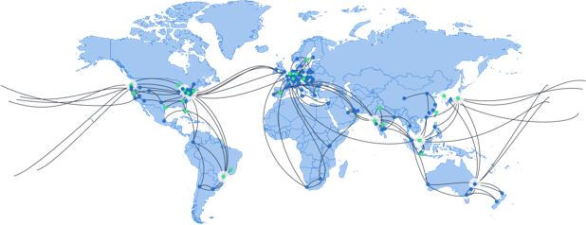

The [AWS Global Infrastructure](https://aws.amazon.com/about-aws/global-infrastructure/?p=ngi&loc=0) is built for performance. AWS Regions offer low latency, low packet loss, and high overall network quality. This is achieved with a fully redundant 400 GbE fiber network backbone, often providing many terabits of capacity between Regions.

[Security at AWS](https://aws.amazon.com/security/) starts with our core infrastructure. Custom-built for the cloud and designed to meet the most stringent security requirements in the world, our infrastructure is monitored 24/7 to help ensure the confidentiality, integrity, and availability of your data. All data flowing across the AWS global network that interconnects our datacenters and Regions is automatically encrypted at the physical layer before it leaves our secured facilities. You can build on the most secure global infrastructure, knowing you always control your data, including the ability to encrypt it, move it, and manage retention at any time.

AWS has the largest global infrastructure footprint of any provider, and this footprint is constantly increasing at a significant rate. Today, the AWS Cloud spans 108 Availability Zones within 34 geographic regions around the world, with announced plans for 18 more Availability Zones and 6 more AWS Regions including the AWS European Sovereign Cloud.

1.