# Why SAP and SAP customers trust AWS

SAP customers trust **AWS** to support their mission critical applications because at Amazon we humbly know a thing or two about operating and innovating within a real business at scale.

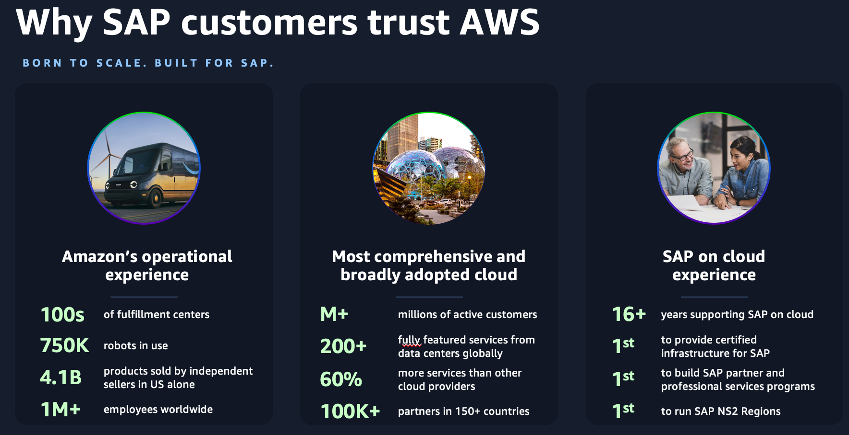Amazon's flagship *Amazon.com* business is a prime example of operating at a level of scale and complexity that few have witnessed. Leveraging AWS technologies and the resources of over 1 million employees, 100's of fulfillment centers, and over 750,000 robots, Amazon facilitates billions of financial transactions and delivers billions of packages to satisfied customers around the world.

AWS was founded to meet Amazon's growing compute and storage needs, and in the past 17 years, it has become the world's most comprehensive and broadly adopted cloud, offering 200+ services from data centers worldwide. AWS is the world's most secure, extensive, and reliable Global Cloud Infrastructure, delivering cloud services to millions of customers with a relentless focus on innovation.

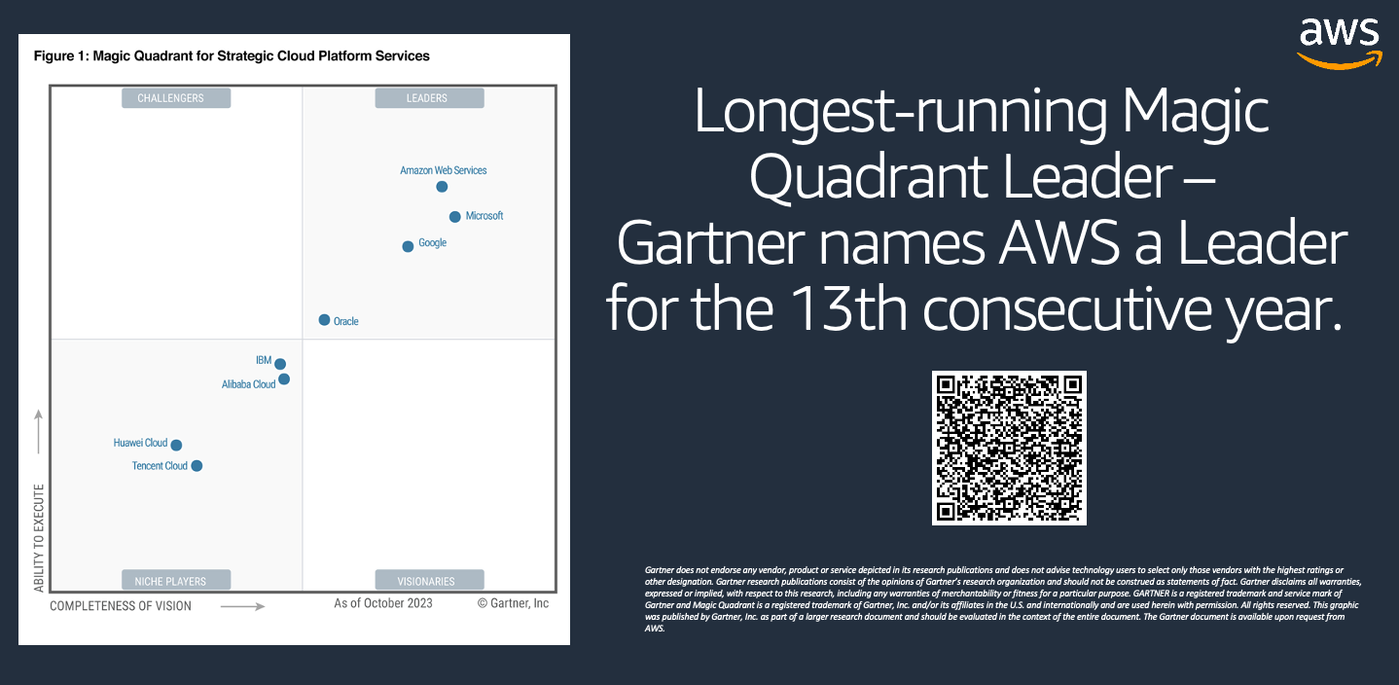These aren’t just *our* opinions – independent analysts agree. The famous [Gartner “Magic Quadrant for Strategic Cloud Platform Services” report](https://aws.amazon.com/resources/analyst-reports/gartner/global-mq-ardm-23-magic-quadrant-for-strategic-cloud-platform-services/?trk=5b366b4c-27fd-4b41-93cb-3195213bc9f6&sc_channel=el) has validated this leadership, naming AWS as “leader” for 13 consecutive years. We believe this report validates AWS’s leadership to innovate and set standards for cloud computing.