# Why SAP and SAP customers trust AWS

SAP customers trust AWS to support their mission critical applications because at Amazon we humbly know a thing or two about operating and innovating within a real business at scale.

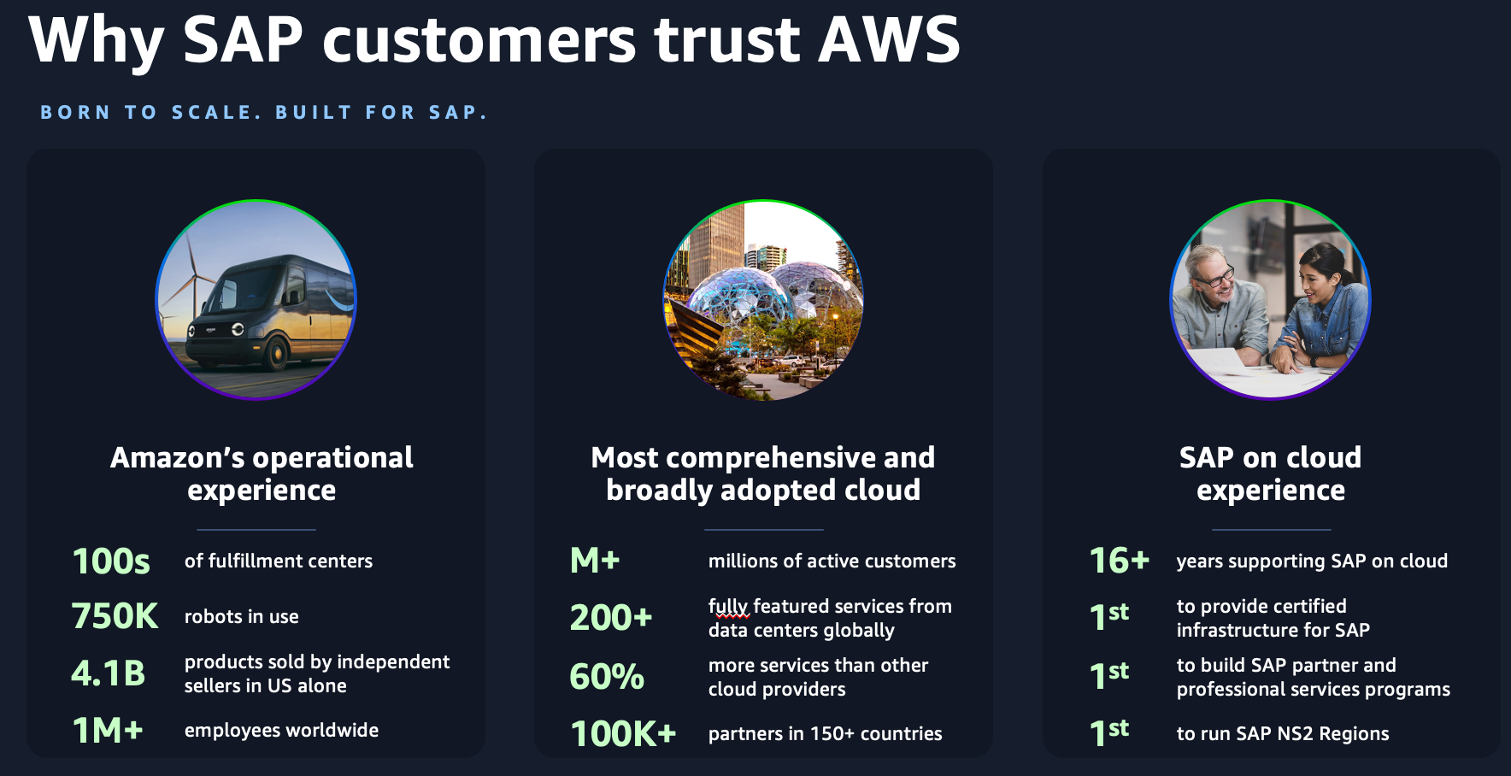Amazon's flagship Amazon.com business is a prime example of operating at a level of scale and complexity that few have witnessed. Leveraging AWS technologies and the resources of over 1 million employees, 100's of fulfillment centers, and over 750,000 robots, Amazon facilitates billions of financial transactions and delivers billions of packages to satisfied customers around the world.

AWS was founded to meet Amazon's growing compute and storage needs, and in the past 17 years, it has become the world's most comprehensive and broadly adopted cloud, offering 200+ services from data centers worldwide. AWS is the world's most secure, extensive, and reliable Global Cloud Infrastructure, delivering cloud services to millions of customers with a relentless focus on innovation.

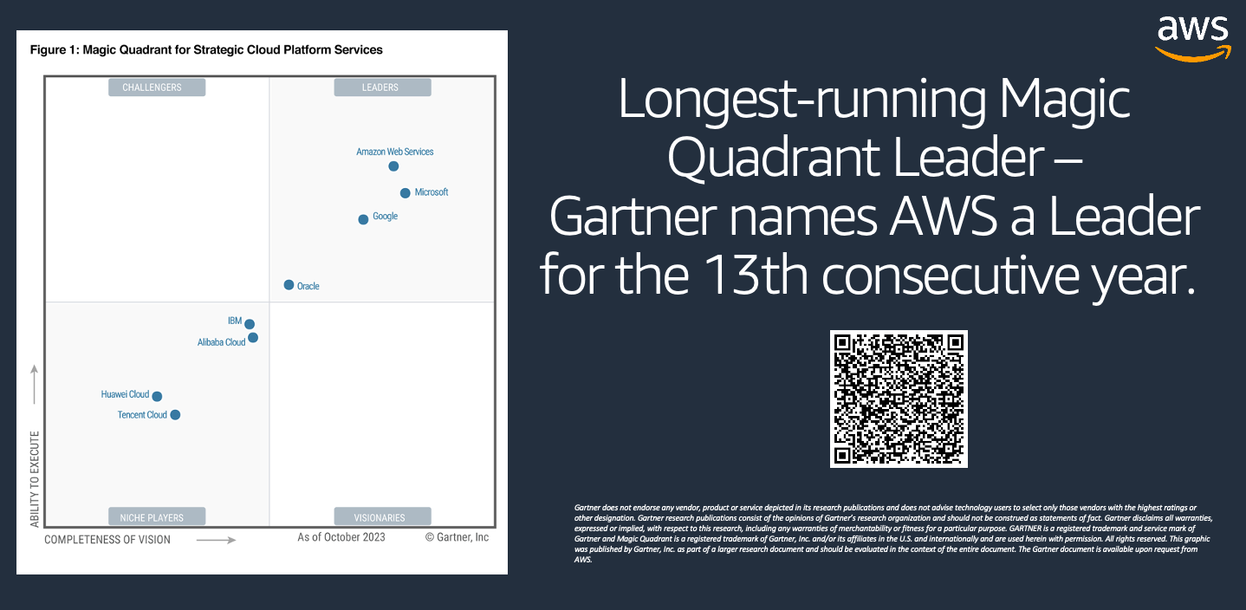These aren’t just *our* opinions – independent analysts agree. The famous [Gartner “Magic Quadrant for Strategic Cloud Platform Services” report](https://aws.amazon.com/resources/analyst-reports/gartner/global-mq-ardm-23-magic-quadrant-for-strategic-cloud-platform-services/?trk=5b366b4c-27fd-4b41-93cb-3195213bc9f6&sc_channel=el) has validated this leadership, naming AWS as “leader” for 13 consecutive years. We believe this report validates AWS’s leadership to innovate and set standards for cloud computing.

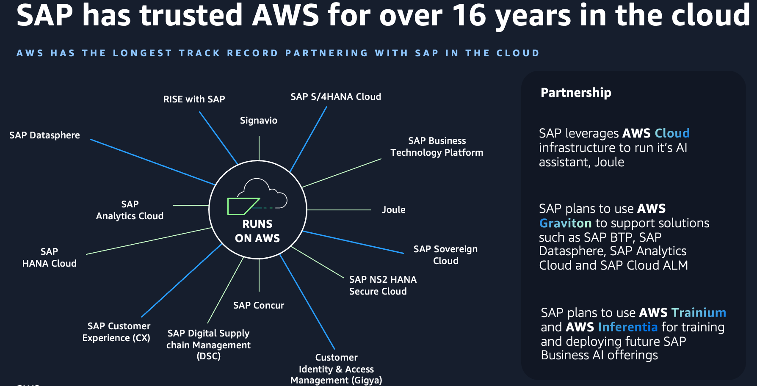But simply running one of the world’s largest companies and being the leading cloud provider aren’t the only reasons why SAP customers trust AWS. It’s our commitment to innovation that drive SAP customers to choose AWS. We have unmatched experience and a history of providing innovative industry-firsts to SAP customers, including being first to support SAP as a customer in the cloud back in 2008, the first to provide certified infrastructure for SAP, the first to host SAP SaaS offering and automate SAP cloud deployment, the first to build dedicated SAP partner and professional services programs, and even the first to run SAP NS2 Regions.

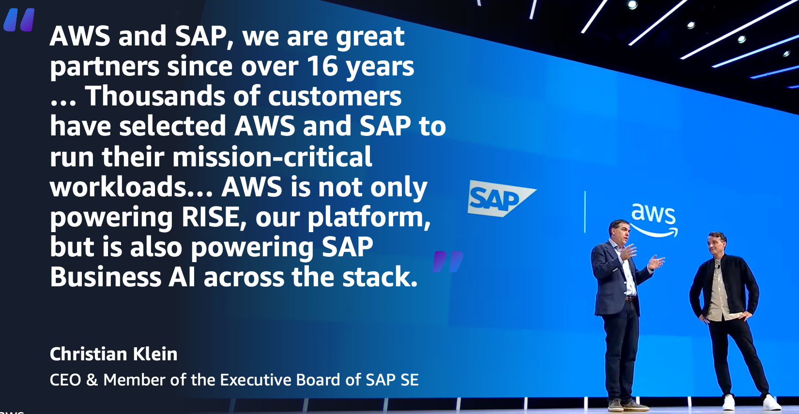SAP has trusted AWS to power SAP workloads in the cloud for over 16 years, far longer than any other cloud service provider. Today, SAP chooses AWS to power their own cloud services and customer-facing offerings, including RISE with SAP, S/4HANA Cloud, SAP Concur, Signavio, and it’s AWS that drives SAP’s Business AI offerings including Joule.

We’ve been able to help thousands of customers achieve positive outcomes and become the proven cloud for SAP workloads in large part due to our extensive and enduring partnership with SAP. This combination of operating and innovating at scale at Amazon, offering the world’s most comprehensive and broadly adopted cloud, and our consistent track record of innovating for SAP customers is what has made AWS the proven cloud to innovate for any SAP workload.