# Cloud Services Policy

#### Last Update Status: Updated October 2022

## Overview

So, the Infosec Team don’t wanna put out this Acceptable Use Policy to make restrictions that goes against what AnyCompany stands for—being open, trusting, and full of integrity. AnyCompany is all about keeping our folks, our partners, and the company safe from bad stuff that people might do, on purpose or by accident.

Internet stuff like computers, phones, software, operating systems, storage stuff, and network accounts that lets you email, browse the Web, and FTP—all these are owned by AnyCompany. They’re meant to be used for doing business, helping the company and our clients and customers when things are running normal. Go check the Human Resources policies for more details.

Being secure is a team thing that needs all hands from every AnyCompany employee and partner dealing with info or info systems. Every person using a computer needs to know these rules and do things right according to them.

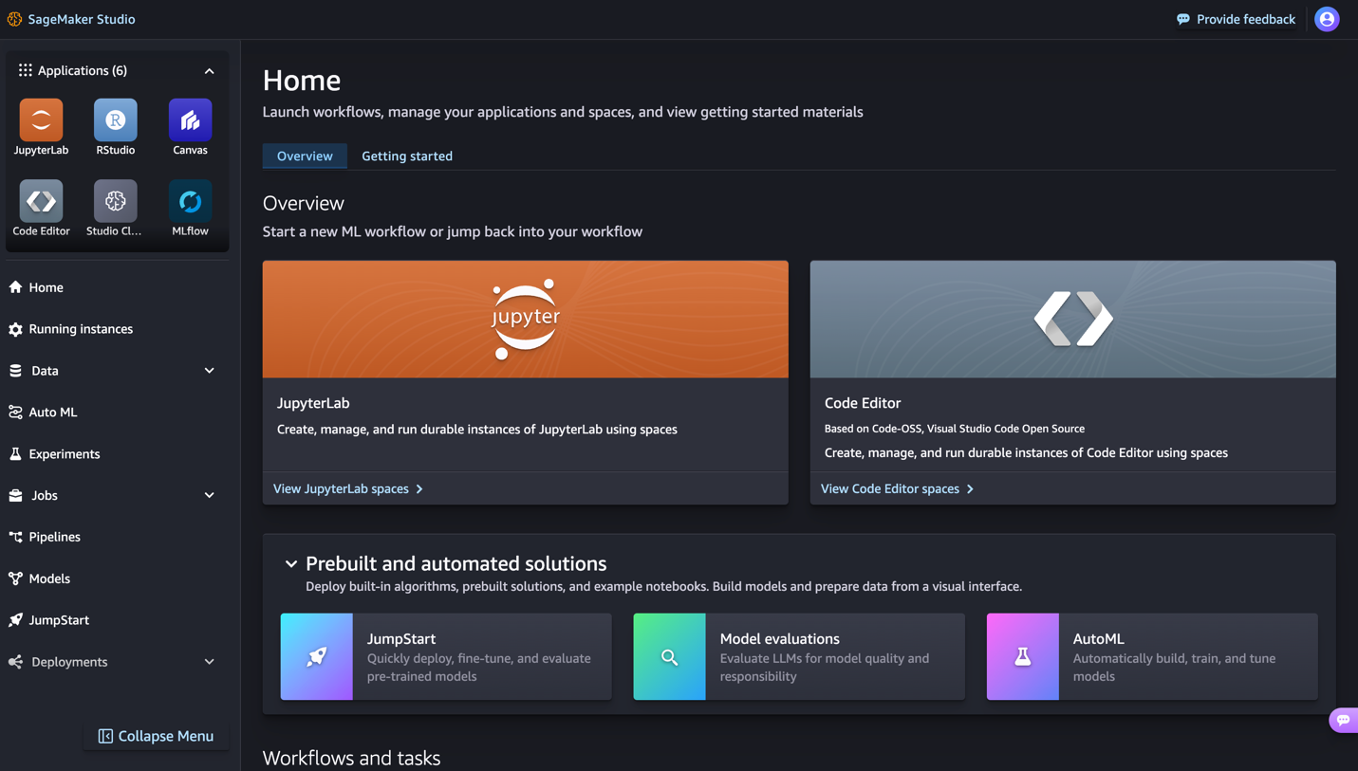

## Purpose

So, this is basically the rules for using computers and other stuff at AnyCompany. We got to have these rules to keep everyone, including the company, safe. If we don't follow the rules, bad stuff like viruses, hackers messing up our network, losing important data, or even getting into legal trouble can happen.

## Scope

This rule book is for anyone using our tech to do AnyCompany stuff or to connect with our networks and business systems, whether the gear is ours, yours, or someone else's. So, it's for all employees, the contract people, consultants, temps, and anyone else working at ARH and its other companies. Everyone's gotta make smart choices about how they use our tech and info according to AnyCompany ‘s rules and the local laws. If there's a special case, it’s talked about in section 5.2.

This applies to all the workers at AnyCompany, including people linked with third parties. It covers all the gear owned or rented by AnyCompany.



## What’s okay to use

### Approved Development Languages

For building stuff on the cloud using code that sets up infrastructure, AnyCompany GIS says it's ok to use:

1. Terraform
2. CloudFormation
   1. YAML
   2. JSON
3. CDK
   1. Python
   2. Java
   3. Typescript

### Code Repositories

AnyCompany GIS have reviewed and approved a set of CloudFormation templates for commonly used architectural patterns in cloud environments. These include:

* A virtual private cloud with areas that are private and public and spread across different zones
* An EC2 that acts like a guard using a special secure setup
* A setup for continuous integration and delivery using GitHub runners

You can find these templates at our GitHub spot here: <https://any-company-gis-iaac.github.com>

Everybody can get to our GitHub place at this link: <https://any-company-gis-iaac.github.com>.