AWS Threat Model Template
Do not delete: This threat model is from the AWS Threat Model template. Feedback here. Change log here.

Introduction

Purpose
A threat model answers four questions: What are we working on? What can go wrong? What are we going to do about it? Did we do a good job? The purpose of a threat model document is to ensure your reader can answer these questions for the system being modeled.

Project background
One or more AWS Customers have given us signal that they need the ability to:
- Retain carefully selected CloudWatch metrics for longer than the 15 month maximum allowed by CloudWatch metrics and at a lower cost than Amazon Managed Prometheus.
- Visualize those retained metrics in CloudWatch dashboards, timeshifting them forward by a user-specified time time so they appear “on top of” the current metrics.
This project goal is to provide a sample of the following capabilities to an AWS Customer:
- Ability to archive metrics from CloudWatch to S3 on-demand based on an API call that contains: namespace, dimensions, and statistics
- Ability to load those metrics from S3 to a CloudWatch dashboard.
- Ability to timeshift those metrics forward in time via a user-specified duration and overlay them with real-time data

Service Overview
This is not an AWS service. It is a one-time sample provided to the customer as a point-in-time snapshot of a current solution to the stated problems.

Security Tenets
- While we know our sample code will not be deployed to real environments, we model secure coding practices whenever possible within the bounds of frugality. For example, we follow relevant practices regarding safe storage and access to secrets. Because our sample code does not connect to any external resources, we do not put our Lambda functions in a VPC – doing so would be unfrugal and does not demonstrate valuable learnings.

Assumptions
<You can make assumptions about design considerations, threats, and mitigations. Assumptions help you focus your effort and avoid wasting time on design considerations that might be irrelevant, threats that may be out of scope, or the effectiveness of common mitigations. If an assumption is invalidated later, you can always revisit those parts of the threat model. Optionally, include mitigations for your assumptions. >
ID | Assumption | Comments
A-01 | AWS authentication (SigV4) and authorization (IAM) work correctly and are trusted methods to authenticate/authorize IAM principals
A-02 | KMS is a secure cryptographic root for our system and can be trusted
A-03 | Properly implemented TLS using cipher suites recommended by the Crypto Bar Raiser team is resistant to information disclosure and tampering to an acceptable level
A-04 | There is no Customer Data present in the solution. All data in all business APIs are generated algorithmically. There is no opportunity for the customer to provide Customer Data to the solution.
A-05 | The CloudWatch Dashboards services are already secure – only authorized users can access them, edit them, etc.
A-06 | The load generation script contains no Customer Data or even any generated data that looks like customer data – because it’s just a hello world API.
A-07 | The S3 services and storage are already secure.
A-08 | The CloudWatch Metrics services and storage are already secure.
A-09 | Lambda Execution Roles already store and vend IAM credentials securely.
A-10 | The existing apigateway:get-api-key API is sufficiently secure for vending API keys for a sample application.

System Architecture
This section answers “What are we working on?” . The intent is to help the reader understand the system that is being modeled.

High Level Design
The system consists of three “tiers”:
- Application Under Monitoring. This provides a sample “application” that we can use to generate the original CloudWatch metrics. Our “application” is a simple “Hello World” Lambda function with an API Gateway in front. We provide a Grafana k6 script that exercises this API at reasonable, variable scale so that we get an interesting load curve in the API Gateway “Count” metric.
- Metric Archival. This tier exposes a REST API that allows the caller to trigger an export of a CloudWatch metric during a given time window to S3. It then loads the metrics from CloudWatch and stores them in an S3 bucket.
- Retrieval and Dashboarding. This tier executes when the end user of the dashboard renders it. It loads the pre-archived metrics from the S3 bucket, parses it from CSV into memory, and timeshifts it by the end-user specified duration.

Low Level Design
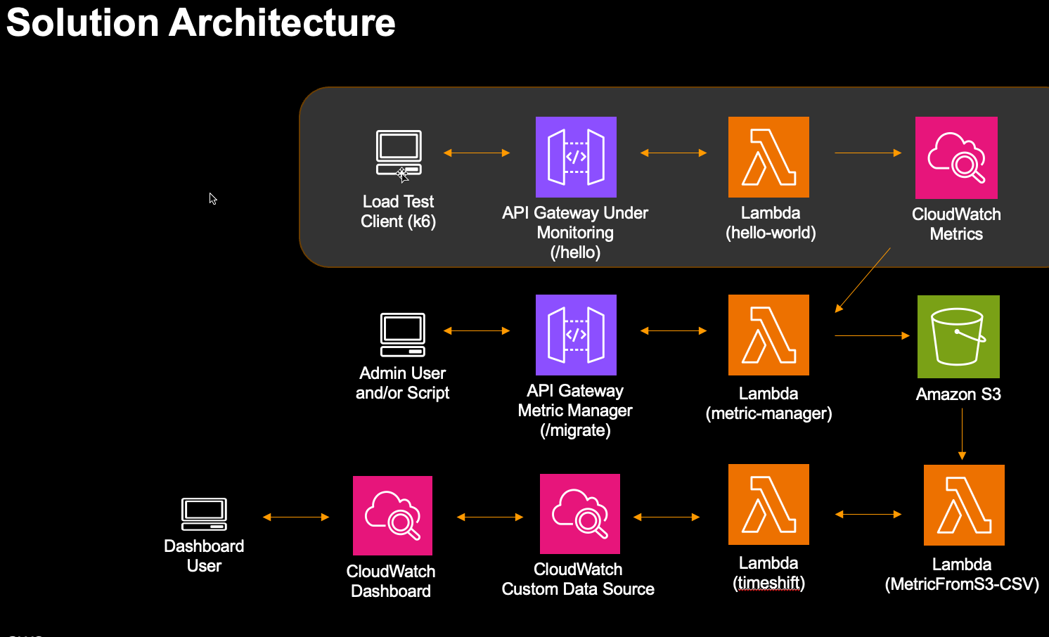< As part of your design, implement authentication and implement authorization. Please include details here >

Data Flow Diagrams

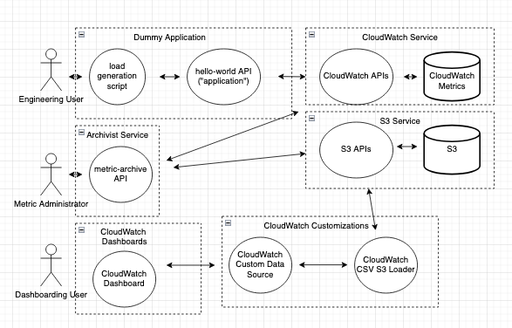

APIs
API | Method | Status | Mutating/  Non-Mutating | Functionality | Callable from Internet | Authorized Callers | Comments
hello-world | GET | New | Non-mutating | Returns static HTTP 200 with “Hello world!” | Yes | Authorized customer principals
exampleGetApplication | GET | Not in scope | Non-Mutating | Fictitious API. Displays detailed information about a specified application. | Yes | Authorized customer principals
exampleUpdateApplication | PUT | Changed | Mutating | Fictitious API. Updates a specified application. An application has to be in a stopped or created state in order to be updated. | Yes | Authorized customer principals
exampleCreateResources | POST | New | Mutating | Fictious API. Internal API to create specialized application for other AWS services. | No | mytestservice.amazonaws.dev service principal | Available on Amazon corp endpoint only

Assets
<Describe each asset in the system. These should be simple nouns or noun phrases. Ensure that these assets are included in the data flow diagram. Documenting your assets helps you think about what you are trying to protect. Use AWS’ data type definitions to categorize your data.>
Asset Name | Asset Usage | Data Type | Comments
(example) service managed KMS keys | Used for encrypting our data-at-rest in DynamoDB and S3 |  | 2 sets (one for KMS and one for S3), only programmatic interaction, auto-rotated
(example) Customer data-at-rest | We store customer cat pictures in S3, and metadata about the cat pictures in DDB in a single table.
(example) Service data-at-rest | The admin DDB stores metadata about our resources and their state. Our transactions DDB table stores data about uploads/downloads of customer cat pictures. We keep our logs in CloudTrail and CloudWatch
(example) TLS certificates - AWS Certificate Manager | Our X.509 certificates that enabled TLS on our public endpoint |  | 1 set for public endpoint, auto-rotated by ACM

Threat Actors
<Optionally, describe the potential adversaries you think might attack your system. This section is included to ensure the people enumerating threats are thinking about the type of actors that may attempt to influence your system.>

Security Anti-Patterns
<Review the Security Anti-Patterns article and identify any that are relevant to the design of the system that is in-scope for this threat model. Try to identify any threats related to these Security Anti-Patterns. This will help you decide whether you should avoid the Security Anti-Pattern, or whether it is acceptable in the context of your system to proceed with it. If it’s helpful, you can copy/paste the Security Anti-Pattern helper table to help you track your work.>

Threats
This section answers the question “What can go wrong?”. The intent is to help the reader understand the threats relevant to the system. Unless you have a preferred way to write threats, use AWS’ threat grammar. If using threat grammar feels difficult, use Threat Composer (wiki).
<Describe the threats to your system. It’s okay to have a lot of threats! Many find it easiest to create several tables for different parts of your system. You may also wish to a table for high level threats and/or threats that apply in many different places in your system. The priority column can help you sort your table. Focus on the threats that are the most impactful to your customers and their data. Ensure you document threats that have no or limited mitigations and raise them with your AppSec engineer.>
Threat Number | Priority | Threat | STRIDE | Affected Assets | Mitigations | Comments | Status
T-001 | High | A threat actor from the internet attempts to modify API calls in transit, leading to the reduction in confidentiality or integrity of requests/responses in-transit | Tampering | Data-in-transit | M-001 | Applies to all traffic between APIs and calling principals
T-002 | Low | A threat actor attempts to impersonate a valid caller to the public endpoint | Spoofing | All | M-002
T-003
T-004
T-005
T-006
T-007
T-008
T-009
T-010
T-011
T-012
T-013
T-014
T-015
T-016
T-017
T-018
T-019
T-020
T-021
T-022
T-023
T-024
T-025
T-026
T-027
T-028
T-029
T-030

Mitigations
This section answers “What are we going to do about it?”. The intent is to help the reader understand the security strategy. Mitigations reduce the likelihood and/or impact of the occurrence of threats.
<The mapping of threats to mitigations is many-to-many. Consider using multiple mitigations for a threat for defense-in-depth.>

Baseline Security Control Mitigations
The Baseline Security Controls (BSCs) are a set of controls that, when applicable, must be implemented in AWS services.
<You can delete BSCs that aren’t applicable for you. You may optionally delete the whole table if it’s not helpful for you, as BSCs will be assigned to you via your Talos security review.>
Mitigation Number | Mitigation | Threats Mitigating | Status | Ticket/Artifact/CR/Tests | Comments
BSC1 | Enable Content Security Policy
BSC2 | Enable security HTTP headers
BSC6 | Implement checks to ensure that only the resource owner can take action against the resource (protect against Confused Deputy)
BSC7 | Implement CSRF protection
BSC9 | Implement authorization for services
BSC10 | Ensure a consistent authorization experience (CAE) using IAM
BSC11 | Disable Instance Metadata Service v1 (IMDSv1) on EC2 instances by configuring the IMDS to require HTTP tokens (IMDSv2)
BSC12 | Ensure that bucket and objects are not world readable or world writable
BSC13 | Encrypt service data using a KMS Customer Managed Key owned by your service
BSC14 | Encrypt customer content and support the use of a customer managed Customer Managed Key (CMK) managed in KMS.
BSC15 | Disable Debug and Development Functionality
BSC16 | Encrypt Data in Transit (HTTPS/TLS)
BSC18 | Enable TLS for all ingress and egress connections
BSC20 | Use Isengard for all AWS accounts and appropriately flag Production accounts
BSC21 | Harden against denial of service
BSC22 | Build all OSS packages from source code pulled from repositories owned and controlled by AWS
BSC23 | Include standard security chapters in customer facing documentation
BSC26 | Use appropriate mechanisms for accessing customer resources
BSC28 | Apply least privilege principle to all processes, accounts, etc.
BSC29 | Use IAM Roles and scoped-down IAM policy
BSC30 | Use the minimum set of permissions in SLR or EZCRC roles required for the service to function
BSC31 | Use resource policies to restrict access to resources to the minimum set required for the service to function
BSC32 | Implement authentication
BSC33 | Use sigv4 as the secure default authentication mechanism for APIS
BSC34 | Implement strong secrets management
BSC37 | Maintain third party dependencies of your code
BSC38 | Monitor Vulnerabilities and Patch Compute Instances Promptly
BSC39 | Ensure Correct Image Selection for EC2 and Containers
BSC40 | Implement secure logging
BSC43 | Enable S3 bucket access logging
BSC44 | Integrate with CloudTrail and emit logs for all successful and unsuccessful actions
BSC45 | Restrict inbound and outbound network access to least privilege
BSC47 | Write security focused test cases
BSC49 | Implement an out-of-band continuous auditing/verification mechanism (canary)
BSC50 | Build new consoles on TangerineBox (new consoles only)
BSC52 | Enable Taj for automated API security integration testing
BSC54 | Onboard to PrivateLink (VPC endpoints) with support for endpoint policies
BSC55 | Separate non-production and production environments
BSC60 | Use Amazon recommended build and deployment tools to maintain a secure development environment

System Specific Mitigations
These are mitigations that are specific to the system being modeled.
Mitigation Number | Mitigation | Threats Mitigating | Status | Related BSC | Ticket/Artifact/CR/Tests | Comments
M-001 | API Gateway Encryption-in-transit using TLS_1_2 policy | T-001
M-002 | Authentication using SigV4 | T-002
M-003
M-004
M-005
M-006
M-007
M-008
M-009
M-010
M-011
M-012
M-013
M-014
M-015
M-016
M-017
M-018
M-019
M-020

Security Tests
<Testing and canaries are super important. The longer we exist as an organization, the stronger our conviction is that having a robust set of tests will prevent the occurrence of regressions into production and a robust set of canaries will identify the presence of regressions, security or otherwise in your production environment.
See the following guidance: Write security focused test cases, build integration and unit tests for security, implement canaries as an out-of-band continuous auditing mechanism. Identify mitigations that are testable and document your intended test coverage. Think about which mitigations are covered by Taj or Bliss, and which are unique to your service.>
Test Number | Mitigations Tested | Test Case | Description | Test Type | Status
Test-001 | M-001 | Example - HTTP Denied | Test endpoints X, Y, Z to ensure non-TLS traffic is rejected | Canary | Planned
Test-002 | M-001 | Example - TLS 1.1 Denied | Test endpoints X, Y, Z to ensure weak TLS traffic is rejected | Canary | Planned
Test-003 | M-001 | Example - TLS 1.2 Allowed | Test endpoints X, Y, Z to ensure only TLS 1.2 is allowed | Canary | Planned
Test-004 | M-001 | Example - APIGW CDK uses TLS_1_2 policy | Check that API Gateway configuration in CDK creates a custom domain and enforces a minimum TLS version | Unit | Planned
Test-005 | M-002 | Example - Successful sigv4 calls should succeed | Check that API Gateway configuration in CDK creates a custom domain and enforces a minimum TLS version | Unit, canary | Planned
Test-006 | M-002 | Example - Requests without valid sigv4 should fail | Check that API Gateway configuration in CDK creates a custom domain and enforces a minimum TLS version | Unit, canary | Planned

Appendix

Glossary
Term | Definition | Example

References
The table below lists related threat models, design documents, PRFAQs, security reviews, pentests, or other documents.
Reference | Comments
SigV4 Public Documentation | Signature Version 4 (SigV4) is the process to add authentication information to AWS API requests sent by HTTP.

Documentation

Managed policy requests

