Build Intelligent Photo System with Smart Caption and Context Search

Introduction
Managing large photo collections presents significant challenges for organizations and individuals alike. Traditional approaches rely on manual tagging, basic metadata, and folder-based organization, which become impractical when dealing with thousands of images containing multiple people and complex relationships.
Intelligent photo search systems address these challenges by combining computer vision, graph databases, and natural language processing to transform how we discover and organize visual content. These systems capture not just who and what appears in photos, but the complex relationships and contexts that make them meaningful, enabling natural language queries and semantic discovery.
In this post, we showcase how to build a comprehensive photo search system using AWS CDK that integrates Amazon Rekognition for face and object detection, Amazon Neptune for relationship mapping, and Amazon Bedrock for AI-powered captioning. We demonstrate how these services work together to create a system that understands natural language queries like "Find all photos of grandparents with their grandchildren at birthday parties" or "Show me pictures of the family car during road trips." The key benefit is the ability to personalize and customize search focus on specific people, objects, or relationships while scaling to handle thousands of photos and complex family or organizational structures. Our approach demonstrates that integrating Neptune's graph database capabilities with Amazon's AI services enables natural language photo search that understands context and relationships, moving beyond simple metadata tagging to truly intelligent photo discovery. We showcase this through a complete serverless implementation that you can deploy and customize for your specific use case. Complete source code is available on GitHub at https://github.com/aws-samples/intelligent-photo-search-neptune-rekognition

Solution Overview
This solution streamlines large photo collection management through intelligent automation, enabling natural language queries without manual tagging.
The architecture combines Amazon S3 for storage, Amazon Rekognition for image analysis, Amazon Bedrock for caption generation, Amazon Neptune for relationship mapping, and AWS Lambda for orchestration. These services work together to create a contextually-aware photo search system that understands relationships between people, objects, and events.
The system serves multiple enterprise needs: corporate employee recognition and event documentation, HIPAA-compliant healthcare photo management, educational institution photo organization, and enhanced event photography services. Built on serverless architecture, it scales efficiently from thousands to millions of images while maintaining cost-effectiveness and rapid deployment capabilities.

Prerequisites
Before implementing this solution, ensure you have:
- AWS Account with appropriate permissions for S3, Lambda, Rekognition, Neptune, Bedrock, and DynamoDB
- AWS CLI configured with programmatic access
- AWS CDK v2.x installed (npm install -g aws-cdk)
- Python 3.11+ with pip package manager
- Basic knowledge of serverless architectures and graph databases
- Bedrock model access - Request access to Claude 3.5 Sonnet in your AWS region

Code Structure
The project is organized into several key directories that separate concerns and enable modular development:
image-name-cap-neptune/
├── lambda/
│ ├── face_indexer.py # Indexes reference faces in Rekognition
│ ├── faces_handler.py # Lists indexed faces via API
│ ├── image_processor.py # Main processing pipeline
│ ├── search_handler.py # Handles search queries
│ ├── style_caption.py # Generates styled captions
│ ├── relationships_handler_neptune.py # Manages Neptune relationships
│ ├── label_relationships.py # Queries label hierarchies
│ └── neptune_search.py # Neptune relationship parsing
├── lambda_layer/ # Pillow image processing layer
├── neptune_layer/ # Gremlin Python Neptune layer
├── ui/
│ └── demo.html # Web interface
├── app.py # CDK application entry point
├── image_name_cap_stack_neptune.py # Neptune-enabled CDK stack
└── requirements_neptune.txt # Python dependencies

Key Lambda Functions:
- image_processor.py: Core processing with face recognition, label detection, and relationship-enriched caption generation
- search_handler.py: Natural language query processing with multi-step relationship traversal
- relationships_handler_neptune.py: Configuration-driven relationship management and graph connections
- label_relationships.py: Hierarchical label queries, object-person associations, and semantic discovery

Architecture Overview
Our solution leverages several AWS services working together:
- Amazon S3 for scalable photo storage
- AWS Lambda for serverless compute
- Amazon Rekognition for face detection and recognition
- Amazon Neptune for storing relationships as a graph
- Amazon Bedrock with your choice of LLM for AI-powered image captioning
- Amazon DynamoDB for metadata storage
- Amazon API Gateway for REST API endpoints
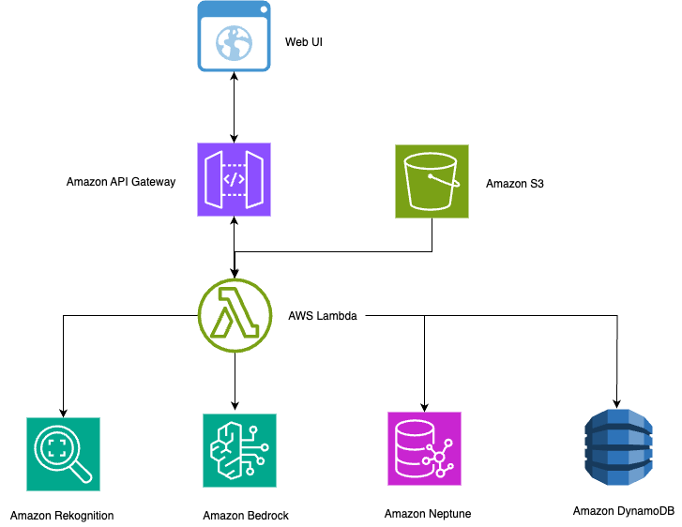

Key Features and Use Cases

1. Automated Face Indexing and Recognition
The system eliminates manual photo tagging by automatically learning to recognize people from reference photos. Upload a few clear photos of each person with their name, and the system immediately begins identifying them across your entire collection - even in group photos, different lighting conditions, and various angles.
Organizations with large photo collections can achieve complete automated tagging within hours rather than weeks of manual effort. This capability proves particularly valuable for corporate events, employee directories, and compliance documentation where accurate people identification is critical.

2. Natural Language Relationship Search
Amazon Neptune's graph database enables the system to understand not just individual identities, but the complex relationships between people. The system supports natural language queries like "Show me photos of Sarah's manager" and family relationships such as "Find all photos of Mom with her children."
Multi-step relationship traversal enables the system to understand complex queries like "Sarah's manager's team" by following the relationship chain through the graph database. This eliminates the need for manual folder organization, allowing users to ask simple questions and get instant results. The relationship modeling scales seamlessly from small family trees to Fortune 500 organizational charts, handling complex hierarchies and cross-functional team structures with equal precision.

3. Smart Object Detection and Context Understanding
The system extends beyond face recognition through Amazon Rekognition's comprehensive label detection capabilities. It automatically identifies objects, scenes, and activities in photos, returning the most confident detections based on configurable confidence thresholds and quantity limits to ensure high-quality results.
The architecture creates semantic relationships by connecting detected labels with recognized individuals in Neptune's graph database. This enables contextual queries that combine person identification with object detection, such as searching for specific individuals with particular objects or in certain environments. For example, the system can understand that a "car" belongs to "vehicle" which belongs to "transportation," enabling broad categorical searches that return all related items within the hierarchy.
Healthcare applications could leverage this for "patient with medical equipment" searches, while educational systems might query "teacher with classroom technology." Corporate organizations can search for "executives with company vehicles" or "employees in meeting rooms." The label relationship architecture adapts to any domain requiring intelligent image organization with contextual associations, automatically building these connections as photos are uploaded without manual configuration.

4. Contextual AI Caption Generation
The system transforms generic photo descriptions into meaningful, context-aware captions that understand both who is in the photo and their relationships. Instead of basic descriptions like "Two people outdoors," you get intelligent captions like "Sarah and her manager discussing quarterly results in the company garden."
This contextual understanding improves photo searchability and creates professional documentation automatically. Event photography businesses can deliver albums faster, while corporate communications teams can instantly generate photo descriptions for newsletters and reports.
The system adapts caption tone for different business needs - objective descriptions for compliance documentation, warm narratives for marketing materials, or professional summaries for executive presentations.
5.User Interface and Experience
The system provides an intuitive web interface that demonstrates the full capabilities of intelligent photo search and management. Users can search using natural language queries, view automatically indexed faces, and interact with AI-generated captions in real-time.
Figure1: Web Interface Demonstrating Intelligent Photo Search and Caption Styling
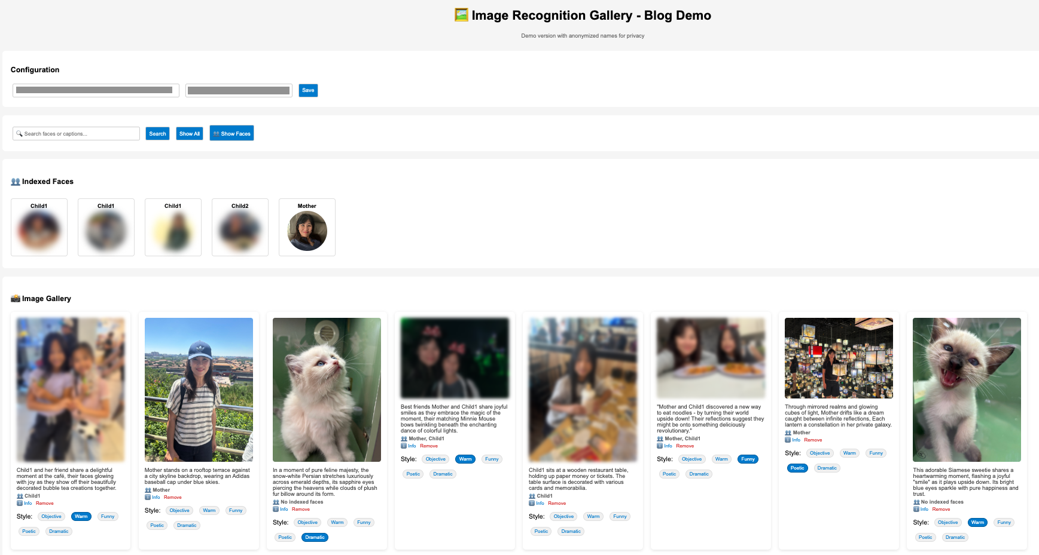
The interface showcases several key capabilities in action: automatic face recognition with privacy-protected anonymization, contextual AI captions that understand relationships and settings, and dynamic caption styling that adapts tone for different use cases. Users can search for photos using natural language queries like "Mother with children" or "outdoor activities," and the system returns relevant results with intelligent captions that provide meaningful context rather than generic descriptions.
The style selector demonstrates the system's adaptability - the same photo can be described objectively for documentation purposes ("Two people pose with decorated cups at a cafe") or warmly for personal use ("Mother and child enjoy a special moment together at their favorite local spot"). This flexibility makes the system suitable for both professional documentation and personal photo management.

6. Scalable Graph Relationships with Label Hierarchies
The Neptune graph database scales to handle complex organizational structures with hundreds of people and intricate relationships, plus label hierarchies and co-occurrence patterns.
Figure 1: Person Relationship Sample Graph (Configuration-Driven)
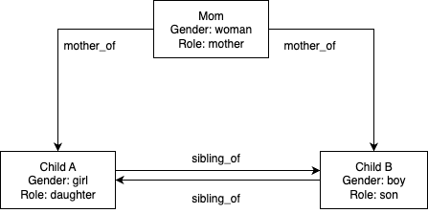
Person relationships are configured through JSON data structures passed to the initialize_relationship_data() function. This configuration-driven approach supports unlimited use cases without code modifications - simply define your people and relationships in the configuration object.
Figure 2: Label Hierarchy Sample Graph (Auto-generated from Rekognition)

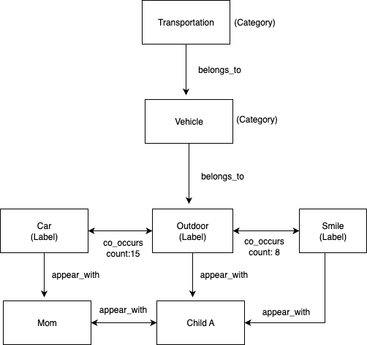
Label hierarchies and co-occurrence patterns are automatically generated during image processing. Rekognition provides category classifications that create the belongs_to relationships, while the appears_with and co_occurs_with relationships are built dynamically as images are processed.
Figure 3: Subset of the Complete Graph (Demonstrating Multi-layered Relationship Types)
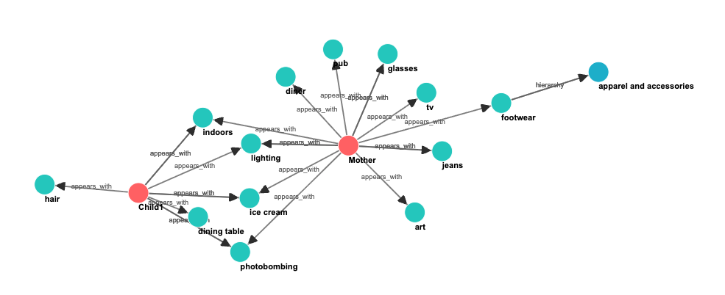

Database Generation Methods
Person Relationships (Configuration-Driven):
The relationship graph uses a flexible configuration-driven approach through the initialize_relationship_data() function. This eliminates hard-coding and supports unlimited use cases:
# Generic configuration structure
config = {
"people": [
{"name": "alice", "gender": "woman", "role": "mother"},
{"name": "jane", "gender": "girl", "role": "daughter"}
],
"relationships": [
{"from": "alice", "to": "jane", "type": "parent_of", "subtype": "mother_of"},
{"from": "jane", "to": "david", "type": "sibling_of", "bidirectional": True}
]
}
# Generic relationship creation
for rel in relationships_data:
g.V().has('name', rel["from"]).addE(rel["type"]).to(
__.V().has('name', rel["to"])
).property('type', rel["subtype"]).next()
# Business example - just change the configuration
business_config = {
"people": [{"name": "sarah", "role": "manager"}],
"relationships": [{"from": "sarah", "to": "john", "type": "manages", "subtype": "manager_of"}]
}
Label Hierarchies (Auto-generated from Rekognition):
The label relationship database is created automatically during image processing through the store_labels_in_neptune() function:
# Rekognition provides labels with categories
response = rekognition.detect_labels(
Image={'Bytes': image_bytes},
MaxLabels=20,
MinConfidence=70
)
# Extract labels and categories
for label in response.get('Labels', []):
label_data = {
'name': label['Name'], # e.g., "Car"
'categories': [cat['Name'] for cat in label.get('Categories', [])] # e.g., ["Vehicle", "Transportation"]
}
# Automatic hierarchy creation in Neptune
for category in categories:
# Create belongs_to relationship (Car -> Vehicle -> Transportation)
g.V().has('name', label_name).addE('belongs_to').to(
__.V().has('name', category_name)
).property('type', 'hierarchy').next()
# Create appears_with relationship (Person -> Car)
g.V().has('name', person_name).addE('appears_with').to(
__.V().has('name', label_name)
).property('confidence', confidence).next()
Use Case: Manage large photo collections with complex relationship queries, discover photos by semantic context, and find themed collections through label co-occurrence patterns.

Performance and Scalability Considerations
Handling Bulk Uploads:
The system processes large photo collections efficiently, handling everything from small family albums to enterprise archives with thousands of images. Built-in intelligence manages API rate limits and ensures reliable processing even during peak upload periods.
The system processes large volumes of photos per hour with automatic retry logic and progress tracking. It gracefully handles network interruptions, API throttling, and large file sizes without manual intervention.
Cost Optimization:
The serverless architecture ensures you only pay for actual usage, making it cost-effective for both small teams and large enterprises. For reference, processing 1,000 images typically costs approximately $15-25 (including Rekognition face detection, Bedrock caption generation, and Lambda execution), with Neptune cluster costs of $100-150 monthly regardless of volume. Storage costs remain minimal at under $1 per 1,000 images in S3.
Scaling Performance:
The Neptune graph database approach scales efficiently from small family structures to enterprise-scale networks with thousands of people. The system maintains fast response times for relationship queries and supports bulk processing of large photo collections with automatic retry logic and progress tracking.

Security and Privacy
Data Protection:
- All photos remain in your AWS account
- Face recognition data is stored in your Rekognition collection
- No data is shared with external services
- VPC isolation for Neptune database
Access Control:
- IAM roles with least-privilege access
- API Gateway can be configured with authentication
- S3 bucket policies restrict access to authorized users

Conclusion
This implementation demonstrates how combining Amazon Rekognition's computer vision capabilities, Neptune's graph database technology, and Amazon Bedrock's natural language processing creates an intelligent photo search system that understands both visual content and contextual relationships.
The system transforms traditional photo management from manual organization to natural language interaction. Users can execute complex queries that combine facial recognition, object detection, and relationship traversal through simple conversational requests. The serverless architecture ensures scalability and cost-effectiveness while maintaining high availability and security.
Key technical achievements include configuration-driven relationship modeling, automatic label hierarchy generation, multi-modal AI integration, and robust error handling with retry mechanisms. The Neptune graph database enables sophisticated relationship queries that scale from simple family structures to complex organizational hierarchies.
This architecture provides a foundation for intelligent content management systems across various domains, demonstrating how AWS AI services can be integrated to create contextually aware applications that understand both the content and meaning of visual data.

Resources
- AWS CDK Documentation
- Amazon Rekognition Developer Guide
- Amazon Neptune User Guide
- Amazon Bedrock User Guide

