Generate a compliance-configured home for AI agents on Amazon Bedrock AgentCore with SGEA
Turn a FedRAMP, HIPAA, or DoD control profile into matching Terraform and AWS CDK for a governed Amazon Bedrock enclave, and check it against the frameworks before you deploy.
Regulated organizations want AI agents in production, and the models are ready. The hard part is everything around them. Every team that wants to run an agent on Amazon Bedrock under FedRAMP, HIPAA, or a DoD impact level ends up building the same governed platform: guardrails on every model call, a default-deny tool path, per-user identity and spend limits, private networking, encryption, logging, and detective controls. Then the team has to show, control by control, that the platform meets the framework, which often takes longer than building it. Repeated across teams, that work slows adoption and leaves an organization with uneven environments that are hard for an information system security officer (ISSO) to assess.
What SGEA is
The Secure GenAI Enclave Accelerator (SGEA) is a toolkit that turns a compliance profile into matching Terraform and AWS CloudFormation (through the AWS Cloud Development Kit, or AWS CDK) for a governed Amazon Bedrock and Amazon Bedrock AgentCore enclave. It checks that infrastructure as code (IaC) against every AWS Config conformance-pack rule of the chosen frameworks, and it gives you the manual steps, runbooks, and evidence tooling around it. The enclave is built once at the environment level and shared: application teams bring their agents and data into isolated tenant spaces and inherit the enclave's controls instead of rebuilding them.
Important: SGEA is sample code for demonstration and evaluation. It is not intended for production use without your own security review, testing, and authorization. SGEA configures an environment for a framework baseline and supports your authorization; it does not make a system compliant. Compliance is determined by your assessor or Authorizing Official (AO) for your whole system, and many requirements, such as policy, process, and organizational controls, sit outside any IaC.
The model behind the enclave is four layers of responsibility, shown in the following figure.
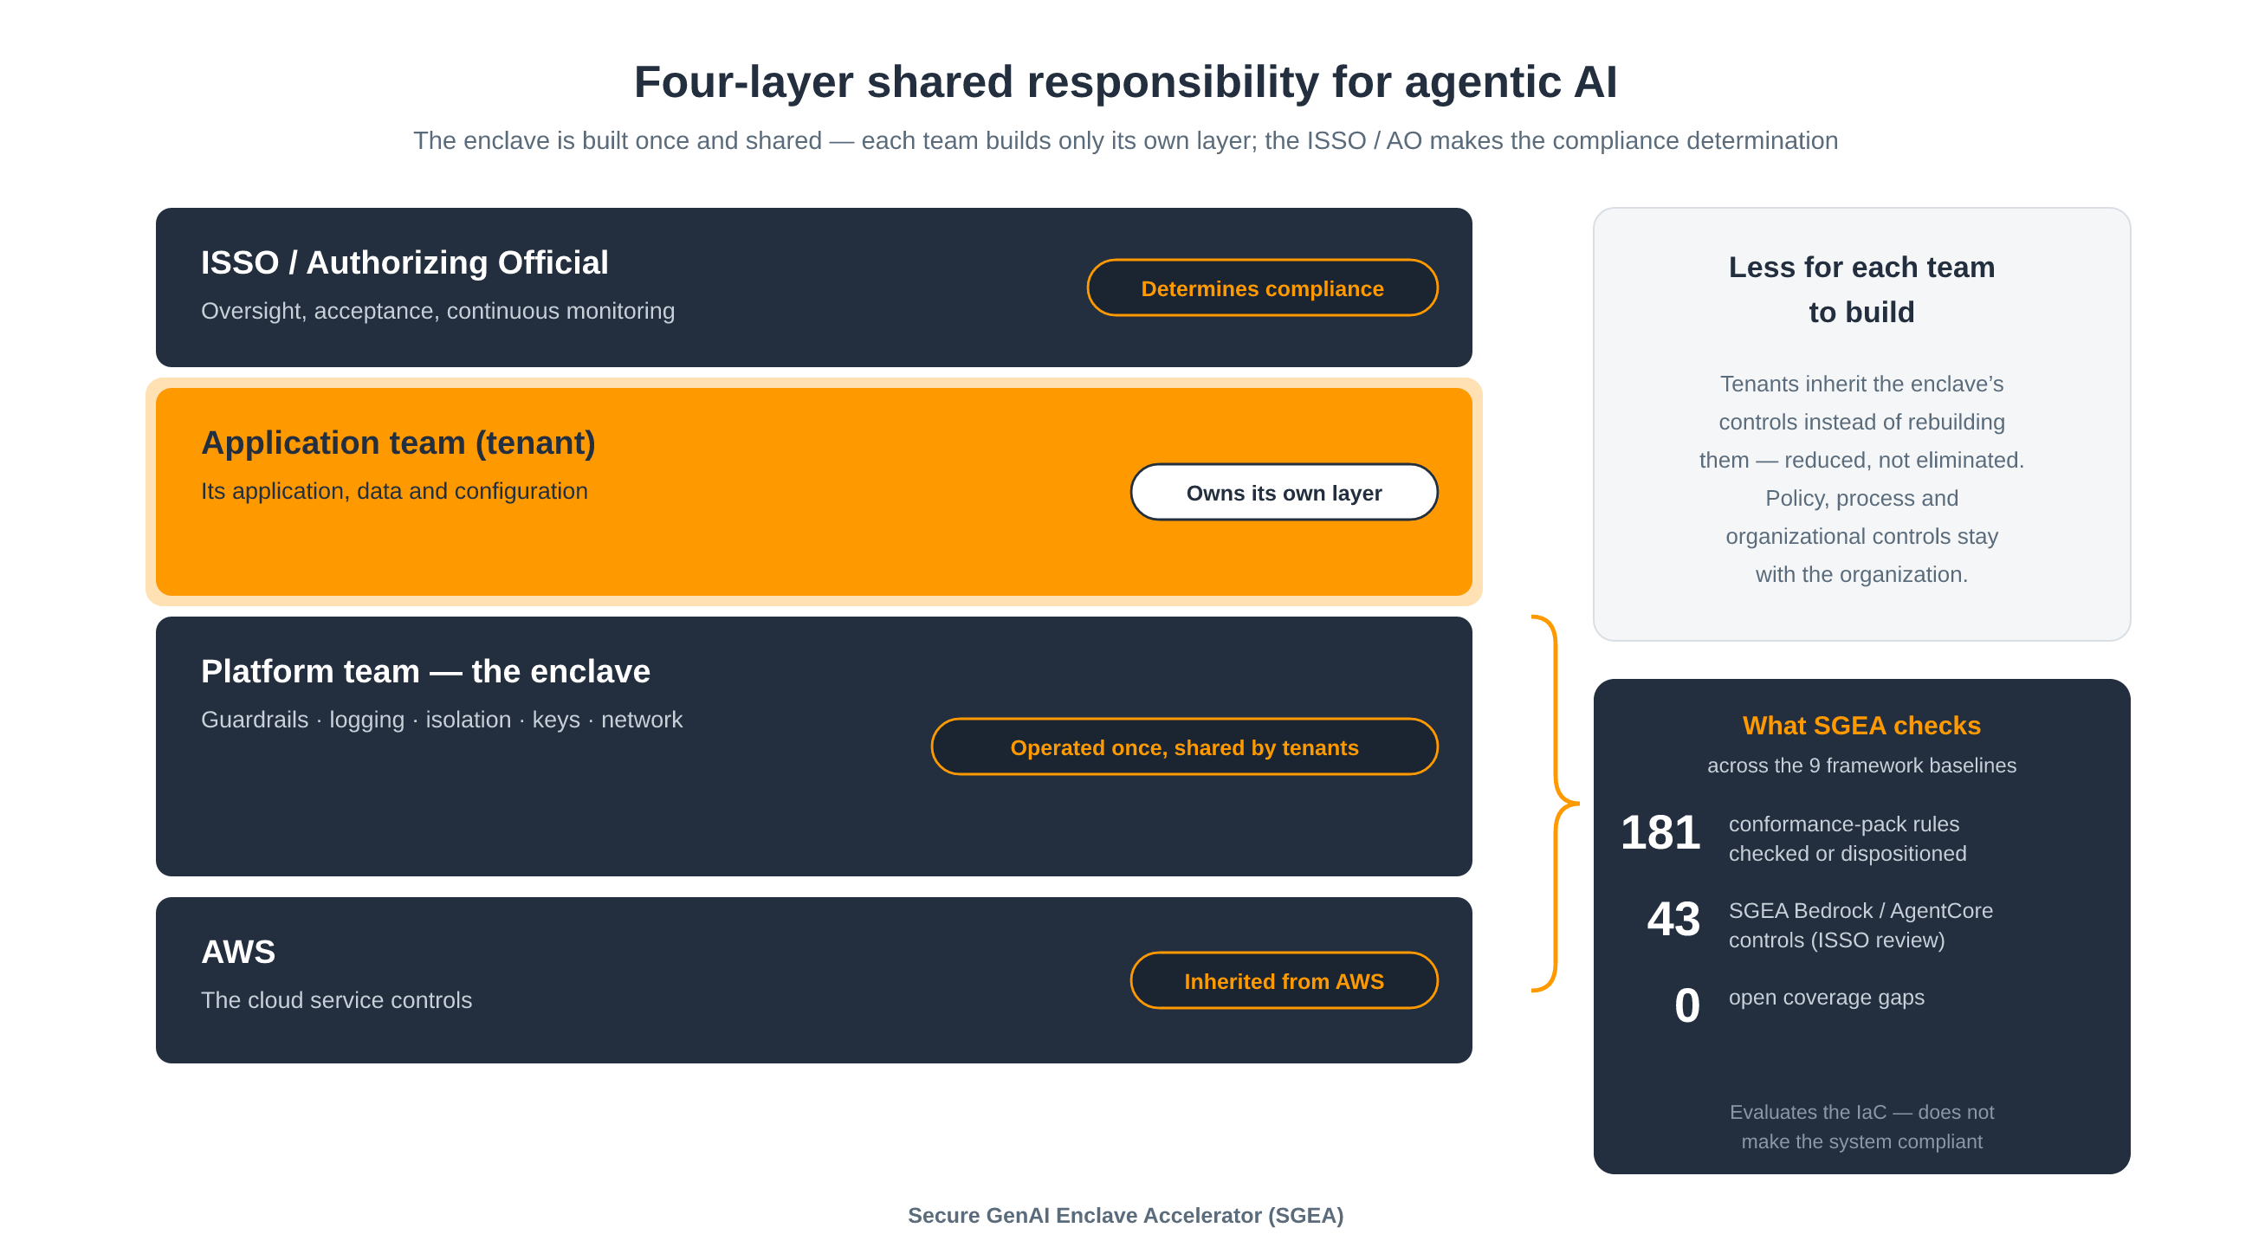
Figure 1. Four-layer shared responsibility for agentic AI — the enclave reduces what each team builds; the ISSO/AO makes the compliance determination.
AWS secures the cloud services. A platform team operates the enclave: guardrails, identity, logging, tenant isolation, keys, network, and organization-level policy. Each tenant team owns its application, data, and configuration. Your ISSO and AO oversee the whole and make the compliance determination. The enclave reduces, but does not eliminate, what each team has to stand up for itself.
How it works
SGEA follows one rule: control decisions are made once, in a single resolved configuration, and everything else is generated from it. The following figure shows the flow from profile to checked, deployable IaC.
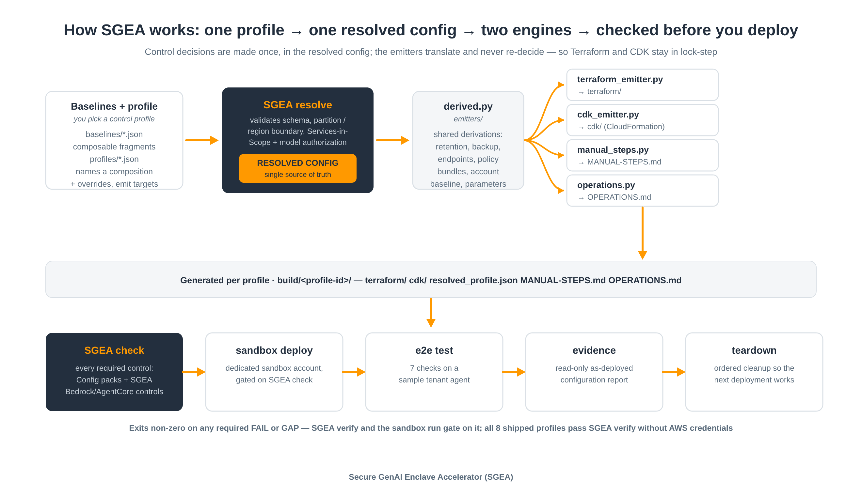
Figure 2. One profile → one resolved config → Terraform, AWS CDK, MANUAL-STEPS.md and OPERATIONS.md → checked before you deploy.
You start with a profile. SGEA ships eight profiles that compose nine framework baselines: FedRAMP Low, Moderate, and High; DoD IL2, IL4, and IL5; HIPAA; HITRUST; and FDA 21 CFR Part 11. A profile names a composition of baselines, overrides such as region and environment, and the engines to emit. It never contains organization data, so you can write your own by extending the shipped baselines.
The sgea resolve command validates the profile before anything is emitted. It checks the schema, the partition and region boundary, AWS Services in Scope authorization, HIPAA eligibility, and Amazon Bedrock model authorization. The result is one resolved configuration, saved with every export as resolved_profile.json for audit.
sgea export then translates that configuration into two engines that stay in lock-step:
- Terraform – a root stack and 15 wrapper modules built on pinned terraform-aws-modules and the official aws and awscc providers.
- AWS CDK (TypeScript) – an app that synthesizes two CloudFormation stacks, SgeaEnclave and SgeaEnclaveLogReplica.
Neither emitter makes its own decisions; shared derivations such as log retention, backup windows, endpoints, and policy bundles are computed once for both. Each layer sits behind a thin wrapper module or construct, so an official module can replace it later as a one-file change. The same export also writes MANUAL-STEPS.md and OPERATIONS.md, described later in this post. The command line has five subcommands: list, resolve, export, verify, and check.
What gets deployed
Both engines emit the same resources, as shown in the following figure. A Terraform module and an AWS CDK construct of the same name implement each area.
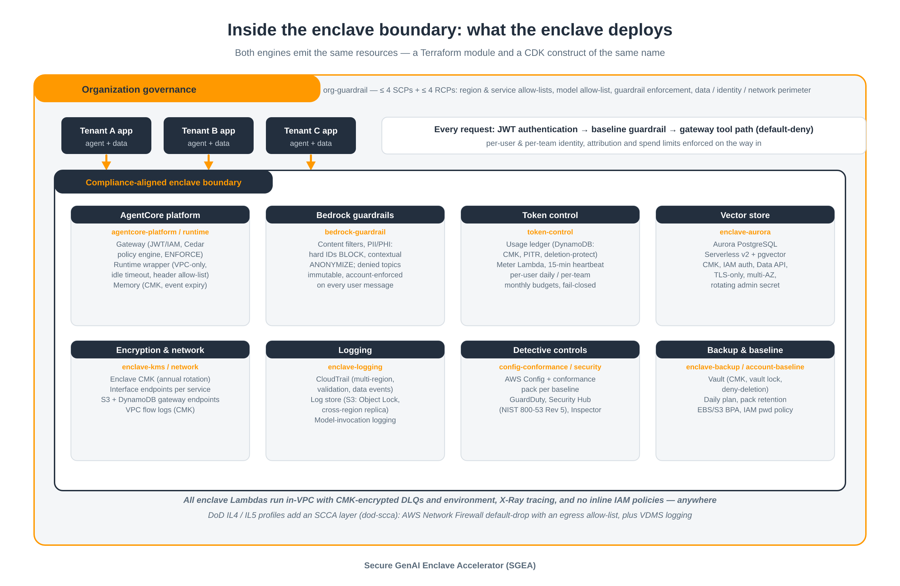
Figure 3. Inside the enclave boundary: what the enclave deploys.
Guardrail enforcement. SGEA generates an Amazon Bedrock guardrail from the profile: content filters, personally identifiable information (PII) and protected health information (PHI) handling where hard identifiers are blocked and contextual entities are anonymized, and denied topics. The guardrail is published as an immutable version and enforced at the account level, so every user message is guarded.
AgentCore gateway and policy. The Amazon Bedrock AgentCore Gateway authenticates callers with JSON Web Tokens (JWT) or AWS Identity and Access Management (IAM) and runs a Cedar policy engine in ENFORCE mode, so tool calls are denied unless explicitly permitted. Where the policy engine is unavailable, such as in AWS GovCloud (US), SGEA's request interceptor enforces the same default-deny rules. The platform layer also provides AgentCore Memory with event expiry, a token-vault key, and an Amazon Elastic Container Registry (Amazon ECR) repository with immutable tags and scan on push. Tenants deploy agents through SGEA's AgentCore Runtime wrapper, which is VPC-only, JWT-authorized, limited to an allow-list of request headers, and restricted to the enclave's VPC endpoints.
Token budgets. A token-control layer enforces per-user daily and per-team monthly budgets. A meter AWS Lambda function reads the model-invocation logs into an Amazon DynamoDB usage ledger, and the gateway interceptor denies tool calls once a caller is over budget. If the meter stops reporting, tool calls fail closed.
Private networking. The enclave creates interface endpoints for every allowed service, only in the Availability Zones each service supports, plus Amazon S3 and DynamoDB gateway endpoints and VPC flow logs.
Logging. AWS CloudTrail is multi-region with log file validation and Amazon Bedrock, AgentCore, and Amazon S3 data events. The S3 log store uses Object Lock, versioning, TLS-only access, a cross-region replica, and an encrypted SNS topic for deletion events. Amazon CloudWatch log groups use the pack-required retention, and Amazon Bedrock model-invocation logging is turned on.
Around that core, one enclave AWS Key Management Service (AWS KMS) customer managed key with annual rotation encrypts logs, data, memory, and the token vault. Amazon Aurora PostgreSQL Serverless v2 provides the vector store, with IAM authentication, the Data API, Multi-AZ, and an RDS-managed rotating secret; a per-application knowledge base wrapper builds on it. AWS Backup protects Aurora, the ledger, and the log stores in a locked vault. Detective controls include an AWS Config recorder with one conformance pack per composed framework, Amazon GuardDuty, AWS Security Hub (NIST SP 800-53 Rev 5), and Amazon Inspector where a pack requires it; each can be switched off where your landing zone already owns it. An account baseline sets default EBS encryption, public-access blocks, an IAM password policy, and a closed default security group.
An organization-level library of service control policies (SCPs) and resource control policies (RCPs) adds region, service, and model allow-lists, guardrail enforcement, and data, identity, and network perimeters. It is bundled into at most four SCPs and four RCPs and applied from the AWS Organizations management account. DoD IL4 and IL5 profiles add a Secure Cloud Computing Architecture (SCCA) layer with AWS Network Firewall (default drop, egress allow-list) and VDMS logging. Throughout, enclave Lambda functions run in the VPC with encrypted dead-letter queues, reserved concurrency, and AWS X-Ray, and no inline IAM policies are used anywhere.
Checked against the frameworks
Generating IaC is only useful if you can see how it maps to the frameworks before you deploy. The sgea check command evaluates a Terraform plan (--plan) or a synthesized CloudFormation template (--cfn) against every required control of the composed frameworks and reports PASS, FAIL, GAP, or NOT-EMITTED for each rule. It exits non-zero on any required FAIL or GAP, and both sgea verify and the sandbox run gate on it.
Coverage is tracked in a register. All 181 distinct AWS Config conformance-pack rules across the nine baselines are either evaluated by sgea check or carry a recorded disposition with a reason, and the catalog build fails if a rule has neither. There are currently no open gaps. The following table shows the per-framework counts.
Framework | Pack rules | Checked by sgea check
FedRAMP Low / Moderate / High | 117 / 129 / 145 | 49 / 54 / 69
HIPAA / HITRUST / FDA Part 11 | 130 / 130 / 129 | 55 / 52 / 57
DoD IL2 / IL4 / IL5 | 130 / 151 / 163 | 53 / 61 / 72

The remaining rules concern services the enclave does not deploy, your landing zone or identity provider, manual processes, or results that are only observable at runtime, and each carries its reason. AWS publishes no conformance rules for Amazon Bedrock and AgentCore, so SGEA adds 43 of its own controls for them. These are marked as SGEA-authored and need ISSO review. The framework catalogs themselves are built from AWS-published sources: Config conformance packs, AWS control-mapping pages, AWS Services in Scope, regional availability, and Amazon Bedrock model authorization. By-design NON_COMPLIANT results are listed as documented exceptions, and open findings flow into each affected profile's manual steps. Continuous integration runs the unit tests and then export plus verify for all eight profiles.
Beyond the IaC
Much of what a framework requires happens outside the code, so each export includes two generated documents alongside it:
- `MANUAL-STEPS.md` lists everything to do before and after deployment: AWS requests (for example, the AWS Lambda concurrent-executions quota, with the exact number the packs require), steps in other accounts (Organizations SCPs, a HIPAA business associate addendum, AWS GovCloud (US) access), landing-zone overlaps, prerequisites you own, process controls, known open findings, and a running-cost estimate. The estimate is a fixed monthly floor from AWS list prices, several hundred US dollars per month before usage, mostly interface endpoints and the Aurora minimum.
- `OPERATIONS.md` is a day-2 runbook for the profile: daily, weekly, monthly, and quarterly checks built from the alarms the enclave actually emits, backup restore tests, concurrency headroom, cost, and a continuous-monitoring evidence calendar for the composed frameworks.
The toolkit also ships one generated page per framework and runbooks for incident response, key and secret management, change and upgrade, tenant onboarding, decommissioning, and access review with break-glass. The tenant onboarding runbook makes the split between enclave and application team explicit, as shown in the following figure.
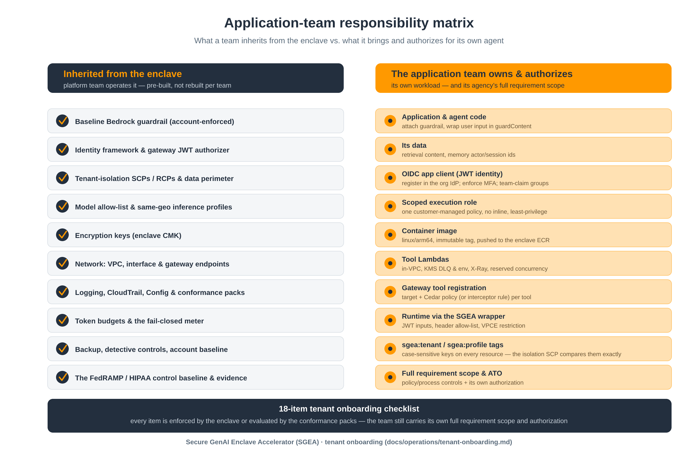
Figure 4. Application-team responsibility matrix — inherited vs. tenant-owned, including the team’s own full requirement scope and authorization.
The tenant team brings its agent code, data, identity provider client, scoped execution role, container image, tool functions, and gateway tool policies, and tags every resource so the tenant-isolation policy applies. Each item is either enforced by the enclave or evaluated by the conformance packs. The team also remains responsible for the full scope of its organization's requirements and its own authorization.
Walkthrough: export, verify, check, and test
The first steps need no AWS credentials. List the shipped baselines and profiles, then export a profile:
python3 sgea.py list
python3 sgea.py export --profile profiles/fedramp-moderate-hipaa.commercial.json --out build
Verify the export. This runs terraform fmt and terraform validate, cdk synth with placeholder inputs, and sgea check --cfn on the synthesized templates:
python3 sgea.py verify --out build/fedramp-moderate-hipaa-commercial # no AWS credentials needed
To check against your own environment, run a read-only terraform plan in the target account and check the plan, or check the CDK template you synthesized with your environment inputs:
python3 sgea.py check --out build/fedramp-moderate-hipaa-commercial --plan plan.json # plan.json = terraform show -json
python3 sgea.py check --out build/fedramp-moderate-hipaa-commercial \
--cfn build/fedramp-moderate-hipaa-commercial/cdk/cdk.out/SgeaEnclave.template.json
To test end to end, use a dedicated sandbox account only. One command deploys a network fixture, the enclave (gated on sgea check), and a sample tenant agent, then runs the end-to-end test. An account-ID guard keeps it from running elsewhere:
examples/run_sandbox_test.sh my-sandbox-profile profiles/fedramp-moderate-hipaa.commercial.json --yes
The sample tenant is an AgentCore Runtime agent with a gateway tool Lambda function and tenant Terraform. The test makes seven checks: an authenticated invocation is answered, the agent's gateway tool call is allowed, a PII prompt is blocked, contextual PII is anonymized rather than blocked, the token meter credits usage, an over-budget caller's tool calls are denied, and an unauthenticated call is rejected. It reports outcomes only, never content. A read-only evidence collector then writes an as-deployed configuration report for each profile and engine, comparing every setting with what the profile requires, mapped to Config rules and NIST SP 800-53 families, with account IDs redacted. An ordered teardown resets the AgentCore token vault and stops the Config recorder before deleting, so the next deployment works.
Supported frameworks and known limitations
The five commercial profiles are sandbox-validated end to end on Terraform and AWS CDK, and the AWS GovCloud (US) profiles pass sgea verify without AWS credentials. The following table lists every shipped profile.
Profile | Frameworks | Status
fedramp-low.commercial | FedRAMP Low | Sandbox-validated, Terraform and CDK
fedramp-moderate-hipaa.commercial | FedRAMP Moderate + HIPAA | Sandbox-validated, Terraform and CDK
fedramp-moderate-hitrust.commercial | FedRAMP Moderate + HIPAA + HITRUST | Sandbox-validated, Terraform and CDK
fedramp-moderate-part11.commercial | FedRAMP Moderate + FDA 21 CFR Part 11 | Sandbox-validated, Terraform and CDK
dod-il2.commercial | FedRAMP Moderate + DoD IL2 | Sandbox-validated, Terraform and CDK
fedramp-high.govcloud | FedRAMP High | Passes sgea verify (AWS GovCloud (US))
dod-il4.govcloud, dod-il5.govcloud | DoD IL4 / IL5 + SCCA | Passes sgea verify (AWS GovCloud (US))

Before you adopt the toolkit, review these limitations:
- The DoD IL4 and IL5 profiles are available for evaluation while AWS completes the AgentCore assessment at those impact levels.
- The SGEA-authored Amazon Bedrock and AgentCore controls and the rule dispositions need ISSO review.
- You close several operational gaps yourself: the enclave emits only three CloudWatch alarms and creates no SNS subscriptions, the token vault must be reset before cdk destroy deletes the key, the SCPs do not deny stopping CloudTrail or Config or scheduling deletion of the enclave key, and there is no break-glass role.
- Tenant Lambda functions need reserved concurrency within the packs' sample range, or tuned pack parameters (finding SGEA-KF-02).
- The SCP and RCP layer is applied from the management account and was not part of the sandbox validation.
- Rebuilding the catalogs requires AWS-published sources and, for some baselines, AWS Artifact reports that you download yourself.
- The enclave has a fixed monthly cost before usage, so tear down sandbox deployments when you finish.
Get started
To try SGEA, clone the repository at [\[GitLab repo URL\]](https://[GitLab-repo-URL]), export a profile, and run sgea verify, which needs no AWS credentials. When you're ready to deploy, follow docs/TESTING.md to test in a dedicated sandbox account, collect the evidence report, and run the ordered teardown to clean up. To go deeper on the services involved, see the Amazon Bedrock and Amazon Bedrock AgentCore documentation and the AWS compliance programs overview. To discuss how an enclave fits your environment, contact your AWS account team or AWS Public Sector.
About the author

Phillip Spies is a senior solutions architect on the AWS Federal Civilian team with 20 years of development and solution architecture experience. He specializes in cloud infrastructure design, container technologies, and generative AI adoption, holding multiple AWS certifications. Phillip builds production-grade generative AI platforms with government agencies, applying proven development practices through a GenAI software development lifecycle (SDLC) approach that takes organizations from concept to deployed capability at speed.

