CRISIL SME Solutions
Somya Vehicles Private Limited

Date: 11/21/2023

Important Notice
The evaluation is a one-time exercise and the evaluation will not be kept under surveillance. CRISIL recommends that the user of the evaluation seeks a review of the evaluation if the organisation experiences significant changes/events during this period which could impact the organisation/its evaluation.
The evaluation and this report are based on the information provided to CRISIL by the organisation and/or obtained by CRISIL from sources it considers reliable including information received from business associates, published annual reports, management meetings, industry data and discussions with bankers, customers and suppliers. CRISIL does not guarantee the accuracy, adequacy or completeness of any information on which the evaluation and the report are based and is not responsible for any errors or omissions for the results/opinions obtained from the use of the evaluation or the evaluation report. The evaluation does not constitute an audit of the organisation by CRISIL. The evaluation is also not a recommendation to enter into or not enter into any transaction with the organisation. CRISIL reserves the right to disclose the organisation’s evaluation and the evaluation report to Government and/or Regulatory Authorities/Courts of Law if required to do so.
It is especially stated that CRISIL, its Directors, Evaluation Committee members, employees and others associated with the evaluation assignment do not have any financial liability whatsoever including but not limited to attorney’s or consultant’s fees to the users of this evaluation or this evaluation report. CRISIL specifically states that it has no financial liability, whatsoever, to any other user of this Report. The report and the information contained in this report are the intellectual property of CRISIL. No part of this report may be reproduced in any form or by any means without the prior written permission. CRISIL or its associates may have other commercial transactions with the company/entity.

Contents
Assessment Score 4
Government Registration verification 4
Company Profile 5
Key Management Personnel 8
Financial Performance 10
Consolidated Financial Performance 18
Statutory Compliances 22
Summary of Background Verification 25
Adverse Media Check 32
Political Exposure Check 33
About CRISIL Market Intelligence & Analytics 34
CRISIL Privacy Notice 34

Assessment Score
Assessment Risk Score
15/100 

Key Indicators
Parameter | Assessment | Risk indicator
Business & Management | - Nature of Business:  - Experience in Years:
Indian Database Check  - Criminal Records  - Civil Litigations  - Credit and Reputational Risk | Adverse records found against Entity/Promoters
Media Check | Political affiliations results against promoters
Compliance checks | Delays in GST Payments & EPFO Payments
Government Registration verification | GST and PAN is verified against database

Parameter
Low Risk
Moderate Risk
High Risk
OPBDIT margin
PAT margin
Return on capital employed
Interest coverage ratio
Debt service coverage ratio
Debt equity ratio
Net cash accruals / Total debt
TOL / TNW
Current ratio
Net worth

Company Profile
About the Company
Somya Vehicles – Mahindra Showroom Indore, specialize in delivering the best in sales & service in automobile industry, we have Mahindra Authorized Showrooms & workshops in different locations of Madhya Pradesh (Indore, Dhar, Kukshi). We are committed to our ever growing customer base. We make these benchmark services available to our valued customers by the amalgamation of dedicated professionals & advanced equipment . It is constant endeavor to provide you with best-in-class services & quality for your Mahindra four wheeler.
Customers comes first and everything we do is to meet our customers need. To setup process and build people who are able to work in synergy to achieve the highest level of customer satisfaction before & after sales and create a customer or lifetime.
Placing customer satisfaction first, we at somya vehicles – mahindra showroom indore, contribute to speedy and efficient sales & service with qualified manpower, allowing customers to experience the convenience & pleasure.
Factsheet
Business Profile
PAN | ABDCS8773P | Verified on | 20-10-2023,5:36 PM
GSTIN | 24ABDCS8773P1ZI | Status | Active
Date of Incorporation | 9/12/2016 | Vintage | 6 Years 1 Month
Constitution | Private Ltd Company | Industry | Trading
CIN | U50100MP2016PTC041462 | Sub Sector
Authorised Capital  (Rs in Lakhs) | 100.00 | Paid up Capital  (Rs in Lakhs) | 100.00
Registered Address | 99, Sharda Vihar, City Centre Gwalior Gwalior Mp 474009 In

Registrar of Company Details
Company Profile
CIN | U50100MP2016PTC041462
Company Name | Somya Vehicles Private Limited
ROC Code | RoC-Gwalior
Registration Number | 41462
Company Category | Company limited by Shares
Company Sub-Category | Non-govt company
Class of Company | Private
Authorised Capital (Rs in Lakhs) | ₹ 100.00
Paid up Capital (Rs in Lakhs) | ₹ 100.00
Number of Members(If Co. w/o Share Capital) | 0
Date of Incorporation | 9/12/2016 | Vintage: | 6 Years 1  Month
Registered Address | 99, Sharda Vihar, City Centre Gwalior Gwalior Mp
Address other than R/o where all or any books of account and papers are maintained | Not Available
Email Id | rakeshshubhi@rediffmail.com
Whether Listed or not | Unlisted
ACTIVE compliance | Not Available
Suspended at stock exchange | Not Available
Date of last AGM | 9/30/2022
Date of Balance Sheet | 3/31/2022
Company Status(for efiling) | Active
Verified on | 10/20/2023 17:23

Business Description
Nature of Business | Trading
Industry
Business profile
Experience in the business
Geographical reach

Key Management Personnel
Promoters Background
Name | Mr.Shweta Agrawal | Mr.Pravesh Kumar Agrawal
Father Name | Not Available | Not Available
DOB/Age | April 10, 1979 | April 01, 1980
Address | Not Applicable | Not Applicable

Shareholding Pattern
 | Equity Shareholders |  | % of Holding
Sl.No | Name | 31-Mar-2023 |  | 31-Mar-2022 | 31-Mar-2021
1 | Mr.SHWETA AGRAWAL | 40.00 |  | 40.00 | 76.19
2 | Mr.PRAVESH KUMAR AGRAWAL | 60.00 |  | 60.00 | 23.81
3 | Mr.MUKESH KUMAR AGRAWAL | 0.00 |  | 0.00 | 33.33
4 | Mr.NIRMALA DEVI | 0.00 |  | 0.00 | 19.05
5 | Mr.KAMESH KUMAR AGARWAL | 0.00 |  | 0.00 | 19.05
6 | Mr.DINESH KUMAR AGARWAL | 0.00 |  | 0.00 | 19.05
7 | Mr.SAMARTH AGARWAL | 0.00 |  | 0.00 | 19.05
8 | Mr.MAMTA AGARWAL | 0.00 |  | 0.00 | 19.05
9 | Mr.RUCHI AGARWAL | 0.00 |  | 0.00 | 19.05
10 | Mr.REKHA AGARWAL | 0.00 |  | 0.00 | 19.05
 | Total | 100.00 |  | 100.00 | 266.67

Auditors
 |  | CA Firms
Name as per document | For RAKESH RAMAN AND Co
Firm ID | 0009337c
Firm Name | For RAKESH RAMAN AND Co
Regd Location | Not Available
Other Locations | Not Available
ID | Member Name
78763 | Mr.RAKESH AGARWAL
Verified on | 11/21/2023

CA Membership Status
 | CA Membership Status
Name as per document | Mr.RAKESH AGARWAL
CA Membership No. | 78763
Associate/Fellow Status | Mr.Fellow (with COP)
Name as per ICAI database | AGARWAL RAKESH
Location | 26 IST FLOOR
Status | ACTIVE
Verified on | 11/21/2023

UDIN Verification Status
 | UDIN Verification Status
UDIN Number | 23078763BGWBRV8035
Status | Active

Financial Performance
Profit and loss account
For the year ended | 3/31/2023 | 3/31/2022 | 3/31/2021
 | Audited | Audited | Audited
Amounts in Actuals | Lakhs | Lakhs | Lakhs
Number of months | 12 | 12 | 12
Net sales | 32,513.28 | 18,097.69 | 11,951.63
Operating income
Cost of sales | 30,142.98 | 16,589.75 | 10,683.37
OPBDIT | 2,370.30 | 1,507.93 | 1,268.26
Interest and finance costs | 260.28 | 139.33 | 138.04
OPBDT | 2,110.02 | 1,368.60 | 1,130.22
Depreciation | 145.43 | 75.99 | 81.36
OPBT | 1,964.59 | 1,292.60 | 1,048.86
Non-operating expense / (Income) | 1,494.25 | 1,075.58 | 891.90
PBT | 470.34 | 217.02 | 156.96
Extraordinary income / (expense)
Reported PBT | 470.34 | 217.02 | 156.96
Provision for taxes | 125.24 | 56.13 | 40.49
Deferred tax liability / (asset) | 0.00 | 0.00 | 0.00
PAT | 345.10 | 160.89 | 116.47
Dividends / Drawings
Net cash accruals | 345.10 | 160.89 | 116.47

Operating income for last 3 Fiscal Years
Particulars | 3/31/2023 | 3/31/2022 | 3/31/2021
Amounts in Lakhs | Lakhs | Lakhs | Lakhs
Not Available
Total | 0.00 | 0.00 | 0.00

Interest and finance costs for last 3 Fiscal Years
Particulars | 3/31/2023 | 3/31/2022 | 3/31/2021
Amounts in Lakhs | Lakhs | Lakhs | Lakhs
Finance Cost (Interest) | 242.10 | 129.87 | 117.88
Other Borrowing Costs | 18.18 | 9.46 | 20.15
Total | 260.28 | 139.33 | 138.04

Non-operating income for last 3 Fiscal Years
Particulars | 3/31/2023 | 3/31/2022 | 3/31/2021
Amounts in Lakhs | Lakhs | Lakhs | Lakhs
Interest Income | 0.00 | 19.74 | 3.11
Other non-operating income | 0.00 | 0.00 | 0.35
Total | 0.00 | 19.74 | 3.46

Long term debt for Latest Fiscal Year - 03-31-2023
Bank name | Facility | Sanction amount (Rs.  Lakh) | O/S amount (Rs lakh)
Amounts in Lakhs | Lakhs | Lakhs | Lakhs
Not Available | Term Loan |  | 756.98
ICICI BANK | Term Loan |  | 231.86
Total | 0.00 | 0.00 | 988.84

Short-term debt for Latest Fiscal Year - 03-31-2023
Bank name | Facility | Sanction amount (Rs.  Lakh) | O/S amount (Rs lakh)
Amounts in Lakhs | Lakhs | Lakhs | Lakhs
Punjab National Bank | CC Limit |  | 1,363.13
Axis Bank | Secured |  | 167.36
ICICI Bank | INF Secured |  | 0.59
Mahindra Finance | Unsecured |  | 675.85
AU Finance | Unsecured |  | 5.06
Cholamandlam Finance | Unsecured |  | 157.26
Sundaram Finance | Unsecured |  | 10.35
Total |  |  | 2,379.60

Other Liabilities & Provision for last 3 Fiscal Years
Particulars | 3/31/2023 | 3/31/2022 | 3/31/2021
Amounts in Lakhs | Lakhs | Lakhs | Lakhs
Reserves and surplus | 884.54 | 539.44 | 378.55
Salary and Reimbursements | 100.62 | 40.12 | 23.97
Contribution to PF | 0.91 | 0.62 | 1.67

Balance sheet
As on | 3/31/2023 | 3/31/2022 | 3/31/2021
 | Audited | Audited | Audited
Amounts in Actuals | Lakhs | Lakhs | Lakhs
Number of months | 12 | 12 | 12
Liabilities
Tangible net worth | 100.00 | 639.44 | 478.55
Deferred tax liabilities / (assets)
Long-term debt | 988.84 | 814.95 | 875.57
of which, current portion of long-term debt
Short-term debt | 2,379.59 | 2,556.78 | 1,097.82
of which, working capital borrowing from banks
Other liabilities and provisions | 1,915.70 | 862.96 | 1,067.07
Total liabilities | 5,384.13 | 4,874.13 | 3,519.01
Assets
Net fixed assets | 1,892.63 | 1,450.70 | 1,442.38
Investments
Inventory | 2,979.29 | 1,748.08 | 1,242.77
Receivables (total) | 277.30 | 172.27 | 106.99
of which, receivables greater than six months
Cash and bank balance | 133.40 | 965.24 | 140.16
Other current assets | 101.51 | 537.83 | 586.72
Total assets | 5,384.13 | 4,874.13 | 3,519.01

Long term debt for Latest Fiscal Year - 03-31-2023
Bank name | Facility | Sanction amount (Rs.  Lakh) | O/S amount (Rs lakh)
Amounts in Lakhs | Lakhs | Lakhs | Lakhs
Not Available | Term Loan |  | 756.98
ICICI BANK | Term Loan |  | 231.86
Total | 0.00 | 0.00 | 988.84

Short-term debt for Latest Fiscal Year - 03-31-2023
Bank name | Facility | Sanction amount (Rs.  Lakh) | O/S amount (Rs lakh)
Amounts in Lakhs | Lakhs | Lakhs | Lakhs
Punjab National Bank | CC Limit |  | 1,363.13
Axis Bank | Secured |  | 167.36
ICICI Bank | INF Secured |  | 0.59
Mahindra Finance | Unsecured |  | 675.85
AU Finance | Unsecured |  | 5.06
Cholamandlam Finance | Unsecured |  | 157.26
Sundaram Finance | Unsecured |  | 10.35
Total |  |  | 2,379.60

Other Liabilities & Provision for last 3 Fiscal Years
Particulars | 3/31/2023 | 3/31/2022 | 3/31/2021
Amounts in Lakhs | Lakhs | Lakhs | Lakhs
Reserves and surplus | 884.54 | 539.44 | 378.55
Salary and Reimbursements | 100.62 | 40.12 | 23.97
Contribution to PF | 0.91 | 0.62 | 1.67
ESI | 0.22 | 0.62 | 0.24
Audit Fees | 5.90 | 4.65 | 3.40
Current Tax Provision | 25.15 | 1.78 | 40.49
TCS | 30.68 | 10.02 | 2.60
Professional Tax | 0.89 | 0.57 | 0.54
TDS | 14.71 | 5.47 | 7.19
Trade Payables | 852.08 | 799.11 | 986.97
Total | 1,915.70 | 1,402.40 | 1,445.62

Other Current Assets for last 3 Fiscal Years
Particulars | 3/31/2023 | 3/31/2022 | 3/31/2021
Amounts in Lakhs | Lakhs | Lakhs | Lakhs
Unsecured, Considered goods | 1.10 | 434.24 | 363.62
Seurity Deposit | 79.35 | 82.30 | 76.12
TDS Receivable | 0.00 | 2.47 | 9.21
Advance | 0.00 | 5.20 | 2.33
Other | 21.06 | 13.62 | 135.44
Total | 101.51 | 537.83 | 586.72

Key Financial Ratios
For the year ended / as at |  | 3/31/2023 | 3/31/2022 | 3/31/2021
OPBDIT margin | % | 2.69 | 2.28 | 3.12
PAT margin | % | 1.06 | 0.89 | 0.97
Return on capital employed | % | 17.47 | 11.03 | NM
Gross current assets | days | 38.00 | 59.00 | 50.00
Days inventory (on COP) | days | 34.00 | 36.00 | 39.00
Days receivable (on gross sales) | days | 3.00 | 3.00 | 3.00
Days payable (on materials) | days | 10.00 | 18.00 | 34.00
Current ratio | Times | 1.00 | 0.85 | 0.76
PBDIT Interest cover | Times | 3.37 | 3.10 | 2.73
Net cash accruals/Total debt | % | 14.56 | 7.03 | 10.03
Debt service coverage ratio | Times | 2.56 | 0.04 | 1.05
Average cost of borrowing | % | 7.72 | 5.21 | NM
Total outside liabilities/Tangible net worth | Times | 4.47 | 6.62 | 6.33
Gearing - Total debt/Tangible net worth | Times | 3.42 | 5.27 | 4.12
Gearing (not including promoter loans as debt) | Times | 3.42 | 5.27 | 4.12

NM: Not Meaningful

Notes:

Graphs
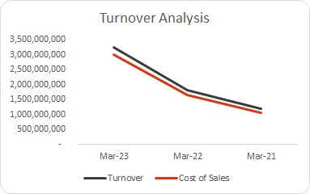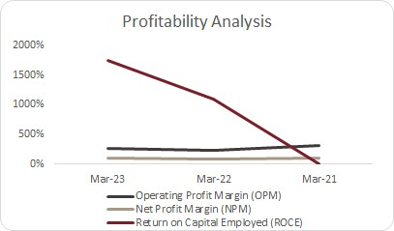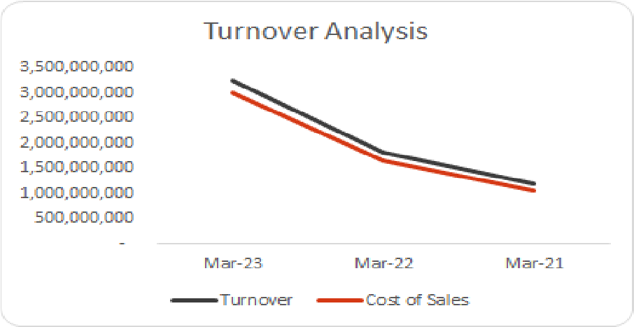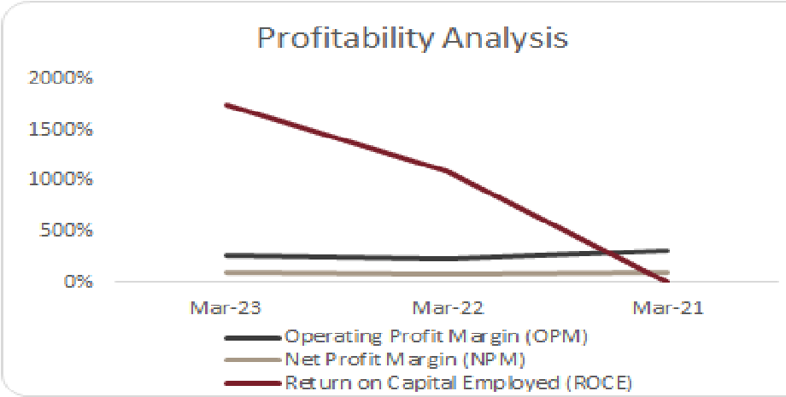
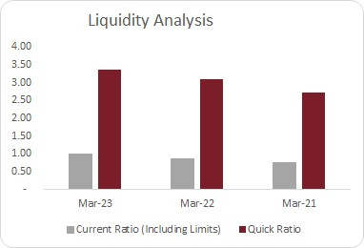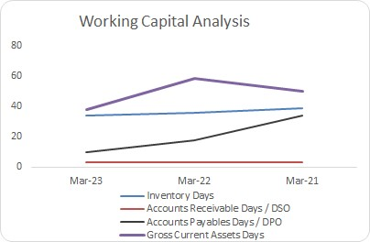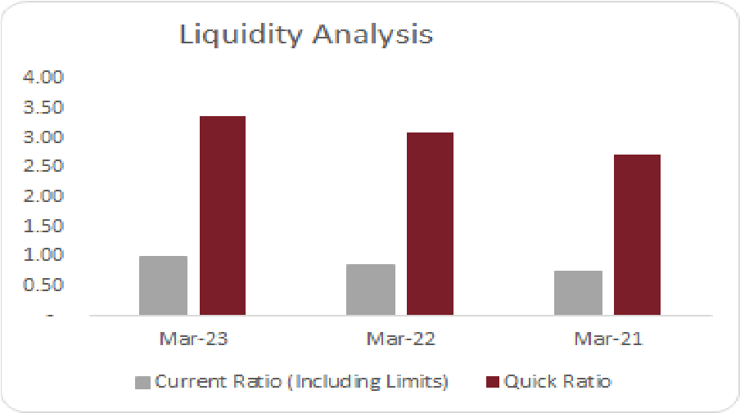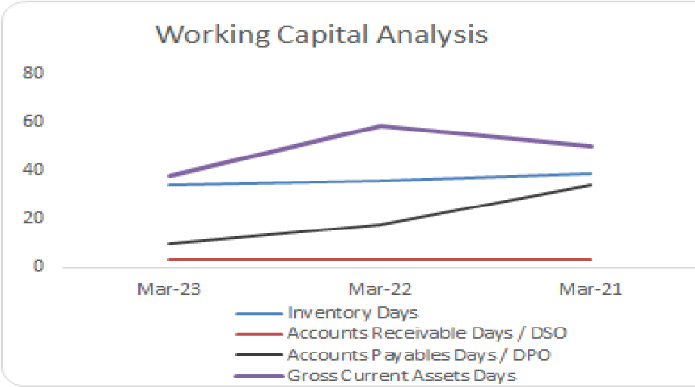
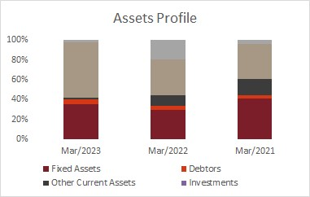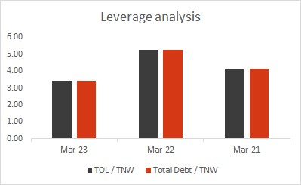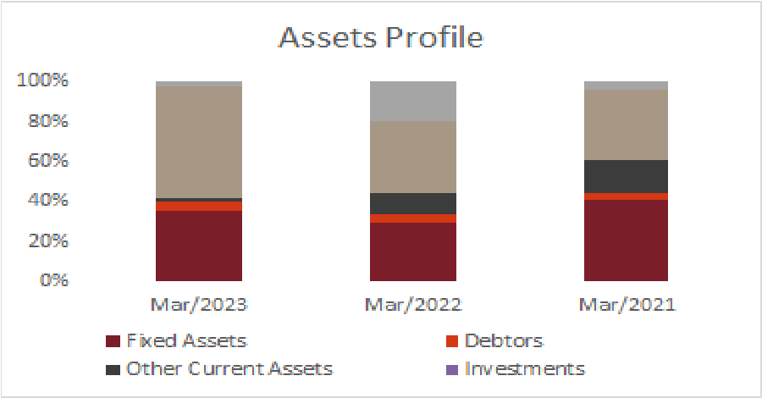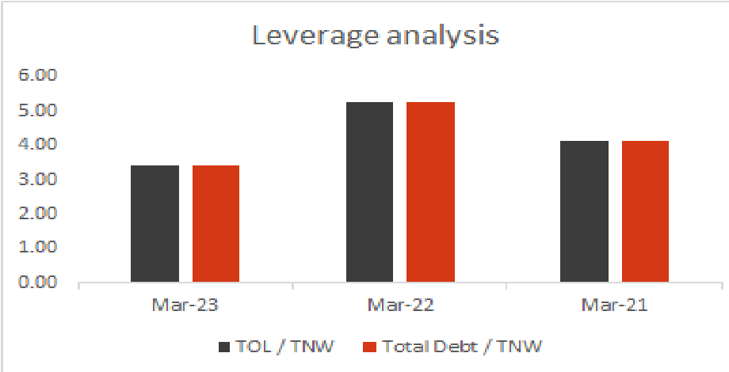

Consolidated Financial Performance
Not Applicable

MCA Charges
Charges Registered
Sl. No | SRN | Charge Id | Charge Holder Name | Date of Creation | Date of Modification | Date of Satisfaction | Amount | Address
1 | AA57758 26 | 100793765 | Bank Of Baroda, Nipaniya Branch | 9/28/2023 | - | NA | 1,040 | Plot No. 12 - Rc, Main  Road, Ground  Floorscheme-134 ,  Nipaniaindoreindoremp45 2016in
2 | AA42890 94 | 100769759 | Kotak Mahindra Bank Limited | 8/18/2023 | - | NA | 298 | 27bkc, C 27, G Block  Bandra Kurla Complex,  Bandra (e),bandra Kurla  Complexmumbaimumbai mh400051in
3 | AA32762 95 | 100733885 | Icici Bank Limited | 03/29/2023 | 06/15/2023 | NA | 2,300 | 4 Chhoti Khajrani Malav Parisar,ab Road  Indoreindoreindore45200 1in
4 | AA10523 22 | 100622515 | Icici Bank Limited | 10/03/2022 | - | NA | 1,200 | Zonal Branch Office At 4, Chhotikhajrani, Malav  Parisar,indoreindoremp452 001in
5 | G285032 66 | 100065021 | Punjab National Bank | 10/25/2016 | - | NA | 938 | Sarafa  Bazargwaliormp474001in
6 | G733085 61 | 100065019 | Punjab National Bank | 9/15/2016 | 8/24/2017 | NA | 2,500 | Sarafa  Bazargwaliormp474001in

Government Registration Verification
a. GST Verification
Good | s & Service Tax
GSTIN/UIN | 24ABDCS8773P1ZI
Legal Name of Business | Somya Wheels Private Limited
Trade Name | Somya Wheels Private Limited
Effective Date of registration | 7/27/2020
Constitution of Business | Private Limited Company
GSTIN / UIN Status | Active
Taxpayer Type | Regular
Principal Place of Business | Plot no 23/B, Gayatrinagar Society, Desainagar, Bhavnagar, Bhavnagar, Gujarat, 364001
Administrative Office | Not Applicable
Other Office | Not Applicable
Effective Date of Cancellation
Verified on | 10/20/2023 17:33

b. PAN Card Verification
Firm / Company Name
1 | Individual Name | Mr.Shweta Agrawal
1 |  | PAN
1 | Document | Not Available
1 | Name as per Document | Mr.Shweta Agrawal
1 | ID No. | AANPP1360M
1 | Name as per Database | Mr.Shweta Agrawal
1 | DOB / Age | 4/10/1979
1 | Address | Not Applicable
1 | Issued Date | Not Applicable
1 | Status | Active
1 | Father Name | Not Available
1 | Verified on | 20-10-2023,5:43 PM
2 | Individual Name | Mr.Pravesh Kumar Agrawal
2 |  | PAN
2 | Document | Not Available
2 | Name as per Document | Mr.Pravesh Kumar Agrawal
2 | ID No. | AKEPA2876N
2 | Name as per Database | Mr.Pravesh Kumar Agrawal
2 | DOB / Age | 4/01/1980
2 | Address | Not Applicable
2 | Issued Date | Not Applicable
2 | Status | Active
2 | Father Name | Not Available
2 | Verified on | 20-10-2023,5:43 PM

Statutory Compliances
ITR
 | ITR-Verification
Name | Pravesh Kumar Agrawal | PAN | AKEPA2876N
Year (AY) | 2023-24 | 2023-22 | 2021-22
Acknowledgement Number | 316639671270923 | 288263520300722 | 549042980291221
Status | Under Processing | Return Processed with No Demand and No  Refund | Return Processed with No Demand and No Refund
Filed On | 9/27/2023 | 7/30/2022 | 12/29/2021
Filing Due Date | 07/31/2023 | 07/31/2022 | 1/10/2021
Verified On | 20-10-2023,6:19 PM | 20-10-2023,6:24 PM | 20-10-2023,6:26 PM
Delay Status | Delayed | Timely | Delayed

GSTR
Sl. No | Return Type | Financial Year | Tax Period | Date of filing | Status | Days Delayed
1 | GSTR3B | 2023-2024 | September | 10/20/2023 | Filed | Timely
2 | GSTR3B | 2023-2024 | August | 09/20/2023 | Filed | Timely
3 | GSTR3B | 2023-2024 | July | 8/19/2023 | Filed | Timely
4 | GSTR3B | 2023-2024 | June | 7/19/2023 | Filed | Timely
5 | GSTR3B | 2023-2024 | May | 6/20/2023 | Filed | Timely
6 | GSTR3B | 2023-2024 | April | 5/20/2023 | Filed | Timely
7 | GSTR3B | 2022-2023 | March | 4/19/2023 | Filed | Timely
8 | GSTR3B | 2022-2023 | February | 3/20/2023 | Filed | Timely
9 | GSTR3B | 2022-2023 | January | 2/20/2023 | Filed | Timely
10 | GSTR3B | 2022-2023 | December | 1/20/2023 | Filed | Timely

EPFO
 |  | Payment Table
Date Of Credit | Wage Month | Amount (Rs) | No of Employees | Status | Days Delayed | ECR
10/15/2022 16:35 | Sep-23 | 93,286 | 51 | Filed | Timely | YES
11/15/2022 17:19 | Oct-23 | 93,099 | 51 | Filed | Timely | YES
12/15/2022 18:42 | Nov-23 | 90,718 | 52 | Filed | Timely | YES
1/14/2023 18:39 | Dec-23 | 89,260 | 50 | Filed | Delayed | YES
2/15/2023 20:08 | Jan-23 | 92,074 | 49 | Filed | Timely | YES
3/15/2023 14:17 | Feb-23 | 91,783 | 49 | Filed | Timely | YES
4/17/2023 21:45 | Mar-23 | 90,599 | 49 | Filed | Timely | YES
5/15/2023 19:13 | Apr-23 | 94,109 | 50 | Filed | Timely | YES
6/15/2023 23:36 | May-23 | 88,995 | 50 | Filed | Timely | YES
7/19/2023 17:05 | Jun-23 | 91,429 | 50 | Filed | Timely | YES
8/16/2023 19:18 | Jul-23 | 91,230 | 50 | Filed | Timely | YES
9/15/2023 16:51 | 45,161 | 91,380 | 50 | Filed | Timely | YES

ESIC
 | Establishment Details
Name | Not Available
Establishment Code | Not Available
Address | Not Available
IP Count | Not Available
Verified on | Not Available

Summary of Background Verification
Litigations
Check Status - Entity / Individuals - High Accuracy
Name | Status | Remarks
Somya Vehicles Private Lim | Case Found | Cases found with 100% Name match + Address state match
Shweta Agrawal | All Clear | No Cases found with 100% Name match + Address state match
Pravesh Kumar Agrawal | All Clear | No Cases found with 100% Name match + Address state match

Crime Check Status - Parameters Level
Matching Criteria | Cases found with 100% Name match + Address state match
Name  Somya Vehicles Private Lim | Criminal Records  Case Found | Civil Litigations  Case Found | Tribunals  Record  All Clear | Defaulter Lists  All Clear | FIR & Other  Records  All Clear | Intellectual Property Database  All Clear
Shweta Agrawal | All Clear | All Clear | All Clear | All Clear | All Clear | All Clear

Pravesh Kumar Agrawal All Clear All Clear All Clear All Clear All Clear All Clear

 | Crime Check
Name: | SOMYA VEHICLES PRIVATE LIMITED
Summary: | SOMYA VEHICLES PRIVATE LIMITED has 7 cases registered.
Risk Indicator: | Very High Risk
Risk Interpretation: | Court Records have high impact on financial liability of the person. May refrain from providing loans and services.
Verified on: | 21-10-2023,9:52 AM

Case No | Case Against | Case Type | Matching Criteria | Act And Section | Status | Petitioner | Respondent | Court | Risk/judgement/order Summar | Order Link
1 | Somya Vehicles Private Limited | Criminal | Not Available | Not Available | Pending | Sudhir Patel | Manager Soumya Vehicle Pvt. Ltd. | District And Sessions Court, Indore | Not Available | Not Available
2 | Somya Vehicles Private Limited | Civil | Not Available | Not Available | Unknown | Dhananjay Tiwari | Narendra Dixit, G.m., Somya Vehicles Pvt.ltd. | Consumer Court | Not Available | Not Available
3 | Somya Vehicles Private Limited | Civil | Not Available | Not Available | Pending | Durga Bai Rathore | Ram Rawal | District And Sessions Court, Indore | Not Available | Not Available
4 | Somya Vehicles Private Limited | Civil | Not Available | Not Available | Unknown | Dr Anu Gupta (raghuwanshi) | Somya Vehicle Private Limited And  Other | Consumer Court | Not Available | Not Available
5 | Somya Vehicles Private Limited | Criminal | Not Available | Not Available | Pending | Somya Vehicles Pvt. Ltd. Through Santosh Bhawsar | Gagan Bhadoriya | District And Sessions Court, Indore | Not Available | Not Available
6 | Somya Vehicles Private Limited | Criminal | Not Available | Not Available | Pending | Soumya Vehicle Pvt. Ltd. Through Santosh Bhavsar | Abhilash Gupta | District And Sessions Court, Indore | Not Available | Not Available

 | Crime Check
Name: | SOMYA VEHICLES PRIVATE LIMITED
Summary: | SOMYA VEHICLES PRIVATE LIMITED has 9 cases registered.
Risk Indicator: | Very High Risk
Risk Interpretation: | Court Records have high impact on financial liability of the person. May refrain from providing loans and services.
Verified on: | 21-10-2023,10:04 AM

Case No | Case Against | Case Type | Matching Criteria | Act And Section | Status | Petitioner | Respondent | Court | Risk/judgement/order Summar | Order Link
1 | Somya Vehicles Private Limited | Criminal | Not Available | Not Available | Pending | Sudhir Patel | Manager Soumya Vehicle Pvt. Ltd. | District And Sessions Court, Indore | Not Available | Not Available
2 | Somya Vehicles Private Limited | Civil | Not Available | Not Available | Unknown | Dhananjay Tiwari | Narendra Dixit, G.m., Somya Vehicles Pvt.ltd. | Consumer Court | Not Available | Not Available
3 | Somya Vehicles Private Limited | Civil | Not Available | Not Available | Pending | Durga Bai Rathore | Ram Rawal | District And Sessions Court, Indore | Not Available | Not Available
4 | Somya Vehicles Private Limited | Civil | Not Available | Not Available | Unknown | Dr Anu Gupta (raghuwanshi) | Somya Vehicle Private Limited And Other | Consumer Court | Not Available | Not Available
5 | Somya Vehicles Private Limited | Civil | Not Available | Not Available | Unknown | Shivnarayan S/o Shambhulal Choudhary | Somya Vehicle | Consumer Court | Not Available | Not Available
6 | Somya Vehicles Private Limited | Civil | Not Available | Not Available | Unknown | Satish Meena | Soumya Vehicle And Other | Consumer Court | Not Available | Not Available
7 | Somya Vehicles Private Limited | Criminal | Not Available | Not Available | Pending | Somya Vehicles Pvt. Ltd.  Through Santosh Bhawsar | Gagan Bhadoriya | District And Sessions Court, Indore | Not Available | Not Available
8 | Somya Vehicles Private Limited | Criminal | Not Available | Not Available | Pending | Soumya Vehicle Pvt. Ltd.  Through Santosh Bhavsar | Abhilash Gupta | District And Sessions Cour | Not Available | Not Available

Check Status - Entity / Individuals - High Coverage
Name | Status |  | Remarks
Somya Vehicles Private  Shweta Agrawal | Case Found  All Clear | Cases found with 50% Name match + Address state match  No Cases found with 50% Name match + Address state match
Pravesh Kumar Agrawa | All Clear | No Cases found with 50% Name match + Address state match
Matching Criteria | Cases found with 50% Name match + Address state match
Name  Somya Vehicles Private | Criminal Records  Case Found | Civil Litigations  Case Found | Tribunals Record  All Clear | Defaulter Lists  All Clear | FIR & Other Records  All Clear | Intellectual Property Database  All Clear
Shweta Agrawal | All Clear | All Clear | All Clear | All Clear | All Clear | All Clear

Crime Check Status - Parameters Level
Pravesh Kumar Agrawa All Clear All Clear All Clear All Clear All Clear All Clear

Adverse Media Check
Date of search | Source | Particulars | Comments
 |  | Somya Vehicles Private Limited
 |  | Shweta Agrawal | https://indiankanoon.or g/docfragment/985389
11/21/2023 | Limited internet search |  | 15/?formInput=SHWET  A%20AGRAWAL
11/21/2023 | Limited internet search | Pravesh Kumar Agrawal
Search methodology used | The below criteria are used to determine which articles to include:  >The first 5 hits returned by google are reviewed in detail.  >When reviewing the article, at least one keyword should be in general proximity to the person’s name or company name.  >Reputable sites are searched (newspapers, regulatory sites, government agencies, etc.) people’s comments on blogs are ignored.  Search Result:

Political Exposure Check
Political Exposure
Name | Mr.Shweta Agrawal
Name as per Document | No Data Found
ID / No. | Aanpp1360m
Name as per Database | No Data Found
DOB / Age | No Data Found
Address | No Data Found
Status | No Match
Verified on | 21-10-2023,8:21 Am
Political Exposure
Name | Mr.Pravesh Kumar Agrawal
Name as per Document | No Data Found
ID / No. | Akepa2876n
Name as per Database | No Data Found
DOB / Age | No Data Found
Address | No Data Found
Status | No Match
Verified on | 21-10-2023,8:22 Am

About CRISIL Limited
CRISIL is a leading, agile and innovative global analytics company driven by its mission of making markets function better. I t is India's foremost provider of ratings, data, research, analytics and solutions with a strong track record of growth, culture of innovation, and global footprint. It has delivered independent opinions, actionable insights, and efficient solutions to over 100,000 customers through businesses that operate from India, the US, the UK, Argentina, Poland, China, Hong Kong, UAE and Singapore.
It is majority owned by S&P Global Inc, a leading provider of transparent and independent ratings, benchmarks, analytics and data to the capital and commodity markets worldwide.
For more information, visit www.crisil.com
Connect with us: LINKEDIN | TWITTER | YOUTUBE | FACEBOOK | INSTAGRAM

About CRISIL Market Intelligence & Analytics
CRISIL Market Intelligence & Analytics, a division of CRISIL, provides independent research, consulting, risk solutions, and data & analytics. Our informed insights and opinions on the economy, industry, capital markets and companies drive impactful decisions for clients across diverse sectors and geographies.
Our strong benchmarking capabilities, granular grasp of sectors, proprietary analytical frameworks and risk management solutions backed by deep understanding of technology integration, make us the partner of choice for public & private organisations, multi-lateral agencies, investors and governments for over three decades.

CRISIL Privacy Notice
CRISIL respects your privacy. We may use your personal information, such as your name, location, contact number and email id to fulfil your request, service your account and to provide you with additional information from CRISIL. For further information on CRISIL’s privacy policy please visit www.crisil.com/privacy.
Argentina | Australia | China | Hong Kong | India | Japan | Poland | Singapore | Switzerland | UAE | UK | USA
CRISIL Limited: CRISIL House, Central Avenue, Hiranandani Business Park, Powai, Mumbai – 400076. India Phone:
+ 91 22 3342 3000 | Fax: + 91 22 3342 3001 | www.crisil.com

