Web navigation

Every year people spend hundreds of thousands of dollars to climb to the top of Mount Everest in Nepal. The question is: is it more important to get to the top of Mount Everest or is it more important to get back to base camp?

As information architects and Web developers, we create navigation systems. We want to create a navigation system that allows people to go into the content and come back out again. Web navigation is a metaphor for our ability to move from information piece to information piece within a Web site. Like our Mount Everest climbers - we want to get back home.

As with any kind of navigation system we use information to represent our progress from where we are now to where we want to be. For example, books are a means of navigating through an information space.

Books have the binding on one side and the pages are available either in single sequence – beginning to end, first to last, or you can, because of page numbers, start at a known spot in the sequence of pages and continue from there. Subsequent additions such as chapters, table of contents, indices, and the like have all added to our ability to simply pick up a book and use it. It is such a strong set of conventions that we barely think about it – in fact when have any of us had a conversation about page numbers?

What is it about book navigation that you need to know and how does it apply to Web navigation?

The reason book navigation is effective, and what good navigation is in general, is based primarily on two key factors: it is easy to learn, and it is consistent. In fact, our mental model of what a book is is so concrete we rarely think about it.

When we are building our navigation systems we need to keep this in mind. How do we simplify? What is simple navigation? What is consistent navigation?

An example of complex navigation are drop-down menus. Drop-down menus are a solution to the problem of limited space in the browser window. However, the actions of the menus, appearing and disappearing, moving, requires a sophisticated use of a pointing device – a mouse – which can be difficult for novices and people with mobility issues. Or just difficult in general.

Another way of thinking about navigation (and interfaces) is as a cup of tea. Let me ask – is there a difference in your experience of a cup of tea when you drink it from a Styrofoam cup or a china teacup? Usually, the thing that contains the content, in this case tea, has a direct bearing on our enjoyment of that content even though it is not a component of that content. In fact, a truly effective interface almost entirely disappears and allows us to enjoy the content. Like a fine teacup – we enjoy the tea and don’t think about the teacup at all.

Consistency is how we manage cause and effect – our most important means of insuring consistency is how we name pieces of content. These navigation terms, also called link names, are critical to how we create an effective experience in the Web sites we are developing. In the first place, we want to use common conventions. The main page is called “Home”. Why? Who knows? But this is the most commonly used link term and everyone knows what it means.

These conventions were also so strong that Web designers have adopted them. We talk about Web “pages”, we use type and images just like books do. But like any metaphor it can only go so far. It is up to us to create a navigation system that is simple and consistent so that our users can enjoy the content our clients are providing.

Types of navigation
As you have read in the lecture notes different purposes and different needs will have an impact on the types of navigation that we provide for the content. Your features will guide you on what type of navigation you will need for your users. For general browsing with the Web site as a whole we will have five kinds of navigation: primary, secondary, tertiary, required, and special. Each of these have their purpose, placement, and content to provide.

Primary navigation
This is the main navigation and should be on every page. As you look at your content you will determine what categories should be in this navigation – these are the content that contains either the main message or the products the Web site owner sells.

In general, this navigation is placed across the top horizontally. The hierarchy is the most important is at the left and as you move along, left to right, the navigation goes in reducing importance. This navigation is also repeated at the bottom of the page. You have to use the same words in the same sequence otherwise you risk confusing your user. Some Web sites will also outline the secondary navigation at the bottom of the page – there is search engine benefits for doing this.

Secondary navigation
Based on the primary navigation the secondary navigation provides more content in these areas. Rather than being on every page – this navigation is tied to the primary navigation term. This navigation will change if you move away to another section from the primary navigation.

In general, this navigation is placed along the vertical at the left-hand side. (If we were reading left to right – it would go along the right-hand side.)

Tertiary navigation
Tied to the secondary navigation we occasionally need to go this deep into the content. For general browsing we should avoid having a third level as it is often not within the needs of the user. It depends upon the content and whether the information needs to be presented somewhere. When we get this deep into the content we will need a different design to incorporate this sort of links. Policy manuals, rule books, and product catalogs sometimes need this kind of navigation. The fourth level down is called quadrennial by the way.

Required navigation
There are three links that have to appear on your Web sites. They are Copyright, Privacy, and Terms of Use. Each of these represent the contractual nature of having a Web site and represent how the Web site owner understands and plans to work with legal content. By putting these links on every page we are creating a close proximity to the legal content. This proximity means that our visitors have access to the information in almost all interactions and makes these terms more binding. If they choose not to read the information – that is their choice but they would not be able to say that they could not find the information.

Special Navigation

There may be navigation needed to fulfill a certain task. For example, if you needed to warn people of a situation in your area but putting up a security alert. Or, in the case of European Web sites, you have ask for explicit acceptance of your Web site’s cookies. Almost every Web site you will work on will have some sort of special navigation you will have to know about and create.

Finally

The answer to the question is you want to get back to base camp. What this means is that we want to create a navigation scheme that takes our visitors into the content and get back again. It is a complete system that lets them work and enjoy the content we have put together.

How to create a navigation system

There are all sorts of ways to create navigation systems – but here is how to start from nothing and build up to a final system. You and your client will sit down and determine what are the goals and objectives having a Web site. For example if they are selling something – then the focus will be on their products. If they are providing a service – then what are the services provided and what does the Web site visitor need to know. Each client will be different and you will have to take them through the process. What you are creating are distinct content pieces that can be grouped together under a single name. You might be able to divide them into smaller pieces with other names as you drill down to those final places where they would expect the visitors to go.

Shoes for example – this would be Shoes, Men’s shoes, type of shoe, colours, sizes, and price.

Service for example – Name of the service, how it is offered, what is done to the customer, what the customer needs to do, and fees.

Each of these categories can be refined further but your job is to create a navigation that anyone can use and you have to start somewhere. If you get too concerned about finding out everything – you may never start!

Using boxes

We use boxes to represent content. A box has a label representing the content. Each discrete piece of navigation is a box. Each box can lead to another box. You can move in any direction to reach a particular box. Boxes do have a hierarchy and it looks like this:

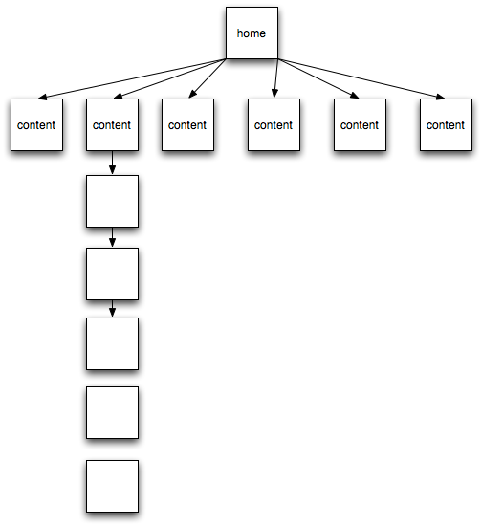
Figure 1: starting site architecture

Each box is a discrete piece of content – so from the previous example –

Shoes, men’s shoes, running, size, colour, product. Each of these would be a box.

It is important to remember that we are create a model with this document and not the actual Web site. As a model it will not give us all of the information nor will it be complete – however it will represent the Web site which is what we want. It is also important to note that these documents are easy to create and easy to change. They act as a means of communicating with the Web site owner, your client, who is paying you, and gets them to give you the information you need to create the Web site. And they can do so in way that makes sense to them and to you. Your clients love documents like the one above because they can understand them.

A final site architecture might look something like this:

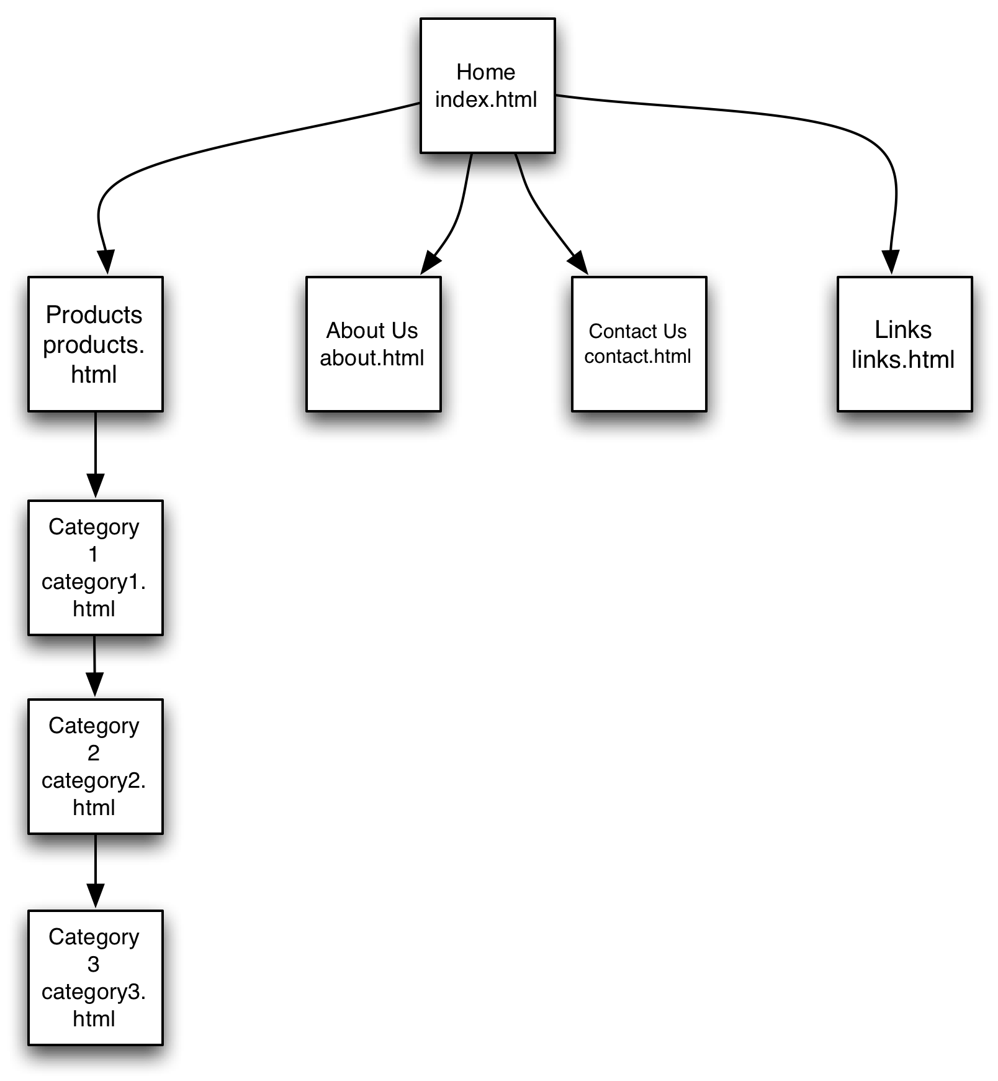
Figure 2: finished site architecture

Each box has a link title and a file name or in the case of a CMS this would be the final part of the URI (Universal Resource Identifier – used for the files you point to with your browser.)

This is a simple version of a Web site architecture – you should get the idea. A more complex Web site will have a more complex architecture covering several pages. As the author of this kind of a document you have to be careful to ensure that if you are going over different pages that your reader knows where they are going.

Site structure

Another thing to keep in mind is where are you putting the files you are creating. One of the most common mistakes new developers make is that they do not know or do not write the correct link to the file they are using. In order to prevent this kind of error it is best to write out your site structure or folder structure in advance and then make sure everyone on the team is using it.

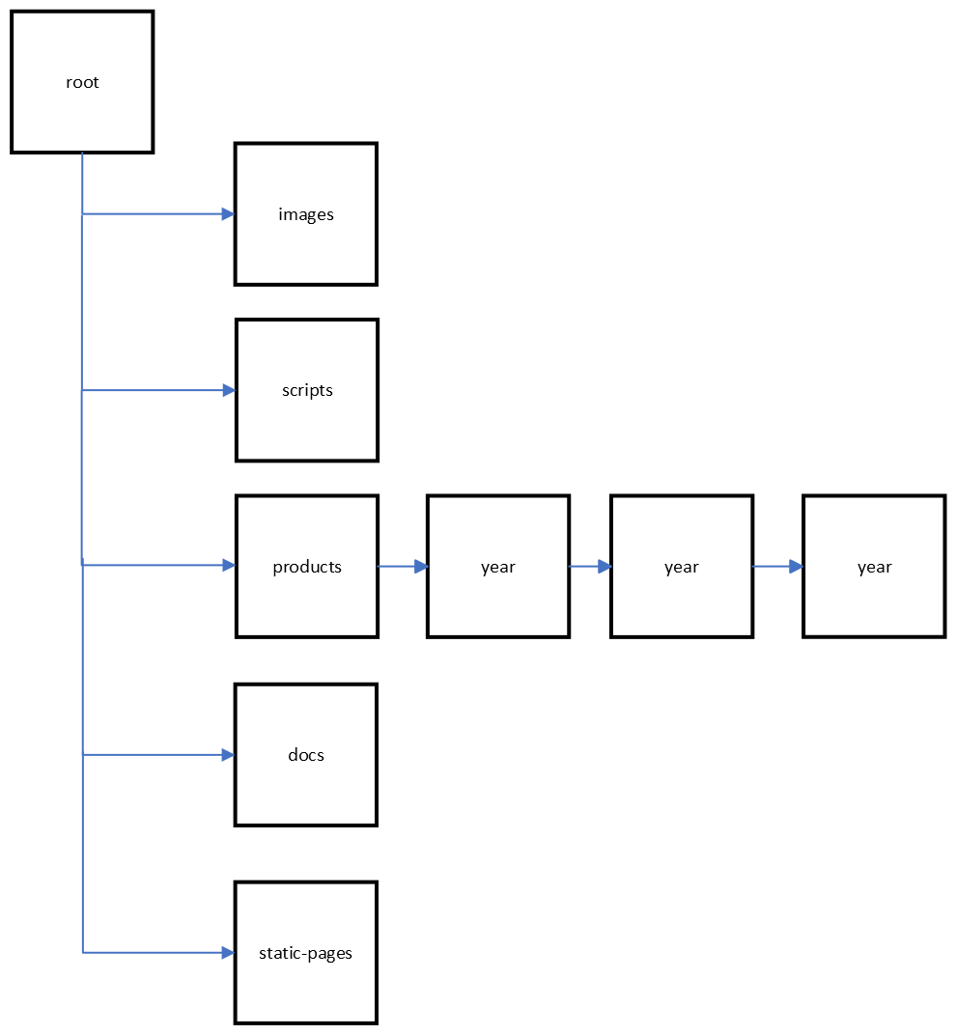
Figure 3: site structure

The folder names are up to you, your client, and your team. Make sure they reflect the contents and are easy to understand just by reading the name. Your content will also dictate how to arrange some folders. For example the folders above reflect a client who has different content every year. This is reflected in the structure of products and years.

Your task this week is to pick a large Web site – ebay, Youtube, Adobe for example. Then you will determine what is the primary navigation (hint: it is the navigation on every page) and the secondary navigation. You will create a chart like I have done above. You can use any software you like, Figma, Miro, Visio, Photoshop, and so on but send me a screenshot as a png. Send that file to me by email before 5 pm tomorrow.

