**Ansible(Configuration Management) Tool**

**Establish passwordless ssh connection from controller to server1 and Server2**

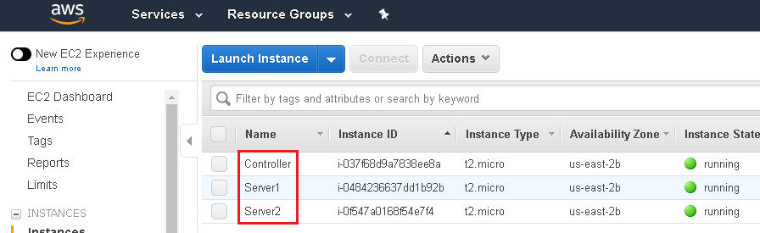

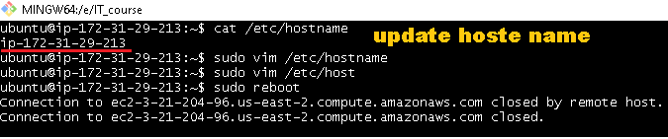

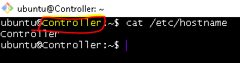

**Server1 & server2:**

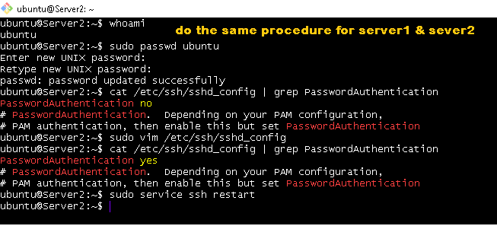

**Controller:**

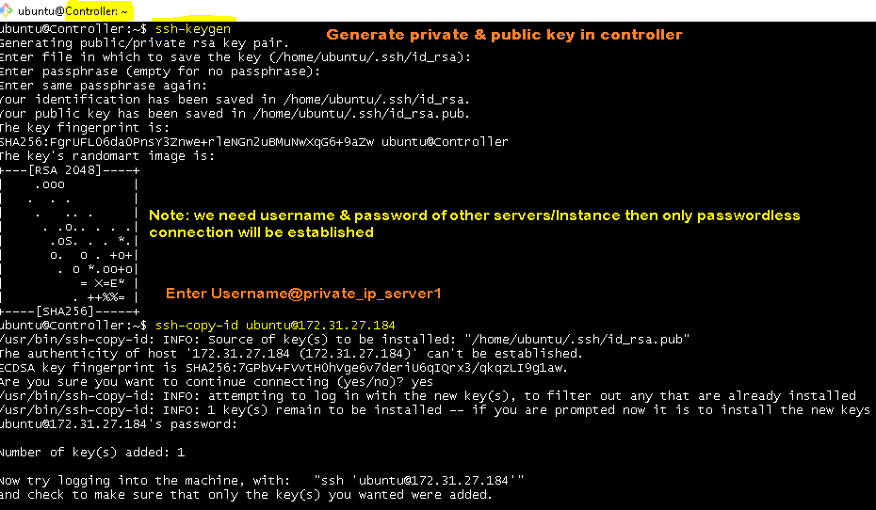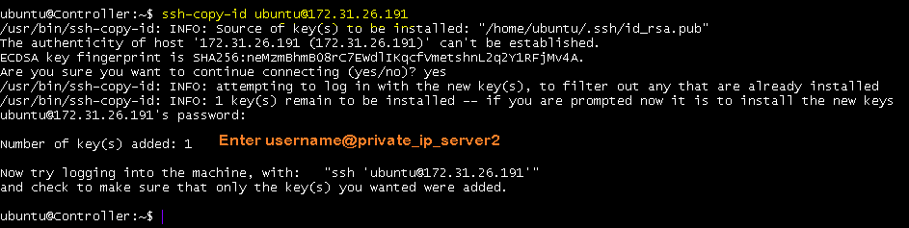

**Installing Ansible on Ubuntu**

**Note refer to google—we will get the below installation steps**

**$ sudo apt update**

**$ sudo apt install software-properties-common**

**$ sudo apt-add-repository --yes --update ppa:ansible/ansible**

**$ sudo apt install ansible**

**Validation:**

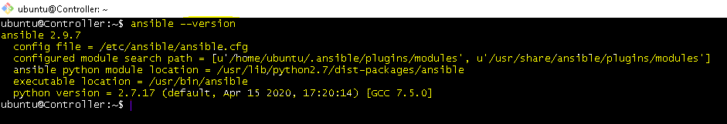

**Note: Ansible store all the remote Servers ip’s into a file called Inventory file**

**We should open the file & store the ip address of all the managed nodes here**

**# sudo vim /etc/ansible/hosts**

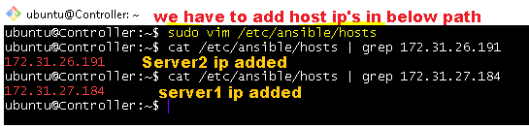

**Architecture**

**Managed Node / Hosts**

7

7

7

8

8

8

**Controller**

**Ansible can perform remote configuration of servers in 3 different ways**

**Important modules in Ansible**

**Command:**

This is the default module of Ansible.

It is used for executing basic Linux command on remote server

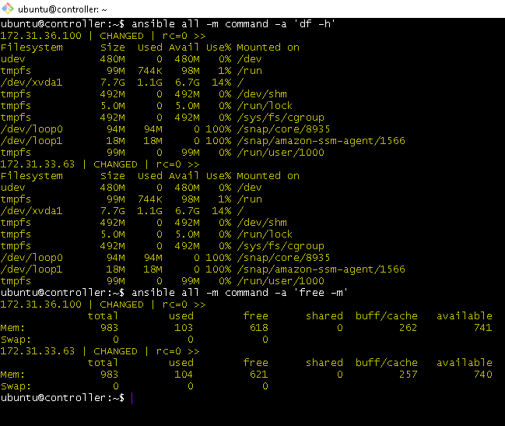

**Shell:**

This is used for executing shell scripts.

Command which use re-direction (o/p file can be used as i/p file to others)

and pipeing ( i/p file can be used as o/p file)

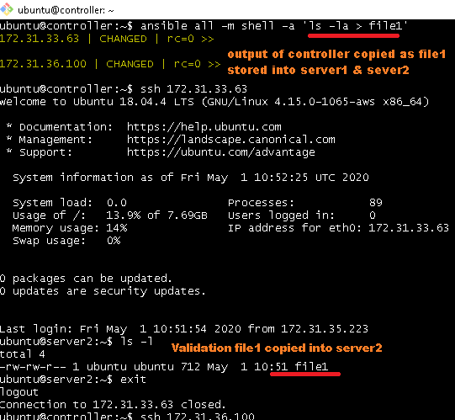

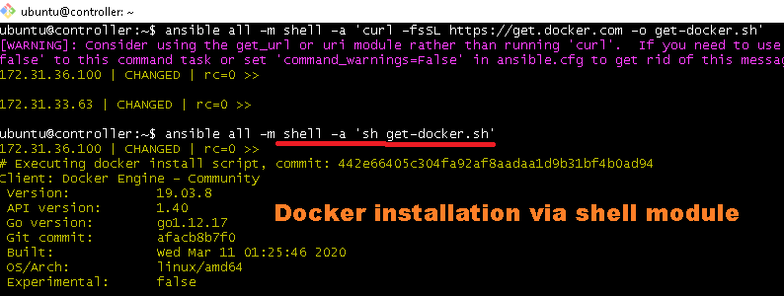

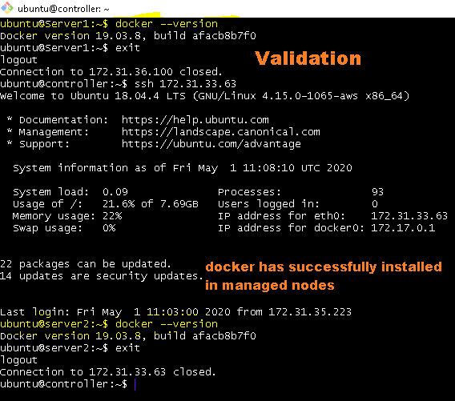

**Ping:**

This is used for checking if the remote servers are pingable or not

**User:**

This is used for performing user administration on Manage nodes

**Ex:** creating users, assigning home directories, default working shell…

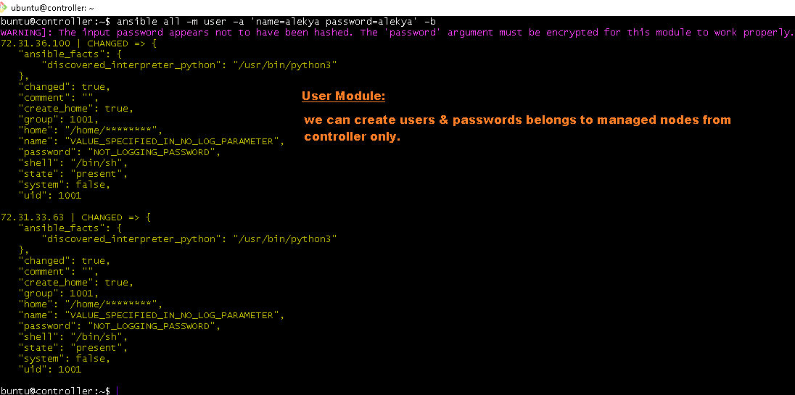

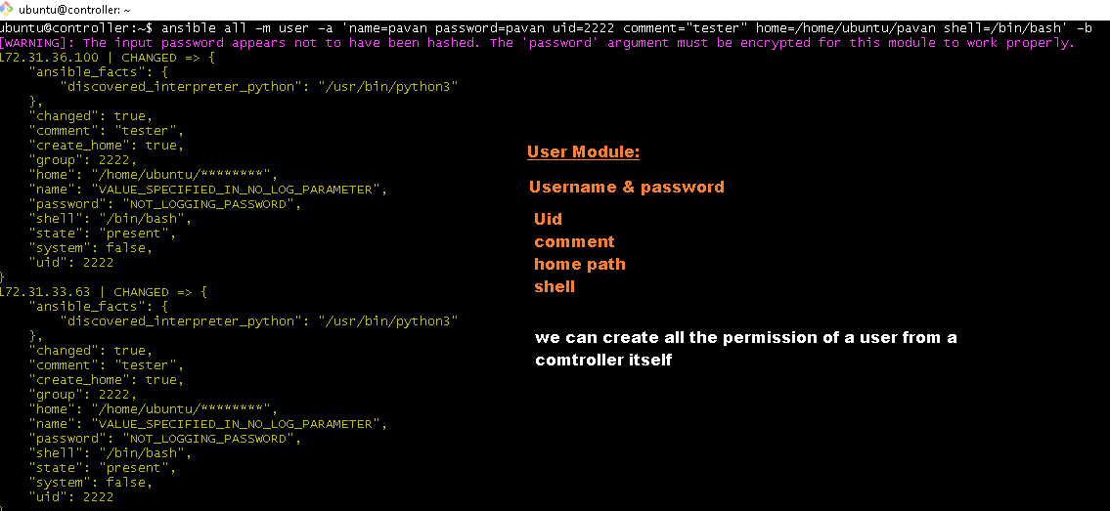

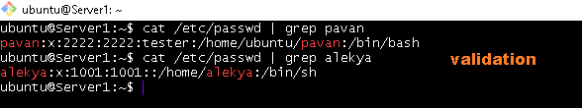

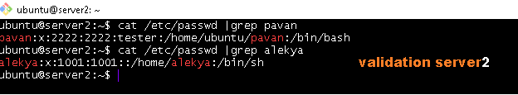

**Copy:**

This is used for copying files & directories from controller to managed nodes

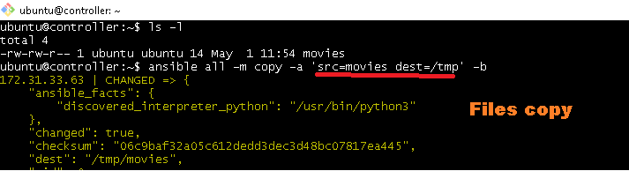

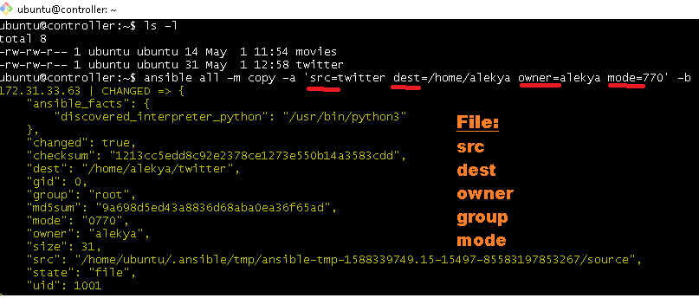

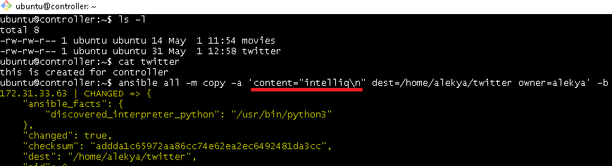

**Fetch:**

This is used for copying files & directories from managed nodes to controller

**apt:**

This is used for performing package management on the managed nodes

Ex: Installing/un-installing/upgrading softwares

Hint: apt works on ubuntu Linux machine

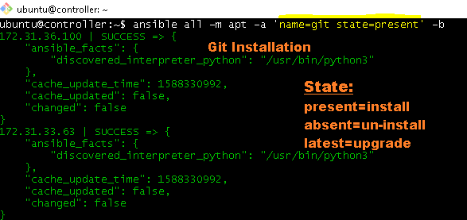

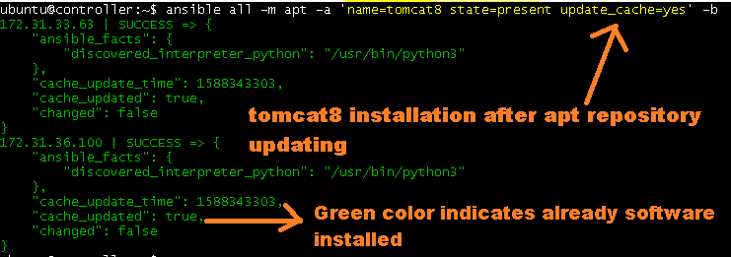

**Yum:**

This is also similar to apt module but it works on Redhat Linux, centos…..

**Service:**

This is used for start/stop/re-start services on manage nodes

**Uri:**

This is useful in checking if the remote URL is useful or not

**Git:**

This is used for git versioning control on Managed nodes

**Debug:**

This is used for printing some output on the screen.

It is generally used for printing the output of the other modules

**Include:**

This is used for calling child playbook from a parent playbook

**File:**

This is used for creating/deleting/managing the permissions of a file present on the managed nodes

**Stat:**

This is used for capturing information related to files present on the managed nodes

**Replace:**

This is used for replacing specific content of file on managed nodes

**Docker_container:**

This is used for handling docker container activity on the manage nodes

**Docker_image:**

This is used for maintaining docker images on the remote server

**Docker_login:**

This is used for login into docker hub into a remote server

**Docker_swarm:**

This is used for triggering swarm related commands on the manage nodes

**Ansible Playbook**

**Playbook1: Install Tree s/w using Ansible playbook**

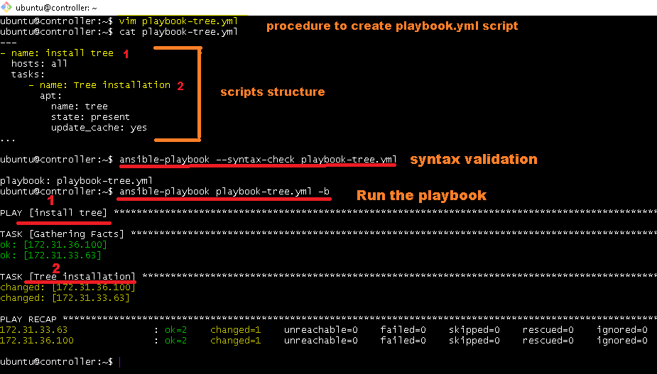

**Playbook2: Create directories & copy files into it via playbook**

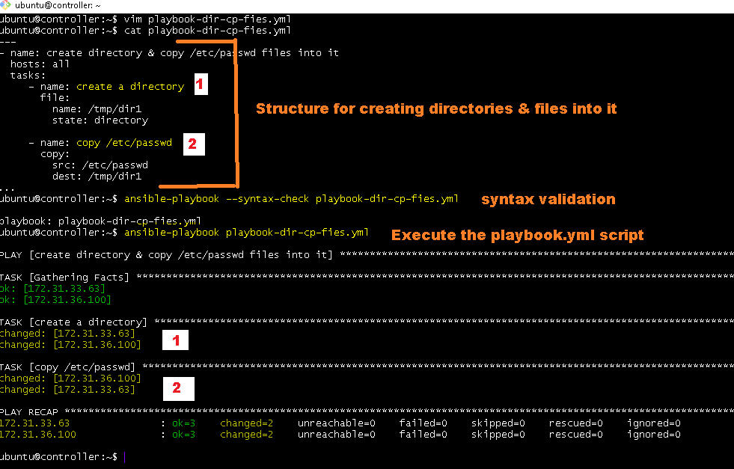

**Playbook3: Configuring apache2 via playbook**

**Ansible**

**Master**

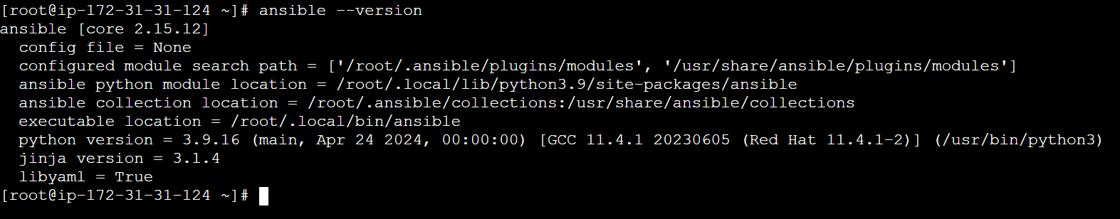

Chmod 600 3try.pem

ssh-copy-id -f "-o IdentityFile /root/3_try/Shell_scripting/3try.pem" ubuntu@ 13.210.219.154