#Install tools

apt update && apt install jq net-tools

#Docker Installation

curl https://get.docker.com/ |bash

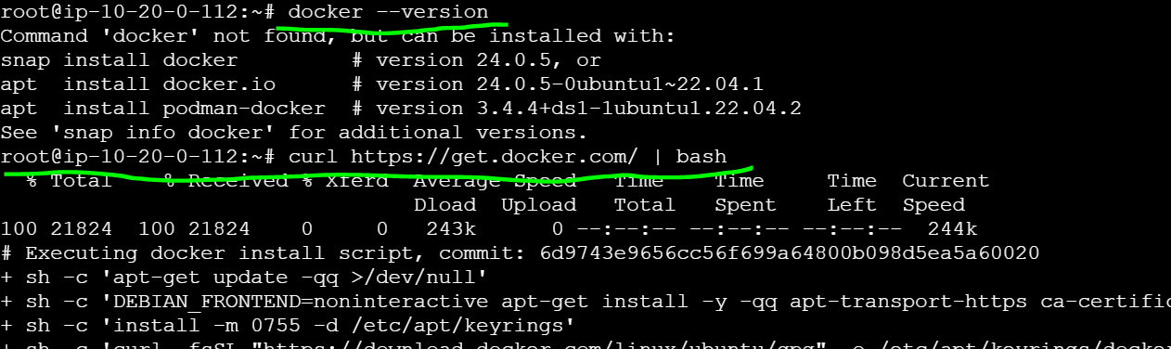

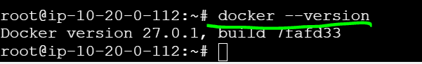

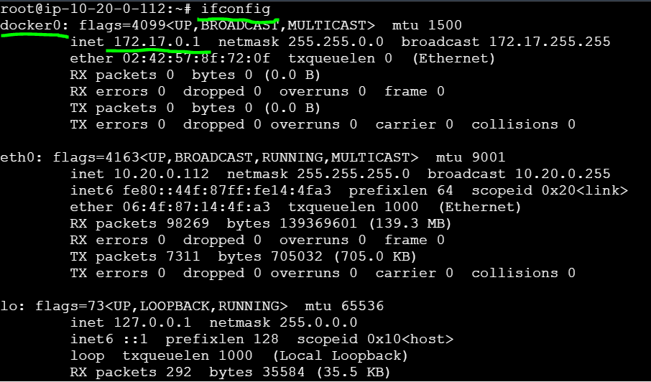

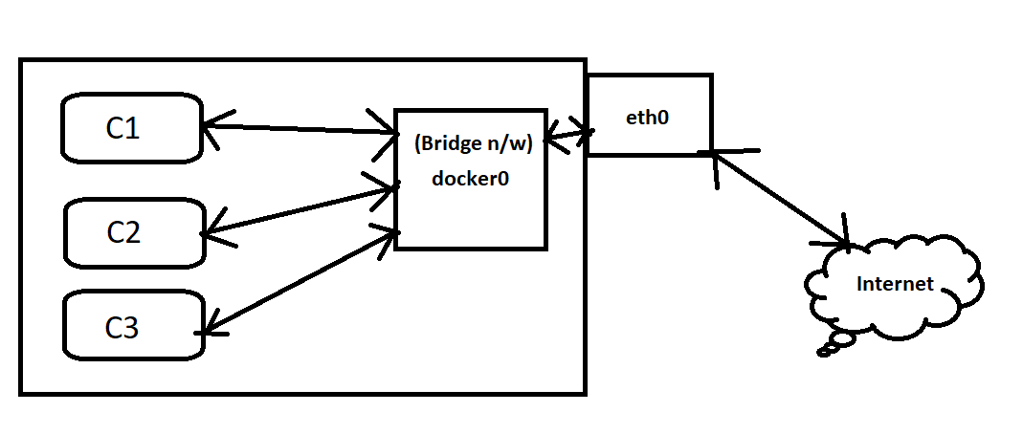

**Docker0 (172.17.0.1) acts as a Bridge N/W between containers & eth0**

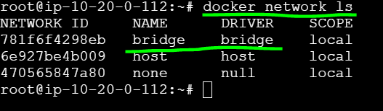

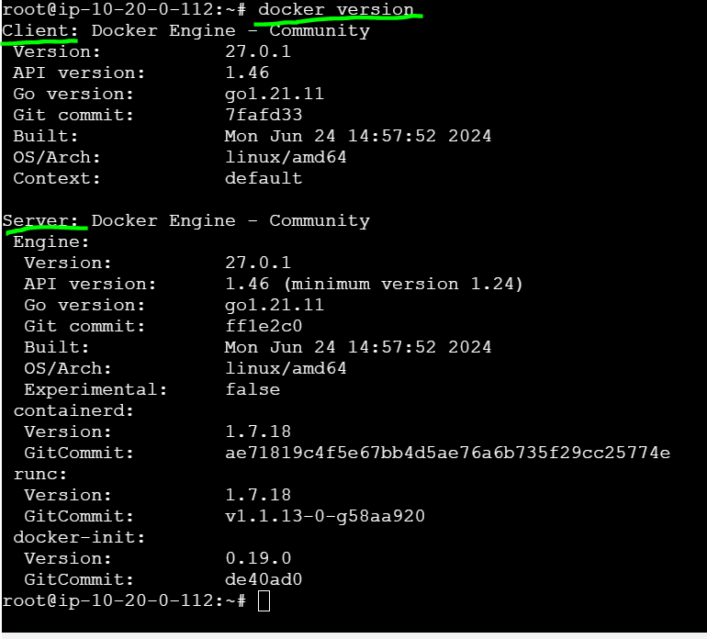

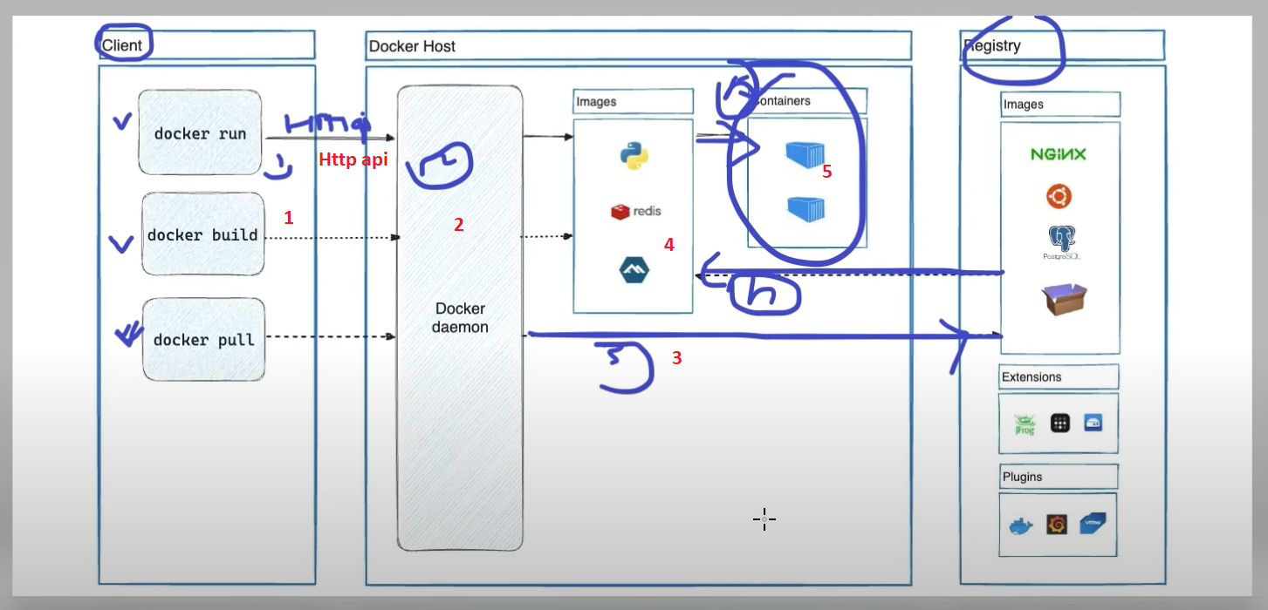

**Process of creating containers**

Docker Run / Build / Pull 🡪 Docker daemon 🡪Registry 🡪 image download 🡪 Container

Docker daemon -- > is a process