**Kubernetes**

**Kops – Installation**

<https://github.com/kubernetes/kops/releases>

wget https://github.com/kubernetes/kops/releases/download/v1.29.0/kops-linux-amd64

Purchased Domain name for 1 year from GoDaddy Expiry date

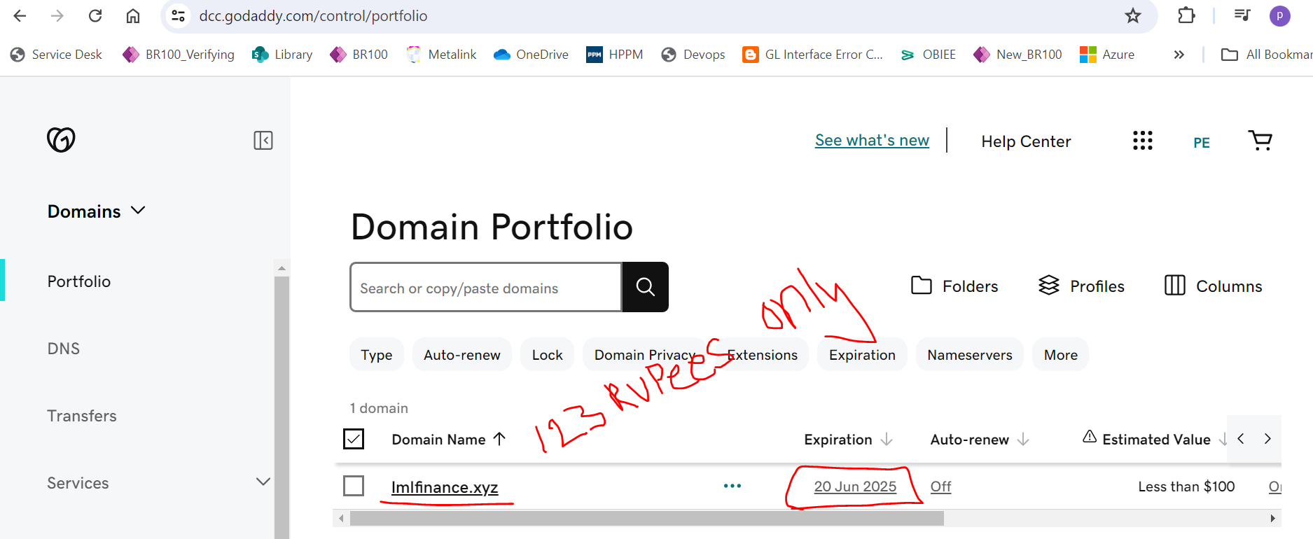

# open this file & paste the below details

vim .bashrc

export CLUSTER_NAME=lmlfinance.xyz

export AWS_REGION=ap-southeast-2

export NAME=lmlfinance.xyz

export KOPS_STATE_STORE=s3://lmlfinance.xyz

export KUBE_EDITOR=vim

# to create cluster

kops create cluster --name=lmlfinance.xyz \

  --state=s3://lmlfinance.xyz \

  --zones=ap-southeast-2a,ap-southeast-2b \

  --node-count=1 \

  --control-plane-count=3 \

  --control-plane-size=t3.medium \

  --control-plane-zones=ap-southeast-2a,ap-southeast-2b \

  --control-plane-volume-size 10 \

  --node-volume-size 10 \

  --node-size=t3.medium \

  --ssh-public-key ~/.ssh/id_rsa.pub \

  --dns-zone=lmlfinance.xyz \

  --networking calico  \

  --dry-run -o yaml > lmlfinance.yaml

  # --networking calico --yes (if you are not use --yes cluster will not deploy created as )

**#validation**

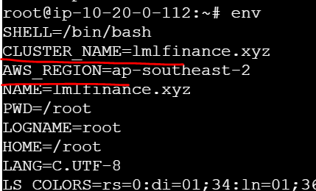

kops get cluster

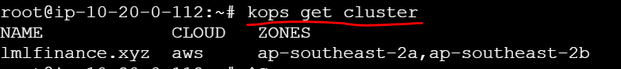

kops edit cluster lmlfinance.xyz #to edit security group details/cidr block



kops get ig --name lmlfinance.xyz # ig = instance group

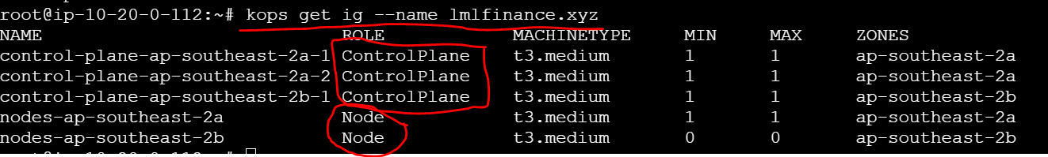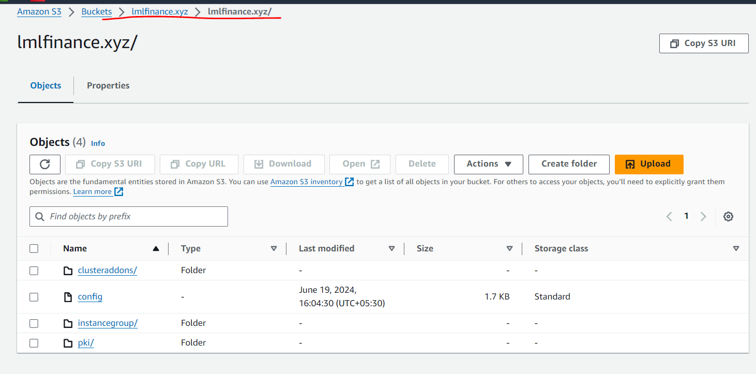

**Delete cluster**

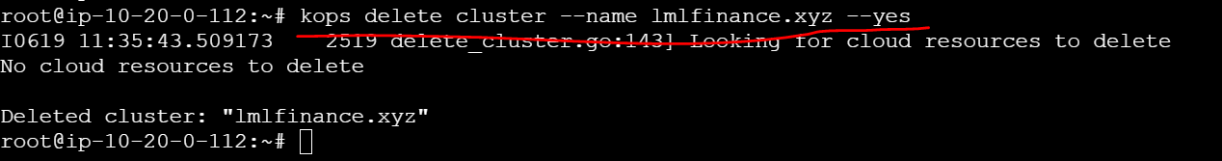

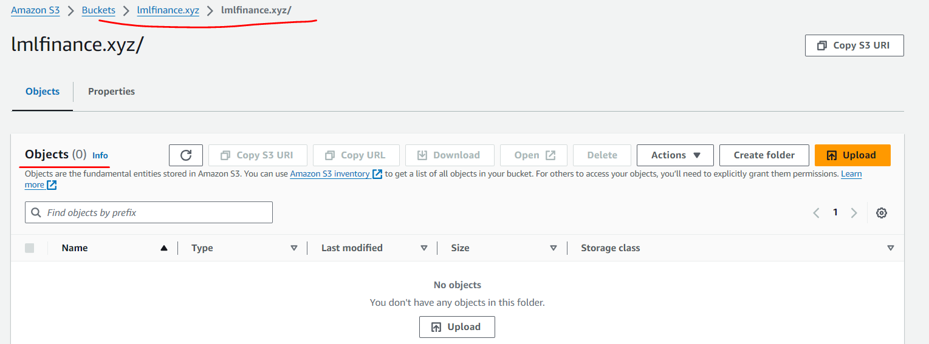

kops create -f lmlfinance.yaml

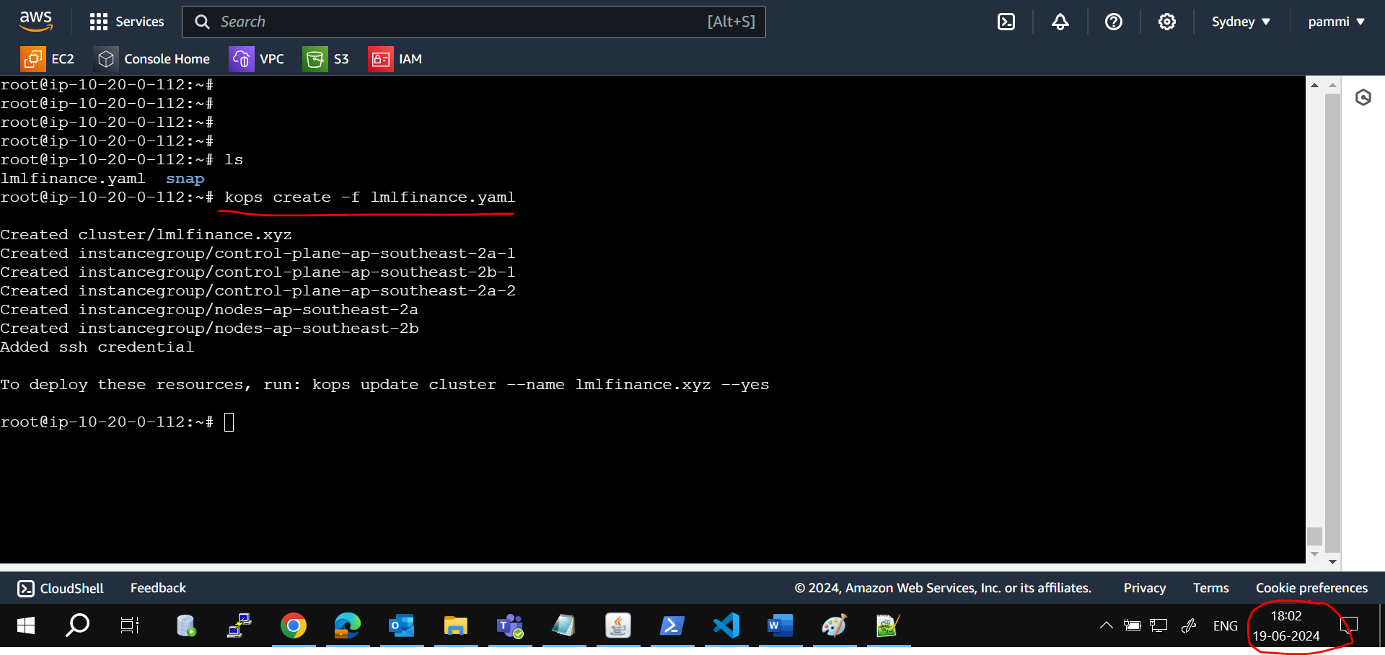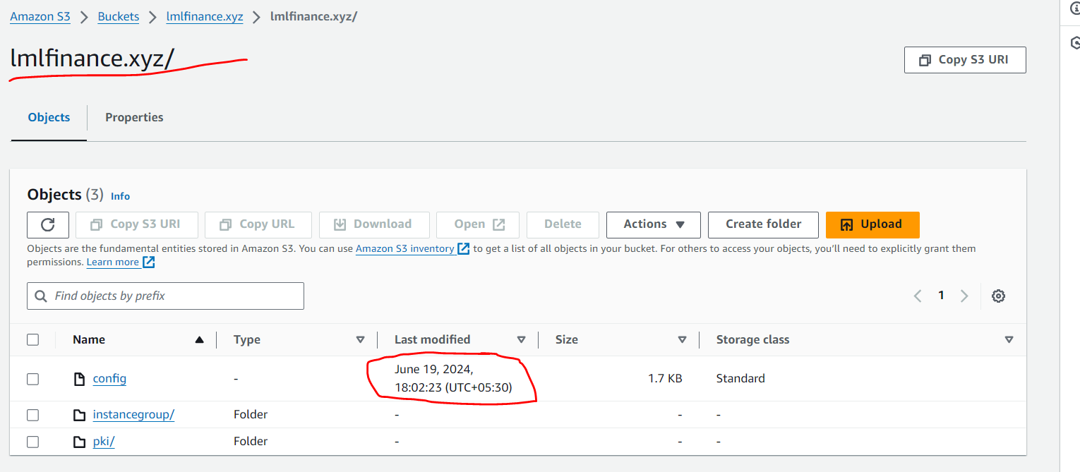

kops update cluster --name lmlfinance.xyz --yes –admin

