Murder Mystery

A murder has been committed. Your job is to decode the clues to find

1. the identity of **the murderer**
2. the **murder weapon**
3. the **room** in which the murder took place

You should take notes on this piece of paper as you proceed through the investigation.

When you have finished, go to the quiz called Murder Mystery and fill in your answers. You have three tries. The quiz can be resumed.

The possible **murder weapons** are:

Picture Frame Chair Scissors Barbell

Keyboard Pen Stapler

The seven **suspects** are:

Mr Broome Dr Sweden Mr Halai Miss Kaur

Mr Scotland Mr Sheppard Mr Smith

The **room** in which the murder was committed could be:

16 23 24 25 28 29 30 Computer room GYM

**Helpful Links:**

<https://www.dcode.fr/>

<https://cryptii.com/>

<http://icyberchef.com/>

<http://www.counton.org/explorer/codebreaking/frequency-analysis.php>

<http://rumkin.com/tools/cipher/>

**Code 1: Pigpen**

This code uses the following **key**. You need to work out how to use the key to decode the message which follows.

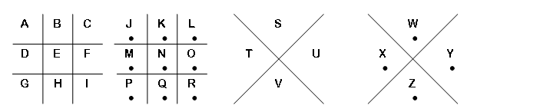



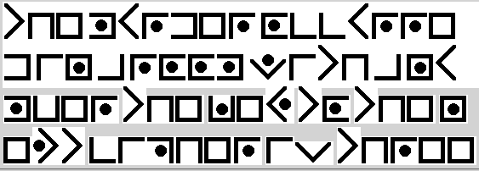

**Code 2: RAILFENCE**

You should have gotten a number from the last message to help you solve this cipher.

Tme svnih eC rkftn hiyfh udrrde aea nternm. leTesce e o h etcpe scbruereoh S ia uhetyrexir en

**Code 3: Vigenere Cipher**

This cipher requires a code word to decrypt

vff qlwxrt bjh etn ucnqie nh n rpjqv sozdcsiu wibo

Lfbk hfhg Rii ejrg egqlvw cf qlf sw ybr qjeijy vnuce se ybr jccvvb uyrfbfvy

**Code 4: Real OLD Cipher**

Each letter is represented by a different letter in a simple way.

Gsv illn mfnyvi rh wrerhryov yb urev

XOFV gsv mvcg xzvhvi orpv drgs z hvevmgvvm

**Code 5: Cipher**

Spin the right number of times.

cqn vdamnanab wjvn fruu cnuu hxd fqjc lxdwcah cqnh jan oaxv

LUDN oxa cqn wngc xwn hxd cruu qjen cx cajwbyxbn lxudvw cx axfb

**Code 6: TRANSPOSE Code**

Toaot hosfo emtar rhwcs

Cnooygaia lenuthrts uxebosthe etdlutwb64

**Code 7: The final challenge**

**Second Step ROT some number**

CgpOeXkgaXZ5eW52YWYgZnJyYSBnYiB1bmlyIG5xaW5hcHJxIHFydGVycmYKCgoK==

ClFiYXIganZndSBuYSB2YWZnZWh6cmFnIHp2dHVndnJlIGd1bmEgbiBmamJlcQoKCg==

**Message from the Murderer**

Use all your cunning to break this final message left by the murderer. You might want to keep a track of which letters represent what using the provided grid.

XNFF OUMN! QUV SEKN TPULNM BSN AUON EMO AEVISB CN. WU TNRUPN H IU BU GPHWUM H XHFF PNXEPO QUV XHBS E FHBBFN THB UR CQ LMUXFNOIN ETUVB AUONW. BSNPN EPN CEMQ XEQW BU TPNEL E CNWWEIN BSEB SEW TNNM NMAUONO VWHMI E AHGSNP. SUXNKNP, BSN TNWB XEQ BU EBBEAL WVAS E CNWWEIN HW VWHMI RPNYVNMAQ EMEFQWHW. BSHW VWNW BSN REAB BSEB NKNPQ FEMIVEIN SEW ANPBEHM FNBBNPW BSEB UAAVP CUPN RPNYVNMBFQ BSEM UBSNPW. UR AUVPWN, MUB NKNPQ GHNAN UR BNJB SEW BSN WECN FNBBNP OHWBPHTVBHUM, WU BSN GNPWUM TPNELHMI BSN AUON SEW BU VWN E ANPBEHM ECUVMB UR HMINMVHBQ EMO GPUTFNC WUFKHMI WLHFFW BU APEAL BSN AUON. BSHW HW XSQ BSN WAHNMAN UR APQGBUIPEGSQ HW EM EGGFHNO WVTDNAB UR CEBSNCEBHAW.

|  |  |  |  |  |  |  |  |  |  |  |  |  |  |
| --- | --- | --- | --- | --- | --- | --- | --- | --- | --- | --- | --- | --- | --- |
| **Code Letter** | A | B | C | D | E | F | G | H | I | J | K | L | M |
| **Real Letter** |  |  |  |  |  |  |  |  |  |  |  |  |  |
|  | | | | | | | | | | | | | |
| **Code Letter** | N | O | P | Q | R | S | T | U | V | W | X | Y | Z |
| **Real Letter** |  |  |  |  |  |  |  |  |  |  |  |  |  |

|  |  |  |  |  |  |  |  |  |  |  |  |  |  |
| --- | --- | --- | --- | --- | --- | --- | --- | --- | --- | --- | --- | --- | --- |
| **Code Letter** | A | B | C | D | E | F | G | H | I | J | K | L | M |
| **Real Letter** |  |  |  |  |  |  |  |  |  |  |  |  |  |
|  | | | | | | | | | | | | | |
| **Code Letter** | N | O | P | Q | R | S | T | U | V | W | X | Y | Z |
| **Real Letter** |  |  |  |  |  |  |  |  |  |  |  |  |  |

|  |  |  |  |  |  |  |  |  |  |  |  |  |  |
| --- | --- | --- | --- | --- | --- | --- | --- | --- | --- | --- | --- | --- | --- |
| **Code Letter** | A | B | C | D | E | F | G | H | I | J | K | L | M |
| **Real Letter** |  |  |  |  |  |  |  |  |  |  |  |  |  |
|  | | | | | | | | | | | | | |
| **Code Letter** | N | O | P | Q | R | S | T | U | V | W | X | Y | Z |
| **Real Letter** |  |  |  |  |  |  |  |  |  |  |  |  |  |

|  |  |  |  |  |  |  |  |  |  |  |  |  |  |
| --- | --- | --- | --- | --- | --- | --- | --- | --- | --- | --- | --- | --- | --- |
| **Code Letter** | A | B | C | D | E | F | G | H | I | J | K | L | M |
| **Real Letter** |  |  |  |  |  |  |  |  |  |  |  |  |  |
|  | | | | | | | | | | | | | |
| **Code Letter** | N | O | P | Q | R | S | T | U | V | W | X | Y | Z |
| **Real Letter** |  |  |  |  |  |  |  |  |  |  |  |  |  |

|  |  |  |  |  |  |  |  |  |  |  |  |  |  |
| --- | --- | --- | --- | --- | --- | --- | --- | --- | --- | --- | --- | --- | --- |
| **Code Letter** | A | B | C | D | E | F | G | H | I | J | K | L | M |
| **Real Letter** |  |  |  |  |  |  |  |  |  |  |  |  |  |
|  | | | | | | | | | | | | | |
| **Code Letter** | N | O | P | Q | R | S | T | U | V | W | X | Y | Z |
| **Real Letter** |  |  |  |  |  |  |  |  |  |  |  |  |  |

