**Comcast Data Engineer Interview Guide – Experienced 3+**

**1. Stored Procedure Syntax and Execution**

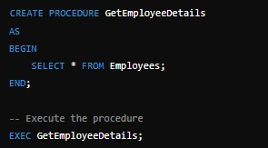

**Explanation**:

• **Stored Procedures** are reusable SQL code blocks.

• EXEC or EXECUTE keyword is used to run the procedure.

**2. Indexing – Types and Benefits**

• **Types**:

**Benefits**:

**Clustered Index**: Sorts and stores data rows in a table based on key columns. One per table.

**Non-clustered Index**: Maintains a separate structure for index entries. Multiple per table.

**Unique Index**: Ensures all values in the indexed column are unique.

**Full-text Index**: Optimized for text searches.

• Speeds up data retrieval.

• Reduces I/O operations by using a smaller subset of data.

**3. List Customers with More Than 5 Orders**

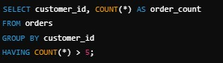

**Explanation**:

• GROUP BY groups rows, and HAVING filters based on aggregation results.

**4. Find Top 3 Products Sold Based on Total Quantity**

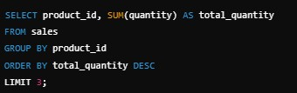

**Explanation**:

• LIMIT restricts the number of results.

**5. Find Orders Exceeding $1,000 in the Last 30 Days**



**Explanation**:

• DATEADD and GETDATE() calculate the date range dynamically.

**6. Azure Fabric in Cloud Architecture**

Azure Service Fabric is a platform for building distributed systems with microservices. Uses:

• Provides high availability and scalability for services.

• Manages stateful and stateless services.

• Used in IoT applications and cloud-scale solutions.

**7. Azure Functions vs. Logic Apps**

**Azure Functions Logic Apps**

Serverless compute service for custom code execution.

Workflow automation using pre-built connectors.

Triggers based on events (HTTP, queue). Integrates multiple systems and processes.

**8. Transformation vs. Action in PySpark**

• **Transformation**: Defines a **new RDD** without immediate execution (lazy). Example:

map().

• **Action**: Triggers computation and returns a result. Example: collect().

**9. Row-Level Records to Column Records**



**10. Deployment Architecture**

Explain a typical big data deployment:

• Data ingestion: Using tools like Kafka or Azure Data Factory.

• Processing: Databricks/Spark for transformation.

• Storage: Data lakes (ADLS) or warehouses (Synapse).

• Visualization: Power BI.

**11. Palindrome Check in Python**

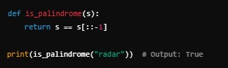

**12. Database vs. Data Warehouse vs. Data Lakehouse**

**Database Data Warehouse Data Lakehouse**

OLTP, structured data OLAP, analytics-ready data Combines warehouse and lake features

Normalized schema Star/snowflake schema Unified storage for both

**13. ER Modeling vs. Dimensional Modeling**

• ER Modeling: Focuses on entities and relationships. Used for OLTP systems.

• Dimensional Modeling: Uses facts and dimensions for analytics in data warehouses.

**14. Data Warehouse for Grocery Store**

• Star Schema:

Fact Table: Sales (product_id, customer_id, amount, date). Dimension Tables: Product, Customer, Date.

**15. Python List Operations**

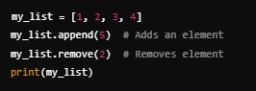

**16. SQL Query with LAG Function**

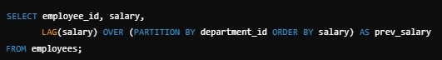

**17. Agile in Project Management**

Agile: An iterative development methodology emphasizing collaboration, flexibility, and customer feedback. Used for continuous delivery of software.

**18. Daily Tasks of a Data Engineer**

• Building pipelines for data ingestion.

• Data cleaning and transformation.

• Optimizing performance of queries.

**19. Databricks vs. PySpark**

**Databricks PySpark**

Managed service for Spark Open-source Spark framework

Integrates with Azure Requires setup and maintenance

**20. Unix Scripting in Data Engineering**

Used for automation of ETL processes, running batch jobs, and managing file systems.